JoshuaRed
- Dread Pyrate
- 
- 
- Member

- 1,342 posts
Posted February 25, 2006 · Report post
This is a self portrait by the artist Godfried Schalcken (1643-1706), painted circa 1670. Clearly not a sailor, and it's a bit prior to the GAOP, but it does show the ol' gold hoop earring worn for fashion's sake...I throw it out there for those who are seeking alternative controversial debates to the Boots. Enjoy! :)

kass
- Scourge o' the 7 Seas
- 
- 
- Member

- 1,526 posts
- Gender:Male
- Location:Easton, Pennsylvania
- Interests:Historical Clothing from the 14th through 18th centuries. Getting all the niggling details right. Dressing up and having fun with my similarly-obsessed friends. :)
Posted February 25, 2006 · Report post
Hey Josh, is this the entire portrait? Because if there is more of his clothing to see, I'd love to see it.
Tell ya why I ask: He looks like he may not be dressed as himself. Now I don't know about the 1670s, but in the 18th century, it was common to be painted as someone else (like a historical figure or a mythological character) or dressed in a costume from another period of history. Now regardless of the fact that the 18th century is a lot closer to the 17th century than we are, boy do they get the clothing WRONG!!! It wasn't so important to them to get the details historically accurate. They just liked the "vibe" of those earlier eras (kinda like some of us, eh?)
Anyways, the shirt he's wearing looks so early 16th century German that I'm having Landsknecht flashbacks. And I can't make out the details of his outer garment, but it looks very much like something you might see on a Burgermeister... or even Henry VIII!
Neato! Thanks bro!
Okay. Enough of a break. Gotta go check the pattern paper...

JoshuaRed
- Dread Pyrate
- Member

- 1,342 posts
Posted February 25, 2006 · Report post
Good observation Kass. He was a student of painters who studied with Rembrandt...and this outfit does look a bit like that...perhaps it's an homage...
This is the whole portrait, so you'll have to go just on this. It's part of a set, the other painting being a portrait of his wife.

Fox
- Old Twillian
- 
- 
- Moderator

- 2,564 posts
- Gender:Male
- Location:Beautiful lush Devon, England
- Interests:Nautical history of the 16-18th centuries and living history based thereon.
Shooting pirates.
Posted February 25, 2006 · Report post
That was my immediate thought too Kass (oh no, now your'e in my head too!). I think it's the square neckline that just screams "16thC!"
I love those pseudo-historical portraits - generals in "Roman" armour is a classic.
As for the earring, nice find! IF it transpires that the portrait is "set" in the 16th century then it may be that the earring is part of the costume and thus irrelevant (hang on, no, we know from this picture that Kidd liked to dress in 16thC clothes, maybe he had one! )

But seriously, if he really is wearing an earring in the 1670s then he's probably wearing it for personal preference rather than for the sake of "fashion". A great piece of evidence to support the theory that now and again occasionally people might have worn earrings during the (nearly) GAoP. :)

Caraccioli
- Notorious Pyrate
- 
- 
- Member

- 999 posts
- Gender:Male
- Interests:HI! Mission is Carracioli is Mark. This is Mission's Doppelganger. Any questions? Good, off with ye'.
Posted February 25, 2006 · Report post
Yeah, what Ed said. Earrings were in fashion pre-GAoP.

kass
- Scourge o' the 7 Seas
- Member

- 1,526 posts
- Gender:Male
- Location:Easton, Pennsylvania
- Interests:Historical Clothing from the 14th through 18th centuries. Getting all the niggling details right. Dressing up and having fun with my similarly-obsessed friends. :)
Posted February 25, 2006 · Report post
JoshuaRed said:
Good observation Kass. He was a student of painters who studied with Rembrandt...and this outfit does look a bit like that...perhaps it's an homage...
This is the whole portrait, so you'll have to go just on this. It's part of a set, the other painting being a portrait of his wife.
Interesting... Because he's dressed 100 years earlier than Rembrandt (he was 1630s; this looks 1530s). However, Rembrandt was one of those famous Dutch painters who painted his patrons as pseudo-historical and mythological characters. Rembrandt always annoys me because I do 1630s and his paintings tell me nothing about what people really wore then...
I wanna see what his wife is wearing. Got a link?
Ed, darling, I'm in everyone's head...

JoshuaRed
- Dread Pyrate
- Member

- 1,342 posts
Posted February 25, 2006 · Report post
Being an artist he may have been trying to show how "ironically uncool" was, or how non-conformist he was, or perhaps it was simply what he liked. Regardless, he's definitely showing it off - it's darn near the focal point. The clothes definitely are not 1670s...is the earring? Who knows. He has another self-portrait from 1679 in contemporary clothing, but his wig covers his ears, so we'll never know for sure.

Capt. Bo of the WTF co.
- Scourge o' the 7 Seas
- 
- Member

- 2,339 posts
- Gender:Male
- Location:Spanish Louisiana - on the river Osage
- Interests:Many and varied.
Posted February 26, 2006 · Report post
Don't know if this will help, as I'm new to cyberworld, so I'm still trying to figure out how to use this darn thing. Anyhow, I have a book, Two Centuries of Costume in America that has a chapter on the vanities of men titled ; Muffs and Earrings. In it are five prints showing men wearing earrings. They are as follows;
Adam Winthrop-grandfather of John Withrop- 1498-1562
Chandos portrait of William Shakespear- shows him with earring.
Robert Carr-Earl of Somerset- 1587-1645
M. St. Quily- drawn 1801
Capt. George Taylor of Salem, Mass. - 1769-1819
On the fronticepiece of the chapter;
Superbus swaggers with a ring in his ear;
And likewise as the custome is doth wear
About his neck a ribband and ring;
Which makes me think he's proud of a string.
" Epigrams", Hutton, 1619
I hope this is some help at least. Wish I knew how to get these prints from my book onto the screen for everyone. The two volume set was published by Corner House Publishers, and "written" by Alice Morse Earle.
Capt. Bo

JoshuaRed
- Dread Pyrate
- Member

- 1,342 posts
Posted February 26, 2006 · Report post
Kass, when I said homage to Rembrandt, this is kind of what I was thinking:
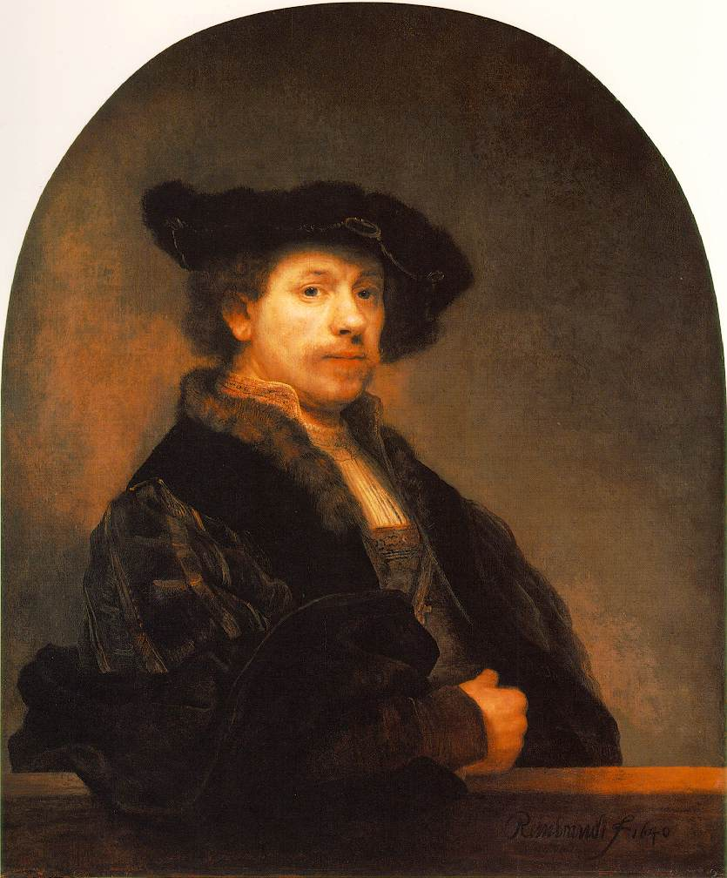
Still can't believe I'm posting about Rembrandt HERE

Fox
- Old Twillian
- Moderator

- 2,564 posts
- Gender:Male
- Location:Beautiful lush Devon, England
- Interests:Nautical history of the 16-18th centuries and living history based thereon.
Shooting pirates.
Posted February 26, 2006 · Report post
Thanks for the info Bo. If you did a Google image search for the paintings you'd probably find most of them online somewhere, then you could post them here.
The list of paintings rather intrigues me though, and bears out current thoughts on earring use: in a chapter specifically about earrings the author has not found any portraits between 1645 and 1769 (in reality, the dates of painting are probably considerably wider, say, up to 1800). They just weren't fashionable during the GAoP! :)
I love Rembrandt, but I gotta say that I like Vermeer even more.

JoshuaRed
- Dread Pyrate
- Member

- 1,342 posts
Posted February 26, 2006 · Report post
I would be hard pressed to choose between Vermeer and Rembrandt. Though Durer may be my all time favorite.

Fox
- Old Twillian
- Moderator

- 2,564 posts
- Gender:Male
- Location:Beautiful lush Devon, England
- Interests:Nautical history of the 16-18th centuries and living history based thereon.
Shooting pirates.
Posted February 26, 2006 · Report post
Durer certainly has charm. I nearly bought a book which had every known Durer picture in it. Just didn't have the spare £90...
David Teniers the Younger is another favourite of mine, Franz Halz, and of course the two Breughels. For maritime painting you can't beat the Van de Veldes (IMHO).

greenighs
- First Mate
- 
- Member

- 221 posts
- Location:Bridgeport, CT
- Interests:I belong to a site what teaches th' proper care o' seahorses in the home aquarium, an' I keep a few o' th' wee beasties m'self. Piracy is what I aspire t' in life, but in reality, I'm an 'umble graphic designer. Yes, I spend long hours practicin' me Long John accent, a fact o' which I'm neither proud nor ashamed. It's like 'aving Buccaneer Tourette's, it be. An affliction of which I must make the best in life, incurable as it seems.<br><br>
Posted February 26, 2006 · Report post
Foxe said:
Durer certainly has charm. I nearly bought a book which had every known Durer picture in it. Just didn't have the spare £90...
David Teniers the Younger is another favourite of mine, Franz Halz, and of course the two Breughels. For maritime painting you can't beat the Van de Veldes (IMHO).
Maritime and Turner go hand in hand for me. The light just blazes in his skys, his seas have such movement.

kass
- Scourge o' the 7 Seas
- Member

- 1,526 posts
- Gender:Male
- Location:Easton, Pennsylvania
- Interests:Historical Clothing from the 14th through 18th centuries. Getting all the niggling details right. Dressing up and having fun with my similarly-obsessed friends. :)
Posted February 26, 2006 · Report post
Oh my God! It's Rembrandt in 1640 in 1530s German dress!!! What he's wearing is unmistakably 1530s German, so if your lad is copying this picture specifically, that would make perfect sense, Josh!
Me, I prefer Vermeer to Rembrandt, but I'm not an artist. I just love how many costume and furniture and table-settings details Vermeer gives. Bruggel is another one of my faves, as is Durer. Man, that lad could draw/engrave!
But I wouldn't be anywhere without Hals.

JoshuaRed
- Dread Pyrate
- Member

- 1,342 posts
Posted February 26, 2006 · Report post
Here's another half-baked thought: The famous illustrators of the Brandywine school used to keep their studios FULL of old clothes, stage props, costumes, etc. I seem to recall reading that Wyeth for instance had many original 18th century articles of clothing from the Revolution era, probably all family hand-me-downs. These "props" turned up in many of the paintings.
I wonder if the Rembrandts and Vermeers of their era kept closets full of old hand-me-down clothes to use merely as attractive drapery for models, because it "looked cool" and not for any higher purpose or intent.

Capt. Bo of the WTF co.
- Scourge o' the 7 Seas
- Member

- 2,339 posts
- Gender:Male
- Location:Spanish Louisiana - on the river Osage
- Interests:Many and varied.
Posted February 26, 2006 · Report post
This is just abit away from the subject, but can anyone tell me when it became "tradition" to "earn" the wearing of an earring after sailing 'round the horn?( Cape Horn ) Is this an old sailors "tradition" or is it more of a modern "fad" thing?
Capt. Bo

Fox
- Old Twillian
- Moderator

- 2,564 posts
- Gender:Male
- Location:Beautiful lush Devon, England
- Interests:Nautical history of the 16-18th centuries and living history based thereon.
Shooting pirates.
Posted February 26, 2006 · Report post
$64billion question!
Depending on who you talk to the earring is earned for different things. The most common is rounding the Horn, but crossing the Equator, crossing the Straits of Gibraltar, and going on the Gosport Ferry are all other possibilities.
We do know that as late as the early 19thC earrings were considered unusual, even remarkable, so we can say that it certainly goes back no earlier than that. The earliest references to the "tradition" seem to come from the very late 19thC - 1880s-90s.

Capt. Bo of the WTF co.
- Scourge o' the 7 Seas
- Member

- 2,339 posts
- Gender:Male
- Location:Spanish Louisiana - on the river Osage
- Interests:Many and varied.
Posted February 26, 2006 · Report post
Thanx Foxe!
I served four in the US Navy, and when we crossed the Equator it was quite a celebration, and first timers-Pollywogs- were "initiated" to become "Shellbacks". I won't go into the gory details of initiation rites, but earrings were certainly NOT a prize at the end!
Again, thanx for the input...Bo

JoshuaRed
- Dread Pyrate
- Member

- 1,342 posts
Posted February 26, 2006 · Report post
LOL I'd say 1964. :)

Capt. Bo of the WTF co.
- Scourge o' the 7 Seas
- Member

- 2,339 posts
- Gender:Male
- Location:Spanish Louisiana - on the river Osage
- Interests:Many and varied.
Posted February 27, 2006 · Report post
"64 you say? Works for me! I was three so it would become part of my own "era" of maritime history. Hey... We gotta have somethin to tell the grand-kids!
As for the original text of the thread, I'm also old school "biker", but I don't wear my earring at the publik events as it isn't proper, especially for a land lubber. The Half beard is bad enough, but I ain't shavin! Gotta have some way of filterin the critters outta my soup!
The more I'm around here, the more I feel like it's time to explore yet another area of history. My She Mate is gonna have a fit when I start building a new kit and start attending a different set of events... But I did warn her in advance of the nuptuals.
Capt. Bo

kass
- Scourge o' the 7 Seas
- Member

- 1,526 posts
- Gender:Male
- Location:Easton, Pennsylvania
- Interests:Historical Clothing from the 14th through 18th centuries. Getting all the niggling details right. Dressing up and having fun with my similarly-obsessed friends. :)
Posted February 27, 2006 · Report post
JoshuaRed said:
I wonder if the Rembrandts and Vermeers of their era kept closets full of old hand-me-down clothes to use merely as attractive drapery for models, because it "looked cool" and not for any higher purpose or intent.
Rembrandt certainly had a closet full of "costumes" in which to dress his models. Matter of fact, I am hard-pressed to name a Rembrandt portrait in which the sitter is wearing the dress of the 1640s. This was the fashion then -- to be painted as an Ottoman princess or in drapery evoking the ancient Greeks. Painting in character is one of Rembrandt's things.
Vermeer on the other hand usually painted people in the dress of the day doing ordinary, daily things, like playing music or drinking with friends. The only notable exception is "Girls with a Pearl Earring" who is wearing scarves wrapped around her head in a decidedly non-Dutch manner.
It may have been the style by the 1660s to paint "after the life". And by the third quarter of the 18th century, people are being painted as "Cavaliers". You know the famous "Blue Boy"? Painted in the 1770s but he's wearing vaguely 1640s dress.

Fox
- Old Twillian
- Moderator

- 2,564 posts
- Gender:Male
- Location:Beautiful lush Devon, England
- Interests:Nautical history of the 16-18th centuries and living history based thereon.
Shooting pirates.
Posted February 27, 2006 · Report post
kass said:
Matter of fact, I am hard-pressed to name a Rembrandt portrait in which the sitter is wearing the dress of the 1640s.
There are a few: Doctor Nicolaes Tulp Demonstrating the Anatomy of the Arm, Jan Rijcksen and Griet Jans, The Mennonite Minister Cornelis Claesz. Anslo, but of course the most famous is The Militia Company Of Franz Banning Cocq.
Did you know there's a group in Holland who are "Night Watch" re-enactors. They go around doing living histories as Banning Cocq's company and of course they DO know what everyone in the company wore. People think that we're sticklers for details!

kass
- Scourge o' the 7 Seas
- Member

- 1,526 posts
- Gender:Male
- Location:Easton, Pennsylvania
- Interests:Historical Clothing from the 14th through 18th centuries. Getting all the niggling details right. Dressing up and having fun with my similarly-obsessed friends. :)
Posted February 27, 2006 · Report post
Oh Foxe! Don't baffle me with logic. I'm postulatin' here!
Seriously, yeah, I knew they existed. But when you have a Rembrandt in your head, no one is wearing the dress of the period.
Except the Night Watch...
I really prefer Codde's Meagre Company (or Hals Banquet of Some Other Officer Types). My husband always makes his clothing demands based on these.

PoD
- Pyrate Captain
- 
- 
- Member

- 696 posts
- Gender:Male
- Location:Warrington UK
- Interests:Pirates, graphic novels, computer art, Listening to music, Going to gigs, Beer and Wine drinking, historical research, Period weaponry and Leatherwork
Posted October 3, 2010 · Report post
Just to open an old thread again. I have just found this picture in the british museum. A Dutch sailor no less with an earring in from 1695:
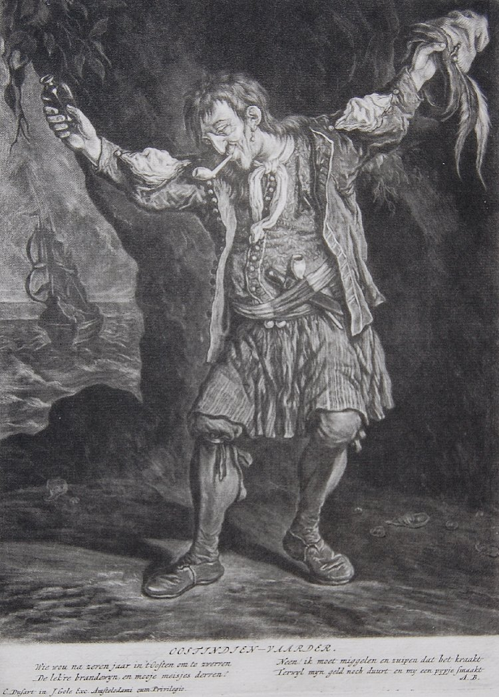
http://www.britishmu...ject_image.aspx

Fox
- Old Twillian
- Moderator

- 2,564 posts
- Gender:Male
- Location:Beautiful lush Devon, England
- Interests:Nautical history of the 16-18th centuries and living history based thereon.
Shooting pirates.
Posted October 3, 2010 · Report post
On 10/3/2010 at 0:09 AM, PoD said:
Just to open an old thread again. I have just found this picture in the british museum. A Dutch sailor no less with an earring in from 1695:
http://www.britishmu...ject_image.aspx

Oh there's so much good stuff in that picture! Nice one PoD.

- 1
- 2
- 3
- Next

- Page 1 of 3

madPete
- Archangel Antagonist
- 
- Member

- 604 posts
- Gender:Male
- Location:Arizona
- Interests:Golden Age of Piracy, Early English Archers, Steampunk
Did I mention Rum!?!
Posted October 3, 2010 (edited) · Report post
Hey - he's wearing me petticoat trousers!
My link
Edited October 3, 2010 by madPete

Jack Roberts
- Dread Pyrate
- 
- Member

- 1,063 posts
- Gender:Male
- Location:Orlando, FL
Posted October 3, 2010 · Report post
Dang that's cool. Couples of things that jump out to me.
The Slashed sleeves of the coat. I can't seem to recall seeing them anywhere else in this period.
(Sterling, Foxe any ideas?) Everything else is looking about right to me. I like the sash and 2 pipes also.
Now let me preface this with I wear earrings and really wish I could keep them in at events.
I'm going to play devils advocate. Perhaps the earring that we are seeing is a wart or skin tag
if some sort? Just a thought.

PoD
- Pyrate Captain
- Member

- 696 posts
- Gender:Male
- Location:Warrington UK
- Interests:Pirates, graphic novels, computer art, Listening to music, Going to gigs, Beer and Wine drinking, historical research, Period weaponry and Leatherwork
Posted October 3, 2010 (edited) · Report post
On 10/3/2010 at 8:31 AM, Foxe said:
Oh there's so much good stuff in that picture! Nice one PoD.
Theres actually another in that series of a drunken dutch Sailor
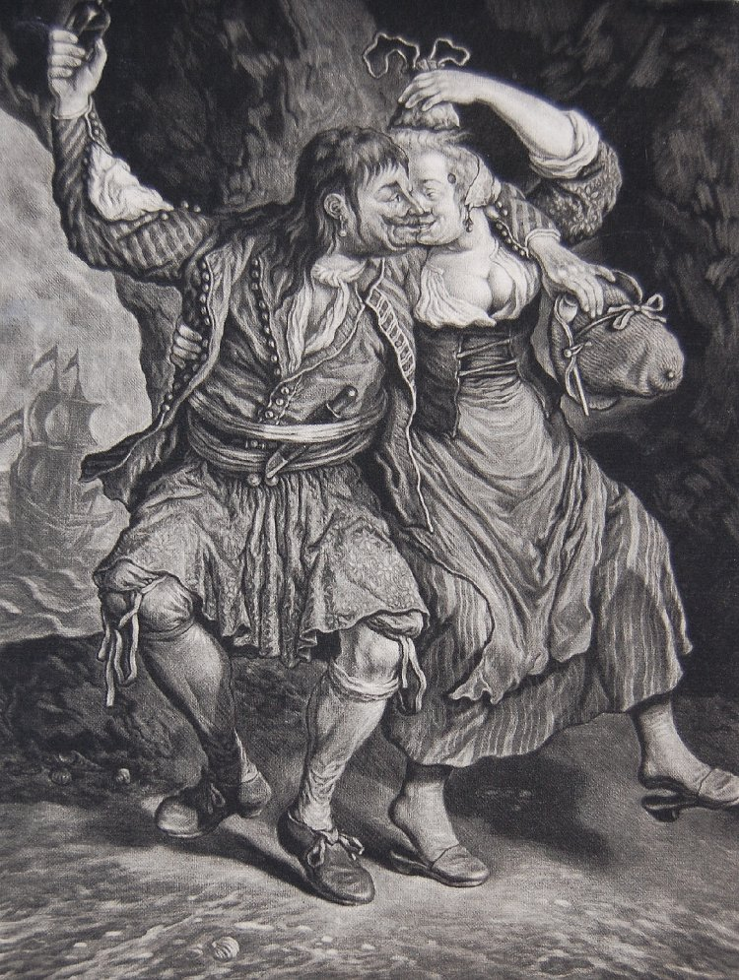
I like the knife he is carrying and the fact he uses ribbons to tie up his stockings. I think its also interesting that Dutch alcohol seems to come in small square bottles. His hat also seems to be a customised wide brimmed peter the great cap.
Edited October 3, 2010 by PoD

Dorian Lasseter
- Where's My Water
- 
- Member

- 3,266 posts
- Gender:Male
- Location:The Sea!
- Interests:18th Century reenactment; Maritime, F&I...
Did ECW as well...
All BP firelocks and cannons!
Also enjoy Swordfighting and a good Donnybrook
Got a question for or about me? Ask!!!
Posted October 3, 2010 (edited) · Report post
Grand images!
other little items of note...
Does he have slash pockets in his wesket? just above the butt of his knife, it looks like a straight line like a pocket opening. Look at the print of his Slops! Not stripes or solid, but a print!
And he's got britches on under the slops too.
PoD, the little square bottles would be Gin bottles. Gin was a very cheap to make spirit in period... Tell that to Tanguray!
Edited October 3, 2010 by Dorian Lasseter

Fox
- Old Twillian
- Moderator

- 2,564 posts
- Gender:Male
- Location:Beautiful lush Devon, England
- Interests:Nautical history of the 16-18th centuries and living history based thereon.
Shooting pirates.
Posted October 3, 2010 · Report post
Well, here's my thoughts:
Slashed sleeves are uncommon, but not unknown from this period - as these pictures show.
The petticoat breeches are indeed awesome, but can we be certain those are breeches and not drawers underneath?
The knife is (to me) even more fantastic.
The small case bottle possibly contain gin, or other spiritous liquor.
The hat in the second picture does look very much like what we now call a "Peter the Great". The story, for those who don't know it, is that Tsar Peter the Great visited England in the 1690s and spent quite a bit of time admiring the Royal Navy. He rather liked the hats that he saw the English sailors wearing, so on his way home, during a visit to the Netherlands, he bought one, which now resides in the Hermitage Museum, St. Petersberg.

Fox
- Old Twillian
- Moderator

- 2,564 posts
- Gender:Male
- Location:Beautiful lush Devon, England
- Interests:Nautical history of the 16-18th centuries and living history based thereon.
Shooting pirates.
Posted October 3, 2010 · Report post
I don't know how many times I've looked at this Picart image, but I've only just notice that he too has an earring.
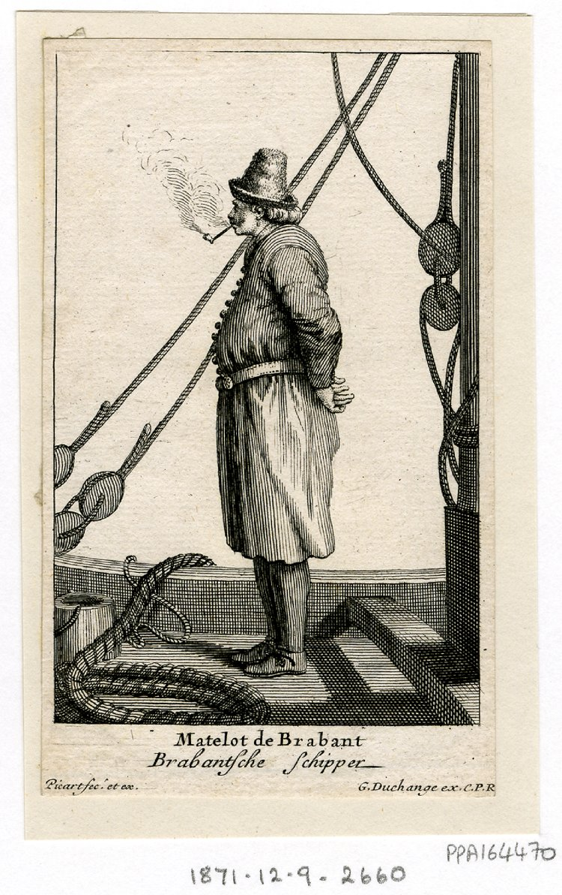

Jack Roberts
- Dread Pyrate
- Member

- 1,063 posts
- Gender:Male
- Location:Orlando, FL
Posted October 3, 2010 (edited) · Report post
Ahh yes now that is definitely an earring and they are petticote breeches. Look at that coat to. the Sleeves button all the way up. Very cool.
Foxe isn't that another Dutch sailor also? mmmmm
Edited October 3, 2010 by Jack Roberts

Jack Roberts
- Dread Pyrate
- Member

- 1,063 posts
- Gender:Male
- Location:Orlando, FL
Posted October 3, 2010 · Report post
Yes I would think the clothing underneath the Petticote breeches are drawers (underwear!)

Bos'n Cross
- Pyrate Captain
- Member

- 536 posts
- Gender:Male
- Location:Portsmouth
- Interests:many things.......
Posted October 3, 2010 (edited) · Report post
I concur with mr.foxe and quartermaster roberts(i didnt vote for 'em). Im quite sure those are drawers under his petticoat breeches, owing to the fact that im many many period images sailors are shown wearing their drawers in this manor....untied and easily seen...lol.... as for ribbons on the stockings, i believe what we are seeing is that he has garters on only one leg (our left his right) so on that side his stocking go all the way up to his drawers..but not so on the other side. Also we can now more clearly see that indeed he is wearing earings....but could this possibly be a fashion trend only with the dutch? ..........the slashed sleeves....i find those quite interesting..... iv see images of sleeves that button up to the elbow(as well as the earlier trend of slashed sleeves)....but his whole bleedin arm can unbutton.....makes me want to sew.......
Edited October 3, 2010 by Bos'n Cross

Capt. Sterling
- Sticky Fingers Sterling Needs a New Hat
- 
- 
- Member

- 10,302 posts
- Gender:Pyrate Hunter
- Location:here
- Interests:Killing pirates, haven't met one yet worth keeping alive....
Posted October 4, 2010 · Report post
Nice find indeed!
Nice to see the case bottles going back that far, as I was told emphatically no,
and must agree with Foxe, hard to tell if it is breeches or drawers under the petticoat breeches.
As to ribbon garters, they were still being worn, one of the coffee house prints, circa 1700 shows them being worn.
so Jack, does this mean you are now Dutch?

Capt. Sterling
- Sticky Fingers Sterling Needs a New Hat
- Member

- 10,302 posts
- Gender:Pyrate Hunter
- Location:here
- Interests:Killing pirates, haven't met one yet worth keeping alive....
Posted October 4, 2010 (edited) · Report post
as to the slash pocket above the knife butt...is it the one closer to the neck opening than the waist? I am thinking it is just part of the wrinkle...
also can post the portrait of Peter the Great in the sailor's kit, but have to wait to get home to do so, unless Foxe has it to post sooner.
I have two other Dutch images, will post them again for easy comparison
Edited October 4, 2010 by Capt. Sterling

Cuisto Mako
- Ship's Master
- 
- 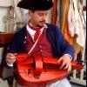
- Member

- 152 posts
Posted October 4, 2010 · Report post
Regarding the slashes sleeves, maybe this drawing done in 1695 is actually portraying 1650s-60s fashion? I ve seen many art work from that era (50s-60s) with such jacket. Or maybe the dutch were notoriously out of fashion? Either way, very interesting

Fox
- Old Twillian
- Moderator

- 2,564 posts
- Gender:Male
- Location:Beautiful lush Devon, England
- Interests:Nautical history of the 16-18th centuries and living history based thereon.
Shooting pirates.
Posted October 4, 2010 · Report post
On 10/4/2010 at 10:39 AM, Capt. Sterling said:
Nice find indeed!
Nice to see the case bottles going back that far, as I was told emphatically no,
and must agree with Foxe, hard to tell if it is breeches or drawers under the petticoat breeches.
Case bottles go back at least as far as the first half of the seventeenth century. One was found at the Martin's Hundred site, c. 1620-45.
And yes, the Picart picture is of a Dutch/Flemish sailor. (Brabant actually straddles the Belgian-Dutch border)

jendobyns
- Pyrate Captain
- 
- Member

- 562 posts
- Gender:Female
- Location:Baltimore
- Interests:too numerous to mention, really. Period foodways, baroque dance, material culture, etc., etc.
Posted October 4, 2010 · Report post
What a cool look! Great prints!
I did a quick check of my Cut of Men's Clothes and found a couple of casaques that were designed with sleeves that buttoned up the length of the inside seam, allowing for a hanging sleeve or cape-like sleeve if unbuttoned. They dated mid-century. There's an example from 1654 (diagram XIII) which has a similar sleeve as the first sailor's.
There is also a version of this second sleeve, on what is called a doublet, in Fashion in Detail. It also dates to the earlier half of the 17 century. The sleeves button the length of the seam, edges are finished.
These are high-end examples, so the sailor's clothing could possibly be second hand, or demonstrate a filtering down of the fashion over time, or are part of the artist's props, or we just don't have any surviving examples from later in the century. It would be so useful to know more about the artist and date of the engravings.
Love the slops, they kind of look like a block print of some kind. The weskit in the first sailor's picture is the same print. And the woman's sleeve also appears to be a print. Interesting.
The earrings are great, pearl drops instead of hoops! I think I've seen this before, in some portrait, but darn if I can find it now! Will do some digging for extant examples. I have seen something similar worn by someone at Jamestown (I think it was an ECW reenactor), it is a very cool look.
Wool tape makes great garters. Slightly stretchy, but grips enough to hold the stockings up. I've abandoned my leather ones in favor of the wool. I think silk ribbon might also have been used, but those show up in later period paintings.
Mistress Dobyns

Jack Roberts
- Dread Pyrate
- Member

- 1,063 posts
- Gender:Male
- Location:Orlando, FL
Posted October 4, 2010 · Report post
On 10/4/2010 at 10:39 AM, Capt. Sterling said:
so Jack, does this mean you are now Dutch?
Lol I don't think so, but we can discuss it this weekend. I do like my earrings.

PoD
- Pyrate Captain
- Member

- 696 posts
- Gender:Male
- Location:Warrington UK
- Interests:Pirates, graphic novels, computer art, Listening to music, Going to gigs, Beer and Wine drinking, historical research, Period weaponry and Leatherwork
Posted October 4, 2010 (edited) · Report post
The painting is actually one of a set that shows dutch people celebrating the Siege of Namur which happened in 1695 (the same year as the prints were made). The Print was made by Cornelis Dusart and published by Jacob Gole.
I like the knife in the 2nd print a lot too. It's my next project to make one. Looks like a standard rounded end rigging knife if you take into account that most people would wear a knife with the sharp part of the blade pointing down rather than up. The scabbard goes up onto the handle to hold the knife more securely and the bottom of it has a metal chape (brass probably judging by the fact it was popular with the Dutch at the time).
I also just noticed that the sailors have their earrings in opposite ears which may suggest that they had both ears pierced.
Edited October 4, 2010 by PoD

jendobyns
- Pyrate Captain
- Member

- 562 posts
- Gender:Female
- Location:Baltimore
- Interests:too numerous to mention, really. Period foodways, baroque dance, material culture, etc., etc.
Posted October 4, 2010 · Report post
On 10/4/2010 at 1:25 PM, Foxe said:
On 10/4/2010 at 10:39 AM, Capt. Sterling said:
Nice find indeed!
Nice to see the case bottles going back that far, as I was told emphatically no,
and must agree with Foxe, hard to tell if it is breeches or drawers under the petticoat breeches.
Case bottles go back at least as far as the first half of the seventeenth century. One was found at the Martin's Hundred site, c. 1620-45.
And yes, the Picart picture is of a Dutch/Flemish sailor. (Brabant actually straddles the Belgian-Dutch border)
This pretty much goes with what I was reading in Hume's "A Guide to Artifacts in Colonial America", it says "Prior to the appearance of the globular-bodied dark green glass bottles of the mid-seventeenth century, the common large bottle was blown into a square-sided mold and had a nearly flat base and a short neck with an everted lip, the latter feature frequently concealed beneath a threaded pewter collar and cap. The bottles varied considerably in size, but because of their vulnerable flat surfaces they were sold, carried, and housed in cases or "cellars", each generally holding a dozen bottles. These case bottles have frequently been described as "Dutch gin bottles," probably because they were so used in the latter part of the eighteenth century. The Dutch bottles for "Hollands" or "Geneva," were certainly square-sectioned (though tapering toward the base), but that does not infer that all square-bodied bottles were of Dutch origin. On the contrary, they undoubtedly represented a very large part of the English bottle output of the first half of the seventeenth century."
There is more, it is really worth checking out a copy of this book if you can get it. Lots of diagrams of various artifacts with their dates and descriptions.
Mistress D.

PoD
- Pyrate Captain
- Member

- 696 posts
- Gender:Male
- Location:Warrington UK
- Interests:Pirates, graphic novels, computer art, Listening to music, Going to gigs, Beer and Wine drinking, historical research, Period weaponry and Leatherwork
Posted October 5, 2010 · Report post
I was looking at the knife last night and I suddenly realised what the shape reminded me of. I had seen a 17th Century trade knife on my travels around the net and as it turned out it was Dutch too:

Capt. Sterling
- Sticky Fingers Sterling Needs a New Hat
- Member

- 10,302 posts
- Gender:Pyrate Hunter
- Location:here
- Interests:Killing pirates, haven't met one yet worth keeping alive....
Posted October 5, 2010 · Report post
Thanks Ed and Mistress Dobyns!

Fox
- Old Twillian
- Moderator

- 2,564 posts
- Gender:Male
- Location:Beautiful lush Devon, England
- Interests:Nautical history of the 16-18th centuries and living history based thereon.
Shooting pirates.
Posted January 14, 2011 · Report post
On 1/14/2011 at 2:07 PM, Mission said:
Wait...in normal life, Professor Foxe has an earring?! A momento from your mis-spent youth?
Two (in the same ear). And yes.

PoD
- Pyrate Captain
- Member

- 696 posts
- Gender:Male
- Location:Warrington UK
- Interests:Pirates, graphic novels, computer art, Listening to music, Going to gigs, Beer and Wine drinking, historical research, Period weaponry and Leatherwork
Posted January 14, 2011 (edited) · Report post
On 1/14/2011 at 5:24 PM, Foxe said:
On 1/14/2011 at 2:07 PM, Mission said:
Wait...in normal life, Professor Foxe has an earring?! A momento from your mis-spent youth?
Two (in the same ear). And yes.
i must have mis-spent my youth in the same way as I have 2 in one ear also (although it was originally 3 but after bending a cheap metal ring together in my ear it went a bit funny and healed up)
There is actually another dutch sketch of a man wearing an earring dating from between 1636-1674. He is aparently wearing oriental costume though so he could be a merchant of some sort. He certainly doesnt look oriental:
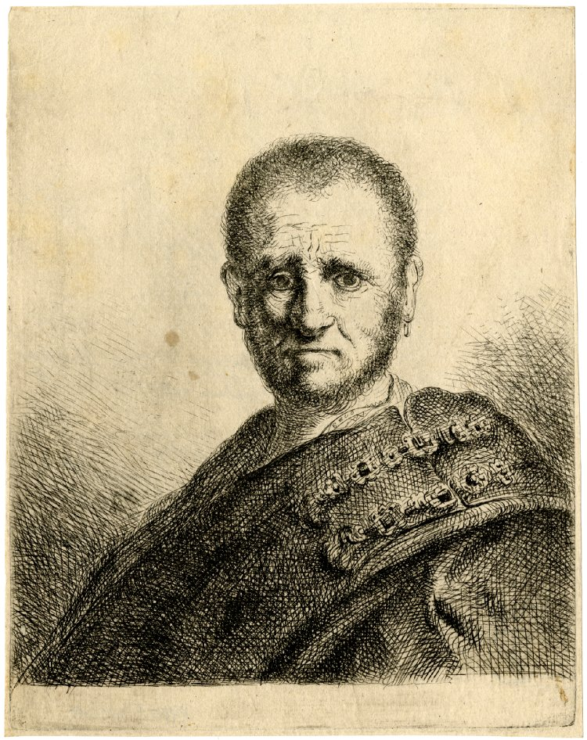
http://www.britishmu...&currentPage=12
Description
Portrait of an unidentified man with a beard and short hair, bust seen in profile to left but staring at the viewer, in oriental costume with jewels on his shoulder, an earring in his left ear
There is also an italian picture of a Turkish man from 1648 - 1651 wearing an earring:
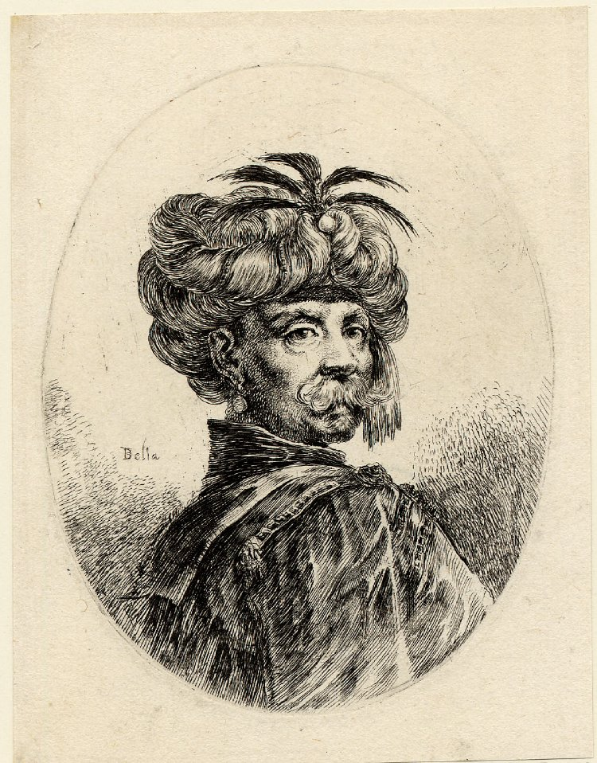
http://www.britishmu...&currentPage=16
Description
Turk with a moustache and beard; bust portrait, turned towards right, wearing an earring and a turban decorated with five small feathers at front; an oval composition. 1649-1650
Then theres this 1683 British drawing of a young boy with an earring very similar to the ones in the Dutch pictures:
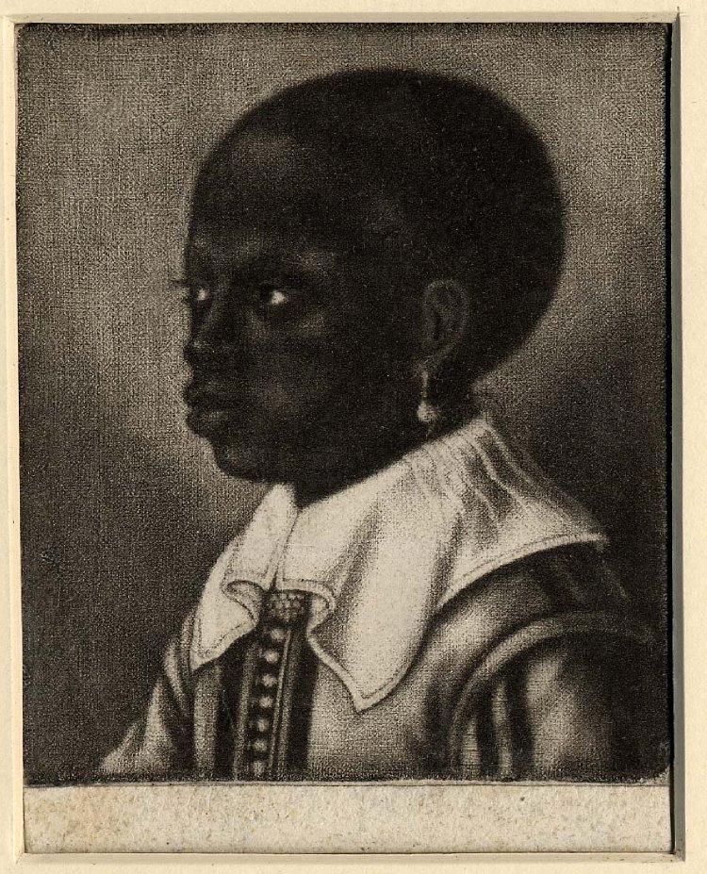
http://www.britishmuseum.org/research/search_the_collection_database/search_object_details.aspx?objectid=1513556&partid=1&searchText=earring&fromDate=1650&fromADBC=ad&toDate=1730&toADBC=ad&numpages=10&orig=%2fresearch%2fsearch_the_collection_database.aspx&currentPage=24
Description
Head of a young black boy, looking to left, wearing a broad square white collar and an earring; a copy in reverse after Hollar. c.1683
Edited January 14, 2011 by PoD

PoD
- Pyrate Captain
- Member

- 696 posts
- Gender:Male
- Location:Warrington UK
- Interests:Pirates, graphic novels, computer art, Listening to music, Going to gigs, Beer and Wine drinking, historical research, Period weaponry and Leatherwork
Posted January 14, 2011 · Report post
Heres a load more (just for reference of what male earrings looked like around the GAOP period if nothing else)
Description
1585-1656 French Portrait of an unknown man; head and shoulders turned slightly to left, looking to front, small beard and moustache, wearing shirt with large collar and earring

http://www.britishmuseum.org/research/search_the_collection_database/search_object_details.aspx?objectid=721818&partid=1&searchText=earring&fromDate=1650&fromADBC=ad&toDate=1730&toADBC=ad&numpages=10&orig=%2fresearch%2fsearch_the_collection_database.aspx&currentPage=28
Description
1642-1665 British Portrait of William Herbert, third Earl of Pembroke, half length in an oval, beard and moustache, wearing earring, ruff, ribbon and George, and holding wand.
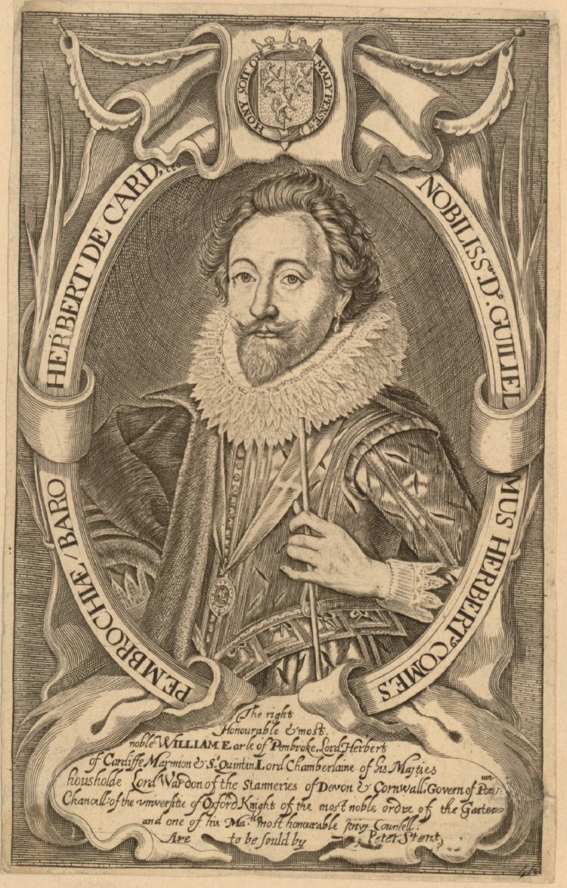
http://www.britishmuseum.org/research/search_the_collection_database/search_object_details.aspx?objectid=3049329&partid=1&searchText=earring&fromDate=1650&fromADBC=ad&toDate=1730&toADBC=ad&numpages=10&orig=%2fresearch%2fsearch_the_collection_database.aspx&currentPage=35
Description
1685-1740 Italian/Dutch Portrait of a tousled-haired soldier with earring on left earlobe, seen three-quarter length, standing before a low bas-relief, his right hand on his sword handle, the other hand pointing to the distance, where three soldiers can be seen in a landscape dominated by a fortress
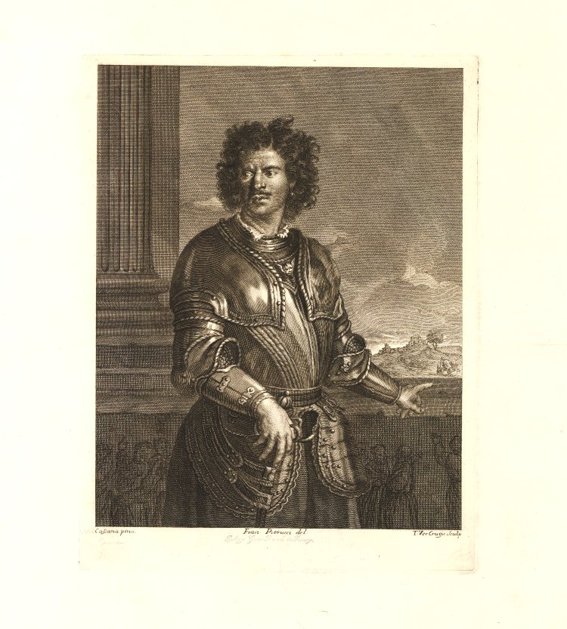
http://www.britishmuseum.org/research/search_the_collection_database/search_object_details.aspx?objectid=3252337&partid=1&searchText=earring&fromDate=1650&fromADBC=ad&toDate=1730&toADBC=ad&numpages=10&orig=%2fresearch%2fsearch_the_collection_database.aspx&currentPage=45

PoD
- Pyrate Captain
- Member

- 696 posts
- Gender:Male
- Location:Warrington UK
- Interests:Pirates, graphic novels, computer art, Listening to music, Going to gigs, Beer and Wine drinking, historical research, Period weaponry and Leatherwork
Posted January 14, 2011 · Report post
Description
1667 French Portrait of Henri de Lorraine, Count of Harcourt, traditionally known as 'le Cadet à la Perle'; the sitter is seen three-quarter length, in a richly embroidered costume with insignia of the Order of the Saint-Esprit and a pearl on his left ear, standing near gauntlets and a helmet, and holding a command baton, with nocturnal landscape and fortress on fire in the background and his coat of arms in the lower margin.
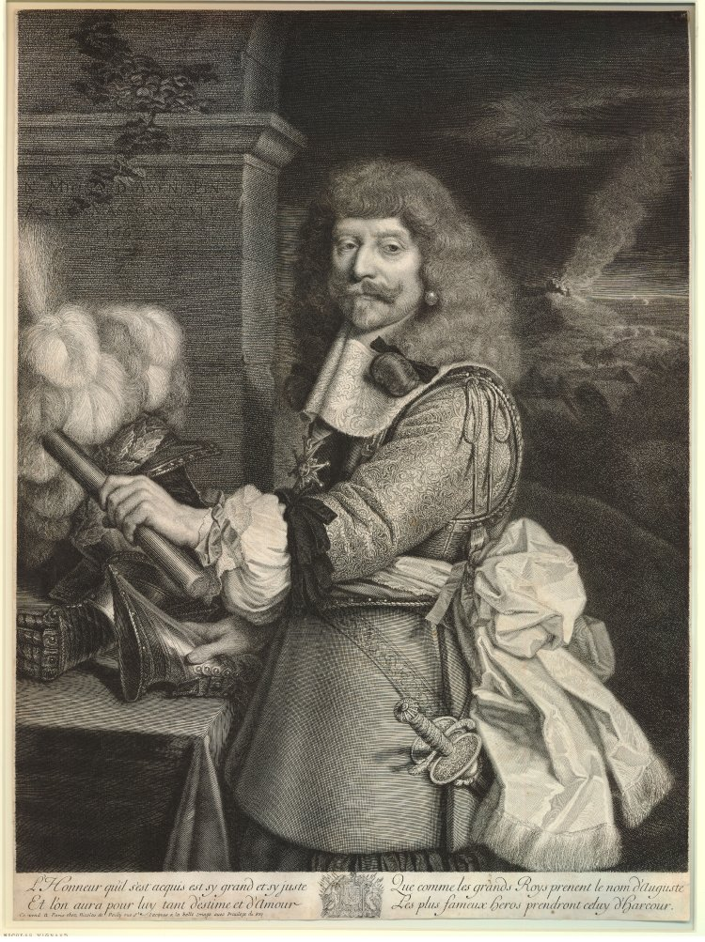
http://www.britishmuseum.org/research/search_the_collection_database/search_object_details.aspx?objectid=1351047&partid=1&searchText=earring&fromDate=1650&fromADBC=ad&toDate=1730&toADBC=ad&numpages=10&orig=%2fresearch%2fsearch_the_collection_database.aspx&currentPage=49
Description
1680-1720 British Portrait of John Hardman the Famous Corncutter (as in chiropodist), half length in an oval, long hair and moustache, wearing hat, earring, neckcloth, coat, and two badges with royal coat of arms.
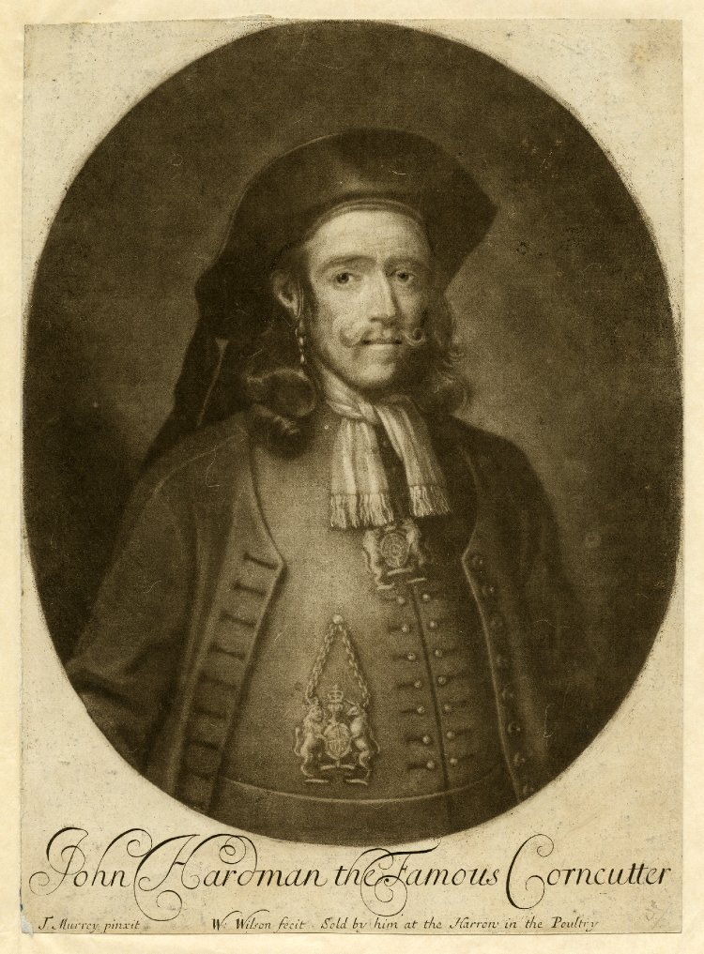
http://www.britishmuseum.org/research/search_the_collection_database/search_object_image.aspx?objectId=1668642&partId=1&searchText=earring&fromDate=1650&fromADBC=ad&toDate=1730&toADBC=ad&orig=%2fresearch%2fsearch_the_collection_database.aspx&numPages=10&currentPage=52&asset_id=225820
Just goes to show that there was people all around the world wearing earrings in that time period and people from different walks of life and social standing too. Still no other pictures of sailors though up to yet. I'll keep looking.

Mission
- Goat Specialist
- 
- Admin

- 5,081 posts
- Gender:Male
- Location:Monroe, MI
- Interests:Scholarly piracy, designing and creating haunted house rooms and props, movies, abstract thinking, abstruse thinking, obstructive thinking, ideating, random thinking, movies, cartoons, movies, movies scores, cycling, world peace and small furry dogs, movies, writing, drawing, personal skills training, gremlins and, of course, lest I forget, movies.
Posted January 15, 2011 · Report post
On 1/14/2011 at 5:24 PM, Foxe said:
On 1/14/2011 at 2:07 PM, Mission said:
Wait...in normal life, Professor Foxe has an earring?! A momento from your mis-spent youth?
Two (in the same ear). And yes.
Man, I have GOT to get over there and meet you - preferably at an event where you have some time to chat. You, dt and PoD are definitely on my list of UK folks to meet...
On 1/14/2011 at 6:30 PM, jendobyns said:
I think Ginger might already be claimed, isn't there already a tall redhead 'round here?
There's Red Jessi, although she's been absent lately. OTOH, I wouldn't put her in either the Ginger or Mary Anne category.
Say, what's with all this OT banter?

hurricane
- Pyrate Legend
- 
- Member

- 2,672 posts
- Gender:Male
- Location:Seattle, Washington
- Interests:Songs of a nautical nature, wine, rum, rum punch, Henry Morgan and Krimson Kat.
Posted January 15, 2011 · Report post
I think Mr. Foxe led the way in surrendering to the fact that people did wear earrings. I think the issue is whether it was the fashion of seamen, thereby commonplace, or simply someone's individual preferences, much as it is today. I would think the latter is the most likely. It was the larger attempt to justify it as a standard issue of seamen and therefore pirates, to accent their fetching eyepatch, parrot and pegleg.
As for the parrot, when someone asks me where it is, I simply respond, "We ate it," given that buccaneers considered it quite tasty.

jendobyns
- Pyrate Captain
- Member

- 562 posts
- Gender:Female
- Location:Baltimore
- Interests:too numerous to mention, really. Period foodways, baroque dance, material culture, etc., etc.
Posted January 15, 2011 · Report post
On 1/15/2011 at 8:01 AM, Mission said:
Say, what's with all this OT banter?
Yep, we're seriously off track for Twill. I think if we want to continue this discussion about earrings, perhaps it should be moved to a more appropriate place for it (in Twill) and let this thread die? I know I've seen pics of earrings here before.

Dorian Lasseter
- Where's My Water
- Member

- 3,266 posts
- Gender:Male
- Location:The Sea!
- Interests:18th Century reenactment; Maritime, F&I...
Did ECW as well...
All BP firelocks and cannons!
Also enjoy Swordfighting and a good Donnybrook
Got a question for or about me? Ask!!!
Posted January 15, 2011 (edited) · Report post
Oi, PoD,
Shift all yer great earring images over to : My link
And we'll all go over and debate and enjoy them there!
(I have 6 earrings and hate having to take 'em out at events... you can see them in all the images at FTPI)
Edited January 15, 2011 by Dorian Lasseter

Fox
- Old Twillian
- Moderator

- 2,564 posts
- Gender:Male
- Location:Beautiful lush Devon, England
- Interests:Nautical history of the 16-18th centuries and living history based thereon.
Shooting pirates.
Posted January 15, 2011 · Report post
On 1/15/2011 at 10:04 AM, hurricane said:
I think Mr. Foxe led the way in surrendering to the fact that people did wear earrings. I think the issue is whether it was the fashion of seamen, thereby commonplace, or simply someone's individual preferences, much as it is today. I would think the latter is the most likely. It was the larger attempt to justify it as a standard issue of seamen and therefore pirates, to accent their fetching eyepatch, parrot and pegleg.
That's precisely it! Yes, there are pictures of people with earrings (though I will note that several of those posted by PoD are from the late 16th to mid-17thC, when we know earrings were generally fashionable), but that doesn't make them widespread. Yes, there are pictures of Dutch sailors wearing them, but how many of us play Dutch pirates? I know of no evidence for Anglo-American sailors, 1690-1730, or indeed pirates of the same period, wearing earrings. End of. So no, we can't say that no pirate of the period sported an earring, but we can say for absolute and definite that they weren't common in any way, and we can definitely say that all the convoluted reasoning, such as prevention of seasickness, has absolutely no basis in historical fact. That such a respected journal as the National Geographic can blithely state not only that pirates wore earrings, but also why, is an illustration of just how far the rot has spread.
Quote
As for the parrot, when someone asks me where it is, I simply respond, "We ate it," given that buccaneers considered it quite tasty.
I've long cherished a plan, for when I'm doing 16th century events, to mock up some dodo feathers and leave them in a mess around the fire, over which I'll have a turkey spit-roasting...

Fox
- Old Twillian
- Moderator

- 2,564 posts
- Gender:Male
- Location:Beautiful lush Devon, England
- Interests:Nautical history of the 16-18th centuries and living history based thereon.
Shooting pirates.
Posted January 15, 2011 · Report post
On 1/15/2011 at 8:01 AM, Mission said:
Man, I have GOT to get over there and meet you - preferably at an event where you have some time to chat. You, dt and PoD are definitely on my list of UK folks to meet...
Mark, if you ever make it to the UK and don't look me up one way or another I shall take it as a personal insult.
For the record, I'm not claiming that my adulthood hasn't been misspent too, just that the earrings have been in since I was 17 or so.

PoD
- Pyrate Captain
- Member

- 696 posts
- Gender:Male
- Location:Warrington UK
- Interests:Pirates, graphic novels, computer art, Listening to music, Going to gigs, Beer and Wine drinking, historical research, Period weaponry and Leatherwork
Posted January 15, 2011 · Report post
On 1/15/2011 at 0:45 PM, Dorian Lasseter said:
Oi, PoD,
Shift all yer great earring images over to : My link
And we'll all go over and debate and enjoy them there!
No Problem. How do i do that then? Cut and paste doesnt seem to work. Is there some secret knowledge to it or do i have to put all the picture links in manually again?

michaelsbagley
- Smells Like Wet Sheep
- 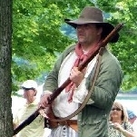
- Moderator

- 2,548 posts
- Gender:Male
- Location:Columbus, Ohio
- Interests:Mostly into GAoP, but starting to develop more Buccaneer era stuff for re-enacting as well. Generally I do re-enact both piratical/nautical and other impressions from the period. I am focusing on more "common" impressions from the period (i.e. average sailor/pirate, rank and file Red Coat, early Colonial huntsman, etc.)
Posted January 15, 2011 · Report post
On 1/15/2011 at 3:04 PM, PoD said:
No Problem. How do i do that then? Cut and paste doesnt seem to work. Is there some secret knowledge to it or do i have to put all the picture links in manually again?
Allow me to assist with this... Give me a few moments, and I will remove all the posts pertaining to earings from this topic, and add them over to the other.

Dorian Lasseter
- Where's My Water
- Member

- 3,266 posts
- Gender:Male
- Location:The Sea!
- Interests:18th Century reenactment; Maritime, F&I...
Did ECW as well...
All BP firelocks and cannons!
Also enjoy Swordfighting and a good Donnybrook
Got a question for or about me? Ask!!!
Posted January 15, 2011 · Report post
Thankee Kindly, Moderator Bagley...

michaelsbagley
- Smells Like Wet Sheep
- Moderator

- 2,548 posts
- Gender:Male
- Location:Columbus, Ohio
- Interests:Mostly into GAoP, but starting to develop more Buccaneer era stuff for re-enacting as well. Generally I do re-enact both piratical/nautical and other impressions from the period. I am focusing on more "common" impressions from the period (i.e. average sailor/pirate, rank and file Red Coat, early Colonial huntsman, etc.)
Posted January 15, 2011 · Report post
On 1/15/2011 at 3:53 PM, Dorian Lasseter said:
Thankee Kindly, Moderator Bagley...
Only too happy to oblige!

Dorian Lasseter
- Where's My Water
- Member

- 3,266 posts
- Gender:Male
- Location:The Sea!
- Interests:18th Century reenactment; Maritime, F&I...
Did ECW as well...
All BP firelocks and cannons!
Also enjoy Swordfighting and a good Donnybrook
Got a question for or about me? Ask!!!
Posted January 15, 2011 (edited) · Report post
Pay no mind to this...
Edited January 15, 2011 by Dorian Lasseter

Swashbuckler 1700
- Dread Pyrate
- 
- Member

- 1,115 posts
- Gender:Male
- Location:Europe
- Interests:pyrates, pryvateers, naval military and other history, different books, good movies, music (a little bit), drawing, games,...
Posted March 24, 2012 · Report post
On 1/15/2011 at 1:36 PM, Foxe said:
On 1/15/2011 at 10:04 AM, hurricane said:
I think Mr. Foxe led the way in surrendering to the fact that people did wear earrings. I think the issue is whether it was the fashion of seamen, thereby commonplace, or simply someone's individual preferences, much as it is today. I would think the latter is the most likely. It was the larger attempt to justify it as a standard issue of seamen and therefore pirates, to accent their fetching eyepatch, parrot and pegleg.
That's precisely it! Yes, there are pictures of people with earrings (though I will note that several of those posted by PoD are from the late 16th to mid-17thC, when we know earrings were generally fashionable), but that doesn't make them widespread. Yes, there are pictures of Dutch sailors wearing them, but how many of us play Dutch pirates? I know of no evidence for Anglo-American sailors, 1690-1730, or indeed pirates of the same period, wearing earrings. End of. So no, we can't say that no pirate of the period sported an earring, but we can say for absolute and definite that they weren't common in any way, and we can definitely say that all the convoluted reasoning, such as prevention of seasickness, has absolutely no basis in historical fact. That such a respected journal as the National Geographic can blithely state not only that pirates wore earrings, but also why, is an illustration of just how far the rot has spread.
Quote
As for the parrot, when someone asks me where it is, I simply respond, "We ate it," given that buccaneers considered it quite tasty.
I've long cherished a plan, for when I'm doing 16th century events, to mock up some dodo feathers and leave them in a mess around the fire, over which I'll have a turkey spit-roasting...
Not talking reenacting but history there were Dutch pirates (Robert's and e.g whydah crew) and there were actually even few indians aboard but indeed earrings were not ïn commonplace in GAoP. Other stuff like rings and fine buttons ot buckles were in more popular use but earrings were rare...

Fox
- Old Twillian
- Moderator

- 2,564 posts
- Gender:Male
- Location:Beautiful lush Devon, England
- Interests:Nautical history of the 16-18th centuries and living history based thereon.
Shooting pirates.
Posted March 24, 2012 · Report post
Of course there were Dutch pirates in the GAoP, but only a tiny tiny number. Charles Johnson was more or less convinced that there were none at all and ascribed it to the Dutch herring fishery soaking up the unemployed seamen.
The same theory might also hold true for other nations such as the Spanish - any Spaniard who wanted to plunder at sea was welcome to do so in the Guarda Costa, in peace as well as war.

Swashbuckler 1700
- Dread Pyrate
- Member

- 1,115 posts
- Gender:Male
- Location:Europe
- Interests:pyrates, pryvateers, naval military and other history, different books, good movies, music (a little bit), drawing, games,...
Posted March 24, 2012 (edited) · Report post
On 3/24/2012 at 6:55 AM, Foxe said:
Of course there were Dutch pirates in the GAoP, but only a tiny tiny number. Charles Johnson was more or less convinced that there were none at all and ascribed it to the Dutch herring fishery soaking up the unemployed seamen.
The same theory might also hold true for other nations such as the Spanish - any Spaniard who wanted to plunder at sea was welcome to do so in the Guarda Costa, in peace as well as war.
Reason for that there were only few Dutch is that that United Provices (people often dont't rememder that "Holland" was actually republic in tis time) did not done same blunder with unemploiment privateers that English and French did. I have found Gaop pirate crew that had large number of spaniards but I dont know where..... I am not fully convinsed of that johnson's theory but indeed it is partly true. I think t´hat Bart Roberts had even Greeks but it is only recollection so I am not sure....
In any case there were some Dutch here and there in GAoP.....
"In late September 1720, Captain Nicholas de Concepcion and 140 pirates (Spaniards “and others of diverse Nations”) cruised the waters of Virginia and the Chesapeake Bay aboard a well-armed Spanish brigantine from Saint Augustine." This story is from bage and it seems to bee real...
http://www.cindyvall...ackpirates.html
Edited April 7, 2012 by Swashbuckler 1700

Swashbuckler 1700
- Dread Pyrate
- Member

- 1,115 posts
- Gender:Male
- Location:Europe
- Interests:pyrates, pryvateers, naval military and other history, different books, good movies, music (a little bit), drawing, games,...
Posted March 27, 2012 (edited) · Report post
It seems that period writers were not always informed of things and even their writings (espicially Johnson's) should be treat with critisims...
I found this: there slave has earring but since picture also has mythical creatures it could be better..... (note that slaves could often become pirates) It is title bage of Pere labat's book from 1725 http://jcb.lunaimagi...&mi=100&trs=127
Note Dutch illustration. So it seems that earrings have someting to do with Dutch... Also on the backround there is interesting sailors with Dutch style caps and interesting hair. is that a pony tail?
Edited April 7, 2012 by Swashbuckler 1700

Swashbuckler 1700
- Dread Pyrate
- Member

- 1,115 posts
- Gender:Male
- Location:Europe
- Interests:pyrates, pryvateers, naval military and other history, different books, good movies, music (a little bit), drawing, games,...
Posted April 7, 2012 (edited) · Report post
On 3/27/2012 at 2:47 PM, Swashbuckler 1700 said:
I found this: there slave has earring but since picture also has mythical creatures it could be better..... (note that slaves could often become pirates) It is title bage of Pere labat's book from 1725 http://jcb.lunaimagi...&mi=100&trs=127
Note Dutch illustration. So it seems that earrings have someting to do with Dutch... Also on the backround there is interesting sailors with Dutch style caps and interesting hair. is that a pony tail?
here is another pic with slave with earring ( and dandana) circa 1700 front piece of one edition Buccaneers of America (and guess what it is Dutch)
http://jcb.lunaimagi...~2&mi=14&trs=32
sorry for posting this in different post I promise to get rid of that habit.
Edited April 7, 2012 by Swashbuckler 1700

Swashbuckler 1700
- Dread Pyrate
- Member

- 1,115 posts
- Gender:Male
- Location:Europe
- Interests:pyrates, pryvateers, naval military and other history, different books, good movies, music (a little bit), drawing, games,...
Posted April 29, 2012 · Report post
I would be happy if someone could delete those posts there (the ones which say Moderator delete this. content is moved to other post) Please
thanks
I was wondering is this earring or not. It is likely that it is not but....
( those are Dutch mariners from 1695) I think it is possible that there is earring (that left fellow?) but it seems it is not but who know. Maker's style is bit shaky, so it may be an error.
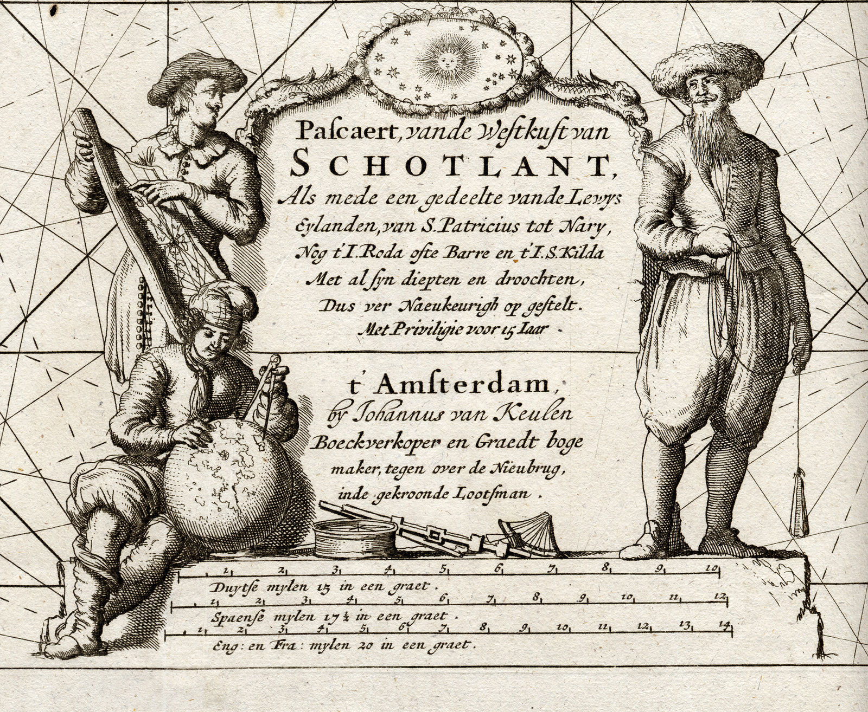

Swashbuckler 1700
- Dread Pyrate
- Member

- 1,115 posts
- Gender:Male
- Location:Europe
- Interests:pyrates, pryvateers, naval military and other history, different books, good movies, music (a little bit), drawing, games,...
Posted May 16, 2012 · Report post
Not gaop period but Shakespeare. He has an hoop that is not often seen in 16th C.
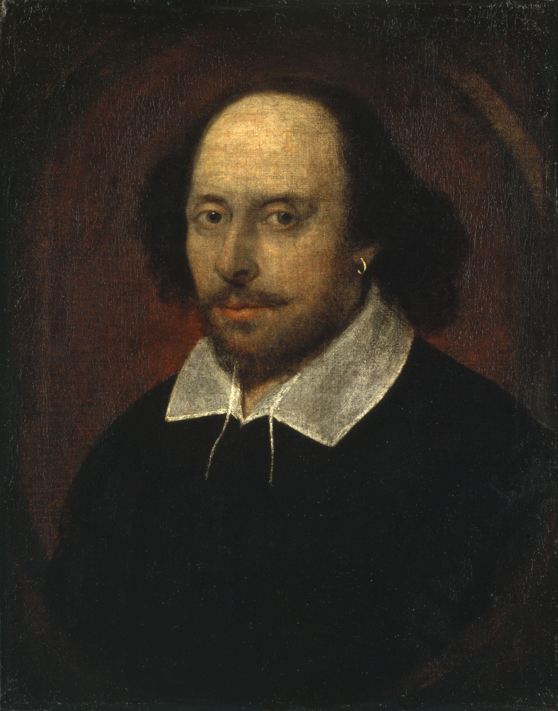

Swashbuckler 1700
- Dread Pyrate
- Member

- 1,115 posts
- Gender:Male
- Location:Europe
- Interests:pyrates, pryvateers, naval military and other history, different books, good movies, music (a little bit), drawing, games,...
Posted June 10, 2012 · Report post
Sorry for multiple posting
Here is Dutch picture (frontpiece of BoA from 1700) there is a slave with an earring (he seems to be African rather that indian) I believe that dutch were the biggets earring users since many pictures of Dutch and Dutch sailors show them. So small pearl earrings in Ducth use are not an errors but looking pirates there was a few Dutch pirates but no really many.
http://jcb.lunaimaging.com/luna/servlet/detail/JCB~1~1~3744~5860004:-Title-page-?sort=Normalized_date%2CCreators%2CPublisher%2CTitle&qvq=q:pirates;sort:Normalized_date%2CCreators%2CPublisher%2CTitle;lc:JCB~1~1,JCBBOOKS~1~1,JCBMAPS~1~1,JCBMAPS~2~2&mi=26&trs=78

Swashbuckler 1700
- Dread Pyrate
- Member

- 1,115 posts
- Gender:Male
- Location:Europe
- Interests:pyrates, pryvateers, naval military and other history, different books, good movies, music (a little bit), drawing, games,...
Posted June 28, 2012 · Report post
That post before can be deleted its stuff is now here!
Sorry for multiple posting
Here is Dutch picture (frontpiece of BoA from 1700) there is a slave with an earring (he seems to be African rather that indian) I believe that dutch were the biggets earring users since many pictures of Dutch and Dutch sailors show them. So small pearl earrings in Ducth use are not an errors but looking pirates there were only a few Dutch pirates but no really many.
http://jcb.lunaimagi...~2&mi=26&trs=78And
the new stuff now
Well we know that earrings don’t jump out of English seaman's wills but has anyone studied any Dutch sailor wills? There might be some earrings....

Swashbuckler 1700
- Dread Pyrate
- Member

- 1,115 posts
- Gender:Male
- Location:Europe
- Interests:pyrates, pryvateers, naval military and other history, different books, good movies, music (a little bit), drawing, games,...
Posted February 5, 2013 (edited) · Report post
John pine by Hogarth made at least before 1765
http://www.fitzmuseum.cam.ac.uk/explorer/index.php?qu=Hogarth%20OR%20Maker:Hogarth%20AND%20Maker:William&oid=157854
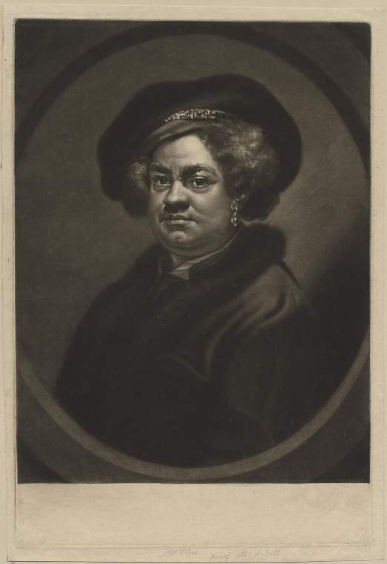
Edited February 5, 2013 by Swashbuckler 1700

