Misson
- Dread Pyrate
- 
- 
- Member

- 1,001 posts
- Gender:Male
- Interests:Who me?
(IP: 64.241.37.140) ·
Posted June 22, 2008 · Report post
In William Dampier's book New Voyage Round the World he has a great deal to say about the coconut tree. In fact, I think it would make a fascinating display if all the things he discusses could be put together.
"The Coco-Nut Trees grow by the Sea, on the Western-side in great Groves, three or four Miles in length, and a Mile or two broad....
The Nut or Fruit grows at the head of the Tree, among the Branches and in Clusters, 10 or 12 to a Cluster. The Branch to which they grow is about the bigness of a Man's Arm, and as long, running small towards the end. It is of a yellow Colour, full of Knots, and very tough. The Nut is generally bigger than a Man's Head. The outer rind is near two Inches thick, before you come to the Shell; the Shell it self is black, thick, and very hard. The Kernel in some Nuts is near an Inch thick, sticking to the inside of the Shell clear round, leaving a hollow in the middle of it, which contains about a Pint, more or less, according to the bigness of the Nut, for some are much bigger than others.
This Cavity is full of sweet, delicate, wholsom and refreshing Water. While the Nut is growing, all the inside is full of this Water, without any Kernal at all; but as the Nut grows towards it Maturity, the Kernel begins to gather and settle round on the inside of the Shell, and is soft like Cream; and as the Nut ripens, it increaseth in substance and becomes hard. The ripe Kernel is sweet enough, but very hard to digest, therefore seldom eaten, unless by Strangers, who know not the effects of it; but while it is young and soft like Pap, some Men will eat it, scraping it out with a Spoon, after they have drunk the Water that was within it. I like the Water best when the Nut is almost ripe, for it is then sweetest and briskest.
...
Besides the Liquor or Water in the Fruit, there is also a sort of Wine drawn from the Tree called Toddy, which looks like Whey. It is sweet and very pleasant, but it is to be drunk within 24 Hours after it is drawn, for afterwards it grows sowre. Those that have a great many Trees, draw a Spirit from the sowre Wine, called Arack. Arack is distill'd also from Rice, and other things in the East-Indies; but none is so much esteemed for making Punch as this sort, made of Toddy, or the Sap of the Coco-nut Tree for it makes most delicate Punch; but it must have a dash of Brandy to hearten it, because this Arack is not strong enough to make good Punch of it self. This sort of Liquor is chiefly used about Goa; and therefore it has the Name of Goa Arack. The way of drawing the Toddy from the Tree, is by cutting the top of a Branch that would bear Nuts; but before it has any Fruit; and from thence the Liquor which was to feed its Fruit, distils into the hole of a Callabash [a bowl made from the rind of a fruit] that is hung upon it.
...
The Kernel is much used in making Broath. When the Nut is dry, they take off the Husk, and giving two good Blows on the middle of the Nut, it breaks in two equal parts, letting the Water fall on the Ground; then with a small Iron Rasp made for the purpose, the Kernel or Nut is rasped out clean, which being put into a little fresh Water, makes it become white as Milk. In this milky Water, they boil a Fowl, or any other sort of Flesh, and it makes a very savoury Broath. English Seamen put this Water into boiled Rice, which they eat instead of Rice-milk, carrying Nuts purposely to Sea with them. This they learnt from the Natives.
But the greatest use of the Kernel is to make Oyl, both for burning and for frying. The way to make the Oyl is to grate or rasp the Kernel, and steep it in fresh Water; then boil it, and scum off the Oyl at top as it rises: But the Nuts that make the Oyl ought to be a long time gathered, so as that the Kernel may be turning soft and oily.
The Shell of this Nut is used in the East-Indies for Cups, Dishes, Ladles, Spoons, and in a manner for all eating and drinking Vessels. Well-shaped Nuts are often brought home to Europe, and much esteemed. The Husk of the Shell is of great use to make Cables; for the dry Husk is full of small Strings and Threads, which being beaten, become soft, and the other Substance which was mixt among it falls away like Saw-dust, leaving only the Strings. These are afterwards spun into long Yarns, and twisted up into Balls for Convenience; and many of these Rope-Yarns joined together make good Cables. This Manufactory is chiefly used at the Maldive-Islands, and the Threads sent in Balls into all places that trade thither, purposely for to make Cables. I made a Cable at Achin with some of it. These are called Coire Cables; they last very well.
...
"In the South Seas the Spaniards do make Oakam to caulk their Ships, with the Husk of the Coco-nut, which is more serviceable than that made of Hemp, and they say it will never rot. I have been told by Captain Knox, who wrote the relation of Ceylon, that in some places of India they make a sort of coarse Cloth of the husk of the Coco-nut, which is used for Sails. I my self have seen a sort of coarse Sail-cloth made of such a kind of substance; but whether the same or no I know not.
I have been the longer on this subject to give the Reader a particular Account of the use and profit of a Vegetable, which is possibly of all others the most generally serviceable to the Conveniences, as well as the Necessities of Human Life. Yet this Tree, that is of such great use, and esteemed so much in the East-Indies, is scarce regarded in the West=Indies, for want of the knowledge of the benefits it may produce...I have found them growing very well in low sandy Islands (on the West of Sumatra) that are over-flowed with the Sea every Spring-tide; and though the Nuts there are not very big, yet this is no loss, for the Kernel is thick and sweet; and the Milk or Water in the inside, is more pleasant and sweet than of the Nuts that grow in rich ground, which are commonly large indeed, but not very sweet. These at Guam grow in dry ground, are of a middle-size, and I think the sweetest that I did ever taste. Thus much for the Coco-nut." (Dampier, p. 202-5)

- Quote
- Edit

lady constance
- Plunderer
- 
- 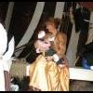
- Member

- 355 posts
- Location:mid usa
- Interests:sewing, sunbathing (o)(o), reading, spoiling my captain, laughing, cooking, praying,<br> screaming when i have a logical, rational reason<br> being crazy with my kids the big ones and small ones...<br>reading,
(IP: 70.246.205.105) · ·
Posted June 22, 2008 · Report post
Mission--
totally interesting---TOTALLY!!
and what i DO wonder , is, do they sell coconut mulch GROUND into chips? salvaged as mulch from left over coconut processing---???
i bought some cocoa bean left over mulch stuff-- it takes it about 3 years to deteriorate AND for nearly 1 year it SMELLS like chocolate---
i would prefer coconut smell to chocolate---{ my kids think i am making cake or brownies--and it is the mulch outside!!LOL!!}
so, Mission, do you know if they sell such a thing?{ gee--can i use you like google.com ?}....
pax,
lady constance--{ now to go back ot sewing pirate shirts}

- Quote
- Edit
- Options

Misson
- Dread Pyrate
- Member

- 1,001 posts
- Gender:Male
- Interests:Who me?
(IP: 75.128.81.170) · ·
Posted June 23, 2008 · Report post
I don't think they used a lot of mulch chips during period.
I suggest you go with your first inclination and see what Google has to say on the matter. I just thought Dampier's description was interesting.

- Quote
- Edit
- Options

Matusalem
- Notorious Pyrate
- 
- 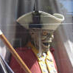
- Member

- 877 posts
- Location:Eastern Seaboard of North America
(IP: 69.125.223.213) · ·
Posted June 24, 2008 · Report post
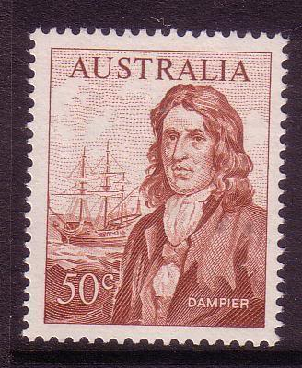

- Quote
- Edit
- Options

Mary Diamond
- It's My Fault
- 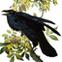
- Moderator

- 1,050 posts
- Gender:Female
- Location:Illinois
- Interests:Things I Love: Horticulture, Travel, Volleyball, Reading, Sewing, Costuming, Halloween, esp. props!, Halo, Halo2, Halo3, ODST, and, of course, Pyracy.
(IP: 67.167.49.211) · ·
Posted June 24, 2008 · Report post
Much obliged, dear Mission, for your excerpts ~
Is this tied to your banana obsession?

- Quote
- Edit
- Options

Misson
- Dread Pyrate
- Member

- 1,001 posts
- Gender:Male
- Interests:Who me?
(IP: 75.128.81.170) · ·
Posted June 25, 2008 (edited) · Report post
Mary, with your background, you and I should talk... Coco-nut, Inc. Main Office, some island in the Caribbean...
Actually, I am a huge fan of wild flora and fauna. I once told one of the local Metropark guys I would gladly pay double the annual fee for membership just for the privilege of being able to walk the forest paths therein. (It turns out he, in turn, would gladly accept.)
Apparently Coco-nuts were all the rage in the East Indies during period and just before. This, from Edward Barlow's Journal:
"Here [belopatan, India] is an English factory also for the Company [East India Trading Co.], the place producing only pepper, with 'cardimunes' [cardamom] and beetle nuts, and some little 'calieves' [unsure on this one], and fruits, as plantains and bananas and cocoanuts in great plenty. I bringing two or three [coconuts] from this place to England to show some that were desirous to see the fashion of them, for it is too far to bring the right taste of them, they being the 'necessariest' fruit that grow, they making things for all uses, being both meat and drink, and clothing and cables and rigging for this country's vessels." (Barlow's Journal, p. 189)
Edited June 25, 2008 by Misson

- Quote
- Edit
- Options

Misson
- Dread Pyrate
- Member

- 1,001 posts
- Gender:Male
- Interests:Who me?
(IP: 64.241.37.140) · ·
Posted July 19, 2008 · Report post
From later trips to the East Indies, Edward Barlow has more to say on this fine "fruit":
“[1685] The country here [Goa] about produceth calicoes and pepper and other goods which they have brought from China and Persia, as rice, cocoanuts, plantains and bananas, very good oranges and limes. The ‘tudey’ [toddy] tree, or old cocoanut tree, which produceth the palm wine of which they drink, makes rack, sugar, or vinegar, and is the most profitable tree that grows here. They have plenty of good fish and potatoes and several fruits that I cannot well name.” (Barlow, p. 372-3)
“[1687] At last, having got [their anchor, which had broke loose], away we sailed down to Calicut and came to anchor in five fathom of water, finding several Moors’ ships in the Road belonging to Surat, which were lading pepper, beetle-nut, cocoanuts and coir, which is a thread of yarn made of the husk of cocoanuts, of which they make all their rigging and ropes for their ships.” (Barlow, p. 381)
“[1697] The air is clear [in ‘Anienga’] and indifferent healthful, but provisions are pretty dear…The fruits are here as they are over most parts of India, the cocoanut tree producing half their food, what with the cocoanut meat, and the liquor, that they make rack and sugar with called ‘todey’ [toddy]." (Barlow, p. 467-8)

- Quote
- Edit
- Options

Raphael Misson
- Plunderer
- Member

- 449 posts
- Gender:Male
- Location:Monroe, MI
- Interests:Period Surgery. Designing Stuff. Creating Stuff. Positions of power without title.
(IP: 64.241.37.140) · ·
Posted August 24, 2008 (edited) · Report post
Mary Diamond said:
Is this tied to your banana obsession?
Speaking of bananas (or bonanos or bononoes or bonanoes or whatever the random spelling variation the different period authors come up with), Dampier speaks quite extensively (especially on page 215) about the plantain - and a bit about the banana. The plantain is, in his opinion, second only to the Coco-nut in usefulness to the Indies. (Say Michael...what do you think about making some slimy plantain clothes? You know, to go with my Patrick Hand original planter's hat?)
“[1686] In some places of Mindanao there is plenty of Rice; but in the hilly Land they plant Yams, Potatoes, and Pumpkins; all which thrive very well. The other Fruits of this Island are Water-Melons, Musk-Melons, Plantains, Bonanoes, Guavas, Nutmegs, Cloves, Betel-Nuts, Durians, Jacks, or Jacas, Coco-Nuts, Oranges & c.
The Plantain I take to be the King of all Fruit, not except the Coco it self. The Tree that bears this Fruit is about 3 Foot, or 3 Foot and an half round, and about 10 or 12 Foot high…. As soon as the Fruit is ripe the Tree decays, but then there are many young ones growing up to supply its place….
__
It is so excellent, that the /i]Spaniards[/i] give it preheminence of all other Fruit, as most conducing to Life. It grows in a Cod about 6 or 7 Inches long, and as big as a Man’s Arm. The Shell, Rind or Cod, is soft, and of a yellow colour when ripe. It resembles in shape a Hogs-gut Pudding. The inclosed Fruit is no harder than Butter in winter, and is much of the colour of the purest yellow Butter. It is of a delicate taste, and melts in one’s Mouth like Marmalet. It is all pure Pulp, without any Seed, Kernal or Stone. This Fruit is so much esteemed by all Europeans that settle in America, that when they make a new Plantation, they commonly begin with a good Plantain-walk, as they call it, or a Field of Plantains; and as their Family increaseth, so they augment the Plantain-walk, keeping one Man purposely to prune the Trees, and gather the Fruit as he sees convenient. For the Trees continue bearing, some or
__
other, most part of the Year; and this is many time the whole Food on which a whole Family subsists. They thrive only in rich fat ground, for poor sandy will not bear them. The Spaniards in their Towns in America, as at Havana, Caragena, Portbel & c. have their Markets of Plantains, it being the common Food of poor People: Their common price is half a Riol, or 3d. a Dozen. When this Fruit is only used for Bread, it is roasted or boil’d when it’s just full grown, but not yet ripe, or turn’d yellow. Poor People, or Negroes, that have neither Fish nor Flesh to eat with it, make Sauce with Cod-Pepper, Salt and Lime-juice, which makes it eat very savory; much better than a crust of Bread alone. Sometimes for a change they eat a roasted Plantain, and a ripe raw Plantain together, which is instead of Bread and Butter. They eat very pleasant so, and I have made many a good Meal in this Manner. Sometimes our English take 5 or 7 ripe Plantains, and mashing them together, make them into a lump, and boil them instead of a Bag-pudding; which they call a Buff-Jacket: and this is a very good way for a change. This Fruit makes also very good Tarts; and the green Plantains slic’d thin, and dried in the Sun, and grated, will make a sort of Flour which is very good to make Puddings. A ripe Plantain slic’d and dried in the Sun may be preserved a great while; and then eat like Figs, very sweet and pleasant. The Darien Indians preserve them a long time, by drying them gently over the Fire; mashing them first, and moulding them into lumps. The Moskito Indians will take a ripe Plantain and roast it; then take a pint and half of Water in a Calabash, and squeeze the Plantain in pieces with their Hand, mixing it with Water; then they drink it all off together: This they call Mishlaw, and it’s pleasant and sweet, and nourishing: somewhat like Lamb’s-wool (as ‘tis call’d) made with Apples and Ale: and have their whole subsistence. When they make Drink with them, they take 10 or 12 ripe Plantains and mash them well in a Trough: then they ferment and froth like Wort. In 4 Hours it is fit to drink, and then they bottle it, and drink it as they have occasion: but this will not keep above 24 or 30 Hours. Those therefore that use this Drink, brew it in this manner every Morning. When I went first to Jamaica I could relish no other drink they had there. It drinks brisk and cool, and is very pleasant. This Drink is windy, and so is the Fruit eaten raw; but boil’d or roasted it is not so. If this drink is kept above 30 Hours it grows sharp: but if then it be put out in the Sun, it will become very good Vinegar. This Fruits grows all over the West-Indies (in the proper Climates) at Guinea, and in the East-Indies.
__
As the Fruit of this Tree is of great use for Food, so it the Body no less serviceable to make Cloaths; but this I never knew till I came to this Island. The ordinary People of Mindanao do wear no other Cloth. The Tree never bearing but once, and so being fell’d when the Fruit is ripe, they but it down close by the Ground if they intend to make Cloth with it. One blow with a Hatchet or long Knife, will strike it asunder; then they cut off the top, leaving the trunk 8 or 10 foot long, stripping off the outer Rind, which is the thickest towards the lower end, having stript 2 or 3 of these Rinds, the Trunk becomes in a manner all of one bigness, and of a whitish colour: Then they splits the Trunk in the middle; which being done, they split the two halves again, as near the middle as they can. This they leave in the Sun 2 or 3 Days, in which time part of the juicy substance of the Tree dries away, and then the ends will appear full of small Threads. The Women, whose employment it is to make the Cloth, take hold of those Threads one by one, which rend away easily from one end of the Trunk to the other, in bigness like whited-brown Thread; for the Threads are naturally of a determinate bigness, as I observed their Cloth to be all of one substance and equal fineness; but ‘tis stubborn when new, wears out soon, and when wet, feels a bit slimy. They make their pieces 7 or 8 Yards long, their Warp and Woof all one thickness and substance.
There is another sort of Plantains in that Island, which are shorter and less than the others, which I never saw any where but here. These are full of black Seeds mixt quite through the Fruit. They are binding, and are much eaten by those that have Fluxes. The Country People gave them us for that use, and with good success.
The Bonano Tree is exactly like the Plantain for shape and bigness, not easily distinguishable from it but its Fruit, which is a great deal smaller, and not above half so long as a Plantain, being also more mellow and soft, less luscious, yet of a more delicate taste. They use this for the making Drink oftner than Plantains, and it is best when use for Drink, all when roasted or boil’d; so ‘tis only necessity that makes any use it this way.” (Dampier, p. 214-7)
Edited March 29, 2010 by Mission

- Quote
- Edit
- Options

Mission
- Goat Specialist
- 
- 
- Admin

- 5,082 posts
- Gender:Male
- Location:Monroe, MI
- Interests:Scholarly piracy, designing and creating haunted house rooms and props, movies, abstract thinking, abstruse thinking, obstructive thinking, ideating, random thinking, movies, cartoons, movies, movies scores, cycling, world peace and small furry dogs, movies, writing, drawing, personal skills training, gremlins and, of course, lest I forget, movies.
(IP: 24.231.217.242) · ·
Posted September 17, 2008 (edited) · Report post
More on the multifarious uses of coconut (as well as some on the banana and other "green trade") from Francis Rogers journal in Three Sea Journals of Stuart Times edited by Bruce Ingram.
“[May 28, 1702] There presently came off to us several canoes, with green trade. This Island [either Saddle or Johanna Island in the Comoros] is high land and very woody and pleasant, and affords good cattle, but small; plenty of goats
__
and fowl, very cheap; but no sheep or hogs, I think, they being a sort of Mahometans. Here is likewise abundance of fine fruit. As first Pine Apples the most delicious of fruit. It grows from a plant out of the ground on a high stalk like an artichoke, and is shaped just like those which we call pineapples which grows on the pine trees with us, but they are as large almost as a small sugar loaf. When ripe, we cut off the outer rough side, and eat all the inside, which is firm, mellow, and juicy, and hath the delicious flavour of strawberry, raspberry, peach, or any fruit you shall think of while eating it. When they are cut green, if they are hung up by the stalk, they will keep several days and ripen as they hang.
May 29. Next the coconut is a very good fruit. They are generally about the bigness of a small cabbage. The tree they grow on is a tall straight tree, without any branches or leaves till at the top, where the fruit grows on clusters; the leaves are very jagged and large, more like bows (Footnote 1: Boughs) than leaves. This tree affords meat, drink, lodging, and cordage to them. As thus; the inside of the nut will have a pint, or more perhaps, of a cool pleasant liquor they call milk, which is mighty pleasing to drink, and within the hard shell (it being like a walnut) sticks all round a firm pleasant substance about ¼ of an inch thick called the meat, which is sweet and pleasant to eat, and very filling. Without the hard shell (which serves for cups to drink out of) is the green shell, which is tough and stringy, and of which, with the bark of the tree, they make ropes (which they call Bass ropes) for their vessels, etc, and with the leaves of this tree they cover their houses, which they call Cajan leaves. They make ropes or withes fast to the foot, and so swarm or run up the tree for the Fruit. Water melons is a very pleasant cooling fruit; they are larger than our Musk melons, and much pleasanter, full of red or black seeds intermixed all over; the outside green as a pumpkin.
Then the Bonano or plantain, this a long fruit (almost like a cucumber) growing in bunches at the top of a small tree. When they are ripe, they are yellow, soft and mellow, and as pleasant as a fig. The body of the tree is of a leafy green substance, not hard, the leaves are large and broad enough to cover a man.
__
Here (are) likewise Oranges, Lemons, Limes etc., all growing wild about the Island.
Purslain (Footnote 1: Purslane) grows here about the seaside, in great quantities. Here (are) likewise Sugar Canes of which they make a sort of Molasses; and divers good roots, the chief of which is their Yam, a large thick root, which, boiled, serveth them instead of bread; tis very rough and harsh to the tongue till boiled.” (Ingram/Rogers, p. 157-9)
“[Fall, 1702] From the coconut or palm tree they draw a liquor called Toddy or Nero, very pleasant; our sailors will some of them get drunk with it. The way of gathering it is thus: of an evening they’ll slit or cut a branch at the top of the tree and make fast an earthen pot or jar under it, which, but morning, will have wept 3 or 4 quarts of the said liquor. It won’t keep well a whole day, the hot weather turning it sour.” (Ingram/Rogers, p. 182-3)
Edited September 17, 2008 by Mission

- Quote
- Edit
- Options

Mission
- Goat Specialist
- Admin

- 5,082 posts
- Gender:Male
- Location:Monroe, MI
- Interests:Scholarly piracy, designing and creating haunted house rooms and props, movies, abstract thinking, abstruse thinking, obstructive thinking, ideating, random thinking, movies, cartoons, movies, movies scores, cycling, world peace and small furry dogs, movies, writing, drawing, personal skills training, gremlins and, of course, lest I forget, movies.
(IP: 24.231.217.242) · ·
Posted December 19, 2008 (edited) · Report post
Everyone publishing informative journals during period seems to have a say about the coconut and it's brethren.
"The Coco-nut-Trees are from 50 to 60 70, 80 and 100 Foot in height, mostly slender and streight. They have Leaves, some four fathom, and four fathom and a half long, and produce a Nut call'd a Co-co-nut; which, with the outer Rind on, is bigger than any Man's Head. the outer Rind being taken off, there appears a Shall, some of which will hold near a Quart. Within the Shell is the Nut; and within the Nut is about a Pint and a half of pure clear Water, which is very cool, brisk, pleasant and sweet. The Kernel of the Nut is also very good; which if it be pretty old, we scrape all to pieces; the scrapings we set to soak in about a quart of fresh Water for three or four hours, and then strain the Water; which when strain'd hath both the colour and taste of Milk: And if it stand a while, it will have a thick scum on it, not unlike Cream. This Milk being boiled with Rice, is accounted by our Doctors to be very nourishing; for which reason we often give of it to our sick Men. The Leaves of the Tree, serve to thatch Houses; the outer Rind of the Nut, to make Linnen-Cloth; of it they also make Ropes for Ships, as
__
Rigging, Cables, &c. which are a good Commodity in most places of the East-Indies. The Shell of the Nut will make very pretty Drinking-cups: It will also burn very well, and make a very fierce and hot Fire. The Kernel serves instead of Meat, and the Water therein contained instead of Drink: And if the Nut be very old, the Kernel will of it self turn to Oyl, which is often made use of to fry with, but most commonly to burn in Lamps. So that from this Tree, as I may say, they [the Indians who live in the river feeding the Bay of St. Matthews] have Meat, Drink, Clothing, houses, Firing and Rigging for their Ships. These Trees may be known by any Ships passing by; for they are void of Leaves, except just at the top. At the bottom of the Leaves the Coco-nuts grow, 10, 15 or 20 in a cluster; and they hang by a small string, which is full of joynts.
The Plantain-tree, is about 13 or 14 foot in heighth, and about four foot round: The Leaves of the Tree are about eight or nine foot long, and two foot broad, and end in a round Point. the Fruit grows at the bottom of the Leaf, upon a great Stalk, in a Cod of about eight Inches long, and the bigness of a Black-pudding. The Cod iis of a fine yellow colour, often speckled with red. The Cod being taken off, the inside of it is white; but the Plantain it
__
self is yellow like Butter, and as soft as a ripe Pear. There will grow 50 or 60 sometimes, upon a Stalk; and five or six Stalks upon a Tree. They are an extraordinary good Fruit; and in most parts of the East and West-Indies there is great plenty of them.
The Bonanoe-Tree is much the same; only the Fruit is not so long as the Plantin, being, as I said before, about eight or nine Inches long, and the Bonanoe not above six. It grows in the same manner as the Plantain; 50 or 60 in a cluster, upon one Stalk. The Fruit is very mellow and extraordinary sweet and good." (Funnell, William, A Voyage Round the World, p. 60-2)
Edited March 29, 2010 by Mission

- Quote
- Edit
- Options

michaelsbagley
- Smells Like Wet Sheep
- 
- 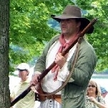
- Moderator

- 2,548 posts
- Gender:Male
- Location:Columbus, Ohio
- Interests:Mostly into GAoP, but starting to develop more Buccaneer era stuff for re-enacting as well. Generally I do re-enact both piratical/nautical and other impressions from the period. I am focusing on more "common" impressions from the period (i.e. average sailor/pirate, rank and file Red Coat, early Colonial huntsman, etc.)
(IP: 199.230.203.254) · ·
Posted December 19, 2008 · Report post
Mission said:
"The Coco-nut-Trees are from 50 to 60 70, 80 and 100 Foot in height, mostly slender and streight. They have Leaves, some four fathom, and four fathom and a half long, and produce a Nut call'd a Co-co-nut; which, with the outer Rind on, is bigger than any Man's Head. the outer Rind being taken off, there appears a Shall, some of which will hold near a Quart. Within the Shell is the Nut; and within the Nut is about a Pint and a half of pure clear Water, which is very cool, brisk, pleasant and sweet. The Kernel of the Nut is also very good; which if it be pretty old, we scrape all to pieces; the scrapings we set to soak in about a quart of fresh Water for three or four hours, and then strain the Water; which when strain'd hath both the colour and taste of Milk: And if it stand a while, it will have a thick scum on it, not unlike Cream. This Milk being boiled with Rice, is accounted by our Doctors to be very nourishing; for which reason we often give of it to our sick Men. The Leaves of the Tree, serve to thatch Houses; the outer Rind of the Nut, to make Linnen-Cloth; of it they also make Ropes for Ships, as
Wow, that may be one of the earliest recipes for Jamaincan style rice that I have seen. Modernly it is called "Rice and Peas", as some time along the intervening centuries it became common to cook the dish with blac eyed peas (beans), although these days although the dish retains the name "rice and peas" it is more commonly served with red kidney beans than black eyed peas. This dish is AWESOME as an accompanyment to Jerked meat dishes.

- Quote
- Edit
- Options

Diosa De Cancion
- Notorious Pyrate
- 
- Member

- 756 posts
- Gender:Female
- Location:Melbourne, Fla
(IP: 24.243.137.247) · ·
Posted December 19, 2008 · Report post
michaelsbagley said:
Mission said:
"The Coco-nut-Trees are from 50 to 60 70, 80 and 100 Foot in height, mostly slender and streight. They have Leaves, some four fathom, and four fathom and a half long, and produce a Nut call'd a Co-co-nut; which, with the outer Rind on, is bigger than any Man's Head. the outer Rind being taken off, there appears a Shall, some of which will hold near a Quart. Within the Shell is the Nut; and within the Nut is about a Pint and a half of pure clear Water, which is very cool, brisk, pleasant and sweet. The Kernel of the Nut is also very good; which if it be pretty old, we scrape all to pieces; the scrapings we set to soak in about a quart of fresh Water for three or four hours, and then strain the Water; which when strain'd hath both the colour and taste of Milk: And if it stand a while, it will have a thick scum on it, not unlike Cream. This Milk being boiled with Rice, is accounted by our Doctors to be very nourishing; for which reason we often give of it to our sick Men. The Leaves of the Tree, serve to thatch Houses; the outer Rind of the Nut, to make Linnen-Cloth; of it they also make Ropes for Ships, as
Wow, that may be one of the earliest recipes for Jamaincan style rice that I have seen. Modernly it is called "Rice and Peas", as some time along the intervening centuries it became common to cook the dish with blac eyed peas (beans), although these days although the dish retains the name "rice and peas" it is more commonly served with red kidney beans than black eyed peas. This dish is AWESOME as an accompanyment to Jerked meat dishes.
Do you have a good Jamaican place up there? If not I can recommend a few when you're down this way. Hurricane and I are Jamaican food lovers after our many trips to Jamaica and are picky, but we have found some folks in our area that are from down that way and make rice an peas, brown stew, and jerk the way it is supposed to be made...yum!!!!
Although, I will tell you the best jerked chicken is on the streets of Port Royal.... Friday and Saturday night they roll out large oil drums that are used as grills and cook the chicken with their homemade jerk sauce and a big hunk of fresh bread. Your lips will burn for hours but DAMN IT"S GOOD!!!!
Mission - Don;t worry, I am not hijacking the topic. Additionally, if you would like to try any of these recipes or just play with some coconuts, I will be happy to bring a large branch of them down to PIP next year. I didn't bring them this year because no one appreciated the ones I brought in 07, but we have a tree that always has dozens and dozens of coconuts! We also have banana, plantain, mango, caldimundian and sugar cane growing in the yard. I will be doing the sugar cane press presentation again next year so if anyone wants to cook it up with a little of that shaved coconut, they could make up great fresh coconut candy!

- Quote
- Edit
- Options

michaelsbagley
- Smells Like Wet Sheep
- Moderator

- 2,548 posts
- Gender:Male
- Location:Columbus, Ohio
- Interests:Mostly into GAoP, but starting to develop more Buccaneer era stuff for re-enacting as well. Generally I do re-enact both piratical/nautical and other impressions from the period. I am focusing on more "common" impressions from the period (i.e. average sailor/pirate, rank and file Red Coat, early Colonial huntsman, etc.)
(IP: 199.230.203.254) · ·
Posted December 19, 2008 · Report post
Goddess in the Bodice said:
Do you have a good Jamaican place up there?
Not that I have found in living in central Ohio for two years, although I have there is passable stuff in neighborhoods I am reluctant to trod into.... Which is why Mr. Wobble is such a hero to me. I don't get back to Toronto nearly as much as I would like (where the is a plethora of good Carribean food places)
Quote
If not I can recommend a few when you're down this way. Hurricane and I are Jamaican food lovers after our many trips to Jamaica and are picky, but we have found some folks in our area that are from down that way and make rice an peas, brown stew, and jerk the way it is supposed to be made...yum!!!!
Although, I will tell you the best jerked chicken is on the streets of Port Royal.... Friday and Saturday night they roll out large oil drums that are used as grills and cook the chicken with their homemade jerk sauce and a big hunk of fresh bread. Your lips will burn for hours but DAMN IT"S GOOD!!!!
Mission - Don;t worry, I am not hijacking the topic. Additionally, if you would like to try any of these recipes or just play with some coconuts, I will be happy to bring a large branch of them down to PIP next year. I didn't bring them this year because no one appreciated the ones I brought in 07, but we have a tree that always has dozens and dozens of coconuts! We also have banana, plantain, mango, caldimundian and sugar cane growing in the yard. I will be doing the sugar cane press presentation again next year so if anyone wants to cook it up with a little of that shaved coconut, they could make up great fresh coconut candy!
Diosa, if you bring a few coconuts next year, I would happily prepare them as a side to a meal! Even more so if it is as a side dish to Mr. Wobble's night of cooking Jerk! Heck if no one wants to eat Jamaican rice, I'll crack them up and just drink the coconut water... I must just remember to bring a machate or other heavy blade with me (or sharpen my dull axe) as my side knife is far too small to deal with the husks or hulls.

- Quote
- Edit
- Options

Diosa De Cancion
- Notorious Pyrate
- Member

- 756 posts
- Gender:Female
- Location:Melbourne, Fla
(IP: 24.243.137.247) · ·
Posted December 19, 2008 · Report post
michaelsbagley said:
Goddess in the Bodice said:
Do you have a good Jamaican place up there?
Not that I have found in living in central Ohio for two years, although I have there is passable stuff in neighborhoods I am reluctant to trod into.... Which is why Mr. Wobble is such a hero to me. I don't get back to Toronto nearly as much as I would like (where the is a plethora of good Carribean food places)
Alrightly then, are you coming to St Augustine for Searles? Remind me a couple days before and I will make sure you get some real food! :) Meanwhile, when it comes to the coconuts, I'm all over some great rice and peas so I will be happy to bring them down and I can even bring a machete.
One thing we did was have many of the coconuts squared off on the bottom (in the spongy husk) and then made it where we just needed to tap the top to be able to pop it open and get the milk. Even better is that you can pop the top and pour in a little rum and pineapple juice and have a pine colada ready to go!!! :)

- Quote
- Edit
- Options

Mission
- Goat Specialist
- Admin

- 5,082 posts
- Gender:Male
- Location:Monroe, MI
- Interests:Scholarly piracy, designing and creating haunted house rooms and props, movies, abstract thinking, abstruse thinking, obstructive thinking, ideating, random thinking, movies, cartoons, movies, movies scores, cycling, world peace and small furry dogs, movies, writing, drawing, personal skills training, gremlins and, of course, lest I forget, movies.
(IP: 64.241.37.140) · ·
Posted March 28, 2010 · Report post
Ah, the venerable coco-nut... Here's Navarrete waxing eloquent on the tree in his book The Travels and Controversies of Friar Domingo Navarrete 1618-1686. Someone was recently asking me how to make wine from a Coconut tree and this points you to which trees you should start with. Alas, I can't remember who that was, or I'd reply to them more directly. Anyhow, to Navarrete:
“[in the town on the river Baco in the Philippines]…they make no account of the Honey; there’s plenty of Batatas and Camotes [Footnote 1: The Camote, or sweet potato, of which there are twenty-nine varieties, is widely cultivated in the Philippeans.], Ubis, [Footnote 2: A jelly is made from the ubi, which is an edible root (Blair, XXIX, 298; Combés, 7).],. Yuñames [yams], and a variety of Fruits: an infinite number of Cedars, whose Blossom, which I often saw, exhales a most fragrant Scent, and reaches far; a multitude of Coco-trees. There are besides abundance of other palm trees, from which they extract Honey, Wine [Footnote 3: On the palm-wine tree [the sago-palm or buri], see Blair, IV, 276 and Delgado, 660-2.], Vinegar, Tuba [Toddy], and Chancaca [black sugar]; also a Tree [the cabo negro], like the Banana, of which they make a sort of black Hemp for Rigging and Ships’ Cables; and of these the number is incredible. There is another sort of white Hemp [Manila Hemp], taken from a Tree call’d the abaca; it is excellent for Cables for the more it is wetted, the stronger it grows [Footnote 4: The leaf of the cable negro yields fibres from which the cordage is made; it is very durable and able to resist even salt water (Blair, XVIII, 177).] There is another Tree from the bark of which they make Stuffs as white as Snow, and delicately soft, which the Indians use for their Beds and Clothing, tho they do not want Cotton, of which they make an excellent Cloth.” (Navarrete, p. 81)

- Quote
- Edit
- Options

Slopmaker Cripps
- Ship's Master
- 
- Member

- 137 posts
- Interests:Maritime Living History<br>Slopmaking<br>Tailoring
(IP: 66.157.238.105) · ·
Posted March 29, 2010 · Report post
I've done caulking with oakum made of cocunut fibers and pine tar.....we had it on a role with the strips flattened, so as we brought it off we would have to rub it between our hands to thicken it up....We would then break it off into hanks and roll them up seperately, and use those when caulking. It works extremely well, though it is heck on your hands if you're not used to rubbing the fibers....though they'll thicken up quick enough. It's pretty much only good for wide seams, and allows you to save the cotton for finer ones.
Cheers,
Adam C.

- Quote
- Edit
- Options

Mission
- Goat Specialist
- Admin

- 5,082 posts
- Gender:Male
- Location:Monroe, MI
- Interests:Scholarly piracy, designing and creating haunted house rooms and props, movies, abstract thinking, abstruse thinking, obstructive thinking, ideating, random thinking, movies, cartoons, movies, movies scores, cycling, world peace and small furry dogs, movies, writing, drawing, personal skills training, gremlins and, of course, lest I forget, movies.
(IP: 64.241.37.140) · ·
Posted April 4, 2010 (edited) · Report post
Here's some more from Navarrete on this king of tropical trees. (Match for firearms!):
“Before the Coco-Nut itself sprouts out they draw an excellent Liquor from the nib of the Branch, this these Indians call Tuba, and the East Indians call it Sura. [Footnote 1: Sura, or toddy, is fermented palm sap, not coco-nut milk. Nor should it be confused with toddy in the Scottish sense of whiskey, sugar and hot water (Dalgado, II, 330-1; Hobson-Jobson, 874] What runs from it at night is a pleasant and wholesome Drink, and if boil’d in the Morning, it holds good all day, they make of it excellent Sirrup, and good Honey, as I have done my self. What drops in the day is made into Wine, and delicate Vinegar. Of the outward rind of the Coco they make a sort of Okam to caulk Ships, and make Ropes, and good Match for all sorts of firearms which the Musketiers there make use of. Of the inward shell are made fine Bowls to drink Water, or Chocolate. The Juice within, when the Coco is fresh, is wholesome and a pleasant drink for sick People, who roast the Coco and, after laying it out all Night in the Open Air, drink the Juice and find a good effect of it. Of the white Nut, into which the Juice by little and little is converted, they extract Milk, and use it several ways, particularly to dress Rice. Besides, they make an excellent Preserve of it, which the Indians call Buchayo. It also yields good Oil. Of the Mash that remains, the Indians and Mulattoes make a very good Dish with Rice. There remains the Trunk of the Tree and Branches, which serve for many other uses. Canes are also very serviceable, some are as thick as a Man’s Thigh, of which they make Chairs, Tables, Houses,
__
Churches, Enclosures for Cattel, Scaffolding for Buildings, and many other things. [Footnote 1: On ‘The Wonders of the Coconut tree’ which included an ‘Impression against Atheism’, see R. Knox, An Historical Relation of Ceylon [1681] (London, 1911), 413-24. Another English contemporary thought it the ‘necessariest fruit that grows, making things for all uses, being both meat and drink, clothing and cables and rigging for this country’s vessels’ (Barlow’s Journal, I, 189). J. González de Mendoza, writing of this ‘plant so full of mysterie and profite’, describes an entire ship and it’s cargo as being the produce of the ‘palma de cocos’ (History of China (London, 1853), II, 266). Delgado (665) suggests that its virtues are illimitable, and concludes a catalogue of them by urging the reader to find more for himself.]” (Navarrete, p. 97-8)
“The Men [natives] are always employ’d in making Oil of Coconuts, of which they sell very much, and pay a great deal of Tribute to the King of Macasar. Whilst we were there, he sent to demand of them 90,000 Pecks of Oil. It is wonderful to see the Coco-trees there are about the Fields. That Country produces and infinite number of Plantan [banana] Trees, and they are the best in the World; the Natives live upon them without sowing Rice or any other Grain. Eight days we continu’d among those People, eating nothing but Plantans, and drinking the Water of Coco-nuts. They breed Bufaloes, Goats, and Horses, which they sell, and when they have general Meetings they eat a Bufalo or two, half raw, half roasted.” (Navarrete, p. 110)
Edited April 4, 2010 by Mission

- Quote
- Edit
- Options

Mission
- Goat Specialist
- Admin

- 5,082 posts
- Gender:Male
- Location:Monroe, MI
- Interests:Scholarly piracy, designing and creating haunted house rooms and props, movies, abstract thinking, abstruse thinking, obstructive thinking, ideating, random thinking, movies, cartoons, movies, movies scores, cycling, world peace and small furry dogs, movies, writing, drawing, personal skills training, gremlins and, of course, lest I forget, movies.
(IP: 12.232.174.154) · ·
Posted October 1, 2011 · Report post
“The Men have their Drinking Bouts of Palm Wine, which is the only Liquor the Country [Angola] affords besides Water; they let it stand two Days after it is taken from the Tree, in which time it ferments and grows sower, and has some Spirit in it, which exhilarates them and makes them merry; they’ll set at these drinking Bouts twelve Hours together till they get drunk. I have tasted it, but found it disagreeable; but when it is first taken from the Tree it has a very pleasant Taste, and I have drank great Quantities of it without perceiving it had any other Effect than quenching my Thirst, though some Travellers affirm that it will make People drunk. This Wine, which the Natives call Malaso, is the Sap of the Palm Tree, and is taken from it thus: They make several small Holes in the upper Part of the Tree, a little below the Head where it branches out, and put in a Reed and fasten it to a Calabash, which is made almost like a Bottle, and it the Shell of a Fruit which receives the Liquor.” (The Voyages and Travels of Captain Nathaniel Uring, 1928 reprint, first published in 1726, p. 42)

- Quote
- Edit
- Options

Mission
- Goat Specialist
- Admin

- 5,082 posts
- Gender:Male
- Location:Monroe, MI
- Interests:Scholarly piracy, designing and creating haunted house rooms and props, movies, abstract thinking, abstruse thinking, obstructive thinking, ideating, random thinking, movies, cartoons, movies, movies scores, cycling, world peace and small furry dogs, movies, writing, drawing, personal skills training, gremlins and, of course, lest I forget, movies.
(IP: 12.232.174.154) · ·
Posted February 12, 2012 (edited) · Report post
Aha! A medically-oriented reference to the Cocoa-nut! Courtesy of Alexander Hamilton's book A New Account of the East Indies.
“It [bombay] has but little good Water on it, and the Air is somewhat unhealthful, which is chiefly imputed to their dunging the Cocoa-nut Trees with Buckshoe, a Sort of small Fishes which their Sea abounds in. They being laid to the Roots of the Trees, putrify, and cause a most unsavoury Smell, and in the Mornings there is generally seen a thick Fog amongst those Trees, that affects both the Brains and the Lungs of Europeans, and breed Consumptions, Fevers, and Fluxes.” (Hamilton, p. 161)
Here's another quote about the alcoholic beverage they make from the tree regarding the British in the East Indies.
"The little Trade they [Goa] have, is mostly from their Arrack, which is distilled from Toddy of the Cocoa-nut Tree, which grows in great Abundance in the Territories of Goa. The English are their best Customers, for they buy great Quantities yearly
__
for Punch. It is sold by the Candy, or two Casks, about 45 Gallons each, for 25 Xerapheens per Cask, but I have bought it for 20 when there was no great Demand for it. They also make a great Deal of Salt in Ponds made in low Grounds, where they may convey the Water at spring Tides. It may be bought for a Crown the Tun, and sometimes cheaper.” (Hamilton, p. 217-8)
Edited February 12, 2012 by Mission

- Quote
- Edit
- Options

Mission
- Goat Specialist
- Admin

- 5,082 posts
- Gender:Male
- Location:Monroe, MI
- Interests:Scholarly piracy, designing and creating haunted house rooms and props, movies, abstract thinking, abstruse thinking, obstructive thinking, ideating, random thinking, movies, cartoons, movies, movies scores, cycling, world peace and small furry dogs, movies, writing, drawing, personal skills training, gremlins and, of course, lest I forget, movies.
(IP: 75.128.82.198) · ·
Posted February 16, 2012 · Report post
“Their [the Lacca Diva Island’s - or Laccadiva's] Product is only Cocoa-nuts and Fish. Of the Coca-nut Kernels they express Oyl, which is fine and clear, fitting for Lamps; and, when it is new, serves their Kitchins. Of the Rind of the Nut they make Cayar, which are the Fibres of the Cask that environs the Nut spun fit to make Cordage and Cables for Shipping, and for several other Uses. Their Fish they dry, and export to the Continent.” (Hamilton, p. 245)

- Quote
- Edit
- Options

Mission
- Goat Specialist
- Admin

- 5,082 posts
- Gender:Male
- Location:Monroe, MI
- Interests:Scholarly piracy, designing and creating haunted house rooms and props, movies, abstract thinking, abstruse thinking, obstructive thinking, ideating, random thinking, movies, cartoons, movies, movies scores, cycling, world peace and small furry dogs, movies, writing, drawing, personal skills training, gremlins and, of course, lest I forget, movies.
(IP: 12.232.174.154) · ·
Posted February 18, 2012 · Report post
I never tire of reading about all the things the coconut was used for. When Raphael Mission retired. I think he established a coconut plantation.
“…their [the Maldiva Islands] only Product is Cocoa-nut. Their Trees are not so high nor gross bodied as those which grow on the Continent, or on Zeloan [sri Lanka], but their Fruit is pleasanter. Of that Tree they build Vessels of 20 or 30 Tuns. Their Hulls, Masts, Sails, Rigging, Anchors, Cables, Provisions and Firing are all from this useful Tree. It also affords them Oyl for their Kitchin and Lamps, Sugar and candied Sweet-meats, and pretty strong Cloth. Their Seas produce Abundance of Fish, but their Trade is chiefly from a small Shell-fish called Courie and the Bonetta.” (Hamilton, p. 286)

- Quote
- Edit
- Options

Swashbuckler 1700
- Dread Pyrate
- 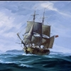
- Member

- 1,115 posts
- Gender:Male
- Location:Europe
- Interests:pyrates, pryvateers, naval military and other history, different books, good movies, music (a little bit), drawing, games,...
(IP: 80.223.160.249) · ·
Posted March 18, 2012 (edited) · Report post
I am not sure is this rigth place but is the coconut palm naturally growing in Americas? I have read that spanish brought there in 16th and 17th centuries like this source says http://www.nhm.ac.uk...#38;ref=coconut but this says that they were there before Columbus http://www.enviromul...DFs/History.pdf
WHAT IS THE TRUTH???? :wacko: :blink:
At least they were popular there in mid and late 17th century (buccaneers burned palm leaves to grill spaniandrs to give up their gold and that Dampier quote says that they were idle in west- indies (but they were there but they had no great purpose there unlike in the east)...)
Edited March 18, 2012 by Swashbuckler 1700

- Quote
- Edit
- Options

Swashbuckler 1700
- Dread Pyrate
- Member

- 1,115 posts
- Gender:Male
- Location:Europe
- Interests:pyrates, pryvateers, naval military and other history, different books, good movies, music (a little bit), drawing, games,...
(IP: 80.223.160.249) · ·
Posted March 19, 2012 (edited) · Report post
On 3/18/2012 at 8:17 AM, Swashbuckler 1700 said:
I am not sure is this rigth place but is the coconut palm naturally growing in Americas? I have read that spanish brought there in 16th and 17th centuries like this source says http://www.nhm.ac.uk...#38;ref=coconut but this says that they were there before Columbus http://www.enviromul...DFs/History.pdf
WHAT IS THE TRUTH???? :wacko: :blink:
At least they were popular there in mid and late 17th century (buccaneers burned palm leaves to grill spaniandrs to give up their gold and that Dampier quote says that they were idle in west- indies (but they were there but they had no great purpose there unlike in the east)...)
Wiki offered a answer so coconust trees are not natural to west indies but there is other endemic palms there http://en.wikipedia....e_note-Morici-1
Edited March 19, 2012 by Swashbuckler 1700

- Quote
- Edit
- Options

Mission
- Goat Specialist
- Admin

- 5,082 posts
- Gender:Male
- Location:Monroe, MI
- Interests:Scholarly piracy, designing and creating haunted house rooms and props, movies, abstract thinking, abstruse thinking, obstructive thinking, ideating, random thinking, movies, cartoons, movies, movies scores, cycling, world peace and small furry dogs, movies, writing, drawing, personal skills training, gremlins and, of course, lest I forget, movies.
(IP: 24.247.94.112) · ·
Posted June 13, 2012 · Report post
And we even have an account of the beloved Co-co nut from the General History:
“[Davis] The Palm-Trees are numerous on the Shores of Africa, and may be reckoned the first of their natural Curiosities, in that they afford them Meat, Drink and Cloathing; they grow very straight to 40 and 50 Foot high, and at the top (only) have 3 or 4 Circles of Branches, that spread and make a capacious Umbrella. The Trunk is very rough with Knobs, either Excrescencies, or the Healings of those Branches that were lopped off to forward the Growth of the Tree, and make it answer better in its Fruit. The Branches are strongly tied together with a Cortex, which may be unravelled to a considerable Length and Breadth; the inward Lamella of this Cortex, I know are wove like a Cloath at Benin and afterwards died and worn: Under the Branches, and close to the Body of the Tree, hang the Nuts, thirty Bunches perhaps on a Tree, and each of thirty Pound Weight, with prickly Films from between them, not unresembling
__
Hedge-Hogs, of these Nuts comes a liquid and pleasant scented Oyl, used as Food and sauce all over the Coast, but chiefly in the Wind-ward Parts of Africa, where they stamp, boil and skim it oft in great Quantities, underneath, where the Branches fasten, they tap for Wine, called Cockra, in this Manner; the Negroes who are mostly limber active Fellows, encompass themselves and the Trees with a Hoop of strong With, and run up with a great deal of Agility, at the Bottom of a Branch of Nuts, he males an Excavation of an Inch and a half over, and tying fast his Calabash, leaves it to destil, which it does to two or three Quarts in a Night's Time, when done he plugs it up, and chooses another, for if suffered to run too much, or in the Day Time, the Sap is unwarily exhausted, and the Tree spoiled. The Liquor thus drawn, is of a wheyish Colour, intoxicating and sours in 24 Hours, but when new drawn, is pleasantest to thirst and hunger both. It is from these Wines they draw their Arack in India. On the very Top of the Palm, grows a Cabbage, called so, I believe, from some resemblance its Taft is thought to have with ours, and is used like it, the Covering has a Down that makes the best of Tinder, and the Weavings of other Parts are drawn out into strong Threads.
Coco-Nut-Trees are branch’d like, but not so tall as, Palm Trees, the Nut like them, growing under the Branches, and close to the Trunk; the milky Liquor they contain, (to half a Pint or more,) is often drank to quench Thirst, but surfeiting, and this may be observed in their Way of Nourishment, that when the Quantity of Milk is large, the Shell and Meat are very thin, and harden and thicken in Proportion, as that loses.” (Johnson, 3rd, p. 198)

- Quote
- Edit
- Options

Swashbuckler 1700
- Dread Pyrate
- Member

- 1,115 posts
- Gender:Male
- Location:Europe
- Interests:pyrates, pryvateers, naval military and other history, different books, good movies, music (a little bit), drawing, games,...
(IP: 80.223.160.249) · ·
Posted June 13, 2012 · Report post
" Coco-Nut-Trees are branch’d like, but not so tall as, Palm Trees, the Nut like them, growing under the Branches, and close to the Trunk."
Funny that he thinks that coco nut trees are not palms.... Nowdays many know the "coconut palm".

• • Quote
• Edit
• Options

Mission
- Goat Specialist
- Admin

- 5,082 posts
- Gender:Male
- Location:Monroe, MI
- Interests:Scholarly piracy, designing and creating haunted house rooms and props, movies, abstract thinking, abstruse thinking, obstructive thinking, ideating, random thinking, movies, cartoons, movies, movies scores, cycling, world peace and small furry dogs, movies, writing, drawing, personal skills training, gremlins and, of course, lest I forget, movies.
(IP: 24.247.94.112) · ·
Posted June 13, 2012 (edited) · Report post
Well there are palms that are not coconut palms. And there are many different varieties of coconut palms.
Although you should be cautious when reading terms in period manuscripts. Their terminology is spotty to say the least. Unless I can recognize what an author is talking about from his description, I just accept that it's some type of what he's describing and don't read much more into it than that. Being no expert in horticulture, I just accept that he is talking about some form of coconut. (If the editor is really good, they'll often tell you what the modern terminology is for the thing an author is talking about.)
Edited June 13, 2012 by Mission

- Quote
- Edit
- Options

Swashbuckler 1700
- Dread Pyrate
- Member

- 1,115 posts
- Gender:Male
- Location:Europe
- Interests:pyrates, pryvateers, naval military and other history, different books, good movies, music (a little bit), drawing, games,...
(IP: 80.223.160.249) · ·
Posted June 13, 2012 (edited) · Report post
I think he mean coconuts palms as one thing and palms as other ( so his definition of palms included those palms which were not coconut palms (coconut tree is just one palm)
Edited June 13, 2012 by Swashbuckler 1700

- Quote
- Edit
- Options

Swashbuckler 1700
- Dread Pyrate
- Member

- 1,115 posts
- Gender:Male
- Location:Europe
- Interests:pyrates, pryvateers, naval military and other history, different books, good movies, music (a little bit), drawing, games,...
(IP: 80.223.160.249) · ·
Posted June 13, 2012 · Report post
http://www.wdl.org/en/item/252/zoom/#group=1&page=35 lol this is getting odd now I am talking about plants .. but 17th C protagonist has put coconut palm among other palms. see somewhere near of page 50.

- Quote
- Edit
- Options

Swashbuckler 1700
- Dread Pyrate
- Member

- 1,115 posts
- Gender:Male
- Location:Europe
- Interests:pyrates, pryvateers, naval military and other history, different books, good movies, music (a little bit), drawing, games,...
(IP: 80.223.160.249) · ·
Posted June 14, 2012 · Report post
Lol I meant botanist not protagonist

- Quote
- Edit
- Options

Mission
- Goat Specialist
- Admin

- 5,082 posts
- Gender:Male
- Location:Monroe, MI
- Interests:Scholarly piracy, designing and creating haunted house rooms and props, movies, abstract thinking, abstruse thinking, obstructive thinking, ideating, random thinking, movies, cartoons, movies, movies scores, cycling, world peace and small furry dogs, movies, writing, drawing, personal skills training, gremlins and, of course, lest I forget, movies.
(IP: 24.247.94.112) · ·
Posted June 15, 2012 (edited) · Report post
From the account of Sir Francis Drake entitled by Walter Bigges' 1583 A Summarie And True Discourse Of Sir Francis Drake's West-Indian Voyage by Walter Bigges:
“Somewhat above the Towne [st. Jago] on the North side betweene the two Mountaines, the valley waxeth somewhat larger then ac the Townes end which Valley is wholly converted into Gardens and Orchards well replenished with diverse sorts of Fruites, Herbes and Trees, as Lymons, Oranges, Sugar Canes, Cochars or Cochos-Nuts, Plantens, Potato-roots, Cocombers, small and round Onyons, Garlike, and some other things not now remembred, amongst which Chochos-nuts and Plantens are very pleasant Fruits, the said Cochos having a hard shell and a greene Huske over it, as hath our Walnut but it farre exceedeth in greatnesse, for this Cochos in his greene huske is bigger then any mans two Fists, of the hard shell many drinking Cups are made here in England, and set in Silver as I have often seen.
Next within this hard shell is a white rine, resembling in shew very much, even as any thing may doe, to the white of an Egge when it is hardboyled. And within this white of the Nut lyeth a water, which is whitish and very cleere, to the quantity of halfe a pint or there abouts, which water and white rine before spoken of, are both of a very coole fresh taste, and as pleasing as any thing may be. I have heard some hold opinion, that it is very restorative.
The Planten groweth in Cods, somewhat like to Beans, but is bigger and longer, and much more thicke together on the stalke, and when it waxeth ripe, the meate which filleth the rine of the Cod becometh yellow, and is exceeding sweet and pleasant.” (Bigges, p. 13)
Edited June 15, 2012 by Mission

- Quote
- Edit
- Options

landlubbersanonymous
- Plunderer
- 
- Member

- 354 posts
- Gender:Not Telling
- Location:California, USA
- Interests:History, arts, collecting, reenacting
(IP: 72.67.12.99) · ·
Posted June 15, 2012 (edited) · Report post
This was something that surfaced during our studies last year. We had a link to a cool illustrated poster showing assorted samples of different coconuts but it has since vanished. If it resurfaces, we'll post it.
"Cocos nucifera Linn. was introduced to Mexico by Spanish navigators in the middle of the 16th century, from Cape Verde and Santo Domingo to the Atlantic coast, and from the Solomon Islands and the Philippines to the Pacific coast. These populations remained isolated from one another for almost 500 years. Morphological studies on fruit characteristics show that coconuts from the two populations are contrasting forms. The Atlantic coast populations show a wild type fruit, with angular shape, thick husk, thick shell, thick endosperm and low water content. The Pacific populations have a domesticated type fruit, with fruit and nut more spherical, with a much thinner husk and shell, and higher water content. The higher variability observed in the Pacific coast raises the possibility of later introductions, also from the Philippines or other Pacific islands." - Economic Botany, 1993 New York Botanical Garden Press
Edited June 15, 2012 by landlubbersanonymous

- Quote
- Edit
- Options

Swashbuckler 1700
- Dread Pyrate
- Member

- 1,115 posts
- Gender:Male
- Location:Europe
- Interests:pyrates, pryvateers, naval military and other history, different books, good movies, music (a little bit), drawing, games,...
(IP: 80.223.160.249) · ·
Posted June 15, 2012 (edited) · Report post
So wiki was indeed rigth cocos palm as we know it was not natural to the caribbean (but there were over 3000 native or endemic palm species there and many of them are related to cocos)
Columbus in his journal (if it is the real one) said http://www.sonofthes...urnal-diary.htm
The Admiral says that " he never beheld such a beautiful place (Cuba), with trees bordering the river, handsome, green, and different from ours, having fruits and flowers each one according to its nature. There are many birds, which sing very sweetly. There are a great number of palm-trees of a different kind from those in Guinea and from ours, of a middling height, the trunks without that covering, and the leaves very large, with which they (natives) thatch their houses
Edited June 15, 2012 by Swashbuckler 1700

- Quote
- Edit
- Options

MadMike
- First Mate
- 
- 
- Member

- 251 posts
- Location:Careened near the Gulf of Mexico
- Interests:1712 raid on Dauphin Island, Alabama.
(IP: 68.111.124.62) · ·
Posted June 16, 2012 · Report post
"Are you suggesting that coconuts migrate?"
Sorry, someone had to throw that in there...

- Quote
- Edit
- Options

Swashbuckler 1700
- Dread Pyrate
- Member

- 1,115 posts
- Gender:Male
- Location:Europe
- Interests:pyrates, pryvateers, naval military and other history, different books, good movies, music (a little bit), drawing, games,...
(IP: 80.223.160.249) · ·
Posted June 16, 2012 · Report post
Well coconuts can go to island to other and since they can travel even in salty water. Also people have carried them so migrateindeed....

- Quote
- Edit
- Options

landlubbersanonymous
- Plunderer
- Member

- 354 posts
- Gender:Not Telling
- Location:California, USA
- Interests:History, arts, collecting, reenacting
(IP: 72.67.12.99) · ·
Posted June 16, 2012 · Report post
On 6/16/2012 at 1:51 PM, MadMike said:
"Are you suggesting that coconuts migrate?"
Sorry, someone had to throw that in there...
On 6/16/2012 at 2:14 PM, Swashbuckler 1700 said:
Well coconuts can go to island to other and since they can travel even in salty water. Also people have carried them so migrateindeed....
MadMike was making a silly film reference.
(In Finnish... Monty Python Hullu Maailma... niellä ja kookos)
Google translation rocks.

- Quote
- Edit
- Options

Swashbuckler 1700
- Dread Pyrate
- Member

- 1,115 posts
- Gender:Male
- Location:Europe
- Interests:pyrates, pryvateers, naval military and other history, different books, good movies, music (a little bit), drawing, games,...
(IP: 80.223.160.249) · ·
Posted June 17, 2012 · Report post
On 6/16/2012 at 9:52 PM, landlubbersanonymous said:
On 6/16/2012 at 1:51 PM, MadMike said:
"Are you suggesting that coconuts migrate?"
Sorry, someone had to throw that in there...
On 6/16/2012 at 2:14 PM, Swashbuckler 1700 said:
Well coconuts can go to island to other and since they can travel even in salty water. Also people have carried them so migrateindeed....
MadMike was making a silly film reference.
(In Finnish... Monty Python Hullu Maailma... niellä ja kookos)
Google translation rocks.
Oh I am well aware of Monty Pyton that was a nice film.... and birds did it!

- Quote
- Edit
- Options

Grymm
- First Mate
- 
- Member

- 281 posts
- Gender:Male
- Location:Chilterns UK
- Interests:Stuff
(IP: 109.149.241.41) · ·
Posted June 17, 2012 · Report post
Don't forget the fancy carved silver and gold mounted coconut cups and mazers that get used in Europe from about mid 14thC
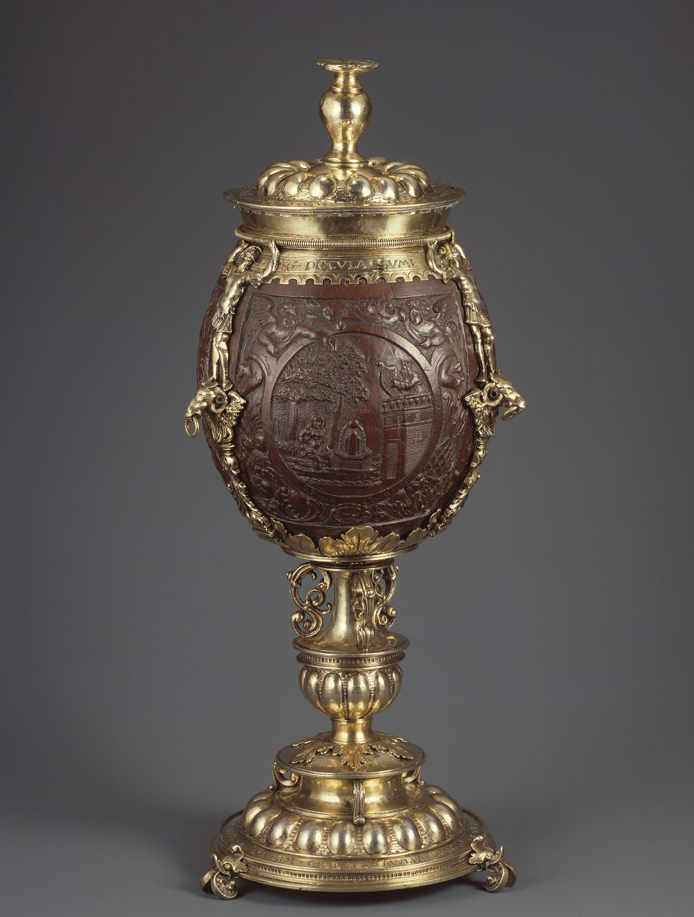
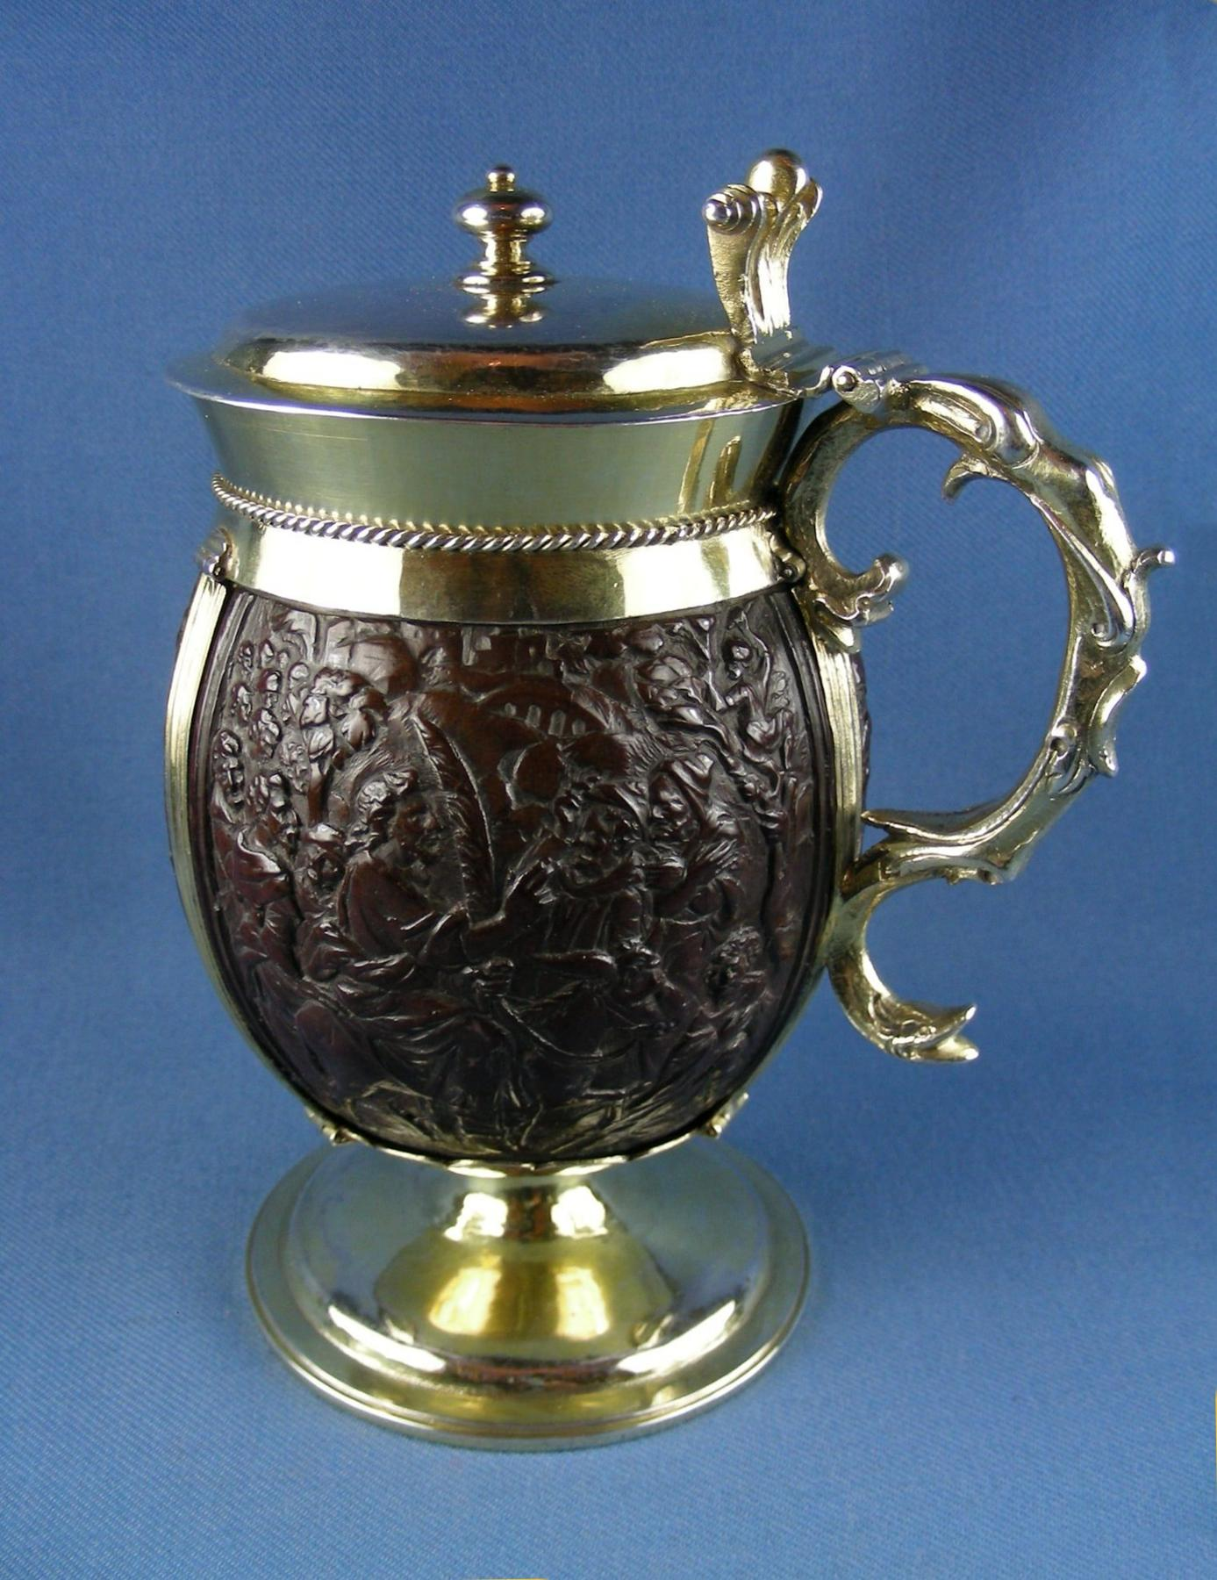
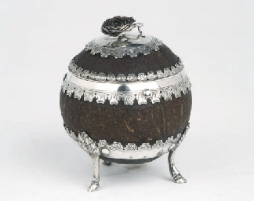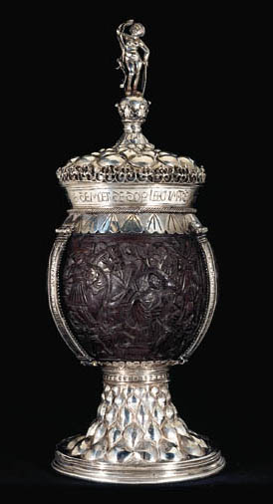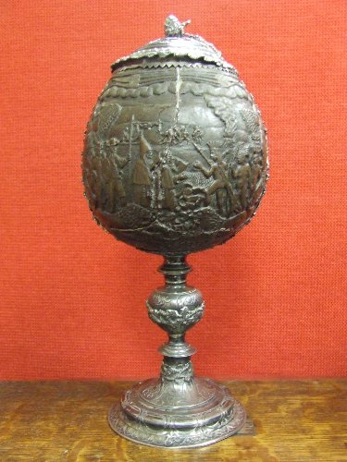
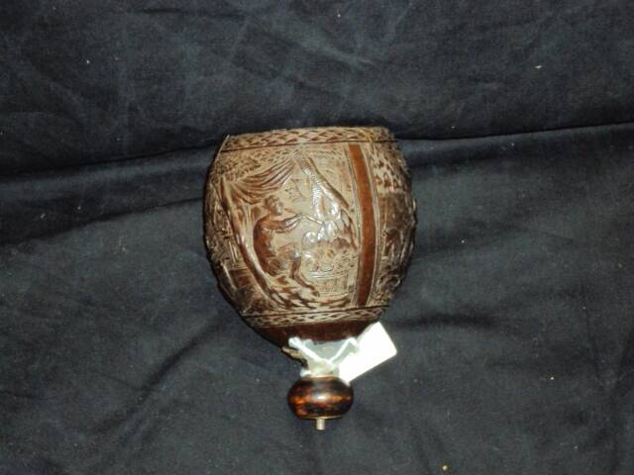

- Quote
- Edit
- Options

William Brand
- Mercury Malefactor
- 
- Admin

- 8,884 posts
- Gender:Male
- Location:Logan, Utah
- Interests:My name is William Pace and I live and work as a graphic designer, illustrator and photographer in Northern Utah. I'm married to the lovely Tracy Pace and we have three children. In addition to all things art, I enjoy traveling and meeting new people from every walk of life. I've always been a fan of history, theology, and of course, Pyracy.
http://www.youtube.com/watch?v=PSkt-q-HihQ
(IP: 166.70.59.121) · ·
Posted June 18, 2012 · Report post
Another fine mazer...
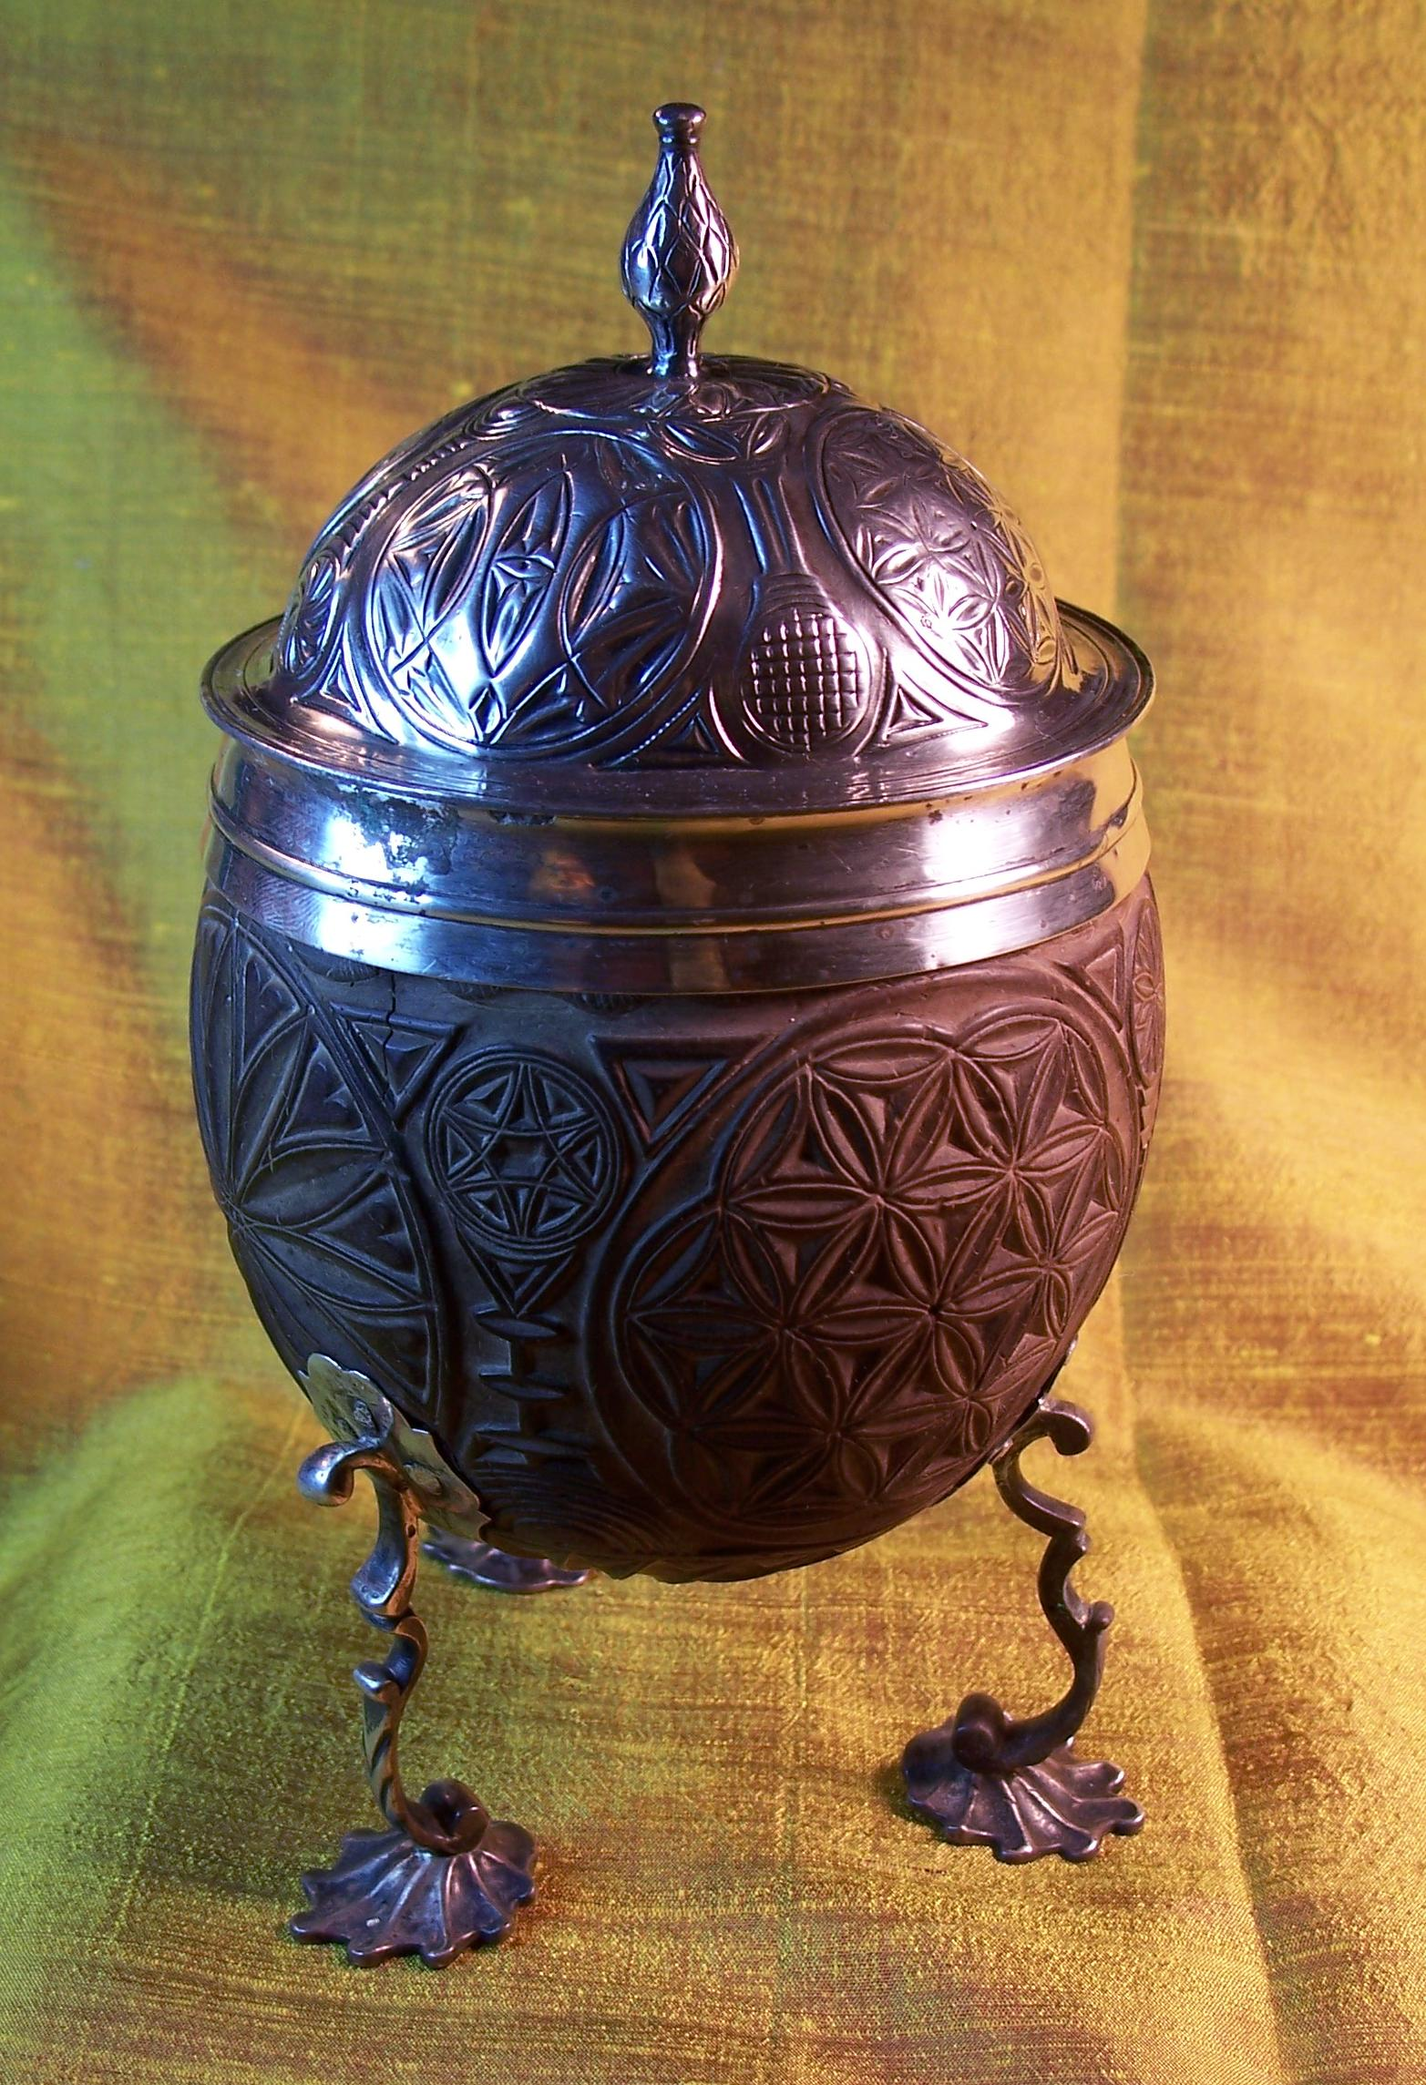

- Quote
- Edit
- Options

Mission
- Goat Specialist
- Admin

- 5,082 posts
- Gender:Male
- Location:Monroe, MI
- Interests:Scholarly piracy, designing and creating haunted house rooms and props, movies, abstract thinking, abstruse thinking, obstructive thinking, ideating, random thinking, movies, cartoons, movies, movies scores, cycling, world peace and small furry dogs, movies, writing, drawing, personal skills training, gremlins and, of course, lest I forget, movies.
(IP: 24.247.94.112) · ·
Posted June 18, 2012 (edited) · Report post
Wonderful! I may have to write an article about coconuts and bananas. There's so much good stuff out there. Here's a bit from Sir Francis Drake's Famous Voyage Round the World by Francis Pretty. (1580):
"Amongst other things we found here a kind of fruit called cocos, which because it is not commonly known with us in England, I thought good to make some description of it. The tree beareth no leaves nor branches, but at the very top the fruit groweth in clusters, hard at the top of the stem of the tree, as big every several fruit as a man's head ; but having taken off the uttermost bark, which you shall find to be very full of strings or sinews, as I may term them, you shall come to a hard shell, which may hold in quantity of liquor a pint commonly, or some a quart, and some less. Within that shell, of the thickness of half-an-inch good, you shall have a kind of hard substance and very white, no less good and sweet than almonds ; within that again, a certain clear liquor, which being drunk, you shall not only find it very delicate and sweet, but most comfortable and cordial." (Pretty, p. 5)
Edited June 18, 2012 by Mission

- Quote
- Edit
- Options

Swashbuckler 1700
- Dread Pyrate
- Member

- 1,115 posts
- Gender:Male
- Location:Europe
- Interests:pyrates, pryvateers, naval military and other history, different books, good movies, music (a little bit), drawing, games,...
(IP: 80.223.160.249) · ·
Posted June 18, 2012 · Report post
It seems that coconut trees were become so oldinary in West- Indies by 17th Century that they was as natural part of the Caribbean than indians were
http://jcb.lunaimaging.com/luna/servlet/detail/JCB~1~1~43~230235:-Du-cocos--?sort=Normalized_date%2CCreators%2CPublisher%2CTitle&qvq=q:cocos;sort:Normalized_date%2CCreators%2CPublisher%2CTitle;lc:JCB~1~1,JCBBOOKS~1~1,JCBMAPS~1~1,JCBMAPS~2~2&mi=6&trs=16
http://jcb.lunaimaging.com/luna/servlet/detail/JCB~1~1~6276~9660004:-Du-Cocos,-&-du-Cacao--?sort=Normalized_date%2CCreators%2CPublisher%2CTitle&qvq=q:cocos;sort:Normalized_date%2CCreators%2CPublisher%2CTitle;lc:JCB~1~1,JCBBOOKS~1~1,JCBMAPS~1~1,JCBMAPS~2~2&mi=3&trs=16
and even botamy books of the period talk like they were popular in caribbean (with other palms) but they were not native in there (unlike over 3000 other palm species).

- Quote
- Edit
- Options

Mission
- Goat Specialist
- Admin

- 5,082 posts
- Gender:Male
- Location:Monroe, MI
- Interests:Scholarly piracy, designing and creating haunted house rooms and props, movies, abstract thinking, abstruse thinking, obstructive thinking, ideating, random thinking, movies, cartoons, movies, movies scores, cycling, world peace and small furry dogs, movies, writing, drawing, personal skills training, gremlins and, of course, lest I forget, movies.
(IP: 24.247.94.112) · ·
Posted June 18, 2012 · Report post
If you think about it, a tree is only native to one spot - the place where the very first one grew. Every other spot is non-native. (And when the first one grew there, it was an invasive species.)

- Quote
- Edit
- Options

Swashbuckler 1700
- Dread Pyrate
- Member

- 1,115 posts
- Gender:Male
- Location:Europe
- Interests:pyrates, pryvateers, naval military and other history, different books, good movies, music (a little bit), drawing, games,...
(IP: 80.223.160.249) · ·
Posted June 18, 2012 · Report post
hmmm quite true
Well cocos has speard in caribbean because of the humans so it is not moved there naturally...

- Quote
- Edit
- Options

Mission
- Goat Specialist
- Admin

- 5,082 posts
- Gender:Male
- Location:Monroe, MI
- Interests:Scholarly piracy, designing and creating haunted house rooms and props, movies, abstract thinking, abstruse thinking, obstructive thinking, ideating, random thinking, movies, cartoons, movies, movies scores, cycling, world peace and small furry dogs, movies, writing, drawing, personal skills training, gremlins and, of course, lest I forget, movies.
(IP: 24.247.94.112) · ·
Posted June 18, 2012 (edited) · Report post
Birds often get credited for spreading seeds and that seems to be OK. Humans are just another animal, like birds, and are a natural part of the environment, so what difference does who put the first seed there? (I have never understood the snapshot theory of the environment. Like all of life (and history), the environment is operated on by so many factors you couldn't comprehend them all if they were listed for you. Like all of life (and not so much history - well, at least past history) the environment is forever in flux, being impacted and operated upon by millions of theoretical butterflies flapping millions of theoretical wings.)
Edited June 18, 2012 by Mission

- Quote
- Edit
- Options

Swashbuckler 1700
- Dread Pyrate
- Member

- 1,115 posts
- Gender:Male
- Location:Europe
- Interests:pyrates, pryvateers, naval military and other history, different books, good movies, music (a little bit), drawing, games,...
(IP: 80.223.160.249) · ·
Posted June 19, 2012 · Report post
well you are rigth indeed

• Quote
• Edit
• Options

