William Brand
- Mercury Malefactor
- 
- 
- Admin

- 8,884 posts
- Gender:Male
- Location:Logan, Utah
- Interests:My name is William Pace and I live and work as a graphic designer, illustrator and photographer in Northern Utah. I'm married to the lovely Tracy Pace and we have three children. In addition to all things art, I enjoy traveling and meeting new people from every walk of life. I've always been a fan of history, theology, and of course, Pyracy.
http://www.youtube.com/watch?v=PSkt-q-HihQ
Posted April 17, 2006 · Report post
Some of the items to be discussed here have been previously hashed out in other threads, so let us look at this as a consolidation of ideas for the overall look and feel of a good period encampment.
Because of many upcoming festivals, and Pirates in Paradise later in the year, I have been getting a fair number of questions about period camps that I would like second opinions and advice about.
1 - Tents
I assume that the common variety wedge is a passable tent, but I would like to know for certain if a wedge is appropriate and what tents may be better suited to the period.
2 - Cookware
Cast iron? forged cookware? Copper? Cooking tripods? There are numerous questions to the overall area of cookware, so I will leave this topic open-ended for whatever advice may come our way.
3 - Camp gear
Sea chests, chairs, kegs, etc. What are the simple and most plausible additions to improve the lived-in look of any good camp. Are canvas buckets period? What furnitire if any might by found in a camp?
4 - And of course...the don'ts
Plastic and resin cast skull candle holders, homemade rotting corpses lounging about as caricatures of doom, metal hope-chests and blanket trunks from WalMart, etc.

Dorian Lasseter
- Where's My Water
- 
- 
- Member

- 3,266 posts
- Gender:Male
- Location:The Sea!
- Interests:18th Century reenactment; Maritime, F&I...
Did ECW as well...
All BP firelocks and cannons!
Also enjoy Swordfighting and a good Donnybrook
Got a question for or about me? Ask!!!
Posted April 17, 2006 · Report post
#1 Tents...
The wedge has been around for a very long time... although, the usual wedge you see around is just OOP.... I used an in period wedge for ECW (1640s), the only difference is that the upright poles are outside the tent instead of inside...
#3 Camp gear...
From doing F&I reenactments, the canvas buckets are Not period...
That's all I remember, on a monday, off the top of my head....

Red-Handed Jill
- Smart-Ass Smarmalade Canuck
- 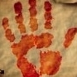
- Moderator

- 3,319 posts
- Gender:Female
- Location:On the shores of the Bay of Saint Francis
- Interests:Fighting with pointy objects (sword, knife, boarding axe, tomahawk - for over thirty years), firing cannons and other black powder implementia, sailing, playing the bodhran and ukulele, sailing, building things, sewing pirate garb, sailing, figuring out new recipes that use RUM, tasting said recipes...
Posted April 17, 2006 · Report post
Quote
4 - And of course...the don'ts
Plastic and resin cast skull candle holders, homemade rotting corpses lounging about as caricatures of doom, metal hope-chests and blanket trunks from WalMart, etc.
What??? No homemade rotting corpses???
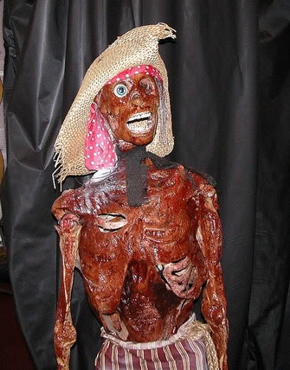
I'm kidding - Twice-Baked Thomas here is strictly for entertainment venues. I'd never think of bringing him to a reinactment.

Hawkyns
- Curmudgeon With A Cannon
- 
- 
- Moderator

- 1,330 posts
- Gender:Male
- Location:New Haven Colony
- Interests:cannon, swords, cannon, wenches, cannon, muskets, cannon, pistols, cannon, re-enacting, cannon, rum, cannon, living history......... Did I mention cannon?
Posted April 17, 2006 · Report post
Goinf to handle these one at a time, since it may take a bit to work through.
Tents. well, if we are going to be correct, i don't think we should have tents at all, at least not in the sense most of think of them. I can think of no cargo bill of lading that lists tents, other than military trnasports. I would say that the most correct thing we can do is a piece of canvas (old sailcloth) over a line between two trees or over a line betwenn two poles. Pretty much what patrick is doing.
That said, it is difficult to do that, especially if you are overburdened with modesty, or have people shairng your tent who are. I am not overburdened and have no problem living under a piece of canvas where everyone can see what I'm doing, whether it be reading, sleeping, or changing. On the other hand, when camping with Gwen or Scarlett, they prefer not to have the world looking at them while engaging in a number of activities. So a tent becomes somewhat of a neccesity, even though anachronistic. I use a number of different styles, depending on the number of people, lenght of stay, and amount of kit that i need to deal with.
Wall tents are a period design, dating back to the Romans, so I have 2 in different sizes. I have a wedge tent also that is quite small (5x7) and can accomodate me if the weather ill be particularly foul, or can be used as a supply tent. I also have a 9x14 marquee that I use when putting on the dog or doing the regimental commander bit.
Hawkyns

Fox
- Old Twillian
- 
- Moderator

- 2,564 posts
- Gender:Male
- Location:Beautiful lush Devon, England
- Interests:Nautical history of the 16-18th centuries and living history based thereon.
Shooting pirates.
Posted April 17, 2006 · Report post
1 - Tents
Wedge tents are certainly period, but as Hawkyns says their use by pirates or other seamen would be a bit suspect. However, if you need a tent then better one which is period than one which is not. Here, for example, are some plain wedge tents from 1695 (with the poles on the inside):

This picture of George Lowther is probably a bit fanciful, but it dates from 1734 and shows a kind of shelter which looks like it's rigged up from branches and a sail (or other large lump of canvas)

Dampier mentions that when he was in Campeche his equipment included a "pavilion", which I suspect was probably a simple bell-tent, so that would be another good alternative.
2 - Cookware
As you say, a huge topic. Since any camp will be on land it is probably not essential to look for specifically nautical cooking gear - and indeed that which I have seen recovered from shipwrecks tends to be the same kind of thing as the stuff found on land anyway. One important thing to bear in mind though is that a bunch of pirate camping on land probably took only the minimum - unlike, say, the army, a pirate camp was going to be temporary, so logic suggests that less is best. Go with whatever amount you need and no more.
3 - Camp gear
I find that sea-chests are the ideal camp furniture: they look nautical; they can be sat on; I would take my chest to an event anyway, so I just don't need to take a chair; and most importantly you can store stuf in them - whether it's delicate living history gear you don't want left out all the time or your modern stuff you don't want on show. My advice based on experience though, is bear in mind that the public will open your chest if they get the chance so either lock it or be careful what you put in it. The Lowther picture above gives some idea of pirate camp gear, but I also love this picture of a camp in Flanders in 1707 (yes, I know, boots! They are cavalrymen.)

4 - And of course...the don'ts
Oh there are just too many - I'm not gonna tell anyone what they can't have in their camp. Just exercise some common sense.

Patrick Hand
- The sailor's sailor
- 
- Moderator

- 6,100 posts
- Gender:Male
- Location:TH' Mountains of Central California
- Interests:I like wierdness... Klingon, Pyrate..... and even..... gasp.... Renn Faires...... (Baseball and tractor pulls I'd have to think about.... could be wierd or Not,,,,)
Posted April 17, 2006 · Report post
“What would a group of Pyrates use if they were in the process of careening their vessel.”
Might be a good way to go about figuring what would be period and acceptable for a period pyrate camp.
There is going to be some “slippage” in what is used… tents being a good example, for all the reasons that Hawkys posted…. Also.... for PiP, there arn't any trees inside the fort to rig a shade or tent on..... Some things will be “close enough”, but the glaringly wrong, should be avoided…..

Dorian Lasseter
- Where's My Water
- Member

- 3,266 posts
- Gender:Male
- Location:The Sea!
- Interests:18th Century reenactment; Maritime, F&I...
Did ECW as well...
All BP firelocks and cannons!
Also enjoy Swordfighting and a good Donnybrook
Got a question for or about me? Ask!!!
Posted April 17, 2006 · Report post
Aye, I knew them's that know more than I would put in there tupence...
I learned a little here... I had been told by those who I thought knew, that the wedges with the poles inside were circa 1730-40 ish... I thank ye fer setting that straight... Any idea when the change was made? When did the upright poles gain the right to be inside the canvas?
I also agree that sailors had very little use for tents, and an old sail was the most comon for a bivouac ashore...
Would it be proper for the sweeps from one of the ships boats to be used as pole structures for makeshift tents?

Capt. Bo of the WTF co.
- Scourge o' the 7 Seas
- 
- 
- Member

- 2,339 posts
- Gender:Male
- Location:Spanish Louisiana - on the river Osage
- Interests:Many and varied.
Posted April 17, 2006 · Report post
On the subject of canvas buckets, I keep two around any time alot of camps are close in on each other for firefighting , and over the years I have aquired two very nice old brass buckets that are also kept full for the same purpose. Most events require at least two gallons minimum if you have a fire in camp.
Capt. Bo

William Brand
- Mercury Malefactor
- Admin

- 8,884 posts
- Gender:Male
- Location:Logan, Utah
- Interests:My name is William Pace and I live and work as a graphic designer, illustrator and photographer in Northern Utah. I'm married to the lovely Tracy Pace and we have three children. In addition to all things art, I enjoy traveling and meeting new people from every walk of life. I've always been a fan of history, theology, and of course, Pyracy.
http://www.youtube.com/watch?v=PSkt-q-HihQ
Posted April 18, 2006 · Report post
Thank you. There are some good comments from everyone. The pole in and pole out issue was not one I had considered.
Let's discuss lighting next. Horn paned lanterns? Pierced tin lanterns? Pitch torches are out of the question from a safety point of view, but I would love to have a night battle on the fort. Complete with a wooden pitchfork waving mob.

Capt. Bo of the WTF co.
- Scourge o' the 7 Seas
- Member

- 2,339 posts
- Gender:Male
- Location:Spanish Louisiana - on the river Osage
- Interests:Many and varied.
Posted April 18, 2006 · Report post
I don't know how period correct the glass panes are for sure, but they will definately put out more light for what you want. I use a variety of different glass paned lanterns with my colonial camp kits, and favor those with metal frames over those with wooden frames. Had a candle fall over against the side of a lantern and caught the woodedn upright on fire. Fortunately I was just outside of the tent and had no damage other than foul smelling smoke all over everything. My two cents.
Capt. Bo

Captain Jim
- Captain Jim for Captain!
- 
- Member

- 2,254 posts
- Gender:Male
- Location:Off the coast of Tampa Bay (Unfortunately, inland from the coast)
- Interests:I'm 57, formerly a wildlife ecologist and biologist, now a stay-at-home dad. I grew up on the west coast of Florida, where Anna Maria Sound and Tampa Bay were my playground. My interests include, but are not limited to cannon, black powder arms, history, fishing the flats, sailing, fine wood working, flint gun building, hunting, good gun dogs. Above all, my wife and children.
Posted April 18, 2006 · Report post
William Red Wake said:
...but I would love to have a night battle on the fort. Complete with a wooden pitchfork waving mob.
Firing BP pistols at night would definately get the locals attention. Cannons too!

Captain_MacNamara
- Plunderer
- 
- 
- Member

- 467 posts
- Gender:Male
- Location:The Seas of Ansteorra
- Interests:Piracy, the Sea, Sailing Vessels, Period Gunnery, and Rum...
Posted April 18, 2006 · Report post
I've always wanted to do a nighttime firing... but ther're not allowed at any event I've been to.

Hawkyns
- Curmudgeon With A Cannon
- Moderator

- 1,330 posts
- Gender:Male
- Location:New Haven Colony
- Interests:cannon, swords, cannon, wenches, cannon, muskets, cannon, pistols, cannon, re-enacting, cannon, rum, cannon, living history......... Did I mention cannon?
Posted April 19, 2006 · Report post
I use both glass and horn paned lanterns. Glass gives more light, but horn is more correct and gives a nicer light. I've even converted a couple of glass lanterns to horn, to make things look better.
Night firings are fun. I've done them at Fort Niagara and Fort Mifflin. Even more fun when you wad with 4 ought steel wool to make tracer rounds. Both of those places have water for a down range, so it makes the safety issues much simpler.
Night battles can be fun, but you need a lot of safety people. I've had a lot of fun doing them for different periods but I've also seen some awful accidents, like when the SS officer came around the corner unexpectedly and caught the Browning Hi-Power on the cheek, just as the Brit fired. Nearly lost his eye on that one.
Hawkyns

Capt. Bo of the WTF co.
- Scourge o' the 7 Seas
- Member

- 2,339 posts
- Gender:Male
- Location:Spanish Louisiana - on the river Osage
- Interests:Many and varied.
Posted April 19, 2006 · Report post
The few battle re-enactments that I attend all follow the same basic "rules"-
Everyone who plans to be on the field attends a safety meeting before each days battle, and must sign a "muster sheet" that proves they attended. This is where the rules are laid down for participants.
No ramrods or lead allowed on the battlefield, knives tied in to their sheaths to prevent them falling out/someone falling on or stepping on the exposed blade. Powder cannot be loaded directly from the horn/flask. Only measures or paper cartridges to be used.
All participants report to the safety officer on the field to have their weapons examined prior to the battle. This is to ensure compliance with the rules and to inspect for loaded weapons so that no accidental,(or intentional), shootings occur.
Capt. Bo

Gentleman of Fortune
- Dread Pyrate
- 
- Member

- 1,456 posts
- Gender:Male
- Location:Germany... Franconia (northern Bavaria)
- Interests:I *used* to be an environmental scientist, until I married a DoDDs teacher in 1997. Since then, I have been living in, and traveling around, Europe (First the UK, now Germany).
My hobbies are all the "usual suspects" for those interested in re-enacting and Golden Age of Piracy stuff.... but I have drifted away from the pirate scene as my location and young family don't allow for any more than "virtual" pirate participation. Besides Piracy, I am into Reverend Guitars and Vintage Corvettes.
Posted April 20, 2006 · Report post
Lots of interesting things to digest.
One is that barrels of the GAoP period are wooden bound, not iron bound.
What a bitch.
GoF

Capt. Bo of the WTF co.
- Scourge o' the 7 Seas
- Member

- 2,339 posts
- Gender:Male
- Location:Spanish Louisiana - on the river Osage
- Interests:Many and varied.
Posted April 20, 2006 · Report post
I forgot to mention hand to hand combat must be approved prior to the beginning of the battle. This normally involves native americans and colonials in wrestling and some use of "faux" war-clubs and rubber knives, but could be applied to swordplay as well.
Capt. Bo

Hawkyns
- Curmudgeon With A Cannon
- Moderator

- 1,330 posts
- Gender:Male
- Location:New Haven Colony
- Interests:cannon, swords, cannon, wenches, cannon, muskets, cannon, pistols, cannon, re-enacting, cannon, rum, cannon, living history......... Did I mention cannon?
Posted April 20, 2006 · Report post
That's one of the reasons I prefer 17th C battles. We load from the bandolier, so we don't have to roll cartridges. We can also get into combat with musket butts, blunt swords, and wood pike and halberd heads.
We still check pouches, ring barrels, and don't use scouring sticks, but at least we are allowed to close, something that the 18th and 19th century folk seem to be very scared about.
I've also defended a cannon with the gun tools, rather than having to give up when the opfor gets with 25 feet.
Hawkyns

Fox
- Old Twillian
- Moderator

- 2,564 posts
- Gender:Male
- Location:Beautiful lush Devon, England
- Interests:Nautical history of the 16-18th centuries and living history based thereon.
Shooting pirates.
Posted April 20, 2006 · Report post
There was some debate about the use of wooden weapons over here a few years ago (ok, maybe ten). Lots of people felt that wooden heads were safer, but amongst those of us actually using short polearms (halberds and partizans) the consensus was in favour of blunt metal, for the following reasons:
Although wooden heads are lighter and thus theoretically easier to control, anyone with a modicum of training is capable of controlling a metal headed weapon perfectly well.
Most importantly, if an injury did occur (god forbid) the wound left by a metal weapon would be relatively clean, whereas a wooden weapon would be likely to break on impact and fill the wound with lovely splinters which are a nightmare for the paramedics to find and remove, and which will fester in the wound if left untreated.
Second most importantly, metal makes a much more satisfying noise when you get a hit on someone's breast-plate.
However, since the decisions lay with the Higher-Ups, most of whom had long since given up such vulgar things as fighting, wooden weapons continued to be the order of the day, though metal ones were tolerated. In fact this was the worst thing because it meant that there was more or less no regulation of polearms.
So, I just started concentrating more on 15thC where everyone was armed with either a metal headed polearm or a longbow. Two short stories which make me chuckle: my first 15thC training event the captain says to me "Always try to hit people on the armour. If they're not wearing armour then they should've bought some." On another occasion I was in full plate and marching towards a line of archer who were shooting straight. Now, the arrows they use have rubber blunt heads so they are safe, but a direct hit till hurts like hell, more so when they are shooting straight instead of up in an arc. I got all the way across this field with arrows bouncing off my armour, and I felt impregnable! About 20 yards from the archers I lifted by sword arm and instantly took an arrow straight in my arm-pit, the only part of my body apart from the soles of my feet that wasn't armoured! Bugger me that hurt for weeks...
I've used gun tools for defence too, funny how nobody want to take you on if you've got the wet-swab, dripping with black smelly water...
I must say that I've been disappointed too with the lack of contact in 18thC. Pirates seem to be the exception. I get frustrated when those damned infantry refuse to get the bayonets off their belts. Came up against some Norwegians a couple of years back who quite happily piled in with their sharp bayonets though - that was quite scary... I reached for the wet-swab.

Patrick Hand
- The sailor's sailor
- Moderator

- 6,100 posts
- Gender:Male
- Location:TH' Mountains of Central California
- Interests:I like wierdness... Klingon, Pyrate..... and even..... gasp.... Renn Faires...... (Baseball and tractor pulls I'd have to think about.... could be wierd or Not,,,,)
Posted April 20, 2006 · Report post
I was no longer doing American Civil War at the time, But I heard that they were going to get some rubber bayonets so they could do charges..
I had a cook come at me with a frying pan once. I told the damn fool to put that down and get over there with the other prisoners. Lets see... loaded .58 musket vs. A frying pan...
We charged artillery once.... one of the gunners grabbed his rammer, I fired high over his head (for safety) and the jerk didn't take the hit. I shoulda just aimed right at the ... (I wouldn't do that. Too dangerous. But awh... heck....)
We did tangle with our sister unit, the 14th Indiana, dang that was a good brawl. but the 'higher upsnn' wouldnn't let us do it again. They thought someone might get hurt... we practiced it before the battle, both units got along really well, and it looked great...
Unfortunately, I've also been in some really 'Hokey ' battles...

William Brand
- Mercury Malefactor
- Admin

- 8,884 posts
- Gender:Male
- Location:Logan, Utah
- Interests:My name is William Pace and I live and work as a graphic designer, illustrator and photographer in Northern Utah. I'm married to the lovely Tracy Pace and we have three children. In addition to all things art, I enjoy traveling and meeting new people from every walk of life. I've always been a fan of history, theology, and of course, Pyracy.
http://www.youtube.com/watch?v=PSkt-q-HihQ
Posted April 21, 2006 · Report post
I wasn't expecting Shea's live steel at PIP.
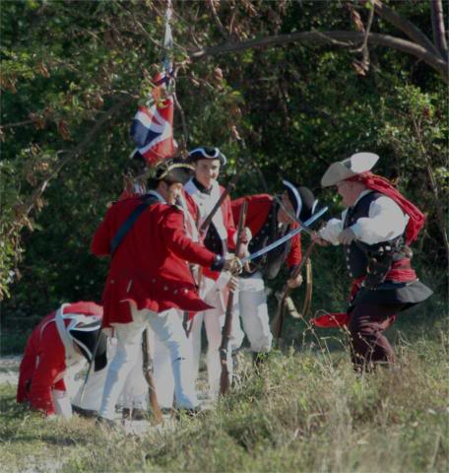

blackjohn
- Iron Age Hero Lost at Sea
- 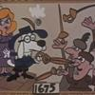
- Member

- 3,745 posts
- Gender:Male
- Location:Columbia, Md
- Interests:Stuff... and junk.
Posted April 21, 2006 · Report post
Gentleman of Fortune said:
Lots of interesting things to digest.
One is that barrels of the GAoP period are wooden bound, not iron bound.
What a bitch.
GoF
Not true. Just so happens I've been doing teeny bits of research on this lately. In those pics we see withy bound barrels, but we know from previous discussions iron banded barrels existed a few hundred years prior to our period. And just the other day I found this:
Quote
Eighty-five barrels were recovered, made mostly of white oak staves, though some were of beech and willow. Split willow and chestnut branches formed the hoops of all but the largest casks, which had iron hoops.
Fwiw, I think even I could take a firkin and place withies over the iron bands.

Gentleman of Fortune
- Dread Pyrate
- Member

- 1,456 posts
- Gender:Male
- Location:Germany... Franconia (northern Bavaria)
- Interests:I *used* to be an environmental scientist, until I married a DoDDs teacher in 1997. Since then, I have been living in, and traveling around, Europe (First the UK, now Germany).
My hobbies are all the "usual suspects" for those interested in re-enacting and Golden Age of Piracy stuff.... but I have drifted away from the pirate scene as my location and young family don't allow for any more than "virtual" pirate participation. Besides Piracy, I am into Reverend Guitars and Vintage Corvettes.
Posted April 21, 2006 · Report post
ok.... let me be a little more specific.
Its kind of relative or maybe even a semantics issue...
By that I mean:
Quote
Eighty-five barrels were recovered, made mostly of white oak staves, though some were of beech and willow. Split willow and chestnut branches formed the hoops of all but the largest casks, which had iron hoops.
The word barrel itself, was a measurement unit which was equal to 31.5 gallons and was half of a hogshead (63 gal).
The size of the hogshead is about the size of a 55 gallon drum to give folks perspective. I am guessing that its the barrel pictured by Lothar (earlier in the post) and a hogshead in the other camp posting.
If your quote is using barrel in the "measurement" sense... then indeed as far as we know all Barrels were wooden bound during (and around) the GAoP.
Quote
Split willow and chestnut branches formed the hoops of all but the largest casks, which had iron hoops
The "largest casks" are indeed huge, and probably not found or made by a cooper on a ship ...
Chaldrons, Weys and Lasts (288, 320, and 640 gallons respectively) are the largest of the standard containers. I can see that a "last" would be e so big that wooden hoops are impractical due to the size of the wooden hoop needed to contain the contents. Iron probably wasn't cost efficient to produce for smaller containers.
Of course, depending on the contents (beer, wine, or dry goods) some containers were varying in sizes... check out the cool chart here:
http://www.footrule.com/1/conversn/oldengu...r=homepage&ac=0
So, its my bet that ANY "wooden staved container" that we would be using for GAoP re-enactment purposes should have wooden hoops.
Unless...
Pete uncovers period pictures of iron bound 70 gallon and below containers (pre-1730s).
GoF

blackjohn
- Iron Age Hero Lost at Sea
- Member

- 3,745 posts
- Gender:Male
- Location:Columbia, Md
- Interests:Stuff... and junk.
Posted April 21, 2006 · Report post
Gentleman of Fortune said:
Unless...
Pete uncovers period drawingspictures of iron bound 70 gallon and below containers (pre-1730s).
I'll take archaeology over period drawings any day of the week! The diagram shows them as being about 1m tall. Thus... probably in the 55 gallon range.

Fairfax
- Bilge Rat
- 
- 
- Member

- 5 posts
Posted April 28, 2006 · Report post
Greg -
You've moved, I think, beyond semantics into pedantics. Most people - PhD-level archaeologists included - wouldn't make the distinction as to the size of the cask. The terms "cask" and "barrel" are, to them, fundamentally interchangeable (just like "keg" and "cask").
Second, I found the following support for iron-bound casks, some of which make no real reference to size:
Quote
9. One Tun of Iron Bound Cask for Water, and a Bundle of Wooden Hoops, is allowed for every hundred Men per Month, in Home Voyages; but in Foreign Voyages, such farther Quantity as shall be thought necessary.
10. In Home Voyages, half the Proportion of Beer is to be contained in Iron-bound Cask, but in Foreign Voyages three-fourths; and every Cask is to have the Contents marked on the Head in Gallons, Winchester Measure. (1)
Emphasis mine.
If "cask" were a measure (not to say you're claiming that; it is to illustrate the level of pedantry we can sink to), or if every cask aboard ship were of similar size, there would be no need to mark the head of the cask.
In 1699, Parliament issued victualling instructions for the Lord High Admiral as follows:
Quote
Jovis, 12 die Januarii; 10 Gulielmi Tertii.
II. To receive into their Charge, and Possession, all such Provision of Victuals, Cask, Iron Hoops, Biscuit-Bags, and other Materials and Utensils for Victualling, as are remaining at any of the Victualling Ports, or in any Victualling Ships, or otherwise, for the Use of the Navy; the same having been first duly surveyed, and appraised; which they are to make use of in the Service of the Victualling, and to charge themselves therewith upon their Accounts.
VII. They are also to allow each Ship they shall be ordered to victual for the Sea, Four Hogsheads, with Eight Iron Hoops on each; the said Hoops to be hammered Hoops, of good Substance, and well wrought; or milled Hoops, where they shall think them sufficient for his Majesty's Service, for Water-Cask; with One Bundle of wooden Hoops, and another of Flags; for every One hundred Men, a Month; and so proportionably for a greater or lesser Number of Men; and such further Quantity of Water-Cask for foreign Voyages, as the Ships can conveniently stow, or shall be thought necessary.
IX. They are also to cause to be delivered, in Iron-bound Cask, hooped with Iron Hoops of good Substance, hammered, and well-wrought Iron, as aforesaid, One complete Moiety of the Proportion of Beer, ordered to each Ship designed for the Chanel, or any other Voyage than for Guinea, or the East or West-Indies; and for any Ship designed for Guinea, or the East or West-Indies, Threefourths of their Proportion of Beer is to be put in Ironbound Cask, hooped with Iron Hoops of good Substance, and well-wrought Iron, as above.(2)
Again, emphasis mine.
Note that exact measure is unmentioned in the case of beer, and specified in the case of water. This is puzzling, and no substantiated reason for this exists. One might make the argument that beer, being much more important to the physical and mental health of the crew than water, was in such a constant state of flux that specification of amount was considered unneccesary by the authorities, but no supporting documentation for this can be found.
To branch out into pure conjecture, the etymology of the term "scuttlebutt" gives support(!) to the standard cask size being the butt, not the barrel or tun.
At the end of the day, it is unwise to take one extreme or the other. There is support for both forms of cask-binding, depending on the intended purpose of the cask.
From a practical, reenacting standpoint, we must refuse to let the best be the enemy of the good. I'd much rather have an iron-bound firkin in camp - even though there should be a wythe-bound hogshead - because it's better than an Igloo cooler. :)
Also, until you stand next to one, you don't really know how big the larger casks are. The biggest cask anyone not employed in the beverage alcohol industry has ever seen is the half-bbl (US measure) keg. A full bbl is twice the size of that, and is in reality even larger, because it's made of oak staves and not welded stainless steel sheets. I don't know about you, but I ain't gonna try and 1.) find a blinkin' hogshead; or 2.) try to fit it in my vehicle to take it to an event.
(1) William Mountaine: The Seaman's Vade-Mecum, and Defensive War by Sea: containing the Proportions of Rigging, Masts and Yards Weight of Anchors, Sizes and Weight of Cables and Cordage, List of the Navy. The Exercise of the Small Arms, Bayonet, Granadoes and Great-Guns, Duty of Officers, &c. also Shewing how to prepare a Merchant-Ship for a close Fight. W. and J. Mount & T. and T. Page, London, 1756
http://www.bruzelius.info/Nautica/Provisio...(1756)_p71.html
(2) House of Commons Journal Volume 12 - 12 January 1699
http://www.british-history.ac.uk/report.as...sp?compid=39699

William Brand
- Mercury Malefactor
- Admin

- 8,884 posts
- Gender:Male
- Location:Logan, Utah
- Interests:My name is William Pace and I live and work as a graphic designer, illustrator and photographer in Northern Utah. I'm married to the lovely Tracy Pace and we have three children. In addition to all things art, I enjoy traveling and meeting new people from every walk of life. I've always been a fan of history, theology, and of course, Pyracy.
http://www.youtube.com/watch?v=PSkt-q-HihQ
Posted May 7, 2006 · Report post
Well...that topic took an unexpected turn from a period camp to containers and measurements. I do appreciate the additional reference materials provided in the debate. There was some very interesting stuff.
It's too bad that cost and convenience are often a factor in camps and reenactments, because the possibilities of a good camp are endless.

Gentleman of Fortune
- Dread Pyrate
- Member

- 1,456 posts
- Gender:Male
- Location:Germany... Franconia (northern Bavaria)
- Interests:I *used* to be an environmental scientist, until I married a DoDDs teacher in 1997. Since then, I have been living in, and traveling around, Europe (First the UK, now Germany).
My hobbies are all the "usual suspects" for those interested in re-enacting and Golden Age of Piracy stuff.... but I have drifted away from the pirate scene as my location and young family don't allow for any more than "virtual" pirate participation. Besides Piracy, I am into Reverend Guitars and Vintage Corvettes.
Posted May 8, 2006 · Report post
BoB?
Well... hmmmm
****EDIT**************************************************
This looks like it might be or become a pissing contest... I really don't want it to be and there is no offense meant
**********************************************************
I will agree that the term "Cask" could mean any size container. I personally do not have enough information to say that a cooper living in the 17th/18th century would use "Barrel" interchangeably with "cask" or when describing "any" size container.
Since these words meant specific things, It would make sense to use "Cask" in the generic term, but to using any other term to mean "any container" would probably be just as misleading then as it is to us now
While it is convenient for us to use the term "barrel" to mean anything from 55 gal to a 2 gal container in 2006, I think it would be a stretch to say that a GAoP era cooper did as well.
My guess is, that's because they were infinitely more familiar with different size storage containers for both dry and wet goods, they would be "specific" with the words that they used.
If someone said, "go to the market and get a barrel (36 gallons) of oats", and didn't mean a "barrel" they could end up with any number of meausres that would result in various quantities of oats. Did they really mean, "go get a strike (16 gallons), or a bag (24 gallons), or a tun (256 gallons) of oats?
Your first set of quotes is a little out of bounds (1756) for a good GAoP reference, by about 25 years. While it is interesting, we should probably limit ourselves to refrences for the time frame that we are trying to portray.
For me personally, its 1690-1720, but if you are doing 1756 pirate, its more relevant so charge right on ahead.
Quote 9 It does say a "tun", and we have already established that it was a more common practice during the GAoP to have the largest casks iron bound.
Quote 10 As you say, it is a little ambiguous. Since they are talking about beer, it could be a number of sizes, but probably a hogshead or even a tun. Many pubs in England are named "The three Tuns, or "The eight tuns" in refrence to the Beer storage container.
It says too that only "3/4ths" of the beer should be bound with iron.
So the other portion of beer is bound with wood? Again, no particular size is mentioned. If it is the larger sizes, this may make sense, but we cannot know for sure, and, as it is a 1756 reference, I don't think its worth splitting hairs.
The second set of quotes is "in" bounds. And it's an interesting find too!
So thanks for posting.
There are some interesting considerations though. The first is this seems to be only for provisioning Royal Navy ships, as its an instruction from Parliament to the Admiralty. Also, its interesting that it is only for certain types of voyages, specifically outlined in the order.
Quote
VII. They are also to allow each Ship they shall be ordered to victual for the Sea, Four Hogsheads, with Eight Iron Hoops on each; the said Hoops to be hammered Hoops, of good Substance, and well wrought; or milled Hoops, where they shall think them sufficient for his Majesty's Service, for Water-Cask[/b]; with One Bundle of wooden Hoops, and another of Flags; for every One hundred Men, a Month; and so proportionally for a greater or lesser Number of Men; and such further Quantity of Water-Cask for foreign Voyages, as the Ships can conveniently stow, or shall be thought necessary.
The emphasis is of course mine. It seems that in this instance, the iron bound casks are used solely for the water storage, and, it specifically calls for a hogshead (63 gallons). The same order also calls for a bundle of wooden hoops, which we know is a common way of binding cask staves.
Quote
IX. They are also to cause to be delivered, in Iron-bound Cask, hooped with Iron Hoops of good Substance, hammered, and well-wrought Iron, as aforesaid, One complete Moiety of the Proportion of Beer, ordered to each Ship designed for the Chanel, or any other Voyage than for Guinea, or the East or West-Indies; and for any Ship designed for Guinea, or the East or West-Indies, Three fourths of their Proportion of Beer is to be put in Ironbound Cask, hooped with Iron Hoops of good Substance, and well-wrought Iron, as above.(2)
This is interesting too. For Royal Navy Channel voyages, or any "shorter" voyage, a moiety (half) of the beer can be in iron bound casks. For longer voyages, 3/4ths will be in iron bound hoops.
Speculation comes into play here too. It seems that the iron bound casks are used for longer term storage. This may also mean that the casks themselves would be of the larger variety as it doesn't make as much sense to use smaller containers for long storage than it would to have larger one, but I can't confirm that. As said above, we know that large casks could be iron bound, but it's a shame that no size is specified.
I have a feeling though that since the second quote (IX) is coming right after the first one (VII) and concludes with the words " as above ", I think that it would be safe to assume that that they would be referring to a hogshead.
And despite the etymology of the term "scuttlebutt", it doesn't seem to be mentioned at all, (though Cask and Hogshead are). I guess scuttle-hogshead was too much of a mouth full for a GAoP sailor.
Quote
At the end of the day, it is unwise to take one extreme or the other. There is support for both forms of cask-binding, depending on the intended purpose of the cask.
and
Quote
From a practical, reenacting standpoint, we must refuse to let the best be the enemy of the good.
Wait a minute... this is coming from the "Object Acquisition Triangle" guy????...
Heresy!
Well I don't know. I refuse to let "good enough win. I prefer better as way point to best. You can re-enact your way, and I can re-enact mine right?
Lets face it, there are plenty of areas where we have to make exceptions due to lack of good reproductions.
Some of these things are necessary though. Like stockings. Most of us wear the cotton or wool knitted ones that, frankly, are not right.
But to me, that is much different that having a wrong item that you really don't "have" to have anyway. I mean, is a cask that necessary?
Even if it is a correct one, I can just imagine the throngs of pirates with tankards dangling from their belts sauntering up to ye old hogshead to slake their piratey thirst....
Now to the champion of good enough, this would be ok. And you know what? Pirate is a big enough re-enacting tent for everyone and if, In your camp, you want an iron bounded firkin, you can go for it! I'd even come over and drink any beer that came out of it.
But to me, its a modern cask or at best an un-authenticated style that is not a:
Quote
Hogsheads, with Eight Iron Hoops on each; the said Hoops to be hammered Hoops, of good Substance, and well wrought; or milled Hoops, where they shall think them sufficient for his Majesty's Service
I just wouldn't use it at all. I would rather "not use" an unnecessary item than to use a wrong item that wasn't necessary. But again, you re-enact your way, and I will do it mine.
To recap the cask debate, what we have established is that:
1) The largest of casks were or could be iron bound
2) That on certain RN voyages, 4 Hogsheads, iron bound, of water could be found
3) On specific Royal Navy voyages, 1/2 of the beer (shorter range?), and on other voyages (longer ranged?), 3/4ths of the beer should come in casks (more than likely Hogsheads) bound in iron hoops.
4) The physical evidence that we have is period pictures (see Lowthar and "camp in Flanders in 1707" and casks recovered from period wrecks. That evidence seems to point to wooden hoops being the norm and iron for larger casks in certain situations
So we can't say that iron hoops didn't exist for GAoP, what we can say though is that the evidence points to their use in certain situations and then on the larger (hogshead or greater) casks.
So, if you have enough information to comfortably put a iron hooped firkin (9 gallons) in your camp, then dude, go ahead.
For me though, I would get some willow or chestnut hoops and replace the iron ones, or, not use any at all and put the igloo cooler with the red bull in the car.
GoF

MadMike
- First Mate
- 
- 
- Member

- 251 posts
- Location:Careened near the Gulf of Mexico
- Interests:1712 raid on Dauphin Island, Alabama.
Posted May 14, 2006 · Report post
Anyone have a copy of the OED handy to look up terms?
Speaking of provisions (and experimental archaeology), anyone ever try eating one pound of biscuit (hardtack) a day? The daily gallon of beer a day, did that many times while in service...
Yours, Mike

Gentleman of Fortune
- Dread Pyrate
- Member

- 1,456 posts
- Gender:Male
- Location:Germany... Franconia (northern Bavaria)
- Interests:I *used* to be an environmental scientist, until I married a DoDDs teacher in 1997. Since then, I have been living in, and traveling around, Europe (First the UK, now Germany).
My hobbies are all the "usual suspects" for those interested in re-enacting and Golden Age of Piracy stuff.... but I have drifted away from the pirate scene as my location and young family don't allow for any more than "virtual" pirate participation. Besides Piracy, I am into Reverend Guitars and Vintage Corvettes.
Posted July 13, 2006 · Report post
Bump
greg

Captain Bob
- Ship's Master
- 
- Member

- 108 posts
- Location:Sacred Tomato, CA
- Interests:Science, technology, history, military history, etc.
Posted July 13, 2006 · Report post
Has anyone got pictures of barrels with wooden hoops? Preferably with close-ups showing how they were secured to the barrel?
~~Cap'n Bob (Or Captain Redd Roberts. Depends on who's askin'.)

Captain Tightpants
- Deck Hand
- 
- Member

- 50 posts
- Location:Easton, PA, USA
Posted July 13, 2006 · Report post
Sorry about the switch in usernames; I had no idea that a few weeks of inactivity would make my old username go away. I'm back now.
And no offense is taken at all! Rigourous debate is, after all, at the heart of any good scholarship. So long as we omit referring to each other as "great big poopiehead," I think we'll be all right.
"GoF" said:
I will agree that the term "Cask" could mean any size container. I personally do not have enough information to say that a cooper living in the 17th/18th century would use "Barrel" interchangeably with "cask" or when describing "any" size container.
You missed the salient point, sir. Modern academics will use the terms "barrel" and "cask" interchangeably, not a 1680s cooper. The same terms for liquid measure have been in use since at least the 1560s, when England was inundated with hopped beer by the Dutch (i.e., firkin, kilderkin, pin).
As for the dates on my quotes, they were the first references I could find quickly. I knew they were out-of-date, but, lacking any other handy reference, I extrapolated therefrom.
Taking Articles VII and IX in context together trumps your analysis that only water was stored in iron-bound casks. Note the use of the word "aforesaid". You did point that out a few sentences later, but I wanted to rub your face in it.
That certain types of voyages specified a certain type of cask is not surprising. The beers stored therein were still actively fermenting at racking (putting the fluid into the cask). As you know, fermenting booze produces prodigious amounts of carbon dioxide, which can put a great deal of pressure on the cask's structure. Since introducing air into the cask will spoil the beer lickety-split, you keep it sealed, which means more and more carbon dioxide is being produced, which means more pressure on the cask the longer you travel - never mind the rocking motion of the vessel keeping the yeast in suspension longer, making it work more, making even more carbon dioxide! (Whew!)
Which is, I think, where we're suffering from this disconnect. You come from the nautical side of research, where I come from brewing. Your information, while valid, can be dashed to pieces on the rocky shore of practical brewing knowledge and detailed research into historical brewing.
Not to put too fine a point on it, but only an idiot apprentice would put fresh beer in a wood-bound cask. The bleedin' thing would burst the first week out from Southampton, because the wood simply cannot handle the pressure. That's science, me-ladd-o.
I think the spare wood for hoops is there to maintain the casks, after the beer has been drained and replaced with pressure-less water. I could dig up a reference from somewhere in my expansive historical brewing library, but I'm at work, so THPPT!
Quote
Wait a minute... this is coming from the "Object Acquisition Triangle" guy????...
Well, yeah. There is no easy and inexpensive source of wood-bound casks. Fact. I can support from many different sources the use of iron-bound casks for storage and dispense of beer, maybe not at sea, but definitely on land (and when we're reenacting, we're almost always on land, not at sea). Also fact. I'm not going to schlep a hogshead to events, because it is not only freakin' huge, it's freakin' expensive. Also fact. I'm not going to schlep the extremely long distance from my camp to my vehicle every time I want to top off my tankard, whether with water or beer. Also fact.
If that makes me a farb, so be it. I think it makes me smarter than the average bear. You think it an unnecessary item; I think such an opinion can only be based on opium dreams, given the heat present at most if not all of our events. You have to drink water! Therefore, a place to hold that water within easy reach is necessary, necessary as hell. And since the public will always be ducking into our tents, there's no easy way to hide the Igloo cooler, either.
If I knew how to replace the iron hoops on a firkin (most people hereabouts use pins, by the by), I'd do it. I don't know how - best I could do is cover them up. Based on my research, I'd still use an iron-bound cask for barley-pop.
That's what I meant by not letting the best be the enemy of the good. I'd rather have a well-stocked larder near at hand.
This next bit is going to sting a little. Brace yourself.
I mean, seriously. If you want to take your stance to a ludicrous extreme, put away all of your firelocks and weaponry. After all, they use modern metallurgical techniques to make the pieces, right? And the alloys are different. They're not perfect, so keep 'em in the car. But me, I don't know the difference. Plus, neither you nor I would put out the kind of cash necessary to purchasing a "perfect" piece like that.
See how stupid that kind of thinking can get? Think about that before you get up on your high horse and talk about "you reenact your way and I'll do mine." If you're going to care enough about one thing, care about everything - and then do it, brook no excuses. Then and only then are you far enough away from your glass house to throw stones.
Sorry that got vituperative, but I wanted to be clear. I hold you in high regard, dude, and don't want to see you going down that road. Call it "tough love". And I never once called you a poopiehead.

Gentleman of Fortune
- Dread Pyrate
- Member

- 1,456 posts
- Gender:Male
- Location:Germany... Franconia (northern Bavaria)
- Interests:I *used* to be an environmental scientist, until I married a DoDDs teacher in 1997. Since then, I have been living in, and traveling around, Europe (First the UK, now Germany).
My hobbies are all the "usual suspects" for those interested in re-enacting and Golden Age of Piracy stuff.... but I have drifted away from the pirate scene as my location and young family don't allow for any more than "virtual" pirate participation. Besides Piracy, I am into Reverend Guitars and Vintage Corvettes.
Posted July 13, 2006 · Report post
Are you going to stick to one forum name from now on or what?
Now just relax a bit, take a good sip o' home brew and don't get your dander up.
The bottom line for me is that, as said in an earlier post, you can make the argument that a percentage of beer and water was put into the largest of cask, iron bound, for certain long range voyages, but not all of it.
If your beer making book collection covers all of 17th/18th century storage containers, than I would certainly enjoy seeing period refrences to iron bound smaller casks.
Quote
Not to put too fine a point on it, but only an idiot apprentice would put fresh beer in a wood-bound cask. The bleedin' thing would burst the first week out from Southampton, because the wood simply cannot handle the pressure. That's science, me-ladd-o.
Thats funny, using your own refrences, not ALL of the beer was ordered in iron bound casks... And its only for the LONG voyages that 1/2 -3/4 of the beer is even ordered in iron bound casks.
The must have had a slew of idiot apprentices putting beer into something, as I would imagine that they counted on the 1/4-1/2 of the beer in wooden casks to last longer than a week....no?
I read what you have written, but I don't think my earlier recap has changed.
Quote
1) The largest of casks were or could be iron bound
2) That on certain RN voyages, 4 Hogsheads, iron bound, of water could be found
3) On specific Royal Navy voyages, 1/2 of the beer (shorter range?), and on other voyages (longer ranged?), 3/4ths of the beer should come in casks (more than likely Hogsheads) bound in iron hoops.
4) The physical evidence that we have is period pictures (see Lowthar and "camp in Flanders in 1707" and casks recovered from period wrecks. That evidence seems to point to wooden hoops being the norm
But anyway, its a moot point. A hogshead is a hell of a lot of beer (as you said), and no one wants to lug one around... which just leaves us with the smaller, easier to manage casks in the pin to kilderkin range.
I have not found any refrence to these sizes being bound with iron. The refrences that I have found all point to just the largest of casks in iron. But if you have them, please share.
So, unless I have a misunderstanding with what authenticity is, an iron bound firkin aint' authentic for GAoP.
We already have to "accept" that some things used in our modern interpretation of GAoP sailors are not correct because there are no reasonable facsimiles.
We already have to make exceptions for a lot of things .... stockings pop into mind, and buckles too.
So what I think I hear you saying is "small casks that are bound with iron aren't authentic for GAoP, but at this point, there is no work around" ?
I can deal with that, but at the same time, I am trying to figure out how to replace the iron bands on my freakin firkin.
Quote
I mean, seriously. If you want to take your stance to a ludicrous extreme, put away all of your firelocks and weaponry. After all, they use modern metallurgical techniques to make the pieces, right? And the alloys are different. They're not perfect, so keep 'em in the car. But me, I don't know the difference. Plus, neither you nor I would put out the kind of cash necessary to purchasing a "perfect" piece like that.
ahhh now why did you have to go and say that?
You know better than that.... Right? If we follow that logic, than we might as well buy a Simplicity pattern and make no attempt at authenticity at all.
That is the same argument that the fantasy crowd uses.... The "your DNA ain't 18th century, so why bother with any authenticity as you can never be "right" anyway".
Use what you want.... I don't care. We all have things that are near and dear, whether its patterns, shoes, or Beer Casks.
Hell, paint an igloo cooler brown and put banding iron around it if It tickles your fancy....
I can only be responsible for me and my kit, and lend advise when asked. To me, authenticity is not a buffet table where I take what I like and leave the rest. If I have something that I can't prove or know is wrong, it gnaws at me until I get it fixed. Sometimes I just avoid sticky wickets altogether so as I don't get stuck.
If an onion bottle or bellermarine jug are authentic and will hold water/beer/wine that is where I will go.
Greg

blackjohn
- Iron Age Hero Lost at Sea
- Member

- 3,745 posts
- Gender:Male
- Location:Columbia, Md
- Interests:Stuff... and junk.
Posted July 14, 2006 · Report post
Gentleman of Fortune said:
I can only be responsible for me and my kit, and lend advise when asked. To me, authenticity is not a buffet table where I take what I like and leave the rest. If I have something that I can't prove or know is wrong, it gnaws at me until I get it fixed. Sometimes I just avoid sticky wickets altogether so as I don't get stuck.
I like that quote. I'm not sure how I feel about it in relationship to my view of the hobby, I'll have to chew on it a bit first, but I do like it.
I do think it's relative to the original theme of this post. IF a GAP encampment is a buffet table, what is there to choose from? And what should we be leaving behind?
I think I'd go with impromptu tentage... things that look like they are jury-rigged sails. I'd take every one of those stinkin' folding camp stools and throw them in a fire. And... hmmm... I guess it depends. Are we reenacting a careening? Or are we reenacting buccaneers ashore, preparing to attack a town?

Patrick Hand
- The sailor's sailor
- Moderator

- 6,100 posts
- Gender:Male
- Location:TH' Mountains of Central California
- Interests:I like wierdness... Klingon, Pyrate..... and even..... gasp.... Renn Faires...... (Baseball and tractor pulls I'd have to think about.... could be wierd or Not,,,,)
Posted July 16, 2006 · Report post
This gets into an interesting arguement on authentisity vs. austetics (and I know I didn't spell that right..... so what looks "right")
OK... I will argue Rendezvous for this one.....
At a Rendezvous,(in Primitive camp)there are many good looking tents and teepees.... tables and chairs, barrels and chest... looks great.... but it would take a wagon to carry all that stuff..... Historicaly, everything (well most everything) is autentic.... but it would not have been carried by a "working" Mountain Man.... he has more important stuff to load his pack horses with.....
But at most Rendezvouse, a buncha guys sleeping under a lean-to made from an old blanket..... just not that Kodac moment.......
So we cheat ......
The same for a Pyrate encampment..... the extra barrels, and chairs are nice.... it's not 100% period..... but it looks "right"......
At a Hard-core Historical Pyrate reenactment, well most of the stuff would get left a home...... but for most of what we do, all the extras just add to the overall impression........ (oh yah.... and the foam pad to sleep on... not period.... but comfortable..... )

LongTom
- Pyrate Captain
- 
- Member

- 629 posts
- Location:San Francisco or thereabouts
- Interests:"If I was a blackbird, could whistle and sing..." (Hm. I guess I must be a blackbird.)<br>Makin' hats, really big ones.<br>WizKids Pirates series games.
Posted July 16, 2006 · Report post
A potential dumb question: Why would a ship bother with tents, when it is full of spare canvas and people who are veritable genii with rigging things with it, along with rope and lumber? I would think a sail and some spars rigged in a picturesque manner would say "pirate" more than a wedge tent would, any day.
The extra barrels might well be ashore for re-watering. (how did they refill in the field, anyway?) Whatever other stuff might come off the ship when expecting an extended stay? Chairs, who knows? Hammocks?
just speculating...

Cire
- Ship's Master
- 
- Member

- 113 posts
Posted July 16, 2006 · Report post
Patrick Hand said:
This gets into an interesting arguement on authentisity vs. austetics (and I know I didn't spell that right..... so what looks "right")
You mean aesthetics? Yeah, can be a pain to spell.

Rabbitz
- Deck Swabber
- 
- Member

- 21 posts
- Location:Port Jackson, Australia
- Interests:Deck Crew on 19th Century Iron Barque (James Craig)
Posted July 16, 2006 · Report post
LongTom said:
A potential dumb question: Why would a ship bother with tents, when it is full of spare canvas and people who are veritable genii with rigging things with it, along with rope and lumber? I would think a sail and some spars rigged in a picturesque manner would say "pirate" more than a wedge tent would, any day.
I am not so sure that tents wouldn't be used, for exactly the same reasons (strangely enough). Given that quantities of sailcloth and duck cloth would be available it would take a boatswain/sailmaker no time to run up some servicable ridge tents for extended stays.
The cloth used for the tents wouldn't be first quality, I am sure that old sail suites would be turned to exactly this purpose.
Rabz
Topman
Barque James Craig

LongTom
- Pyrate Captain
- Member

- 629 posts
- Location:San Francisco or thereabouts
- Interests:"If I was a blackbird, could whistle and sing..." (Hm. I guess I must be a blackbird.)<br>Makin' hats, really big ones.<br>WizKids Pirates series games.
Posted July 22, 2006 · Report post
Rabbitz said:
LongTom said:
A potential dumb question: Why would a ship bother with tents, when it is full of spare canvas and people who are veritable genii with rigging things with it, along with rope and lumber? I would think a sail and some spars rigged in a picturesque manner would say "pirate" more than a wedge tent would, any day.
I am not so sure that tents wouldn't be used, for exactly the same reasons (strangely enough). Given that quantities of sailcloth and duck cloth would be available it would take a boatswain/sailmaker no time to run up some servicable ridge tents for extended stays.
The cloth used for the tents wouldn't be first quality, I am sure that old sail suites would be turned to exactly this purpose.
This is plausible.
My thought was that the creation of a dedicated tent would require at least part of the cloth goods to be cut up and tailored, at which point they would be less serviceable as sail materials. Not necessarily something one would want to risk while far away from home. To leave the sail intact, and accomplish the tent via some creative rigging would be more economical (cloth ain't cheap) as well as better conservation of your repair stores.
Regarding the time factor, the rigging of awnings and other shelter from large pieces of cloth is probably an order of magnitude faster than sewing up real tents, even with an experienced sailmaker. They are stitching by hand, after all, and you are talking about tens of feet of seam per tent. The crew could string up ten crude but perfectly serviceable shelters in the time it would take to sew one tent.
I'm thinking of this from the perspective of an ultralight backpacker, having seen some of the perfectly marvelous shelter configurations you can get out of a tarp with some creative folding and guying; no cutting or sewing necessary. I'm not saying that these would be the actual rigging techniques used (some of them look distinctly outlandish and modern). More a matter of speculating on what would be important to the sailor of the period.
That, and working up a justification for a shelter with the ends of spars and sweeps sticking out all over the place, for visual effect.

Captain Jim
- Captain Jim for Captain!
- Member

- 2,254 posts
- Gender:Male
- Location:Off the coast of Tampa Bay (Unfortunately, inland from the coast)
- Interests:I'm 57, formerly a wildlife ecologist and biologist, now a stay-at-home dad. I grew up on the west coast of Florida, where Anna Maria Sound and Tampa Bay were my playground. My interests include, but are not limited to cannon, black powder arms, history, fishing the flats, sailing, fine wood working, flint gun building, hunting, good gun dogs. Above all, my wife and children.
Posted September 21, 2006 · Report post
Okay, just re-read the thread and pirates ashore with sail shelters seems perfectly normal for the short term. But if I am to be ashore for long, I want something to keep the wind off at night. Ships carried lots of spare canvas, and a successful pirate ship would carry even more, the canvas of several ships, having pillaged it along the way.
So let's set up a scenario: It is late hurricane season, don't want to go north now so the crew votes to pull into a small but snug harbor to winter. So now it's mid-December and a succession of cold fronts have moved through and we, the crew, have had enough. We all want to head north in the spring, so going south is out. Besides, thar be wenches here. (Sorry, pyrate speak foul) We all want tents, privacy and to keep our bums warm. So we set the sailmaker to making us tents. Especially me. I'm the captain, after all.
In case you're wondering, I'm setting up an argument for having a tent at PiP this year.
So the question is this; Is this tent and fly plausible for a sailmaker-built period shelter?
Storage tent and fly.
Also, I intend to go back next year as a vendor and this tent could serve double duty as living quarters and "booth", saving me from having to spend money twice.
So, what's the verdict?

William Brand
- Mercury Malefactor
- Admin

- 8,884 posts
- Gender:Male
- Location:Logan, Utah
- Interests:My name is William Pace and I live and work as a graphic designer, illustrator and photographer in Northern Utah. I'm married to the lovely Tracy Pace and we have three children. In addition to all things art, I enjoy traveling and meeting new people from every walk of life. I've always been a fan of history, theology, and of course, Pyracy.
http://www.youtube.com/watch?v=PSkt-q-HihQ
Posted September 21, 2006 · Report post
A good rule of thumb is simple and functional, especially in the face of little evidence and in lue of the ongoing speculations.
This tent is simple so it works on many levels. Straight pieces. No unnecessary flash. And given your future plans to travel to events as a vendor, it is also pragmatic.

If you can add to it some hemp ropes and hand forged stakes, not to mention some stains and a little wear over time, then I think this would be a good tent.

Captain Tightpants
- Deck Hand
- Member

- 50 posts
- Location:Easton, PA, USA
Posted September 24, 2006 · Report post
"GoF" said:
"I" said:
I mean, seriously. If you want to take your stance to a ludicrous extreme, put away all of your firelocks and weaponry. After all, they use modern metallurgical techniques to make the pieces, right? And the alloys are different. They're not perfect, so keep 'em in the car. But me, I don't know the difference. Plus, neither you nor I would put out the kind of cash necessary to purchasing a "perfect" piece like that.
ahhh now why did you have to go and say that?
You know better than that.... Right? If we follow that logic, than we might as well buy a Simplicity pattern and make no attempt at authenticity at all.
That is the same argument that the fantasy crowd uses.... The "your DNA ain't 18th century, so why bother with any authenticity as you can never be "right" anyway".
That it is the same agument fails to lessen its truth or its impact. It is a matter of expertise on the part of the beholder and, for lack of a better term, scale on the part of the error.
I see beer in a glass that is clear, not cloudy, and I see inauthenticity, but very very few other people see any fault with that. Kass can spot a waistcoat with machine-sewn seams at ten paces, but very very few people have a problem with that, much less the expertise to spot it.
I call your stance on this argument "letting the best be the enemy of the good." You won't have a "close to authentic but not quite there" object in your camp, so you make sacrifices like not having a convenient water source in your camp. But you go further than that:
Quote
Hell, paint an igloo cooler brown and put banding iron around it if It tickles your fancy....
That's letting the best be the enemy of the good. No one ever suggested such an action. Yet you clearly see no problem in painting the same person who would use an iron-bound wood cask with the same brush as someone with a painted Igloo cooler!
I can understand your desire for perfection; I share it. It's just that our perception of "acceptable" differ. Moreover, I'm not willing to make the sort of sacrifices you are in your quest towards perfection. Even something as simple as walking to a storage or parking area for stuff instead of having it near to hand is a sacrifice I'm unwilling to make if there's an inconspicuous alternative.
It's akin to my absence at events which threaten foul weather - this is my hobby. I'm not going to freeze or get drenched or suck up mud on my weekend off; I spent enough time wearing camouflage face-paint getting paid to suck up mud and rain to want to do it, years later, on my unpaid time off. I also have Dr Scholl's foot-comfort products in my machine-made Fugawee straight-last shoes. Makes 'em much more comfy and fairly weather-resistant.
If my not-obvious use of modern amenities makes me less of a living historian, I'll bear that cross.
I'm not saying, "If they'd've had 'em, they'd've used 'em." Any fool can plainly see that.
Quote
I can only be responsible for me and my kit, and lend advise when asked. To me, authenticity is not a buffet table where I take what I like and leave the rest. If I have something that I can't prove or know is wrong, it gnaws at me until I get it fixed. Sometimes I just avoid sticky wickets altogether so as I don't get stuck.
And that's your choice, just like it's mine to turn a blind eye to things that are pretty damned close, but not quite there, if those items are used in an inconspicuous or invisible way. To clarify that statement: Dr Scoll's insoles = invisible. Why? Because noone can see inside my shoes, less'n I take 'em off (look out, nose!). Iron-bound casks = inconspicuous. Why? Because most professional historians wouldn't notice, much less the public we attempt to edu-tain.
Quote
If an onion bottle or bellermarine jug are authentic and will hold water/beer/wine that is where I will go.
I need to get some appropriate bottles myself. I've got some pewterware, but insufficient to hold enough liquid for satisfaction.
Speaking of appropriate stuff, can someone point me to some pics of seachests? I know they existed, but I haven't a clue what they looked like. (And I'm having no luck with Google. ) I intend to use some sawn-in-half, tired old barrels for seating/storage, and a coupla seachests would also be ideal.

Patrick Hand
- The sailor's sailor
- Moderator

- 6,100 posts
- Gender:Male
- Location:TH' Mountains of Central California
- Interests:I like wierdness... Klingon, Pyrate..... and even..... gasp.... Renn Faires...... (Baseball and tractor pulls I'd have to think about.... could be wierd or Not,,,,)
Posted September 26, 2006 · Report post
This isn't a good picture of my new sail / tarp..... Space was limited at Ojai, so I had rig it kinda funny......
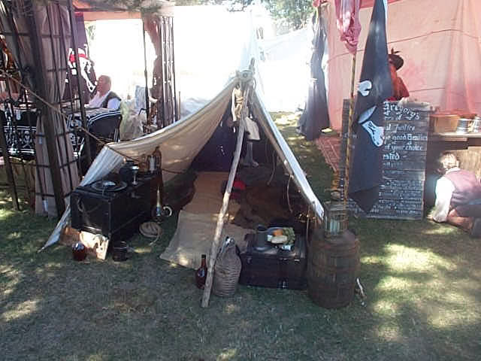
But it is all hand sewn...... (hey how's that for crazy..... )

Gentleman of Fortune
- Dread Pyrate
- Member

- 1,456 posts
- Gender:Male
- Location:Germany... Franconia (northern Bavaria)
- Interests:I *used* to be an environmental scientist, until I married a DoDDs teacher in 1997. Since then, I have been living in, and traveling around, Europe (First the UK, now Germany).
My hobbies are all the "usual suspects" for those interested in re-enacting and Golden Age of Piracy stuff.... but I have drifted away from the pirate scene as my location and young family don't allow for any more than "virtual" pirate participation. Besides Piracy, I am into Reverend Guitars and Vintage Corvettes.
Posted September 27, 2006 · Report post
Hey tightpants, maybe I am missing something here...
Going back to the original discussion, which I believe started with a discussion about encampment water containers.
The point I was trying to make was this
Wooden containers for liquids, in a size manageable by a re-enactor, was bound by wood during the GAoP.
Yes hogsheads and tuns could be bound in iron, but smaller containers were wood bound during the gaop. And the two photos that Foxe posted in this thread backs that up.
That is all I said, and that is all I meant to say.
Now, if we have proof that "smaller" containers (that is anything under a hogshead, about 60 gallons), I will retract my statement and jump on the iron bound bandwagon.
And as we have said earlier, some things you just have to work around. Period stockings comes to my mind.
But, just because your average viewer doesn't know the difference or can't tell the difference doesn't make it correct... which I am sure you are not saying.
Which is why, at the end of the day, the things that I can take care of I will try my best to do so. I won't force my agenda on anyone esle, but I will provide comment when asked, or participate in open discussion opportunities like this.
Greg---
we will have to continue this, in person, at TORM.

blackjohn
- Iron Age Hero Lost at Sea
- Member

- 3,745 posts
- Gender:Male
- Location:Columbia, Md
- Interests:Stuff... and junk.
Posted September 28, 2006 · Report post
Captain Tightpants said:
Speaking of appropriate stuff, can someone point me to some pics of seachests? I know they existed, but I haven't a clue what they looked like.
Hey there Tighty, I believe you and I are cut from very similar cloth... I'm banging me mug on the table in agreement... ouch... should've used me other mug!
As for seachest, this could very well be in here at the bottom of this pic. Foxe, please correct me if I'm wrong, but I do believe I've seen some evidence pointing to slope-sided sea chests.
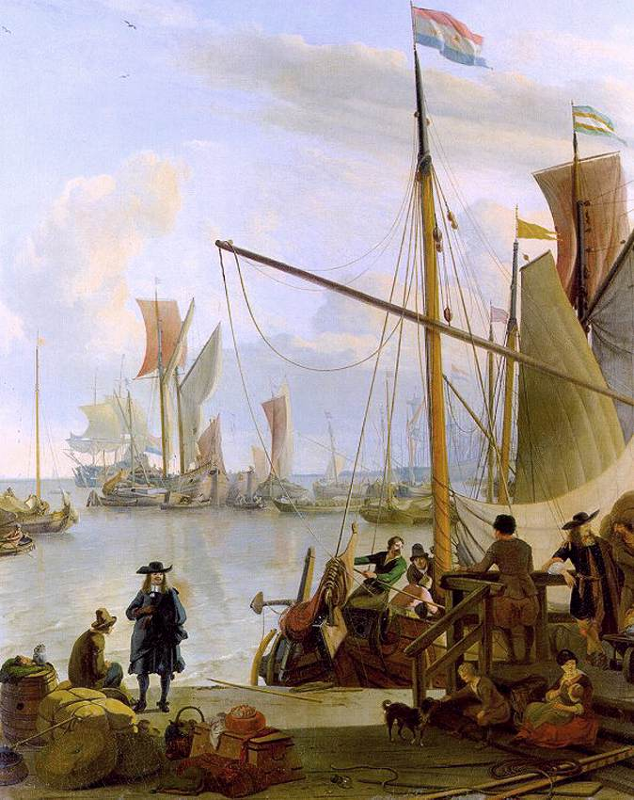
I remember discussing chests once, but I don't remember if that was here, or on the Pirate Brethren forum...

Scrounger
- Ship's Master
- Member

- 107 posts
- Location:Gillingham,Kent,England
- Interests:Pyracy,Scrounging,Thieving,Groging,Looting, Ect,Ect
Posted September 28, 2006 · Report post
Ahoy Pat Fantastic Rig!!! Ye Given Me A Idea CHEERS

William Brand
- Mercury Malefactor
- Admin

- 8,884 posts
- Gender:Male
- Location:Logan, Utah
- Interests:My name is William Pace and I live and work as a graphic designer, illustrator and photographer in Northern Utah. I'm married to the lovely Tracy Pace and we have three children. In addition to all things art, I enjoy traveling and meeting new people from every walk of life. I've always been a fan of history, theology, and of course, Pyracy.
http://www.youtube.com/watch?v=PSkt-q-HihQ
Posted January 29, 2007 · Report post
I good point was brought up another thread about the good of the ship being offloaded before the ship could be hauled over on its side. This would allow us an explanation for all of the extra barrels and bales lying about in camp. Perhaps even unassembled cannon are in order.

Captain Jim
- Captain Jim for Captain!
- Member

- 2,254 posts
- Gender:Male
- Location:Off the coast of Tampa Bay (Unfortunately, inland from the coast)
- Interests:I'm 57, formerly a wildlife ecologist and biologist, now a stay-at-home dad. I grew up on the west coast of Florida, where Anna Maria Sound and Tampa Bay were my playground. My interests include, but are not limited to cannon, black powder arms, history, fishing the flats, sailing, fine wood working, flint gun building, hunting, good gun dogs. Above all, my wife and children.
Posted January 29, 2007 · Report post
Actually, assembled cannon ashore would have been likely, as a ship aground is helpless. Defensive strategy would have been high on the priority list in selecting a place to careen. Cannon ashore would have been able to outshoot cannon on a ship coming into the shore, keeping them back until the ship could be re-floated. Then you attack with your freshly careened ship which is now fast and nimble.
Cannon located on a rise or cliff would have been devastating, to the point of sinking or disabling any ship foolish enough to try and take a careened ship.

William Brand
- Mercury Malefactor
- Admin

- 8,884 posts
- Gender:Male
- Location:Logan, Utah
- Interests:My name is William Pace and I live and work as a graphic designer, illustrator and photographer in Northern Utah. I'm married to the lovely Tracy Pace and we have three children. In addition to all things art, I enjoy traveling and meeting new people from every walk of life. I've always been a fan of history, theology, and of course, Pyracy.
http://www.youtube.com/watch?v=PSkt-q-HihQ
Posted January 29, 2007 · Report post
The big question is, can we make a truly authentic looking cannon? Of course, much of it might be faked, but if the cannon is going to look fake, I'd almost rather not do one. I'm confident I could make one, but I'm far away and I'm flying.
The ever present problems are the logistics of transportation and cost.

Patrick Hand
- The sailor's sailor
- Moderator

- 6,100 posts
- Gender:Male
- Location:TH' Mountains of Central California
- Interests:I like wierdness... Klingon, Pyrate..... and even..... gasp.... Renn Faires...... (Baseball and tractor pulls I'd have to think about.... could be wierd or Not,,,,)
Posted January 29, 2007 · Report post
Or the cannons are set-up at the same place where we are careening the ship..... (outside the fort....)
Sorry.... I could have moved part of this to the PiP thread.....
To kinda put this back on topic.....
I figure that other than Buccaneers who camped much of the time, the only times Pyrates would have camped would be when they were Careening thier ship.... (part of the reason we are portraying that for our encampment at PiP)
Anyone interested in a period 1720's pyrate camp, can check out the threads in the Pirates in Paridice ... the Careening Camp threads..... Some of the information could be posted in Capt. Twill, but some of it is specfic to the camp at PiP.....and some of it will only "look" right... we have some problems with transporting a lot of gear to PiP... so quite frankly... were going to have to "fake" some of it... for the time being..........

capnwilliam
- Lost at Sea
- 
- Member

- 1,287 posts
- Gender:Male
Posted February 4, 2007 · Report post
William Red Wake said:
4 - And of course...the don'ts
Plastic and resin cast skull candle holders, homemade rotting corpses lounging about as caricatures of doom, metal hope-chests and blanket trunks from WalMart, etc.
The biggest "don't: should be: don't use Edward England's or Jack Rackham's flags, unless you're reenacting specifically THEM.
Capt. William

capnwilliam
- Lost at Sea
- Member

- 1,287 posts
- Gender:Male
Posted February 4, 2007 · Report post
Foxe said:
I find that sea-chests are the ideal camp furniture: they look nautical; they can be sat on; I would take my chest to an event anyway, so I just don't need to take a chair; and most importantly you can store stuf in them - whether it's delicate living history gear you don't want left out all the time or your modern stuff you don't want on show. My advice based on experience though, is bear in mind that the public will open your chest if they get the chance so either lock it or be careful what you put in it.
Kegs come in handy for the same purposes, also.
Capt. William

CaptainSatan
- Notorious Pyrate
- 
- 
- Member

- 791 posts
Posted February 27, 2007 · Report post
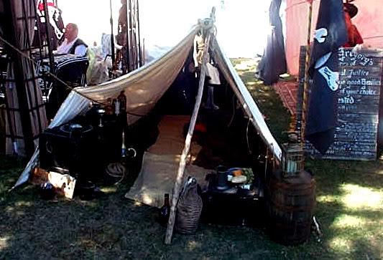
Good looking camp Mister Hand!
What are the DIMs on yer fine sail/tarp?
What's it made of?
And....how much does it weigh?
-CS

Patrick Hand
- The sailor's sailor
- Moderator

- 6,100 posts
- Gender:Male
- Location:TH' Mountains of Central California
- Interests:I like wierdness... Klingon, Pyrate..... and even..... gasp.... Renn Faires...... (Baseball and tractor pulls I'd have to think about.... could be wierd or Not,,,,)
Posted March 1, 2007 · Report post
That's not the best set-up for the sail/tarp,... but there wasn't much space for me to set-up at Ojai, So I had to squeeze it in......It does show the sheer poles and ridge pole...but they are off to the side at a wierd angle, so I could get in and out of the sail/tarp, And there is a rope that I tied to a tree, to hold the one side out farther..... it's a good thing that the sail/tarp is so adaptable.....The picture below shows it set-up as a lean-to at PiP
It was made from about 10 oz. cotton canvas, that I got 7 yards for $5.00 a yard from a lady that makes bags....linen would have been nice, but it would have cost three times as much... The fabric was 60" wide before I pre-shrunk it, to make it water-restant. I don't bother witerproofing tents/tarps, figuring that it adds too much weight, and that is what my waterproof ground cloth is for. I tore the fabric into 2' wide strips and then hand sewed the whole thing togehter....all the main seams were flatfelled, and all others are turned... I also handsewed on the foot,luff,head and leech ropes....... I don't know for sure if they would have used reef points on a sail that small, but I added them anyway..... all the grommets and the eyelets for the reefpoints are rope, and handsewn also,....
the finished dementions are..... foot 7' ...luff 7'... head 8' ...leech 12'.
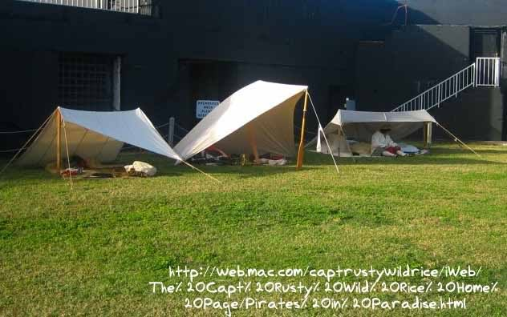

michaelsbagley
- Smells Like Wet Sheep
- 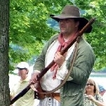
- Moderator

- 2,548 posts
- Gender:Male
- Location:Columbus, Ohio
- Interests:Mostly into GAoP, but starting to develop more Buccaneer era stuff for re-enacting as well. Generally I do re-enact both piratical/nautical and other impressions from the period. I am focusing on more "common" impressions from the period (i.e. average sailor/pirate, rank and file Red Coat, early Colonial huntsman, etc.)
Posted May 3, 2007 · Report post
In case anyone is still interested in this thread... I found this link History of Tents
Most of the focus of the linked web site is for early period stuff, but there is a decent amount of information on 17th century tents on this particular page of the web site. Mostly military purpose, so period correct, but possibly not correct for a naval or piratical context.

Fox
- Old Twillian
- Moderator

- 2,564 posts
- Gender:Male
- Location:Beautiful lush Devon, England
- Interests:Nautical history of the 16-18th centuries and living history based thereon.
Shooting pirates.
Posted May 3, 2007 · Report post
capnwilliam said:
The biggest "don't: should be: don't use Edward England's or Jack Rackham's flags, unless you're reenacting specifically THEM.
Erm... England's flag was used by plenty of other pirates, and "Rackham's flag" is a modern invention so shouldn't be used by anyone...

Matusalem
- Notorious Pyrate
- 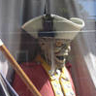
- Member

- 877 posts
- Location:Eastern Seaboard of North America
Posted May 3, 2007 · Report post
Quote
QUOTE (capnwilliam @ Feb 3 2007, 11:09 PM)
The biggest "don't: should be: don't use Edward England's or Jack Rackham's flags, unless you're reenacting specifically THEM.
....So much for Disney's use of Rackham's flag. I think each respective group shoud establish their own flag.

Carlislekid
- Deck Swabber
- Member

- 24 posts
- Location:High Point, N.C
- Interests:F & I War, Reenacting, AMR, Pirates, cannons, forts, ships, 18th century life and recreation of it
Posted June 16, 2007 · Report post
How much camp crap would a ship carry?
Canvas buckets are taboo. Leather fire buckets were found on board. Fire was #1 Threat to ships. Your choice burn down the ship and drown or put the fire out.
Furniture: Where was it stowed? Real good replacement is to cut pieces of styrofoam sheets and stack together to make a block, big enough to sit on, wrap it in painted canvas, mark it as "furs", "silk" or other booty, tie it up with rope, Viola, an authentic looking, lightweight bundle of loot ya can park yer arse on!
Fire irons: who carried them?
Cookware:What do we have aboard we can take ashore?
Plates: Wooden boWls were found aboard. ! was evovered from the wreck of the HMS Pandora.
Bags? Sailors used Ditty boxes and sea chest up until the AMCW When bags were issued by the Navy.
Barrels, ropes, boat hooks, canvas pieces, aLl make a camp look good.
Think of yopur car as your ship, how much crapola can you carry?
Flags: use yer own or just plain black or red!

Carlislekid
- Deck Swabber
- Member

- 24 posts
- Location:High Point, N.C
- Interests:F & I War, Reenacting, AMR, Pirates, cannons, forts, ships, 18th century life and recreation of it
Posted June 20, 2007 · Report post
Because of many upcoming festivals, and Pirates in Paradise later in the year, I have been getting a fair number of questions about period camps that I would like second opinions and advice about.
1 - Tents
I assume that the common variety wedge is a passable tent, but I would like to know for certain if a wedge is appropriate and what tents may be better suited to the period. The wedge tent (bell back for xtra space is the most common tent. It will raise the least ire amongst hysterical reenactors. Captain Cook had pavillion tents he set up as observatories (1773)Wall tents are very period, but not often used by 18th century reenactors in military type camps.
2 - Cookware
Cast iron? forged cookware? Copper? Cooking tripods? There are numerous questions to the overall area of cookware, so I will leave this topic open-ended for whatever advice may come our way. Cast Iron by far was the most Common and is the easiest to cookwith. Beware the copPer stuff, it wilL make you very very very sick if you use it with acidic foods (Experience here)3 - Camp gear
Sea chests, chairs, kegs, etc. What are the simple and most plausible additions to improve the lived-in look of any good camp. Are canvas buckets period? What furniture if any might by found in a camp?Canvas buckets are taboo. Good leather fire buckets are period and nautical. Sea Chests, kegs, etc. The Question going aRound Authentic camps is "how did you carry all that crap around? Military infantry groups are banning most chairs, lantern holders, lanterns, boxes, chests, etc. How were they carried? Chais & tables could be "linerated" from surround inhabitants.
4 - And of course...the don'ts
Plastic and resin cast skull candle holders, homemade rotting corpses lounging about as caricatures of doom, metal hope-chests and blanket trunks from WalMart, etc.

CrazyCholeBlack
- Scourge o' the 7 Seas
- 
- Member

- 1,578 posts
- Gender:Female
- Location:Illinois
- Interests:Everything! Historic clothing, sewing, fabric dying, cooking, mead, ale, astronomy, celestial navigation, reading, music, film making, blogging & pillaging the internet for visual inspirations.
Posted June 20, 2007 · Report post
Carlislekid said:
Plastic and resin cast skull candle holders, homemade rotting corpses lounging about as caricatures of doom, metal hope-chests and blanket trunks from WalMart, etc.
I won't even touch that
Otherwise, where do you get such authoritative information? Sources? Painting references? First person accounts? Kindly share with the class.

Silkie McDonough
- Proprietress of the Sealkies Hide
- 
- Moderator

- 5,695 posts
- Gender:Female
- Location:I have been a Virginian for 2 months now. LOVING it.
- Interests:Music, vocalizing, Irish balads. I love to draw, I do pencile portraits/detail drawings for barter and sale. The link in in my signature. Ireland, its history and culture. Sewing garb, mostly for myself. The arm of a strong gentleman round my waist.
Unfortunately, I don't do nearly enough of any of a these.
Posted June 21, 2007 · Report post
When it comes to period reinacting we all come from Iowa ...the show me state. how me the proof!

Carlislekid
- Deck Swabber
- Member

- 24 posts
- Location:High Point, N.C
- Interests:F & I War, Reenacting, AMR, Pirates, cannons, forts, ships, 18th century life and recreation of it
Posted June 21, 2007 · Report post
First hand account's, military orderly books, paintings are ok, but the artist is usually painting from memory. Hogarth is an excellent source.
Missouri is the Show me state.

Carlislekid
- Deck Swabber
- Member

- 24 posts
- Location:High Point, N.C
- Interests:F & I War, Reenacting, AMR, Pirates, cannons, forts, ships, 18th century life and recreation of it
Posted June 21, 2007 · Report post
Try the resources of the BAR (Brigade of the American Revolution) or The NWTA, (Northwest Territorial Alliance)

MadMike
- First Mate
- Member

- 251 posts
- Location:Careened near the Gulf of Mexico
- Interests:1712 raid on Dauphin Island, Alabama.
Posted July 11, 2007 · Report post
Try "The Collector's Illustrated Encyclopedia of the American Revolution". Most of the artifacts are from the F&I and RevWar period, but some will work for GAOP. Other sources are items recovered from the Whydah, Henrietta Marie, etc.
As for fire irons or cast iron cookwear, never bothered with them (too heavy). I use Y-forked poles, steel ramrods, or just flat rocks arranged around the coals...
Yours, Mike

Capt. Sterling
- Sticky Fingers Sterling Needs a New Hat
- 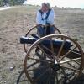
- Member

- 10,302 posts
- Gender:Pyrate Hunter
- Location:here
- Interests:Killing pirates, haven't met one yet worth keeping alive....
Posted July 11, 2007 · Report post
Isn't there a thread some where here, regarding the cook stoves on the ships? Wasn't large copper pots/cauldrons mentioned?

AnnaMarie
- Bilge Rat
- Member

- 17 posts
Posted August 17, 2007 · Report post
Captain Bob said:
Has anyone got pictures of barrels with wooden hoops? Preferably with close-ups showing how they were secured to the barrel?
~~Cap'n Bob (Or Captain Redd Roberts. Depends on who's askin'.)
Well i know tht this was like a year ago...but I never saw any pictures posted so i figure better late than never right?
Well here is one.
If you look at the first hoop from the bottom you can see whear the ends meet.
I took the time at one point to talk to a cooper as well about how these are made...my memory is not always 100% accurate but I think I am rembering this correct.
basically you take youg green branches or saplings that are thin and long enough to fit around whatever barrell you are making. You keep them wet and shave them in two.
You then wrap them around and twist them under and over in a flat knot almost . you then clamp the hoop on til the wood dries and shrinks around the barrell.
I hope that is right...it has been two years since I talked to the bloke.
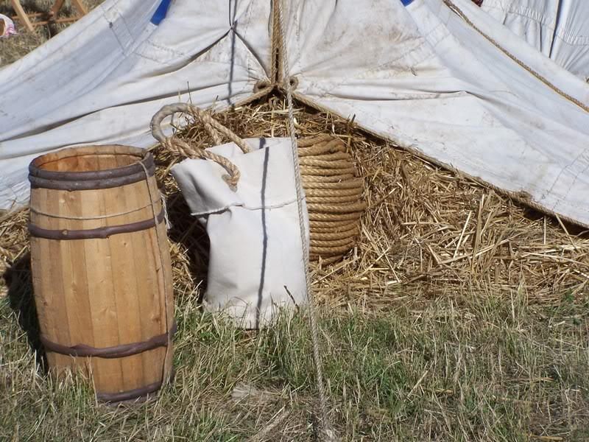

Patrick Hand
- The sailor's sailor
- Moderator

- 6,100 posts
- Gender:Male
- Location:TH' Mountains of Central California
- Interests:I like wierdness... Klingon, Pyrate..... and even..... gasp.... Renn Faires...... (Baseball and tractor pulls I'd have to think about.... could be wierd or Not,,,,)
Posted August 17, 2007 · Report post
This is from Eric Sloane's book "Diary of an Early American Boy Noal Blake 1805" ISBN 0-345-32100-6
It's out of period, but a lot ot the information is still of use to us.....
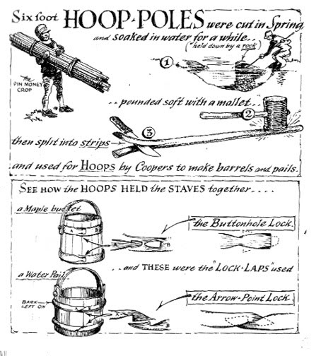

AnnaMarie
- Bilge Rat
- Member

- 17 posts
Posted August 17, 2007 · Report post
Yay! As i said my info was a vague recollection. Finding better info = much better. SO I guess that answers it! :)

Calico Jack
- Ship's Master
- 
- Member

- 126 posts
- Location:Port o' Halifax, New Scotland...
Posted August 18, 2007 · Report post
The question fo wooden or iron barrel hoops [which crops up now and again] might be answerable by someone who visits and asks in Missouri -
Quote
In Lebanon, tour the largest barrel factory in the world at Barrels of Fun. Independent Stave Company produces more than 50 percent of the barrels made worldwide. Tours highlight the care and skill involved in producing these barrels used to age fine bourbons and wines. Viewing windows and TV screens offer a “live eye” look at the production process. A cooperage museum spans 4,000 years of cooperage history.
[Emphasis mine.]

michaelsbagley
- Smells Like Wet Sheep
- Moderator

- 2,548 posts
- Gender:Male
- Location:Columbus, Ohio
- Interests:Mostly into GAoP, but starting to develop more Buccaneer era stuff for re-enacting as well. Generally I do re-enact both piratical/nautical and other impressions from the period. I am focusing on more "common" impressions from the period (i.e. average sailor/pirate, rank and file Red Coat, early Colonial huntsman, etc.)
Posted January 4, 2008 · Report post
I almost feel guilty about bringing this thread up again, especially the particular part of the thread that I am going to try to add to....
I stumbled across the below quote a few months ago, and promptly forgot about it until I had a conversation recently were iron bound casks/barrels (I use the terms interchangeably incorrect or not)...
Anyway, the quote is from "The London and Country Brewer" (2nd edition: dated to 1736). I know this is a bit after the GAoP, but the fact that it is a 2nd edition (how much earlier was the 1st edition?) and the tone of the quote leads one to believe the practice is not new, but standard at that time, could place the practice of using iron bound casks as fairly common in the late GAoP at least for brewing and storing wine, if not other things as well... (below bolded emphasis mine)
Quote
Some are of Opinion, that _October_ is the best of all other Months to brew any sort of Malt in, by reason there are so many cold Months directly follow, that will digest the Drink and make it much excel that Brewed in _March_ because such Beer will not want that Care and Watching, as that brewed in _March_ absolutely requires, by often taking out and putting in the Vent-peg on Change of Weather; and if it is always left out, then it deadens and palls the Drink; yet if due Care is not taken in this respect, a Thunder or Stormy Night may marr all, by making the Drink ferment and burst the Cask; for which Reason, as Iron Hoops are most in Fashion at this time, they are certainly the greatest Security to the safety of the Drink thus exposed; and next to them is the Chesnut Hoop; both which will endure a shorter or longer time as the Cellar is more or less dry, and the Management attending them. The Iron Hoop generally begins to rust first at the Edges, and therefore should be rubbed off when opportunity offers, and be both kept from wet as much as possible; for 'tis Rust that eats the Iron Hoop in two sometimes in ten or twelve Years, when the Ashen and Chesnut in dry Cellars have lasted three times as long.
There are other quotes within this writing that relate to casks and them having iron hoops, feel free to browse for yourselves...
Scan of Page 103
Scan of Page 104
Full text transcription of the book
Also, related to this thread... I hope this isn't a faux pas, but if you look at THIS THREAD FROM ANOTHER FORUM, there is an image of a huge canvas amorphous tent in a painting dated to 1713 (right smack dab in our period). If posting links to threads in other forums is a "no-no", please let me know so I can edit this out and not make the mistake again.
Hope this info comes as use or at least amusing to some....

Red Maria
- Dread Pyrate
- Member

- 1,057 posts
Posted January 4, 2008 · Report post
Hawkyns said:
. I also have a 9x14 marquee that I use when putting on the dog or doing the regimental commander bit.
Hawkyns
Putting on the dog Hawkins? Would that be your pup tent then? Our Barber-surgeon has a wedge tent with tongue and groove easy to assemble bed. She says it's quite comfy.

hurricane
- Pyrate Legend
- 
- Member

- 2,672 posts
- Gender:Male
- Location:Seattle, Washington
- Interests:Songs of a nautical nature, wine, rum, rum punch, Henry Morgan and Krimson Kat.
Posted January 4, 2008 · Report post
michaelsbagley said:
Also, related to this thread... I hope this isn't a faux pas, but if you look at THIS THREAD FROM ANOTHER FORUM, there is an image of a huge canvas amorphous tent in a painting dated to 1713 (right smack dab in our period).
Interesting. I just read in Benerson's new book about careening camps and how the crewe would erect a large tent to shelter the ship's stores while they were careened. The balance of the crewe then simply slept on the beach and/or hammocks, leaving their possessions under the large central tent.
Forgive me if it's a little off - I'm doing this from memory.
-- Hurricane

Dutchman
- Has anyone seen my cousin?
- Admin

- 1,773 posts
- Gender:Male
- Location:tidewater virginia
Posted January 25, 2008 · Report post
Sorry if this has already been posted somewhere, but i found this reference while digging around on the Jamestown research site. It's a bit early for us but is still of some documentation use.
"The First and Second Churches--Captain John Smith reported that the first church services were held outdoors "under an awning (which was an old saile)" fastened to three or four trees."

William Brand
- Mercury Malefactor
- Admin

- 8,884 posts
- Gender:Male
- Location:Logan, Utah
- Interests:My name is William Pace and I live and work as a graphic designer, illustrator and photographer in Northern Utah. I'm married to the lovely Tracy Pace and we have three children. In addition to all things art, I enjoy traveling and meeting new people from every walk of life. I've always been a fan of history, theology, and of course, Pyracy.
http://www.youtube.com/watch?v=PSkt-q-HihQ
Posted January 25, 2008 · Report post
michaelsbagley said:
Also, related to this thread... I hope this isn't a faux pas, but if you look at THIS THREAD FROM ANOTHER FORUM, there is an image of a huge canvas amorphous tent in a painting dated to 1713 (right smack dab in our period). If posting links to threads in other forums is a "no-no", please let me know so I can edit this out and not make the mistake again.
It isn't a no-no to reference any material, thread or website which may further the cause of knowledge and understanding. Love the painting.
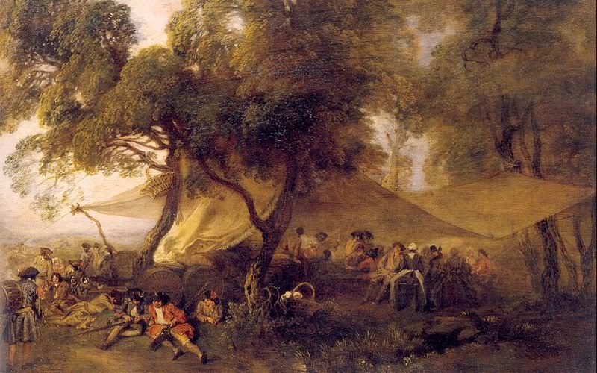

Silkie McDonough
- Proprietress of the Sealkies Hide
- Moderator

- 5,695 posts
- Gender:Female
- Location:I have been a Virginian for 2 months now. LOVING it.
- Interests:Music, vocalizing, Irish balads. I love to draw, I do pencile portraits/detail drawings for barter and sale. The link in in my signature. Ireland, its history and culture. Sewing garb, mostly for myself. The arm of a strong gentleman round my waist.
Unfortunately, I don't do nearly enough of any of a these.
Posted January 25, 2008 · Report post
^^^That is what I had in mind for the "ordinary" at PiP ^^^
Mary Diamond pointed that painting it out to me once before.

Gentleman of Fortune
- Dread Pyrate
- Member

- 1,456 posts
- Gender:Male
- Location:Germany... Franconia (northern Bavaria)
- Interests:I *used* to be an environmental scientist, until I married a DoDDs teacher in 1997. Since then, I have been living in, and traveling around, Europe (First the UK, now Germany).
My hobbies are all the "usual suspects" for those interested in re-enacting and Golden Age of Piracy stuff.... but I have drifted away from the pirate scene as my location and young family don't allow for any more than "virtual" pirate participation. Besides Piracy, I am into Reverend Guitars and Vintage Corvettes.
Posted January 26, 2008 · Report post
"The London and Country Brewer"
first edition was 1734, First reprint 1735, Second edition 1736.
GoF

blackjohn
- Iron Age Hero Lost at Sea
- Member

- 3,745 posts
- Gender:Male
- Location:Columbia, Md
- Interests:Stuff... and junk.
Posted January 26, 2008 · Report post
I bet he was taking kickbacks or owned stock in a metal hoop making business.
On the subject of tents... seems to me like there's no one true way. Hey, now that I think about it, I don't believe there's one true way for any of this stuff!

Red Cat Jenny
- Truly one of a Kind
- 
- Member

- 7,468 posts
- Gender:Female
- Location:New York but pining for the open sea
- Interests:Pirates, history, anthing nautical, salt water fish tanks, the Caribbean and South Pacific, a good barbecue and a cold Sam Adams, travel, airplanes, rockabilly, Grand Mariner on the rocks, fabulous sunsets accompanied by a warm breeze and good friends.
Diverse enough?
I's love to learn to sail and also surf. I grew up around the waters of LI. Cept for 2 yrs land lubbin in AZ. The pirate thing? When I was 6, I stole my brother's halloween tricorn pirate hat and proceeded to wear it for three months till it ripped and the string fell off. Needless to say the rest is history!
Posted January 26, 2008 · Report post
Wow I love that painting...I'm going to have to look for a print.

Gentleman of Fortune
- Dread Pyrate
- Member

- 1,456 posts
- Gender:Male
- Location:Germany... Franconia (northern Bavaria)
- Interests:I *used* to be an environmental scientist, until I married a DoDDs teacher in 1997. Since then, I have been living in, and traveling around, Europe (First the UK, now Germany).
My hobbies are all the "usual suspects" for those interested in re-enacting and Golden Age of Piracy stuff.... but I have drifted away from the pirate scene as my location and young family don't allow for any more than "virtual" pirate participation. Besides Piracy, I am into Reverend Guitars and Vintage Corvettes.
Posted January 26, 2008 · Report post
I am not trying to beat a dead horse... really.
But I have looked, searched and hoped to find evidence of metal bound casks in "normal" sized containers. That is, in a size that could be used in and around a camp and not meant to store 300+ gallons of liquid.
I haven't found anything. If anyone else has.... I would love to see it.
Until then, here are a few wooden bound examples that I have found.
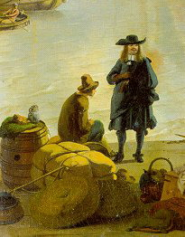
1673
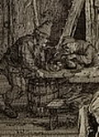
Dusart 1685
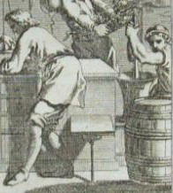German Workers 1700
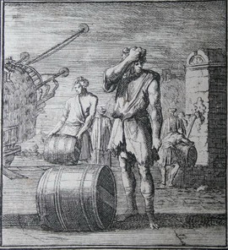
Casks being loaded onto ship 1700
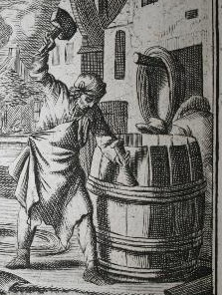
German Cooper 1700
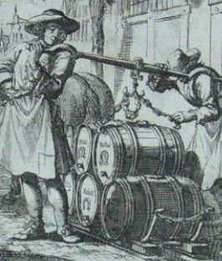
"The beer Carrier" 1700
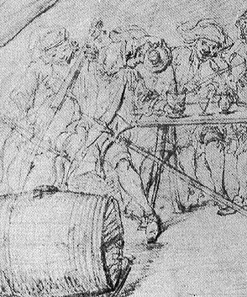
Flanders Camp 1707
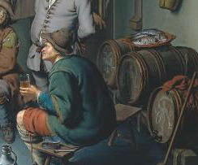Mieris 1718
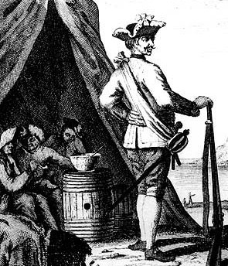
Captain Lowthar 1734
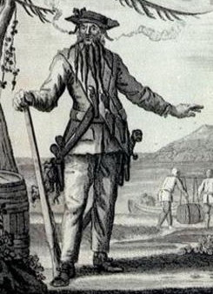Black Beard 1730s
GoF

Capt. Sterling
- Sticky Fingers Sterling Needs a New Hat
- Member

- 10,302 posts
- Gender:Pyrate Hunter
- Location:here
- Interests:Killing pirates, haven't met one yet worth keeping alive....
Posted January 26, 2008 · Report post
Hey GoF,
Have you ever contacted Jamestown...I know they are a lot earlier, but the guys there, swear they had metal bound casks for smaller, heavier loads, such as nails. They also told me they had brass barrels for carrying gunpowder. I would love to know what those looked like and how far over they carried into the later part of the century.

Patrick Hand
- The sailor's sailor
- Moderator

- 6,100 posts
- Gender:Male
- Location:TH' Mountains of Central California
- Interests:I like wierdness... Klingon, Pyrate..... and even..... gasp.... Renn Faires...... (Baseball and tractor pulls I'd have to think about.... could be wierd or Not,,,,)
Posted January 27, 2008 · Report post
Hey... A GAoP Encampment, or did barrels have wood or metal hoops..... new thread time.......

Silver
- Plunderer
- Member

- 347 posts
- Gender:Male
- Location:Virginia Beach, Virginia
- Interests:Maritime history
Posted January 27, 2008 · Report post
i have the book "the mayflower destiny" cyril l. marshall. printed in 1976. he was curator of technology and crafts at plimoth plantation in plymouth, mass. on page 171 under coopering it states that "iron hoops, with the exception of those fitted on the top and bottom of a cask to take the punishment when it was dropped, were not { common }until late in the 18th century".

LadyBarbossa
- Wealth Redistributor & Mischief Making
- 
- Moderator

- 4,641 posts
- Gender:Female
- Location:The Land Between Two Rivers, aka Iowa
- Interests:18th c Piracy to American Revolution, Victorian Thespians, Equitation, tigers, Friesians, cooking, playing my viola & music in general. Researcher of Major General Baron Johann de Kalb. LOVES the Phantom of the Opera (who's also Brethren)! Transformers, Stargate, Star Trek, Star Wars, NCIS, Bones, The X Files
Posted May 4, 2009 · Report post
Ahhh... the resurfacing of this topic.
Great picture that ye provided, Will. That's generally the idea I've had in mind.
Oh, and Sterling... ye be right about the copper.
The Odyssey Marine Salvage group (ones on "Treasure Quest" on the Discovery Channel and the ones who found the "Black Swan")... have discoverd the first HMS Victory (the one that sank in the Channel) and they did find a massive copper kettle for the ship's galley.
~Lady B

Fox
- Old Twillian
- Moderator

- 2,564 posts
- Gender:Male
- Location:Beautiful lush Devon, England
- Interests:Nautical history of the 16-18th centuries and living history based thereon.
Shooting pirates.
Posted May 25, 2009 · Report post
Couple of pics of my 'tent' last weekend. Ingredients: spare main (lug) and jib sails from my boat, 2 short oars, some rope.
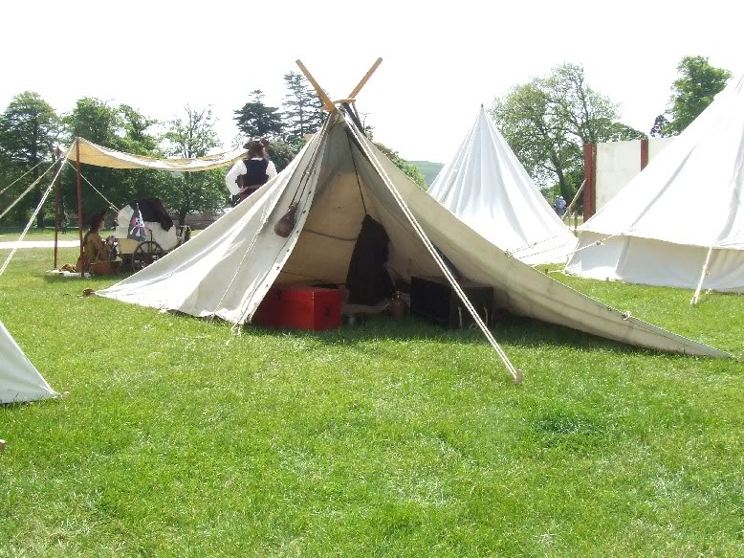
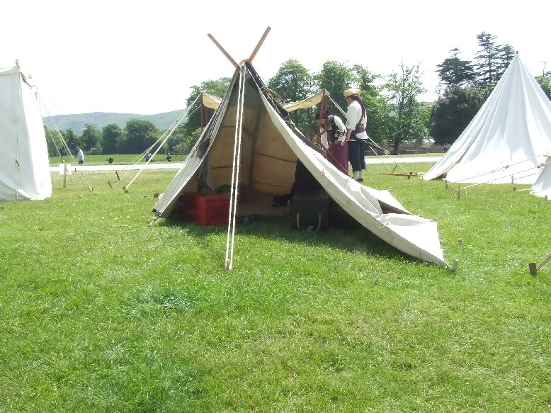

callenish gunner
- Scourge o' the 7 Seas
- 
- Member

- 2,138 posts
- Gender:Male
- Location:Pennsylvania mountains north of Clarion
- Interests:The Callenish gunner has just hoved into view looking for safe anchorage in these waters... purveyor of bladed and flintlock weaponry also leather accessories ..........painter of portraits and period scenes by avocation I'm getting my armoury business underway and will be doing as many festivals as I can ...right now along the east coast or great lakes
Posted May 25, 2009 · Report post
Foxe, a fine looking encampment there sir ....

Captain Jim
- Captain Jim for Captain!
- Member

- 2,254 posts
- Gender:Male
- Location:Off the coast of Tampa Bay (Unfortunately, inland from the coast)
- Interests:I'm 57, formerly a wildlife ecologist and biologist, now a stay-at-home dad. I grew up on the west coast of Florida, where Anna Maria Sound and Tampa Bay were my playground. My interests include, but are not limited to cannon, black powder arms, history, fishing the flats, sailing, fine wood working, flint gun building, hunting, good gun dogs. Above all, my wife and children.
Posted May 26, 2009 · Report post
Another "Oar House!" May they spread throughout the known Pyrate world.

Patrick Hand
- The sailor's sailor
- Moderator

- 6,100 posts
- Gender:Male
- Location:TH' Mountains of Central California
- Interests:I like wierdness... Klingon, Pyrate..... and even..... gasp.... Renn Faires...... (Baseball and tractor pulls I'd have to think about.... could be wierd or Not,,,,)
Posted May 26, 2009 · Report post
Ye can never go wrong usin' a sail.......

William Brand
- Mercury Malefactor
- Admin

- 8,884 posts
- Gender:Male
- Location:Logan, Utah
- Interests:My name is William Pace and I live and work as a graphic designer, illustrator and photographer in Northern Utah. I'm married to the lovely Tracy Pace and we have three children. In addition to all things art, I enjoy traveling and meeting new people from every walk of life. I've always been a fan of history, theology, and of course, Pyracy.
http://www.youtube.com/watch?v=PSkt-q-HihQ
Posted January 15, 2014 · Report post
On 5/25/2009 at 6:15 PM, Foxe said:
Couple of pics of my 'tent' last weekend. Ingredients: spare main (lug) and jib sails from my boat, 2 short oars, some rope.
I love this tent! I was just reviewing old threads and found this. Great looking careening style tent,.

Captain Jim
- Captain Jim for Captain!
- Member

- 2,254 posts
- Gender:Male
- Location:Off the coast of Tampa Bay (Unfortunately, inland from the coast)
- Interests:I'm 57, formerly a wildlife ecologist and biologist, now a stay-at-home dad. I grew up on the west coast of Florida, where Anna Maria Sound and Tampa Bay were my playground. My interests include, but are not limited to cannon, black powder arms, history, fishing the flats, sailing, fine wood working, flint gun building, hunting, good gun dogs. Above all, my wife and children.
Posted January 15, 2014 · Report post
I remember this from years gone by; I wonder if he's ever used it again. It inspires me to go ahead and sew up a sail. Although I wonder if the bosun would be disposed to let perfectly good sails (which represent a lot of work) be used for tents. But even bolts of canvas would have to sewn together to make even as crude a tent as I put up.

William Brand
- Mercury Malefactor
- Admin

- 8,884 posts
- Gender:Male
- Location:Logan, Utah
- Interests:My name is William Pace and I live and work as a graphic designer, illustrator and photographer in Northern Utah. I'm married to the lovely Tracy Pace and we have three children. In addition to all things art, I enjoy traveling and meeting new people from every walk of life. I've always been a fan of history, theology, and of course, Pyracy.
http://www.youtube.com/watch?v=PSkt-q-HihQ
Posted January 16, 2014 · Report post
Well, many ships carried spare sail and stole their share of it, so you could make it look worn and mended enough to have the appearance of too much wear for use. It could also be leftovers from the Speedwell.

Fox
- Old Twillian
- Moderator

- 2,564 posts
- Gender:Male
- Location:Beautiful lush Devon, England
- Interests:Nautical history of the 16-18th centuries and living history based thereon.
Shooting pirates.
Posted January 16, 2014 · Report post
It's had a couple of outings, but I think those photos were taken at the last event that I didn't take my children to, so now when we authenti-camp we usually take a bigger (and proper) tent.

Captain Jim
- Captain Jim for Captain!
- Member

- 2,254 posts
- Gender:Male
- Location:Off the coast of Tampa Bay (Unfortunately, inland from the coast)
- Interests:I'm 57, formerly a wildlife ecologist and biologist, now a stay-at-home dad. I grew up on the west coast of Florida, where Anna Maria Sound and Tampa Bay were my playground. My interests include, but are not limited to cannon, black powder arms, history, fishing the flats, sailing, fine wood working, flint gun building, hunting, good gun dogs. Above all, my wife and children.
Posted January 16, 2014 · Report post
That is a proper tent, for a pyrate careening. Most proper, in my estimation.

