Dorian Lasseter
- Where's My Water
- 
- 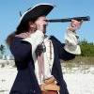
- Member

- 3,266 posts
- Gender:Male
- Location:The Sea!
- Interests:18th Century reenactment; Maritime, F&I...
Did ECW as well...
All BP firelocks and cannons!
Also enjoy Swordfighting and a good Donnybrook
Got a question for or about me? Ask!!!
Posted July 20, 2009 · Report post
Had a though while reading...
I've read where during doldrums and whatnot that sailors fished...
What did they use?
I've seen nets for hauling a large catch if possible, but what about a single line?
I've even read an instance where a crew baited a hook with a '4 pound hunk of beef and caught a 100 pound fish'. How big was the hook and what was the line?
I'd like to maybe add a small fishing kit to my gear, but what would it consist of?

Raphael Misson
- Plunderer
- 
- 
- Member

- 449 posts
- Gender:Male
- Location:Monroe, MI
- Interests:Period Surgery. Designing Stuff. Creating Stuff. Positions of power without title.
Posted July 20, 2009 · Report post
I know they used a net (called a seine). Dutch and I discussed fishing starting about here in the food sailors ate thread. There is also a period description of fishhooks out of nails in there, although it doesn't specify the technical details.

Story
- Plunderer
- Member

- 306 posts
Posted July 20, 2009 · Report post
http://www.luminarium.org/renascence-editions/walton/index.html
Izaak Walton (1593-1683) : English biographer, who is best known for THE COMPLEAT ANGLER (1653), a classic guide to the joys of fishing with over 300 new printings. It combines practical information about angling with folklore. The story of three friends, traveling through the English countryside, is enlivened by occasional songs, ballads, quotations from several writers, and glimpses of an idyllic and now lost rural life.
"Indeed, my good scholar, we may say of angling, as Dr. Boteler said of strawberries, " Doubtless God could have made a better berry, but doubtless God never did "; and so, if I might be judge, God never did make a more calm, quiet, innocent recreation than angling." (from The Compleat Angler, 1653-1655)

Red Cat Jenny
- Truly one of a Kind
- 
- 
- Member

- 7,468 posts
- Gender:Female
- Location:New York but pining for the open sea
- Interests:Pirates, history, anthing nautical, salt water fish tanks, the Caribbean and South Pacific, a good barbecue and a cold Sam Adams, travel, airplanes, rockabilly, Grand Mariner on the rocks, fabulous sunsets accompanied by a warm breeze and good friends.
Diverse enough?
I's love to learn to sail and also surf. I grew up around the waters of LI. Cept for 2 yrs land lubbin in AZ. The pirate thing? When I was 6, I stole my brother's halloween tricorn pirate hat and proceeded to wear it for three months till it ripped and the string fell off. Needless to say the rest is history!
Posted July 20, 2009 · Report post
I was wondering that very thing on the way to work this morning. How odd..
You would assume sailors would at times have contact with local fishermen in ports the visited, so it would stand to reason they may have traded both knowledge and perhaps fishing hooks. I wondered if the fishermen might have had lures. Looks like the fresh water fishermen were better equipped. I would bet when stores were low if the sea was calm enough, some might have improvised as Mission said and tried their luck.

Raphael Misson
- Plunderer
- Member

- 449 posts
- Gender:Male
- Location:Monroe, MI
- Interests:Period Surgery. Designing Stuff. Creating Stuff. Positions of power without title.
Posted July 21, 2009 (edited) · Report post
On 7/20/2009 at 6:19 PM, Red Cat Jenny said:
I would bet when stores were low if the sea was calm enough, some might have improvised as Mission said and tried their luck.
Not as Mission said, as sailor Edward Coxere said in his journal. (Seriously, go read that thread I quoted starting with the bits highlighted about the seine. There is a lot of info on fishing during period. For example, one source notes that fish were not preferred by sailors.)
Edited July 21, 2009 by Raphael Misson

Dutchman
- Has anyone seen my cousin?
- 
- Admin

- 1,773 posts
- Gender:Male
- Location:tidewater virginia
Posted July 21, 2009 · Report post
this just a throw together of tidbits of fishing I have run across over time. I'm not even going to pretend to know where I recall some of the information from but here we go.
The Jamestown Colonist suffered through the starving time while the natives had oyster bars, were spearing fish and collecting crabs and small school fish in wharps(sp), a basket shaped like a funnel that the catch could not swim out of. The fishing was so good in fact that fish remains and whole fish were placed underneath individual corn and crop plants as fertilizer. During the exploration of the bay in 1607 and 1609 fishermen were included in the 15 man crew. Nets and lines were in the inventory, but other than references to the fishermen caught such and such, little is recorded about methods or techniques. John Smith did have one recorded attempt at fishing. HE speared a stingray with his sword. It slid down the blade when he raised it up and it in return skewered him in the arm almost killing him.
There was a failed attempt at a whaling industry on the Eastern Shore of the Chesapeake Bay in the mid 1600's. It failed as the migratory route was too far out to sea. There are a small hand full of reports of fishermen having luck with catching the occasional wayward one that wandered into the bay though.
Grandpa Anthony died in 1649. he had just run a load of bunk, a type of fish, to plymouth colony and was returning to scituate with a load of wood. amongst his inventory was a set of hooked lines. no further description has ever been figured out.

Mr.Tignor
- Ship's Master
- 
- 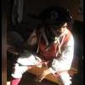
- Member

- 102 posts
- Location:Portsmouth, zee silly english colony of virginia
- Interests:I can only be described as a history loving nerd. I like anything with the word "star" in the title, i read comics, watch anime, and annyyttinng else you could get thrown in a locker for LOL. As for reenacting, iv only be at it a year, buutt i am quite committed to trying for an accurate portrayal. Im still working on the finer details of my persona, but im trying for a french impression(without butchering the accent). Later on in time i internd to also do some events in the fur trade era. More details as i figure them out, Cheers mates!
Posted July 21, 2009 · Report post
What would the average person in the period use for fishing then(if sailors didnt fancy fish all too much), after all, not all of us even portray sailors(all the time at least) so far as iv been able to research, fly fishing was popular, but that seems to be portrayed in a more, leisurely light. Would the average hungry joe have a fishing pole,lure,float etc. or would he have to make due with just line, hook ,and bait?.........(id really like to know, for i would love to try some period fishing...ssooo many good fishing spots in hampton roads...yyeess)

Raphael Misson
- Plunderer
- Member

- 449 posts
- Gender:Male
- Location:Monroe, MI
- Interests:Period Surgery. Designing Stuff. Creating Stuff. Positions of power without title.
Posted July 21, 2009 · Report post
That was kind of what I was wondering about the period book on fishing. Admittedly, I didn't get very far into it, but it seemed to be more of a sportsman's guide than something an average sailor would have recourse to. (Provided the sailor could even read, of course.)
Somewhere in the back of my mind is the notion that one of the reasons the Catholic church forbade meat on Fridays was to boost the market for fish. A rather cursory internet search turned up this, "You could buy better fish and vegetables, but the point is that you could eat without money if you were poor. So meat was rich people's food and fish was poor people's food. That is why the most common form of fasting was to omit meat and eat fish." This sort of aligns with the idea that fish would not be the preferred meat.
A final bit of info to toss out there - I recently came across was in the Galen book I am reading that says meat is an important element in creating blood (the "best" humour) while other provender (vegetables and fruits) where of little or no value in this regard. (Sorry, I don't have the actual quote handy.) It doesn't say whether fish was better or worse for generating this best of humors, but I could easily understand an argument that would favor red meat over white in the creation of blood. (Note that none of these points are necessarily tied to period thinking. It's more like rambling than PC thinking.)

Sjöröveren
- Plunderer
- 
- Member

- 457 posts
- Location:Minnesota, Land of 10,000 Lakes and 1 mini-ocean
- Interests:Re-enactment, gradually working my way back from the 19th Century. I figure I'm in about 1700 right now. I specialize in the history of medicine. I like maps, and the general history of geography and geodesy. <br />And in case you're wondering, "Sjöröveren" is Swedish for "the sea rover." And it's supposed to be spelled "Sjörövaren" but I guess it's too late for that!
Posted July 22, 2009 · Report post
Jas. Townsend has a good fishing kit for sale. The picture gives a good basic idea of how the pole, line, floats and hooks looked like. One big difference is that small hooks like this didn't have eyes - the line was tied around the shaft of the hook instead. There must have been quite a few lost fish!
As far as fishing for food was concerned, I'm sure that nets, seines, weirs, etc were the methods of choice, rather than hook & line. There were no game laws in the modern sense, so there were no worries about catch limits or methods. Of course, the concept of all waters being open to public fishing is an American concept. Back in Europe, fishing rights were (and still are in many cases) are held privately by the land owner.
At sea, from what I've read, fish were often purchased from local fisherman, who could be an important source of intelligence if sailing in enemy waters. Also, sailors would fish from the ship when becalmed or not on watch, if the captain permitted it. I imagine the ship's armourer could easily fashion hooks of the appropriate size for whatever quarry was available. Tuna and sharks were both mentioned in books I have read, both of which would require larger hooks.
I'm sorry I don't have my references in front of me, but these are just general things that I recall. Don't take them for gospel.

Mr.Tignor
- Ship's Master
- Member

- 102 posts
- Location:Portsmouth, zee silly english colony of virginia
- Interests:I can only be described as a history loving nerd. I like anything with the word "star" in the title, i read comics, watch anime, and annyyttinng else you could get thrown in a locker for LOL. As for reenacting, iv only be at it a year, buutt i am quite committed to trying for an accurate portrayal. Im still working on the finer details of my persona, but im trying for a french impression(without butchering the accent). Later on in time i internd to also do some events in the fur trade era. More details as i figure them out, Cheers mates!
Posted July 22, 2009 · Report post
thanks all for the info! I always do find it interesting how reluctant english people of the time were about eating many many many things. Thanks to Sjoroveren for the link to the kit at Jas. Townsend....not sure why i didnt think to look there myself.....

Dorian Lasseter
- Where's My Water
- Member

- 3,266 posts
- Gender:Male
- Location:The Sea!
- Interests:18th Century reenactment; Maritime, F&I...
Did ECW as well...
All BP firelocks and cannons!
Also enjoy Swordfighting and a good Donnybrook
Got a question for or about me? Ask!!!
Posted July 22, 2009 · Report post
Aye, good information all around...
Still lacking in some respects, but not for lack of trying.
The one link talks of making fishing line out of hair... but I see that as only so good, mainly for fishing streams, rivers and lakes for smaller fish.
Nets and such used are known, but I can't see sailors encumbering a ship with fishing poles...
In my mundane lifetime, I've fished with several different poles, and just a line with a hook. I would think a hook and line would be ideal for a sailor to have in a seachest. If I still have the thing, I'll take a pic of it and post it, but it was just a square frame about 3-4 inches that the line wrapped around. Add a hook and maybe a cork bobber...
Just still need to know what would be used for the line...

Mr.Tignor
- Ship's Master
- Member

- 102 posts
- Location:Portsmouth, zee silly english colony of virginia
- Interests:I can only be described as a history loving nerd. I like anything with the word "star" in the title, i read comics, watch anime, and annyyttinng else you could get thrown in a locker for LOL. As for reenacting, iv only be at it a year, buutt i am quite committed to trying for an accurate portrayal. Im still working on the finer details of my persona, but im trying for a french impression(without butchering the accent). Later on in time i internd to also do some events in the fur trade era. More details as i figure them out, Cheers mates!
Posted July 22, 2009 · Report post
This might be helpful in reguards to line , found this site this morning. Still not exactly what im looking for, but getting closer!

Dutchman
- Has anyone seen my cousin?
- Admin

- 1,773 posts
- Gender:Male
- Location:tidewater virginia
Posted July 22, 2009 · Report post
fly fishing was a leisure sport and considered frivilous in some realms of society as it was a sport to spend all that time catching one fish. In narrow, quick moving waters baskets with funnels on one end were used and placed in the rivers chutes. to catch a mess or mass o' fish on open waters large sein nets were used. this could be done two ways. first much like circling the wagons, the net was set and then rounded up. the bottom was snugged making a "purse" and the whole lot was pulled aboard or atleast till it could be hauled no more, then the fish dipped out of the purse. The second was to run the net perpendicular from shore and then into a pen. the fish, not being able to get out of the pen were then collected with a net. I know where a set up like this is used commercially still. I'll see if I cant get a picture of it.
Obviously, the above two methods would not work out so well onboard an trans-ocean vessel under way. So two things were done. the first- stop the ship and set a net. not ideal as this is time consuming and depending on the size of the net sometimes resulted in the launch being lost at sea. there are many reports of this in the fishing industries. the second is to set numerous trolling lines behind the ship and wait it out. This is where the ship nail/ baited hook narratives come into play. I'm still at a loss as to what type of line would be used to land something the size of a hundred pounds by trolling though.

Dorian Lasseter
- Where's My Water
- Member

- 3,266 posts
- Gender:Male
- Location:The Sea!
- Interests:18th Century reenactment; Maritime, F&I...
Did ECW as well...
All BP firelocks and cannons!
Also enjoy Swordfighting and a good Donnybrook
Got a question for or about me? Ask!!!
Posted August 15, 2009 · Report post
After much digging and head scratching as to where I put this thing... I found it!
I've had this since my dad gave it to me, and I have no idea how long he had it...
While looking I made a part out of wood from memory...
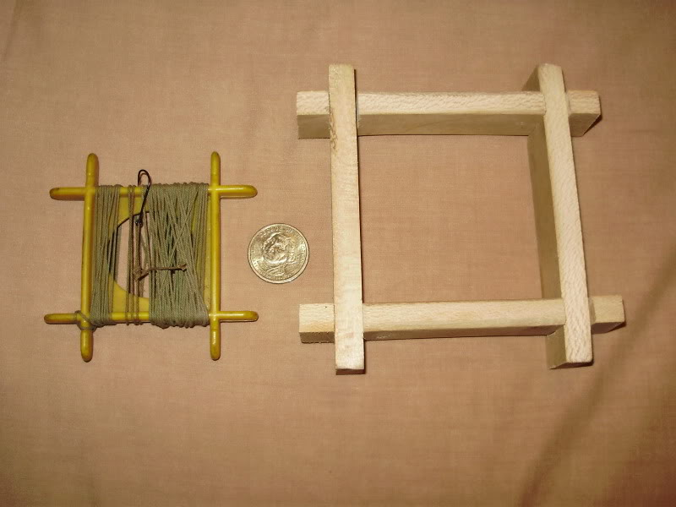
My memory thought it was bigger... heh
As you can see, it's plastic, but I can imagine it would originally be made of wood...
Here's a closeup...
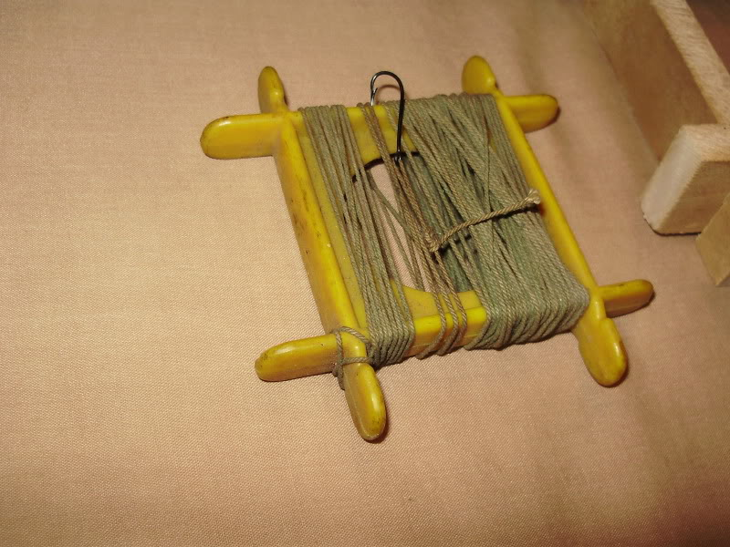
I can see something of this nature being in a sailor's kit to while away some time, add a bobber (small chunk of whittled wood, or some cork) and bait the hook...

Sjöröveren
- Plunderer
- Member

- 457 posts
- Location:Minnesota, Land of 10,000 Lakes and 1 mini-ocean
- Interests:Re-enactment, gradually working my way back from the 19th Century. I figure I'm in about 1700 right now. I specialize in the history of medicine. I like maps, and the general history of geography and geodesy. <br />And in case you're wondering, "Sjöröveren" is Swedish for "the sea rover." And it's supposed to be spelled "Sjörövaren" but I guess it's too late for that!
Posted August 15, 2009 · Report post
On 7/22/2009 at 4:14 PM, Mr.Tignor said:
This might be helpful in reguards to line , found this site this morning. Still not exactly what im looking for, but getting closer!
What a great find! This guy has obviously done his homework! I highly recommend spending some time on this site!
On 8/15/2009 at 10:31 AM, Dorian Lasseter said:
After much digging and head scratching as to where I put this thing... I found it!
I've had this since my dad gave it to me, and I have no idea how long he had it...
While looking I made a part out of wood from memory...
My memory thought it was bigger... heh
As you can see, it's plastic, but I can imagine it would originally be made of wood...
Here's a closeup...
I can see something of this nature being in a sailor's kit to while away some time, add a bobber (small chunk of whittled wood, or some cork) and bait the hook...
I'd check your local game laws before actually using something like this to catch fish. I know that something like this is illegal in Minnesota without a commercial fishing license. And if you're making one just to keep in your kit, I'd probably dull the ends of the hooks, or put little corks on them. No one wants to reach into their snapsack and pull out a bloody stump! (unless it ain't your bloody stump that you're carrying around in your snapsack!)

Dorian Lasseter
- Where's My Water
- Member

- 3,266 posts
- Gender:Male
- Location:The Sea!
- Interests:18th Century reenactment; Maritime, F&I...
Did ECW as well...
All BP firelocks and cannons!
Also enjoy Swordfighting and a good Donnybrook
Got a question for or about me? Ask!!!
Posted August 15, 2009 · Report post
Well, It would be in the til or a drawer of my sea chest, so no real worries there... and sticking the hooks into a cork is always the way to go!
This is just for reenactment... at this point... If you look at the first image, there is a dollar coin there for size reference. Not a very big item.
That site Mr. Tognor found, excellent indeed! I plan to order some line and/or a rough fishing kit from him soon.

René la Gaffe
- Deck Hand
- 
- 
- Member

- 74 posts
- Gender:Male
- Location:Portsmouth, zee silly english colony of virginia
- Interests:I can only be described as a history loving nerd. I like anything with the word "star" in the title, i read comics, watch anime, and annyyttinng else you could get thrown in a locker for LOL. As for reenacting, iv only be at it a year, buutt i am quite committed to trying for an accurate portrayal. Im still working on the finer details of my persona, but im trying for a french impression(without butchering the accent). Later on in time i internd to also do some events in the fur trade era. More details as i figure them out, Cheers mates!
Posted August 15, 2009 · Report post
I glad the site was of good help....... though fly fishing still is a rather frivolous sport...i still enjoy it....i see a kit purchase in the future yyyyeeeeeeeee

Cascabel
- Evil Drooling Henchman
- 
- 
- Moderator

- 848 posts
- Gender:Male
Posted August 16, 2009 · Report post
On 8/15/2009 at 10:31 AM, Dorian Lasseter said:
After much digging and head scratching as to where I put this thing... I found it!
I've had this since my dad gave it to me, and I have no idea how long he had it...
While looking I made a part out of wood from memory...
My memory thought it was bigger... heh
As you can see, it's plastic, but I can imagine it would originally be made of wood...
Here's a closeup...
I can see something of this nature being in a sailor's kit to while away some time, add a bobber (small chunk of whittled wood, or some cork) and bait the hook...
When I was a kid, my father and I used these things quite often. We went out regularly in a wooden rowboat off of Salem, Ma. To catch flounder with these. Back then, they were indeed made of wood. They were available just about everywhere, including the hardware store, in several sizes. They were made a bit different than your sample attempt, however. The two side pieces were a bit heavier than the cross pieces. The cross pieces were of round form, and protruded through the side sections to become sort of crank handles. If you grabbed two diagonally opposed "handles", you could wind the line back up fairly quickly. It was sort of a wobbly cranking motion, but worked very well. We always referred to them as "drop lines"

Dorian Lasseter
- Where's My Water
- Member

- 3,266 posts
- Gender:Male
- Location:The Sea!
- Interests:18th Century reenactment; Maritime, F&I...
Did ECW as well...
All BP firelocks and cannons!
Also enjoy Swordfighting and a good Donnybrook
Got a question for or about me? Ask!!!
Posted August 16, 2009 · Report post
Thank You Cascabel!
That's just what I needed... I can easily modify what I have now, or produce another one...
I have rounded the edges on two of the pieces (the horizontal ones in the images) so as not to have the line go across a semi sharp edge.
So, 'Drop Lines'... sounds good to me... I had thought to transfer the line off this one onto my piece, but I can't... I'll be getting a kit from tha place Rene showed us to add to it.
Slainte and happy fishing!

Dutchman
- Has anyone seen my cousin?
- Admin

- 1,773 posts
- Gender:Male
- Location:tidewater virginia
Posted November 7, 2009 · Report post
found this over the weekend
“Sturgeon and shad are in such prodigious numbers that one day within the
space of two miles only, some gentlemen in canoes caught above six hundred
of the former with hooks . . . and of the latter above five thousand have
been caught at one single haul of a seine.”
English traveler Andrew Burnaby, 1759

Mission
- Goat Specialist
- 
- Admin

- 5,081 posts
- Gender:Male
- Location:Monroe, MI
- Interests:Scholarly piracy, designing and creating haunted house rooms and props, movies, abstract thinking, abstruse thinking, obstructive thinking, ideating, random thinking, movies, cartoons, movies, movies scores, cycling, world peace and small furry dogs, movies, writing, drawing, personal skills training, gremlins and, of course, lest I forget, movies.
Posted October 1, 2011 · Report post
From the book The Voyages and Travels of Captain Nathaniel Uring (1928 reprint, first published in 1726), while on-board the Martha in 1701.
"On our Arrival near the Coast of Guinea we sounded, and found our selves upon the Shoales of Grandee, in fourteen Fathom Water, which obliged us to stand off to the Sea; and the next Day I saw a large broad Fish, at least four Foot over, and a proportionable Length, much like a Scate, but a longer Tail, with some little Difference; they are commonly called amongst the Seamen Devil Fish. I struck it with a Fish-gigg [Footnote 1: A small harpoon or staff with three or more prongs and a line, used for striking at large fish.] in the Middle of the Back from the Round-House and the Line of the Fish-gigg being made fast to the Deep
__
Sea Line, I was in hopes to have caught it, but the Fish being very large and strong, swam away very swiftly, with the Gigg standing upright in his Back; and the Line hitching about my Foot had like to have pulled me over-board, and had not the Knot luckily slipp'd where the Line was fastn'd, I should have been in great Danger [uring couldn't swim], but I came off only with the Loss of my Slipper. The Loss of our Fish-gigg was a very great Misfortune to us, having no more on Board, and therefore could strike no more Fish, by which Means we lost many a good Meal during our Voyage." (Uring, p. 22-3)

Mission
- Goat Specialist
- Admin

- 5,081 posts
- Gender:Male
- Location:Monroe, MI
- Interests:Scholarly piracy, designing and creating haunted house rooms and props, movies, abstract thinking, abstruse thinking, obstructive thinking, ideating, random thinking, movies, cartoons, movies, movies scores, cycling, world peace and small furry dogs, movies, writing, drawing, personal skills training, gremlins and, of course, lest I forget, movies.
Posted December 4, 2014 · Report post
Here's a delightful bit of detail on sailors surviving in the wilderness from Ed Fox's book Pirates in Their Own Words. It is an excerpt of Richard Hawkins second account given to The British Journal on 22 August, 1724 from when he and some other men were on an otherwise uninhabited island near 'Benacca' (today called Guanaja - located in the Bay of Honduras) where they had been left by Francis Spriggs' pirates:
"Here we found a Well of good fresh Water, Soldiers [Caribbean hermit crabs] and Guayanas [lizards - possibly Cnemidophorus lemniscatus]; and from Benacco we fetch’d Plenty of Cocoa-Nuts. We saw several Fish swimming about us, but we were very uneasy, not knowing how to come at them: At length Tobias Martin, my boatswain, (who is come home with me,) found a Tenpenny Nail in the Canoe; this he
__
crook’d like a Hook, and made it fast to a Line of the old Man’s, and therewith caught a Rock-fish as large as a Cod; which, with the Broth made us a good Meal. Some Days after, we shot at another of them with a single Ball, which being in Shoal Water, and among the Rocks, we had the good Fortune to take." (Fox, p. 303-4)

