Kian McBrian
- Ship's Master
- 
- 
- Member

- 197 posts
- Location:New York
(IP: 69.206.131.239) ·
Posted June 22, 2009 · Report post
I just wanted to see if anyone had any information on kilts during the GAoP. Did they wear it when they went to shore? I dont think twould be a great idea on board, but maybe on a night out on the town..and if so would Great Kilts or "wee" kilts be the fashion of the times...I would love to see some proof of this so i could break out a few kilts to some events/ pirate balls

- Quote
- Edit

Tartan Jack
- Notorious Pyrate
- 
- 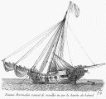
- Member

- 908 posts
- Location:South Carolina
- Interests:History, Scotland, Batman, Cars, and more<br />Married with 2 kids<br />
(IP: 74.181.91.31) · ·
Posted June 22, 2009 · Report post
I have a LOT to say about this.
That is a major personal interest and I have done a LOT research on this.
But, I have to split right now.
I'll post more tonight.
Look at the 1715 Jacobite rebellion for info on the primary part of the GAoP, which was just after that rebellion.
More to come later tonight.
Oh, and NOTHING like the modern 8-yard knife pleat existed until many, many years later (like Victorian/Edwardian times).

- Quote
- Edit
- Options

Capn' Mac
- Ship's Master
- 
- Member

- 141 posts
- Location:Land Locked in the Rockies!
- Interests:The Golden Age of Pyracy<br />Scottish History<br />Home Brewing<br />Rum
(IP: 67.166.20.98) · ·
Posted June 22, 2009 · Report post
I don not wish to step on Tartan Jack’s toes but I too have quite a bit of info on this one as my main area of historic interest has always been the ’45 and Culloden.
I am very interested to see what Tartan jack has to say so I’ll keep this brief so as not to steal his thunder. 18th century kilts are, as Jack says, nothing like the sewn, knife pleated kilts of today that gained popularity in the Victorian era. And this is to say nothing of tartan as we know it today.
I cannot speak overly much about life aboard ship as concerns kilts, however I would highly doubt they were worn on a ship. The ‘wee” kilt really did not become popular or common until the 1800s and the belted plaid would have been way too cumbersome. As to if they were worn when going ashore, I cannot say.
Those on land though, in Scotland did wear them until the failed ’45 rebellion, after which the wearing of tartan was outlawed until the repeal in 1782.

- Quote
- Edit
- Options

Kian McBrian
- Ship's Master
- Member

- 197 posts
- Location:New York
(IP: 69.206.131.239) · ·
Posted June 22, 2009 · Report post
Ahh bollix all I have for now is a wee kilt...no knife pleats though
Guess I will have to stick with the more traditional clothing

- Quote
- Edit
- Options

Tartan Jack
- Notorious Pyrate
- Member

- 908 posts
- Location:South Carolina
- Interests:History, Scotland, Batman, Cars, and more<br />Married with 2 kids<br />
(IP: 74.181.91.31) · ·
Posted June 22, 2009 · Report post
OK.
I'm back now.
The old "kilts" were actually called "belted plaids," among other names. I like that term, as "plaid" really just means "blanket."
What is it?
It is essentially a large rectangle of fabric worn belted around the waist. That rectangle is 4 to 6 yards long. I prefer smaller to larger, and I'll tell why later. That rectangle is also "double width" wide. First, remember that most Highland looms were 24-28 inches wide or so with 27 inches seeming to be very common. So, a double width is 2 sections of 27-ish wide material, each being 4-6 yards long. The result is a rectangle 54 or so inches wide and 4-6 yards long.
-Now, that rectangle is set up so the length (4-6 yards) is gathered in the middle and strapped to the body with the 54-ish inches width going from the knees to over the head.
There are flat flaps in front and gathers in the back. They are gathers, not pleats. They are loose and not ironed or pressed in any form or fashion.
I am becoming more and more convinced that the original belted plaids had some form of belt loops and the plaid was strung along a belt or cord and put on. If using a cord, then a belt was put on over it. An argument is found: http://albanach.org/drawstring.htm
Anyways, it is commonly shown as being put on like:
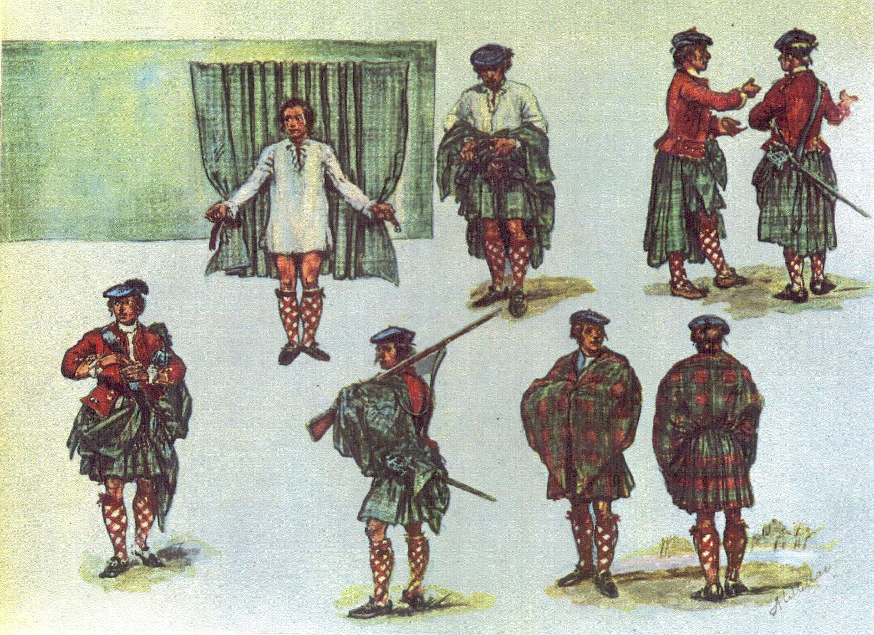
So, a belted plaid is a plaid worn as using a belt. It was like a "swiss-army-knife" garments that was body covering, rain coat, carrying bag (the pockets created by the top part hanging down), blanket, sleeping bag, and more all in one.
The result looks like:
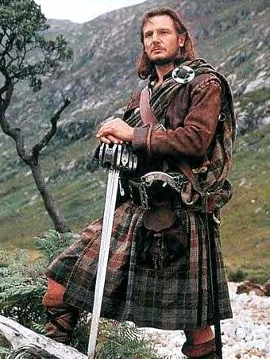
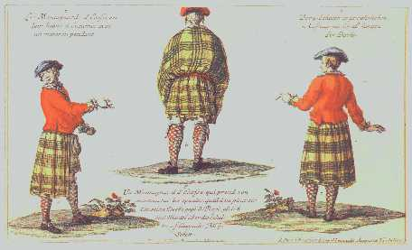
Soon (after I finish the cuffs, I'm taking picts of my shirt and sleeveless jacket. As my trousers or slops aren't yet finished, I'll post picts of a belted plaid instead.
Around the 17-teens, the garment commonly called a "philabeg" (I don't like that name) started to show up. Basically, it is half of a belted plaid. It is the lower half of the 2 sewn together parts without the top part sewn on. So, the result is a waist down only variation of the belted plaid. The question is why it shows up at this time. I think it is a) the more common use of a jacket negating the need to the upper part for warmth and rain coverage and the move of highlanders and the belted plaid to cities and factories and away from the outdoors and open glens and mountain sides (it wasn't needed for many of the "swiss-army-knife" purposes and became just a wasted bulk of fabric.
So, it IS period appropriate too, but looks almost exactly like the belted plaid shown in the upper picts hanging loose, just a few inches hanging down rather than several feet.
Aside: The philabeg is one of the 2 main reasons I think beltloops are historical, as a philabeg falls off with only a belt and loose fabric. So, more attachment is needed. Add that to the fact that the hanging gathers is NO different than a belted plaid implies that they are hanging the same way at the base.
Add to that the fact that there aren't really pleats one direction or the other, just a hanging mess, doesn't look like how one would fold it up on the ground (in loose pleats). Rather, it looks like each is scrunched along a central point. They are irregular gathers, rather than pleats of any kind.
Now, for the length:
Having tried to wear belted plaids anywhere from 8 yards to under 4, I like 4 MUCH more than more. The top part is more managable and very easy to make look practically identical to early illustrations. More than 4 just adds too much material and the result of manipulating the top part never looks like period picts.
Add to that, ALL the earliest surviving tailored kilts are 4 yards or less (most less).
To me, that makes a convincing case to plaids being closer to 4 yards (or roughly 3 times hip measurement) than the more commonly cited (today) length of 6 yards.
The 6 yards reference looks to come from 2 types of sources: 1) lengths of single width fabric orders (later cut and sewn lenthwise to double width THREE yard plaids) and 2) references to THIN material, which is folded in HALF (to make a 3 yard length of double thickness) before it is put on.
The more common period references are to 3 to 3.5 yard plaids, even more than 4.
As I am likely larger than most Highlanders of the 1700s (I am 6'2" with 45 inch hips/butt), so 60 inches wide and 4 yards is pretty close to a scaled up version (maybe a bit large)
Oh, and I have sources for all the above statements (documentation, much from period or post period, but still old books). If you want them, ask, and I'll try to find them.

- Quote
- Edit
- Options

Tartan Jack
- Notorious Pyrate
- Member

- 908 posts
- Location:South Carolina
- Interests:History, Scotland, Batman, Cars, and more<br />Married with 2 kids<br />
(IP: 74.181.91.31) · ·
Posted June 22, 2009 · Report post
Oh, on the modern 8 yard, knife pleat, kilts to sett . . .
The most important document for me is "The Kilt & How to Wear It" by The Hon. Stuart Ruaidri Erskine (1901),
(As found on: http://giftshop.scottishtartans.org/books.htm )
His book is a collection of articles Erskine wrote around the turn of the 1900s. In it he decrys the "excessive" length of kits at SIX yards, describes kilts as 4 yards, discussed the civilianizing of military side pleat kilt in "recent years" and favored the traditional BOX pleat kilt for practical use. In one section, he praises and says he is fond of the NEW idea of making the pleats in such a way as to accurately imitate the sett of the tartan on the back of the kilt as on the front. That implies that the COMMON way they were pleated was "to stripe" or to nothing at all (as the older civilian kilts are seen).
By that document, the "modern" 8-yard, knife pleat, to sett kilts aren't even accurate for the mid-1800s, much less anywhere in the 1700s.
So, the "correct" period "kilts" for the 1700s were the Belted Plaid and the Half-Plaid (a name I saw somewhere and liked)/"Philabeg" . . .
My opinion: BOTH were 4 yards or so (often less) in length, used belt loops in some form, were not sewn (except sometimes with bound edges by a ribbon), were gathered (as happens with belt loops) and so forth.
Either way, there is ZERO evidence of a plaid (full or half) being worn on ANY ship outside the Scottish Isles (and those are debatable).
So, NO ONE should were one shipboard or represent themselves at a reenactment as having worn on ship-board.
(I will bring one to Lockhouse, but for after hours comfort, not during the day.
Next post Tartan and Colors:

- Quote
- Edit
- Options

Tartan Jack
- Notorious Pyrate
- Member

- 908 posts
- Location:South Carolina
- Interests:History, Scotland, Batman, Cars, and more<br />Married with 2 kids<br />
(IP: 74.181.91.31) · ·
Posted June 22, 2009 · Report post
(I am breaking these into smaller posts, so I don't lose them in computer hiccups. Each is a lot of work.)
First, the term "tartan" originally meant a think, hard, wool material. There is debate over what it exactly was and how it was made. It likely wasn't the worseted wool of today, but was something else with a harder "hand" (in no way fuzzy or felted). Anyways, the term references the material NOT the color or pattern. They could be solid, patterned or ANY colors possible to be dyed.
Over time, it became a reference to a particular type of pattern woven into the material, rather than the material itself. That is what it is understood as today, and seems to have meant in the 1700s too.
Now, using the term as we mean it today:
Tartans are VERY common for a long time in Scotland. We have found ancient artifacts and many scraps of wool in what we would call tartan patterned in archaeological finds. Many were stoppers in bottles. So, we know that had it and it was common. By 1600, it was already seen as being commonly Scottish and is shown in many illustrations of Scots.
One reason it was common:
They dyed wool thread in small batches in buckets. As anyone who had hand dyed material, it is hard to match one batch to another. To balance the shades and mask the differences in shading, a complex criscrossing pattern was used.
Also, it seems to have been popular and used widely for a LONG time.
Now, belted plaids are shown as both tartaned and solid. A status symbol was a solid red belted plaid, seen in MANY period paintings. It would have meant they were wealthy enough to afford that much red AND could afford to get it dyed consistently to get a near-uniform plaid (as in blanket, not pattern).
Solid ones are period and not very rare. Though tartan ones were common.
Now, family associations for tartans were (basically) unheard of before the 18-teens. The issue that created them was the writings of Sir Walter Scott and Scotts staging of the Tartan Gala of the 1819 visit of George IV to Edinburgh.
- I say basically, as Grant tried to make one and had a set of matching tartan plaids made for his household and shown in the FAMOUS paintings of the Grant Champion and the Piper (their tartans are artistic attempts to paint matching tartan, though the paintings don't actually match exactly). These are the 2 shown to "prove" tartans as livery. It was an attempt at that, but failed MISERABLY. Grant's own son used other tartans and ignored the one his father tried to implement.
So, many of the "clan tartans" existed in-period, some of them actually being based on period paintings, but they meant nothing and were chosen and worn as a matter of personal taste and preference. Don't worry about them for period garb and wear what you like.
Now, for the shades themselves:
The best writing I have found is by Peter MacDonald, a top scholar on the subject of tartan.
He wrote and article on tartan colors:
http://www.scottishtartans.co.uk/colour.htm
I agree with him!

- Quote
- Edit
- Options

Tartan Jack
- Notorious Pyrate
- Member

- 908 posts
- Location:South Carolina
- Interests:History, Scotland, Batman, Cars, and more<br />Married with 2 kids<br />
(IP: 74.181.91.31) · ·
Posted June 22, 2009 · Report post
Capn said:
I cannot speak overly much about life aboard ship as concerns kilts, however I would highly doubt they were worn on a ship. The ‘wee” kilt really did not become popular or common until the 1800s and the belted plaid would have been way too cumbersome. As to if they were worn when going ashore, I cannot say.
Those on land though, in Scotland did wear them until the failed ’45 rebellion, after which the wearing of tartan was outlawed until the repeal in 1782.
Except that there ARE period pictures showing half-plaids form the 1715 Jacobite Rebellion through the 1745 one and plenty of picts of the Highlander regiments after that using them as fatigue garments, as the belted plaids were their uniform. Examples abound by the American War/Revolution of the 1770s/1780s.
In the 1700s, belted plaids remained the more common garment. It was in the 1800s that it was dropped and the "wee kilt" became formalized and was sewn down, developing during the 1800s into the kilt we know today.

- Quote
- Edit
- Options

PoD
- Pyrate Captain
- 
- 
- Member

- 697 posts
- Gender:Male
- Location:Warrington UK
- Interests:Pirates, graphic novels, computer art, Listening to music, Going to gigs, Beer and Wine drinking, historical research, Period weaponry and Leatherwork
(IP: 82.24.80.245) · ·
Posted June 23, 2009 · Report post
really interesting post and the pictures are really helpfull as I have just spent the last week making jacobite sporrans and belt pouches for a client that does Jacobite reenactment. Also made a highland womans belt to hold up one of them "belted plaids".

- Quote
- Edit
- Options

Duchess
- I Make A Good Troll
- 
- 
- Admin

- 1,195 posts
- Gender:Male
(IP: 72.21.232.40) · ·
Posted June 23, 2009 · Report post
Tartan Jack said:
I'm taking picts of my shirt and sleeveless jacket.
PUN!

- Quote
- Edit
- Options

Tartan Jack
- Notorious Pyrate
- Member

- 908 posts
- Location:South Carolina
- Interests:History, Scotland, Batman, Cars, and more<br />Married with 2 kids<br />
(IP: 74.181.91.31) · ·
Posted June 23, 2009 · Report post
Duchess said:
Tartan Jack said:
I'm taking picts of my shirt and sleeveless jacket.
PUN!
FINALLY!
Someone realized my intentional use of "picts" instead of "pics" as the abbreviation for "pictures."
Congrats and KUDOS!

- Quote
- Edit
- Options

Kian McBrian
- Ship's Master
- Member

- 197 posts
- Location:New York
(IP: 69.206.131.239) · ·
Posted June 23, 2009 · Report post
Wow, fantastic write up!!! I glad you too the time and effort into posting all of this information!! Well i guess I will leave my kilt at home then for reenactments and just save it for around the house, renfaires, and St. Patricks Day then lol. I believe the kilt I have does not have knife pleats but it is made or worsted wool so it wouldn't even be period correct. I originally bought the kilt (Black Watch Pattern) from Highland Secrets (websites down as of right now) and I bought a great kilt, but cut it into a half kilt and amd saving the extra fabric for another project. Just looking for another excuse to wear it...cause lets face it...they are VERY comfortable (and women love them too). Thanks again for that great write up jack...I'll see ya at the lockhouse next month (wow time flys) and make sure to post picts of your kit when you are done!!!

- Quote
- Edit
- Options

Tartan Jack
- Notorious Pyrate
- Member

- 908 posts
- Location:South Carolina
- Interests:History, Scotland, Batman, Cars, and more<br />Married with 2 kids<br />
(IP: 74.181.91.31) · ·
Posted June 23, 2009 · Report post
Kian McBrian said:
Wow, fantastic write up!!! I glad you too the time and effort into posting all of this information!! Well i guess I will leave my kilt at home then for reenactments and just save it for around the house, renfaires, and St. Patricks Day then lol. I believe the kilt I have does not have knife pleats but it is made or worsted wool so it wouldn't even be period correct. I originally bought the kilt (Black Watch Pattern) from Highland Secrets (websites down as of right now) and I bought a great kilt, but cut it into a half kilt and amd saving the extra fabric for another project. Just looking for another excuse to wear it...cause lets face it...they are VERY comfortable (and women love them too). Thanks again for that great write up jack...I'll see ya at the lockhouse next month (wow time flys) and make sure to post picts of your kit when you are done!!!
We can talk kilts then.
Oh, and I am a mod on the Brotherhood of the Kilt and also interested in Jacobite reenacting. I am more than a tad interested in the subject and have actually researched that far more than anything pirate over the years (hence my opinions on some things argued over by kilties).

- Quote
- Edit
- Options

Liam McMac
- First Mate
- 
- Member

- 201 posts
- Gender:Male
- Location:Modesto, CA
- Interests:Tailoring reenactment clothing, Piracy, Scots-Irish/Jacobite reinactment
(IP: 174.50.132.68) · ·
Posted September 7, 2009 · Report post
No big deal but, the movie Rob Roy take place before the '45 and most of the men are wearing philabegs. Rob wears a kilt and a bratt slung over the shoulder for use in harsh weather and formal occasions. In my oppinion the Feileadh Mor isn't practical for everyday wear and work... even in the winter. I believe the Feileadh Mor had a specific function for use in travel and harsh weather.

- Quote
- Edit
- Options

John Maddox Roberts
- First Mate
- Member

- 272 posts
(IP: 64.136.26.230) · ·
Posted September 11, 2009 · Report post
The kiltie is definitely not good shipboard wear. Remember, when you're up in the rigging, people are looking up at you from below.

