BriarRose Kildare
- Scourge o' the 7 Seas
- 
- 
- Member

- 2,004 posts
- Location:Pittsbugh Pennsylvania
- Interests:I love History. I have a deep thirst for knowledge and I am rarely with out a book under my nose. Some of my historical interests include: Greco-Roman times, Middle ages, Tudor-Elizabethan, the Golden Age of Pyracy, Napoleonic, French and Indian War, American Revolution, American Civil War, and the Victorian era.<br />Some of my many other interests include: Fencing, belly and romney gypsy dancing, apothecary and herbal healing, disease through out history and how it has effected societies. I also enjoy a good ghost story and I am always ready for ghost hunting. The paranormal absolutely fascinates me. <br />One of my life long dreams is to travel and to sail upon the ocean on a glorious period ship.<br />I also enjoy spending time with friends and family. And above all, I love having fun. And a good drink of Drambuie is always a warm touch to my heart.
Posted June 10, 2008 · Report post
I have recently begun to study lighthouses and their use through out history. I have been trying to research specifically their time of use during the GAOP era. The only thing I have found so far is "The first lighthouse in America was Boston Light on Little Brewster Island (1716)", which is not quite correct.
I was hoping to find specific lighthouses that were famous for the time of the GAOP. Does any one have any information concerning this quest?
I realize lighthouses have a wide range of history dating back to ancient times so I hope this does not interfere with my specific quest in researching the GAOP era.

Red Maria
- Dread Pyrate
- 
- 
- Member

- 1,057 posts
Posted June 10, 2008 · Report post
You might be able to get the following trough an ILL at your local library
The world's lighthouses before 1820 / D. Alan Stevenson
London ; New York : Oxford University Press, 1959
Great American lighthouses /F. Ross Holland, Jr. ; foreword by George J. Mitchell.
Washington, D.C. : Preservation Press, 1989.
Historically famous lighthouses
[Wash., D.C. :|bU.S. Coast Guard,|c1986]

hurricane
- Pyrate Legend
- 
- 
- Member

- 2,672 posts
- Gender:Male
- Location:Seattle, Washington
- Interests:Songs of a nautical nature, wine, rum, rum punch, Henry Morgan and Krimson Kat.
Posted June 10, 2008 · Report post
Here is the most up to date list of lighthouses I know of... each has its respective build date.
http://www.unc.edu/~rowlett/lighthouse/
-- Hurricane

BriarRose Kildare
- Scourge o' the 7 Seas
- Member

- 2,004 posts
- Location:Pittsbugh Pennsylvania
- Interests:I love History. I have a deep thirst for knowledge and I am rarely with out a book under my nose. Some of my historical interests include: Greco-Roman times, Middle ages, Tudor-Elizabethan, the Golden Age of Pyracy, Napoleonic, French and Indian War, American Revolution, American Civil War, and the Victorian era.<br />Some of my many other interests include: Fencing, belly and romney gypsy dancing, apothecary and herbal healing, disease through out history and how it has effected societies. I also enjoy a good ghost story and I am always ready for ghost hunting. The paranormal absolutely fascinates me. <br />One of my life long dreams is to travel and to sail upon the ocean on a glorious period ship.<br />I also enjoy spending time with friends and family. And above all, I love having fun. And a good drink of Drambuie is always a warm touch to my heart.
Posted June 10, 2008 · Report post
Thanks Red Maria for the list of books. I have been wanting to go to the library. I will be sure to write these down on my list to look up books.
Hurricane, thanks too. What an awesome site. It will keep me busy for awhile.

Misson
- Dread Pyrate
- Member

- 1,001 posts
- Gender:Male
- Interests:Who me?
Posted June 11, 2008 · Report post
I don't have the book handy, nor did I underline the quote, but in The Journal of James Yonge, 1647-1721, Plymouth surgeon he mentions a lighthouse in the Mediterranean. (Not much help, is it?) If you're really curious, I could try and find it again.

BriarRose Kildare
- Scourge o' the 7 Seas
- Member

- 2,004 posts
- Location:Pittsbugh Pennsylvania
- Interests:I love History. I have a deep thirst for knowledge and I am rarely with out a book under my nose. Some of my historical interests include: Greco-Roman times, Middle ages, Tudor-Elizabethan, the Golden Age of Pyracy, Napoleonic, French and Indian War, American Revolution, American Civil War, and the Victorian era.<br />Some of my many other interests include: Fencing, belly and romney gypsy dancing, apothecary and herbal healing, disease through out history and how it has effected societies. I also enjoy a good ghost story and I am always ready for ghost hunting. The paranormal absolutely fascinates me. <br />One of my life long dreams is to travel and to sail upon the ocean on a glorious period ship.<br />I also enjoy spending time with friends and family. And above all, I love having fun. And a good drink of Drambuie is always a warm touch to my heart.
Posted June 12, 2008 · Report post
That is very interesting Mission. If you have time it would be very thoughtful of you when ever you can to find the quote you spoke of.
I really do need to get to the library soon. My fingers are itchin' to get a hold of some books to research through.

Misson
- Dread Pyrate
- Member

- 1,001 posts
- Gender:Male
- Interests:Who me?
Posted June 12, 2008 · Report post
You'll probably need a large college library to get hold of Yonge. I paid a princely sum for that one...

Captain Jim-sib
- First Mate
- 
- Member

- 264 posts
Posted June 13, 2008 · Report post
Here is another worthy website devoted to lighthouses.
Has an in depth history for each location.
http://www.lighthousefriends.com/maps.html

William Brand
- Mercury Malefactor
- 
- 
- Admin

- 8,884 posts
- Gender:Male
- Location:Logan, Utah
- Interests:My name is William Pace and I live and work as a graphic designer, illustrator and photographer in Northern Utah. I'm married to the lovely Tracy Pace and we have three children. In addition to all things art, I enjoy traveling and meeting new people from every walk of life. I've always been a fan of history, theology, and of course, Pyracy.
http://www.youtube.com/watch?v=PSkt-q-HihQ
Posted June 13, 2008 · Report post
The Eddystone Lighthouse
http://en.wikipedia.org/wiki/Eddystone_Lighthouse
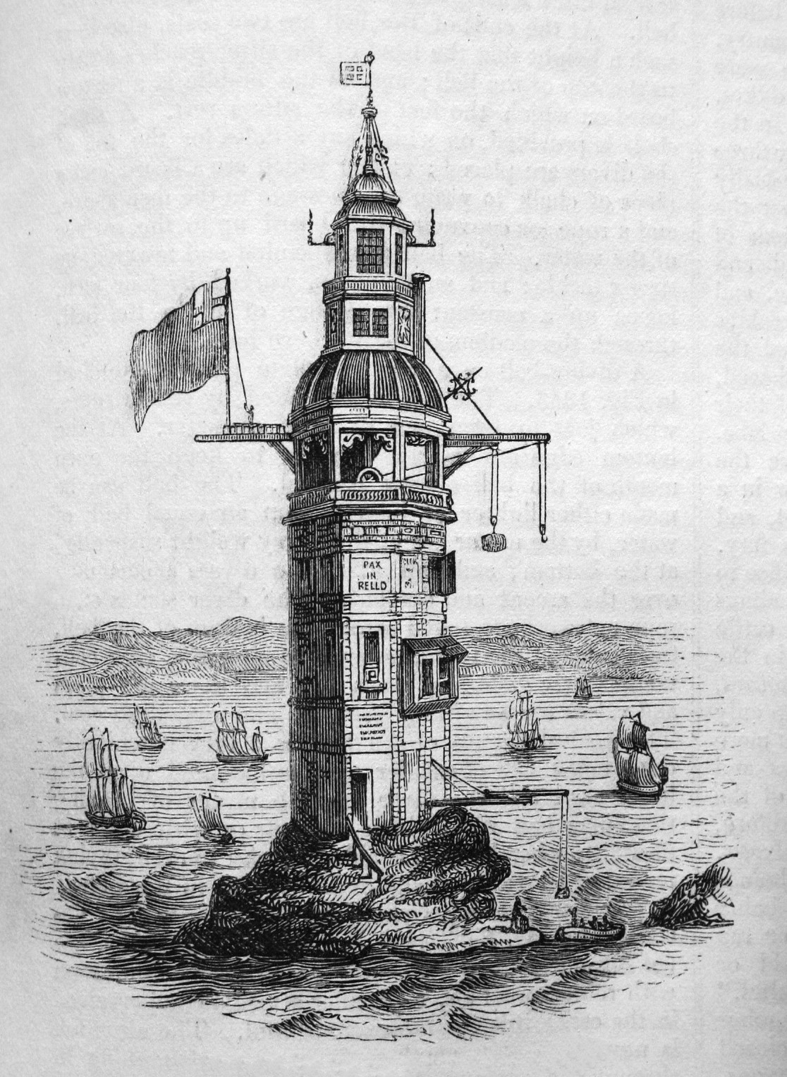

hurricane
- Pyrate Legend
- Member

- 2,672 posts
- Gender:Male
- Location:Seattle, Washington
- Interests:Songs of a nautical nature, wine, rum, rum punch, Henry Morgan and Krimson Kat.
Posted June 13, 2008 · Report post
"My father was the keeper of the Eddystone Light..."
-- Hurricane

BriarRose Kildare
- Scourge o' the 7 Seas
- Member

- 2,004 posts
- Location:Pittsbugh Pennsylvania
- Interests:I love History. I have a deep thirst for knowledge and I am rarely with out a book under my nose. Some of my historical interests include: Greco-Roman times, Middle ages, Tudor-Elizabethan, the Golden Age of Pyracy, Napoleonic, French and Indian War, American Revolution, American Civil War, and the Victorian era.<br />Some of my many other interests include: Fencing, belly and romney gypsy dancing, apothecary and herbal healing, disease through out history and how it has effected societies. I also enjoy a good ghost story and I am always ready for ghost hunting. The paranormal absolutely fascinates me. <br />One of my life long dreams is to travel and to sail upon the ocean on a glorious period ship.<br />I also enjoy spending time with friends and family. And above all, I love having fun. And a good drink of Drambuie is always a warm touch to my heart.
Posted June 17, 2008 · Report post
Thank you William for the link. It was a very interesting read and full of a lot of information too.

Captain Tito
- Scourge o' the 7 Seas
- Member

- 1,667 posts
- Interests:Pirates and their history, Latin Music and Dance, Latino Culture and Cuisine, Camping, Snowshoeing.
Posted June 17, 2008 · Report post
Aye m'lovely lass, here be a link to a fine article about some o'the many lighthouses along the St. Lawrence. These here be in Quebec.
Travel World Magazine

Misson
- Dread Pyrate
- Member

- 1,001 posts
- Gender:Male
- Interests:Who me?
Posted June 18, 2008 · Report post
I finally remembered to bring Yonge's book. This is from The Journal of James Yonge, Plymouth Surgeon 1647-1721:
"At last, Nov. 24th [1664], it pleased God we stood over to the eastward of Genoa [in the Mediterranean] to see how favourable that shore would be to us. Falling in between Spetia and Port Pinn, we plyed on to Genoa, and against the wind got in to the old mole [a large man-made stone wall used as a breakwater and built to enclose or protect an anchorage or harbor], within the castle....
Things notable during my stay there were...The Lantern, which is a tall tower, smaller than the steeple of Plymouth Church, but very much higher. On the top it's glazed round with large and very thick glass. In it are 32 lamps of glass, which so hang as not one of them hides the other, so that they give the greater light, and is seen a great way off at sea. It stands near the water side, at the west end of the Haven." (Yonge, p. 70-1)
He also put a bunch of sketches in his journal, including this one of Genoa:

(It's about midway down on the left side. If you Google the Genoa lighthouse, you'll find they think it goes back to the 12th century.)
He mentions the lighthouse at Eddystone as well:
"November 26th this year [1703] happened a most terrible tempest the like never known, in which much damage was done to churches, houses and trees in abundance. Many ships were lost in Catwoller, but not one man-of-war, but the wonderful structure on Edyston was beaten down and in it perished Mr. Winstanly, the contriver and make of it, and 4 more. (Footnote 1: The first lighthouse at Eddystone was built by Winstanly in 1698 and was raised from 80 to 120 feet in the following year. After its destruction in 1703 it was rebuilt by Rudyerd in 1708.)" (Yonge, p. 226-7)

Misson
- Dread Pyrate
- Member

- 1,001 posts
- Gender:Male
- Interests:Who me?
Posted June 29, 2008 · Report post
I found another reference to one:
"[1675] ...yet we hoped we should get to windward of them [the Goodwin Sands] for neither our master nor mate nor any in the ship were very well acquainted with them: yet we hoped we should get to windward of them and carry clear into the Downs, for we saw the lighthouse very fair upon South Foreland, and the land showing as it were not half a mile from us, but it was very dark." (Barlow, p. 259)
The ship, a merchant vessel called the fflorintine eventually wrecked upon the sands, despite the presence of the South Foreland lighthouse [which is in Dover]. You'll be relieved to know that no one was killed.

Misson
- Dread Pyrate
- Member

- 1,001 posts
- Gender:Male
- Interests:Who me?
Posted July 6, 2008 · Report post
And another one -
"[1681]...and then we began to look out for land, and sounding again had sixty fathoms, and by the 'osey' ground we were in the latitude of the Island of Scilly or to the northward of it; so we steered easy by south and E.S.E, intending to steer so till ten of the clock at night; and at seven we espied the lighthouse, which is placed upon the island [of St. Agnes in the Isles of Scilly], and at twelve of the clock the light bore north from us, and the wind veering to the north-west, we steered easy by north; and in the morning we were in sight of England." (Barlow, p. 349)

Misson
- Dread Pyrate
- Member

- 1,001 posts
- Gender:Male
- Interests:Who me?
Posted July 8, 2008 · Report post
Yet another:
"[1687] And at eight at night we were abreast of Dungeness Lighthouse; and having then a fresh gale at north, we steered away west-south-west and sometimes 'lasked' [Footnote 1: 'Lasked' may be best defined by the modern term 'reached'] to the southward; and the next day at eleven of the clock we made land upon the coast of France..." (Barlow, p. 387)
While looking for a web page to give me more details on that lighthouse, I came across this page which those looking for info on lighthouses may find interesting: http://www.lanternroom.com/lighthouses/nlharsel.htm
It seems quite extensive. Check out the Arizona lighthouse in particular!

Matusalem
- Notorious Pyrate
- 
- 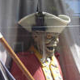
- Member

- 877 posts
- Location:Eastern Seaboard of North America
Posted July 18, 2008 · Report post
1729 engraving of Armed Ship in Boston
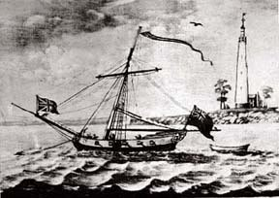

Raphael Misson
- Plunderer
- 
- Member

- 449 posts
- Gender:Male
- Location:Monroe, MI
- Interests:Period Surgery. Designing Stuff. Creating Stuff. Positions of power without title.
Posted July 31, 2008 · Report post
Here's one from The Diary of Henry Teonge:
"[June 15, 1676] We are as far as the lighthouse, on Capt Tygta. (Endnote 214: Cape Kiti [Cyprus]; the S.W. point of the Gulf of Larnaka.)" (Teonge, p. 171)

Mission
- Goat Specialist
- 
- Admin

- 5,081 posts
- Gender:Male
- Location:Monroe, MI
- Interests:Scholarly piracy, designing and creating haunted house rooms and props, movies, abstract thinking, abstruse thinking, obstructive thinking, ideating, random thinking, movies, cartoons, movies, movies scores, cycling, world peace and small furry dogs, movies, writing, drawing, personal skills training, gremlins and, of course, lest I forget, movies.
Posted September 22, 2011 · Report post
From the book The Voyages and Travels of Captain Nathaniel Uring (1928 reprint, first published in 1726): This part of the book takes place in 1709.
"Boston is the chief Town in the Province of Massechusets Bay, it stands upon a Peninsula, at the Bottom of a
__
Bay, which runs in about eight miles, and is fenced with Islands, Rocks, and Sands, which makes it a very secure Harbour; the Entrace into it is narrow, and some Shoals lie on the South Side: Some small rocky Islands, which are called the Brewsters, makes the North Side of it, on one of which Islands stands a Light-House, to give Notice to Ships who may arrive on that Coast in the Night, and be a Guide to them..." (Uring, p. 76-7)

Mission
- Goat Specialist
- Admin

- 5,081 posts
- Gender:Male
- Location:Monroe, MI
- Interests:Scholarly piracy, designing and creating haunted house rooms and props, movies, abstract thinking, abstruse thinking, obstructive thinking, ideating, random thinking, movies, cartoons, movies, movies scores, cycling, world peace and small furry dogs, movies, writing, drawing, personal skills training, gremlins and, of course, lest I forget, movies.
Posted July 26 · Report post
The Opening of the First Eddystone Lighthouse, 1698 by Peter Monomy (c. 1703). This was an octagonal structure built by Henry Winstanley beginning in 1696 located on the Eddystone rocks, 12 miles off of Plymouth Sound.
"England was at war with France at this time and such was the importance of the Eddystone project that the Admiralty provided Winstanley with a warship for protection on the days when work was taking place. One morning at the end of June in 1697 the protective vessel did not arrive; in its stead a French privateer arrived, and subsequently carried Winstanley against his will to France. When Louis XIV heard of the incident he ordered that Winstanley be immediately released saying that 'France was at war with England, not with humanity'." (Trinity House Website, Eddystone Lighthouse, gathered 7/26/16)
