Capt. Bo of the WTF co.
- Scourge o' the 7 Seas
- 
- 
- Member

- 2,339 posts
- Gender:Male
- Location:Spanish Louisiana - on the river Osage
- Interests:Many and varied.
Posted April 15, 2011 (edited) · Report post
OK, so I know this is not pyratey but I am looking for an impression I can do anywhere, anytime besdies my late colonial hide-hunter. I have settled on building myself a portable knife grinding rig based on these ideas. I figure this impression will put me in any time period from Elizibethan to post American Civil War just by changing clothes. Anyone got any thoughts on this?

Thanks...
Bo
Edited April 15, 2011 by Capt. Bo of the WTF co.

Capt. Bo of the WTF co.
- Scourge o' the 7 Seas
- Member

- 2,339 posts
- Gender:Male
- Location:Spanish Louisiana - on the river Osage
- Interests:Many and varied.
Posted April 15, 2011 (edited) · Report post
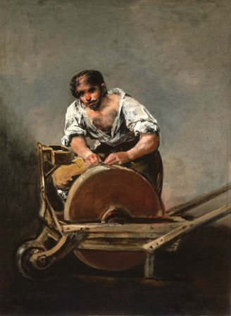
And can anyone help me identify and date this image??? Ever seen it before? This is the one that fits my current clothing the best:
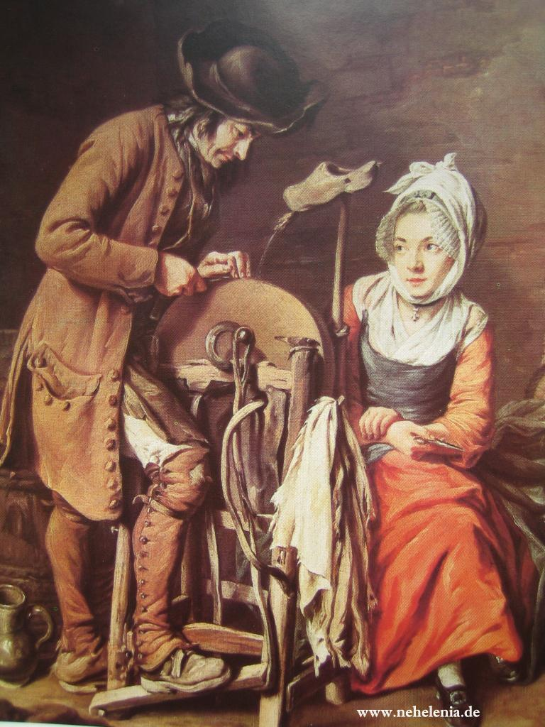
Thanks again...
Bo
Edited April 15, 2011 by Capt. Bo of the WTF co.

Darrel Morris
- Deck Hand
- 
- 
- Member

- 58 posts
- Gender:Male
- Location:Riverside, CA
Posted April 15, 2011 · Report post
What a great idea! Will you be building your own grinding wheel?

Silkie McDonough
- Proprietress of the Sealkies Hide
- 
- 
- Moderator

- 5,695 posts
- Gender:Female
- Location:I have been a Virginian for 2 months now. LOVING it.
- Interests:Music, vocalizing, Irish balads. I love to draw, I do pencile portraits/detail drawings for barter and sale. The link in in my signature. Ireland, its history and culture. Sewing garb, mostly for myself. The arm of a strong gentleman round my waist.
Unfortunately, I don't do nearly enough of any of a these.
Posted April 15, 2011 · Report post
I think it is a great idea! My character isn't a sailor or a pirate. I own an ordinary/tavern/inn/coffee house. Life went on around the port city even when the ships were out. Come to think of it my cleaver needs to be sharpened.

Duchess
- I Make A Good Troll
- 
- 
- Admin

- 1,195 posts
- Gender:Male
Posted April 15, 2011 · Report post
We've got one of those in our shed here. Fair warning, despite the name including the word "portable", they are heavy as hell and not terribly portable.
But I do think it is a great idea!

Cuisto Mako
- Ship's Master
- 
- 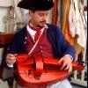
- Member

- 152 posts
Posted April 15, 2011 · Report post
Love it! Very cool idea!

Mission
- Goat Specialist
- 
- Admin

- 5,082 posts
- Gender:Male
- Location:Monroe, MI
- Interests:Scholarly piracy, designing and creating haunted house rooms and props, movies, abstract thinking, abstruse thinking, obstructive thinking, ideating, random thinking, movies, cartoons, movies, movies scores, cycling, world peace and small furry dogs, movies, writing, drawing, personal skills training, gremlins and, of course, lest I forget, movies.
Posted April 15, 2011 · Report post
Most surgical outfits were purchased from cutlery shops during period.
As Duchess notes, that wheel is basically a big, dense stone. If you were going to take it around to events, you'd probably be wise to just mount it on a trailer and then cover the base of the trailer up once you got to your spot at the event. It would look like you were grinding from a platform, which could actually be advantageous for presenting to crowds. It would certainly give you a unique presentation, though.

jendobyns
- Pyrate Captain
- 
- 
- Member

- 562 posts
- Gender:Female
- Location:Baltimore
- Interests:too numerous to mention, really. Period foodways, baroque dance, material culture, etc., etc.
Posted April 15, 2011 · Report post
No idea of origin of the top pic, other than that it looks rather late, possibly Victorian in style.
The second pic is most likely second half 18C, probably continental if the sabot being used as a water reservoir for the wheel is anything to go by afaik. I've seen it somewhere else on the web, but can't remember where.
Good look finding the source.
On 4/15/2011 at 0:07 AM, Capt. Bo of the WTF co. said:
And can anyone help me identify and date this image??? Ever seen it before? This is the one that fits my current clothing the best:
Thanks again...
Bo

Jas. Hook
- Scourge o' the 7 Seas
- 
- Member

- 1,650 posts
- Gender:Male
- Location:Long Island NY
- Interests:Fishing & Piracy
Posted April 15, 2011 · Report post
'Bo the Grinder'...
Sounds like a plan. I think maybe downsizing the stone might help in portability. The painting with the sabot being used as a water reservoir the grind stone seems a bit smaller than the others illustrated.
Jas. Hook

Capt. Bo of the WTF co.
- Scourge o' the 7 Seas
- Member

- 2,339 posts
- Gender:Male
- Location:Spanish Louisiana - on the river Osage
- Interests:Many and varied.
Posted April 15, 2011 (edited) · Report post
I have the stone picked out and yes they are heavy, we had an iron pedal grinder on the farm with a tractor type seat and double pedals. it dodint go very far. If you will notice, most of the rigs I am looking at are built on wheelbarrow type structures, and as veteran contsruction worker, I am sure I can build something I can handle. My stone is only about 16-18 inches instead of the bigger 24-30 inch ones.
The top picture in the second post is a *Francisco De Goya (1746-1828) from the late 18th century(?)or early 19th.* It is the second one I am most curious about, appears to maybe be French from about 1740-1760?
*edited portion*
bo
Edited April 15, 2011 by Capt. Bo of the WTF co.

michaelsbagley
- Smells Like Wet Sheep
- 
- 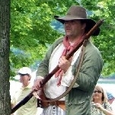
- Moderator

- 2,548 posts
- Gender:Male
- Location:Columbus, Ohio
- Interests:Mostly into GAoP, but starting to develop more Buccaneer era stuff for re-enacting as well. Generally I do re-enact both piratical/nautical and other impressions from the period. I am focusing on more "common" impressions from the period (i.e. average sailor/pirate, rank and file Red Coat, early Colonial huntsman, etc.)
Posted April 15, 2011 · Report post
On 4/15/2011 at 0:02 AM, Capt. Bo of the WTF co. said:
OK, so I know this is not pyratey but I am looking for an impression I can do anywhere, anytime besdies my late colonial hide-hunter. I have settled on building myself a portable knife grinding rig based on these ideas. I figure this impression will put me in any time period from Elizibethan to post American Civil War just by changing clothes. Anyone got any thoughts on this?

Thanks...
Bo
Love the idea and concept.... as it is a portrayal that will get you through hundreds of years with only different clothes.
Sorry I can't help identify the provenance of the picture you are wondering about, but I would love to know the year and artist of the picture above! If anyone has the details on that.

Cuisto Mako
- Ship's Master
- Member

- 152 posts
Posted April 15, 2011 · Report post
the one with the sabot reminded me of Jean Baptiste Simeon Chardin, but a google search of his painting didn't come up with the knife grinder scene, so propbably not him...

Capt. Bo of the WTF co.
- Scourge o' the 7 Seas
- Member

- 2,339 posts
- Gender:Male
- Location:Spanish Louisiana - on the river Osage
- Interests:Many and varied.
Posted April 15, 2011 (edited) · Report post
Michael, I'll go back to the site I got it from and see iff there is any more information.
OK, the best I can do is the painters name and lifespan, none of the galleries offering repros give the date of the image itself. It was painted by Antonio Puga, 1602-1648. I tried several different searches but cannot find the date of the painting itself. Hope this helps some.
Bo
Bo
Edited April 15, 2011 by Capt. Bo of the WTF co.

Gentleman of Fortune
- Dread Pyrate
- 
- Member

- 1,456 posts
- Gender:Male
- Location:Germany... Franconia (northern Bavaria)
- Interests:I *used* to be an environmental scientist, until I married a DoDDs teacher in 1997. Since then, I have been living in, and traveling around, Europe (First the UK, now Germany).
My hobbies are all the "usual suspects" for those interested in re-enacting and Golden Age of Piracy stuff.... but I have drifted away from the pirate scene as my location and young family don't allow for any more than "virtual" pirate participation. Besides Piracy, I am into Reverend Guitars and Vintage Corvettes.
Posted April 26, 2011 · Report post
GREAT Idea!
Not only is it super cool, but I bet you could actually MAKE MONEY by sharping stuff at the events!
**For those of you who have yet to figure it out, if you can get the hobby to pay for itself, you will have the system licked! AND it will keep your spouse off your back (somewhat!)***
Can't wait to see pictures of you plying your trade!

Capt. Bo of the WTF co.
- Scourge o' the 7 Seas
- Member

- 2,339 posts
- Gender:Male
- Location:Spanish Louisiana - on the river Osage
- Interests:Many and varied.
Posted May 9, 2011 · Report post
Found my grindstone today! My best friend and I were going through his junk piles in the back forty, and out popped a 14" wheel on a metal stand with modern type rigging. he forgot having it. I will need to do some re-facing and of course make it all more primitive/period, but the stone was the most important and elusive item. This one came free, so that makes things go a lot faster! I already have my oak lumber, and metal aplenty to make all the hardware I will need. I may have it operational by Ft. DeChartres if all goes well.
Bo

William Brand
- Mercury Malefactor
- 
- Admin

- 8,884 posts
- Gender:Male
- Location:Logan, Utah
- Interests:My name is William Pace and I live and work as a graphic designer, illustrator and photographer in Northern Utah. I'm married to the lovely Tracy Pace and we have three children. In addition to all things art, I enjoy traveling and meeting new people from every walk of life. I've always been a fan of history, theology, and of course, Pyracy.
http://www.youtube.com/watch?v=PSkt-q-HihQ
Posted May 9, 2011 · Report post
That's a great idea. I used to sharpen all the tools at the American West Heritage Center on a very similar rig. It was a great gig, because I was in the shade all day and I enjoyed the work.

Dutchman
- Has anyone seen my cousin?
- 
- Admin

- 1,773 posts
- Gender:Male
- Location:tidewater virginia
Posted May 9, 2011 · Report post
hey bo,
great find! I love the picture with the wooden shoe being used as the watering can. Find an online book called market faire- i'll find the author when i get home. He has a section on the different vendors found at a colonial market and i think almost two pages are dedicated to descriptions of sharpeners and their stones. I think the book is $10 or so. he has it locked so you can't copy any of it unfortunately. I think it would go over well as there tend to be a lot of dull blades and axe heads at encampments and lots of people don't have the equipment/patience to sharpen a blade properly.

Iron Hand
- First Mate
- 
- 
- Member

- 220 posts
- Location:Hanford,Ca
- Interests:I'm envolved in RevWar and Pyratical Reenacting.Own my own boat, tho she be a small sail of 21'. Sailed the Lady Washington,The Swift,and Royalist.Currently I Captain the "Lost Souls of the Iron Brigade", I'm a minstrel, songwriter,Captain,sailor,and excellent gunner. Likes me Rum.
Posted May 9, 2011 · Report post
Damn Good Idea Bo. I was gonna suggest a smaller stone pump driven by foot, but hte bigger one sounds too cool....

Cuisto Mako
- Ship's Master
- Member

- 152 posts
Posted May 10, 2011 · Report post
Found another one, late 17th century
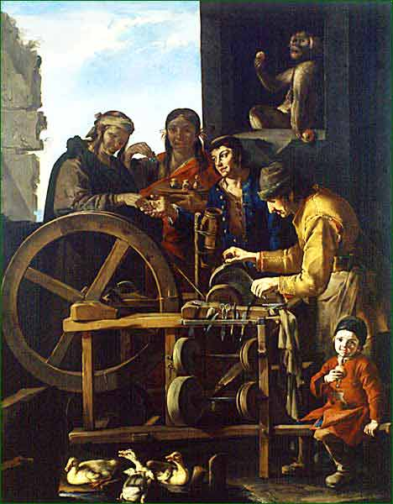
le rémouleur
by Giacomo Francesco Cipper dit Il Todeschini

Capt. Bo of the WTF co.
- Scourge o' the 7 Seas
- Member

- 2,339 posts
- Gender:Male
- Location:Spanish Louisiana - on the river Osage
- Interests:Many and varied.
Posted May 10, 2011 · Report post
WOW! That is fantatsic!!! He has three different grinder/buffer mandrel set-ups! That's pretty amazing for the period. this guy is a true professional grinder.
As an aside, is it me or does anyone else notice the frequent number of monkeys that appear in many GAoP paintings/images?!? (That is a monkey above the people isn't it?)
Bo

Dutchman
- Has anyone seen my cousin?
- Admin

- 1,773 posts
- Gender:Male
- Location:tidewater virginia
Posted May 10, 2011 · Report post
ah I learned this one from one of those touchy feely art appreciation classes I had to sit through for work. animals and plants were used as symbolism. it's in the background so it is a symbol rather than a subject of the art itself. depending on the source monkeys stand for agility and playfulness or mischief, mimicry, cunning, benevolence.
Sorry Bo, blondie says no to a pet monkey

capn'rob
- Pyrate Captain
- Member

- 535 posts
- Gender:Male
- Location:Morehead City, NC
- Interests:Cruising, power or sail. Music and Maritime History. Pilaging, Plundering and General Mayhem!
Posted May 10, 2011 (edited) · Report post
Either wot Dutch sez or wun ugli nipper!
On a serious note. As a kid, a man would come through our neighborhood fairly regular with a cart drawn by a pony. He was rigged to sharpen anything you'd have in that age of antiquity, the 50s. He did knives, scissors, scyths and lawnmowers. I only remember one neighbor with a power mower and he sharpened his own. If I recall, his various stones were on a treadle powered shaft. I would walk a while and watch him until he moved on from our neighborhood. We had a Fishmonger, Fruit and Veg. Man and the Rag Man. They all had horse or ass drawn carts. The Tinkers, although you could find them to do the work they did, no longer plyed their trade by cart. My father-in-law was one of the last of the men who could mend the copper leaders, gutters and flashing. A Tinker.
Edited May 10, 2011 by capn'rob

Capt. Bo of the WTF co.
- Scourge o' the 7 Seas
- Member

- 2,339 posts
- Gender:Male
- Location:Spanish Louisiana - on the river Osage
- Interests:Many and varied.
Posted May 11, 2011 (edited) · Report post
Here is my wheel. It has a chip in it that I hope I can resurface. I won't be doing other peoples knives unless I can get it repaired, but axes and tommyhawks will be OK I think. Anyhow, I have set a goal to have it "functional" by Fort DeChartres.
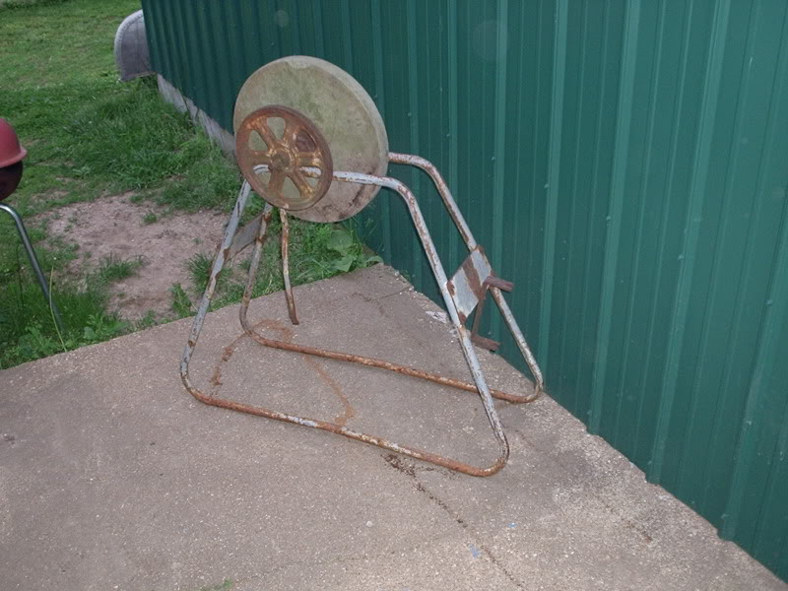
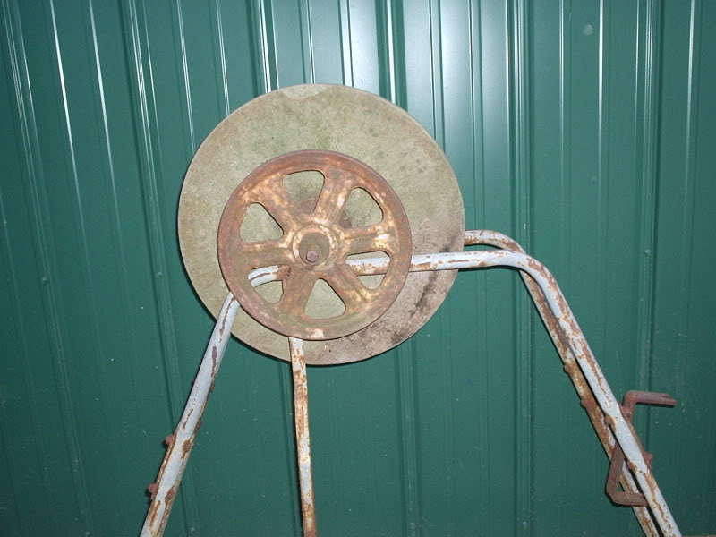
I'll try to keep photo-track of my progress on this one, but I'm not very good at taking pictures. Once I get started on something I pretty much go start-to-finish if everything is going well.
Bo
Edited May 31, 2011 by Capt. Bo of the WTF co.

John Maddox Roberts
- First Mate
- Member

- 272 posts
Posted May 11, 2011 · Report post
As part of your impression, remember that being an itinerant knife-and-scissors grinder puts you pretty close to the bottom of the working class, about the equivalent of a 20th century shoe-shine boy. This could entail a lot of forelock-tugging. On the plus side, the calling had quite a few nice street cries, "Knives to grind! Scissors to grind!" being about the simplest. There are some good studies of British street cries to be found, some of them including recordings. This is something often lacking in reenactment. Most of us don't imagine how noisy cities were during the day, with everyone with goods or services to sell bellowing at the top of their lungs, trying to outshout the competition. It's a great idea. As an aside, in "A Tramp Abroad" Mark Twain describes a German grinder whose specialty was sharpening the swords used by the Heidelberg duelling fraternities. He said, "After he was done, you could shave with a blade he'd sharpened."

Capt. Bo of the WTF co.
- Scourge o' the 7 Seas
- Member

- 2,339 posts
- Gender:Male
- Location:Spanish Louisiana - on the river Osage
- Interests:Many and varied.
Posted May 31, 2011 · Report post
Well, I managed to make a little progress but not much. Today was too humid and sticky to work the forge so I went back to this project. I was hoping to get the thing resurfaced today and off the original stand. I got halfway and the old bearings shelled. At least it isn't egg-shaped anyore. I didn't get past the chip though. So I got out the pullers and penetrating oil and took it off the stand. I set it up on my temporary stand but decided it is too cheesy looking to use so we now have another saddle stand.
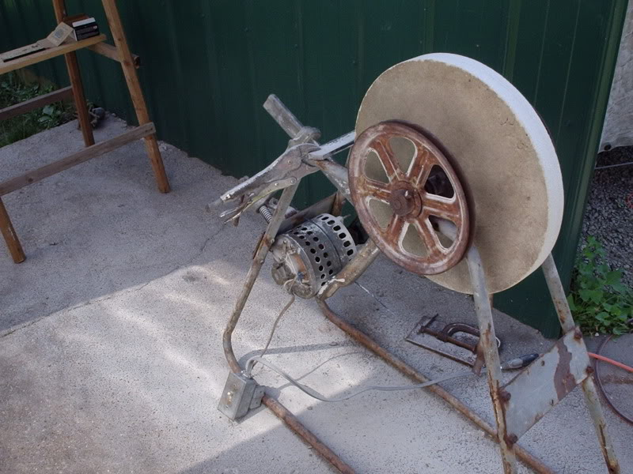
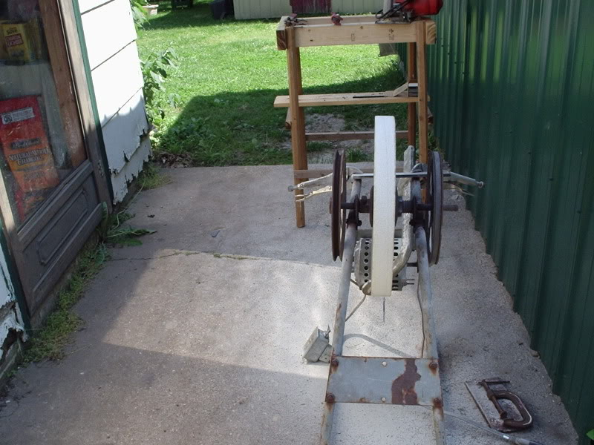
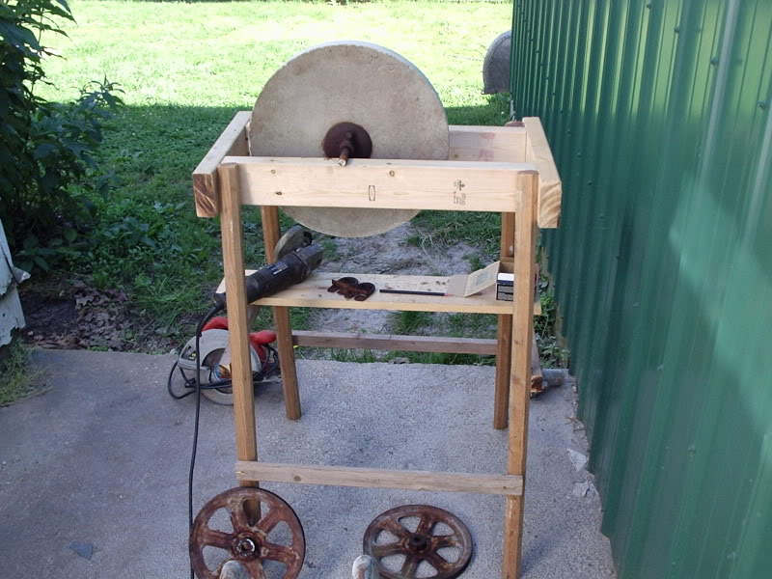
I was hoping to have it ready for this weekend but that isn't going to happen. I'll have to re-mount it and hook it back up to the electric motor to finish resurfacing before I can mount it permanently and use it.
Dangitt!
Bo

William Brand
- Mercury Malefactor
- Admin

- 8,884 posts
- Gender:Male
- Location:Logan, Utah
- Interests:My name is William Pace and I live and work as a graphic designer, illustrator and photographer in Northern Utah. I'm married to the lovely Tracy Pace and we have three children. In addition to all things art, I enjoy traveling and meeting new people from every walk of life. I've always been a fan of history, theology, and of course, Pyracy.
http://www.youtube.com/watch?v=PSkt-q-HihQ
Posted June 1, 2011 · Report post
I was and still am looking forward to the finished product.

Capt. Bo of the WTF co.
- Scourge o' the 7 Seas
- Member

- 2,339 posts
- Gender:Male
- Location:Spanish Louisiana - on the river Osage
- Interests:Many and varied.
Posted June 1, 2011 · Report post
The original shaft is bent too. I took it out this morning after letting the penatrating oil soak on it overnight. I have a piece of stock for that. Gonna have to wait til after this wekend to finish the project though. Gotta start packing!
Bo

Capt. Bo of the WTF co.
- Scourge o' the 7 Seas
- Member

- 2,339 posts
- Gender:Male
- Location:Spanish Louisiana - on the river Osage
- Interests:Many and varied.
Posted June 11, 2011 · Report post
Ever had one of those sudden memory flashes that just about knocks your knees loose from under ya?
I was working around the shop preparing to work some more on this project when suddenly I got this flash of memory of the Whydah exhibit, which I have seen twice.
In the belowdecks display with the sleeping sailor and the surgery, there was also the carpenters display. I am certain there was a grinder set-up in that display. I cannot remember if it was a hand-crank or tredle type. On pg. 130 of the Real Pirates book I bought from the gift shop at the Field Museumis a photo of a grindstone, so I know they had one at least.
I have been looking through google and ask.com images and tried several searches but cannot find any images of the grinder unit on-line. (probably copyright issues). Does anyone know of any, *ahem* pyrated images of it, or remember it well enough to say whetehr it was hand-cranked or tredle powered?
Always cool when a project can be directly documented to pyrates!!!
Bo

Dorian Lasseter
- Where's My Water
- 
- Member

- 3,266 posts
- Gender:Male
- Location:The Sea!
- Interests:18th Century reenactment; Maritime, F&I...
Did ECW as well...
All BP firelocks and cannons!
Also enjoy Swordfighting and a good Donnybrook
Got a question for or about me? Ask!!!
Posted June 12, 2011 · Report post
Oi Bo,
Grand idea for an impression!
I have in front of me a copy of the book; Real Pirates, the untold story of the Whydah...
On page 130 is a picture of the grindstone and is noted as such;
"Operated by hand-crank, a grindstone was essential equipment on board the Whydah. The carpenter had many tools that needed to be kept sharp. The grindstone was also used to sharpen blades on weapons and kitchen knives."
Sadly, there is no dimensions listed as to the size of the stone. Also no idea what the hand-crank rig for it looked like.
Yrs&c,
Dorian

Capt. Bo of the WTF co.
- Scourge o' the 7 Seas
- Member

- 2,339 posts
- Gender:Male
- Location:Spanish Louisiana - on the river Osage
- Interests:Many and varied.
Posted June 12, 2011 · Report post
Funny, I read that and looked at it several times and still had to ask...
I believe I am going to make mine intercahngeable for different situations. A hand-crank will be good to interact with the public/school kids when necessary, (or to keep one of my kids busy diuring an event), and use the foot treadle when I will be doing just solo demos. No big trick to it really so I might as well design this thing right from the start huh?
Bo

PoD
- Pyrate Captain
- 
- Member

- 696 posts
- Gender:Male
- Location:Warrington UK
- Interests:Pirates, graphic novels, computer art, Listening to music, Going to gigs, Beer and Wine drinking, historical research, Period weaponry and Leatherwork
Posted June 24, 2011 · Report post
just came across this image at the british museum from 1688
The Cryes of the City of London Drawne after the Life / Knives or cisers to Grinde
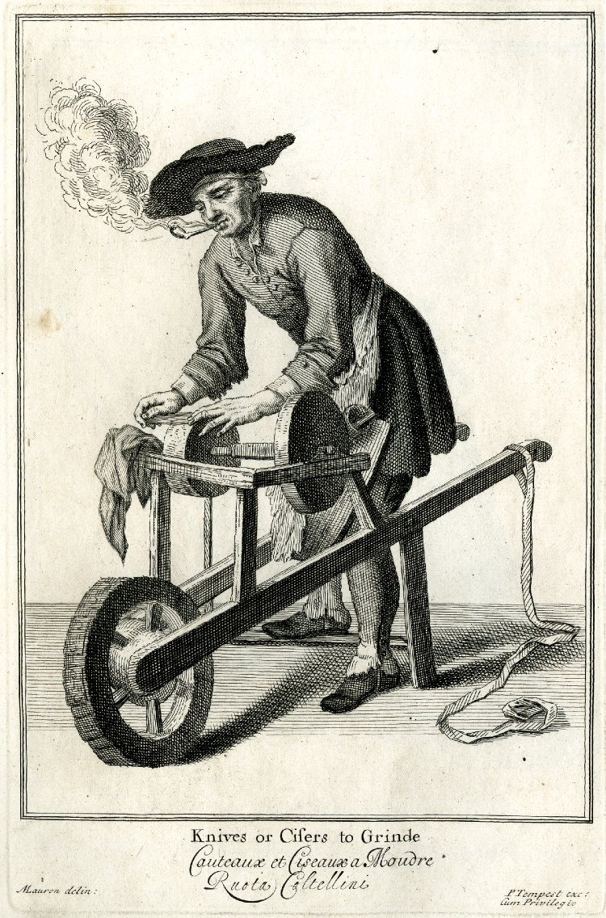

Capt. Bo of the WTF co.
- Scourge o' the 7 Seas
- Member

- 2,339 posts
- Gender:Male
- Location:Spanish Louisiana - on the river Osage
- Interests:Many and varied.
Posted June 24, 2011 · Report post
This is interesting on many levels! Thanks PoD!!!
No water reservoir, he's wearing a doo-rag under his hat,and leggins!!! (although they don't appera to have buttons)
The over-the-shoulder strap to help carry the weight of the grinder,and two stones, one for grinding and one for the finish/polish?
Nice find, thanks again.
Bo

PoD
- Pyrate Captain
- Member

- 696 posts
- Gender:Male
- Location:Warrington UK
- Interests:Pirates, graphic novels, computer art, Listening to music, Going to gigs, Beer and Wine drinking, historical research, Period weaponry and Leatherwork
Posted June 24, 2011 · Report post
theres another example here (this time german) from 1645-1700
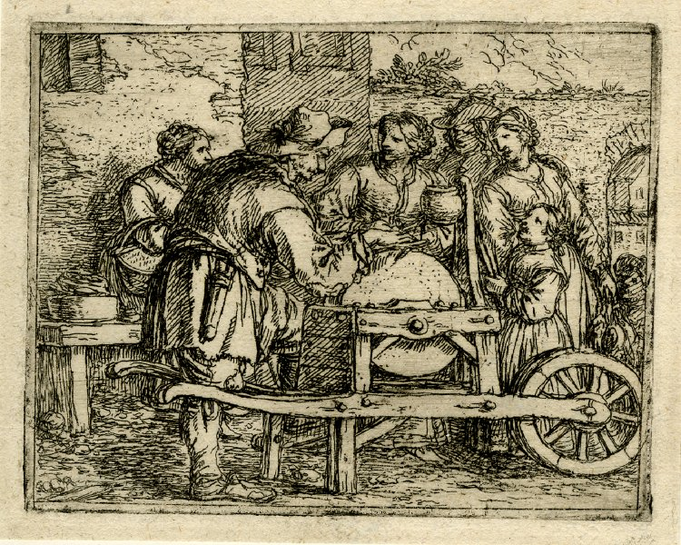
I am wondering that that little sheath thing is that he has on his belt

Grymm
- First Mate
- 
- Member

- 281 posts
- Gender:Male
- Location:Chilterns UK
- Interests:Stuff
Posted June 24, 2011 (edited) · Report post
In creamware possible 18thc or a 19thC copy of an 18thC painting

Hogarths The Enraged Musician (Grinder is bottom right)

Edited June 24, 2011 by Grymm

Grymm
- First Mate
- Member

- 281 posts
- Gender:Male
- Location:Chilterns UK
- Interests:Stuff
Posted June 24, 2011 · Report post
A Watteau
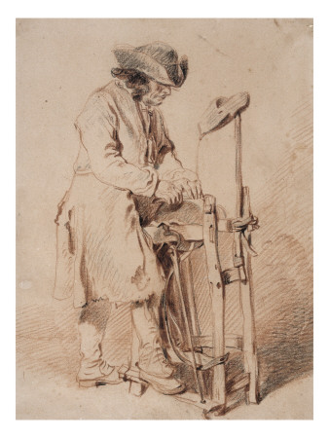
late 16thC -mid 17thC Dutch

Dutch circa 1630-50

Teniers mid 17thC
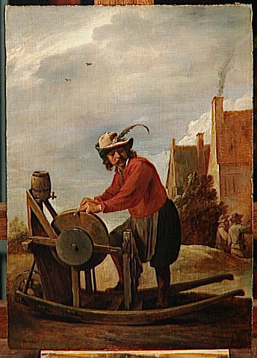

William Brand
- Mercury Malefactor
- Admin

- 8,884 posts
- Gender:Male
- Location:Logan, Utah
- Interests:My name is William Pace and I live and work as a graphic designer, illustrator and photographer in Northern Utah. I'm married to the lovely Tracy Pace and we have three children. In addition to all things art, I enjoy traveling and meeting new people from every walk of life. I've always been a fan of history, theology, and of course, Pyracy.
http://www.youtube.com/watch?v=PSkt-q-HihQ
Posted July 3, 2011 · Report post
No shortage of good examples. Wow. I like the little details, such as the water cask.

Capt. Bo of the WTF co.
- Scourge o' the 7 Seas
- Member

- 2,339 posts
- Gender:Male
- Location:Spanish Louisiana - on the river Osage
- Interests:Many and varied.
Posted January 12, 2012 · Report post
I have completed the grinder and use it regularly. Deer season made for a great trial period as I and many of my neighbors were successful. I am getting much more proficient in its use as more people bring knives to me just to see it in use. I wish I had the ability to post photos, but will have to wait for an event whereby someone else will have to take and post them. I no longer have those capabilities at my disposal.
Bo

William Brand
- Mercury Malefactor
- Admin

- 8,884 posts
- Gender:Male
- Location:Logan, Utah
- Interests:My name is William Pace and I live and work as a graphic designer, illustrator and photographer in Northern Utah. I'm married to the lovely Tracy Pace and we have three children. In addition to all things art, I enjoy traveling and meeting new people from every walk of life. I've always been a fan of history, theology, and of course, Pyracy.
http://www.youtube.com/watch?v=PSkt-q-HihQ
Posted January 13, 2012 · Report post
I have noticed my share of monkeys. The exotic animal in vogue at the time.
Have you decided which example you'll follow for your impression? I really look forward to this one.

Mister Tossinpots
- Bilge Rat
- 
- 
- Member

- 12 posts
- Gender:Male
- Location:idaho
- Interests:black powder, rendezvous, hunting, fishing, pirate movies
Posted January 17, 2012 · Report post
On 1/12/2012 at 11:57 AM, Capt. Bo of the WTF co. said:
I have completed the grinder and use it regularly. Deer season made for a great trial period as I and many of my neighbors were successful. I am getting much more proficient in its use as more people bring knives to me just to see it in use. I wish I had the ability to post photos, but will have to wait for an event whereby someone else will have to take and post them. I no longer have those capabilities at my disposal.
Bo
camera break?

Stynky Tudor
- Fugitive at large
- 
- Admin

- 2,339 posts
- Gender:Male
- Location:Wandering Spanish held Territories of the New World
- Interests:I'm not interested in anything or anybody & I hate you.
Posted January 18, 2012 · Report post
Wow, very cool - great images!
Can't wait to see your impression.

Capt. Bo of the WTF co.
- Scourge o' the 7 Seas
- Member

- 2,339 posts
- Gender:Male
- Location:Spanish Louisiana - on the river Osage
- Interests:Many and varied.
Posted January 19, 2012 · Report post
On 1/17/2012 at 9:06 PM, Mister Tossinpots said:
camera break?
Nope, but I don't have access to the net at home anymore and the library won't let me do it here. Something about liability/porn issues or some such trouble they had in the past.
I am going with the stationary rig for now. I still would like to make the wheelbarrow rig, but I really like the impression of the scissors grinder with the pretty young lady seated in front of the grinder from the first page of this thread. Also, the grinder rig from the Whydah exhibit is a stationary rig. I am still in the design stages but will build the wheelbarrow rig so that all I will have to do is remove the wheel assembly and mount it on the frame so as to be interchangeable.
Bo

Gentleman of Fortune
- Dread Pyrate
- Member

- 1,456 posts
- Gender:Male
- Location:Germany... Franconia (northern Bavaria)
- Interests:I *used* to be an environmental scientist, until I married a DoDDs teacher in 1997. Since then, I have been living in, and traveling around, Europe (First the UK, now Germany).
My hobbies are all the "usual suspects" for those interested in re-enacting and Golden Age of Piracy stuff.... but I have drifted away from the pirate scene as my location and young family don't allow for any more than "virtual" pirate participation. Besides Piracy, I am into Reverend Guitars and Vintage Corvettes.
Posted February 22, 2012 · Report post
Whats the latest with the project?

Capt. Bo of the WTF co.
- Scourge o' the 7 Seas
- Member

- 2,339 posts
- Gender:Male
- Location:Spanish Louisiana - on the river Osage
- Interests:Many and varied.
Posted March 21, 2012 · Report post
On 2/22/2012 at 11:30 AM, Gentleman of Fortune said:
Whats the latest with the project?
Sorry, don't get to the library often these days. I have the grinder up and running, just came from the flea-market and scored some good primitive whetstones to go with the kit. Due to the recent sudden passing of my best friend and brother (who gave me the grinding wheel-stone) I just don't know if I'll ever get back into playing anymore. Kinda took the wind outta my sails so-to-speak. I have my application in to participate in the juried Trade Faire event at Fort de Chartres at the end of the month, but not sure if I will do it or not. If so, I'll see if anyone there will post some pic's of the set-up here.
Not sure if I'll ever get out again now. "Big Ed" was my anchor in life, and without him I am adrift.
Bo

Gentleman of Fortune
- Dread Pyrate
- Member

- 1,456 posts
- Gender:Male
- Location:Germany... Franconia (northern Bavaria)
- Interests:I *used* to be an environmental scientist, until I married a DoDDs teacher in 1997. Since then, I have been living in, and traveling around, Europe (First the UK, now Germany).
My hobbies are all the "usual suspects" for those interested in re-enacting and Golden Age of Piracy stuff.... but I have drifted away from the pirate scene as my location and young family don't allow for any more than "virtual" pirate participation. Besides Piracy, I am into Reverend Guitars and Vintage Corvettes.
Posted March 22, 2012 · Report post
Sorry to hear of your brother's passing. Gotta be tough as I am close with both my brothers as well (I am in the middle)
But if they gave you the Grinding stone, I would imagine that he would want you to keep on, keeping on. And do it, have fun with it, and think of him.
Ya gotta walk your own path though.
I'll be praying for you.

William Brand
- Mercury Malefactor
- Admin

- 8,884 posts
- Gender:Male
- Location:Logan, Utah
- Interests:My name is William Pace and I live and work as a graphic designer, illustrator and photographer in Northern Utah. I'm married to the lovely Tracy Pace and we have three children. In addition to all things art, I enjoy traveling and meeting new people from every walk of life. I've always been a fan of history, theology, and of course, Pyracy.
http://www.youtube.com/watch?v=PSkt-q-HihQ
Posted March 22, 2012 · Report post
I would like to see you complete the impression, as much for yourself as Big Ed. It's a great new idea and I believe people would find it fresh and interesting. It's such a good idea for re-enacting.

peglegstrick
- Dread Pyrate
- 
- Member

- 1,203 posts
- Gender:Male
- Location:Funston Ga
Posted March 22, 2012 · Report post
I was the youngest of 7 kids...5 boys & 2 girls. Have lost 3 brothers now. You keep going.....that is what they would want.
I know you have been through a lot Bo.... with our back & forth conversations and you seem like a fighter. Keep on going my friend.
I'm Praying for you too..... Pegleg

Capt. Bo of the WTF co.
- Scourge o' the 7 Seas
- Member

- 2,339 posts
- Gender:Male
- Location:Spanish Louisiana - on the river Osage
- Interests:Many and varied.
Posted March 24, 2012 · Report post
OK, I have access to publish photo's so here is the new impression so far:
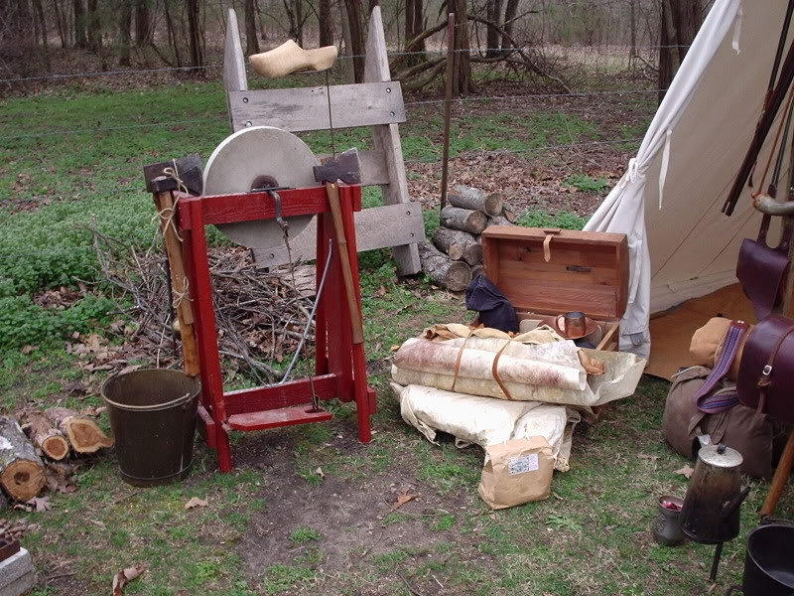
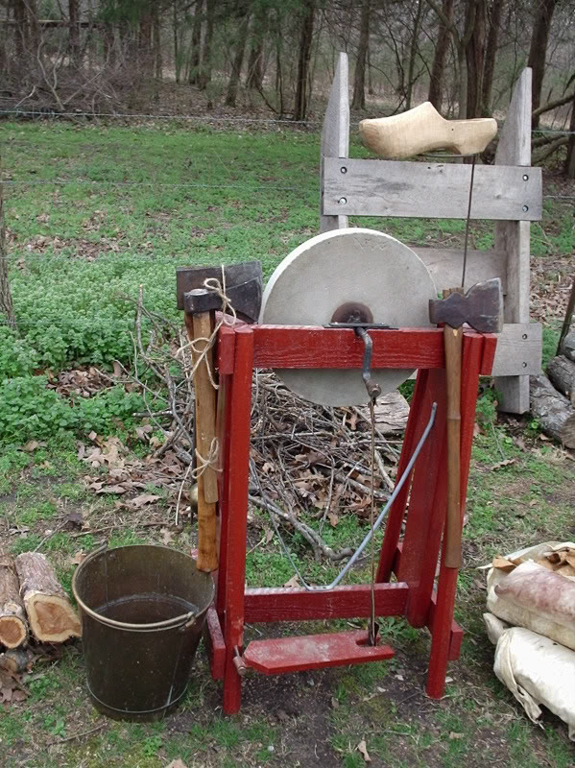
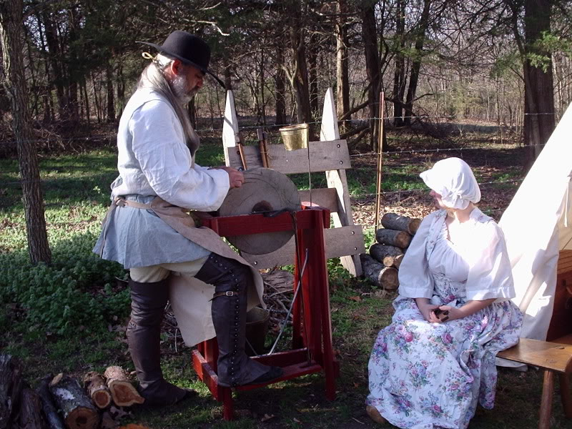
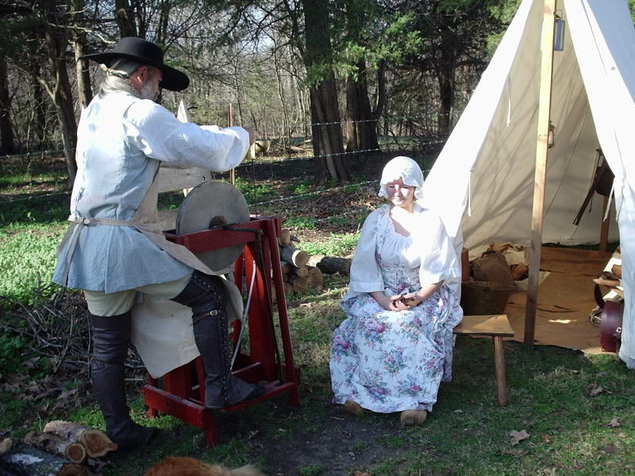
I hope this works...enjoy...
Bo

Capt. Bo of the WTF co.
- Scourge o' the 7 Seas
- Member

- 2,339 posts
- Gender:Male
- Location:Spanish Louisiana - on the river Osage
- Interests:Many and varied.
Posted March 24, 2012 · Report post
I just found the wooden shoes at one of the local flea-markets and have not yet brought myself to bore a hole in them to use as the water dispenser. They are perfectly good wooden shoes and they actually fit Rose, so I am still looking for and old beat-up pair or single if anyone sees one or two for this purpose.
Bo

William Brand
- Mercury Malefactor
- Admin

- 8,884 posts
- Gender:Male
- Location:Logan, Utah
- Interests:My name is William Pace and I live and work as a graphic designer, illustrator and photographer in Northern Utah. I'm married to the lovely Tracy Pace and we have three children. In addition to all things art, I enjoy traveling and meeting new people from every walk of life. I've always been a fan of history, theology, and of course, Pyracy.
http://www.youtube.com/watch?v=PSkt-q-HihQ
Posted March 24, 2012 · Report post
That is a fantastic impression, believable and well executed.
On 3/24/2012 at 10:47 AM, Capt. Bo of the WTF co. said:
I just found the wooden shoes at one of the local flea-markets and have not yet brought myself to bore a hole in them to use as the water dispenser. They are perfectly good wooden shoes and they actually fit Rose, so I am still looking for and old beat-up pair or single if anyone sees one or two for this purpose.
Bo
I will look about for one. It would be a shame to ruin a good shoe if an old one may be found.

William Brand
- Mercury Malefactor
- Admin

- 8,884 posts
- Gender:Male
- Location:Logan, Utah
- Interests:My name is William Pace and I live and work as a graphic designer, illustrator and photographer in Northern Utah. I'm married to the lovely Tracy Pace and we have three children. In addition to all things art, I enjoy traveling and meeting new people from every walk of life. I've always been a fan of history, theology, and of course, Pyracy.
http://www.youtube.com/watch?v=PSkt-q-HihQ
Posted March 24, 2012 · Report post
Just a few off ebay....
http://www.ebay.com/itm/Vtg-Pair-Unpainted-Unfinished-REAL-Non-souvenir-Wood-Wooden-Dutch-Holland-Shoes-/260981102172?pt=LH_DefaultDomain_0&hash=item3cc3af965c
http://www.ebay.com/itm/WOODEN-SHOES-from-HOLLAND-ca-World-War-Two-/251024089121?pt=LH_DefaultDomain_0&hash=item3a7233a021
http://www.ebay.com/itm/Hand-made-wooden-shoes-purchased-in-Holland-never-worn-/320874055309?pt=LH_DefaultDomain_0&hash=item4ab595868d

peglegstrick
- Dread Pyrate
- Member

- 1,203 posts
- Gender:Male
- Location:Funston Ga
Posted March 24, 2012 · Report post
Very nice Bo......Great and original impression!

Gentleman of Fortune
- Dread Pyrate
- Member

- 1,456 posts
- Gender:Male
- Location:Germany... Franconia (northern Bavaria)
- Interests:I *used* to be an environmental scientist, until I married a DoDDs teacher in 1997. Since then, I have been living in, and traveling around, Europe (First the UK, now Germany).
My hobbies are all the "usual suspects" for those interested in re-enacting and Golden Age of Piracy stuff.... but I have drifted away from the pirate scene as my location and young family don't allow for any more than "virtual" pirate participation. Besides Piracy, I am into Reverend Guitars and Vintage Corvettes.
Posted March 24, 2012 · Report post
Bo... you nailed' it.
Looks outstanding! What a cool idea, and useful too.
Cheers!

landlubbersanonymous
- Plunderer
- 
- 
- Member

- 354 posts
- Gender:Not Telling
- Location:California, USA
- Interests:History, arts, collecting, reenacting
Posted March 24, 2012 · Report post
Here's another one. Slightly post GAOP.
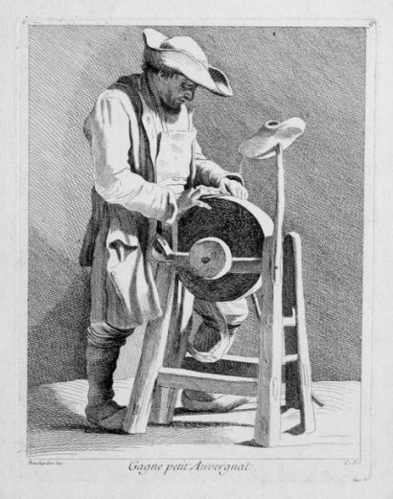
Blade Sharpener Les Cris De Paris 1737-46 (Artist Comte de Caylus)

Dutchman
- Has anyone seen my cousin?
- Admin

- 1,773 posts
- Gender:Male
- Location:tidewater virginia
Posted March 24, 2012 · Report post
big ed's a-watchin and smilin mate. well done!

Mission
- Goat Specialist
- Admin

- 5,082 posts
- Gender:Male
- Location:Monroe, MI
- Interests:Scholarly piracy, designing and creating haunted house rooms and props, movies, abstract thinking, abstruse thinking, obstructive thinking, ideating, random thinking, movies, cartoons, movies, movies scores, cycling, world peace and small furry dogs, movies, writing, drawing, personal skills training, gremlins and, of course, lest I forget, movies.
Posted March 25, 2012 · Report post
On 1/19/2012 at 11:45 AM, Capt. Bo of the WTF co. said:
I am going with the stationary rig for now. I still would like to make the wheelbarrow rig, but I really like the impression of the scissors grinder with the pretty young lady seated in front of the grinder from the first page of this thread. Also, the grinder rig from the Whydah exhibit is a stationary rig. I am still in the design stages but will build the wheelbarrow rig so that all I will have to do is remove the wheel assembly and mount it on the frame so as to be interchangeable.
Looks really cool to me. It makes sense (to me at least) that a shipboard grinding wheel would be stationary. Probably the only time they would want to move it would be when they were careening. For a local city vendor, you probably do need your wheelbarrow rig, though. There's nothing quite like diversifying impressions to make a pirate groups display more interesting. (Nearly everybody has personal weapons; nobody I can recall seeing to date has a grinding stone.)

Captain Jim
- Captain Jim for Captain!
- 
- Member

- 2,254 posts
- Gender:Male
- Location:Off the coast of Tampa Bay (Unfortunately, inland from the coast)
- Interests:I'm 57, formerly a wildlife ecologist and biologist, now a stay-at-home dad. I grew up on the west coast of Florida, where Anna Maria Sound and Tampa Bay were my playground. My interests include, but are not limited to cannon, black powder arms, history, fishing the flats, sailing, fine wood working, flint gun building, hunting, good gun dogs. Above all, my wife and children.
Posted March 25, 2012 · Report post
Excellent impression! I wish I had thought of it.

William Brand
- Mercury Malefactor
- Admin

- 8,884 posts
- Gender:Male
- Location:Logan, Utah
- Interests:My name is William Pace and I live and work as a graphic designer, illustrator and photographer in Northern Utah. I'm married to the lovely Tracy Pace and we have three children. In addition to all things art, I enjoy traveling and meeting new people from every walk of life. I've always been a fan of history, theology, and of course, Pyracy.
http://www.youtube.com/watch?v=PSkt-q-HihQ
Posted March 25, 2012 · Report post
On 3/25/2012 at 9:20 AM, Mission said:
There's nothing quite like diversifying impressions to make a pirate groups display more interesting. (Nearly everybody has personal weapons; nobody I can recall seeing to date has a grinding stone.)
Agreed. I love this impression. The day to day, working additions to the hobby round out the vitality of the whole thing. Impressions like Silkie's Hide, Chloe's Coffe House, Bo's Grinding and Ivan Henry's father's Chicken Crier are awesome additions to events.
Everyone needs to experience the 'indentured washer woman' at Fort de Chartres to know what I'm talking about.

Capt. Bo of the WTF co.
- Scourge o' the 7 Seas
- Member

- 2,339 posts
- Gender:Male
- Location:Spanish Louisiana - on the river Osage
- Interests:Many and varied.
Posted March 26, 2012 · Report post
I recieved my acceptance letter from the jury for the April trade faire at Fort de Chartres for this coming weekend. depending on my work schedule and how I feel by Thursday, I may take this show on the road for the first time. I have had to abandon my search for a job in education, just nothing out there with things as they are, so I have had to return to my old trade of electrician, and it hurts alot more than it used to. At least I am out in the world earning a wage again. I am looking at building the wheelbarrow rig also. It will be made to where one can simply remove the wheel and axle assembly and mount the stone to either stationery or mobile rig with a minimum of effort. Thanks for the compliments and encouragements.
Bo

William Brand
- Mercury Malefactor
- Admin

- 8,884 posts
- Gender:Male
- Location:Logan, Utah
- Interests:My name is William Pace and I live and work as a graphic designer, illustrator and photographer in Northern Utah. I'm married to the lovely Tracy Pace and we have three children. In addition to all things art, I enjoy traveling and meeting new people from every walk of life. I've always been a fan of history, theology, and of course, Pyracy.
http://www.youtube.com/watch?v=PSkt-q-HihQ
Posted March 26, 2012 · Report post
Will photography be allowed at the event? If so, take lots of pictures.

Jas. Hook
- Scourge o' the 7 Seas
- Member

- 1,650 posts
- Gender:Male
- Location:Long Island NY
- Interests:Fishing & Piracy
Posted March 26, 2012 · Report post
On 3/24/2012 at 10:47 AM, Capt. Bo of the WTF co. said:
I just found the wooden shoes at one of the local flea-markets and have not yet brought myself to bore a hole in them to use as the water dispenser. They are perfectly good wooden shoes and they actually fit Rose, so I am still looking for and old beat-up pair or single if anyone sees one or two for this purpose. Bo
Bo -
Although using a sabot as a dripper is practical, as shown in sketch, but would it give a too 'old world' look to your setup? Perhaps a copper pot or a gourd would be more in order.
Now, when are ye setting up? I've work for the grindman.
Jas. Hook

Jas. Hook
- Scourge o' the 7 Seas
- Member

- 1,650 posts
- Gender:Male
- Location:Long Island NY
- Interests:Fishing & Piracy
Posted March 27, 2012 · Report post
On 3/24/2012 at 9:07 PM, landlubbersanonymous said:
Here's another one. Slightly post GAOP.
Blade Sharpener Les Cris De Paris 1737-46 (Artist Comte de Caylus)
Any thoughts on the small diameter wheel on right-hand side? A balance weight, different grit, polish wheel, or a buffer?????
The larger grindstone looks as if it would be in the way of most work that would be performed on the smaller wheel.
Jas. Hook

Grymm
- First Mate
- Member

- 281 posts
- Gender:Male
- Location:Chilterns UK
- Interests:Stuff
Posted March 27, 2012 (edited) · Report post
On 6/24/2011 at 2:09 PM, PoD said:
theres another example here (this time german) from 1645-1700
I am wondering that that little sheath thing is that he has on his belt
Sorry, missed this'un 'til now
Looks like a cooks case of knives, I have summat very similar looking sets for my Henrican and Georgian cooks outfits, but given the subject it could also be steels, stones and or paddle strops for finishing/touching up razors knives and the like.
Edited March 27, 2012 by Grymm

Mister Tossinpots
- Bilge Rat
- Member

- 12 posts
- Gender:Male
- Location:idaho
- Interests:black powder, rendezvous, hunting, fishing, pirate movies
Posted March 27, 2012 · Report post
On 3/27/2012 at 11:44 AM, Jas. Hook said:
On 3/24/2012 at 9:07 PM, landlubbersanonymous said:
Here's another one. Slightly post GAOP.
Blade Sharpener Les Cris De Paris 1737-46 (Artist Comte de Caylus)
Any thoughts on the small diameter wheel on right-hand side? A balance weight, different grit, polish wheel, or a buffer?????
The larger grindstone looks as if it would be in the way of most work that would be performed on the smaller wheel.
Jas. Hook
seen in other pics, maybe polishing or a hand crank break for starting stopping
bo, how do you get your wheel in motion?

Capt. Bo of the WTF co.
- Scourge o' the 7 Seas
- Member

- 2,339 posts
- Gender:Male
- Location:Spanish Louisiana - on the river Osage
- Interests:Many and varied.
Posted March 27, 2012 · Report post
William- no photography by participants while in period dress/personna. I won't be taking my camera but there are usually several people taking photos and providing links to albums for those who participate to access. I'll try to post something like that after the event if possible.
Mr. Hook- I have the little brass flowerpot I am currently using, and it will probably be just fine as-is. As to setting-up shop.... who knows what I'm going to do. Life just keeps getting more complicated for me these days. Still have to deal with all my brother Ed's junk piles and help his wife through the legal/insurance stuff too. Back to full-time electricianing and my body is really retaliating against it. Just not feeling much like playing right now. I was trying to get Ed back in the game to keep his mind occupied and positive before he up and died. kinda took the momentum out of it for me.
Mr. T- I usually either give it a thrust by hand or use the crank/axle to start it in motion.
Bo

