MadL
- Dread Pyrate
- 
- 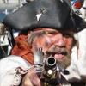
- Member

- 1,283 posts
- Gender:Male
- Location:Where ever I need ta be
- Interests:I like pirates, ye got a problem with that?
Blame me mu'm, she the one who decked me room out like a captain's cabin an' that be what I grew'd up in. Also me pa fer he built boats when I was but a wee lad. Later they ran off an' joined the carnivals, so I learn ta be a scalawag from the best.
I like weapons, some that go BOOM, and always sharp shiny ones.
I work with computers, currently contracted to hire by Xerox, their engineers [I]Need[/I] all the help they can get, this is fer sure! But I also have taught the Microsoft Certification course for a private contact school, an' spent 4 years working third level support at Earthlink before that scalawag Sky jumped ship an' let it go down.
They call me Mad L cuz, well, cuz many think I be mad, mad as a hatter they say but that only because they never jumped from a perfectly good airplane....over a thousand times. They also call me Mad L cuz I don't much like dogs n' cats, but I like things with scales and teeth, even the venomous ones for they be quit tasty when roasted over an open flame....even bet'r wit rum! They also call me Mad L, well, cuz very few know how to say me sir name properly, so in the military they give up and just call me "Mad L"
Oh, an' I dabble in the arts, computer 3D arts that be. Thar they all think I be mad, I do me best to make sure they all know I be mad. I have fun run'n amok as a pirate monkey character and makin' the moderators thar go bald. Several times the moderators try ta toss me o'r board, but the crew say will have none o' that now ;\
So, I like pirates, ye got a problem with that?
(IP: 4.131.137.39) ·
Posted March 6, 2011 · Report post
You have seen them in the movies, you have seen them in paintings and woodcarvings; the short braid or tail worn on the back of the head. But how do they Wrap them in black?
I have read that some sailors used eel skin as it be water proof and the purpose of wrapping the queue was to prevent the salt from the ocean spray from building in the braid then drying out and becoming abrasive on the neck. I have read that landlubbers and gents would wrap them with silk ribbon or cloth, there is even one mention of a "silk pouch" being used that would cover the whole queue including the tip.
But what I can not find is just HOW the wrap would be made, sure enough to last the whole day (and while working on and below deck) without it coming all undone??
I have tried wrapping from the bottom up and using the ends for the top bow - no good, it unwraps from the bottom, kinda walks itself up then unwraps once loosened.....
Does anyone know, have leads to detailed information, or perhaps know a period wig maker that may know this mystery? I am sure someone today knows, just look at all the wrapped queues in the movies (Master and Commander, Damn the Defiant, Horatio Hornblower, and such)

- Quote
- Edit

adam cyphers
- Plunderer
- 
- 
- Member

- 428 posts
- Gender:Male
- Location:hampton,va
- Interests:blacksmithing,tattoos,art in general,crafting things with my own two hands,many others...
(IP: 68.229.100.114) · ·
Posted March 6, 2011 · Report post
i was just wondering the same thing the other day.i hope someone knows :)

- Quote
- Edit
- Options

Jas. Hook
- Scourge o' the 7 Seas
- 
- 
- Member

- 1,650 posts
- Gender:Male
- Location:Long Island NY
- Interests:Fishing & Piracy
(IP: 71.190.101.94) · ·
Posted March 7, 2011 · Report post
Good question MadL
It seems that tar may have been used historically in some applications. For our lifestyles, ye hair gooped with tar might be frightful thought. For an event perhaps an small application of spirit gum might hold a ribbon in place for the day or two. I haven't tried it, just a thought.
Jas. Hook
Order of the Slipping Hair Band
Fashion Encyclopedia
Pigtails and Ramillies
The fashion of wearing large, curled wigs in the eighteenth century was impractical for some men. Soldiers developed a unique style that gave them the appearance of long, flowing, curly hair, but allowed them to be active. The style was the pigtail, or queue. Pigtails could be styled in many different ways. Commonly pigtails hung loose from a black ribbon knotted at the back of the head, but they could also be braided, smeared with tar, or completely hidden beneath a tightly wrapped ribbon or fabric pouch. Although the first military pigtails were fashioned from the wearers' own hair, later styles were made of wigs, called campaign wigs. The Ramillies wig, a version of the campaign wig that became a popular style among soldiers throughout the The Ramillies wig featured a long pigtail tied with black ribbons at its top and bottom. Courtesy of the . century, was named after a British victory over the French in 1706 during the War of Spanish Succession (1701–14). The Ramillies wig featured a long pigtail tied with a black tie at the top and another at the bottom of the pigtail. Throughout the eighteenth century, pigtails of all sorts were covered in flour or another white powder to create the white hair so popular during the century.
Read more: Pigtails and Ramillies - Fashion, Costume, and Culture: Clothing, Headwear, Body Decorations, and Footwear through the Ages http://www.fashionencyclopedia.com/fashion_costume_culture/European-Culture-18th-Century/Pigtails-and-Ramillies.html#ixzz1FtGX1iNf

- Quote
- Edit
- Options

Mission
- Goat Specialist
- 
- 
- Admin

- 5,082 posts
- Gender:Male
- Location:Monroe, MI
- Interests:Scholarly piracy, designing and creating haunted house rooms and props, movies, abstract thinking, abstruse thinking, obstructive thinking, ideating, random thinking, movies, cartoons, movies, movies scores, cycling, world peace and small furry dogs, movies, writing, drawing, personal skills training, gremlins and, of course, lest I forget, movies.
(IP: 24.231.221.86) · ·
Posted March 7, 2011 (edited) · Report post
Not to turn this into an advert thread, but why try to make one yourself? I got one made by Madam Joan for something like $25 or $30. I sent her a sample of my hair and she matched it and made me a queue. It's lasted for 5 or 6 outings so far. (The only problem with it is that the braid has become somewhat messy with stray hairs poking out of the braid and I don't have the wherewithal to learn how to re-braid it. Plus I like it sort of ratty and unraveled - it fits my concept of a pirate-captured surgeon.)
Edited March 7, 2011 by Mission

- Quote
- Edit
- Options

jendobyns
- Pyrate Captain
- 
- 
- Member

- 562 posts
- Gender:Female
- Location:Baltimore
- Interests:too numerous to mention, really. Period foodways, baroque dance, material culture, etc., etc.
(IP: 72.81.193.64) · ·
Posted March 7, 2011 · Report post
I seem to remember this conversation going on in another forum (RevList, perhaps), so I'll try to track it down. I also seem to remember a discussion about pomade (which may serve instead of tar). Pomade is still available in some places (like styling salons) and these days comes in a variety of colors (not that a self respecting Pirate would be caught dead with purple hair )

- Quote
- Edit
- Options

MajorChaos
- Ship's Master
- 
- 
- Member

- 141 posts
- Gender:Male
- Location:Catonsville, MD
(IP: 199.173.226.236) · ·
Posted March 7, 2011 · Report post
My hair is long enough to be braided and I've seen the queues mentioned in movies and read about in books (historical fiction stuff). I've wondered what and how the queues where made too. I can usually get one of the ladies in our camp to braid my hair and I have them do that very tight to last a few days. I was thinking I'd get a two or three foot piece of ribbon silk or probably scrap linen and have them start at the top of the braid (closest to me head) and just wrap the braid very tightly down the length and then back up to the top. Finishing it with a bow tie. Maybe if needed, get a small string and tie of the tip in a bow to try an prevent it from riding up the braid, but I think if the wrap is tight enough it won't ride up.
Just a thought

- Quote
- Edit
- Options

PoD
- Pyrate Captain
- 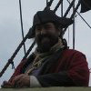
- Member

- 696 posts
- Gender:Male
- Location:Warrington UK
- Interests:Pirates, graphic novels, computer art, Listening to music, Going to gigs, Beer and Wine drinking, historical research, Period weaponry and Leatherwork
(IP: 82.24.80.245) · ·
Posted March 7, 2011 · Report post
I wonder what the fabric pouch looked like? Thats definately a good option if ever i needed to hide my dreadlocks at an event.

- Quote
- Edit
- Options

jendobyns
- Pyrate Captain
- Member

- 562 posts
- Gender:Female
- Location:Baltimore
- Interests:too numerous to mention, really. Period foodways, baroque dance, material culture, etc., etc.
(IP: 72.81.193.64) · ·
Posted March 7, 2011 · Report post
Check out plates 436 and 437 in Diderot, under "The Wigmaker"
Styles changed, and this is late, but this might be a starting point. The basic bag (I think they were called "bag wigs") looks fairly simple. Sort of a draw-string pouch, with a big bow stitched to the outside, it probably covers the wrinkly draw-string part.
Ah, here's a copy of plate 436 at the top of this article: http://www.historycooperative.org/journals/ahr/111.3/kwass.html
On 3/7/2011 at 0:11 PM, PoD said:
I wonder what the fabric pouch looked like? Thats definately a good option if ever i needed to hide my dreadlocks at an event.

- Quote
- Edit
- Options

jendobyns
- Pyrate Captain
- Member

- 562 posts
- Gender:Female
- Location:Baltimore
- Interests:too numerous to mention, really. Period foodways, baroque dance, material culture, etc., etc.
(IP: 72.81.193.64) · ·
Posted March 7, 2011 · Report post
OK, I know there was a discussion on the Revlist before they changed servers in 1999. Can't figure out how to access the info on the previous server, though. But there was one post in the newer forum, which I will share with you here, regarding the making of a queue. It's later, so no guarantee of accuracy for GAoP.
Recently there was some discussion on the list about how British
soldiers wore their hair during the AWI. The following is from just after the
AWI and is from Memoirs of the Military Career of John Shipp, late a lieutenant
in His Majesty's 87th Regiment. Shipp entered the British Army as a ranker and
was one a relatively small number who eventually achieved commissioned rank.
His remembrances of his early days in the ranks are interesting even though
they are a few years after the period of the AWI.
In the following excerpt Shipp gives us a lot of detail about the
military queue and how the results were obtained.
"After this I went into town, to purchase a few requisites, such as a
powder-bag, puff, soap, candles, grease &c.; and , having procured what I stood
in need of, I returned to my barrack, where I underwent the operation of having
my hair tied for the first time, to the no small amusement of all the boys
assembled. A large piece of candle -grease was applied, first to the sides of
my head, then to the hind long hair; after this the same kind of operation was
performed with nasty stinking soap ___ sometimes the man who was dressing me
applying his knuckles, instead of the soap, to the delight of the surrounding
boys, who were bursting their sides with laughter, to see the tears roll down
my cheeks. When this operation was over, I had to go through one of a more
serious nature. A large pad, or bag filled with sand, was poked into the back
of my head, round which the hair was gathered tight, and the whole tied round
with a leather thong. When I was dressed for parade, I could scarcely get my
eyelids to perform their office; the skin of my eyes and face was drawn so
tight by the plug that was stuck in the back of my head, that I could not
possibly shut my eyes; and to this, an enormous high stock was poked under my
chin; so that , altogether, I felt as stiff as if I had swallowed a ramrod, or
a sergeant's halberd. Shortly after I was thus equipped, dinner was served;
but my poor jaws refused to act on the offensive, and when I made an attempt
to eat, my pad behind went up and down like a sledge-hammer."
Shipp's remarks about the high leather stock may not be appropriate to
the AWI since the year in which Shipp enlisted was 1795. There were certainly
changes in the uniform between the end of the AWI and 1795 as we all know. I
would be surprised, however, if the manner of forming the military queue had
really changed much at all by that time. The radical changes in how the
British Army were required to wear their hair was still some years away.

- Quote
- Edit
- Options

MadL
- Dread Pyrate
- Member

- 1,283 posts
- Gender:Male
- Location:Where ever I need ta be
- Interests:I like pirates, ye got a problem with that?
Blame me mu'm, she the one who decked me room out like a captain's cabin an' that be what I grew'd up in. Also me pa fer he built boats when I was but a wee lad. Later they ran off an' joined the carnivals, so I learn ta be a scalawag from the best.
I like weapons, some that go BOOM, and always sharp shiny ones.
I work with computers, currently contracted to hire by Xerox, their engineers [I]Need[/I] all the help they can get, this is fer sure! But I also have taught the Microsoft Certification course for a private contact school, an' spent 4 years working third level support at Earthlink before that scalawag Sky jumped ship an' let it go down.
They call me Mad L cuz, well, cuz many think I be mad, mad as a hatter they say but that only because they never jumped from a perfectly good airplane....over a thousand times. They also call me Mad L cuz I don't much like dogs n' cats, but I like things with scales and teeth, even the venomous ones for they be quit tasty when roasted over an open flame....even bet'r wit rum! They also call me Mad L, well, cuz very few know how to say me sir name properly, so in the military they give up and just call me "Mad L"
Oh, an' I dabble in the arts, computer 3D arts that be. Thar they all think I be mad, I do me best to make sure they all know I be mad. I have fun run'n amok as a pirate monkey character and makin' the moderators thar go bald. Several times the moderators try ta toss me o'r board, but the crew say will have none o' that now ;\
So, I like pirates, ye got a problem with that?
(IP: 66.81.253.135) · ·
Posted March 7, 2011 · Report post
Mission: What for would I want'a "make one m'self" when I have already Grown one m'self in Proper period style...honestly I am not sure that pirates, or others of the period actually "made" one themselves, more likely they purchased, stole, or otherwise accosted a wig if they could not grow one themselves. I recall some readings that some men just shaved their heads and wore wigs simply because it kept the lice away as well..but ne'r heard o' one that 'made' he's own wig...unless perhaps he twas a wig maker already.
MajorChaos: I was thinking of using a longer piece as well, but my queue is not all that thick as it grows only off the back o me neck, not from the sides (I also gotta please them cor-pirates as well ye knows) so thinner must be the better fer me....I have seen many on screen but never one I can zoom in on to see how they done it.
PoD: I will have to see if I can find the link that mentioned it, there was actually a 'period' name for such a silken pouch...one place I think I actually saw one in use was in the movie "Buccaneer", worn by the evil governor and can be seen in at least one scene. Basically it be just a thin lacy silk pouch with ties on the end, drop yer queue inside and tie th' ends (at yer head side)
just read further and saw jendobyns' statement; yup, that be th' Bagwig I mentioned.
Ok, jendobyns' seems to have a good one about the pain the British soldiers went through...but how can we reproduce this with such extreme....

- Quote
- Edit
- Options

jendobyns
- Pyrate Captain
- Member

- 562 posts
- Gender:Female
- Location:Baltimore
- Interests:too numerous to mention, really. Period foodways, baroque dance, material culture, etc., etc.
(IP: 72.81.193.64) · ·
Posted March 7, 2011 · Report post
I suspect if you took the element of "hazing" out of it it wouldn't be so bad Kind of like some of the procedures we ladies go through in the salon
On 3/7/2011 at 4:29 PM, MadL said:
Ok, jendobyns' seems to have a good one about the pain the British soldiers went through...but how can we reproduce this with such extreme....

- Quote
- Edit
- Options

M.A.d'Dogge
- Second to None
- 
- Member

- 1,534 posts
- Gender:Male
- Location:the Port of the Great Inland Sea, Detroit originally from the great inland corn seas of Illinois
- Interests:pyratin, story-tellin, historyin, suba divin, drynkin, skirt chassin, eatin, campin, photographin, cavin, rockclimbin, ghost huntin, talkin, sword fightin, canonin, black powder pistolin, travelin and pretty much anythin that could be included in ADVENTURIN!!!
(IP: 69.14.41.221) · ·
Posted March 7, 2011 · Report post
the silk bags are quite simple really....and were even for the NON HAIRED INDOWED...as many would even be "stuffed" as it were to give the impression of more hair
many of the ques wer actually long braids then doublled back...then tied with ribbon...again giving the impression of MORE hair...but since it was doubled back it would lend itself for better purchase for the ribbon than just the braid itself...have worn both kinds for sometime now and have had very little issure with them comming undone

- Quote
- Edit
- Options

MadL
- Dread Pyrate
- Member

- 1,283 posts
- Gender:Male
- Location:Where ever I need ta be
- Interests:I like pirates, ye got a problem with that?
Blame me mu'm, she the one who decked me room out like a captain's cabin an' that be what I grew'd up in. Also me pa fer he built boats when I was but a wee lad. Later they ran off an' joined the carnivals, so I learn ta be a scalawag from the best.
I like weapons, some that go BOOM, and always sharp shiny ones.
I work with computers, currently contracted to hire by Xerox, their engineers [I]Need[/I] all the help they can get, this is fer sure! But I also have taught the Microsoft Certification course for a private contact school, an' spent 4 years working third level support at Earthlink before that scalawag Sky jumped ship an' let it go down.
They call me Mad L cuz, well, cuz many think I be mad, mad as a hatter they say but that only because they never jumped from a perfectly good airplane....over a thousand times. They also call me Mad L cuz I don't much like dogs n' cats, but I like things with scales and teeth, even the venomous ones for they be quit tasty when roasted over an open flame....even bet'r wit rum! They also call me Mad L, well, cuz very few know how to say me sir name properly, so in the military they give up and just call me "Mad L"
Oh, an' I dabble in the arts, computer 3D arts that be. Thar they all think I be mad, I do me best to make sure they all know I be mad. I have fun run'n amok as a pirate monkey character and makin' the moderators thar go bald. Several times the moderators try ta toss me o'r board, but the crew say will have none o' that now ;\
So, I like pirates, ye got a problem with that?
(IP: 66.81.249.103) · ·
Posted March 7, 2011 · Report post
Aye M.A.d'Dogge, the sack would be fine enough, and the doubling of one's hair does lend fer a fuller look, however I intend t' keep mine at about 6inch and want t' pursue the tied look.
If anyone knows how th' profishonal hair dressers do it kindly let me know.

- Quote
- Edit
- Options

jendobyns
- Pyrate Captain
- Member

- 562 posts
- Gender:Female
- Location:Baltimore
- Interests:too numerous to mention, really. Period foodways, baroque dance, material culture, etc., etc.
(IP: 72.81.193.64) · ·
Posted March 7, 2011 · Report post
If there is any chance that you will be attending the Market Fair at Fort Frederick (April 29-May 1st , iirc) in Big Pool, MD, you might be able to talk to the wigmaker of Williamsburg (Betty Myers) about it. Hopefully someone will sort it out for you before then *g*
On 3/7/2011 at 7:45 PM, MadL said:
Aye M.A.d'Dogge, the sack would be fine enough, and the doubling of one's hair does lend fer a fuller look, however I intend t' keep mine at about 6inch and want t' pursue the tied look.
If anyone knows how th' profishonal hair dressers do it kindly let me know.

- Quote
- Edit
- Options

Fox
- Old Twillian
- 
- 
- Moderator

- 2,564 posts
- Gender:Male
- Location:Beautiful lush Devon, England
- Interests:Nautical history of the 16-18th centuries and living history based thereon.
Shooting pirates.
(IP: 86.158.116.197) · ·
Posted March 8, 2011 · Report post
I hate to pee on cornflakes, but can anyone point me to a picture or reference to a GAoP era sailor (or other) with queued hair?

- Quote
- Edit
- Options

Dread Pyrate Greyhound
- Plunderer
- 
- Member

- 451 posts
- Gender:Male
- Location:Ohio
- Interests:Golden Age of Pyracy, Age of Sailing ships (spacifically 1600-1730) Vintage pirate Legos, weaponry in usage during the Age of Pyrates, Fuedal Japan
(IP: 66.213.122.130) · ·
Posted March 8, 2011 · Report post
I have found that tying the hair back with a strand of hemp rope works excelently. Simply wrap about a foot of hemp around the tuft of hair a few times and tie a bow. I did this for a while and was emensley pleased for two reasons.
1. Rope will be found on a ship, this is historically plausible and very likely
2. If made tight enough, and wraped enough, the friction of rope on rope will keep it tied the entire day.

- Quote
- Edit
- Options

MadL
- Dread Pyrate
- Member

- 1,283 posts
- Gender:Male
- Location:Where ever I need ta be
- Interests:I like pirates, ye got a problem with that?
Blame me mu'm, she the one who decked me room out like a captain's cabin an' that be what I grew'd up in. Also me pa fer he built boats when I was but a wee lad. Later they ran off an' joined the carnivals, so I learn ta be a scalawag from the best.
I like weapons, some that go BOOM, and always sharp shiny ones.
I work with computers, currently contracted to hire by Xerox, their engineers [I]Need[/I] all the help they can get, this is fer sure! But I also have taught the Microsoft Certification course for a private contact school, an' spent 4 years working third level support at Earthlink before that scalawag Sky jumped ship an' let it go down.
They call me Mad L cuz, well, cuz many think I be mad, mad as a hatter they say but that only because they never jumped from a perfectly good airplane....over a thousand times. They also call me Mad L cuz I don't much like dogs n' cats, but I like things with scales and teeth, even the venomous ones for they be quit tasty when roasted over an open flame....even bet'r wit rum! They also call me Mad L, well, cuz very few know how to say me sir name properly, so in the military they give up and just call me "Mad L"
Oh, an' I dabble in the arts, computer 3D arts that be. Thar they all think I be mad, I do me best to make sure they all know I be mad. I have fun run'n amok as a pirate monkey character and makin' the moderators thar go bald. Several times the moderators try ta toss me o'r board, but the crew say will have none o' that now ;\
So, I like pirates, ye got a problem with that?
(IP: 66.81.253.252) · ·
Posted March 8, 2011 · Report post
Commodore Greyhound, that is pretty much to what I do now, however I use a strand of thin tared hemp (about kite string size) and just wrap it up from the tuft about 6 or 7 wraps then thread it back down (with a needle, actually my girlfriend does it) and then tie it off at the beginning in a knot. I then use a strip of black linen to tie the bow at the top of the braid.
But I would like to figure out a way to properly wrap the whole braid in cloth, and still have the bow, attached or not, tied at the top.
Fox: don't think I have ever seen any pictures from the GAoP specifically but the queue has been around through many cultures since nearly the beginning of time, and worn in many many different styles...perhaps not specifically "British", "French", or "Spanish", but I am pretty sure they were not the only ones on the waters during GAoP, or aboard a pirate ship. I am pretty sure you have seen many of ancient Chinese wearing a queue. And there was one document I read some years ago that described a period when the British Navy in its early days had troubles with some sailors, as I recall they where trying to get more organized (with uniforms and such) and when the order was given for the men to cut their queues they "nearly had a revolt on their hands"....can't recall just when or where I had read that. But braids, pony tails and such have long been worn by men throughout history and cultures. If you read up on the history of wigs you will find a lot about the era's fascination with long hair, curls, and ribbons dating back as far as Queen Elizabeth herself.

- Quote
- Edit
- Options

Capt. Bo of the WTF co.
- Scourge o' the 7 Seas
- 
- Member

- 2,339 posts
- Gender:Male
- Location:Spanish Louisiana - on the river Osage
- Interests:Many and varied.
(IP: 216.106.48.195) · ·
Posted March 8, 2011 · Report post
How d'ye wear yer hair
does yer hair hang low
do ye wear it in a ribbon
do ye tie it in a bow
do ye throw it o'er yer shoulder
like a Continental soldier
does yer haaaair haaaang looooow
Sorry, but when I saw this thread
the tune just started playin' in me 'ead.
now would a good time
for me to go to bed.
Bo

- Quote
- Edit
- Options

Patrick Hand
- The sailor's sailor
- 
- Moderator

- 6,100 posts
- Gender:Male
- Location:TH' Mountains of Central California
- Interests:I like wierdness... Klingon, Pyrate..... and even..... gasp.... Renn Faires...... (Baseball and tractor pulls I'd have to think about.... could be wierd or Not,,,,)
(IP: 67.187.145.251) · ·
Posted March 9, 2011 · Report post
Off topic.....
Quote
How d'ye wear yer hair
does yer hair hang low
do ye wear it in a ribbon
do ye tie it in a bow
do ye throw it o'er yer shoulder
like a Continental soldier
does yer haaaair haaaang looooow
Sorry, but when I saw this thread
the tune just started playin' in me 'ead.
now would a good time
for me to go to bed.
Hey... I know that song ... well ... but when I heard it.... well it was just a bit differently... (and a little bit dirtier... )

- Quote
- Edit
- Options

Fox
- Old Twillian
- Moderator

- 2,564 posts
- Gender:Male
- Location:Beautiful lush Devon, England
- Interests:Nautical history of the 16-18th centuries and living history based thereon.
Shooting pirates.
(IP: 86.143.114.22) · ·
Posted March 9, 2011 · Report post
On 3/8/2011 at 10:47 PM, MadL said:
Fox: don't think I have ever seen any pictures from the GAoP specifically but the queue has been around through many cultures since nearly the beginning of time, and worn in many many different styles...perhaps not specifically "British", "French", or "Spanish", but I am pretty sure they were not the only ones on the waters during GAoP, or aboard a pirate ship. I am pretty sure you have seen many of ancient Chinese wearing a queue. And there was one document I read some years ago that described a period when the British Navy in its early days had troubles with some sailors, as I recall they where trying to get more organized (with uniforms and such) and when the order was given for the men to cut their queues they "nearly had a revolt on their hands"....can't recall just when or where I had read that. But braids, pony tails and such have long been worn by men throughout history and cultures. If you read up on the history of wigs you will find a lot about the era's fascination with long hair, curls, and ribbons dating back as far as Queen Elizabeth herself.
Certainly, I have no problem with anyone portraying a Chinese pirate or Victorian sailor wearing a queue.
But in the original post you asked about a very specific hair style (short queue wrapped in black), and the correct way to obtain it. All of the advice (and good advice it is too) has been based on a later period interpretation. It may well be that there isn't a 'correct' GAoP way of doing it.

- Quote
- Edit
- Options

Mission
- Goat Specialist
- Admin

- 5,082 posts
- Gender:Male
- Location:Monroe, MI
- Interests:Scholarly piracy, designing and creating haunted house rooms and props, movies, abstract thinking, abstruse thinking, obstructive thinking, ideating, random thinking, movies, cartoons, movies, movies scores, cycling, world peace and small furry dogs, movies, writing, drawing, personal skills training, gremlins and, of course, lest I forget, movies.
(IP: 24.231.221.86) · ·
Posted March 9, 2011 · Report post
No one wore hair queues in the GAoP?

- Quote
- Edit
- Options

Slopmaker Cripps
- Ship's Master
- Member

- 137 posts
- Interests:Maritime Living History<br>Slopmaking<br>Tailoring
(IP: 98.82.198.29) · ·
Posted March 9, 2011 · Report post
On 3/9/2011 at 8:12 AM, Mission said:
No one wore hair queues in the GAoP?
Doesn't seem to be any evidence for it until the later decades of the 18th century among seamen. I'm with Fox, we'd be really interested if someone could provide a primary source of queues that early, but he hasn't found anything, nor have I.
-Adam C.

- Quote
- Edit
- Options

Fox
- Old Twillian
- Moderator

- 2,564 posts
- Gender:Male
- Location:Beautiful lush Devon, England
- Interests:Nautical history of the 16-18th centuries and living history based thereon.
Shooting pirates.
(IP: 86.143.114.22) · ·
Posted March 9, 2011 · Report post
On 3/9/2011 at 8:12 AM, Mission said:
No one wore hair queues in the GAoP?
Define hair queues.
If you mean, effectively, a pony tail, then yes, there are probably GAoP era references (though I struggle off the top of my head).
If you mean the solid pony tail, usually black, seen on all self-respecting sailors in old movies (as implied in the original post), then they seem very much to be a later fashion.

- Quote
- Edit
- Options

michaelsbagley
- Smells Like Wet Sheep
- 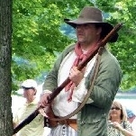
- Moderator

- 2,548 posts
- Gender:Male
- Location:Columbus, Ohio
- Interests:Mostly into GAoP, but starting to develop more Buccaneer era stuff for re-enacting as well. Generally I do re-enact both piratical/nautical and other impressions from the period. I am focusing on more "common" impressions from the period (i.e. average sailor/pirate, rank and file Red Coat, early Colonial huntsman, etc.)
(IP: 174.252.204.19) · ·
Posted March 9, 2011 · Report post
What about "bagged" hair? I gave seen references to that in military (I know, not sailors) manuals dating to the first decade of the 1700s.

- Quote
- Edit
- Options

Mission
- Goat Specialist
- Admin

- 5,082 posts
- Gender:Male
- Location:Monroe, MI
- Interests:Scholarly piracy, designing and creating haunted house rooms and props, movies, abstract thinking, abstruse thinking, obstructive thinking, ideating, random thinking, movies, cartoons, movies, movies scores, cycling, world peace and small furry dogs, movies, writing, drawing, personal skills training, gremlins and, of course, lest I forget, movies.
(IP: 24.231.221.86) · ·
Posted March 9, 2011 · Report post
No, I mean non-attached (to the skull) hair queues as seen, let us say, on working landsman, let us say, as a trained surgeon?

• • Quote
• Edit
• Options

jendobyns
- Pyrate Captain
- Member

- 562 posts
- Gender:Female
- Location:Baltimore
- Interests:too numerous to mention, really. Period foodways, baroque dance, material culture, etc., etc.
(IP: 72.81.193.64) · ·
Posted March 9, 2011 (edited) · Report post
On 3/9/2011 at 5:03 AM, Foxe said:
On 3/8/2011 at 10:47 PM, MadL said:
Fox: don't think I have ever seen any pictures from the GAoP specifically but the queue has been around through many cultures since nearly the beginning of time, and worn in many many different styles...perhaps not specifically "British", "French", or "Spanish", but I am pretty sure they were not the only ones on the waters during GAoP, or aboard a pirate ship. I am pretty sure you have seen many of ancient Chinese wearing a queue. And there was one document I read some years ago that described a period when the British Navy in its early days had troubles with some sailors, as I recall they where trying to get more organized (with uniforms and such) and when the order was given for the men to cut their queues they "nearly had a revolt on their hands"....can't recall just when or where I had read that. But braids, pony tails and such have long been worn by men throughout history and cultures. If you read up on the history of wigs you will find a lot about the era's fascination with long hair, curls, and ribbons dating back as far as Queen Elizabeth herself.
Certainly, I have no problem with anyone portraying a Chinese pirate or Victorian sailor wearing a queue.
But in the original post you asked about a very specific hair style (short queue wrapped in black), and the correct way to obtain it. All of the advice (and good advice it is too) has been based on a later period interpretation. It may well be that there isn't a 'correct' GAoP way of doing it.
Have to say I agree with you there, we need to dig further to find something appropriate for GAoP. Sadly, it's a period that is about as easy to pin down as jello when it comes to some details. I have a meeting at a site tomorrow which was established in the 1680's as a tobacco port. It has a decent library, so I'll see if I can find anything useful while I'm there.
Edited March 9, 2011 by jendobyns

- Quote
- Edit
- Options

Tartan Jack
- Notorious Pyrate
- 
- 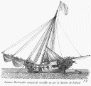
- Member

- 908 posts
- Location:South Carolina
- Interests:History, Scotland, Batman, Cars, and more<br />Married with 2 kids<br />
(IP: 74.181.91.31) · ·
Posted March 9, 2011 · Report post
On 3/9/2011 at 11:51 AM, Foxe said:
On 3/9/2011 at 8:12 AM, Mission said:
No one wore hair queues in the GAoP?
Define hair queues.
If you mean, effectively, a pony tail, then yes, there are probably GAoP era references (though I struggle off the top of my head).
If you mean the solid pony tail, usually black, seen on all self-respecting sailors in old movies (as implied in the original post), then they seem very much to be a later fashion.
I know it is commonly portrayed in the Napoleonic Wars period Royal Navy (see Horatio Hornblower films, for example). But, how much earlier was it?
As I recall, in period, sailors were often commented upon and recognized by their short hair . . .

- Quote
- Edit
- Options

Mission
- Goat Specialist
- Admin

- 5,082 posts
- Gender:Male
- Location:Monroe, MI
- Interests:Scholarly piracy, designing and creating haunted house rooms and props, movies, abstract thinking, abstruse thinking, obstructive thinking, ideating, random thinking, movies, cartoons, movies, movies scores, cycling, world peace and small furry dogs, movies, writing, drawing, personal skills training, gremlins and, of course, lest I forget, movies.
(IP: 24.231.221.86) · ·
Posted March 10, 2011 · Report post
On 3/9/2011 at 4:06 PM, Mission said:
No, I mean non-attached (to the skull) hair queues as seen, let us say, on working landsman, let us say, as a trained surgeon?
So...does no one know if landsmen wore these things?

- Quote
- Edit
- Options

capn'rob
- Pyrate Captain
- Member

- 535 posts
- Gender:Male
- Location:Morehead City, NC
- Interests:Cruising, power or sail. Music and Maritime History. Pilaging, Plundering and General Mayhem!
(IP: 65.184.150.127) · ·
Posted March 10, 2011 · Report post
I'd like to offer me tuppence. Once we'uns wuz deprived o' our daily hot showers in the day o' Men wi' Hearts o' Oak. The early days of the sailing Navy. The treatment o' ones traditional long hair o' the sailor wuz to slick the whole mess wi' good Stockholm Tar and braid in four strand round sennit. The kerchief and later in the days when uniforms had the attachment, this was for protection from said Tar. The purpose: First, stays in place and out o' yer eyes. Then, wi' out those hot showers and no shampoo and conditioner (damn their eyes) the natural oils were kept in and the salt kept out. A simple rinse o' spirits would remove the Tar and then, Only Your Hairdresser Knew For Sure!

- Quote
- Edit
- Options

Capt. Sterling
- Sticky Fingers Sterling Needs a New Hat
- 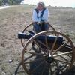
- Member

- 10,302 posts
- Gender:Pyrate Hunter
- Location:here
- Interests:Killing pirates, haven't met one yet worth keeping alive....
(IP: 71.53.217.60) · ·
Posted March 10, 2011 (edited) · Report post
Thomas Brown, in his "Letters from the Dead to the Living," presents a pen-portrait of beaux as they appeared at the commencement of the eighteenth century. Some of the passages are well worth reproducing, as they contain valuable information concerning wigs. "We met," says the writer, "three flaming beaux of the first magnitude. He in the middle made a most magnificent figure—his periwig was large enough to have loaded a camel, and he bestowed upon it at least a bushel of powder, I warrant you. His sword-knot dangled upon the ground, and his steinkirk, that was most agreeably discoloured with snuff from the top to the bottom, reach'd down to his waist; he carry'd his hat under his left arm, walk'd with both hands in the waistband of his breeches, and his cane, that hung negligently down in a string from his right arm, trail'd most harmoniously against the pebbles, while the master of it was tripping it nicely upon his toes or humming to himself." About this period in cold weather men wore muffs as well as wigs. A ballad, describing the frost fair on the Thames in the winter of 1683-84, mentions amongst those present:—
"A spark of the Bar with his cane and his muff."
Down to the middle of the eighteenth century wigs continued to increase in size. It will not now be without interest to direct attention to a few of the many styles of wigs. Randle Holme, in his "Academy of Armory," published in 1684, has some interesting illustrations, and we will draw upon him for a couple of pictures. Our first example is called the campaign-wig. He says it "hath knobs or bobs, or dildo, on each side, with a curled forehead." This is not so cumbrous as a periwig we have noticed. Another example from Holme is a smaller style of periwig with tail, and from this wig doubtless originated the familiar pig-tail. It was of various forms, and Swift says:—
"We who wear our wigs
With fantail and with snake."
Periwig with Tail.
A third example given by Holme is named the "short-bob," and is a plain peruke, imitating a natural head of hair. "Perukes," says Malcolm, in his "Manners and Customs," "were an highly important article in 1734. Those of right gray human hair were four guineas each; light grizzle ties, three guineas; and other colours in proportion, to twenty-five shillings. Right gray human hair, cue perukes, from two guineas; white, fifteen shillings each, which was the price of dark ones; and right gray bob perukes, two guineas and a half; fifteen shillings was the price of dark bobs. Those mixed with horsehair were much lower. It will be observed from the gradations in price, that real gray hair was most in fashion, and dark of no estimation." As time ran its course, wigs became more varied in form, and bore different names.
We find in the days of Queen Anne such designations as black riding-wigs, bag-wigs, and nightcap-wigs. These were in addition to the long, formally curled perukes. In 1706 the English, led by Marlborough, gained a great victory on the battlefield of Ramillies, and that gave the title to a long wig described as "having a long, gradually diminishing, plaited tail, called the 'Ramillie-tail,' which was tied with a great bow at the top, and a smaller one at the bottom." It was at the great battle fought before the town of Ramillies that France lost the whole Spanish Netherlands, and Europe gained a wig from the vanity of Louis XIV., of whom Thackeray irreverently speaks in his "Henry Esmond," as "a little, wrinkled old man, pock-marked, and with a great periwig and red heels." Lord Lyttelton in his letters thus refers to the French king: "Louis XIV. annexed great dignity to his peruke, which he increased to an enormous size, and made a lion's mane the object of its similitude. That monarch, who daily studied the part of a king, was never seen uncovered but by the barber who shaved him. It was not his practice to exchange his wig for a nightcap till he was enclosed by his curtains, when a page received the former from his hand and delivered it to him in the morning before he undrew them. The figure of the great Bourbon must at times have been truly ridiculous." It is stated in Read's Weekly Journal of May 1st, 1736, in a report of the marriage of the Prince of Wales, that "the officers of the Horse and Foot Guards wore Ramillie periwigs by His Majesty's order." This wig survived until the days of George III. We meet, in the reign of George II., other forms of the wig, and more titles for them; the most popular, perhaps, was the pig-tail. The pig-tails were worn hanging down the back, or tied up in a knot behind as shown in our illustration. This form of wig was popular in the army, but in 1804 orders were given for it to be reduced to seven inches in length, and finally, in 1808, to be cut off. It is recorded that when the Reform Bill of 1832 received the Royal assent, the Lord Bathurst of the period solemnly cut off his pig-tail, saying, "Ichabod, for the glory was departed."
AT THE SIGN
OF THE BARBER'S POLE
STUDIES IN HIRSUTE HISTORY
BY
WILLIAM ANDREWS
AUTHOR OF "BYGONE ENGLAND
which can be found here...
http://www.gutenberg.org/files/19925/19925-h/19925-h.htm
and yet, I cannot find any references to these type of items being worn by the common sailor... I am seeing mostly short hair or down to the top of shoulders
Edited March 10, 2011 by Capt. Sterling

- Quote
- Edit
- Options

Capt. Sterling
- Sticky Fingers Sterling Needs a New Hat
- Member

- 10,302 posts
- Gender:Pyrate Hunter
- Location:here
- Interests:Killing pirates, haven't met one yet worth keeping alive....
(IP: 71.53.217.60) · ·
Posted March 10, 2011 (edited) · Report post
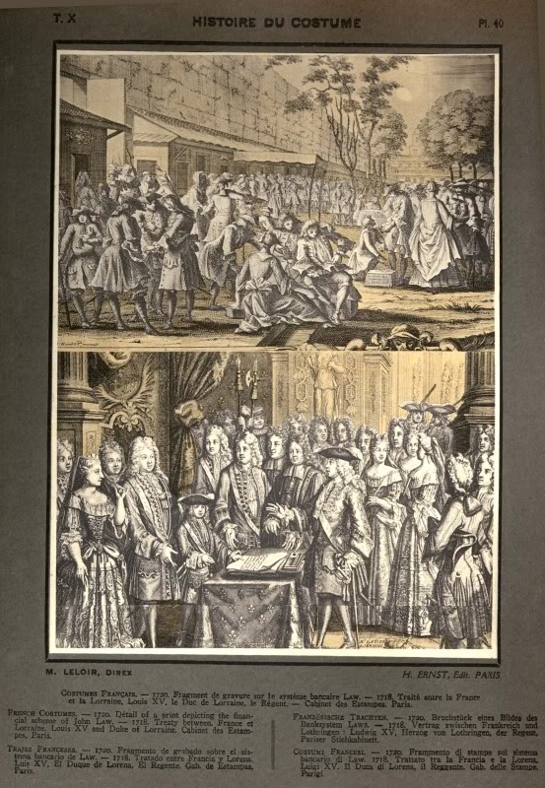
Top plate and sorry cannot make these bigger, perhaps someone else can...there are two gentlemen, note gentlemen, in bag wigs..
easiest to see if the second man in from the left foreground
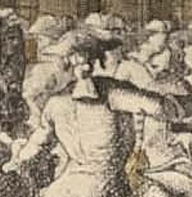detail of a man in the background which can be seen above the man bending down to speak to someone
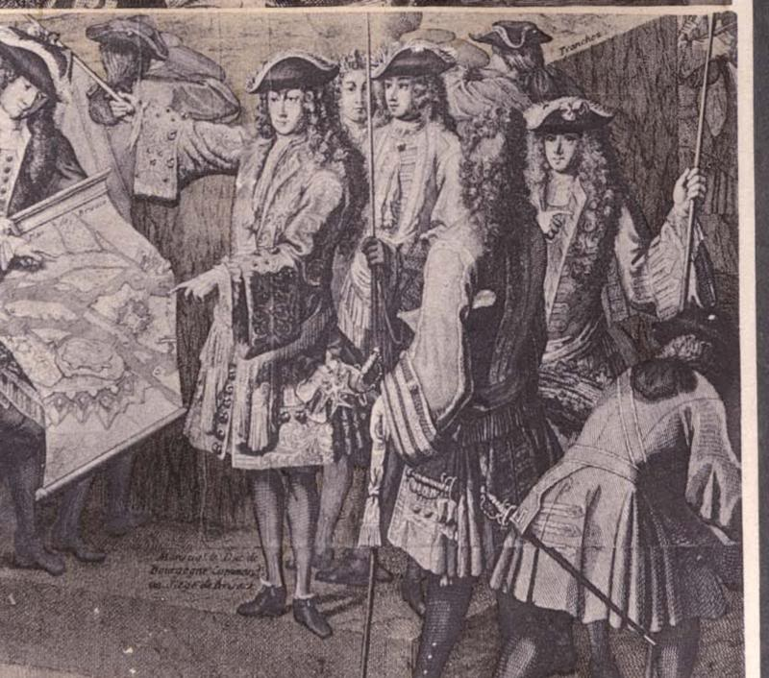a detail from a picture c. 1702-03 showing two men in bag wigs
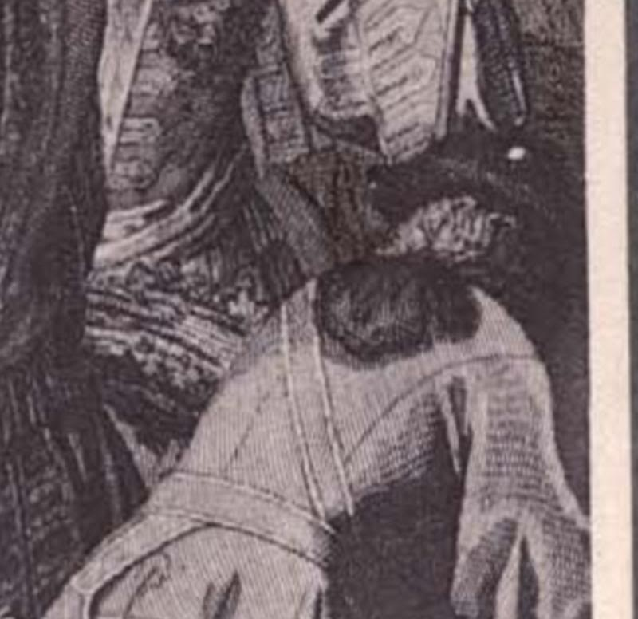a detail from above picture
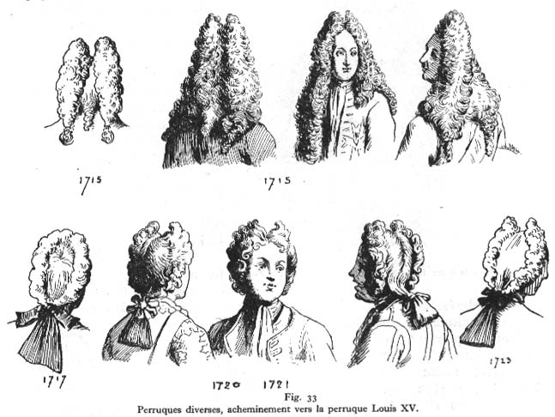some more illustrations of bag wigs... still haven't found a common sailor wearing one
Edited March 10, 2011 by Capt. Sterling

- Quote
- Edit
- Options

MadL
- Dread Pyrate
- Member

- 1,283 posts
- Gender:Male
- Location:Where ever I need ta be
- Interests:I like pirates, ye got a problem with that?
Blame me mu'm, she the one who decked me room out like a captain's cabin an' that be what I grew'd up in. Also me pa fer he built boats when I was but a wee lad. Later they ran off an' joined the carnivals, so I learn ta be a scalawag from the best.
I like weapons, some that go BOOM, and always sharp shiny ones.
I work with computers, currently contracted to hire by Xerox, their engineers [I]Need[/I] all the help they can get, this is fer sure! But I also have taught the Microsoft Certification course for a private contact school, an' spent 4 years working third level support at Earthlink before that scalawag Sky jumped ship an' let it go down.
They call me Mad L cuz, well, cuz many think I be mad, mad as a hatter they say but that only because they never jumped from a perfectly good airplane....over a thousand times. They also call me Mad L cuz I don't much like dogs n' cats, but I like things with scales and teeth, even the venomous ones for they be quit tasty when roasted over an open flame....even bet'r wit rum! They also call me Mad L, well, cuz very few know how to say me sir name properly, so in the military they give up and just call me "Mad L"
Oh, an' I dabble in the arts, computer 3D arts that be. Thar they all think I be mad, I do me best to make sure they all know I be mad. I have fun run'n amok as a pirate monkey character and makin' the moderators thar go bald. Several times the moderators try ta toss me o'r board, but the crew say will have none o' that now ;\
So, I like pirates, ye got a problem with that?
(IP: 4.131.142.197) · ·
Posted March 14, 2011 (edited) · Report post
Ok, so it would appear that wigs, tails, bag wigs, and bows did appear during the GAoP, just so far none specifically depicted on a "common sailor"...but then since when was a 'pirate' a 'common sailor'?
As I recall it has been stated that Pirates enjoyed mocking, mimicking, and simply thumbing their nose at "gentlemen" and at royalty....I don't recall any images of pirates wearing silk, lace, and other refineries yet we know they stole them and of course would not have them long once they made safe port somewhere, but until then or should they need to come ashore in less-then-friendly ports, would it not make reason that if they so wished then they would wear them?
Also I had read long ago, not "sailor lore" per-se, but speaking of common landlubber folk that those who could not afford a wig would sometimes attempt to grow their own 'tail' (queue, whatever).
It seems to me that to search for "images" or even writings of EVERY conceivable concept of a "pirate at sea" (or on land for that matter) would be a search in vain. Simply because most writings and images would be done to not put too much emphasis on mocking the royalty, but rather to make them look evil, disgusting so as not to offend the king (queen, monarch, etc). I know I would not want to be the editor of a parchment and image that made a loathsomely pirate appear more grandeur then the king!! But we do know Calico Jack was quite the dandy, and others had what about Captain Kidd, did he dress as a "common" sailor? Then what about the thousands of other pirates, some that perhaps vanished before even falling under the British Navy's radar....if there were queues Before the GAoP and queues After the GAoP as well as queues on "gentlemen" During the GAoP......hmmmmmmm
**oh, and as far as my original post, where I asked about "a specific style..." - twas a starting point mate, lighten up fer I am seeking the 'method of', and that be that....aye, I still be seeking the how to fer wrapping me queue (without use o' tar, just the cloth) so it stays put on an active day.
Edited March 14, 2011 by MadL

- Quote
- Edit
- Options

Capt. Bo of the WTF co.
- Scourge o' the 7 Seas
- Member

- 2,339 posts
- Gender:Male
- Location:Spanish Louisiana - on the river Osage
- Interests:Many and varied.
(IP: 216.106.26.196) · ·
Posted March 14, 2011 · Report post
Read some of the runaway ads from the Virginia and Pennsylvania gazzettes. "wears his own hair" comes up in many of the ads. Also see portraits by Peale, and there are some others but my brain is sleepy and I need to get off here and get some sleep. Anyhow, many folks did in fact wear their own hair long.
Patrick... I first heard that tune when my uncle and his biker buddies snuck me into the drive-in to see Easyriders in 1969. I was in third grade I think, and I sang that tune all summer long. (it was at the desert commune with Luke Askew as the leader, and if you look at some of the others, Dan Haggerty-Grizzly Adams-is in there too).
Bo

- Quote
- Edit
- Options

Slopmaker Cripps
- Ship's Master
- Member

- 137 posts
- Interests:Maritime Living History<br>Slopmaking<br>Tailoring
(IP: 98.71.245.178) · ·
Posted March 14, 2011 · Report post
One thing to keep in mind with the runaway ads is that terms like "long" and "short" are relative....and changed throughout the 18th century. So even if it says he wore his own hair long, what that length would be in say 1736 compared to 1770 may be two different animals.
Will have to dig them up again, but there have been a number of good articles adressing this whole long versus short hair topic for the RevWar era crowd...and while they post-date the GAOP, they do raise some interesting points that should be considered when looking at hair during the earlier part of the century.
-Adam C.

- Quote
- Edit
- Options

Swashbuckler 1700
- Dread Pyrate
- 
- Member

- 1,115 posts
- Gender:Male
- Location:Europe
- Interests:pyrates, pryvateers, naval military and other history, different books, good movies, music (a little bit), drawing, games,...
(IP: 80.223.160.249) · ·
Posted May 16, 2012 (edited) · Report post
Let's see can I offer queues.
http://www.flickr.com/photos/44890094@N08/sets/72157622836818796/with/4272966919/
There was some ponytails. Date is unknown me not 100% sure but it is 99% from gaop. I think circa 1700 or likely earlier.
Cavarlymen in 1704. I have read that queues were cavarly mens fashion in gaop

But as for sailor queue I agree with Foxe: It was few decades later fashion.
I don't use these as nothing more as period pictures and I am not defending sailor's queues since these pirates are fine dressed and more like gentlemen than sailors (and many pics from same sources don't put queues to others than these and those who have more sailor like outfit look more like sailors and they have no queues.)
Roberts in 1725 Dutch GHoP
http://jcb.lunaimagi.../what/Artifacts, industry, and human activities/Pirates/where/[Amsterdam];sort:Normalized_date%2CCreators%2CPublisher%2CTitle;lc:JCB~1~1,JCBBOOKS~1~1,JCBMAPS~1~1,JCBMAPS~2~2&mi=7&trs=22
England picture made 1736 for GHoP

Bonnet in 1725 picture
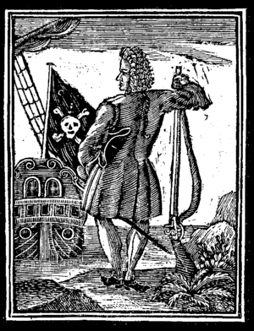
Edited May 16, 2012 by Swashbuckler 1700

