Captain Midnight
- Pyrate Captain
- 
- 
- Member

- 643 posts
- Gender:Male
- Location:Richland, GA USA
- Interests:I am the Captain of The Cursed Few, the deadliest pirate crew on the East Coast. I am a charter member of the Order of Leviathan, or "Devil's Dozen".
(IP: 70.144.232.16) ·
Posted September 24, 2005 · Report post
Ahoy me mateys!
What did a sea chest for the GAoP look like? Did they look like the ones seen at Marlinespike.com? I'm looking to build one of me own, but I'd like one that is appropriate to our time period. Thanks for your help!

- Quote
- Edit

Fox
- Old Twillian
- 
- 
- Moderator

- 2,564 posts
- Gender:Male
- Location:Beautiful lush Devon, England
- Interests:Nautical history of the 16-18th centuries and living history based thereon.
Shooting pirates.
(IP: 81.103.216.152) · ·
Posted September 24, 2005 · Report post



- Quote
- Edit
- Options

JoshuaRed
- Dread Pyrate
- 
- 
- Member

- 1,342 posts
(IP: 70.152.216.209) · ·
Posted September 24, 2005 (edited) · Report post
What would you use for hinges? You could probably find some original hardware somewhere online, I'd wager. At least for reference. And do you think GAOP seamen had the artistic creativity of later seamen, in terms of decorating chests?
Edited September 24, 2005 by JoshuaRed

- Quote
- Edit
- Options

Fox
- Old Twillian
- Moderator

- 2,564 posts
- Gender:Male
- Location:Beautiful lush Devon, England
- Interests:Nautical history of the 16-18th centuries and living history based thereon.
Shooting pirates.
(IP: 81.103.144.100) · ·
Posted September 25, 2005 · Report post
Can't say about GAoP period seamen, but I have seen Drake's seachest, which is vividly painted on the inside of the lid with stylistic pictures of ships.

- Quote
- Edit
- Options

Captain Midnight
- Pyrate Captain
- Member

- 643 posts
- Gender:Male
- Location:Richland, GA USA
- Interests:I am the Captain of The Cursed Few, the deadliest pirate crew on the East Coast. I am a charter member of the Order of Leviathan, or "Devil's Dozen".
(IP: 68.217.192.232) · ·
Posted September 25, 2005 (edited) · Report post
Thanks, Foxe! I wonder what type of chest the two figures to the far right are carrying on their shoulders? They resemble the chests at marlinespike.com moreso than the two chests in the center of the engraving, which appear to be just plain boxes. I'd like to build something a little bit fancier than just a plain wooden box. I intend to paint the inside of the lid of mine as well with some nautical scene.
Edited September 25, 2005 by Captain Midnight

- Quote
- Edit
- Options

Slopmaker Cripps
- Ship's Master
- 
- Member

- 137 posts
- Interests:Maritime Living History<br>Slopmaking<br>Tailoring
(IP: 66.177.197.181) · ·
Posted September 25, 2005 (edited) · Report post
Looks to me they're sea chests just like the others, just with their lids open.
The slanted wall style of sea chest wasn't around until the very late 18th and early 19th century.
Frank Rodriques did a lot of research on 18th century sea chests while he was working at the National Archives in Britain, and he found that most "sea chests" were similar to period boxes or blanket chests. Some were even just crates. So, it's just something to think about. It seems to me that people tended to want things strong and functional instead of dandified.
Cheers,
Adam
Edited September 25, 2005 by Slopmaker Cripps

- Quote
- Edit
- Options

Captain Midnight
- Pyrate Captain
- Member

- 643 posts
- Gender:Male
- Location:Richland, GA USA
- Interests:I am the Captain of The Cursed Few, the deadliest pirate crew on the East Coast. I am a charter member of the Order of Leviathan, or "Devil's Dozen".
(IP: 68.217.192.232) · ·
Posted September 25, 2005 · Report post
Ahoy Mr. Cripps!
Thanks for that bit of information, that is what I was really driving at. I didn't know the history of the sea chest, so I didn't know if marlinespike's were appropriate or not. As for being dandified, though, I don't think the later ones were...as a matter of fact, most of them shown on marlinespike's web site are pretty utilitarian looking, even if they are from a later period.

- Quote
- Edit
- Options

Slopmaker Cripps
- Ship's Master
- Member

- 137 posts
- Interests:Maritime Living History<br>Slopmaking<br>Tailoring
(IP: 66.177.197.181) · ·
Posted September 25, 2005 (edited) · Report post
Aye, when I said dandified I meant painted, fancy rope work, carvings, all that kind of stuff. Anything other than wood and the utilities holding it together. Mostly they were just boxes with a latch to keep thieves from lifting the lid. In fact, Frank told me that one of the documented sea chests he examined was a blanket box the guy brought from home that was originally at the foot of his bed. As I said, all sailors back then tended to be practical. In fact, it is my opinon that sailors are the most practical people of any age. So, when putting together an impression, practicality and simplicity are really the way to go.
addendum- when I say "painted" above I am referring to pictures and that kind of thing, not a couple coats of paint to cover up the natural wood (which is correct, but you have to choose colors wisely).
Cheers,
Adam
Edited September 25, 2005 by Slopmaker Cripps

- Quote
- Edit
- Options

Fox
- Old Twillian
- Moderator

- 2,564 posts
- Gender:Male
- Location:Beautiful lush Devon, England
- Interests:Nautical history of the 16-18th centuries and living history based thereon.
Shooting pirates.
(IP: 81.103.217.252) · ·
Posted September 25, 2005 · Report post
Quote
it is my opinon that sailors are the most practical people of any age.
I'd agree with that wholeheartedly FWIW. At sea you don't have the time to do things that are impractical - every difficulty is 5 times more difficult at sea, so you don't want to start introducing new ones. Given the limited space aboard most ships, but probably among pirate ships particularly (given their relatively large crews) you just don't have the room to take fripperies.
However, all that means that you probably make the best of the things you do have, hence the traditional pride taken in such seemingly small things as chest beckets and the like.

- Quote
- Edit
- Options

JoshuaRed
- Dread Pyrate
- Member

- 1,342 posts
(IP: 70.157.195.114) · ·
Posted September 25, 2005 (edited) · Report post
Wow! Cool to see marlinespike.com mentioned here...my dad is friends with that guy. Had some custom work done from him awhile back...he does beautiful work. Small world and getting smaller!
Edited September 25, 2005 by JoshuaRed

- Quote
- Edit
- Options

Captain Midnight
- Pyrate Captain
- Member

- 643 posts
- Gender:Male
- Location:Richland, GA USA
- Interests:I am the Captain of The Cursed Few, the deadliest pirate crew on the East Coast. I am a charter member of the Order of Leviathan, or "Devil's Dozen".
(IP: 68.154.90.94) · ·
Posted September 25, 2005 · Report post
Yep, he does indeed do excellent work! I have never seen such magnificent knotwork...I wish I knew how to do that. And the chests are awesome!

- Quote
- Edit
- Options

Deadeye
- Ship's Master
- 
- Member

- 176 posts
- Location:Va Beach, Virginia
- Interests:Hell Raisin, Carousing, General Malady. Marlinespike, swordplay, Reenacting, Bladesmithing, foundry work.
(IP: 70.174.70.36) · ·
Posted September 25, 2005 · Report post
Quote
Wow! Cool to see marlinespike.com mentioned here
I actually posted them a fw weeks ago in PLUNDER under "Swag fer yer Quarters". Been a longtime admirer myself of their work, and have studied the pictures to try and further my marlinespiking.
I think they also sell the plans and patterns for their chests if i am not mistaken.

- Quote
- Edit
- Options

blackjohn
- Iron Age Hero Lost at Sea
- 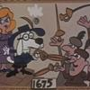
- Member

- 3,745 posts
- Gender:Male
- Location:Columbia, Md
- Interests:Stuff... and junk.
(IP: 68.55.33.108) · ·
Posted September 26, 2005 · Report post
Foxe said:
Quote
it is my opinon that sailors are the most practical people of any age.
I'd agree with that wholeheartedly FWIW.
I don't like to disagree with either of you, but in this case I will. My vote is going to the soldier, on the march, as most practical. I'll place sailors second.
I found some interesting info on sea chests in a book I have on the Plimouth colony. I'd post it, but I'm still worn out from this weekend.

- Quote
- Edit
- Options

Captain Midnight
- Pyrate Captain
- Member

- 643 posts
- Gender:Male
- Location:Richland, GA USA
- Interests:I am the Captain of The Cursed Few, the deadliest pirate crew on the East Coast. I am a charter member of the Order of Leviathan, or "Devil's Dozen".
(IP: 166.102.243.129) · ·
Posted September 26, 2005 · Report post
I'd be extremely interested in seeing that information, Blackjohn, thanks so much. I look forward to your post.

- Quote
- Edit
- Options

Fox
- Old Twillian
- Moderator

- 2,564 posts
- Gender:Male
- Location:Beautiful lush Devon, England
- Interests:Nautical history of the 16-18th centuries and living history based thereon.
Shooting pirates.
(IP: 81.101.64.223) · ·
Posted September 26, 2005 · Report post
That's ok John <sniff> I don't mind you not agreeing with my every word...
On second thoughts, I'd place soldiers pretty high too. The big difference between seamen and soldiers (and this isn't an argument, it's an extension) is that the soldier carries minimal kit as he marches through his world. The seaman carries slightly more gear, but that gear represents his whole world for the time he is at sea. If the soldier's gear wears out, breaks, gets lost etc he can replace it. If the same happens to the sailor's gear then he's got to get my without it. It's for that reason that in the question of practicality I'd rate the seaman top and the soldier a close second.
I've seen a sea-chest from the Vasa (roughly contemporary with the Plymouth colony) which was basically a square box like the ones in the pictures I posted. Are the Plymouth ones radically different John?

- Quote
- Edit
- Options

blackjohn
- Iron Age Hero Lost at Sea
- Member

- 3,745 posts
- Gender:Male
- Location:Columbia, Md
- Interests:Stuff... and junk.
(IP: 68.55.33.108) · ·
Posted September 26, 2005 (edited) · Report post
Foxe said:
That's ok John <sniff> I don't mind you not agreeing with my every word...
Ed... haha... too bad there's this big pond in our way, because I'd really like to shake your hand someday.
Ok, I wouldn't be suprised if you felt this way. If necessity is a spur to ingenuity and the mother of invention, then disagreement is a spur to research and the mother of new ideas.
Quote
I've seen a sea-chest from the Vasa (roughly contemporary with the Plymouth colony) which was basically a square box like the ones in the pictures I posted. Are the Plymouth ones radically different John?
I don't know, I'd have to look at Lisa's Wasa book (she lived in Sweden for a year and has actually seen the Wasa). Since there is so much in this Plymouth book, I'll have to do a little bit at a time.
"The simplest form of construction of case pieces is the nailed configuration. It was quick, efficient and less expensive than joined furniture."
"Dovetailed joints on boxes and chests were not commonly seen until the end of the century, and rarely then. Nailed construction was used well into the nineteenth century in the more rural and isolated communities in the United States."
This is from A Cubberd, Four Joyne Stools & Other Smalle Thinges: The Material Culture of Plymouth Colony. It's a great book, and don't let the title fool you. There's a wealth of info on things later than the Pilgrims.
The book has a good 15 pages on chests, though only the first few resemble anything close to a sea chest. Frankly, I'm suprised that nailed construction was so popular.
Edited September 26, 2005 by blackjohn

- Quote
- Edit
- Options

MadMike
- First Mate
- 
- 
- Member

- 251 posts
- Location:Careened near the Gulf of Mexico
- Interests:1712 raid on Dauphin Island, Alabama.
(IP: 209.26.26.142) · ·
Posted September 27, 2005 · Report post
Just found some info regarding a chest (although not specifically a seaman's chest) on the LaSalle shipwreck site (Belle) which sank near Matagorda Bay (betwixt Houston and Corpus Christi), Texas in 1686-
http://nautarch.tamu.edu/crl/Report5/oldsite/Chest.htm
The measurements of the chest are 25.5" long x 13" wide x 13.5" tall.
Months ago, I used pic's supplied by Foxe to make a chest; I made two chests, one which measures 26" long x 11" wide x 13" tall- not bad, eh?
Yours, &c.
Mike

- Quote
- Edit
- Options

Fox
- Old Twillian
- Moderator

- 2,564 posts
- Gender:Male
- Location:Beautiful lush Devon, England
- Interests:Nautical history of the 16-18th centuries and living history based thereon.
Shooting pirates.
(IP: 81.103.145.24) · ·
Posted September 27, 2005 · Report post
MadMike said:
Months ago, I used pic's supplied by Foxe to make a chest; I made two chests, one which measures 26" long x 11" wide x 13" tall- not bad, eh?
Fine work! Any chance of photos?

- Quote
- Edit
- Options

MadMike
- First Mate
- Member

- 251 posts
- Location:Careened near the Gulf of Mexico
- Interests:1712 raid on Dauphin Island, Alabama.
(IP: 64.45.210.35) · ·
Posted September 27, 2005 · Report post
Foxe,
I used the 1700's trader picture as the basis for a box, using details based on antique chests and those pictured in "Collectors Illustrated Encyclopedia of the American Revolution (hasps, lids, handles, paint scheme, etc).
Will try to take pics, the cell phone photo's aren't the greatest of quality.
Any info on chests recovered from the Mary Rose or Wasa?
Yours, &c.
Mike

- Quote
- Edit
- Options

Captain Midnight
- Pyrate Captain
- Member

- 643 posts
- Gender:Male
- Location:Richland, GA USA
- Interests:I am the Captain of The Cursed Few, the deadliest pirate crew on the East Coast. I am a charter member of the Order of Leviathan, or "Devil's Dozen".
(IP: 68.217.210.112) · ·
Posted September 27, 2005 · Report post
This is great information, thanks guys! I think the chest recovered from the wreck is interesting, but I can't really make out any of its details from the small pics, and the videos wouldn't play on my computer. Is it a plain rectangular box?
So the slant-sided chests are too late for our period? That's a shame, I really like that design, and I love the marlinespike handles on them!

- Quote
- Edit
- Options

blackjohn
- Iron Age Hero Lost at Sea
- Member

- 3,745 posts
- Gender:Male
- Location:Columbia, Md
- Interests:Stuff... and junk.
(IP: 205.156.36.11) · ·
Posted September 28, 2005 · Report post
I don't know if this is germane, considering it is not listed as a sea chest, but I found it interesting nonetheless:
Quote
147. Leather Trunk
Wood, leather, iron
England, 1698
H: 20 W: 35 D: 18 1/4
Lent by The Pilgrim Society
This leather covered trunk was owned by Ephraim Little, pastor of the Church of the Christ at Plymouth from 1699 to 1723. It bears his initials and the date 1698 on the top with brass tacks and is lined with nineteenth century cream-colored paper decorated with blue dots. The trunk has been recovered at some point during the nineteenth century; therefore we do not know if we are seeing the original tack pattern. The hardware appears to be original and at least some of the original paper lining is present under the early nineteenth century stenciled paper.
At least twenty-one trunks are listed in Plymouth Colony wills and inventories between 1633 and 1650. The English Leather Seller's Ordinance of 1635 required that trunks be covered with well-tanned leather, without hair; horsehide, hogs', or calves leather was not to be used. Twelves or more "squires," or corner braces were required. The lining was to be linin, cloth, or silk; paper was forbidden and the penalty for lining with it was a fine and defacement of the trunk. When the Leather Sellers guild lost control, horsehide and sealskin with the hair on became common, and trunks were lined with decorated paper (often stenciled-over waste leaves from books), and later newspaper.
The probate inventory of Edward Sturgis, Junior, of Yarmouth listed "a lether trunk" for 8 shillings in 1679.

- Quote
- Edit
- Options

kass
- Scourge o' the 7 Seas
- 
- 
- Member

- 1,526 posts
- Gender:Male
- Location:Easton, Pennsylvania
- Interests:Historical Clothing from the 14th through 18th centuries. Getting all the niggling details right. Dressing up and having fun with my similarly-obsessed friends. :)
(IP: 68.162.108.91) · ·
Posted September 28, 2005 · Report post
Forgive my ignorance on the subject, but do you think there would be a discernable difference between a "sea chest" and a regular trunk? I've always assumed that a sea chest was just a chest that went to sea and it would be the same if it were used as storage in a house. I don't know if that's true, of course, and frankly I know more about early 20th century trunks than anything else. But it may be that we're giving it a classification that didn't really exist. Or not...
The chest described in your post sounds very much like a replica chest they have at Pennsbury Manor. As I said, it is a replica but it based on a description of a chest numbered among William Penn's possessions when he left Pennsylvania for the last time in 1701.

- Quote
- Edit
- Options

blackjohn
- Iron Age Hero Lost at Sea
- Member

- 3,745 posts
- Gender:Male
- Location:Columbia, Md
- Interests:Stuff... and junk.
(IP: 205.156.36.11) · ·
Posted September 28, 2005 · Report post
I've assumed the same. Foxe, what are your assumptions?
The authors suggest chest number 148 in the text has travelled, as evidenced by the nail marks in the lid.

- Quote
- Edit
- Options

Fox
- Old Twillian
- Moderator

- 2,564 posts
- Gender:Male
- Location:Beautiful lush Devon, England
- Interests:Nautical history of the 16-18th centuries and living history based thereon.
Shooting pirates.
(IP: 81.103.144.78) · ·
Posted September 28, 2005 · Report post
Except for the picture of the French traders above I can't offhand think of any strictly GAoP period sea-chests, so a certain amount must be educated speculation based on evidence from either side. With that in mind I don't recall having seen the tapered style of sea-chest prior to the 19th century, so I suspect that it's like a lot of nautical "traditions" ie. dating from the twilight of the age of sail.
The chests I've seen from the Mary Rose are all rectangular, likewise the Vasa chest I've seen, likewise the French traders' chests, Hogarth's "Idle's" chest, and the chests currently on HMS Victory (which are all repros, but presumably from a decent source, all their stuff is). I reckon you guys are right and "Seachest" is just a name, meaning no more than a chest which is taken to sea. FWIW, I don't recall ever having come across a barrel-topped sea chest either. Anyone?

- Quote
- Edit
- Options

kass
- Scourge o' the 7 Seas
- Member

- 1,526 posts
- Gender:Male
- Location:Easton, Pennsylvania
- Interests:Historical Clothing from the 14th through 18th centuries. Getting all the niggling details right. Dressing up and having fun with my similarly-obsessed friends. :)
(IP: 68.162.108.91) · ·
Posted September 28, 2005 · Report post
Nope. The few chests I've seen from this period are flat topped and rectangular.

• • Quote
• Edit
• Options

JoshuaRed
- Dread Pyrate
- Member

- 1,342 posts
(IP: 151.138.254.21) · ·
Posted September 28, 2005 · Report post
Or buoyant & bodiced.
Sorry, someone just HAD to go there at some point in this thread, so I thought I'd get it out of the way!

- Quote
- Edit
- Options

blackjohn
- Iron Age Hero Lost at Sea
- Member

- 3,745 posts
- Gender:Male
- Location:Columbia, Md
- Interests:Stuff... and junk.
(IP: 205.156.36.11) · ·
Posted September 28, 2005 · Report post
I'm glad someone did that. Mine was going to be something like "flat in front, but very rounded on top."
Oh! Chest 147 has a slight curved on top. Very slight.

- Quote
- Edit
- Options

kass
- Scourge o' the 7 Seas
- Member

- 1,526 posts
- Gender:Male
- Location:Easton, Pennsylvania
- Interests:Historical Clothing from the 14th through 18th centuries. Getting all the niggling details right. Dressing up and having fun with my similarly-obsessed friends. :)
(IP: 68.162.108.91) · ·
Posted September 28, 2005 · Report post
<sigh> Boys...
Speaking of chests, I'll have pictures of the girls to post tomorrow. Grab your drool collection devices!

- Quote
- Edit
- Options

blackjohn
- Iron Age Hero Lost at Sea
- Member

- 3,745 posts
- Gender:Male
- Location:Columbia, Md
- Interests:Stuff... and junk.
(IP: 205.156.36.11) · ·
Posted September 29, 2005 · Report post
And if anyone is interested, I can try taking a picture of chest 147 with my digital camera and post it (Blackjohn sans scanner).

- Quote
- Edit
- Options

kass
- Scourge o' the 7 Seas
- Member

- 1,526 posts
- Gender:Male
- Location:Easton, Pennsylvania
- Interests:Historical Clothing from the 14th through 18th centuries. Getting all the niggling details right. Dressing up and having fun with my similarly-obsessed friends. :)
(IP: 68.162.111.208) · ·
Posted September 29, 2005 · Report post
As promised, here they are: Scylla and Charybdis
Girls flanking Jay
(I'm not responsible for the guy in the middle.)
Where shall we start the bidding?

- Quote
- Edit
- Options

Gentleman of Fortune
- Dread Pyrate
- 
- Member

- 1,456 posts
- Gender:Male
- Location:Germany... Franconia (northern Bavaria)
- Interests:I *used* to be an environmental scientist, until I married a DoDDs teacher in 1997. Since then, I have been living in, and traveling around, Europe (First the UK, now Germany).
My hobbies are all the "usual suspects" for those interested in re-enacting and Golden Age of Piracy stuff.... but I have drifted away from the pirate scene as my location and young family don't allow for any more than "virtual" pirate participation. Besides Piracy, I am into Reverend Guitars and Vintage Corvettes.
(IP: 84.170.207.138) · ·
Posted September 29, 2005 · Report post
Cool stays... did you make them?
GoF

- Quote
- Edit
- Options

JoshuaRed
- Dread Pyrate
- Member

- 1,342 posts
(IP: 151.138.254.21) · ·
Posted September 29, 2005 · Report post
Boy oh boy this sure isn't the same thread it began as!

- Quote
- Edit
- Options

kass
- Scourge o' the 7 Seas
- Member

- 1,526 posts
- Gender:Male
- Location:Easton, Pennsylvania
- Interests:Historical Clothing from the 14th through 18th centuries. Getting all the niggling details right. Dressing up and having fun with my similarly-obsessed friends. :)
(IP: 68.162.111.208) · ·
Posted September 29, 2005 · Report post
Just remember, Josh, we were talking about wooden trunks until you piped up. So it's all YOUR fault.
Greg, I didn't make their stays. They made them all by themselves. Of course I taught them how. Aren't they cute?
<proud mama face>

- Quote
- Edit
- Options

blackjohn
- Iron Age Hero Lost at Sea
- Member

- 3,745 posts
- Gender:Male
- Location:Columbia, Md
- Interests:Stuff... and junk.
(IP: 205.156.36.11) · ·
Posted October 4, 2005 · Report post
I took a picture of the slightly round topped chest (don't laugh!!! ) and put it on the Pirate Brethren site.
http://www.piratebrethren.com/Chest1698.jpg

- Quote
- Edit
- Options

Deadeye
- Ship's Master
- Member

- 176 posts
- Location:Va Beach, Virginia
- Interests:Hell Raisin, Carousing, General Malady. Marlinespike, swordplay, Reenacting, Bladesmithing, foundry work.
(IP: 138.162.0.37) · ·
Posted October 4, 2005 · Report post
Quote
(I'm not responsible for the guy in the middle.)
I hope not, he looks like an sherbet factory exploded on him!

- Quote
- Edit
- Options

Diego Santana de la Vega
- Pyrate Legend
- 
- Member

- 3,494 posts
- Location:Anaheim, California
- Interests:Piracy, Ren Faires, Fishing, Cooking, Writing, Teaching, Pub Darts, Women with brains.
(IP: 63.166.210.133) · ·
Posted October 4, 2005 (edited) · Report post
JoshuaRed said:
Or buoyant & bodiced.
Sorry, someone just HAD to go there at some point in this thread, so I thought I'd get it out of the way!
Grammercy fer that thought!
just in case and fer what it be worth fer looks and the likes cheap yeh free frieght even better try these on!
wood trunk at Target
Bouyant! God bless ye matey!
Edited October 4, 2005 by Diego Santana de la Vega

- Quote
- Edit
- Options

Pirate Petee
- Dread Pyrate
- Member

- 1,447 posts
(IP: 69.228.124.196) · ·
Posted October 4, 2005 · Report post
kass said:
Just remember, Josh, we were talking about wooden trunks until you piped up. So it's all YOUR fault.
Greg, I didn't make their stays. They made them all by themselves. Of course I taught them how. Aren't they cute?
<proud mama face>
There were wooden trunks in that picture.

- Quote
- Edit
- Options

blackjohn
- Iron Age Hero Lost at Sea
- Member

- 3,745 posts
- Gender:Male
- Location:Columbia, Md
- Interests:Stuff... and junk.
(IP: 205.156.36.11) · ·
Posted October 4, 2005 (edited) · Report post
And Not So Young Jim Hawkins is way off in the background, staring at the saucy ones...
:)
Edited October 4, 2005 by blackjohn

- Quote
- Edit
- Options

Diego Santana de la Vega
- Pyrate Legend
- Member

- 3,494 posts
- Location:Anaheim, California
- Interests:Piracy, Ren Faires, Fishing, Cooking, Writing, Teaching, Pub Darts, Women with brains.
(IP: 63.166.210.133) · ·
Posted October 4, 2005 · Report post
I'm jes reliving the idea of bouyant! Nice thought I tell ye!

- Quote
- Edit
- Options

Misson
- Dread Pyrate
- Member

- 1,001 posts
- Gender:Male
- Interests:Who me?
(IP: 75.128.81.170) · ·
Posted May 4, 2008 (edited) · Report post
I have been reading The Age of Sail by W.R. Thrower (1972) and he said something I found interesting regarding seamen's sea chests:
"Many men joining a ship had little more than the clothes they stood in and the 'bundle' containing their few possessions. More senior men and petty officers, as well as apprentices and first-timers, had a sea chest. Sea chests were not necessarily plain wooden boxes, they were often very well made and fitted inside at the whim of the owner. A fine example of one believed to have been used by [Admiral Robert] Blake [1599—1657] in the 17th century, is shown in Fig 25." (Thrower, p. 74)
Here is the figure, scanned from the book:

It actually looks to me a bit like various descriptions I have read of Medicine Chests. Although my impression is that they often had a top compartment with a hinged lid for storing bottles.
I would like to note that Thrower has at times (IMHO) a tendency to make sweeping statements that I'm not certain other sources I've read would completely agree with. He also does a less than stellar job of citing some of his sources which I find annoying. (I wonder if the above info also came from a placard or description in the Blake Museum in Bridgewater, Somerset? Alas, he doesn't say.)
Still, I find this book quite comprehensive in its way as well as being very interesting. So I wanted to share the comment.
Edited May 4, 2008 by Misson

- Quote
- Edit
- Options

Captain Jim
- Captain Jim for Captain!
- 
- Member

- 2,254 posts
- Gender:Male
- Location:Off the coast of Tampa Bay (Unfortunately, inland from the coast)
- Interests:I'm 57, formerly a wildlife ecologist and biologist, now a stay-at-home dad. I grew up on the west coast of Florida, where Anna Maria Sound and Tampa Bay were my playground. My interests include, but are not limited to cannon, black powder arms, history, fishing the flats, sailing, fine wood working, flint gun building, hunting, good gun dogs. Above all, my wife and children.
(IP: 12.195.96.35) · ·
Posted May 4, 2008 · Report post
Just my humble opinion but that seems to be more of a sea desk than a sea chest.

- Quote
- Edit
- Options

Mary Diamond
- It's My Fault
- 
- Moderator

- 1,050 posts
- Gender:Female
- Location:Illinois
- Interests:Things I Love: Horticulture, Travel, Volleyball, Reading, Sewing, Costuming, Halloween, esp. props!, Halo, Halo2, Halo3, ODST, and, of course, Pyracy.
(IP: 67.167.49.211) · ·
Posted May 4, 2008 · Report post
Agreed, Captain Jim. Lovely specimen, though, and would seem fitting for a Captain, to contain documents, etc.
Thanks for the image and info, Mission!

- Quote
- Edit
- Options

Misson
- Dread Pyrate
- Member

- 1,001 posts
- Gender:Male
- Interests:Who me?
(IP: 75.128.81.170) · ·
Posted May 5, 2008 (edited) · Report post
Hmm. I'm starting to wonder if I can trust Thrower's research. It's too bad, because this particular book contains an extensive amount of info on the day-to-day life of seamen from the Navy, merchant ships, privateers and pirates. (Although it is not organized quite as nicely as that list, but it still has more info than any similar book I've seen.) I wonder how the museum has the chest labeled?
Edited May 5, 2008 by Misson

- Quote
- Edit
- Options

Silver
- Plunderer
- 
- Member

- 347 posts
- Gender:Male
- Location:Virginia Beach, Virginia
- Interests:Maritime history
(IP: 68.10.222.87) · ·
Posted May 8, 2008 · Report post
i saw the movie treasure island. it was the later one made. in it they show the sea chest belonging to the pirate who was rooming at the inn. it wasn't very large something a sailor could pick up and carry on one shoulder. having been in the navy and having to move your whole worldly possions in one tripand on your back if it didn't fit in the sea bag or on your person there was no room in your life for it. you learn to keep only what you had to have.

- Quote
- Edit
- Options

Dorian Lasseter
- Where's My Water
- 
- Member

- 3,266 posts
- Gender:Male
- Location:The Sea!
- Interests:18th Century reenactment; Maritime, F&I...
Did ECW as well...
All BP firelocks and cannons!
Also enjoy Swordfighting and a good Donnybrook
Got a question for or about me? Ask!!!
(IP: 71.182.132.115) · ·
Posted April 29, 2009 · Report post
blackjohn said:
Foxe said:
That's ok John <sniff> I don't mind you not agreeing with my every word...
Ed... haha... too bad there's this big pond in our way, because I'd really like to shake your hand someday.
Ok, I wouldn't be suprised if you felt this way. If necessity is a spur to ingenuity and the mother of invention, then disagreement is a spur to research and the mother of new ideas.
Quote
I've seen a sea-chest from the Vasa (roughly contemporary with the Plymouth colony) which was basically a square box like the ones in the pictures I posted. Are the Plymouth ones radically different John?
I don't know, I'd have to look at Lisa's Wasa book (she lived in Sweden for a year and has actually seen the Wasa). Since there is so much in this Plymouth book, I'll have to do a little bit at a time.
"The simplest form of construction of case pieces is the nailed configuration. It was quick, efficient and less expensive than joined furniture."
"Dovetailed joints on boxes and chests were not commonly seen until the end of the century, and rarely then. Nailed construction was used well into the nineteenth century in the more rural and isolated communities in the United States." Bold, my addition...
This is from A Cubberd, Four Joyne Stools & Other Smalle Thinges: The Material Culture of Plymouth Colony. It's a great book, and don't let the title fool you. There's a wealth of info on things later than the Pilgrims.
The book has a good 15 pages on chests, though only the first few resemble anything close to a sea chest. Frankly, I'm surprised that nailed construction was so popular.
Digging up an old thread....
Nails used for chests, any ideas what?
The old square, forged style? Copper or brass?
Think their were ever brass wood screws used?
I know copper and brass nails/tacks were used aboard ships, just wondered if the same goes for sea chests...
most of the images I've found of sea chests, they are painted so you can't see what might be holding them together...

- Quote
- Edit
- Options

Dutchman
- Has anyone seen my cousin?
- Admin

- 1,773 posts
- Gender:Male
- Location:tidewater virginia
(IP: 198.246.136.35) · ·
Posted April 29, 2009 · Report post
as i recall from a class i took a couple years ago. nails were more common than turn screws, but they were both used. iron fasteners mostly, copper nails would bend too easily in this application- not sure about brass. copper or brass rivets would have been used in some finer pieces.

- Quote
- Edit
- Options

callenish gunner
- Scourge o' the 7 Seas
- 
- Member

- 2,138 posts
- Gender:Male
- Location:Pennsylvania mountains north of Clarion
- Interests:The Callenish gunner has just hoved into view looking for safe anchorage in these waters... purveyor of bladed and flintlock weaponry also leather accessories ..........painter of portraits and period scenes by avocation I'm getting my armoury business underway and will be doing as many festivals as I can ...right now along the east coast or great lakes
(IP: 98.21.67.36) · ·
Posted April 29, 2009 · Report post
Another method that can be used which I learned from my Great Grandfather is a locking pin dowel rod joint where you use a larger dowel to originally join the boards of the chest and then drill through the sides through the side and dowel rod and place a smaller dowel through both pieces of the sides to lock the peg permanently ...solid and rugged wearing joint for uses that require a joint you can depend upon! Just my humble opinion

- Quote
- Edit
- Options

Joe Pyrat
- Plunderer
- 
- Member

- 395 posts
- Location:Sailing down the east coast
- Interests:Sailing, History, specifically 1670 - 1725, all manner of muzzle loading weapons, good food, good music and good rum, aye, good rum...
(IP: 72.181.202.191) · ·
Posted April 30, 2009 · Report post
WRT construction methods, have any of you taken a look at the Foxfire books? Seems the first one had an article on building using wooden pins. I think it was building a cabin, but the method should work on smaller projects.

- Quote
- Edit
- Options

Dorian Lasseter
- Where's My Water
- Member

- 3,266 posts
- Gender:Male
- Location:The Sea!
- Interests:18th Century reenactment; Maritime, F&I...
Did ECW as well...
All BP firelocks and cannons!
Also enjoy Swordfighting and a good Donnybrook
Got a question for or about me? Ask!!!
(IP: 147.72.68.65) · ·
Posted April 30, 2009 · Report post
bbcddutchman said:
as i recall from a class i took a couple years ago. nails were more common than turn screws, but they were both used. iron fasteners mostly, copper nails would bend too easily in this application- not sure about brass. copper or brass rivets would have been used in some finer pieces.
So, using these would be the ticket...

- Quote
- Edit
- Options

oderlesseye
- Scourge o' the 7 Seas
- Member

- 2,126 posts
- Gender:Male
- Location:San Diego, Ca. (North Park) me cove !
- Interests:Oderlesseye is a mutinous two bit sand dollar with a thirst for adventure. Sailing on tall ships, firing black powder weapons, and sword fighting.. I most love to entertain the public in piratical skit presentations that involve all of the above. My name is befitting of my position on board as that of the look-out. Some ask what’s the meaning of the name Oderlesseye...It is simple really.. When Eye am aloft, ye can’t smell me...But it’s spelled wrong some exclaim! Hey now! What pirate can spell? - is my retort!
I have been an active member of the pirate community since 2005. I consider myself a fan of living history in the Golden Age of Piracy. As a child I , like the lot of ye, loved the old time pirate movies with Errol Flynn and Douglas Fairbanks. Long live Long John Silver !
Inspired by them, Eye created a Pirate Ninja Movie called "Treachery and a Dead Mans Promise" Available on YouTube.
Being a pirate, as it turns out, is multi-dimensional. For me, a lifestyle has been carved out of it. There is a six foot tall skeleton pirate in a make shift hide out called Dead Mans Cove behind my house. The walls are painted giving the impression you are in a sea cave. There is a mural of a pirate coming ashore in a long boat at the mouth of the cove. Believe me, it is a great place to enjoy rum now and again!
Exploration into all things piratical have led me to being an attempted escapee from the Governors noose to impersonating a judge in the Anne Bonnie and Mary Read trial held in Pirates In Paradise.. As Oderlesseye, my one on one impression to patrons is as one whom barley escaped the flames of the ship we took when the powder magazine blew with the booty in me hands from the Captains quarters.. The tale explains the soot on me face, the tattered clothing, and the burnt tricorn, as I hand out a gold coin or two. I hate them plastic ones and I know kids appreciate the metal coins even more so.
When an event is slated for a historical time line presentation to the public, I do not do these things mentioned above. Rather, I share about what is a grape shot or how a flintlock works. I ware clothing that is more closely representing the era in these cases. I am still updating me togs (Period Kit) as I learn more thru fellow pirates and sources like the Pyracy Pub.
So far, there have been many exciting moments of adventure the world of PIRACY has afforded me. From standing on a bar top with Pirates Charles singing to me in New Orleans to shooting cannons ( Ships Guns for you PC Pirates!), on the tall ship Spirit of Dana Point. Cheers from a crowd during a show as last man standing on the Treasure chest proclaiming to an excited crowd ITS MINE! THE BOOTY IS MINE ! YARR ! ~ These things and the notoriety that comes with being a pirate has me hooked! Whats More Is the greater bonds of friendships that have been forged with those whose course finds me at such events, sharing the same love and passion of the Life within the pirate/reenactment community. To Them Eye take me hat off and offer a tot of Rum! Cheers mates!
(IP: 72.220.144.209) · ·
Posted April 30, 2009 · Report post
well reading this thread ..Eye learned that older chest more to our period were a 90 ' box and not slanted in like the ones illistrated on marlineSpike.com.. The guy from that site said he is not accepting orders...We he wants to many duckets any way... The finger joint was brought up also being too modern.. reguardless I can still customize...

• Quote
• Edit
• Options

Edward O'Keeffe
- Occupy Fort Taylor!
- 
- 
- Member

- 90 posts
- Gender:Male
- Location:Rochester, NY
- Interests:Woodworking
(IP: 74.34.9.14) · ·
Posted April 30, 2009 · Report post
Alright, my sea chest is almost done. So it's time to post pictures. I used the Marlinespike plans, and adapted them to my taste. The box is rabbit jointed and nailed with forged square nails. All that is left from here is to put on the beckets, and install the till box.
It is 3/4 pine, with poplar trim for stiffening, Milk paint and linseed oil finish. I used 7 1/2" hammered strap hinges, and a full mortise lock.
Still deciding on whether or not the till box will get a separate lock.
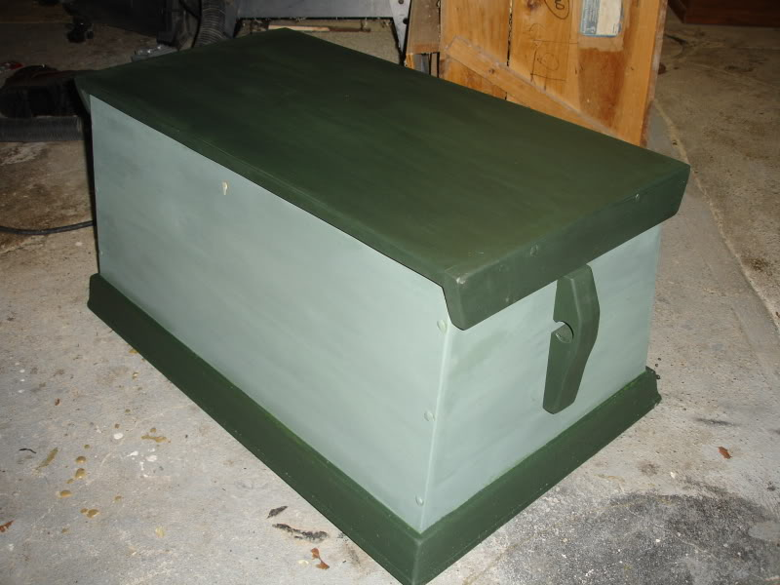
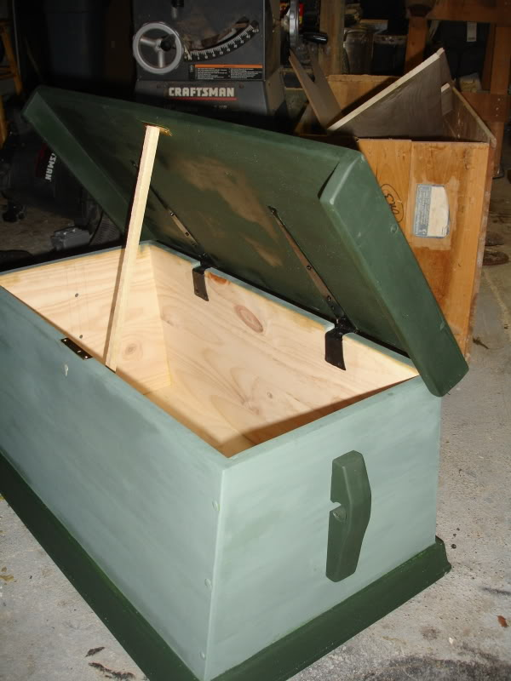
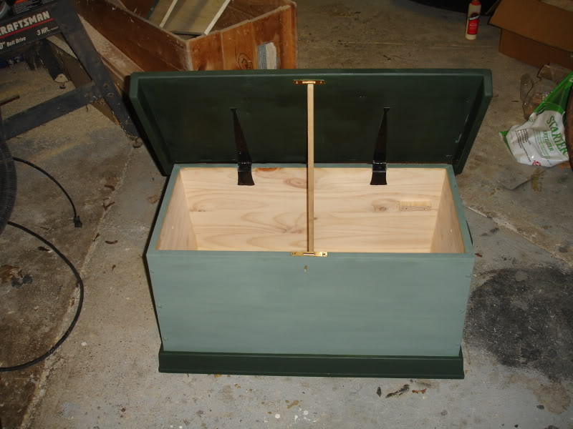
Comments welcome.
E O'K

- Quote
- Edit
- Options

William Brand
- Mercury Malefactor
- 
- 
- Admin

- 8,884 posts
- Gender:Male
- Location:Logan, Utah
- Interests:My name is William Pace and I live and work as a graphic designer, illustrator and photographer in Northern Utah. I'm married to the lovely Tracy Pace and we have three children. In addition to all things art, I enjoy traveling and meeting new people from every walk of life. I've always been a fan of history, theology, and of course, Pyracy.
http://www.youtube.com/watch?v=PSkt-q-HihQ
(IP: 166.70.59.121) · ·
Posted April 30, 2009 · Report post
Comment # 1
Nice.
Comment # 2
wow.

- Quote
- Edit
- Options

callenish gunner
- Scourge o' the 7 Seas
- Member

- 2,138 posts
- Gender:Male
- Location:Pennsylvania mountains north of Clarion
- Interests:The Callenish gunner has just hoved into view looking for safe anchorage in these waters... purveyor of bladed and flintlock weaponry also leather accessories ..........painter of portraits and period scenes by avocation I'm getting my armoury business underway and will be doing as many festivals as I can ...right now along the east coast or great lakes
(IP: 98.21.67.36) · ·
Posted April 30, 2009 · Report post
Very nice Mr. O'Keeffe!!!! ....as if we would expect anything less

- Quote
- Edit
- Options

michaelsbagley
- Smells Like Wet Sheep
- 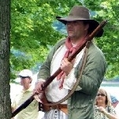
- Moderator

- 2,548 posts
- Gender:Male
- Location:Columbus, Ohio
- Interests:Mostly into GAoP, but starting to develop more Buccaneer era stuff for re-enacting as well. Generally I do re-enact both piratical/nautical and other impressions from the period. I am focusing on more "common" impressions from the period (i.e. average sailor/pirate, rank and file Red Coat, early Colonial huntsman, etc.)
(IP: 99.54.97.253) · ·
Posted April 30, 2009 · Report post
Wow,
Mr. O'Keefe's stuff always makes me drool! he is truly a gifted artisan when it comes to woodworking, or rope/knotwork, or... or... or... Damn, you're just too good at too much man!

- Quote
- Edit
- Options

Silkie McDonough
- Proprietress of the Sealkies Hide
- 
- Moderator

- 5,695 posts
- Gender:Female
- Location:I have been a Virginian for 2 months now. LOVING it.
- Interests:Music, vocalizing, Irish balads. I love to draw, I do pencile portraits/detail drawings for barter and sale. The link in in my signature. Ireland, its history and culture. Sewing garb, mostly for myself. The arm of a strong gentleman round my waist.
Unfortunately, I don't do nearly enough of any of a these.
(IP: 68.45.167.109) · ·
Posted May 1, 2009 · Report post
Beautiful work Edward!

- Quote
- Edit
- Options

Capt. Sterling
- Sticky Fingers Sterling Needs a New Hat
- 
- Member

- 10,302 posts
- Gender:Pyrate Hunter
- Location:here
- Interests:Killing pirates, haven't met one yet worth keeping alive....
(IP: 65.160.148.76) · ·
Posted May 1, 2009 · Report post
Oh I have seen better....
like the one he made for me to use....

- Quote
- Edit
- Options

Silkie McDonough
- Proprietress of the Sealkies Hide
- Moderator

- 5,695 posts
- Gender:Female
- Location:I have been a Virginian for 2 months now. LOVING it.
- Interests:Music, vocalizing, Irish balads. I love to draw, I do pencile portraits/detail drawings for barter and sale. The link in in my signature. Ireland, its history and culture. Sewing garb, mostly for myself. The arm of a strong gentleman round my waist.
Unfortunately, I don't do nearly enough of any of a these.
(IP: 68.45.167.109) · ·
Posted May 1, 2009 · Report post
Nah, I like this one ...of course green is my favorite color.

- Quote
- Edit
- Options

oderlesseye
- Scourge o' the 7 Seas
- Member

- 2,126 posts
- Gender:Male
- Location:San Diego, Ca. (North Park) me cove !
- Interests:Oderlesseye is a mutinous two bit sand dollar with a thirst for adventure. Sailing on tall ships, firing black powder weapons, and sword fighting.. I most love to entertain the public in piratical skit presentations that involve all of the above. My name is befitting of my position on board as that of the look-out. Some ask what’s the meaning of the name Oderlesseye...It is simple really.. When Eye am aloft, ye can’t smell me...But it’s spelled wrong some exclaim! Hey now! What pirate can spell? - is my retort!
I have been an active member of the pirate community since 2005. I consider myself a fan of living history in the Golden Age of Piracy. As a child I , like the lot of ye, loved the old time pirate movies with Errol Flynn and Douglas Fairbanks. Long live Long John Silver !
Inspired by them, Eye created a Pirate Ninja Movie called "Treachery and a Dead Mans Promise" Available on YouTube.
Being a pirate, as it turns out, is multi-dimensional. For me, a lifestyle has been carved out of it. There is a six foot tall skeleton pirate in a make shift hide out called Dead Mans Cove behind my house. The walls are painted giving the impression you are in a sea cave. There is a mural of a pirate coming ashore in a long boat at the mouth of the cove. Believe me, it is a great place to enjoy rum now and again!
Exploration into all things piratical have led me to being an attempted escapee from the Governors noose to impersonating a judge in the Anne Bonnie and Mary Read trial held in Pirates In Paradise.. As Oderlesseye, my one on one impression to patrons is as one whom barley escaped the flames of the ship we took when the powder magazine blew with the booty in me hands from the Captains quarters.. The tale explains the soot on me face, the tattered clothing, and the burnt tricorn, as I hand out a gold coin or two. I hate them plastic ones and I know kids appreciate the metal coins even more so.
When an event is slated for a historical time line presentation to the public, I do not do these things mentioned above. Rather, I share about what is a grape shot or how a flintlock works. I ware clothing that is more closely representing the era in these cases. I am still updating me togs (Period Kit) as I learn more thru fellow pirates and sources like the Pyracy Pub.
So far, there have been many exciting moments of adventure the world of PIRACY has afforded me. From standing on a bar top with Pirates Charles singing to me in New Orleans to shooting cannons ( Ships Guns for you PC Pirates!), on the tall ship Spirit of Dana Point. Cheers from a crowd during a show as last man standing on the Treasure chest proclaiming to an excited crowd ITS MINE! THE BOOTY IS MINE ! YARR ! ~ These things and the notoriety that comes with being a pirate has me hooked! Whats More Is the greater bonds of friendships that have been forged with those whose course finds me at such events, sharing the same love and passion of the Life within the pirate/reenactment community. To Them Eye take me hat off and offer a tot of Rum! Cheers mates!
(IP: 72.220.144.209) · ·
Posted May 1, 2009 (edited) · Report post
That is one sweet box!
I went ahead and ordered the plans for my box also from marlinespike.com
I hope to have it ready for PIP.
I looked at this one here:
Original early sea chest
However they wanted 2 grand for it too much.. come on..it's a wooden box!
Edited May 1, 2009 by oderlesseye

- Quote
- Edit
- Options

Edward O'Keeffe
- Occupy Fort Taylor!
- Member

- 90 posts
- Gender:Male
- Location:Rochester, NY
- Interests:Woodworking
(IP: 74.34.9.14) · ·
Posted May 1, 2009 · Report post
Thank you all for you comments, I am glad you all approved of my attempt.
Michael, I may be able to slap planks together and loop rope rope around itself, but man if I could sew like you, that would be helpful.
Capt Sterling, Of course yours is nicer....you are the Captain.
Oderlesseye....having worked the Marlinespike plans, if you have any questions, please drop me a line, I will be glad to help out if I can.
E O'K

- Quote
- Edit
- Options

Tartan Jack
- Notorious Pyrate
- 
- 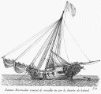
- Member

- 908 posts
- Location:South Carolina
- Interests:History, Scotland, Batman, Cars, and more<br />Married with 2 kids<br />
(IP: 74.181.91.31) · ·
Posted May 1, 2009 · Report post
Now that this thread has been revived . . .
Can ya'll show your built chests?
(You know what I mean)
I am now thinking of making one myself.
Are the corners beveled, like the green one above or just cut and nailed end-to-side?
Any "tips" on colors?

- Quote
- Edit
- Options

Captain_MacNamara
- Plunderer
- 
- Member

- 467 posts
- Gender:Male
- Location:The Seas of Ansteorra
- Interests:Piracy, the Sea, Sailing Vessels, Period Gunnery, and Rum...
(IP: 70.164.231.221) · ·
Posted May 2, 2009 · Report post
I'm working on mine... Well, the beckets at least. The wood itself is going to cost me upwards of $75, because I want mine in oak. I haven't decided yet if I am going to "cheat" and make copper nails out of copper nail rivets, or if I want to fire up the forge and try to make some square headed nails. Either way, I plan to glue it together as well, and even though it's not "correct", I prefer the slanted sides.

- Quote
- Edit
- Options

Lily Alexander
- tribekugeln sammler
- 
- Moderator

- 1,624 posts
- Gender:Female
- Location:Rochester, NY
- Interests:Professionally I am a retired classical dancer and movement specialist.
My darlin' hubby (Edward O'Keeffe) and I are from Western NY where we live with our golden retrievers Sophie, Sammie and cats, Ms. Whiskers and Captain Boo.
I enjoy gardening, reading, sailing, traveling, reenacting and learning more about pyracy.
(IP: 74.34.9.14) · ·
Posted May 2, 2009 (edited) · Report post
Here's a picture you might find interesting. It's from Jamestown, VA. Note the slanted sides and small size.
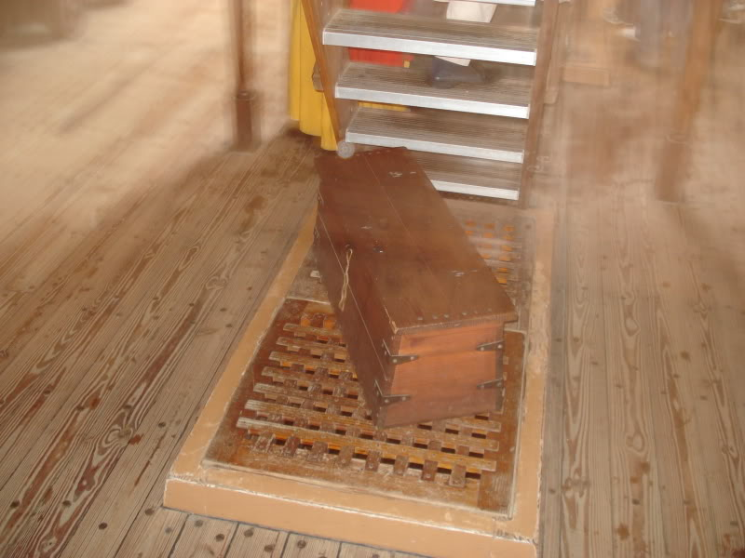
Another Jamestown chest inside a house
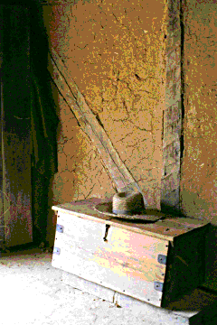
Edited May 2, 2009 by Haunting Lily

- Quote
- Edit
- Options

Cascabel
- Evil Drooling Henchman
- 
- Moderator

- 848 posts
- Gender:Male
(IP: 72.148.237.64) · ·
Posted May 2, 2009 · Report post
As a matter of curiosity, is there a purpose or a reason for the slanted sides ? Seems like a lot of trouble to go through on a simple utilitarian item when a straight sided box would do nicely for an ordinary working man.....
>>>> Cascabel

- Quote
- Edit
- Options

Edward O'Keeffe
- Occupy Fort Taylor!
- Member

- 90 posts
- Gender:Male
- Location:Rochester, NY
- Interests:Woodworking
(IP: 74.34.9.14) · ·
Posted May 2, 2009 · Report post
Cascabel said:
As a matter of curiosity, is there a purpose or a reason for the slanted sides ? Seems like a lot of trouble to go through on a simple utilitarian item when a straight sided box would do nicely for an ordinary working man.....
>>>> Cascabel
My understanding of this is to allow access to individual chests when they were stacked next to each other, also to give extra stability by lowering the center of gravity. From experience, they are hard to tip over. Another suggestion is that the sloped front served to protect sailors shins as the ship heeled.
E O'K

- Quote
- Edit
- Options

Dorian Lasseter
- Where's My Water
- Member

- 3,266 posts
- Gender:Male
- Location:The Sea!
- Interests:18th Century reenactment; Maritime, F&I...
Did ECW as well...
All BP firelocks and cannons!
Also enjoy Swordfighting and a good Donnybrook
Got a question for or about me? Ask!!!
(IP: 147.72.68.65) · ·
Posted May 2, 2009 · Report post
Oh, I see were gonna have some more interesting conversations!
I see a conflict in this thread, are the slant sided chests too early, too late, or in period at one end or another?
Regardless, a straight sided chest is probably THE most common style, as it was said in a manner "Functionality over style is the rule of the sailor."
If the slant sided chest was superior, why do we not see them today?
Pros to the slant side; If you set two chests side by side, the beckets are given space so the bottom of the chests could touch, no waste of deck space. Plus, to pull one out you can get to the sides to pull easily. Lower CG so harder to tip over.
Cons; Harder to construct, very slight waste of wood, harder to repair if damaged, slightly less space inside than a straight sided chest.
At present in my very sparse spare time, I'm refurbishing a grand old chest into a sea chest... it was in my parents basement and is actually a patternmakers chest... I'll post images of the progress later...

- Quote
- Edit
- Options

Dutchman
- Has anyone seen my cousin?
- Admin

- 1,773 posts
- Gender:Male
- Location:tidewater virginia
(IP: 198.246.136.35) · ·
Posted May 2, 2009 · Report post
i'll save the excitement. Per Roy Underhill-slanted sided boxes (sea chests, blanket boxes, what have you) were around prior, durring, and post era. They were not specifically sailor utilitarian though- E,ok. is correct in his reasons for slanted sides on sea chests. Slanted angled joints are tough on a good day- craftsmen did complicated joints like this as a sort of calling card/ shameless marketing for their skill. Larger chests from the period normally did not survive for various reasons, but look to tea boxes (not shipping crates) for different patterns and construction techniques.

- Quote
- Edit
- Options

Dorian Lasseter
- Where's My Water
- Member

- 3,266 posts
- Gender:Male
- Location:The Sea!
- Interests:18th Century reenactment; Maritime, F&I...
Did ECW as well...
All BP firelocks and cannons!
Also enjoy Swordfighting and a good Donnybrook
Got a question for or about me? Ask!!!
(IP: 147.72.68.65) · ·
Posted May 2, 2009 · Report post
Aww, come on... get just a little excited...
Any other bits of knowledge?
Here's another question; Locking the chest.
I see most chests with mortised or half-mortised locks... those were expensive to a point and in some ways, easy to pry open.
I see only a handful of hasp/padlock combos on chests, which I would think would be more common?
I can't find the image of a setup I really like; two hasps spaced on the front of the chest with a bar/rod passing through them, the end has a ring that a padlock goes through and the one hasp. A nice rugged way to lock the chest, but using only one lock.
Beckets; I also see several chests that have no beckets, some with no handles at all, and others with more 'traditional' handles... Thoughts on this?

- Quote
- Edit
- Options

Dutchman
- Has anyone seen my cousin?
- Admin

- 1,773 posts
- Gender:Male
- Location:tidewater virginia
(IP: 198.246.136.35) · ·
Posted May 2, 2009 · Report post
hey guys, just went back through the posts. wow- good looking box there keith!
Dorian, you're spot on the nails- remember though, where aplicable, they go all the way through then cinch over. if the nail does not go all the way through- then set them in different directions (one up, one down to lock them in place.) speaking of locks. what ever suits yer fancy i would think. neither the mortice or hasp are very secure- but your double hasp would be the most secure. I've used that technique to hold down deck hatches. that rod and a couple wedges is darned near invincible to waves. IMHO- I think the morticed lock would be a bit more expensive to make and instal therefor be on a higher end box.
Beckets- dude, ya ever try to lift a heavy chest just by the beckets? if not made properly, they will pinch your hand then rub your nuckles raw on the chest lid if too short. sometimes its just easier to use both hands and pick it up from the bottom. I suspect your answer would lie with the utilitarian purpose of the owner.
I really should get some pictures of my stuff up. I'm really quite fond of graces box- despite the color.

- Quote
- Edit
- Options

M.A.d'Dogge
- Second to None
- Member

- 1,534 posts
- Gender:Male
- Location:the Port of the Great Inland Sea, Detroit originally from the great inland corn seas of Illinois
- Interests:pyratin, story-tellin, historyin, suba divin, drynkin, skirt chassin, eatin, campin, photographin, cavin, rockclimbin, ghost huntin, talkin, sword fightin, canonin, black powder pistolin, travelin and pretty much anythin that could be included in ADVENTURIN!!!
(IP: 69.14.41.221) · ·
Posted May 2, 2009 · Report post
i have seen the "beckets" used as more of a way to lash to each other or for stowin away...not so much for lifting...while on board....how many times do you have to lift once its stowed??

- Quote
- Edit
- Options

Dutchman
- Has anyone seen my cousin?
- Admin

- 1,773 posts
- Gender:Male
- Location:tidewater virginia
(IP: 198.246.136.35) · ·
Posted May 2, 2009 · Report post
ah good point dogge

- Quote
- Edit
- Options

callenish gunner
- Scourge o' the 7 Seas
- Member

- 2,138 posts
- Gender:Male
- Location:Pennsylvania mountains north of Clarion
- Interests:The Callenish gunner has just hoved into view looking for safe anchorage in these waters... purveyor of bladed and flintlock weaponry also leather accessories ..........painter of portraits and period scenes by avocation I'm getting my armoury business underway and will be doing as many festivals as I can ...right now along the east coast or great lakes
(IP: 98.21.67.36) · ·
Posted May 2, 2009 (edited) · Report post
If you were on a ship with multi-level gun decks your chests and your hammocks could have to be moved whenever you cleared for action (more chests than could be stowed directly between the guns) The stability of a low center of gravity with wider bottom than top would make sure that in rough seas your chest would stay in place for the most part (moving chests in tight quarters could do a lot of damage to a sailors pegs)...one other reason I was told for the slanted sides was the curve of the of hull of the ship for stability and access to the chest when placed along the outer hull walls
Edited May 2, 2009 by callenish gunner

- Quote
- Edit
- Options

Silkie McDonough
- Proprietress of the Sealkies Hide
- Moderator

- 5,695 posts
- Gender:Female
- Location:I have been a Virginian for 2 months now. LOVING it.
- Interests:Music, vocalizing, Irish balads. I love to draw, I do pencile portraits/detail drawings for barter and sale. The link in in my signature. Ireland, its history and culture. Sewing garb, mostly for myself. The arm of a strong gentleman round my waist.
Unfortunately, I don't do nearly enough of any of a these.
(IP: 68.45.167.109) · ·
Posted May 2, 2009 (edited) · Report post
I am basically a lubber and know little of sailing for years on end, but how much of a lock would be needed on a sea chest while at sea? Yes, you wouldn't want to leave it without a lock of some sort however, if the ship is at sea and a person on board has no place to go, no place to hide and little time alone below deck to riffle through another's belongings, how much theft would go on and how many cases of thievery would go unsolved? It would be my guess that anything of real value might be left in the care of the captain or quartermaster at least while at sea. Finally, how much personal wealth might the average sailor have in his possession at any one time? I am sure thievery did happen, why else would a ships articles mention punishment for theft? I just wonder how much security would be needed on each chest.
Edited May 2, 2009 by Silkie McDonough

- Quote
- Edit
- Options

Dorian Lasseter
- Where's My Water
- Member

- 3,266 posts
- Gender:Male
- Location:The Sea!
- Interests:18th Century reenactment; Maritime, F&I...
Did ECW as well...
All BP firelocks and cannons!
Also enjoy Swordfighting and a good Donnybrook
Got a question for or about me? Ask!!!
(IP: 71.182.132.115) · ·
Posted May 2, 2009 · Report post
Interesting take on why have a lock on your sea chest...
I guess you could argue the same on every chest on this page;
http://www.mycountrytreasures.com/blanketc...umentboxes.html
Why have a lock on a chest inside your home? it's already locked inside your dwelling, right?
Lock = privacy...
Just my humble opinion...
Dutch, get some pictures of your stuff up!

- Quote
- Edit
- Options

Silkie McDonough
- Proprietress of the Sealkies Hide
- Moderator

- 5,695 posts
- Gender:Female
- Location:I have been a Virginian for 2 months now. LOVING it.
- Interests:Music, vocalizing, Irish balads. I love to draw, I do pencile portraits/detail drawings for barter and sale. The link in in my signature. Ireland, its history and culture. Sewing garb, mostly for myself. The arm of a strong gentleman round my waist.
Unfortunately, I don't do nearly enough of any of a these.
(IP: 68.45.167.109) · ·
Posted May 2, 2009 (edited) · Report post
I'm not saying don't lock it I am simply commenting/musing on how much security would be needed. Heck, all of the chests and desks in my house have locks ...none of them (antiques) has a key that I can find. LOL Of course the desks and chests are more valuable than anything inside of them.
Edited May 2, 2009 by Silkie McDonough

- Quote
- Edit
- Options

Edward O'Keeffe
- Occupy Fort Taylor!
- Member

- 90 posts
- Gender:Male
- Location:Rochester, NY
- Interests:Woodworking
(IP: 74.34.9.14) · ·
Posted May 3, 2009 · Report post
Silkie McDonough said:
I'm not saying don't lock it I am simply commenting/musing on how much security would be needed. Heck, all of the chests and desks in my house have locks ...none of them (antiques) has a key that I can find. LOL Of course the desks and chests are more valuable than anything inside of them.
A lock will keep honest people honest. I was at sea with a thief. He only stole from from CPO's, but he was thief none the less. I am glad I kept my locker locked on that cruise.

• Quote
• Edit
• Options

Dorian Lasseter
- Where's My Water
- Member

- 3,266 posts
- Gender:Male
- Location:The Sea!
- Interests:18th Century reenactment; Maritime, F&I...
Did ECW as well...
All BP firelocks and cannons!
Also enjoy Swordfighting and a good Donnybrook
Got a question for or about me? Ask!!!
(IP: 71.182.132.115) · ·
Posted May 3, 2009 · Report post
Aye,
A lock is more of a deterrent... and how do you prove someone stole specie? "Oi! I had ten shillings in me chest an' someone stole 'em!"
How do you prove that? Now a personal item is another matter, but even that can be difficult to prove given how personalized the item might be.
So the mortised lock is more expensive, yet not as secure? Either that, or the locks of that type available today aren't as good/large as what was used on chests in the past? Most of the ones I've found are rather small in my opinion.
I can even see the common sailor not being able to afford a lock, given their level of poverty at times. A simple hasp could be secured with a bit of line, just to keep it shut, or even a rough wedge of wood. There are hasps that have a hook already attached that swings into the loop to secure it.
Now what would it be like on a pirate ship? Would any of the crew have the same security of a sea chest as they had aboard a navy or merchant ship?
Next bit; inside the chest.
We see most have a 'till box', which is essentially a small storage box with or without a lid on one side of the chest for small items so they do not get lost in the bottom of the chest. Edward mentioned he may add a lock for that as well. How common was that? I personally like the idea of a second lock on the till (again most likely on higher end chests) for extra security for your small valuables.
Also, I've seen a couple examples of a till box with a drawer underneath, some of which are almost a secret compartment...
Details, details, details... keep them coming!

- Quote
- Edit
- Options

William Brand
- Mercury Malefactor
- Admin

- 8,884 posts
- Gender:Male
- Location:Logan, Utah
- Interests:My name is William Pace and I live and work as a graphic designer, illustrator and photographer in Northern Utah. I'm married to the lovely Tracy Pace and we have three children. In addition to all things art, I enjoy traveling and meeting new people from every walk of life. I've always been a fan of history, theology, and of course, Pyracy.
http://www.youtube.com/watch?v=PSkt-q-HihQ
(IP: 166.70.59.121) · ·
Posted May 3, 2009 · Report post
I found this one dating back to 1779...

- Quote
- Edit
- Options

Captain_MacNamara
- Plunderer
- Member

- 467 posts
- Gender:Male
- Location:The Seas of Ansteorra
- Interests:Piracy, the Sea, Sailing Vessels, Period Gunnery, and Rum...
(IP: 70.164.231.221) · ·
Posted May 3, 2009 (edited) · Report post
I like that
I decided to get some pine and make my first chest out of pine just to get a feel for it. I compromised between straight and slanted sides, coming up with a slight slant. So far, I just have the pieces rough cut, but I'll be throwing her together over the next few days. Still working on the beckets as well... and then once she's together save for the beckets, I plan to do a bit of carving before I stain her in red oak to start. Haven't decided if I am going to do any painting or not yet... my choice of colors aren't exactly "period friendly".
Edit:
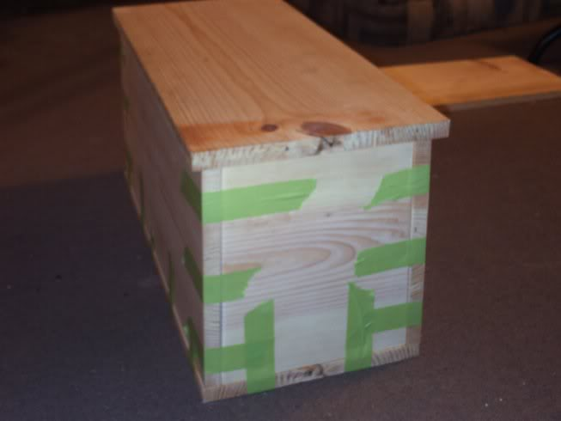
The tape's just to hold her together for the picture.
Edited May 3, 2009 by Captain_MacNamara

- Quote
- Edit
- Options

Captain_MacNamara
- Plunderer
- Member

- 467 posts
- Gender:Male
- Location:The Seas of Ansteorra
- Interests:Piracy, the Sea, Sailing Vessels, Period Gunnery, and Rum...
(IP: 70.164.231.221) · ·
Posted May 4, 2009 · Report post
Glued together with gorilla glue...
Word of warning, this stuff gets everywhere and is tougher than the wood. And it doesn't wash off hands.
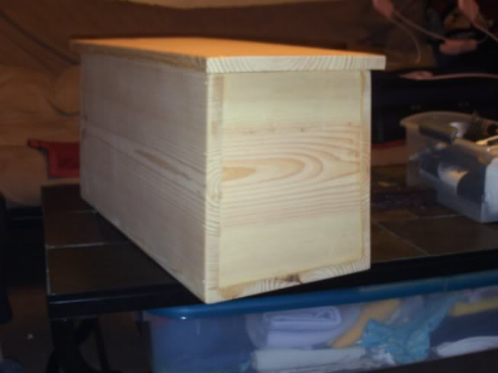

- Quote
- Edit
- Options

oderlesseye
- Scourge o' the 7 Seas
- Member

- 2,126 posts
- Gender:Male
- Location:San Diego, Ca. (North Park) me cove !
- Interests:Oderlesseye is a mutinous two bit sand dollar with a thirst for adventure. Sailing on tall ships, firing black powder weapons, and sword fighting.. I most love to entertain the public in piratical skit presentations that involve all of the above. My name is befitting of my position on board as that of the look-out. Some ask what’s the meaning of the name Oderlesseye...It is simple really.. When Eye am aloft, ye can’t smell me...But it’s spelled wrong some exclaim! Hey now! What pirate can spell? - is my retort!
I have been an active member of the pirate community since 2005. I consider myself a fan of living history in the Golden Age of Piracy. As a child I , like the lot of ye, loved the old time pirate movies with Errol Flynn and Douglas Fairbanks. Long live Long John Silver !
Inspired by them, Eye created a Pirate Ninja Movie called "Treachery and a Dead Mans Promise" Available on YouTube.
Being a pirate, as it turns out, is multi-dimensional. For me, a lifestyle has been carved out of it. There is a six foot tall skeleton pirate in a make shift hide out called Dead Mans Cove behind my house. The walls are painted giving the impression you are in a sea cave. There is a mural of a pirate coming ashore in a long boat at the mouth of the cove. Believe me, it is a great place to enjoy rum now and again!
Exploration into all things piratical have led me to being an attempted escapee from the Governors noose to impersonating a judge in the Anne Bonnie and Mary Read trial held in Pirates In Paradise.. As Oderlesseye, my one on one impression to patrons is as one whom barley escaped the flames of the ship we took when the powder magazine blew with the booty in me hands from the Captains quarters.. The tale explains the soot on me face, the tattered clothing, and the burnt tricorn, as I hand out a gold coin or two. I hate them plastic ones and I know kids appreciate the metal coins even more so.
When an event is slated for a historical time line presentation to the public, I do not do these things mentioned above. Rather, I share about what is a grape shot or how a flintlock works. I ware clothing that is more closely representing the era in these cases. I am still updating me togs (Period Kit) as I learn more thru fellow pirates and sources like the Pyracy Pub.
So far, there have been many exciting moments of adventure the world of PIRACY has afforded me. From standing on a bar top with Pirates Charles singing to me in New Orleans to shooting cannons ( Ships Guns for you PC Pirates!), on the tall ship Spirit of Dana Point. Cheers from a crowd during a show as last man standing on the Treasure chest proclaiming to an excited crowd ITS MINE! THE BOOTY IS MINE ! YARR ! ~ These things and the notoriety that comes with being a pirate has me hooked! Whats More Is the greater bonds of friendships that have been forged with those whose course finds me at such events, sharing the same love and passion of the Life within the pirate/reenactment community. To Them Eye take me hat off and offer a tot of Rum! Cheers mates!
(IP: 72.220.144.209) · ·
Posted May 5, 2009 · Report post
Looking good so far Captain_MacNamara! Keep posting the Progress..Piticularly the Beckets..
I don't want to build the box, my schedule is too cramped for that. So I am going to order the hard ware pieces and Use a wrought iron hasp lock instead of the inlaid type. I am going for the front to be slanted in only.. I am going to have a cabinette maker do the job for me.. And engrave my Monikier on the front of it.
What I am currious about are these "Milk finishes" and how does one do that..I want to do a painted Black
or forest green milk finish. that part of the job I will do myself..

- Quote
- Edit
- Options

Captain_MacNamara
- Plunderer
- Member

- 467 posts
- Gender:Male
- Location:The Seas of Ansteorra
- Interests:Piracy, the Sea, Sailing Vessels, Period Gunnery, and Rum...
(IP: 70.164.231.221) · ·
Posted May 5, 2009 (edited) · Report post
oderlesseye said:
What I am currious about are these "Milk finishes" and how does one do that..I want to do a painted Black
or forest green milk finish. that part of the job I will do myself..
As am I... This being the "test run" chest so to speak, I am staining it in red oak. But for my "real" chest, I was thinking maybe a black milk paint finish with a purple trim...
Edit:
More progress pics
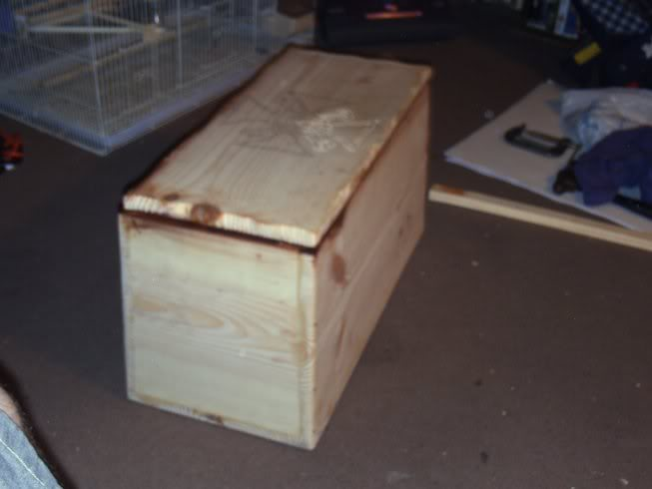
I opted to make copper nails out of copper rivets, though you can't see them all that well in the pic. I also finished shaping the lid, and cut out recesses for hinges. The design in progress on the lid is my tattoo, designed by our very own Pynch.
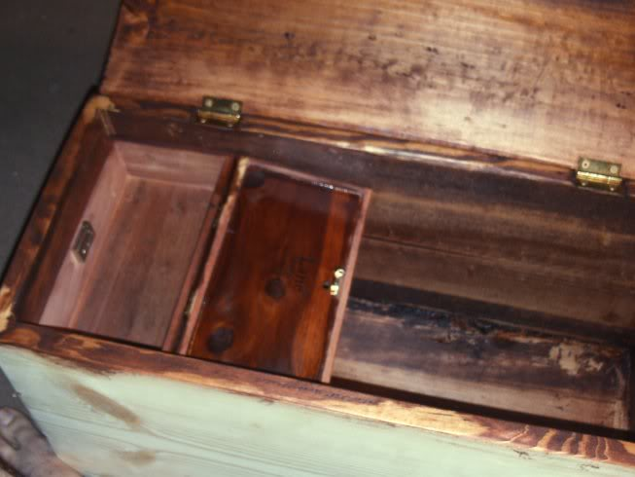
I made the till box from an old cedar jewelry box. A bit of a shortcut, but it works beautifully.
Edited May 5, 2009 by Captain_MacNamara

- Quote
- Edit
- Options

Edward O'Keeffe
- Occupy Fort Taylor!
- Member

- 90 posts
- Gender:Male
- Location:Rochester, NY
- Interests:Woodworking
(IP: 74.34.9.14) · ·
Posted May 5, 2009 · Report post
oderlesseye said:
What I am currious about are these "Milk finishes" and how does one do that..I want to do a painted Black
or forest green milk finish. that part of the job I will do myself..
Milk paint is available as a powder. The best source I have found for the real stuff is here: http://milkpaint.com/ The web site has a good bit of background on what milk paint is and how long it has been around. Just look to see if you have a local distributor. Since you mix it yourself you have a lot of flexibility with results. Mix in a bit of black or white pigment to alter colors, make it real thin for more of a color wash effect. Just be careful with it, it does contain lime, and can be a bit irritating, especially any sanding dust.
E O'K

- Quote
- Edit
- Options

Ivan Henry aka Moose
- Plunderer
- 
- Member

- 486 posts
- Gender:Male
- Location:tampa, fl
- Interests:Bicycles
Travel
Wine
Beer
Good Food
Pizza!
Pirate Stuff
Design
(IP: 71.41.81.2) · ·
Posted May 5, 2009 · Report post
Found these pics the other day. Thought someone might be interested in this thread.
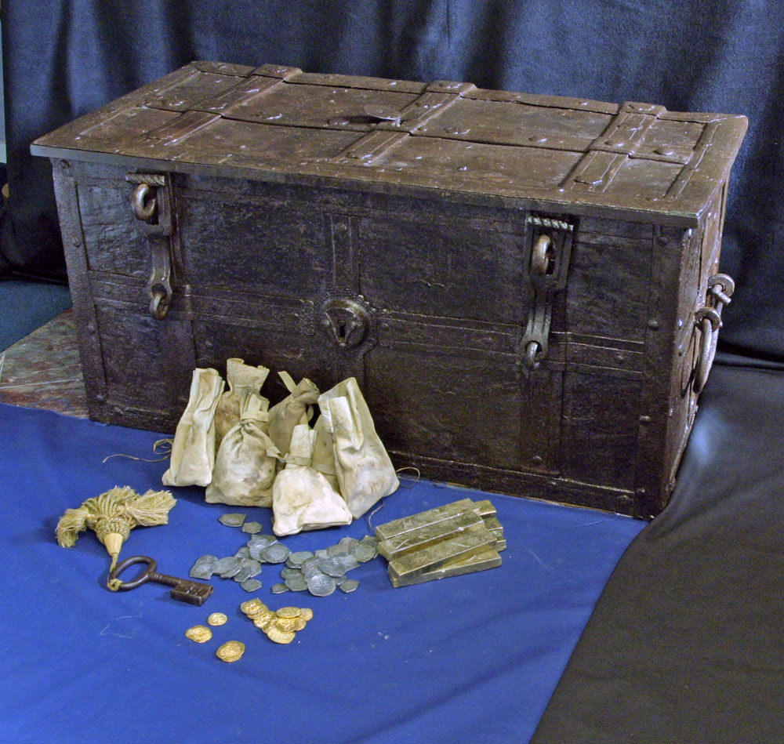
THe page is here with more pics: http://www.vallejogallery.com/item.php?tit...cts&id=1940

- Quote
- Edit
- Options

Captain_MacNamara
- Plunderer
- Member

- 467 posts
- Gender:Male
- Location:The Seas of Ansteorra
- Interests:Piracy, the Sea, Sailing Vessels, Period Gunnery, and Rum...
(IP: 70.164.231.221) · ·
Posted May 5, 2009 · Report post
Here's the lid now that I'm finished carving it...
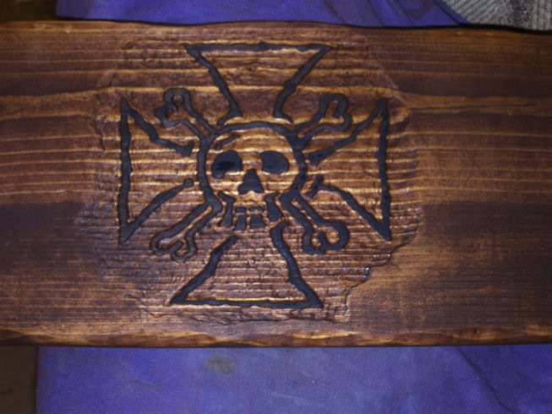
The design was originally a tattoo design Pynch did for me, which then became the symbol of the Iron Lotus. It is relief carved, and the raised portions are painted in a very watered down matte black acrylic. The lid, as with the rest of the chest, is stained in red oak.

- Quote
- Edit
- Options

Captain_MacNamara
- Plunderer
- Member

- 467 posts
- Gender:Male
- Location:The Seas of Ansteorra
- Interests:Piracy, the Sea, Sailing Vessels, Period Gunnery, and Rum...
(IP: 70.164.231.221) · ·
Posted May 6, 2009 · Report post
More update pictures:
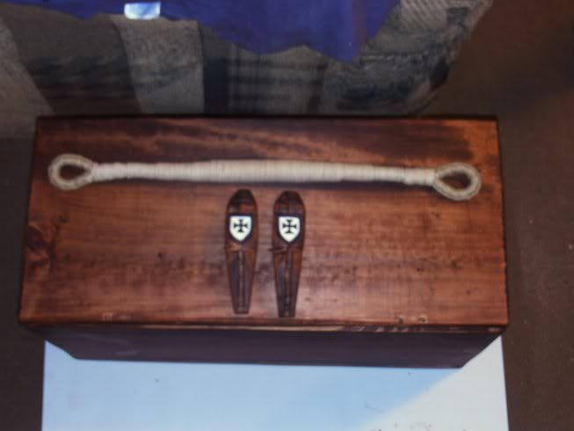
Becket in progress, with 3 strand coxcombing on the spliced eyes, and 3-strand cotton line wrapped in several layers to build up the tapering handle. Below that, the becket cleats, carved and painted with my SCA coat of arms.
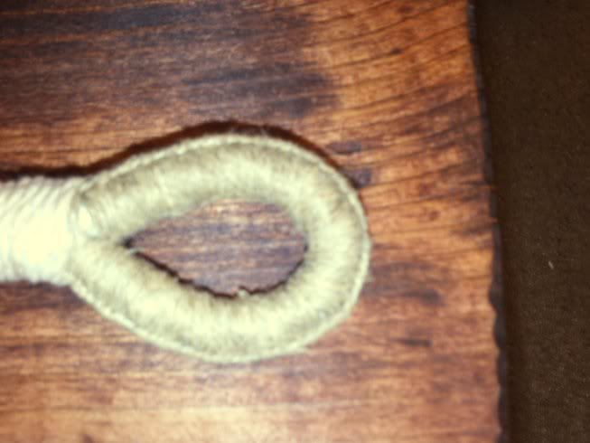
Close-up of one of the eyes.
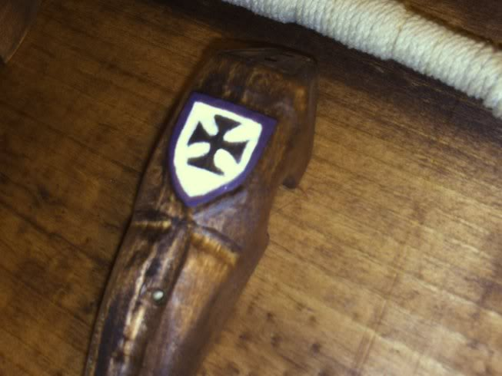
Close up of the becket cleat.

- Quote
- Edit
- Options

oderlesseye
- Scourge o' the 7 Seas
- Member

- 2,126 posts
- Gender:Male
- Location:San Diego, Ca. (North Park) me cove !
- Interests:Oderlesseye is a mutinous two bit sand dollar with a thirst for adventure. Sailing on tall ships, firing black powder weapons, and sword fighting.. I most love to entertain the public in piratical skit presentations that involve all of the above. My name is befitting of my position on board as that of the look-out. Some ask what’s the meaning of the name Oderlesseye...It is simple really.. When Eye am aloft, ye can’t smell me...But it’s spelled wrong some exclaim! Hey now! What pirate can spell? - is my retort!
I have been an active member of the pirate community since 2005. I consider myself a fan of living history in the Golden Age of Piracy. As a child I , like the lot of ye, loved the old time pirate movies with Errol Flynn and Douglas Fairbanks. Long live Long John Silver !
Inspired by them, Eye created a Pirate Ninja Movie called "Treachery and a Dead Mans Promise" Available on YouTube.
Being a pirate, as it turns out, is multi-dimensional. For me, a lifestyle has been carved out of it. There is a six foot tall skeleton pirate in a make shift hide out called Dead Mans Cove behind my house. The walls are painted giving the impression you are in a sea cave. There is a mural of a pirate coming ashore in a long boat at the mouth of the cove. Believe me, it is a great place to enjoy rum now and again!
Exploration into all things piratical have led me to being an attempted escapee from the Governors noose to impersonating a judge in the Anne Bonnie and Mary Read trial held in Pirates In Paradise.. As Oderlesseye, my one on one impression to patrons is as one whom barley escaped the flames of the ship we took when the powder magazine blew with the booty in me hands from the Captains quarters.. The tale explains the soot on me face, the tattered clothing, and the burnt tricorn, as I hand out a gold coin or two. I hate them plastic ones and I know kids appreciate the metal coins even more so.
When an event is slated for a historical time line presentation to the public, I do not do these things mentioned above. Rather, I share about what is a grape shot or how a flintlock works. I ware clothing that is more closely representing the era in these cases. I am still updating me togs (Period Kit) as I learn more thru fellow pirates and sources like the Pyracy Pub.
So far, there have been many exciting moments of adventure the world of PIRACY has afforded me. From standing on a bar top with Pirates Charles singing to me in New Orleans to shooting cannons ( Ships Guns for you PC Pirates!), on the tall ship Spirit of Dana Point. Cheers from a crowd during a show as last man standing on the Treasure chest proclaiming to an excited crowd ITS MINE! THE BOOTY IS MINE ! YARR ! ~ These things and the notoriety that comes with being a pirate has me hooked! Whats More Is the greater bonds of friendships that have been forged with those whose course finds me at such events, sharing the same love and passion of the Life within the pirate/reenactment community. To Them Eye take me hat off and offer a tot of Rum! Cheers mates!
(IP: 72.220.144.209) · ·
Posted May 6, 2009 · Report post
Looking Good!
Captain_MacNamara
Lemme know if you think I should wait on the cleats
and give you a stab at them before I order them from Marlinespike.

- Quote
- Edit
- Options

William Brand
- Mercury Malefactor
- Admin

- 8,884 posts
- Gender:Male
- Location:Logan, Utah
- Interests:My name is William Pace and I live and work as a graphic designer, illustrator and photographer in Northern Utah. I'm married to the lovely Tracy Pace and we have three children. In addition to all things art, I enjoy traveling and meeting new people from every walk of life. I've always been a fan of history, theology, and of course, Pyracy.
http://www.youtube.com/watch?v=PSkt-q-HihQ
(IP: 166.70.59.121) · ·
Posted May 7, 2009 · Report post
Great stuff, all. It's great to see a few different approaches.

- Quote
- Edit
- Options

Captain_MacNamara
- Plunderer
- Member

- 467 posts
- Gender:Male
- Location:The Seas of Ansteorra
- Interests:Piracy, the Sea, Sailing Vessels, Period Gunnery, and Rum...
(IP: 70.164.231.221) · ·
Posted May 7, 2009 (edited) · Report post
Thanky... I went with the edge design I did on the lid because I always liked the look of Long John Silvers' tables... that is, before they changed styles.
Chest update...
The spar varnish on the chest is taking forever to dry because of the damnable humidity here lately. After an all-nighter, however, I managed to nearly finish one of the beckets:
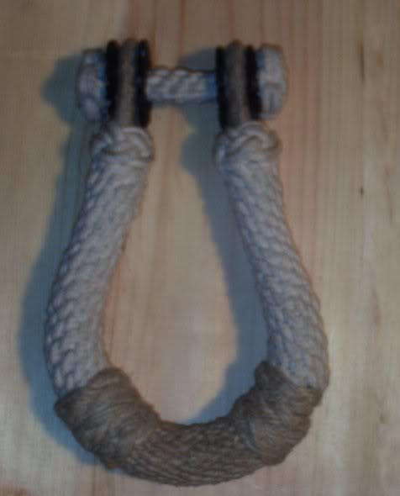
3-lead coxcombing on the eyes, mirrored continuous crown sennits on the upper portion of the becket, and 33-lead grafting in hemp for the handle. 2-lead 5-bight 1/4" cotton turks heads just below the eyes, with 2.4mm hemp wormed into the middle for contrast. The handle is flanked by 3-lead 5-bight 2.4mm hemp turk's heads on either side. The "washers" are 1/8" vegtable-tanned leather, pinked(the edge notches), and stained black. I broke with "tradition" on the bolt. I used 4-point star knots for the ends, with a 4-lead continuous crown sennit for the axle. Normally, there would be a leather "sleeve" covering the axle, but the thing is already too fat.
Before anyone asks, yes they are disproportionate... they came out too fat because I used what I had on hand instead of buying new material. Un-tarred 2.4mm hemp and 1/4 cotton line make up the bulk of the work. My next set will come out more proper, as I'll have proper materials.
Edited May 7, 2009 by Captain_MacNamara

- Quote
- Edit
- Options

William Brand
- Mercury Malefactor
- Admin

- 8,884 posts
- Gender:Male
- Location:Logan, Utah
- Interests:My name is William Pace and I live and work as a graphic designer, illustrator and photographer in Northern Utah. I'm married to the lovely Tracy Pace and we have three children. In addition to all things art, I enjoy traveling and meeting new people from every walk of life. I've always been a fan of history, theology, and of course, Pyracy.
http://www.youtube.com/watch?v=PSkt-q-HihQ
(IP: 166.70.59.121) · ·
Posted May 7, 2009 · Report post
Captain_MacNamara said:
WANT.
Seriously, what would you charge for beckets?

- Quote
- Edit
- Options

Commodore Swab
- Dread Pyrate
- 
- Member

- 1,148 posts
- Gender:Male
- Location:Key Largo
- Interests:Flintlocks, Cannons, Ships, Sailing, antique cars
(IP: 68.223.170.215) · ·
Posted May 7, 2009 · Report post
Very nice work, I know how to tie all those knots (yes the star knots as well) I started knot tying in 5th grade and you are doing a beautiful job. I know how much work that is.

- Quote
- Edit
- Options

Captain_MacNamara
- Plunderer
- Member

- 467 posts
- Gender:Male
- Location:The Seas of Ansteorra
- Interests:Piracy, the Sea, Sailing Vessels, Period Gunnery, and Rum...
(IP: 70.164.231.221) · ·
Posted May 7, 2009 · Report post
William Red Wake said:
WANT.
Seriously, what would you charge for beckets?
It depends... I'm about to start a set for oderlesseye. His will come out alot more proportionate, because I am getting all-new materials for his. After I finish his, I'll let you know.
vintagesailor said:
Very nice work, I know how to tie all those knots (yes the star knots as well) I started knot tying in 5th grade and you are doing a beautiful job. I know how much work that is.
Thanks
Here's the same becket, tarred, with the (still not quite dry dammit)cleat sitting on the axle:
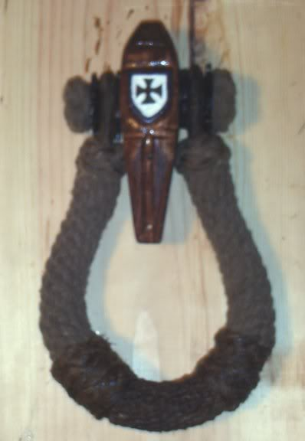

- Quote
- Edit
- Options

Dorian Lasseter
- Where's My Water
- Member

- 3,266 posts
- Gender:Male
- Location:The Sea!
- Interests:18th Century reenactment; Maritime, F&I...
Did ECW as well...
All BP firelocks and cannons!
Also enjoy Swordfighting and a good Donnybrook
Got a question for or about me? Ask!!!
(IP: 71.182.132.115) · ·
Posted May 7, 2009 · Report post
And now to stir things up a bit....
http://www.mariner.org/exhibitions/artifac...ct_seachest.php
This sea chest was acquired in Muscat, Oman and is typical of the style of sea chest carried by the Portuguese in the sixteenth and early seventeenth centuries. The Portuguese conquered Oman in 1507 to protect their trade routes to India . They controlled the coastline and maintained a powerful presence in the Gulf of Oman until the imam Sultan bin Saif recaptured the area in 1650.
OOP but so cool...
And, no beckets.... but handles...
And next we have;
http://travel.webshots.com/photo/1047569817039209602WUrSjU
The Ark of the Covenant of Sea Chests...

- Quote
- Edit
- Options

oderlesseye
- Scourge o' the 7 Seas
- Member

- 2,126 posts
- Gender:Male
- Location:San Diego, Ca. (North Park) me cove !
- Interests:Oderlesseye is a mutinous two bit sand dollar with a thirst for adventure. Sailing on tall ships, firing black powder weapons, and sword fighting.. I most love to entertain the public in piratical skit presentations that involve all of the above. My name is befitting of my position on board as that of the look-out. Some ask what’s the meaning of the name Oderlesseye...It is simple really.. When Eye am aloft, ye can’t smell me...But it’s spelled wrong some exclaim! Hey now! What pirate can spell? - is my retort!
I have been an active member of the pirate community since 2005. I consider myself a fan of living history in the Golden Age of Piracy. As a child I , like the lot of ye, loved the old time pirate movies with Errol Flynn and Douglas Fairbanks. Long live Long John Silver !
Inspired by them, Eye created a Pirate Ninja Movie called "Treachery and a Dead Mans Promise" Available on YouTube.
Being a pirate, as it turns out, is multi-dimensional. For me, a lifestyle has been carved out of it. There is a six foot tall skeleton pirate in a make shift hide out called Dead Mans Cove behind my house. The walls are painted giving the impression you are in a sea cave. There is a mural of a pirate coming ashore in a long boat at the mouth of the cove. Believe me, it is a great place to enjoy rum now and again!
Exploration into all things piratical have led me to being an attempted escapee from the Governors noose to impersonating a judge in the Anne Bonnie and Mary Read trial held in Pirates In Paradise.. As Oderlesseye, my one on one impression to patrons is as one whom barley escaped the flames of the ship we took when the powder magazine blew with the booty in me hands from the Captains quarters.. The tale explains the soot on me face, the tattered clothing, and the burnt tricorn, as I hand out a gold coin or two. I hate them plastic ones and I know kids appreciate the metal coins even more so.
When an event is slated for a historical time line presentation to the public, I do not do these things mentioned above. Rather, I share about what is a grape shot or how a flintlock works. I ware clothing that is more closely representing the era in these cases. I am still updating me togs (Period Kit) as I learn more thru fellow pirates and sources like the Pyracy Pub.
So far, there have been many exciting moments of adventure the world of PIRACY has afforded me. From standing on a bar top with Pirates Charles singing to me in New Orleans to shooting cannons ( Ships Guns for you PC Pirates!), on the tall ship Spirit of Dana Point. Cheers from a crowd during a show as last man standing on the Treasure chest proclaiming to an excited crowd ITS MINE! THE BOOTY IS MINE ! YARR ! ~ These things and the notoriety that comes with being a pirate has me hooked! Whats More Is the greater bonds of friendships that have been forged with those whose course finds me at such events, sharing the same love and passion of the Life within the pirate/reenactment community. To Them Eye take me hat off and offer a tot of Rum! Cheers mates!
(IP: 72.220.144.209) · ·
Posted May 7, 2009 (edited) · Report post
Hey Dorian, are ye bringing Vasco De Gama's sea chest to PIP?
Eye am a lucky man having seen Captain MacNamaras handy werk!
Da check be in da Mail!
Edited May 8, 2009 by oderlesseye

- Quote
- Edit
- Options

Silkie McDonough
- Proprietress of the Sealkies Hide
- Moderator

- 5,695 posts
- Gender:Female
- Location:I have been a Virginian for 2 months now. LOVING it.
- Interests:Music, vocalizing, Irish balads. I love to draw, I do pencile portraits/detail drawings for barter and sale. The link in in my signature. Ireland, its history and culture. Sewing garb, mostly for myself. The arm of a strong gentleman round my waist.
Unfortunately, I don't do nearly enough of any of a these.
(IP: 68.45.167.109) · ·
Posted May 8, 2009 · Report post
Vasco De Gama's sea chest ...wow ...so ...what does the ship look like?

- Quote
- Edit
- Options

Dorian Lasseter
- Where's My Water
- Member

- 3,266 posts
- Gender:Male
- Location:The Sea!
- Interests:18th Century reenactment; Maritime, F&I...
Did ECW as well...
All BP firelocks and cannons!
Also enjoy Swordfighting and a good Donnybrook
Got a question for or about me? Ask!!!
(IP: 71.182.132.115) · ·
Posted May 9, 2009 · Report post
Dunno if this would be better in the Thieves Market...
But here's a fine place that has all kinds of hardware for a sea chest and more...
http://www.horton-brasses.com/
Locks, hasps, hinges...
http://www.horton-brasses.com/store/hinges...ron/snipehinges
Someone else posted there before I believe... I may use these on another project...

- Quote
- Edit
- Options

oderlesseye
- Scourge o' the 7 Seas
- Member

- 2,126 posts
- Gender:Male
- Location:San Diego, Ca. (North Park) me cove !
- Interests:Oderlesseye is a mutinous two bit sand dollar with a thirst for adventure. Sailing on tall ships, firing black powder weapons, and sword fighting.. I most love to entertain the public in piratical skit presentations that involve all of the above. My name is befitting of my position on board as that of the look-out. Some ask what’s the meaning of the name Oderlesseye...It is simple really.. When Eye am aloft, ye can’t smell me...But it’s spelled wrong some exclaim! Hey now! What pirate can spell? - is my retort!
I have been an active member of the pirate community since 2005. I consider myself a fan of living history in the Golden Age of Piracy. As a child I , like the lot of ye, loved the old time pirate movies with Errol Flynn and Douglas Fairbanks. Long live Long John Silver !
Inspired by them, Eye created a Pirate Ninja Movie called "Treachery and a Dead Mans Promise" Available on YouTube.
Being a pirate, as it turns out, is multi-dimensional. For me, a lifestyle has been carved out of it. There is a six foot tall skeleton pirate in a make shift hide out called Dead Mans Cove behind my house. The walls are painted giving the impression you are in a sea cave. There is a mural of a pirate coming ashore in a long boat at the mouth of the cove. Believe me, it is a great place to enjoy rum now and again!
Exploration into all things piratical have led me to being an attempted escapee from the Governors noose to impersonating a judge in the Anne Bonnie and Mary Read trial held in Pirates In Paradise.. As Oderlesseye, my one on one impression to patrons is as one whom barley escaped the flames of the ship we took when the powder magazine blew with the booty in me hands from the Captains quarters.. The tale explains the soot on me face, the tattered clothing, and the burnt tricorn, as I hand out a gold coin or two. I hate them plastic ones and I know kids appreciate the metal coins even more so.
When an event is slated for a historical time line presentation to the public, I do not do these things mentioned above. Rather, I share about what is a grape shot or how a flintlock works. I ware clothing that is more closely representing the era in these cases. I am still updating me togs (Period Kit) as I learn more thru fellow pirates and sources like the Pyracy Pub.
So far, there have been many exciting moments of adventure the world of PIRACY has afforded me. From standing on a bar top with Pirates Charles singing to me in New Orleans to shooting cannons ( Ships Guns for you PC Pirates!), on the tall ship Spirit of Dana Point. Cheers from a crowd during a show as last man standing on the Treasure chest proclaiming to an excited crowd ITS MINE! THE BOOTY IS MINE ! YARR ! ~ These things and the notoriety that comes with being a pirate has me hooked! Whats More Is the greater bonds of friendships that have been forged with those whose course finds me at such events, sharing the same love and passion of the Life within the pirate/reenactment community. To Them Eye take me hat off and offer a tot of Rum! Cheers mates!
(IP: 72.220.144.209) · ·
Posted May 10, 2009 (edited) · Report post
I looked at the first site Dorian posted. The Hinges are too long for our purposes.
Departing from original specs though I decided to go with the old fasion lock and wrought iron
hasp instead of the inset lock seen on Marline Spike. Though I had not researched it..it is my feeling that
an average sailor could only afford a cheaper way of locking his belongings. Besides: it will add more style
to the box over all. I got this in the mail today..Gonna look sweet when it is all together!
I got it from here: http://www.rensup.com/Wrought-iron/21061.htm
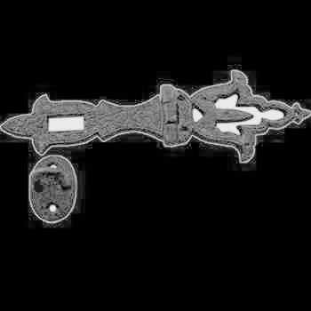
I found another great link that shows off different style beckets and Cleats..These are some old pics..
http://www.frayedknotarts.com/beckets.html
Edited May 11, 2009 by oderlesseye

- Quote
- Edit
- Options

oderlesseye
- Scourge o' the 7 Seas
- Member

- 2,126 posts
- Gender:Male
- Location:San Diego, Ca. (North Park) me cove !
- Interests:Oderlesseye is a mutinous two bit sand dollar with a thirst for adventure. Sailing on tall ships, firing black powder weapons, and sword fighting.. I most love to entertain the public in piratical skit presentations that involve all of the above. My name is befitting of my position on board as that of the look-out. Some ask what’s the meaning of the name Oderlesseye...It is simple really.. When Eye am aloft, ye can’t smell me...But it’s spelled wrong some exclaim! Hey now! What pirate can spell? - is my retort!
I have been an active member of the pirate community since 2005. I consider myself a fan of living history in the Golden Age of Piracy. As a child I , like the lot of ye, loved the old time pirate movies with Errol Flynn and Douglas Fairbanks. Long live Long John Silver !
Inspired by them, Eye created a Pirate Ninja Movie called "Treachery and a Dead Mans Promise" Available on YouTube.
Being a pirate, as it turns out, is multi-dimensional. For me, a lifestyle has been carved out of it. There is a six foot tall skeleton pirate in a make shift hide out called Dead Mans Cove behind my house. The walls are painted giving the impression you are in a sea cave. There is a mural of a pirate coming ashore in a long boat at the mouth of the cove. Believe me, it is a great place to enjoy rum now and again!
Exploration into all things piratical have led me to being an attempted escapee from the Governors noose to impersonating a judge in the Anne Bonnie and Mary Read trial held in Pirates In Paradise.. As Oderlesseye, my one on one impression to patrons is as one whom barley escaped the flames of the ship we took when the powder magazine blew with the booty in me hands from the Captains quarters.. The tale explains the soot on me face, the tattered clothing, and the burnt tricorn, as I hand out a gold coin or two. I hate them plastic ones and I know kids appreciate the metal coins even more so.
When an event is slated for a historical time line presentation to the public, I do not do these things mentioned above. Rather, I share about what is a grape shot or how a flintlock works. I ware clothing that is more closely representing the era in these cases. I am still updating me togs (Period Kit) as I learn more thru fellow pirates and sources like the Pyracy Pub.
So far, there have been many exciting moments of adventure the world of PIRACY has afforded me. From standing on a bar top with Pirates Charles singing to me in New Orleans to shooting cannons ( Ships Guns for you PC Pirates!), on the tall ship Spirit of Dana Point. Cheers from a crowd during a show as last man standing on the Treasure chest proclaiming to an excited crowd ITS MINE! THE BOOTY IS MINE ! YARR ! ~ These things and the notoriety that comes with being a pirate has me hooked! Whats More Is the greater bonds of friendships that have been forged with those whose course finds me at such events, sharing the same love and passion of the Life within the pirate/reenactment community. To Them Eye take me hat off and offer a tot of Rum! Cheers mates!
(IP: 72.220.144.209) · ·
Posted May 12, 2009 (edited) · Report post
Bump
Edited May 12, 2009 by oderlesseye

- Quote
- Edit
- Options

oderlesseye
- Scourge o' the 7 Seas
- Member

- 2,126 posts
- Gender:Male
- Location:San Diego, Ca. (North Park) me cove !
- Interests:Oderlesseye is a mutinous two bit sand dollar with a thirst for adventure. Sailing on tall ships, firing black powder weapons, and sword fighting.. I most love to entertain the public in piratical skit presentations that involve all of the above. My name is befitting of my position on board as that of the look-out. Some ask what’s the meaning of the name Oderlesseye...It is simple really.. When Eye am aloft, ye can’t smell me...But it’s spelled wrong some exclaim! Hey now! What pirate can spell? - is my retort!
I have been an active member of the pirate community since 2005. I consider myself a fan of living history in the Golden Age of Piracy. As a child I , like the lot of ye, loved the old time pirate movies with Errol Flynn and Douglas Fairbanks. Long live Long John Silver !
Inspired by them, Eye created a Pirate Ninja Movie called "Treachery and a Dead Mans Promise" Available on YouTube.
Being a pirate, as it turns out, is multi-dimensional. For me, a lifestyle has been carved out of it. There is a six foot tall skeleton pirate in a make shift hide out called Dead Mans Cove behind my house. The walls are painted giving the impression you are in a sea cave. There is a mural of a pirate coming ashore in a long boat at the mouth of the cove. Believe me, it is a great place to enjoy rum now and again!
Exploration into all things piratical have led me to being an attempted escapee from the Governors noose to impersonating a judge in the Anne Bonnie and Mary Read trial held in Pirates In Paradise.. As Oderlesseye, my one on one impression to patrons is as one whom barley escaped the flames of the ship we took when the powder magazine blew with the booty in me hands from the Captains quarters.. The tale explains the soot on me face, the tattered clothing, and the burnt tricorn, as I hand out a gold coin or two. I hate them plastic ones and I know kids appreciate the metal coins even more so.
When an event is slated for a historical time line presentation to the public, I do not do these things mentioned above. Rather, I share about what is a grape shot or how a flintlock works. I ware clothing that is more closely representing the era in these cases. I am still updating me togs (Period Kit) as I learn more thru fellow pirates and sources like the Pyracy Pub.
So far, there have been many exciting moments of adventure the world of PIRACY has afforded me. From standing on a bar top with Pirates Charles singing to me in New Orleans to shooting cannons ( Ships Guns for you PC Pirates!), on the tall ship Spirit of Dana Point. Cheers from a crowd during a show as last man standing on the Treasure chest proclaiming to an excited crowd ITS MINE! THE BOOTY IS MINE ! YARR ! ~ These things and the notoriety that comes with being a pirate has me hooked! Whats More Is the greater bonds of friendships that have been forged with those whose course finds me at such events, sharing the same love and passion of the Life within the pirate/reenactment community. To Them Eye take me hat off and offer a tot of Rum! Cheers mates!
(IP: 72.220.144.209) · ·
Posted May 12, 2009 (edited) · Report post
I am currious to know which is the right kind of nail to use ..There are a variety to choose from on this web site.
Eye wanna order the correct one to use in the construction of the sea chest. I was thinkin the fine finish 2" ones..
http://www.yorstor.com/s.nl;jsessionid=ac1...amp;category=22
Edited May 12, 2009 by oderlesseye

- Quote
- Edit
- Options

Captain_MacNamara
- Plunderer
- Member

- 467 posts
- Gender:Male
- Location:The Seas of Ansteorra
- Interests:Piracy, the Sea, Sailing Vessels, Period Gunnery, and Rum...
(IP: 70.164.231.221) · ·
Posted May 12, 2009 · Report post
I hammered some out of copper that are similar to the boat nails. Just a preference really on my end, but boat nails "seem" to be right. Felt right, as it were.

- Quote
- Edit
- Options

Captain_MacNamara
- Plunderer
- Member

- 467 posts
- Gender:Male
- Location:The Seas of Ansteorra
- Interests:Piracy, the Sea, Sailing Vessels, Period Gunnery, and Rum...
(IP: 174.131.224.120) · ·
Posted May 24, 2009 (edited) · Report post
Well, I got her finished a while back, just didn't get pictures until our little "lake adventure". Here's me first sea chest:
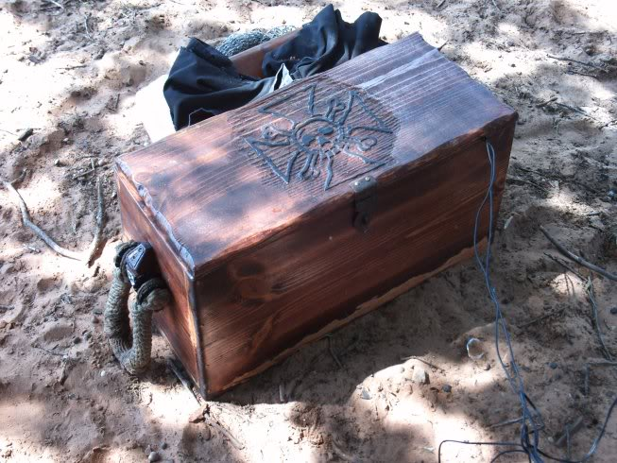
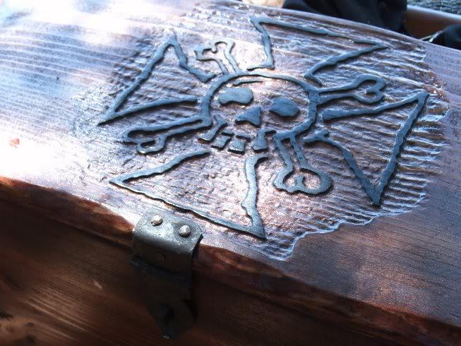
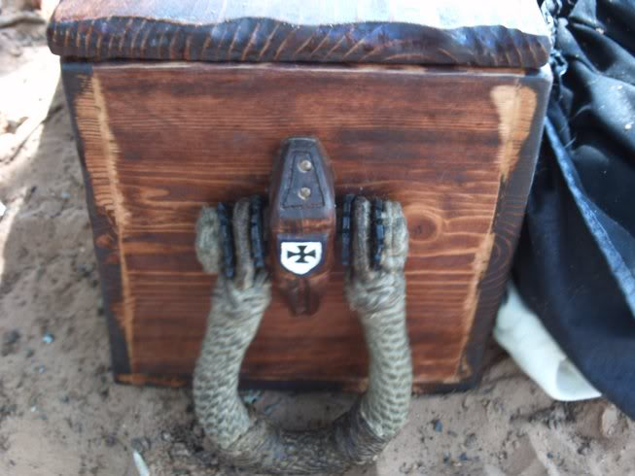
She's built of pine, put together with wood glue and handmade square-shanked copper nails. The beckets are primarily cotton and tarred. The till box used to be a cedar jewelry box.
The wires coming out of the chest in the first pic are speaker wires from my laptop, which is inside the chest. We were using it for piratey music. :angry:
Edited May 24, 2009 by Captain_MacNamara

oderlesseye
- Scourge o' the 7 Seas
- Member

- 2,126 posts
- Gender:Male
- Location:San Diego, Ca. (North Park) me cove !
- Interests:Oderlesseye is a mutinous two bit sand dollar with a thirst for adventure. Sailing on tall ships, firing black powder weapons, and sword fighting.. I most love to entertain the public in piratical skit presentations that involve all of the above. My name is befitting of my position on board as that of the look-out. Some ask what’s the meaning of the name Oderlesseye...It is simple really.. When Eye am aloft, ye can’t smell me...But it’s spelled wrong some exclaim! Hey now! What pirate can spell? - is my retort!
I have been an active member of the pirate community since 2005. I consider myself a fan of living history in the Golden Age of Piracy. As a child I , like the lot of ye, loved the old time pirate movies with Errol Flynn and Douglas Fairbanks. Long live Long John Silver !
Inspired by them, Eye created a Pirate Ninja Movie called "Treachery and a Dead Mans Promise" Available on YouTube.
Being a pirate, as it turns out, is multi-dimensional. For me, a lifestyle has been carved out of it. There is a six foot tall skeleton pirate in a make shift hide out called Dead Mans Cove behind my house. The walls are painted giving the impression you are in a sea cave. There is a mural of a pirate coming ashore in a long boat at the mouth of the cove. Believe me, it is a great place to enjoy rum now and again!
Exploration into all things piratical have led me to being an attempted escapee from the Governors noose to impersonating a judge in the Anne Bonnie and Mary Read trial held in Pirates In Paradise.. As Oderlesseye, my one on one impression to patrons is as one whom barley escaped the flames of the ship we took when the powder magazine blew with the booty in me hands from the Captains quarters.. The tale explains the soot on me face, the tattered clothing, and the burnt tricorn, as I hand out a gold coin or two. I hate them plastic ones and I know kids appreciate the metal coins even more so.
When an event is slated for a historical time line presentation to the public, I do not do these things mentioned above. Rather, I share about what is a grape shot or how a flintlock works. I ware clothing that is more closely representing the era in these cases. I am still updating me togs (Period Kit) as I learn more thru fellow pirates and sources like the Pyracy Pub.
So far, there have been many exciting moments of adventure the world of PIRACY has afforded me. From standing on a bar top with Pirates Charles singing to me in New Orleans to shooting cannons ( Ships Guns for you PC Pirates!), on the tall ship Spirit of Dana Point. Cheers from a crowd during a show as last man standing on the Treasure chest proclaiming to an excited crowd ITS MINE! THE BOOTY IS MINE ! YARR ! ~ These things and the notoriety that comes with being a pirate has me hooked! Whats More Is the greater bonds of friendships that have been forged with those whose course finds me at such events, sharing the same love and passion of the Life within the pirate/reenactment community. To Them Eye take me hat off and offer a tot of Rum! Cheers mates!
(IP: 72.220.147.23) · ·
Posted May 24, 2009 (edited) · Report post
That is one rustic lookin sea chest.. The Insign on the top of the box...That is all chiseled out..Man you put some hours into that! Beautiful ! And Who would of thought to use it as music box on top of that? Very creative & cool Sea chest!
Mine will be a traditional sea chest . AIthough it will definatley be personalized.. I will have Grey Milk paint with a wash finish and a deep barn red for the trim...
Edited May 24, 2009 by oderlesseye

- Quote
- Edit
- Options

Aedon
- Deck Hand
- 
- Member

- 81 posts
- Location:North Carolina
- Interests:I am Aedon MacGregor, Scottish/Irish pyrate calling the Carolinas home. My interests include surfing, boating, fishing, and various types of booty.
(IP: 76.0.161.207) · ·
Posted May 24, 2009 · Report post
Every time I think I can innocently read a topic without the sudden, overwhelming need to go out and build something... one of you scalawags posts pictures like that.
Tell me, MacNamara, exactly how I'm supposed to resist trying my hand at building a sea chest after looking at your handiwork. You need a disclaimer.

- Quote
- Edit
- Options

j8ksdad
- First Mate
- 
- Member

- 204 posts
- Gender:Male
- Location:Escondido, CA (just North of San Diego)
- Interests:Learnin' 'bout rum, pirates, knots, ships and such.
(IP: 76.216.175.16) · ·
Posted May 24, 2009 · Report post
Great work!

- Quote
- Edit
- Options

Commodore Swab
- Dread Pyrate
- Member

- 1,148 posts
- Gender:Male
- Location:Key Largo
- Interests:Flintlocks, Cannons, Ships, Sailing, antique cars
(IP: 68.223.170.162) · ·
Posted May 24, 2009 · Report post
I just picked up some wood for my chest at least the top and bottom. I have some plans that may be very intriguing when one sees it. The base size will be roughly 30X12X11 so relativly small but still heavy since the chest will be built out of hard wood (brazilian cherry/Jatoba) comparable to teak in wear and weight.

- Quote
- Edit
- Options

CaptainSatan
- Notorious Pyrate
- 
- Member

- 791 posts
(IP: 173.57.109.34) · ·
Posted May 24, 2009 (edited) · Report post
Slopmaker Cripps said:
The slanted wall style of sea chest wasn't around until the very late 18th and early 19th century.
Yes, I realize that I am am responding to a post from 4 years ago (ha ha).
But hey, this is an active thread
This painting is from around 1673. It's been posted on this forum before.
Anyone remember the name of it? Primitive but similarly shaped chests were in
use at sea at least as long as the Viking age. Also take a look at the Jamestown
chest posted previously in this thread.
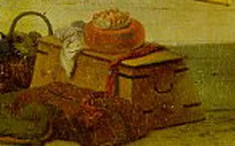
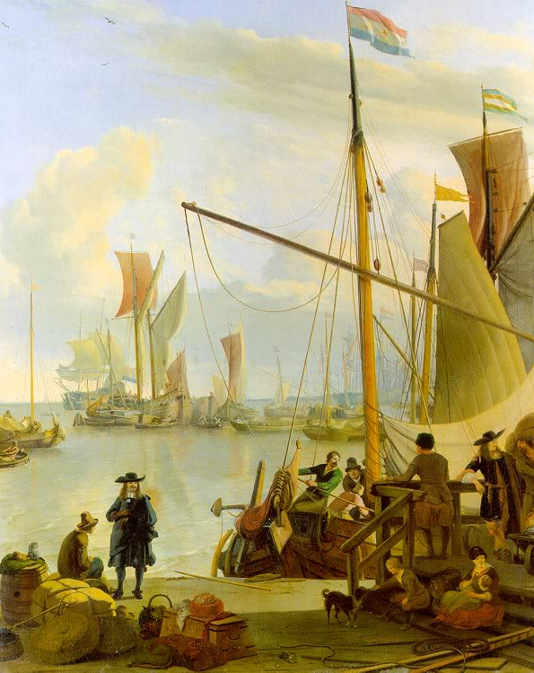
Edited May 24, 2009 by CaptainSatan

- Quote
- Edit
- Options

Edward O'Keeffe
- Occupy Fort Taylor!
- Member

- 90 posts
- Gender:Male
- Location:Rochester, NY
- Interests:Woodworking
(IP: 74.34.9.14) · ·
Posted July 21, 2009 (edited) · Report post
Here we go, I am finally posting pics of William's sea chest that has been lurking around my garage for the past several weeks. It is made from pine with poplar trim. I am also building one out of cherry for the dear Miss Lily Alexander. Mr Roberts....Yours is on the schedule

Edited July 21, 2009 by Edward O'Keeffe

- Quote
- Edit
- Options

William Brand
- Mercury Malefactor
- Admin

- 8,884 posts
- Gender:Male
- Location:Logan, Utah
- Interests:My name is William Pace and I live and work as a graphic designer, illustrator and photographer in Northern Utah. I'm married to the lovely Tracy Pace and we have three children. In addition to all things art, I enjoy traveling and meeting new people from every walk of life. I've always been a fan of history, theology, and of course, Pyracy.
http://www.youtube.com/watch?v=PSkt-q-HihQ
(IP: 166.70.59.121) · ·
Posted July 21, 2009 · Report post
On 7/21/2009 at 8:38 PM, Edward O said:
Here we go, I am finally posting pics of William's sea chest that has been lurking around my garage for the past several weeks. It is made from pine with poplar trim. I am also building one out of cherry for the dear Miss Lily Alexander. Mr Roberts....Yours is on the schedule

Sniff. It's beautiful.
I can't wait to drop it, tip it over, spill things on it, and trip over it in the dark.

- Quote
- Edit
- Options

Edward O'Keeffe
- Occupy Fort Taylor!
- Member

- 90 posts
- Gender:Male
- Location:Rochester, NY
- Interests:Woodworking
(IP: 74.34.9.14) · ·
Posted July 21, 2009 · Report post
On 7/21/2009 at 8:56 PM, William Red Wake said:
On 7/21/2009 at 8:38 PM, Edward O said:
Here we go, I am finally posting pics of William's sea chest that has been lurking around my garage for the past several weeks. It is made from pine with poplar trim. I am also building one out of cherry for the dear Miss Lily Alexander. Mr Roberts....Yours is on the schedule

Sniff. It's beautiful.
I can't wait to drop it, tip it over, spill things on it, and trip over it in the dark.
May it taste as much of your blood as it has mine.

- Quote
- Edit
- Options

willie wobble
- Plunderer
- 
- Member

- 336 posts
- Gender:Male
- Location:ROCKVEGAS, FLORIDA
- Interests:CANNONS , BLACKPOWDER,Wood carving and Knotwork
(IP: 74.235.238.165) · ·
Posted July 21, 2009 · Report post
Very nice Mr O'keeffe ,and doved tailed too !!
i've been build a chest also and close to compleation only working on the beckets and bottom trim now and aquireing the milk paint next week when in orlando, i have taken some pictures of the progres but don't know how to post them yet , i'll try to shortly though..... wobbler

- Quote
- Edit
- Options

callenish gunner
- Scourge o' the 7 Seas
- Member

- 2,138 posts
- Gender:Male
- Location:Pennsylvania mountains north of Clarion
- Interests:The Callenish gunner has just hoved into view looking for safe anchorage in these waters... purveyor of bladed and flintlock weaponry also leather accessories ..........painter of portraits and period scenes by avocation I'm getting my armoury business underway and will be doing as many festivals as I can ...right now along the east coast or great lakes
(IP: 98.21.66.55) · ·
Posted July 21, 2009 · Report post
Nicely done Edward!!! I wish I had a shop to make one of those.

- Quote
- Edit
- Options

callenish gunner
- Scourge o' the 7 Seas
- Member

- 2,138 posts
- Gender:Male
- Location:Pennsylvania mountains north of Clarion
- Interests:The Callenish gunner has just hoved into view looking for safe anchorage in these waters... purveyor of bladed and flintlock weaponry also leather accessories ..........painter of portraits and period scenes by avocation I'm getting my armoury business underway and will be doing as many festivals as I can ...right now along the east coast or great lakes
(IP: 98.21.66.55) · ·
Posted July 21, 2009 · Report post
Nicely done Edward!!! I wish I had a shop to make one of those.

- Quote
- Edit
- Options

Ivan Henry aka Moose
- Plunderer
- Member

- 486 posts
- Gender:Male
- Location:tampa, fl
- Interests:Bicycles
Travel
Wine
Beer
Good Food
Pizza!
Pirate Stuff
Design
(IP: 65.32.145.42) · ·
Posted July 22, 2009 · Report post
Had this image in my reference file. While not a sea chest, it's still a good period reference for chests.

- Quote
- Edit
- Options

Tar Bucket Bill
- Deck Hand
- 
- Member

- 80 posts
- Gender:Male
- Location:Indianapolis, Ind.
- Interests:Pillagin', plunderin', riflin', lootin', kidnappin', ravagin' and splicin' the mainbrace whenever I can. Hehe.
(IP: 12.186.80.1) · ·
Posted July 22, 2009 · Report post
That's a nice reenforced banded chest Mooseworth.
Are there any photos of the bottom, back with hinges and the insides?
-Tar Bucket Bill

- Quote
- Edit
- Options

Dorian Lasseter
- Where's My Water
- Member

- 3,266 posts
- Gender:Male
- Location:The Sea!
- Interests:18th Century reenactment; Maritime, F&I...
Did ECW as well...
All BP firelocks and cannons!
Also enjoy Swordfighting and a good Donnybrook
Got a question for or about me? Ask!!!
(IP: 71.182.132.115) · ·
Posted July 23, 2009 · Report post
I posted these elsewhere...
Over the last several months I've taken an old pattern-makers chest that belonged to my father's aunt's husband and refurbished it into a good yet large sea chest.
Here's how I found it;
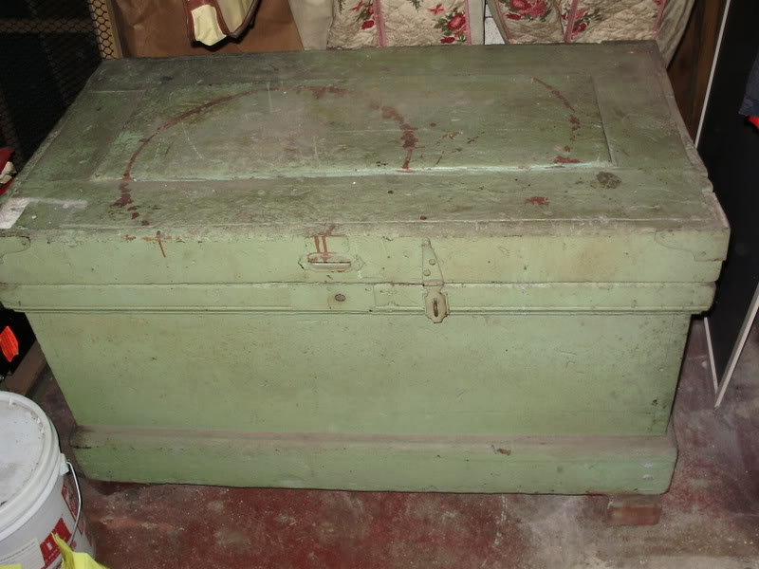
it had been painted several times, poorly I might add, so I took it outside and stripped off all the paint I could;
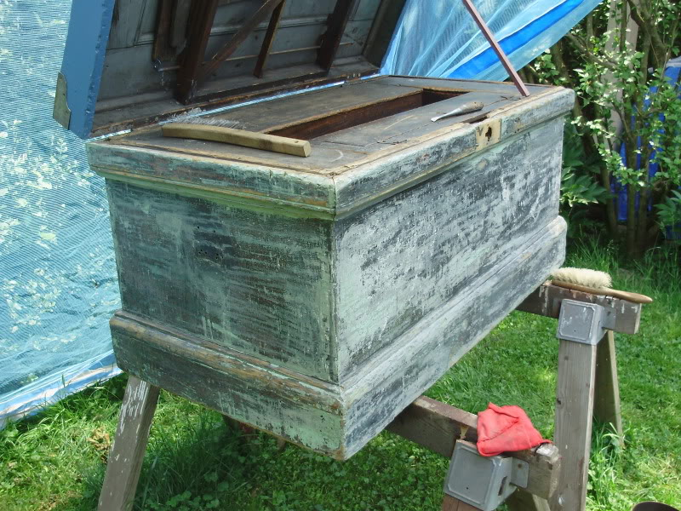
Found some good paint;
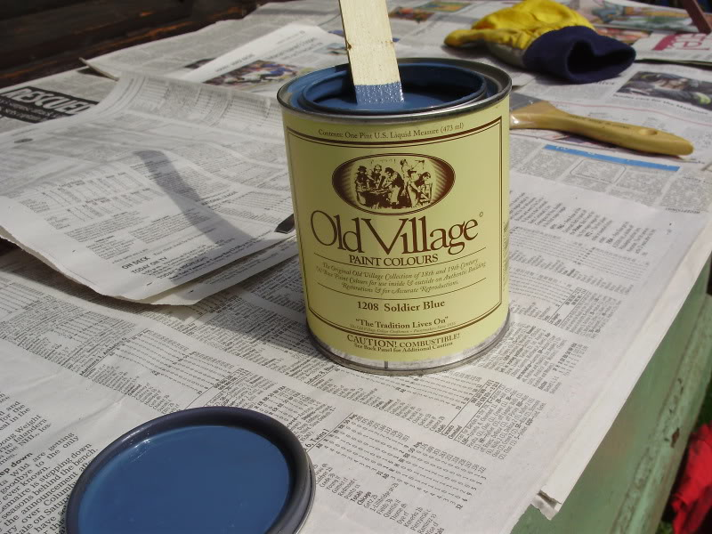
And presto!
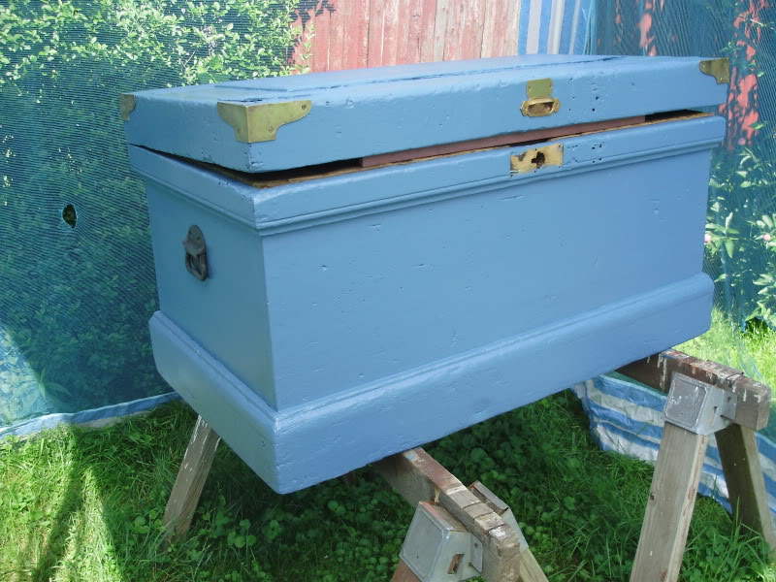
Internally there was also some interesting things;
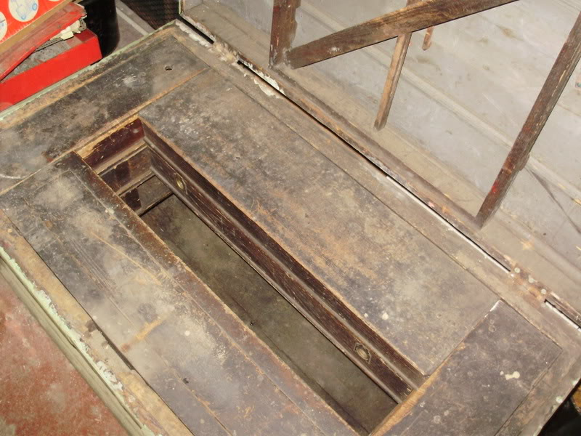
Four tils, some removable shelves, and eight drawers... well, two drawers were missing, so I made new ones;
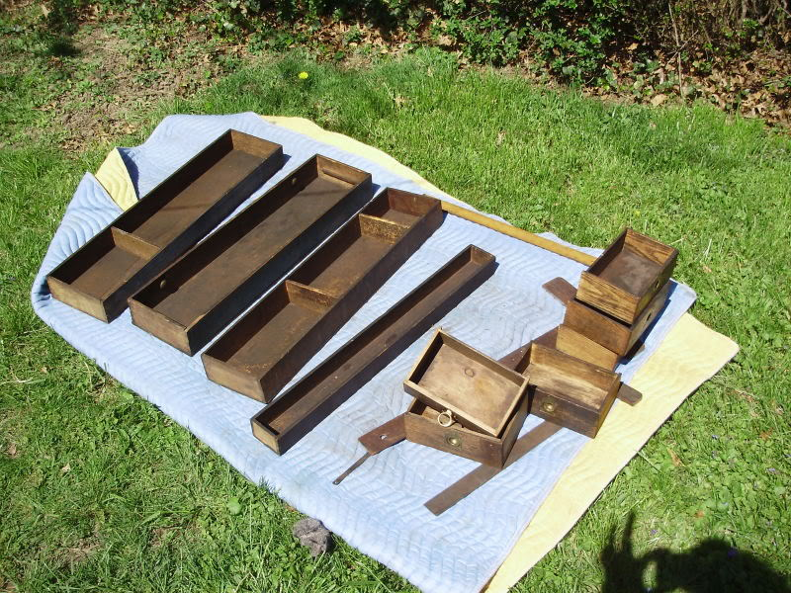
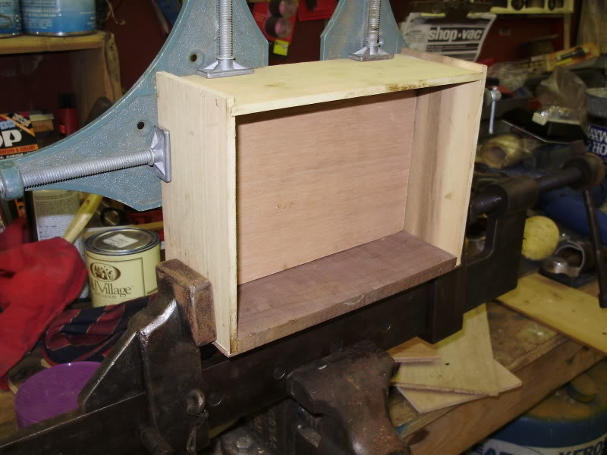
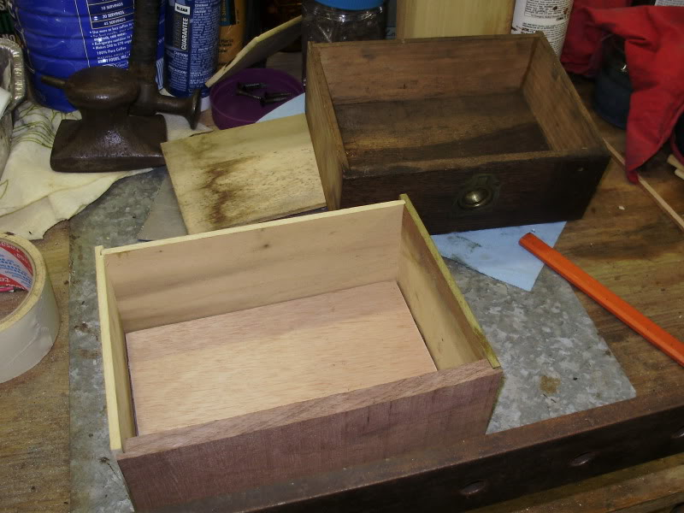
it all goes in;
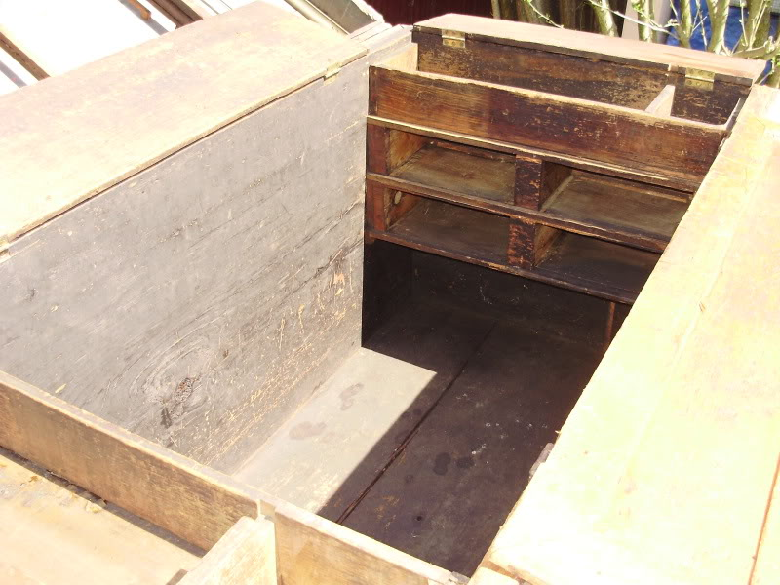
lots of places to store all kinds of gear...

- Quote
- Edit
- Options

Dorian Lasseter
- Where's My Water
- Member

- 3,266 posts
- Gender:Male
- Location:The Sea!
- Interests:18th Century reenactment; Maritime, F&I...
Did ECW as well...
All BP firelocks and cannons!
Also enjoy Swordfighting and a good Donnybrook
Got a question for or about me? Ask!!!
(IP: 71.182.132.115) · ·
Posted July 23, 2009 · Report post
While I was at that, I also built a smaller chest...
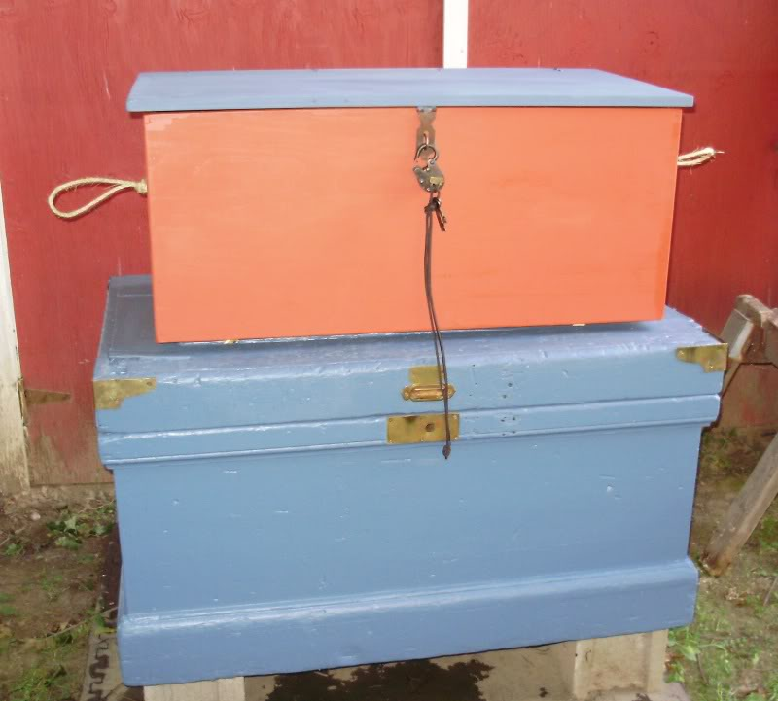
Had to do something while the paint and such dried...
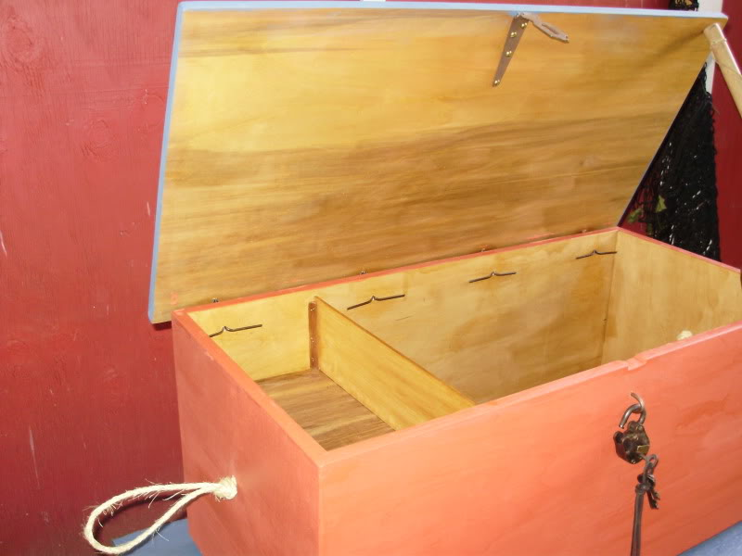

- Quote
- Edit
- Options

HarborMaster
- Dread Pyrate
- 
- Member

- 1,446 posts
- Gender:Male
- Location:Centralia Wa and Cebu Philippines
- Interests:Scuba Diving ., Shooting ., Drinking ., Cannons ., Motorcycling . I hope I didn't , leave out anything important.
(IP: 76.121.132.133) · ·
Posted July 23, 2009 (edited) · Report post
On 7/23/2009 at 0:03 AM, Dorian Lasseter said:
While I was at that, I also built a smaller chest...
Complex drawer and or shelf system ., I like it.
Edited July 23, 2009 by HarborMaster

- Quote
- Edit
- Options

oderlesseye
- Scourge o' the 7 Seas
- Member

- 2,126 posts
- Gender:Male
- Location:San Diego, Ca. (North Park) me cove !
- Interests:Oderlesseye is a mutinous two bit sand dollar with a thirst for adventure. Sailing on tall ships, firing black powder weapons, and sword fighting.. I most love to entertain the public in piratical skit presentations that involve all of the above. My name is befitting of my position on board as that of the look-out. Some ask what’s the meaning of the name Oderlesseye...It is simple really.. When Eye am aloft, ye can’t smell me...But it’s spelled wrong some exclaim! Hey now! What pirate can spell? - is my retort!
I have been an active member of the pirate community since 2005. I consider myself a fan of living history in the Golden Age of Piracy. As a child I , like the lot of ye, loved the old time pirate movies with Errol Flynn and Douglas Fairbanks. Long live Long John Silver !
Inspired by them, Eye created a Pirate Ninja Movie called "Treachery and a Dead Mans Promise" Available on YouTube.
Being a pirate, as it turns out, is multi-dimensional. For me, a lifestyle has been carved out of it. There is a six foot tall skeleton pirate in a make shift hide out called Dead Mans Cove behind my house. The walls are painted giving the impression you are in a sea cave. There is a mural of a pirate coming ashore in a long boat at the mouth of the cove. Believe me, it is a great place to enjoy rum now and again!
Exploration into all things piratical have led me to being an attempted escapee from the Governors noose to impersonating a judge in the Anne Bonnie and Mary Read trial held in Pirates In Paradise.. As Oderlesseye, my one on one impression to patrons is as one whom barley escaped the flames of the ship we took when the powder magazine blew with the booty in me hands from the Captains quarters.. The tale explains the soot on me face, the tattered clothing, and the burnt tricorn, as I hand out a gold coin or two. I hate them plastic ones and I know kids appreciate the metal coins even more so.
When an event is slated for a historical time line presentation to the public, I do not do these things mentioned above. Rather, I share about what is a grape shot or how a flintlock works. I ware clothing that is more closely representing the era in these cases. I am still updating me togs (Period Kit) as I learn more thru fellow pirates and sources like the Pyracy Pub.
So far, there have been many exciting moments of adventure the world of PIRACY has afforded me. From standing on a bar top with Pirates Charles singing to me in New Orleans to shooting cannons ( Ships Guns for you PC Pirates!), on the tall ship Spirit of Dana Point. Cheers from a crowd during a show as last man standing on the Treasure chest proclaiming to an excited crowd ITS MINE! THE BOOTY IS MINE ! YARR ! ~ These things and the notoriety that comes with being a pirate has me hooked! Whats More Is the greater bonds of friendships that have been forged with those whose course finds me at such events, sharing the same love and passion of the Life within the pirate/reenactment community. To Them Eye take me hat off and offer a tot of Rum! Cheers mates!
(IP: 72.220.149.99) · ·
Posted July 23, 2009 · Report post
Glad to see all the hard work bringing about the fruit of their hands eerr!
Eye wanted fancy dovetail joints so I hired an experienced
hand for that..The Sea Chest is coming right along. The Box is made of
sugar pine with maple trim and aromatic cedar for the till box.
I am still waiting for the beckets and cleats but won't need them for another week.
We are going to experiment with milk paint on test pieces.
If that does not work out then it will have a dark wood marbled
look like Capt. Macnamaras Sea chest.
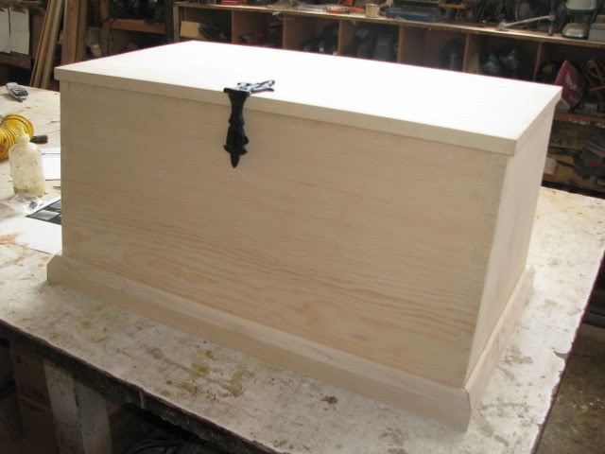
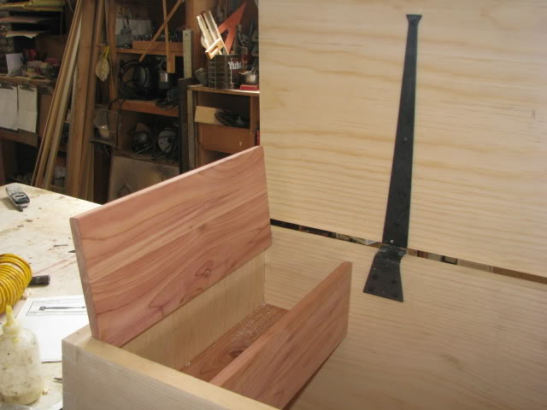
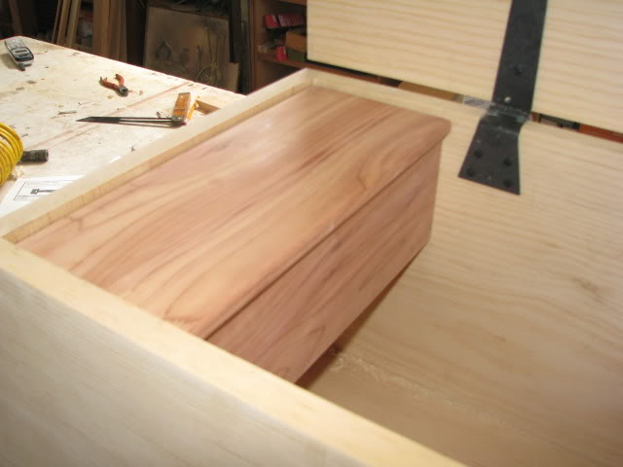

- Quote
- Edit
- Options

Dorian Lasseter
- Where's My Water
- Member

- 3,266 posts
- Gender:Male
- Location:The Sea!
- Interests:18th Century reenactment; Maritime, F&I...
Did ECW as well...
All BP firelocks and cannons!
Also enjoy Swordfighting and a good Donnybrook
Got a question for or about me? Ask!!!
(IP: 147.72.68.65) · ·
Posted July 24, 2009 · Report post
On 7/23/2009 at 0:44 PM, HarborMaster said:
On 7/23/2009 at 0:03 AM, Dorian Lasseter said:
While I was at that, I also built a smaller chest...
Complex drawer and or shelf system ., I like it.
Aye...
The front and rear tils are actually removable shelf/boxes. it's actually set up to have three layers, but at present there are only two. Here's more images to show you what I mean.
With just the side drawers in;
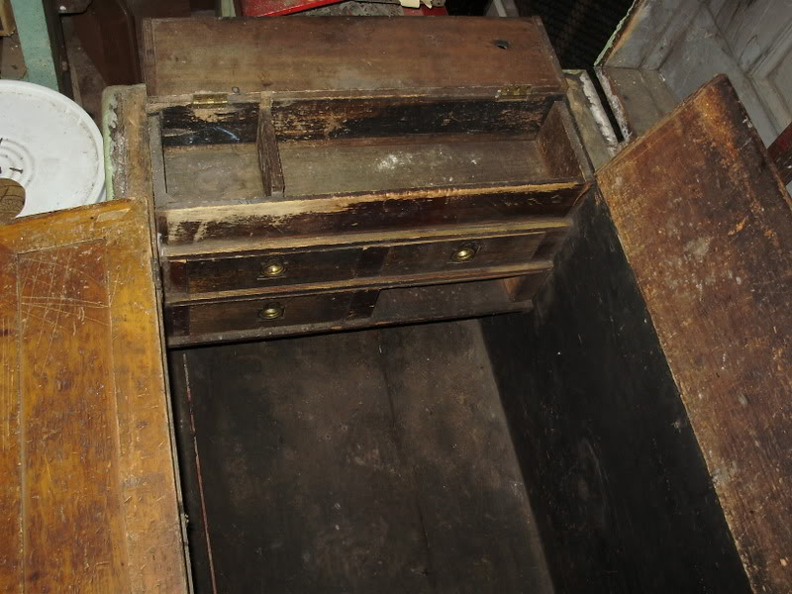
As you can see, there is a side til and two levels of drawers. each level has a lip for a shelf/box to sit on.
Here we have the first layer of shelves;
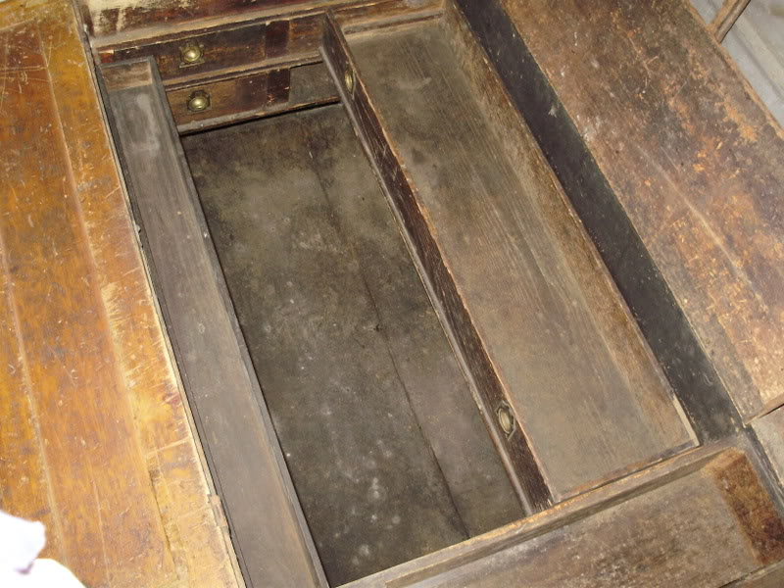
I may make some more to fill in the lowest level, which also keeps the drawers from coming out if the chest is shifted.
Top layer in place;
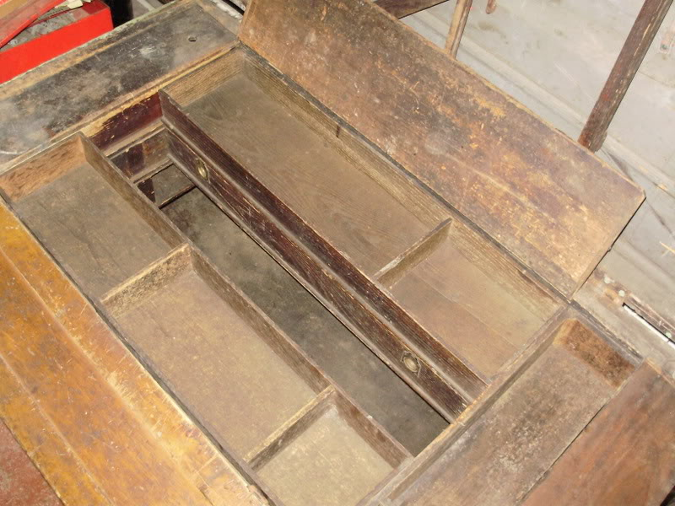
All lids shut;
Here you can see under the shelves, and one of the newly made drawers pulled out;
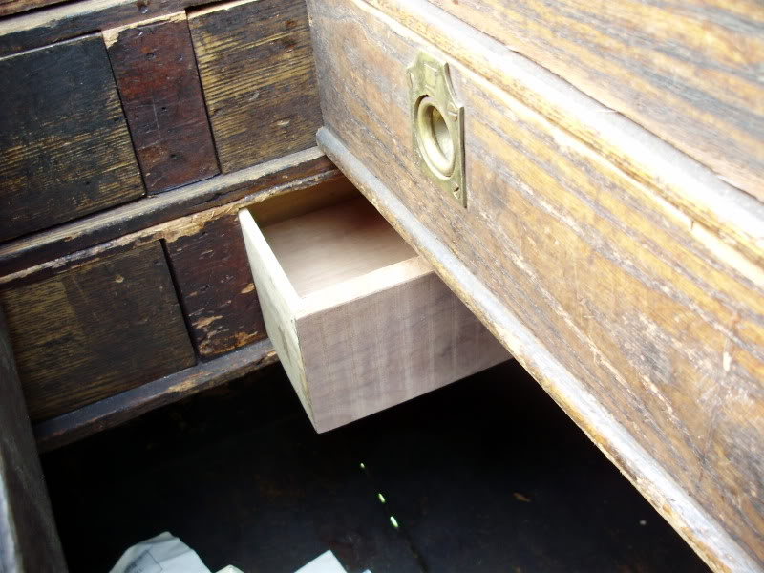

- Quote
- Edit
- Options

oderlesseye
- Scourge o' the 7 Seas
- Member

- 2,126 posts
- Gender:Male
- Location:San Diego, Ca. (North Park) me cove !
- Interests:Oderlesseye is a mutinous two bit sand dollar with a thirst for adventure. Sailing on tall ships, firing black powder weapons, and sword fighting.. I most love to entertain the public in piratical skit presentations that involve all of the above. My name is befitting of my position on board as that of the look-out. Some ask what’s the meaning of the name Oderlesseye...It is simple really.. When Eye am aloft, ye can’t smell me...But it’s spelled wrong some exclaim! Hey now! What pirate can spell? - is my retort!
I have been an active member of the pirate community since 2005. I consider myself a fan of living history in the Golden Age of Piracy. As a child I , like the lot of ye, loved the old time pirate movies with Errol Flynn and Douglas Fairbanks. Long live Long John Silver !
Inspired by them, Eye created a Pirate Ninja Movie called "Treachery and a Dead Mans Promise" Available on YouTube.
Being a pirate, as it turns out, is multi-dimensional. For me, a lifestyle has been carved out of it. There is a six foot tall skeleton pirate in a make shift hide out called Dead Mans Cove behind my house. The walls are painted giving the impression you are in a sea cave. There is a mural of a pirate coming ashore in a long boat at the mouth of the cove. Believe me, it is a great place to enjoy rum now and again!
Exploration into all things piratical have led me to being an attempted escapee from the Governors noose to impersonating a judge in the Anne Bonnie and Mary Read trial held in Pirates In Paradise.. As Oderlesseye, my one on one impression to patrons is as one whom barley escaped the flames of the ship we took when the powder magazine blew with the booty in me hands from the Captains quarters.. The tale explains the soot on me face, the tattered clothing, and the burnt tricorn, as I hand out a gold coin or two. I hate them plastic ones and I know kids appreciate the metal coins even more so.
When an event is slated for a historical time line presentation to the public, I do not do these things mentioned above. Rather, I share about what is a grape shot or how a flintlock works. I ware clothing that is more closely representing the era in these cases. I am still updating me togs (Period Kit) as I learn more thru fellow pirates and sources like the Pyracy Pub.
So far, there have been many exciting moments of adventure the world of PIRACY has afforded me. From standing on a bar top with Pirates Charles singing to me in New Orleans to shooting cannons ( Ships Guns for you PC Pirates!), on the tall ship Spirit of Dana Point. Cheers from a crowd during a show as last man standing on the Treasure chest proclaiming to an excited crowd ITS MINE! THE BOOTY IS MINE ! YARR ! ~ These things and the notoriety that comes with being a pirate has me hooked! Whats More Is the greater bonds of friendships that have been forged with those whose course finds me at such events, sharing the same love and passion of the Life within the pirate/reenactment community. To Them Eye take me hat off and offer a tot of Rum! Cheers mates!
(IP: 72.220.149.99) · ·
Posted August 22, 2009 (edited) · Report post
My sea chest is finally complete.
Eye am still waiting on Capt. Macnamara to deliver the beckets and cleats.
The Box is built according to plans supplied by Marlinespike.com
The painted finish came out really cool and antiqued looking do to crazing.
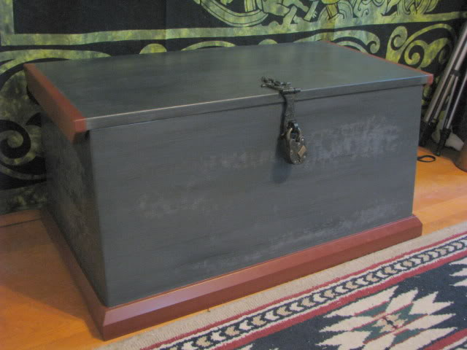
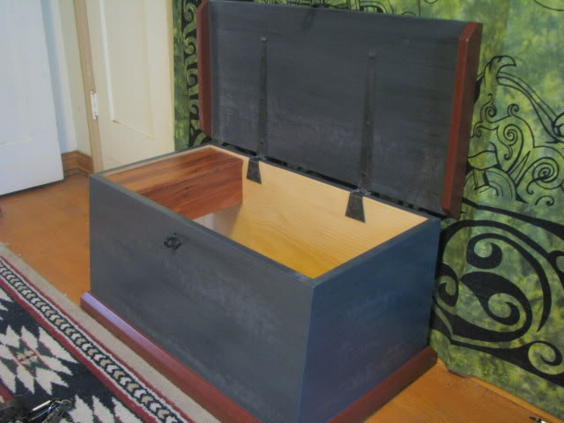
Edited August 23, 2009 by oderlesseye

- Quote
- Edit
- Options

callenish gunner
- Scourge o' the 7 Seas
- Member

- 2,138 posts
- Gender:Male
- Location:Pennsylvania mountains north of Clarion
- Interests:The Callenish gunner has just hoved into view looking for safe anchorage in these waters... purveyor of bladed and flintlock weaponry also leather accessories ..........painter of portraits and period scenes by avocation I'm getting my armoury business underway and will be doing as many festivals as I can ...right now along the east coast or great lakes
(IP: 98.21.75.253) · ·
Posted August 22, 2009 · Report post
Very nicely done gentlemen.... You have all raised the bar to a fine level now I guess I'll have to make ours .....but with Salty, Hamish, Hannah & M'self I'll be quite busy for the next few months.

- Quote
- Edit
- Options

Dorian Lasseter
- Where's My Water
- Member

- 3,266 posts
- Gender:Male
- Location:The Sea!
- Interests:18th Century reenactment; Maritime, F&I...
Did ECW as well...
All BP firelocks and cannons!
Also enjoy Swordfighting and a good Donnybrook
Got a question for or about me? Ask!!!
(IP: 71.182.132.115) · ·
Posted August 22, 2009 · Report post
Nicely done, Eye!
Updates on the other chest;
I added a drawer and lid to the til...
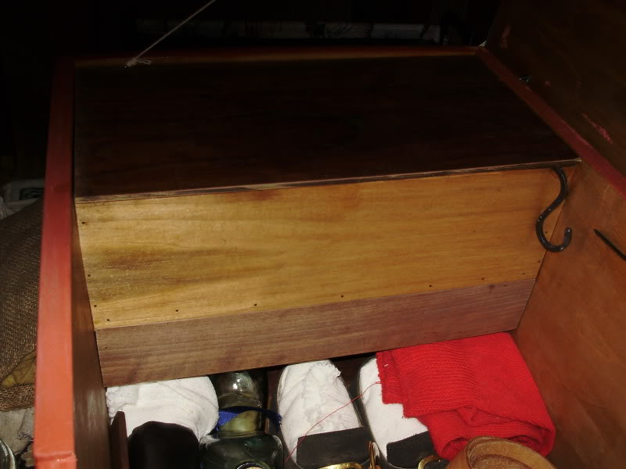
At the moment the lid just sits on top, I plan to add some slides so it will slide over to get into the til.
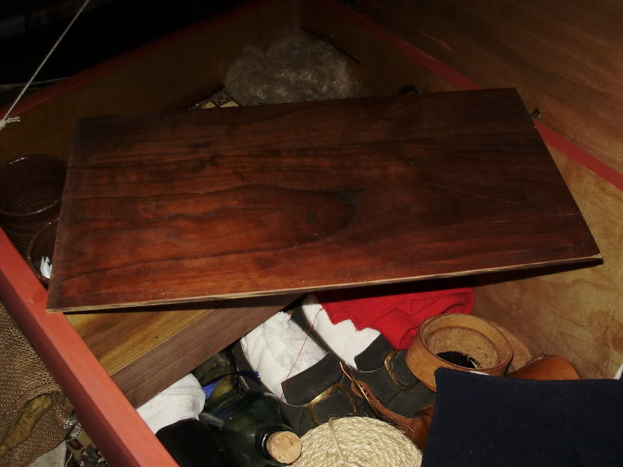
The drawer fits very nicely...
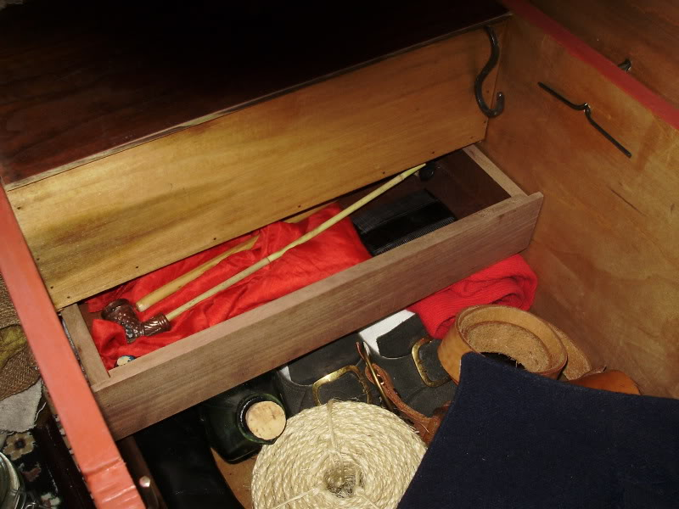
At present it stays shut by friction, I may add some sort of lock eventually...
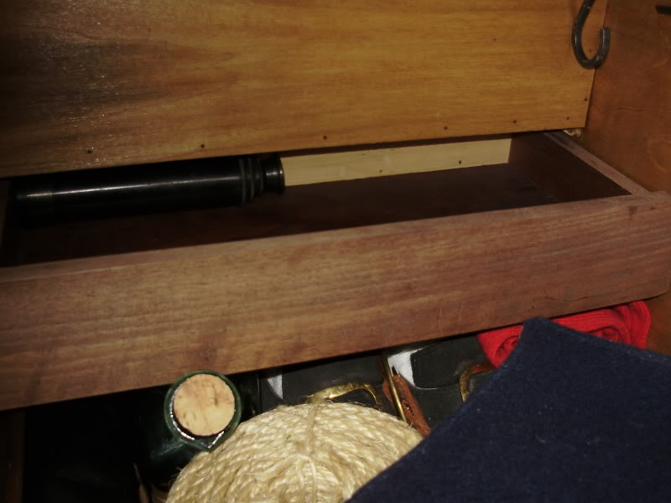

- Quote
- Edit
- Options

oderlesseye
- Scourge o' the 7 Seas
- Member

- 2,126 posts
- Gender:Male
- Location:San Diego, Ca. (North Park) me cove !
- Interests:Oderlesseye is a mutinous two bit sand dollar with a thirst for adventure. Sailing on tall ships, firing black powder weapons, and sword fighting.. I most love to entertain the public in piratical skit presentations that involve all of the above. My name is befitting of my position on board as that of the look-out. Some ask what’s the meaning of the name Oderlesseye...It is simple really.. When Eye am aloft, ye can’t smell me...But it’s spelled wrong some exclaim! Hey now! What pirate can spell? - is my retort!
I have been an active member of the pirate community since 2005. I consider myself a fan of living history in the Golden Age of Piracy. As a child I , like the lot of ye, loved the old time pirate movies with Errol Flynn and Douglas Fairbanks. Long live Long John Silver !
Inspired by them, Eye created a Pirate Ninja Movie called "Treachery and a Dead Mans Promise" Available on YouTube.
Being a pirate, as it turns out, is multi-dimensional. For me, a lifestyle has been carved out of it. There is a six foot tall skeleton pirate in a make shift hide out called Dead Mans Cove behind my house. The walls are painted giving the impression you are in a sea cave. There is a mural of a pirate coming ashore in a long boat at the mouth of the cove. Believe me, it is a great place to enjoy rum now and again!
Exploration into all things piratical have led me to being an attempted escapee from the Governors noose to impersonating a judge in the Anne Bonnie and Mary Read trial held in Pirates In Paradise.. As Oderlesseye, my one on one impression to patrons is as one whom barley escaped the flames of the ship we took when the powder magazine blew with the booty in me hands from the Captains quarters.. The tale explains the soot on me face, the tattered clothing, and the burnt tricorn, as I hand out a gold coin or two. I hate them plastic ones and I know kids appreciate the metal coins even more so.
When an event is slated for a historical time line presentation to the public, I do not do these things mentioned above. Rather, I share about what is a grape shot or how a flintlock works. I ware clothing that is more closely representing the era in these cases. I am still updating me togs (Period Kit) as I learn more thru fellow pirates and sources like the Pyracy Pub.
So far, there have been many exciting moments of adventure the world of PIRACY has afforded me. From standing on a bar top with Pirates Charles singing to me in New Orleans to shooting cannons ( Ships Guns for you PC Pirates!), on the tall ship Spirit of Dana Point. Cheers from a crowd during a show as last man standing on the Treasure chest proclaiming to an excited crowd ITS MINE! THE BOOTY IS MINE ! YARR ! ~ These things and the notoriety that comes with being a pirate has me hooked! Whats More Is the greater bonds of friendships that have been forged with those whose course finds me at such events, sharing the same love and passion of the Life within the pirate/reenactment community. To Them Eye take me hat off and offer a tot of Rum! Cheers mates!
(IP: 72.220.149.99) · ·
Posted August 24, 2009 · Report post
Dorian Lasseter..your chest looks really big.. wot size is that?
BTW I like the pipe!

- Quote
- Edit
- Options

D.man
- Ship's Master
- 
- Member

- 153 posts
- Gender:Male
- Location:california, Monterey county
(IP: 70.134.76.175) · ·
Posted August 24, 2009 · Report post
Nice chests

- Quote
- Edit
- Options

Dorian Lasseter
- Where's My Water
- Member

- 3,266 posts
- Gender:Male
- Location:The Sea!
- Interests:18th Century reenactment; Maritime, F&I...
Did ECW as well...
All BP firelocks and cannons!
Also enjoy Swordfighting and a good Donnybrook
Got a question for or about me? Ask!!!
(IP: 71.182.132.115) · ·
Posted August 24, 2009 · Report post
On 8/24/2009 at 6:55 PM, oderlesseye said:
Dorian Lasseter..your chest looks really big.. wot size is that?
BTW I like the pipe!
The 'Other Chest' is 36 long x 18 wide x 16 tall...
The first chest with all the drawers and tils is 42 long x 24 wide x 24 tall...
Aye, I like me pipes too... I've got two of them... fired clay bowls with reed stems, they smoke nice and I've a loooong stem for that one so it's a cool smoke...

- Quote
- Edit
- Options

oderlesseye
- Scourge o' the 7 Seas
- Member

- 2,126 posts
- Gender:Male
- Location:San Diego, Ca. (North Park) me cove !
- Interests:Oderlesseye is a mutinous two bit sand dollar with a thirst for adventure. Sailing on tall ships, firing black powder weapons, and sword fighting.. I most love to entertain the public in piratical skit presentations that involve all of the above. My name is befitting of my position on board as that of the look-out. Some ask what’s the meaning of the name Oderlesseye...It is simple really.. When Eye am aloft, ye can’t smell me...But it’s spelled wrong some exclaim! Hey now! What pirate can spell? - is my retort!
I have been an active member of the pirate community since 2005. I consider myself a fan of living history in the Golden Age of Piracy. As a child I , like the lot of ye, loved the old time pirate movies with Errol Flynn and Douglas Fairbanks. Long live Long John Silver !
Inspired by them, Eye created a Pirate Ninja Movie called "Treachery and a Dead Mans Promise" Available on YouTube.
Being a pirate, as it turns out, is multi-dimensional. For me, a lifestyle has been carved out of it. There is a six foot tall skeleton pirate in a make shift hide out called Dead Mans Cove behind my house. The walls are painted giving the impression you are in a sea cave. There is a mural of a pirate coming ashore in a long boat at the mouth of the cove. Believe me, it is a great place to enjoy rum now and again!
Exploration into all things piratical have led me to being an attempted escapee from the Governors noose to impersonating a judge in the Anne Bonnie and Mary Read trial held in Pirates In Paradise.. As Oderlesseye, my one on one impression to patrons is as one whom barley escaped the flames of the ship we took when the powder magazine blew with the booty in me hands from the Captains quarters.. The tale explains the soot on me face, the tattered clothing, and the burnt tricorn, as I hand out a gold coin or two. I hate them plastic ones and I know kids appreciate the metal coins even more so.
When an event is slated for a historical time line presentation to the public, I do not do these things mentioned above. Rather, I share about what is a grape shot or how a flintlock works. I ware clothing that is more closely representing the era in these cases. I am still updating me togs (Period Kit) as I learn more thru fellow pirates and sources like the Pyracy Pub.
So far, there have been many exciting moments of adventure the world of PIRACY has afforded me. From standing on a bar top with Pirates Charles singing to me in New Orleans to shooting cannons ( Ships Guns for you PC Pirates!), on the tall ship Spirit of Dana Point. Cheers from a crowd during a show as last man standing on the Treasure chest proclaiming to an excited crowd ITS MINE! THE BOOTY IS MINE ! YARR ! ~ These things and the notoriety that comes with being a pirate has me hooked! Whats More Is the greater bonds of friendships that have been forged with those whose course finds me at such events, sharing the same love and passion of the Life within the pirate/reenactment community. To Them Eye take me hat off and offer a tot of Rum! Cheers mates!
(IP: 72.220.149.99) · ·
Posted April 22, 2010 (edited) · Report post
In Late May thru June of 2009, I had an agreement from a person who said they would make Becketts and cleats for me. I sent him the Money. He was sent two checks for a total of $225.00
I trusted him because of prior business with him and I got what I expected in a timely manner.
It is now getting to be a year later and I still have not received anything. I wish to make warning about this person and also ask if any one knows him personally ..to let him know he needs to set things right with me and return my money. I found him on face book recently but he just shined me on.
He went by the Name Capt. Macnamara.. Sometimes he uses the name Duncan as well.
I believe he was the Captain of a SCA group called the Iron Lotus. His real name is Josiah Mcnamara and he now lives in Shawnee, Oklahoma
He was posting in on the topic of Sea chests at the time here: http://pyracy.com/in...%20Chests&st=60
I have ordered becketts from Marline Spike to finish the Sea Chest Project.
Eye realize it is a long shoot to get my money back however it is even more important for my mates here on the Pub to steer clear of him.
Because the Pyracy Pub Was revamped almost a year ago..My -E- mail conversations were lost...However In this thread ye can see plainly he said he was making them for me to William Red Wake..
Sincerely
Oderlesseye
This was Post by permission of the powers that be..
Edited April 22, 2010 by oderlesseye

• Quote
• Edit
• Options

Dutchman
- Has anyone seen my cousin?
- Admin

- 1,773 posts
- Gender:Male
- Location:tidewater virginia
(IP: 72.82.108.17) · ·
Posted April 22, 2010 · Report post
for clarification- the "duncan" he is refering to is NOT Duncan Mcguyver of the Crewe of the Vigilant.

- Quote
- Edit
- Options

Ivan Henry aka Moose
- Plunderer
- Member

- 486 posts
- Gender:Male
- Location:tampa, fl
- Interests:Bicycles
Travel
Wine
Beer
Good Food
Pizza!
Pirate Stuff
Design
(IP: 70.125.5.174) · ·
Posted April 22, 2010 · Report post
On 7/22/2009 at 2:38 PM, Tar Bucket Bill said:
That's a nice reenforced banded chest Mooseworth.
Are there any photos of the bottom, back with hinges and the insides?
-Tar Bucket Bill
YEs... :et me see what I can do.

- Quote
- Edit
- Options

Tartan Jack
- Notorious Pyrate
- Member

- 908 posts
- Location:South Carolina
- Interests:History, Scotland, Batman, Cars, and more<br />Married with 2 kids<br />
(IP: 74.181.91.31) · ·
Posted April 22, 2010 · Report post
OK . . .
What is THAT lid from?
A 18th C. safe?

- Quote
- Edit
- Options

PoD
- Pyrate Captain
- 
- Member

- 696 posts
- Gender:Male
- Location:Warrington UK
- Interests:Pirates, graphic novels, computer art, Listening to music, Going to gigs, Beer and Wine drinking, historical research, Period weaponry and Leatherwork
(IP: 82.24.80.245) · ·
Posted April 23, 2010 (edited) · Report post
It's the locking mechanism used in one of these:
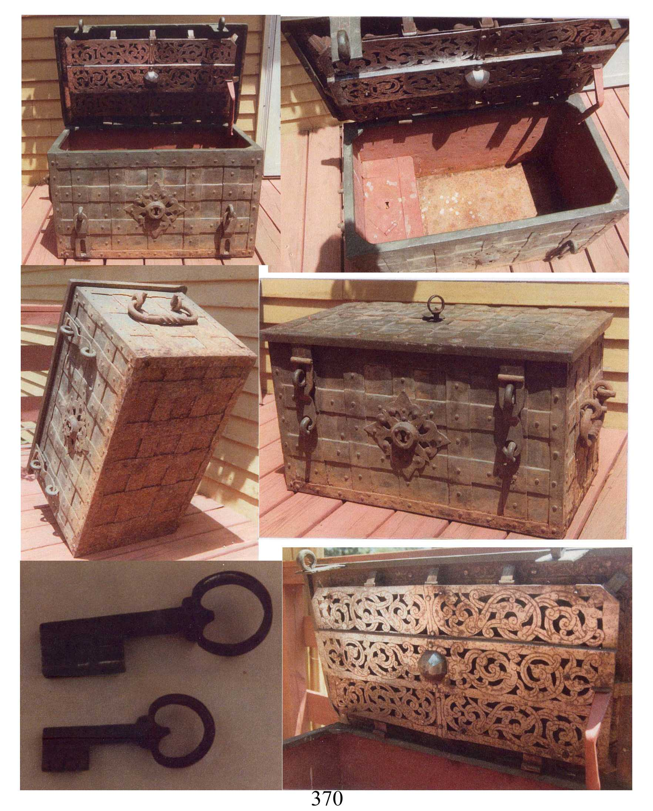
It's hidden beneath the cutout metal plated on this particular one. I actually started to make one of these a couple of days ago (minus the locking bit as I have no idea how that bugger supposed to work)
They are the chests carried by the Armada or Treasure Fleets that held the treasures taken from the New World
Edited April 23, 2010 by PoD

- Quote
- Edit
- Options

Tartan Jack
- Notorious Pyrate
- Member

- 908 posts
- Location:South Carolina
- Interests:History, Scotland, Batman, Cars, and more<br />Married with 2 kids<br />
(IP: 74.181.91.31) · ·
Posted April 23, 2010 · Report post
So . . .
It IS an 18th C. portable safe!

- Quote
- Edit
- Options

PoD
- Pyrate Captain
- Member

- 696 posts
- Gender:Male
- Location:Warrington UK
- Interests:Pirates, graphic novels, computer art, Listening to music, Going to gigs, Beer and Wine drinking, historical research, Period weaponry and Leatherwork
(IP: 82.24.80.245) · ·
Posted April 23, 2010 · Report post
On 4/23/2010 at 7:55 AM, Tartan Jack said:
So . . .
It IS an 18th C. portable safe!
Ha ha yep pretty much but more likely a 17th C. portable safe

- Quote
- Edit
- Options

IronTom
- Bilge Rat
- 
- 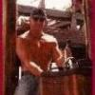
- Member

- 8 posts
- Location:New Orleans, LA.
- Interests:Pyrates, Literature, Martial Arts, Music, Scuba Diving, Beach, Cuisine, Art,
(IP: 24.248.12.179) · ·
Posted April 23, 2010 · Report post
Cool chests. Remember, pyrates usually had double the normal crew for raiding purposes so compared to any other crew they would have had much more free time. Other than Rum, most would gamble or carve wood or hard cheese in their spare time. It is entirely posssible that they would personalize their chest for no other reason other than to ward others away! Skulls, sharks, Kraken, dire!

- Quote
- Edit
- Options

oderlesseye
- Scourge o' the 7 Seas
- Member

- 2,126 posts
- Gender:Male
- Location:San Diego, Ca. (North Park) me cove !
- Interests:Oderlesseye is a mutinous two bit sand dollar with a thirst for adventure. Sailing on tall ships, firing black powder weapons, and sword fighting.. I most love to entertain the public in piratical skit presentations that involve all of the above. My name is befitting of my position on board as that of the look-out. Some ask what’s the meaning of the name Oderlesseye...It is simple really.. When Eye am aloft, ye can’t smell me...But it’s spelled wrong some exclaim! Hey now! What pirate can spell? - is my retort!
I have been an active member of the pirate community since 2005. I consider myself a fan of living history in the Golden Age of Piracy. As a child I , like the lot of ye, loved the old time pirate movies with Errol Flynn and Douglas Fairbanks. Long live Long John Silver !
Inspired by them, Eye created a Pirate Ninja Movie called "Treachery and a Dead Mans Promise" Available on YouTube.
Being a pirate, as it turns out, is multi-dimensional. For me, a lifestyle has been carved out of it. There is a six foot tall skeleton pirate in a make shift hide out called Dead Mans Cove behind my house. The walls are painted giving the impression you are in a sea cave. There is a mural of a pirate coming ashore in a long boat at the mouth of the cove. Believe me, it is a great place to enjoy rum now and again!
Exploration into all things piratical have led me to being an attempted escapee from the Governors noose to impersonating a judge in the Anne Bonnie and Mary Read trial held in Pirates In Paradise.. As Oderlesseye, my one on one impression to patrons is as one whom barley escaped the flames of the ship we took when the powder magazine blew with the booty in me hands from the Captains quarters.. The tale explains the soot on me face, the tattered clothing, and the burnt tricorn, as I hand out a gold coin or two. I hate them plastic ones and I know kids appreciate the metal coins even more so.
When an event is slated for a historical time line presentation to the public, I do not do these things mentioned above. Rather, I share about what is a grape shot or how a flintlock works. I ware clothing that is more closely representing the era in these cases. I am still updating me togs (Period Kit) as I learn more thru fellow pirates and sources like the Pyracy Pub.
So far, there have been many exciting moments of adventure the world of PIRACY has afforded me. From standing on a bar top with Pirates Charles singing to me in New Orleans to shooting cannons ( Ships Guns for you PC Pirates!), on the tall ship Spirit of Dana Point. Cheers from a crowd during a show as last man standing on the Treasure chest proclaiming to an excited crowd ITS MINE! THE BOOTY IS MINE ! YARR ! ~ These things and the notoriety that comes with being a pirate has me hooked! Whats More Is the greater bonds of friendships that have been forged with those whose course finds me at such events, sharing the same love and passion of the Life within the pirate/reenactment community. To Them Eye take me hat off and offer a tot of Rum! Cheers mates!
(IP: 72.220.190.137) · ·
Posted May 3, 2010 · Report post
Well despite my set back.. Eye now have my seaman's chest completed.. It weighs a bit..like at least 25 LBS. So If I just use it for clothing and odds and ends, I think Eye still can handle it on my own though I have to admit an extra person on the other side is a big help.. This said, Eye really don't think a seaman moved his chest around too much because of weight.
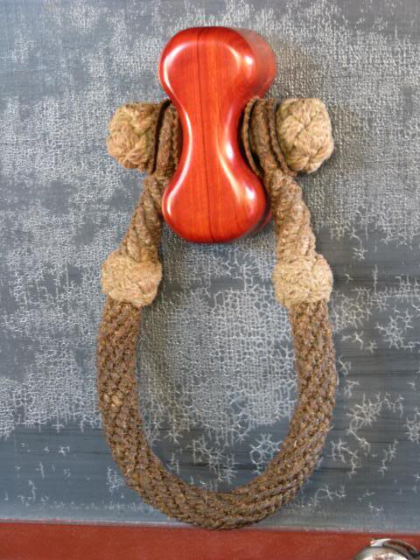
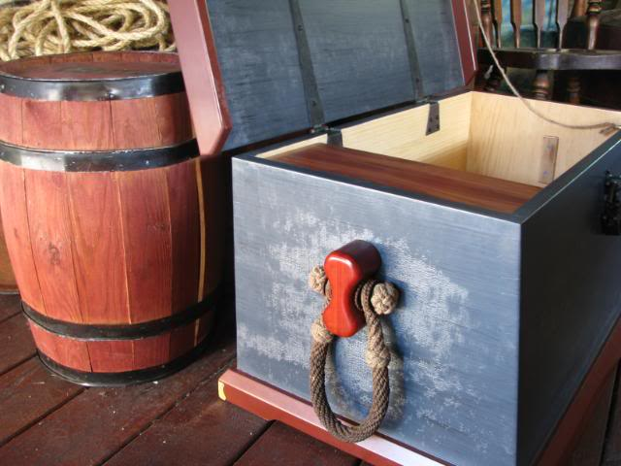

- Quote
- Edit
- Options

capn'rob
- Pyrate Captain
- Member

- 535 posts
- Gender:Male
- Location:Morehead City, NC
- Interests:Cruising, power or sail. Music and Maritime History. Pilaging, Plundering and General Mayhem!
(IP: 75.201.30.23) · ·
Posted May 3, 2010 · Report post
On 5/3/2010 at 7:14 PM, oderlesseye said:
Well despite my set back.. Eye now have my seaman's chest completed.. It weighs a bit..like at least 25 LBS. So If I just use it for clothing and odds and ends, I think Eye still can handle it on my own though I have to admit an extra person on the other side is a big help.. This said, Eye really don't think a seaman moved his chest around too much because of weight.

- Quote
- Edit
- Options

capn'rob
- Pyrate Captain
- Member

- 535 posts
- Gender:Male
- Location:Morehead City, NC
- Interests:Cruising, power or sail. Music and Maritime History. Pilaging, Plundering and General Mayhem!
(IP: 75.201.30.23) · ·
Posted May 3, 2010 · Report post
I believe that transport from ship to ship would have employed a wheelbarrow to move Sea Chests. I think it was in the beginning of Moby Dick, with Gregory Peck, when loading the Pequod this was in practice.

- Quote
- Edit
- Options

Mission
- Goat Specialist
- 
- Admin

- 5,082 posts
- Gender:Male
- Location:Monroe, MI
- Interests:Scholarly piracy, designing and creating haunted house rooms and props, movies, abstract thinking, abstruse thinking, obstructive thinking, ideating, random thinking, movies, cartoons, movies, movies scores, cycling, world peace and small furry dogs, movies, writing, drawing, personal skills training, gremlins and, of course, lest I forget, movies.
(IP: 24.247.94.112) · ·
Posted July 10, 2012 (edited) · Report post
OK, so I have this quote from Leo Eloesser's 1926 article "Pirate and Buccaneer Doctors."
"...the French West Indies it came to a head that he [Edward Low] wanted a doctor's chest, so he put four French captives aboard a prize sloop and sent them off to St. Thomas to tell the Governor that if he'd not sell him a good chest for the money his captive brought with them he'd kill all the Frenchmen and burn ten or more French vessels that he had in his hands. His captives returned with the chest."
I want to use it, but I can't find the original source. Does anyone know what this is from? It doesn't seem to be in the 3rd edition of the General History, which is where I would have expected to find this. Is there another contemporary Low source? Or did Eloesser somehow confuse the Blackbeard account with Low?
Edited July 10, 2012 by Mission

- Quote
- Edit
- Options

Mission
- Goat Specialist
- Admin

- 5,082 posts
- Gender:Male
- Location:Monroe, MI
- Interests:Scholarly piracy, designing and creating haunted house rooms and props, movies, abstract thinking, abstruse thinking, obstructive thinking, ideating, random thinking, movies, cartoons, movies, movies scores, cycling, world peace and small furry dogs, movies, writing, drawing, personal skills training, gremlins and, of course, lest I forget, movies.
(IP: 24.247.94.112) · ·
Posted July 10, 2012 · Report post
Never mind, I found it. I really need to read Dow and Edmond's The Pirates of the New England Coast one of these days...

• Quote
• Edit
• Options

