Captain Bob
- Ship's Master
- 
- 
- Member

- 108 posts
- Location:Sacred Tomato, CA
- Interests:Science, technology, history, military history, etc.
Posted May 18, 2006 · Report post
In our modern world today, we can have light whenever we want, in just about any amount we want, and we don't have to set fire to anything to get it. Just throw a switch, push a button, turn a knob and the ceiling lamp, flashlight, or portable lantern is ready to help us keep from crashing into, tripping over, or falling off of our environment.
What were one's options with regard to lighting in the 17th and 18th centuries (apart, of course, from doing without)? What did the lamps use, oil? What did they look like? Were torches just sticks with one end afire or was there more to it than that? Did the guys in the magazine work in the dark or was there some sort of safety lantern used? Zippo™ and Bic™ were centuries away. How did they light things when they didn't have a handy fire? What did those tools look like?
I'll just sit here and listen, k?
~~Cap'n Bob

kass
- Scourge o' the 7 Seas
- 
- 
- Member

- 1,526 posts
- Gender:Male
- Location:Easton, Pennsylvania
- Interests:Historical Clothing from the 14th through 18th centuries. Getting all the niggling details right. Dressing up and having fun with my similarly-obsessed friends. :)
Posted May 18, 2006 · Report post
Okay, I don't know alot about lighting in the 17th and 18th centuries (but frankly, I'm dying to learn), but I can share with you one type of light that was pretty typical and used by all levels of society. The rush light.
Rush lights were simple stands into which you clamped a single rush. The stand looked like one of those things you use to hold the hook when you're tying fishing lures -- a foot with about a 8-10" upright with a clamp off to one side. The rush (which is a type of tall grass) was dipped in tallow (rendered animal fat) and lit.
Candles were of course in use, but beeswax was expensive and even tallow was costly (and takes a lot of stinky work to make). Rushes were the common man's lighting system.
Rush lights were around as early as the middle ages, but I have seen rush light holders that date from the 18th century.

blackjohn
- Iron Age Hero Lost at Sea
- 
- 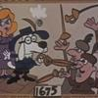
- Member

- 3,745 posts
- Gender:Male
- Location:Columbia, Md
- Interests:Stuff... and junk.
Posted May 18, 2006 · Report post
Here's an article about fat lamps in the 18thC...
http://www.continentalline.org/articles/ar...&article=950405
Here's the wiki list o' light sources...
http://en.wikipedia.org/wiki/List_of_light_sources
Duh... of course, Betty Lamps... couldn't think of the name...
I remember one time at... the National Colonial Farm...???... watching a woman do a weaving demo by candle light... using a spermaceti candle... those suckers are amazing... bright light... no soot... she only lit it for a sec because... obviously you really can't get sperm whale candles anymore...
There's this pretty neat external link from the wiki link above...
http://www.ramshornstudio.com/early_lighting_1.htm

Gentleman of Fortune
- Dread Pyrate
- 
- 
- Member

- 1,456 posts
- Gender:Male
- Location:Germany... Franconia (northern Bavaria)
- Interests:I *used* to be an environmental scientist, until I married a DoDDs teacher in 1997. Since then, I have been living in, and traveling around, Europe (First the UK, now Germany).
My hobbies are all the "usual suspects" for those interested in re-enacting and Golden Age of Piracy stuff.... but I have drifted away from the pirate scene as my location and young family don't allow for any more than "virtual" pirate participation. Besides Piracy, I am into Reverend Guitars and Vintage Corvettes.
Posted May 18, 2006 · Report post
What a great question. Never thought of it, and I am glad you asked!
Greg

blackjohn
- Iron Age Hero Lost at Sea
- Member

- 3,745 posts
- Gender:Male
- Location:Columbia, Md
- Interests:Stuff... and junk.
Posted May 18, 2006 · Report post
Spermaceti candles may be just a tad bit later than our period. Earliest references to them in colonial America that I have found thus far are 1750ish. A NPS site referenced a Jewish candlemaker bringing the process to America about then. But it didn't say how long the process existed in Europe before coming to America.
Fwiw, sperm whales are fascinating creatures. Read the wiki article if you don't believe me.
http://en.wikipedia.org/wiki/Sperm_whale

Red Dog
- Plunderer
- 
- Member

- 398 posts
- Location:Lake Forest, O.C., CA
- Interests:Piracy, weapons, history, photography, reasearch, reading, SCUBA, costuming, ebay, <br><br>a little of everything really.......
Posted May 18, 2006 · Report post
Interesting timing, I was just browsing a nautical catalog and found red and green glass .....prisms.... for lack of a better word. these had a flat round base on one end and came to a point at the other. It looks as if these were set into the deck to cast light into the holds/decks below. I assume it would work only if it were, 1 daytime and 2 the deck was directly below the topside deck. I guess you could set them into the bulkhead. It's the first I'd seen of this and it made sense.

kass
- Scourge o' the 7 Seas
- Member

- 1,526 posts
- Gender:Male
- Location:Easton, Pennsylvania
- Interests:Historical Clothing from the 14th through 18th centuries. Getting all the niggling details right. Dressing up and having fun with my similarly-obsessed friends. :)
Posted May 18, 2006 · Report post
Hey Dog, is that what the catalog says they were used for? Does it give a date at all?
Interesting stuff...

Dorian Lasseter
- Where's My Water
- 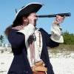
- Member

- 3,266 posts
- Gender:Male
- Location:The Sea!
- Interests:18th Century reenactment; Maritime, F&I...
Did ECW as well...
All BP firelocks and cannons!
Also enjoy Swordfighting and a good Donnybrook
Got a question for or about me? Ask!!!
Posted May 18, 2006 · Report post
Those are known as, oddly enough, 'Deck Prisims'.... I have one in plain glass, it has a slight greenish tint to it.... the best I've heard is they 'invented' in the late 19th century for luxury yachts... But I have to believe that they have an older history...

kass
- Scourge o' the 7 Seas
- Member

- 1,526 posts
- Gender:Male
- Location:Easton, Pennsylvania
- Interests:Historical Clothing from the 14th through 18th centuries. Getting all the niggling details right. Dressing up and having fun with my similarly-obsessed friends. :)
Posted May 18, 2006 · Report post
They sound very pretty in any case.

Dorian Lasseter
- Where's My Water
- Member

- 3,266 posts
- Gender:Male
- Location:The Sea!
- Interests:18th Century reenactment; Maritime, F&I...
Did ECW as well...
All BP firelocks and cannons!
Also enjoy Swordfighting and a good Donnybrook
Got a question for or about me? Ask!!!
Posted May 18, 2006 · Report post
do a google search for Deck Prism... intersting indeed...

kass
- Scourge o' the 7 Seas
- Member

- 1,526 posts
- Gender:Male
- Location:Easton, Pennsylvania
- Interests:Historical Clothing from the 14th through 18th centuries. Getting all the niggling details right. Dressing up and having fun with my similarly-obsessed friends. :)
Posted May 18, 2006 · Report post
Thanks Dorian!

Dorian Lasseter
- Where's My Water
- Member

- 3,266 posts
- Gender:Male
- Location:The Sea!
- Interests:18th Century reenactment; Maritime, F&I...
Did ECW as well...
All BP firelocks and cannons!
Also enjoy Swordfighting and a good Donnybrook
Got a question for or about me? Ask!!!
Posted May 18, 2006 · Report post
Aye Gerl...
Ni h-ea fadhb.........

kass
- Scourge o' the 7 Seas
- Member

- 1,526 posts
- Gender:Male
- Location:Easton, Pennsylvania
- Interests:Historical Clothing from the 14th through 18th centuries. Getting all the niggling details right. Dressing up and having fun with my similarly-obsessed friends. :)
Posted May 18, 2006 · Report post
Boy, you Scots spell funny...

Dorian Lasseter
- Where's My Water
- Member

- 3,266 posts
- Gender:Male
- Location:The Sea!
- Interests:18th Century reenactment; Maritime, F&I...
Did ECW as well...
All BP firelocks and cannons!
Also enjoy Swordfighting and a good Donnybrook
Got a question for or about me? Ask!!!
Posted May 18, 2006 · Report post
Scotts?
Hmmmm..... Gaelic....
Irish Gaelic......
The Deck prism is also known as a 'deadlight'....

kass
- Scourge o' the 7 Seas
- Member

- 1,526 posts
- Gender:Male
- Location:Easton, Pennsylvania
- Interests:Historical Clothing from the 14th through 18th centuries. Getting all the niggling details right. Dressing up and having fun with my similarly-obsessed friends. :)
Posted May 18, 2006 · Report post
Ah ha...
I got "Ni h'ea". Didn't understand the last word.

The Doctor
- aka Mad Jack Wolfe
- 
- Moderator

- 3,670 posts
- Gender:Male
- Location:╦┐◤︻㍕┻═▄
- Interests:Historian and writer, partnered with the dazzling and lovely Honour Bright.
Posted May 18, 2006 · Report post
I'd thought that "deadlights" were interior shutters placed over the gallery windows to allow a sailing ship to truly run dark. I believe I got that from the works of Angus Konstam.

Silver Steele
- Ship's Master
- Member

- 183 posts
- Location:Vegas
- Interests:Pillaging, plundering, rifling and looting of course. Now wheres the damn rum?
Posted May 18, 2006 · Report post
I though deadlights also meant eyes.... *shruggs* "Close yer deadlights!"

Dorian Lasseter
- Where's My Water
- Member

- 3,266 posts
- Gender:Male
- Location:The Sea!
- Interests:18th Century reenactment; Maritime, F&I...
Did ECW as well...
All BP firelocks and cannons!
Also enjoy Swordfighting and a good Donnybrook
Got a question for or about me? Ask!!!
Posted May 18, 2006 · Report post
Kass,
Ni h-ea fadhb in english, no problem...
Jack,
I'll admit, I'm uncertain, but mayhaps the deck prisms and the shutters were refered as the same thing? I cannot say, as I was quoting a source, mayhaps not the best one...
Steele,
Aye, slang term fer eyes...

Dorian Lasseter
- Where's My Water
- Member

- 3,266 posts
- Gender:Male
- Location:The Sea!
- Interests:18th Century reenactment; Maritime, F&I...
Did ECW as well...
All BP firelocks and cannons!
Also enjoy Swordfighting and a good Donnybrook
Got a question for or about me? Ask!!!
Posted May 18, 2006 · Report post
I found more out about deadlights...
They are, essentially, portholes or portlights that cannot or are not made to open...
Today, a deadlight is an interior porthole window...
So, I guess the deck prism would be a horizontal deadlight...
Google is a grande thing...

Red Dog
- Plunderer
- Member

- 398 posts
- Location:Lake Forest, O.C., CA
- Interests:Piracy, weapons, history, photography, reasearch, reading, SCUBA, costuming, ebay, <br><br>a little of everything really.......
Posted May 18, 2006 · Report post
i've gotta locate the catalog again, I'll include the name and stuff ASAP.

Red Dog
- Plunderer
- Member

- 398 posts
- Location:Lake Forest, O.C., CA
- Interests:Piracy, weapons, history, photography, reasearch, reading, SCUBA, costuming, ebay, <br><br>a little of everything really.......
Posted May 18, 2006 · Report post
Ok, my daughter last saw the catalog and now it's disappeared, I found the link below and it shows some actual deck prisms recovered from wrecks. It doesnt give a date though.
http://www.njscuba.net/artifacts/obj_deck_light.html

Patrick Hand
- The sailor's sailor
- 
- 
- Moderator

- 6,100 posts
- Gender:Male
- Location:TH' Mountains of Central California
- Interests:I like wierdness... Klingon, Pyrate..... and even..... gasp.... Renn Faires...... (Baseball and tractor pulls I'd have to think about.... could be wierd or Not,,,,)
Posted May 19, 2006 · Report post
Hummmm..... they have some of those at the Maritime museam (whatever it's called) in San Fransico......
Chunks of glass that let the light below.........
I thought it was cool when I first saw them..........

blackjohn
- Iron Age Hero Lost at Sea
- Member

- 3,745 posts
- Gender:Male
- Location:Columbia, Md
- Interests:Stuff... and junk.
Posted May 19, 2006 · Report post
Red Dog said:
Ok, my daughter last saw the catalog and now it's disappeared, I found the link below and it shows some actual deck prisms recovered from wrecks. It doesnt give a date though.
I'll try to nail down a date for them when I get home this evening... I suspect they are late 1700s or early 1800s.

The Doctor
- aka Mad Jack Wolfe
- Moderator

- 3,670 posts
- Gender:Male
- Location:╦┐◤︻㍕┻═▄
- Interests:Historian and writer, partnered with the dazzling and lovely Honour Bright.
Posted May 19, 2006 · Report post
I've been schooled by my own brother (a retired Navy captain) that "Deadlights are windows that allow the passive transmission of light in to or out of the vessel. Shuttering of the deadlights is done to secure the vessel for nocturnal action."
So, ol' Jack was off the mark yet again...

Dorian Lasseter
- Where's My Water
- Member

- 3,266 posts
- Gender:Male
- Location:The Sea!
- Interests:18th Century reenactment; Maritime, F&I...
Did ECW as well...
All BP firelocks and cannons!
Also enjoy Swordfighting and a good Donnybrook
Got a question for or about me? Ask!!!
Posted May 19, 2006 · Report post
Jack.... Jaaaack....... JAAAACK!!!!
No worries mate....
Life is a learning experience.... when ye stop learnin', life ends...
So.... Learn something new every day... and live well....

The Doctor
- aka Mad Jack Wolfe
- Moderator

- 3,670 posts
- Gender:Male
- Location:╦┐◤︻㍕┻═▄
- Interests:Historian and writer, partnered with the dazzling and lovely Honour Bright.
Posted May 19, 2006 · Report post
Nah, Dorian, I'm used to being wrong. I'm married!

Dorian Lasseter
- Where's My Water
- Member

- 3,266 posts
- Gender:Male
- Location:The Sea!
- Interests:18th Century reenactment; Maritime, F&I...
Did ECW as well...
All BP firelocks and cannons!
Also enjoy Swordfighting and a good Donnybrook
Got a question for or about me? Ask!!!
Posted May 19, 2006 · Report post
Pray tell me ye didn't marry Mrs. Right....

Black Syren
- At the sign of the trident
- 
- Admin

- 4,646 posts
- Gender:Female
- Location:Texas
- Interests:Writing, Singing, Drawing, Painting, Reading, Horseback Riding, Pirates and more pirates
Posted May 19, 2006 · Report post
Aye I heard that Deadlights were referred to as the eyes. This is very intresting and will look at the link as well.

The Doctor
- aka Mad Jack Wolfe
- Moderator

- 3,670 posts
- Gender:Male
- Location:╦┐◤︻㍕┻═▄
- Interests:Historian and writer, partnered with the dazzling and lovely Honour Bright.
Posted May 19, 2006 · Report post
Dorian Lasseter said:
Pray tell me ye didn't marry Mrs. Right....
I married Mrs. "Right Just About As Often As Me"...

LongTom
- Pyrate Captain
- 
- Member

- 629 posts
- Location:San Francisco or thereabouts
- Interests:"If I was a blackbird, could whistle and sing..." (Hm. I guess I must be a blackbird.)<br>Makin' hats, really big ones.<br>WizKids Pirates series games.
Posted May 19, 2006 · Report post
Dorian Lasseter said:
Pray tell me ye didn't marry Mrs. Right....
:angry:
Hey, you know Alice? Alice Right?

blackjohn
- Iron Age Hero Lost at Sea
- Member

- 3,745 posts
- Gender:Male
- Location:Columbia, Md
- Interests:Stuff... and junk.
Posted May 19, 2006 · Report post
Silver Steele said:
I though deadlights also meant eyes.... *shruggs* "Close yer deadlights!"
My edition of Grose has "Day Lights" as being slang for eyes.
I have checked two very good books on the fitting of ships from the late-16th to early-19thC and have found nothing on deck prisms. I've found alot on wiindows, companionways, deck gratings, etc., but nothing on the little jewels.

Captain Bob
- Ship's Master
- Member

- 108 posts
- Location:Sacred Tomato, CA
- Interests:Science, technology, history, military history, etc.
Posted May 23, 2006 · Report post
Hmmm... Deadlights are cool!
So. About the lanterns -- was oil used in the GAOP or were candles all they had? What did the lanterns look like?
~~Cap'n Bob

CaptainJackRussell
- Ship's Master
- Member

- 122 posts
- Location:Hamburg/ Germany
- Interests:Piracy. Certainly. Martial Arts, Pirates Tabletop by wizkidz, LARP, Reenactment, shooting my muzzleloaders and have always a lot of fun with good company.
Posted May 23, 2006 · Report post
They should be having oil, I guess. Even the romans had oil lanterns, so why not the 18th century?
Lanterns where made of tin with a lot of holes, just enough to let a little light outside and keeping the wind away. If more light was needed and no wind there, they just opened the little door (as seen in "Master And commander). The also used animal (pork was common) parchment or even the dried ***(missing english word...inside of body where the kidneys put their leftovers in), also commonly from pig.
Glass lanterns seem to appear approx. 100 years later.
Also a common source of light keen seems to be. Resin-keeping wood out of the center of dead pinewood burns like hell.
As firestarters matches where frequently appearing, but quite dangerous because they have been made of phosphor and salpeter. The tinderbox and a striker as well as matchcord where used to start fire or to carry it along.
Fair winds,
Jack

Rumba Rue
- Immortal Pyrate
- 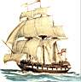
- Member

- 7,270 posts
- Gender:Female
Posted May 23, 2006 · Report post
You can find the deck prisms at Preston's Ships & Seas.
Preston's
The catalog I have states: In the days before electricity, light below a vessel's deck was limited to candles, oil and kerosene lamps. A clever solution for the light problem was a deck prism. Laid flush into the deck, the prism point drew light down below decks.
Hope this answers any questions and where to buy them.

hitman
- Pyrate Captain
- 
- Member

- 720 posts
- Gender:Male
- Location:Sardis Ga
- Interests:women, booze,books,tobacco,tall ships.hot rods and other monstrocities
Posted May 27, 2006 · Report post
CaptainJackRussell said:
Resin-keeping wood out of the center of dead pinewood burns like hell.
If I understand you correctly that be what I call fat lighter. You are most certinaly right in that it burns like hell fire itself and is the best kindling wood one can get Imho

Patrick Hand
- The sailor's sailor
- Moderator

- 6,100 posts
- Gender:Male
- Location:TH' Mountains of Central California
- Interests:I like wierdness... Klingon, Pyrate..... and even..... gasp.... Renn Faires...... (Baseball and tractor pulls I'd have to think about.... could be wierd or Not,,,,)
Posted May 27, 2006 · Report post
Quote
that be what I call fat lighter
Or fat pine........(same thing.... just different names fer it....)

kass
- Scourge o' the 7 Seas
- Member

- 1,526 posts
- Gender:Male
- Location:Easton, Pennsylvania
- Interests:Historical Clothing from the 14th through 18th centuries. Getting all the niggling details right. Dressing up and having fun with my similarly-obsessed friends. :)
Posted May 28, 2006 · Report post
CaptainJackRussell said:
They should be having oil, I guess. Even the romans had oil lanterns, so why not the 18th century?
Jack, the Romans also had indoor plumbing and a complex system of roads, which didn't emerge again until the 20th century. Don't make the leap that if oil lamps existed anciently, they existed continuously since then. That's a dangerous assumption.
I can't think of any oil lamps in use in the early 18th century. All kinds of candle lanterns, but not oil. Of course I don't pretend to be an expert on the subject. Just can't remember seeing them in any pictures or museums...
Does anyone know when oil lamps were used? Did it take the whale oil industry to bring oil lamps back into the Western world?

hitman
- Pyrate Captain
- Member

- 720 posts
- Gender:Male
- Location:Sardis Ga
- Interests:women, booze,books,tobacco,tall ships.hot rods and other monstrocities
Posted May 28, 2006 · Report post
They had Oil lamps for stage lights in the GAOP don't see why they wouldn't be used else where. Here is a sight for the stage lights
http://www.stage-lighting-museum.com/html/.../17fr-rest.html

kass
- Scourge o' the 7 Seas
- Member

- 1,526 posts
- Gender:Male
- Location:Easton, Pennsylvania
- Interests:Historical Clothing from the 14th through 18th centuries. Getting all the niggling details right. Dressing up and having fun with my similarly-obsessed friends. :)
Posted May 29, 2006 · Report post
Not necessarily, Hitman. There are plenty of types of lights used in the theatre that aren't used anywhere else. Theatre lights have different qualities than domestic lighting -- they have to be brighter at longer distances and they don't have to be terribly efficient.
The problem is that I have searched and searched online for 18th century lighting fixtures and all I've found are lanterns and chandeliers that hold candles. No oil lamps. But I haven't even found any rush lights and I know they existed.

Patrick Hand
- The sailor's sailor
- Moderator

- 6,100 posts
- Gender:Male
- Location:TH' Mountains of Central California
- Interests:I like wierdness... Klingon, Pyrate..... and even..... gasp.... Renn Faires...... (Baseball and tractor pulls I'd have to think about.... could be wierd or Not,,,,)
Posted May 29, 2006 · Report post
In "The Book of Buckskinning IV" there is a chapter "Lighting the Primitive Camp"
It showes some fat lamps, that are period, but dosen't say what the date is for Betty and Ipswitch Betty lamps...... It also showes three rush holders, but dosen't Date them......
But a few quotes from the chapter..... just for fun......
"The producthio of light has always had an economic factor that is not ofren considered. It was only in times of relative prosperity that light fuels other than wood were used, because all the other fuels are edible."
"By 1750 there was a development that allowed the more convenient burning of oil; the various kinds of drop-wick or vertical-wick tube lamps. These lamps were made possible by improved techniques of obtaining thinner oils that could be drawn up a vertical wick. Whale oil was also beginning to be used to a greater extent."

Red Dog
- Plunderer
- Member

- 398 posts
- Location:Lake Forest, O.C., CA
- Interests:Piracy, weapons, history, photography, reasearch, reading, SCUBA, costuming, ebay, <br><br>a little of everything really.......
Posted May 30, 2006 · Report post
I think the main concern with the use of an open flame below deck is the reson this wouldn't have been too common.
In alot of the articals I've read, it was a flogging offence to have a candel or uncovered pipe below deck. Peticularly around the powder stores. The lighter, more fine priming powder was known to seep through barrels and canvas and hang in the air like dust. I know anyone working in the powder magazine wore felt slippers and used copper knives and picks to avoid static sparks.
Thoe holds must have been a pain to move around in.

Captain Bob
- Ship's Master
- Member

- 108 posts
- Location:Sacred Tomato, CA
- Interests:Science, technology, history, military history, etc.
Posted June 7, 2006 · Report post
RE: torches...
Were torches always just a stick with a fire on one end or were they more complicated than that? In more than one movie I've seen (not documentaries) characters wrap a cloth around a stick and dip it in flammable liquid, thus making a torch. Was it really that simple?
Also, if you wanted to light a lamp, fire, torch, or even your pipe, what did you use? I presume matches were a few years away yet (lighters, too). What was the GAOP equivalent to a book of matches?
~~Cap'n Bob

hitman
- Pyrate Captain
- Member

- 720 posts
- Gender:Male
- Location:Sardis Ga
- Interests:women, booze,books,tobacco,tall ships.hot rods and other monstrocities
Posted June 7, 2006 · Report post
Ok on the subject of lamps I got a little more info but as always it's a little thin and leaves more to guess but here goes
First up an 18th century oil lamp
http://www.sciencetech.technomuses.ca/engl...recieuse/huile/
no nautical application there to my eye.
Next Indian oil lamps from the 16th,17th,and 18th cent.
http://images.google.com/imgres?imgurl=htt...s%3Den%26sa%3DN
Time frame is covered but not local although to be honest these are the only thing that even looks like I'd light on a tall ship.
Next up is an example of Theatere lighting from the 17th cent.
http://images.google.com/imgres?imgurl=htt...s%3Den%26sa%3DN
I posted this as an example of how little lamps changed over time. To be honest this is like most lamps I've found in my net search they really are just reincarnation's of early clay oil lamps just made in metal.
Last but not least the closest thing I can get to time frame availability and local .....the "Betty Lamp"
http://www.ramshornstudio.com/early_lighting_2.htm
Agian it's just like a Roman (or earlier) oil lamp in metal. It appears to be OoP but I never found a hard start date for it so LATE period it may be. I can't find any thing that would counter the idea of candles as the main means of lighting but it does not appear oil lamps ever disappeared from the scene. As to fuel it appears from what I've seen animal fat was primary in lamps until kerosene swept in. Although whale oil was great it was expensive at over $2.00 a gallon or $200.00 a gallon in moderen terms to quote one sites estimate and early mixtures of alchool and turpentine were also expensive and prone to go BOOM!!!! all by there selves. Even worse were the home brew concotions that people cooked up to save money.(All of these alternitaves are OoP but thought you might like to know.) I doubt this is THE final thought on this but my final thought of this post is that oil lamps were exsistant may have been used in GAOP era taverns and homes (in witch case they'd burn animal fat most likely) but most likely never went to sea. It also appears from what I can see that theatere lights in 17th and early 18th century weren't much diffrent than home lighting (Not really disagreeing with you here Kass) witch to some degree makes sense at this point given the relative lack of advances in lighting from the stone age to that point and as a side note if I recall correctly the "globe" that surronds most lights today to diffuse and spread light was an invention for theatre that quickly spread to home use. However obviously lime lights and arc lights never made it big on the residential side

Rumba Rue
- Immortal Pyrate
- Member

- 7,270 posts
- Gender:Female
Posted June 8, 2006 · Report post
I can't remember where I read it, but ships did keep what's called a 'smoking lamp' on board, usually near the galley. Most likely a simple wick lantern that the globe could be raised up for lighting other things, like the cannons.

michaelsbagley
- Smells Like Wet Sheep
- 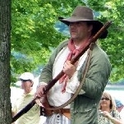
- Moderator

- 2,548 posts
- Gender:Male
- Location:Columbus, Ohio
- Interests:Mostly into GAoP, but starting to develop more Buccaneer era stuff for re-enacting as well. Generally I do re-enact both piratical/nautical and other impressions from the period. I am focusing on more "common" impressions from the period (i.e. average sailor/pirate, rank and file Red Coat, early Colonial huntsman, etc.)
Posted March 23, 2007 · Report post
In an effort to revise this thread based on the interest on a different thread...
I did find this...
From Esquemeling’s Buccaneers of America Page 20.
"Such is the vellow saunder, which by the inhabitants is called bois de chandel, or, in English, candle-wood, because it burns like a candle, and serves them with light while they fish by night. Here grows, also, Lignurm Sanctum, or Guaiacum. Its virtues are very well known, more especially, to those who observe not the seventh commandment, and are given to impure copulations! - physicians drawing hence, in several compositions, the greatest antidote for venereal diseases, as also for cold and viscous humors. The trees, likewise, which afford gummi elemi, grow here in great abundance, as doth radix Chince, or China root. Yet this is not so good as that of other parts of the western world. It is very white and soft, and serves for pleasant food to the wild boars, when they can find nothing else."

William Brand
- Mercury Malefactor
- 
- Admin

- 8,884 posts
- Gender:Male
- Location:Logan, Utah
- Interests:My name is William Pace and I live and work as a graphic designer, illustrator and photographer in Northern Utah. I'm married to the lovely Tracy Pace and we have three children. In addition to all things art, I enjoy traveling and meeting new people from every walk of life. I've always been a fan of history, theology, and of course, Pyracy.
http://www.youtube.com/watch?v=PSkt-q-HihQ
Posted March 23, 2007 · Report post
I am resurrecting this thread for the purpose of asking about lanterns, specifically ship lanterns (i.e. horn pane, glass, pierced, etc.) Most of this thread covers lights sources such as open flames (i.e., candles, oil lamps, etc.), but I need ship lantern sources.
Any assistance would be appreciated.

michaelsbagley
- Smells Like Wet Sheep
- Moderator

- 2,548 posts
- Gender:Male
- Location:Columbus, Ohio
- Interests:Mostly into GAoP, but starting to develop more Buccaneer era stuff for re-enacting as well. Generally I do re-enact both piratical/nautical and other impressions from the period. I am focusing on more "common" impressions from the period (i.e. average sailor/pirate, rank and file Red Coat, early Colonial huntsman, etc.)
Posted March 23, 2007 · Report post
And a google search found me these... You'll need to scroll about two thirds of the way down the linked page....
History of Pendant Lamps
To find these lamps...

and

The Chapman
- First Mate
- 
- Member

- 216 posts
Posted March 26, 2007 · Report post
For close work in dim light a glass globe filled with water, according to a source (around here somewhere), was I guess known as a shoemaker's or lacemaker's lamp; it was placed between a candle and the work being done. The same effect can be achieved using, say, a round goldfish-type bowl. I've tried it, it works pretty well.
I have also read that reflectors, mirrors or polished metal, were also sometimes used.

blackjohn
- Iron Age Hero Lost at Sea
- Member

- 3,745 posts
- Gender:Male
- Location:Columbia, Md
- Interests:Stuff... and junk.
Posted March 27, 2007 · Report post
In a bit of a hurry, so I'll be brief... linky linky.

William Brand
- Mercury Malefactor
- Admin

- 8,884 posts
- Gender:Male
- Location:Logan, Utah
- Interests:My name is William Pace and I live and work as a graphic designer, illustrator and photographer in Northern Utah. I'm married to the lovely Tracy Pace and we have three children. In addition to all things art, I enjoy traveling and meeting new people from every walk of life. I've always been a fan of history, theology, and of course, Pyracy.
http://www.youtube.com/watch?v=PSkt-q-HihQ
Posted March 27, 2007 · Report post
Excellen

Ol Man From the Sea
- Ship's Master
- Member

- 121 posts
- Location:1/2 degree on the 270 radial from da big city on the third coast
- Interests:Pirates in Paradise, Women Pirates and pirate's Women, GAoP, Small airplanes that I can fly in or tiny ones I fly indoors, Sailin', Drivin' ah heck just Goin'...
Posted March 27, 2007 · Report post
Damn you Blackjohn!
How am I gona read all these books from the library that will almost tell me what I need to know, when you keep postin' links to thesesis that WILL tell me what I need to know. :angry:
Well, quess I'll just HAVE to do more plunderin' ta pay my overdo fees
(in other words Thanks)

The Chapman
- First Mate
- Member

- 216 posts
Posted March 27, 2007 · Report post
Some thoughts on lanterns after looking through the PIP discussion.
Free standing or hand lanterns are probably different in style than actual ship's lanterns, which (?) tended to be fixed in place, although probably removable. I am eminently correctable.
Glass was a scarce and valuable commodity at the time and I wonder if it would have been a good idea to have glass panes in a handheld lantern, i.e. breakage, etc.
I suspect the key is in the word 'lanthorn'. Panes would likely have been cowhorn. Now, if you want to get all picky,the horn itself is processed relatively simply (by a craftsman known as, what else, a 'horner'): soaking in water for a few weeks, boiled for until soft(er), and then peeled like the rind of an onion. If you're in a rush or a hack, you can boil the horn quickly in ash, but I suspect the reason this technique was not universally used is the rapid heat would, in my opinion, render the product brittle in the end.
The pieces would be selected into darker and lighter depending on use, obviously the lightest panels being chosen for lanthorn lights.
Pieces could be cut into squares and flattened between two heated metal plates (iron?), or easier, and which leads me to believe a lot of lanthorns were cylindrical in shape, left curved and set into wood muntins in a hardwood... uhh... body? What's the name for that? Anyone?
Anyway, a typical shape for a cheapie quick and cool type lantern would be two wood circles with wood posts attaching them, a spike inset for a candle, and thinly peeled cowhorn of the lighter type cut and inset in lieu of glass.
Actually, I think I'll add that to the projects list; it sounds like fun.

Salty
- Dread Pyrate
- Member

- 1,012 posts
- Location:back in the mountains of westren pa...good to be back home
- Interests:maker o pots, tankards, and rum jugs. the natural world as it be and history that was not written by the winners.
Posted March 27, 2007 · Report post
ok glass out
cowhorn in
any thoughts on sheets of mica?
and if this has been posted and i missed it i apologize now
on the lighter side and in good fun as it can be to go thud and swear in the dark......how did they manage to cover the light when they choose to or is that a seperate piece of material. was it even a consideration ?

Ol Man From the Sea
- Ship's Master
- Member

- 121 posts
- Location:1/2 degree on the 270 radial from da big city on the third coast
- Interests:Pirates in Paradise, Women Pirates and pirate's Women, GAoP, Small airplanes that I can fly in or tiny ones I fly indoors, Sailin', Drivin' ah heck just Goin'...
Posted March 28, 2007 · Report post
Following Blackjohn's linky linky, I mean reading the paper Blackjohn suggested. It looks like the short answer, as posted by William Red Wake, is

Thank you Blackjohn and William!
The paper raised an other question, It talked about canvas fire buckets on ships in 1650? Can this be trusted? Is there a second source to back this up?

Salty
- Dread Pyrate
- Member

- 1,012 posts
- Location:back in the mountains of westren pa...good to be back home
- Interests:maker o pots, tankards, and rum jugs. the natural world as it be and history that was not written by the winners.
Posted March 29, 2007 · Report post
bloody "ell thanks fer pointing out the link ,ol man. will fynd what be correct as i read i gather. asked cause mica i have cow horn i do nae have ta see if i can get some.

The Chapman
- First Mate
- Member

- 216 posts
Posted March 31, 2007 · Report post
I am not finding any information on the use of isinglass/mica/muscovite in lanthorn use of the period being discussed here. It's entirely possible it was used, I just can't find anything, and I've talked to some of our stove suppliers at my job who ought to know about isinglass. Horn appears to be the most 'authentic' material for lights (or, as spelled in the construction trade so as to differentiate from natural light, 'lite').
Boring trivia:
The above material is mined commercially in India, where a vertical shaft is cut; the 'mica' accessed; and the material is split into 'books', or sheets, some of which have been notated as larger than three feet (meter) square.
'Scrap' mica/isinglass is found in the Carolinas of the USA, where it is largely ground up and used for a glittery effect on wallpaper and such; larger chunks are used in the electrical industry as insulators.
For period authenticity if you're writing about Russians, apparently its most well-known use in the past was as windows in both Russian houses and in ships from that locale, hence the moniker 'Muscovite'.
Good Lord I'm boring. Well, that's what happens when you drive a truck all day.
Personal experience and observation about early artificial light:
In my own experience about ambient light, I've found that total darkness in nature is very rare, and for the most part the idea of total darkness is a man-made creation unless you are deep in a cave. If the eye is accustomed to ambient light, it's not unduly difficult to function normally in what most modern eyes would view as extremely dim lighting. When I was working for a utility in what I'll politely call a 'low-income' area, I was constantly wandering around in the basements of apartment buildings, the lighting of which had long since been stolen, destroyed, or disabled. You just stop for a minute, allow your eyes to get used to the dark, and almost always I could do what I needed to do without recourse to artificial light, i.e. my Maglite/bludgeon.
Well, actually I didn't like turning on the flashlight for two reasons. Firstly, if you turn it on then off, you are blind for a minute. Not good. Secondly, who knew what was in those basements? Turning on a light just seemed like announcing, "Here I am, please shoot me!"
As far as natural light at night, I once drove South to Cheyenne on Highway 85 from Torrington, Wyoming in the middle of the night. I went almost 60 miles without seeing an artificial light or another car. I had trouble outrunning my headlights, so I stopped, got out, walked around for while, and then turned the headlights off. There was no moon, and the starlight was so bright I had a clearly defined shadow; I drove easily by that light, and having not really had an experience like that previously, I was amazed at how bright natural 'darkness' really is. Also, a single artificial illumination, when I finally saw one, was visible for a distance of what I would estimate as more than a mile.
And, since in my childhood I lived in a house with no electricity, I learned about candles, lamps, etc. And chopping wood.
Stupid crazy hippie parents.

MrSnailGrave
- Deck Hand
- 
- Member

- 84 posts
- Location:Bakersfield,Ca
- Interests:Blackpowder (pistols-Cannons)<br>Knives<br>Swords<br>Sewing<br>Leather sewing, bending, folding<br>Shopping for material<br>lookin for new stuff to make
Posted October 12, 2007 · Report post
just wondering what kind i can use or make im thinkin about makin this one
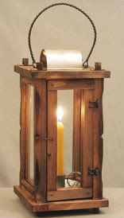

Red Cat Jenny
- Truly one of a Kind
- 
- Member

Posted October 12, 2007 · Report post
That one's nice!
You might want to check here
Lanterns

MrSnailGrave
- Deck Hand
- Member

- 84 posts
- Location:Bakersfield,Ca
- Interests:Blackpowder (pistols-Cannons)<br>Knives<br>Swords<br>Sewing<br>Leather sewing, bending, folding<br>Shopping for material<br>lookin for new stuff to make
Posted October 12, 2007 · Report post
thanks it helps

Morgan Dreadlocke
- Plunderer
- 
- Member

- 394 posts
- Gender:Male
- Location:On the starboard railin'
- Interests:Folk music, Pirate ships, Buells, Woodworkin', Livin' free unshackeled by the Diana Moonglompers of the socialist left.
Posted December 7, 2007 · Report post
A very similar plan be available from Woodcraft magazine, Mar 05 issue. I'll be makin' a few fer me pirate fishpond dock.
Seems a good excuse ta play wi' stained glass too

Captain Midnight
- Pyrate Captain
- Member

- 643 posts
- Gender:Male
- Location:Richland, GA USA
- Interests:I am the Captain of The Cursed Few, the deadliest pirate crew on the East Coast. I am a charter member of the Order of Leviathan, or "Devil's Dozen".
Posted December 7, 2007 · Report post
Is there an on-line link to the back issue that has these lantern plans?

Matty Bottles
- Notorious Pyrate
- 
- 
- Member

- 891 posts
- Gender:Male
- Location:Milwaukee, WI
- Interests:Writing, Art, Spending exorbinant amounts of money on action figures, rum, murder.
Posted December 7, 2007 · Report post
Morgan Dreadlocke said:
A very similar plan be available from Woodcraft magazine, Mar 05 issue. I'll be makin' a few fer me pirate fishpond dock.
Seems a good excuse ta play wi' stained glass too
Is it anything like this?

Morgan Dreadlocke
- Plunderer
- Member

- 394 posts
- Gender:Male
- Location:On the starboard railin'
- Interests:Folk music, Pirate ships, Buells, Woodworkin', Livin' free unshackeled by the Diana Moonglompers of the socialist left.
Posted December 7, 2007 · Report post
Captain Midnight said:
Is there an on-line link to the back issue that has these lantern plans?
There is, but it be a subscription site. www.woodcraftmagazine.com. The articles name was Illuminating History by Ken Weaver. Its a tad shorter than the one posted by Bloody Jack. It appears that most people are makin 'em to fit whatever glass they has available.
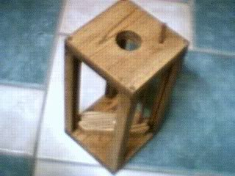

Fayma Callahan
- Don't Even Think About It!
- 
- Moderator

- 259 posts
- Gender:Female
- Location:Key West, Florida
Posted December 25, 2007 · Report post
The ones we got for Pirates in Paradise came from a company called the Maryland Sutler. They came in plain, unfinished and William Redwake and crew finished them at PiP. They came out beautifully, and the sutler (John) was very reasonable on price, even shipping some extra glass in case of breakage.

Dutchman
- Has anyone seen my cousin?
- Admin

- 1,773 posts
- Gender:Male
- Location:tidewater virginia
Posted June 25, 2008 · Report post
so anyone ever use one? the same guy that had the nav set on ebay also had a rush lantern- on a stiiiiiick- ( jeff dunham humor- sorry) anyhow. it was apparently used to light street lanterns or any thing high in the air. so has anyone used a rush candle or lantern. Looking at the few pictures i could find on line, they are an exposed flame. while i'm not wild about it exposed in a tent, has anyone ever put one in a lantern to see how it would do?

michaelsbagley
- Smells Like Wet Sheep
- Moderator

- 2,548 posts
- Gender:Male
- Location:Columbus, Ohio
- Interests:Mostly into GAoP, but starting to develop more Buccaneer era stuff for re-enacting as well. Generally I do re-enact both piratical/nautical and other impressions from the period. I am focusing on more "common" impressions from the period (i.e. average sailor/pirate, rank and file Red Coat, early Colonial huntsman, etc.)
Posted June 26, 2008 · Report post
I haven't used this type of light for late period re-enacting.... But I have a lamp I forged for late Dark Age use.
It is open and without glass, so I never used it inside a tent, but I did use to light it and leave it a few paces from my tent (for safety) and it was sufficient light to find my way into my tent late at night. Remarkably enough, I have used both vegitable oils and bacon grease, and have found that the bacon grease gives the more steady light. I had to stop using it though as the bowl of the lamp is about 3 feet off the ground, and too often I was camping with groups that had small unruley children.
Hope this helps.

oderlesseye
- Scourge o' the 7 Seas
- Member

Posted July 5, 2011 (edited) · Report post
Question is>>>> were these use ship board too ?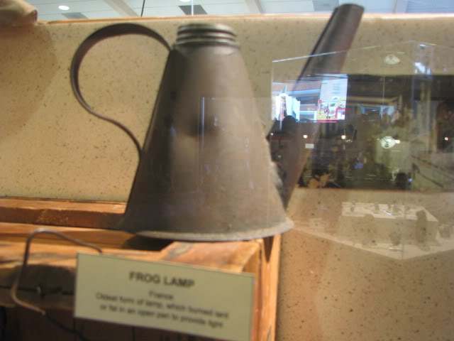?
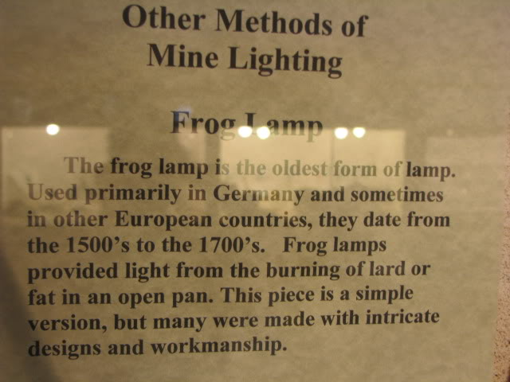
Edited July 5, 2011 by oderlesseye

Silver
- Plunderer
- Member

- 347 posts
- Gender:Male
- Location:Virginia Beach, Virginia
- Interests:Maritime history
Posted July 5, 2011 · Report post
has anyone ever seen what is known as a gunners dark lantern. used to keep the slow match lighted, i think?

Dutchman
- Has anyone seen my cousin?
- Admin

- 1,773 posts
- Gender:Male
- Location:tidewater virginia
Posted July 5, 2011 · Report post
i have heard of them, but not seen one. would it be similar to a grenadeers lantern? tinpunch i believe.

Silver
- Plunderer
- Member

- 347 posts
- Gender:Male
- Location:Virginia Beach, Virginia
- Interests:Maritime history
Posted July 6, 2011 · Report post
found a web site that had dark lanterns shown on it, but they are from the early 1900's. it states that a dark lantern is a lantern that is used for light but is fitted with a shading device that will allow you to cover the light (go dark) without blowing out the fire inside. so they are not for lighting slow matches. what would a gunner aboard a ship need this for?

Silver
- Plunderer
- Member

- 347 posts
- Gender:Male
- Location:Virginia Beach, Virginia
- Interests:Maritime history
Posted July 7, 2011 · Report post
the frog lamp looks like it would burn with an open flame?

Cascabel
- Evil Drooling Henchman
- 
- Moderator

- 848 posts
- Gender:Male
Posted July 7, 2011 · Report post
On 7/5/2011 at 6:56 PM, oderlesseye said:
Question is>>>> were these use ship board too ??
The picture shows what appears to be something to pour liquids from, yet the description sounds more like what is usually called a "Betty Lamp".
>>>>> Cascabel

Capt. Bo of the WTF co.
- Scourge o' the 7 Seas
- 
- Member

- 2,339 posts
- Gender:Male
- Location:Spanish Louisiana - on the river Osage
- Interests:Many and varied.
Posted July 7, 2011 · Report post
FWIW I checked this site to see if it would turn up anything:
http://www.british-history.ac.uk/source.aspx?pubid=739
I found nothing about "frog lamps" in any searches, other than modern lamps with frog motif.
I'd say that this museum/site needs to do more research. Germany wasn't even Germany in the 1500s-1700s, and why would anyone make a fancy highly decorated lamp to work in a mine? That's why we have to be careful about accepting the descriptions found in museum cases at face value. I don't doubt that it could be some kind of betty-lamp, but the rest of the information is suspect. I could be wrong, but my sentiment is this place has got the wrong information on this piece of equiptment.
Bo

Jas. Hook
- Scourge o' the 7 Seas
- 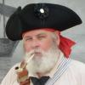
- Member

- 1,650 posts
- Gender:Male
- Location:Long Island NY
- Interests:Fishing & Piracy
Posted July 7, 2011 · Report post
On 7/6/2011 at 5:02 PM, L. Silver said:
found a web site that had dark lanterns shown on it, but they are from the early 1900's. it states that a dark lantern is a lantern that is used for light but is fitted with a shading device that will allow you to cover the light (go dark) without blowing out the fire inside. so they are not for lighting slow matches. what would a gunner aboard a ship need this for?
Dark lanterns I've read about were being used in small craft during cutting out raids against an enemy ships or positions. Used as a shielded or shuttered light source for signals, taking compass bearings, light fuses, etc. No MiniMag lights or Zippo lighters then.
Jas. Hook

Silver
- Plunderer
- Member

- 347 posts
- Gender:Male
- Location:Virginia Beach, Virginia
- Interests:Maritime history
Posted July 7, 2011 · Report post
the frog lantern- found a site where miner's lamps are shown this lamp is like what we call the tea pot lamp which is a oil burning lamp made in the 1860's for mining, the tea pot had a hook that allowed the lamp to be fastened on the front of the hat. as far a using oil and open flame for lighting aboard wooden sailing ships "fire hazzard" comes to mind. anyone got any doc. on prefered 17th century shipboard lighting? i vote for candles.

Capt. Bo of the WTF co.
- Scourge o' the 7 Seas
- Member

- 2,339 posts
- Gender:Male
- Location:Spanish Louisiana - on the river Osage
- Interests:Many and varied.
Posted July 7, 2011 (edited) · Report post
I'm bored, it's raining AND hot, so I did a little more digging. I cannot translate but this has pictures:
http://www.museum-joanneum.at/upload/file/Geo7_10_Hiden_1_.pdf
Maybe this will help some, but I don't know about using them on ships.
*EDIT*
Then I found this site:
http://www.century-artifacts.com/securestore/c50991.2.html
...using "frog lamps used in european mines" as my search.
http://www.google.com/search?hl=en&source=hp&biw=1575&bih=980&q=frog+lamps+used+in+european+mines&btnG=Google+Search&oq=frog+lamps+used+in+european+mines&aq=f&aqi=&aql=undefined&gs_sm=s&gs_upl=2766l14047l0l14l14l0l0l0l2l1110l3907l5-2.2.1l5
Now we're getting somewhere.
Bo
Edited July 7, 2011 by Capt. Bo of the WTF co.

Capt. Bo of the WTF co.
- Scourge o' the 7 Seas
- Member

- 2,339 posts
- Gender:Male
- Location:Spanish Louisiana - on the river Osage
- Interests:Many and varied.
Posted July 7, 2011 · Report post
Well I did my best to try and find out if those lamps were ever used on ships, and the best I came up with is not likely. Nothing conclusive though. The only oil lamps that were shown to be used on ships are the later types with glass globes. The type shown in the original post is way past GAoP anyhow, and is not really a typical design for the "frog lamp", which is more like the "betty lamp" in design than the "pitcher" type. If they were to use an oil lamp aboard ship it would have to be suspended and kept free to move with the pitch and roll of the sea. That big base would work well on a table on land or on a pedestal in a mine, but common sense tells me not on a ship.
FWIW
Bo

Silver
- Plunderer
- Member

- 347 posts
- Gender:Male
- Location:Virginia Beach, Virginia
- Interests:Maritime history
Posted July 7, 2011 · Report post
good finds so the "frog" is actually a common oilwick lamp and the squatty little lamps are frogs. i have a small lamp like the frog, bought it oversea in turkey it is shaped like an arab slipper the wick at the toe. in the P.I. folks would use something like the oilwick lamp they made them from tin cans you could burn anything in them that the wick could draw up. i brought a couple back with me. good bug lamps. btw hitler is on page 183!

jendobyns
- Pyrate Captain
- 
- Member

- 562 posts
- Gender:Female
- Location:Baltimore
- Interests:too numerous to mention, really. Period foodways, baroque dance, material culture, etc., etc.
Posted July 7, 2011 · Report post
On 7/7/2011 at 4:59 PM, L. Silver said:
good finds so the "frog" is actually a common oilwick lamp and the squatty little lamps are frogs. i have a small lamp like the frog, bought it oversea in turkey it is shaped like an arab slipper the wick at the toe. in the P.I. folks would use something like the oilwick lamp they made them from tin cans you could burn anything in them that the wick could draw up. i brought a couple back with me. good bug lamps. btw hitler is on page 183!
The style you brought back from Turkey sounds like the really ancient type that is common there, you find them in Roman digs and other places as well. The label for the metal one in the original post was rather misleading, that isn't the particular style that is the oldest, but oil lamps that burn fat and oil are very ancient, like the style you have.
I have one that is more dish shaped, with a lip, and open. Burns olive oil quite nicely, although it smells kind of odd until you get used to it. The light it gives off is lovely. I think it is a 14C style. The 18C site where I volunteer has two, a betty lamp and a double cruzie lamp, which also burn oil. Very primitive style, but made of iron.
There is an organization, called the Rushlight Society, which is, or was, devoted to early lighting. They have publications that it might be worth reading if you can get them. If it makes light, they probably cover it.

oderlesseye
- Scourge o' the 7 Seas
- Member

- 2,126 posts
- Gender:Male
- Location:San Diego, Ca. (North Park) me cove !
- Interests:Oderlesseye is a mutinous two bit sand dollar with a thirst for adventure. Sailing on tall ships, firing black powder weapons, and sword fighting.. I most love to entertain the public in piratical skit presentations that involve all of the above. My name is befitting of my position on board as that of the look-out. Some ask what’s the meaning of the name Oderlesseye...It is simple really.. When Eye am aloft, ye can’t smell me...But it’s spelled wrong some exclaim! Hey now! What pirate can spell? - is my retort!
I have been an active member of the pirate community since 2005. I consider myself a fan of living history in the Golden Age of Piracy. As a child I , like the lot of ye, loved the old time pirate movies with Errol Flynn and Douglas Fairbanks. Long live Long John Silver !
Inspired by them, Eye created a Pirate Ninja Movie called "Treachery and a Dead Mans Promise" Available on YouTube.
Being a pirate, as it turns out, is multi-dimensional. For me, a lifestyle has been carved out of it. There is a six foot tall skeleton pirate in a make shift hide out called Dead Mans Cove behind my house. The walls are painted giving the impression you are in a sea cave. There is a mural of a pirate coming ashore in a long boat at the mouth of the cove. Believe me, it is a great place to enjoy rum now and again!
Exploration into all things piratical have led me to being an attempted escapee from the Governors noose to impersonating a judge in the Anne Bonnie and Mary Read trial held in Pirates In Paradise.. As Oderlesseye, my one on one impression to patrons is as one whom barley escaped the flames of the ship we took when the powder magazine blew with the booty in me hands from the Captains quarters.. The tale explains the soot on me face, the tattered clothing, and the burnt tricorn, as I hand out a gold coin or two. I hate them plastic ones and I know kids appreciate the metal coins even more so.
When an event is slated for a historical time line presentation to the public, I do not do these things mentioned above. Rather, I share about what is a grape shot or how a flintlock works. I ware clothing that is more closely representing the era in these cases. I am still updating me togs (Period Kit) as I learn more thru fellow pirates and sources like the Pyracy Pub.
So far, there have been many exciting moments of adventure the world of PIRACY has afforded me. From standing on a bar top with Pirates Charles singing to me in New Orleans to shooting cannons ( Ships Guns for you PC Pirates!), on the tall ship Spirit of Dana Point. Cheers from a crowd during a show as last man standing on the Treasure chest proclaiming to an excited crowd ITS MINE! THE BOOTY IS MINE ! YARR ! ~ These things and the notoriety that comes with being a pirate has me hooked! Whats More Is the greater bonds of friendships that have been forged with those whose course finds me at such events, sharing the same love and passion of the Life within the pirate/reenactment community. To Them Eye take me hat off and offer a tot of Rum! Cheers mates!
Posted July 8, 2011 · Report post
Thanx For all your input on this subject..Eye now have a broader perspective when it came to lighting..but on board a tall ship of the day? Wot was common and considered safe ?

Silver
- Plunderer
- Member

- 347 posts
- Gender:Male
- Location:Virginia Beach, Virginia
- Interests:Maritime history
Posted July 8, 2011 · Report post
that is a very good question? there where lanterns used about the ships, i can think of a few places i have found in my reads such as the big stern light called the "poop lantern" the light in the powder room, the helmsman light in the binnacle, the captain, surgeon and navigator had lighting, the gunner(dark lantern) someone going below deck into the hold. and of course the smoking lamp.

Capt. Bo of the WTF co.
- Scourge o' the 7 Seas
- Member

- 2,339 posts
- Gender:Male
- Location:Spanish Louisiana - on the river Osage
- Interests:Many and varied.
Posted July 8, 2011 · Report post
Don't ave time today to browse all the wreck stuff, but heres a link to a site where you can see what has been recovered from different wrecks. Maybe some clues here:
http://www.oceantreasures.org/rubrique,famous-wrecks,1070488.html
You might also look into the threads in the shipyard forum on Whydah, the LaBelle, and there's another "stickied" there as well. Gotta go back to mowing and cutting trails.
Bo

MarkG
- Pyrate Captain
- 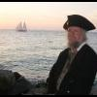
- Member

- 587 posts
- Location:Ohio
Posted July 9, 2011 · Report post
On 7/7/2011 at 0:02 PM, L. Silver said:
the frog lantern- found a site where miner's lamps are shown this lamp is like what we call the tea pot lamp which is a oil burning lamp made in the 1860's for mining, the tea pot had a hook that allowed the lamp to be fastened on the front of the hat. as far a using oil and open flame for lighting aboard wooden sailing ships "fire hazzard" comes to mind. anyone got any doc. on prefered 17th century shipboard lighting? i vote for candles.
Candles were expensive in the 17th century and they take up a lot of space. Ships usually used oil lamps. As far as I can tell, these were short with a wide base and a wick on the top.
Very few lights were allowed on a ship. Typically the only lights would be a running light in a lantern hung from the stern, a light for the captain and/or navigator to use, a light in the binnacle, and, possibly, a single light below decks. Even four lights constituted a fire hazard and many ships burned.

Silver
- Plunderer
- Member

- 347 posts
- Gender:Male
- Location:Virginia Beach, Virginia
- Interests:Maritime history
Posted July 10, 2011 · Report post
i have a book by robinson and dow "sailing ships of new england" i pulled it off the shelve and found the inventory done on march 16 1703 of ship PROVIDENCE GALLEY 90 tons in the listing is "three poop lights" "three lanthorns" i look for oil or candles none listed.

Silver
- Plunderer
- Member

- 347 posts
- Gender:Male
- Location:Virginia Beach, Virginia
- Interests:Maritime history
Posted July 11, 2011 · Report post
did some digging through my pirate library and have come up with some quotes where lighting is addressed: 1- articals of the ship "revenge" capt. J. Phillips 1723, VI. the man that snaps his arms, or smokes tobacco in the hold, without a cap to his pipe, or carry a candle lighted without a lanthorn, shall suffer the same punishment as in the former article. (40stripes lacking 1 on the bare back). 2- articals of the "royal fortune" capt. Robert's 1720 IV. the lights and candles to be put out at eight a-clock at night: if any of the crew, after that hour , still remained inclined for drinking, they were to do it on the open deck. 3- "the sea gunner" J. sellers 1691- art of gunnery pg162- lanthorns, muscovia-lights (means the openings in the lanthorns are covered by mica sheets allowing the light to come through)with a large bottom to put water in, to prevent danger from sparks of the candle flying upon the powder dust that may get into the lanthorn. i tried to find oil but could not as of now.

Capt. Bo of the WTF co.
- Scourge o' the 7 Seas
- Member

- 2,339 posts
- Gender:Male
- Location:Spanish Louisiana - on the river Osage
- Interests:Many and varied.
Posted July 11, 2011 · Report post
Tallow candles were less expensive and far more common than expensive wax ones, and the cost of operating a ship, (including providing lighting), was one reason why there were few people that could afford to invest in shipping. Oil for lamps is also very expensive and far more dangerous than candles, as candles don't spill and create a huge flammable area.
Bo

silas thatcher
- Notorious Pyrate
- 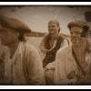
- Member

- 774 posts
- Location:st. louis, mo.
- Interests:probably too many interests :) old vw's, sailing, photography, home improvements, and lots more ;)
Posted April 15, 2012 · Report post
during the gaop, they had candle lanterns as well as oil lanterns...my question is which type was used aboard ship and why ?? i am gonna take a semi educated guess that oil type lanterns ( may have been animal fat type ) were not used due to the fire hazard they posed if spilled...
does anyone have any info on this ??

Silver
- Plunderer
- Member

- 347 posts
- Gender:Male
- Location:Virginia Beach, Virginia
- Interests:Maritime history
Posted April 15, 2012 · Report post
that came up awhile back, search twill "frog lanterns" july 5th 2011.

Mission
- Goat Specialist
- 
- Admin

- 5,081 posts
- Gender:Male
- Location:Monroe, MI
- Interests:Scholarly piracy, designing and creating haunted house rooms and props, movies, abstract thinking, abstruse thinking, obstructive thinking, ideating, random thinking, movies, cartoons, movies, movies scores, cycling, world peace and small furry dogs, movies, writing, drawing, personal skills training, gremlins and, of course, lest I forget, movies.
Posted April 15, 2012 · Report post
After looking at them and the lack of recent postings, I decided to combine these four threads due to the similarity in topic. The comments below are here for posterity or something.
________________
There were several threads on the topic. The two most actively discussed were:
frog lanterns
and
Things that go *Thud* Arrr! Dammit!" in the Night
The second thread seems to contain a little bit more information than the first, but both will be of interest to your question, Silas.
After looking into these, I am really considering combining all these with some of the lesser-discussed threads on the topic with a better title like this thread has. It is an interesting question as to whether such a thread belongs here or in Twill. I was charged with moving all the old Twill threads the fit better in this forum and at the time it seemed like a detail to me, so not really a topic for this forum. Lanterns have wider use than just being on the ship, after all.
Some of the other threads (which are not nearly as helpful as those other two threads) are:
rush candles/lanterns
lanterns

IvanHenry
- Deck Swabber
- 
- 
- Member

- 44 posts
Posted April 17, 2012 · Report post
As per the norm - I have a gallery on lanterns... :-)
http://www.ivanhenry.com/extras/16th_17th_18th_century_lantern.html

landlubbersanonymous
- Plunderer
- 
- Member

- 354 posts
- Gender:Not Telling
- Location:California, USA
- Interests:History, arts, collecting, reenacting
Posted June 20, 2012 (edited) · Report post
A decent article on period lighting...
http://clanntartan.s...l/lighting.html
Have not done business with these folks before but product looks good...
http://www.twojs.me.uk/Lanterns.htm
Interesting electric alternative where fire isn't allowed or practical...
http://www.oocities....ern/lantern.htm
Edited June 20, 2012 by landlubbersanonymous

Mission
- Goat Specialist
- Admin

- 5,081 posts
- Gender:Male
- Location:Monroe, MI
- Interests:Scholarly piracy, designing and creating haunted house rooms and props, movies, abstract thinking, abstruse thinking, obstructive thinking, ideating, random thinking, movies, cartoons, movies, movies scores, cycling, world peace and small furry dogs, movies, writing, drawing, personal skills training, gremlins and, of course, lest I forget, movies.
Posted October 23, 2015 · Report post
I found some artwork showing period lanterns on wikimedia, so I thought I'd store then in here for those searching for images.
Stilleben mit Küchenutensilien, by Martin Dichtl (before 1710):
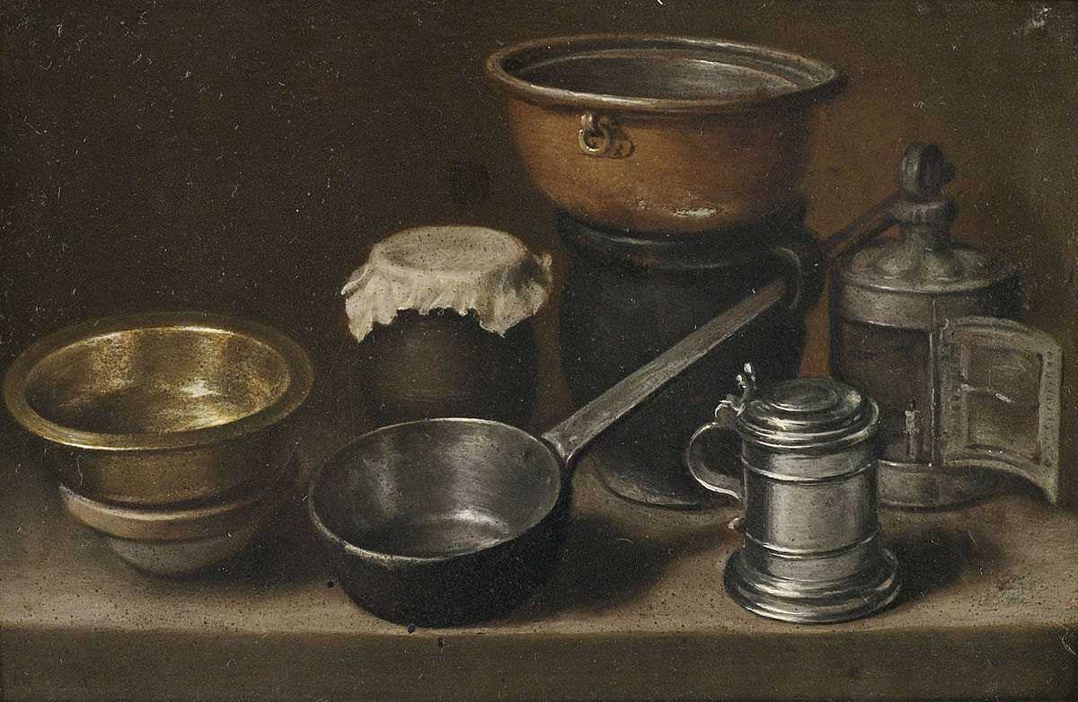
A supposed ship's lantern dating to 1720, from American home and garden magazine, July, 1913.
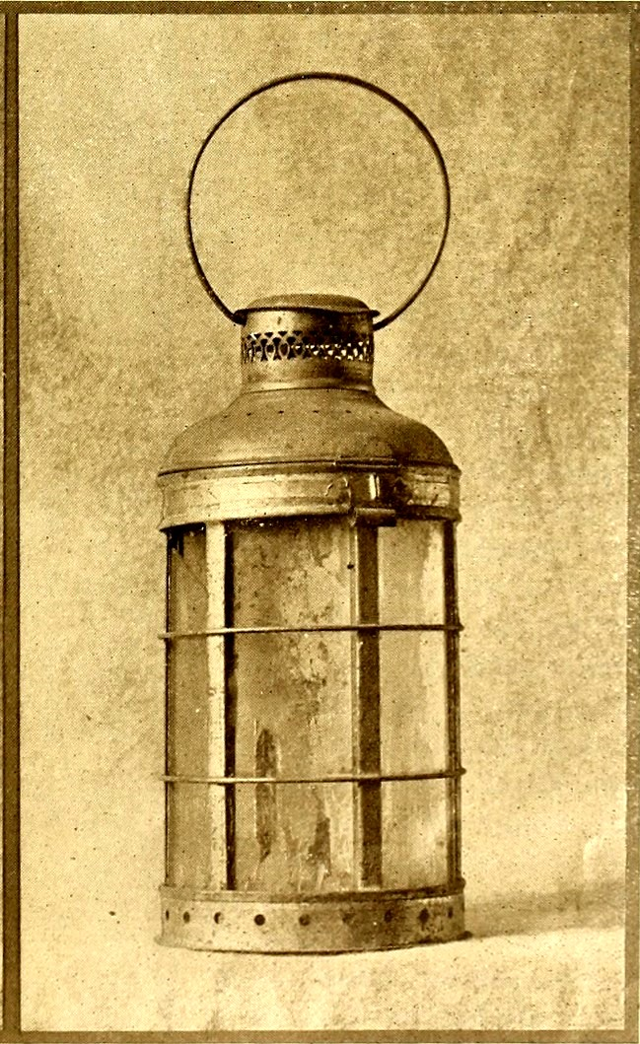
Dentist by Candlelight, Gerrit Dou, c. 1660-65:
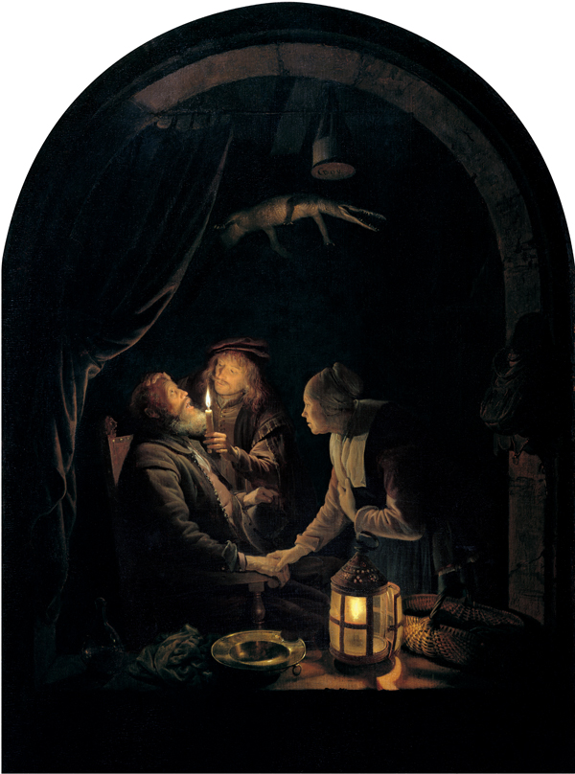
Loss of HMS Victory, 4 October 1744, Peter Monomy, (between 1744 and 1749):
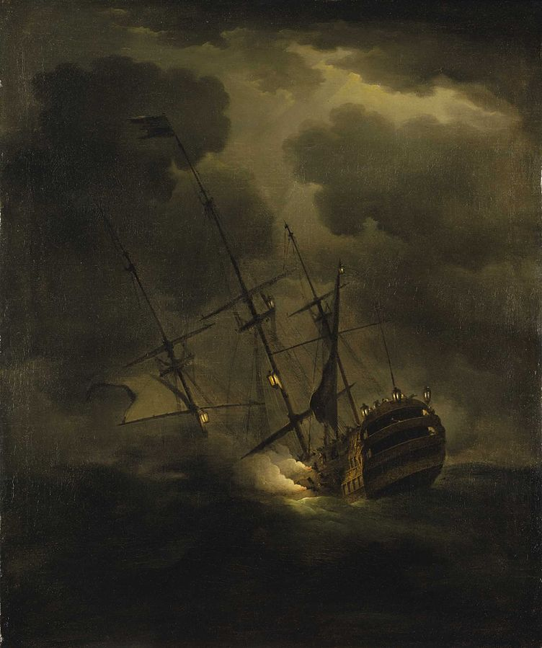

William Brand
- Mercury Malefactor
- Admin

- 8,884 posts
- Gender:Male
- Location:Logan, Utah
- Interests:My name is William Pace and I live and work as a graphic designer, illustrator and photographer in Northern Utah. I'm married to the lovely Tracy Pace and we have three children. In addition to all things art, I enjoy traveling and meeting new people from every walk of life. I've always been a fan of history, theology, and of course, Pyracy.
http://www.youtube.com/watch?v=PSkt-q-HihQ
Posted November 30, 2015 · Report post
Thanks for adding more and more variations to this thread. I wish we had more period lanterns availably commercially.

Swashbuckler 1700
- Dread Pyrate
- 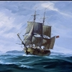
- Member

- 1,115 posts
- Gender:Male
- Location:Europe
- Interests:pyrates, pryvateers, naval military and other history, different books, good movies, music (a little bit), drawing, games,...
Posted December 1, 2015 (edited) · Report post
About lantern, if looking to ship's lantern rather than the type carried by hand, it seems different nation's vessel had different styles. These are lanterns for ship's stern.
(Remove this if this picture was already posted somewhere here. I didn't see it.)
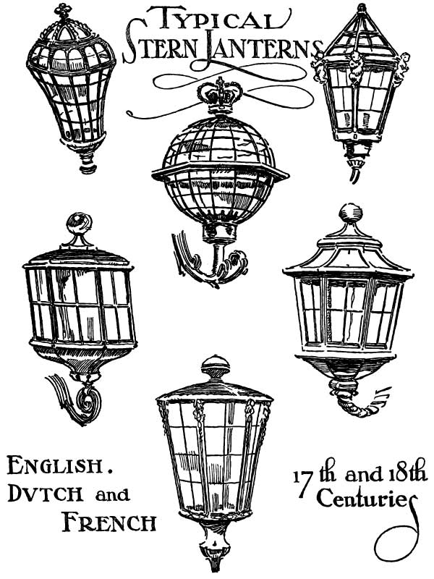
Edited December 1, 2015 by Swashbuckler 1700

sea haugh
- Deck Swabber
- Member

- 32 posts
- Gender:Male
- Location:united kingdom
- Interests:18th century pirates is my interest and as usual interested in learning more.
Posted January 30 · Report post
On 7/11/2011 at 7:42 PM, Capt. Bo of the WTF co. said:
Tallow candles were less expensive and far more common than expensive wax ones, and the cost of operating a ship, (including providing lighting), was one reason why there were few people that could afford to invest in shipping. Oil for lamps is also very expensive and far more dangerous than candles, as candles don't spill and create a huge flammable area.
Bo
Hi, I have a rather odd question in concerns of tallow candles....
are there any instances or records covering the tallow of humans within piracy?
also this....
Tallow Candles or Song of a Doomed Man
Tallow Candles or Song of a Doomed Man
from the singing of Jacqui & Bridie
I have tallow candles white, hanging high, hanging high
I have tallow candles white, hanging high
I have tallow candles white, and I stole them all by night
And my life shall pay for all, when I die, when I die
And my life shall pay for all, when I die
I have twenty ox in store, that's no joke...
...and I aimed for twenty more
And my life shall pay for all...
I went up the Tyburn Hill, in a cart...
...and twas there I made my will
And my life...
I climb'ed up the ladder by a rope...
...then the hangman pulled the rope
And twas never a word I spoke, coming down...
Take a warning all by me, that's no lie...
... for to shun bad company
Or your life...

