Sjöröveren
- Plunderer
- 
- 
- Member

- 457 posts
- Location:Minnesota, Land of 10,000 Lakes and 1 mini-ocean
- Interests:Re-enactment, gradually working my way back from the 19th Century. I figure I'm in about 1700 right now. I specialize in the history of medicine. I like maps, and the general history of geography and geodesy. <br />And in case you're wondering, "Sjöröveren" is Swedish for "the sea rover." And it's supposed to be spelled "Sjörövaren" but I guess it's too late for that!
Posted January 17, 2004 · Report post
I'm looking to hook up with anyone else interested in the subject of ship's surgeons. I've been in re-enactment for some time now, and usually portray physicians or surgeons from about 1700-1880, depending on who's paying me. But I've always been land-locked. I've become more and more interested in sea-faring things, thanks mostly to my wife Red Bess, who also lurks about these parts.
Any other sawbones and leech doctors about?

Capt Grey
- Wicked Costumes & Lost at Sea
- 
- 
- Member

- 1,114 posts
- Gender:Male
Posted January 18, 2004 · Report post
I was thinking about doing that too; although being female would automatically make it non-historical.
I had the opportunity to tour the ship from the movie "Master and Commander" and one of the displays was of the doctor's cabin. He had many of his medicines in vials in a pouch, for easy transport I suppose.
I also did a few searches for medicine in the 18th century to see what the knowledge was at the time.

capnwilliam
- Lost at Sea
- 
- Member

- 1,287 posts
- Gender:Male
Posted January 18, 2004 · Report post
Speaking of leeches; did you know they are still used in modern medicine? They are used to suck out blood to prevent, e.g., a cauliflower ear from developing.
At the Pharmacy Museum here in New Orleans they keep a live one on display. Though he's not at work.
Capt. William

Bootstrap Bill Turner
- Bilge Rat
- 
- 
- Member

- 17 posts
- Interests:http://www.panhistoria.com/Stacks/Novels/Character_Homes/home.php?CharID=14689
Posted January 18, 2004 · Report post
From the way I understand it, if you're a surgeon/barber-surgeon and want to be a ship's surgeon all you need to do is walk on the boat! Most physicians didn't become ship surgeons because A- they had to touch people, B- the pay stinks and private practice pays better (except on a pirate ship where you're valued) and C- It wasn't an elevated position.
If you were with the Royal Navy or the East India Company you would be supplied with a Ship's surgeon's chest and plaster box which contained 270+ medicines as well as surgeon tools. Generally you'd have done your 7 year barber-surgeon apprenticeship then gone into the Navy or into practice. Most navy surgeons had no experience. Not sure how you got into EI co.
Hope this helps.
PS they're starting to use leeches again but not in bloodletting. (Although I'm sure some new agers are) but in surgeries in tiny places the surgeons cant reach.

Matty Bottles
- Notorious Pyrate
- 
- 
- Member

- 891 posts
- Gender:Male
- Location:Milwaukee, WI
- Interests:Writing, Art, Spending exorbinant amounts of money on action figures, rum, murder.
Posted January 19, 2004 · Report post
The Sutler of Mount Misery, G. Gedney Godwin, offers 18th century medical instruments.
http://www.gggodwin.com/

Wartooth
- Ship's Master
- 
- 
- Member

- 119 posts
- Location:Dusty & Boring Reno, Nevada
- Interests:My wife and 3 sons, of course. My Welsh & Dutch heritage, including the substantial privateering and roguish ancestry therein. Martial sword work focusing on longsword, short sword, rapier, and baskethilt saber.
Posted January 19, 2004 · Report post
This whole subject is givin' me the shivers! I'll need another few shots o' rum afore I let any o' you ghouls cut into me.
YIKE!!!
Wartooth

capnwilliam
- Lost at Sea
- Member

- 1,287 posts
- Gender:Male
Posted January 19, 2004 · Report post
Thanks fer the Godwin site, Bloody Jack! Lots of great stuff there; sorry I saw it!
There was a bloke at the Battle of New Orleans reenactment a few years ago who had a great display of period medical instruments. I'd pictured him painstakingly accumulating antiques, over the years. Now I wonder if he didn't just buy the whole shebang from Godwin's?
Capt. William

Matty Bottles
- Notorious Pyrate
- Member

- 891 posts
- Gender:Male
- Location:Milwaukee, WI
- Interests:Writing, Art, Spending exorbinant amounts of money on action figures, rum, murder.
Posted January 19, 2004 · Report post
Did ye check out the swords from Godwin? That's how I ran across them. Not the biggest selection, but reasonably priced alternatives to the standard pirate blade. Of course, I have yet to get a decent pirate blade, much less alternatives, so i can't attest to their quality. perhaps someone else has used their blades?

Red Maria
- Dread Pyrate
- Member

- 1,057 posts
Posted January 19, 2004 · Report post
Capt Grey said:
I was thinking about doing that too; although being female would automatically make it non-historical.
I had the opportunity to tour the ship from the movie "Master and Commander" and one of the displays was of the doctor's cabin. He had many of his medicines in vials in a pouch, for easy transport I suppose.
I also did a few searches for medicine in the 18th century to see what the knowledge was at the time.
Capt Grey
Not necessarily. Women were trained as surgeons up till the 1820 or so when surgical colleges first appeared. Some even had eccleastical liencese and practiced leagally. I have even found one women in Portsmouth Engalnd who had a licence in both surgery and physick (medcine) named Mary Rose. Her practice was restricted to in port Naval personell so she never as far as I know set foot on a ship. I have a pesona with another pirate crew partially based on Mary Rose except my charecter did set sail on a ship. It wasn't easy for a woman to train as a surgeon but it was possible. I have somewhere and article about feamle surgeons from the Middle Ages to the 19th century. I'll try and dig it up.

Red Maria
- Dread Pyrate
- Member

- 1,057 posts
Posted January 19, 2004 · Report post
Found it! the title is: "The Surgeoness: The Female Practitioner of Surgery, 1400-1800" by A.L. Wyman in the periodical "Medical History" v.28, 1984 pgs.22-41. If anyone wants a copy I will photocopy it for the price of the copies plus postage. :)
There is also a book the titled "Health, Medicine, & Mortality in the Sixteenth Century" Charles Webster editor. There is a good essay in there about education and training of various types of medical practioners in Britian during the 16th c. While earlier than Golden Age of Piracy many things stilled appiled then as they did later. I am trying to track it down to get the essay. My copy is packed away and in storage.

Sjöröveren
- Plunderer
- Member

- 457 posts
- Location:Minnesota, Land of 10,000 Lakes and 1 mini-ocean
- Interests:Re-enactment, gradually working my way back from the 19th Century. I figure I'm in about 1700 right now. I specialize in the history of medicine. I like maps, and the general history of geography and geodesy. <br />And in case you're wondering, "Sjöröveren" is Swedish for "the sea rover." And it's supposed to be spelled "Sjörövaren" but I guess it's too late for that!
Posted January 19, 2004 · Report post
Bootstrap Bill Turner said:
Most physicians didn't become ship surgeons because A- they had to touch people, B- the pay stinks and private practice pays better (except on a pirate ship where you're valued) and C- It wasn't an elevated position.
PS they're starting to use leeches again but not in bloodletting. (Although I'm sure some new agers are) but in surgeries in tiny places the surgeons cant reach.
Yes, surgery was considered to be a distinct profession from physic (doling out medicine, hence the title physician) Surgeons were much further down the status ladder from physicians. To this day, if a Physician in the UK specializes in surgery, he/she loses the title "Doctor" and reverts to Mr, Mrs or Miss. They don't suffer the same drop in status or income, however.
I understand ship's surgeons to be warrant officers, i.e. entitle to the same benefits and respect due an officer, but was not a proper member of the Navy. A warrant officer was also accorded the right to board and disembark the ship as he pleased, subject to Captain's approval. On board a pirate ship, however, who knows how a surgeon fit into the hierarchy. I haven't come across any factual accounts of such a situation.
I've heard of leeches being used today in reattachment of severs bits -- fingers, ears, etc. They secrete a natural anticoagulant, and this keeps the blood in the severed bit from clotting.

hitman
- Pyrate Captain
- 
- 
- Member

- 720 posts
- Gender:Male
- Location:Sardis Ga
- Interests:women, booze,books,tobacco,tall ships.hot rods and other monstrocities
Posted January 20, 2004 · Report post
My primary way of studing history has to date always been to come to a mean understanding as I have yet to get involved in reinacting(working on it though) I haven't made the detailed study of specific periods that has been done by several others here, however I have come across several more general ideas about medicine from the general time frame and wonder if anone could set about correcting any flaws in them?
1 Medical knowledge in the middle east was at least in terms of infection more advanced than that of the west through out this time frame.
2 The massive number of ambutations performed by surgeons of this time period were not neccasarily due to a lack of knowledge as the wonds recived by a large slow moving ball were much more devistating to bone than today's lighter higher velocity rounds..... my refrence on this is civil war era but the same would concevably hold true for earlier fire arms as they for the most part were very heavy by todays standard and moved at much slower velocities.

endkaos
- First Mate
- 
- 
- Member

- 231 posts
- Location:Arizona
- Interests:Pirates, Ghosts and Sailing. Mother to three rowdy boys.
Posted January 20, 2004 · Report post
Red Maria said:
Found it! the title is: "The Surgeoness: The Female Practitioner of Surgery, 1400-1800" by A.L. Wyman in the periodical "Medical History" v.28, 1984 pgs.22-41. If anyone wants a copy I will photocopy it for the price of the copies plus postage. :)
Red Maria,
I sent you an email. I am interested in getting a copy. :)

Red Maria
- Dread Pyrate
- Member

- 1,057 posts
Posted January 21, 2004 · Report post
I found this intersting bit in "Pirates: Myths &Realities" by Robert C. Ritchie:
"There were two groups who did not share in the contract (articles)... Physcians were also forced o board to watch over the men's health. Once on board the experts had to make their mind up about their future. If they freely joined the crew & shared in the booty they could go home without risk of being jailed for piracy. However if the man wanted to return home, he got his comrades on board to his old ship to report to hios family and the authorities that he had been siezed against his will. Some went so far as to get a certificate from the pirates attesting to their innocence. ... If the ship had a physician he might get more than a share ..."
Sometimes it was a share and a half.
"These actions might thwart leagal charges when they returned home, but the law was unforgiving if the kidnapped person ever particapted in sharing the booty. Possesion of stolen goods automatically brought a charge of piracy"
I guess it was hard to have your cake and eat it too. Medical personell did serve aboard pirate ships. Sometimes willingly, sometimes not.

capnwilliam
- Lost at Sea
- Member

- 1,287 posts
- Gender:Male
Posted January 23, 2004 · Report post
Aye, Maria: it's hard to share the wealth, and play the innocent! In one of the stories in CAPTURED BY PIRATES, the freebooters have taken a liking to the captain of the vessel they've captured, and want to give him a share of their pillage. He can't seem to convinvce them that for him to accept same would be a moral and legal wrong. They just regard his rebuffs as ingratitude!
This whole pirate surgeon thread is very interesting. I've not really thought out a coherent pirate persona. Maybe a ship's surgeon or doctor could be the way to go. Of course, I know virtually noting about medicine in real life; which might add to my persona's authenticity!
Capt. William

Sjöröveren
- Plunderer
- Member

- 457 posts
- Location:Minnesota, Land of 10,000 Lakes and 1 mini-ocean
- Interests:Re-enactment, gradually working my way back from the 19th Century. I figure I'm in about 1700 right now. I specialize in the history of medicine. I like maps, and the general history of geography and geodesy. <br />And in case you're wondering, "Sjöröveren" is Swedish for "the sea rover." And it's supposed to be spelled "Sjörövaren" but I guess it's too late for that!
Posted January 23, 2004 · Report post
Bloody Jack Madd said:
The Sutler of Mount Misery, G. Gedney Godwin, offers 18th century medical instruments.
http://www.gggodwin.com/
G. Gedney Godwin has, IMHO, the best medical supplies for the reenactor available anywhere. Their prices can be a bit on the high side, however, which has earned them the nickname, in some circles, of "Oh My Godwin." Worth every penny though.
:)

Red Maria
- Dread Pyrate
- Member

- 1,057 posts
Posted January 23, 2004 · Report post
Right now Iam reading an article titled "Pratical Medicine & the Britsh Armed Forces After the Glorious Revolution" by Harold J. Cook "Medical History" v.34:1, pg. 1-26. It's about reforms in army & naval medicine under William & Mary (mostly by William III). William III sought improvments in the standard of medical care soilders & sailors received. One of his counselors even proposed to impress memeber of the College of Barber-Surgeons! The Barber-Surgeons were not impressed
There is some bits that men went into the armed force as surgeon's assistants to learn the trade and avoid havig to deal with the politics of the College of Barber Surgeons. They could attain the title of Surgeon and still leagally practice after serving duty because of "an Act of 1698 that allowed all discharged "soilder" to practice their trade regardless of guild rules." (afroementioned article pg. 8).
So you play someone who joined the navy at one time to learn surgery on the job, did so and then ended up on a pirate ship.

hitman
- Pyrate Captain
- Member

- 720 posts
- Gender:Male
- Location:Sardis Ga
- Interests:women, booze,books,tobacco,tall ships.hot rods and other monstrocities
Posted January 24, 2004 · Report post
Aye capnwilliam sounds like a real 17th century doc already

capnwilliam
- Lost at Sea
- Member

- 1,287 posts
- Gender:Male
Posted January 24, 2004 · Report post
Now, why do you say that, Hitman? Because I know about the medicinal use of leeches? Or, because that's about all that I DO know about medicine!
Capt. William

hitman
- Pyrate Captain
- Member

- 720 posts
- Gender:Male
- Location:Sardis Ga
- Interests:women, booze,books,tobacco,tall ships.hot rods and other monstrocities
Posted January 26, 2004 · Report post
A little of both mate but more of the latter than the former. As a side note from the reading I hve done from this period it looks like there were some pretty smart people acting as doc.'s around about this time just none of em wanted to be aboard ship longer than it took to cross the channel.

capnwilliam
- Lost at Sea
- Member

- 1,287 posts
- Gender:Male
Posted January 26, 2004 · Report post
I really think that this ship's surgeon angle has real potential for me old self; I could portray a "forced" doctor who comes to love life on the account. :)
Capt. William

Red Maria
- Dread Pyrate
- Member

- 1,057 posts
Posted January 27, 2004 · Report post
I just remembered there was a dcotor who was also a pirate (well actually privateer) captain, Thomas Dover of Dover's Powder fame. He was captain of the Bachelor Frigate under Woodes Rogers. He was one of the people who found Alexander Selkirk on Juan Fernandez Island.
He was also known as "the Quick-silver Doctor" for proscribing metallic mercury fro just about everything! :)

Desert Pyrate
- Plunderer
- Member

- 377 posts
Posted January 27, 2004 · Report post
I've always thought reenacting a surgeon would be fun. I've got a Wilderness First Responder license, meaning I know about the right amount o' medicine to convincingly be one...

Dorian Lasseter
- Where's My Water
- 
- 
- Member

- 3,266 posts
- Gender:Male
- Location:The Sea!
- Interests:18th Century reenactment; Maritime, F&I...
Did ECW as well...
All BP firelocks and cannons!
Also enjoy Swordfighting and a good Donnybrook
Got a question for or about me? Ask!!!
Posted January 28, 2004 · Report post
Aye,
Re-enacting a surgeon could be fun. Many years ago at an English Civil War re-enactment, we had a Lad doin' that.... he got one of our unit members ta play along with him...
We did a battle fer th' public, and this lad got "hit" by a musketball in th' shoulder, I believe he had a blood squib ta make it look real. So a few of the other lads dragged him off the battlefield, and over to th' Doc.... Who performed field side surgery on him... got out his probes, wiped away some blood, "removed" the musketball, and then cauterized the wound, he had a hot iron from a fire, and a small wet sponge in his hand, made a nice sizzling sound.... Hehehehe.... I think one o' the public onlookers almost fainted... It was grande!!!!
Hawkyns, ya remember this? down at Bacon's Castle, oh, so many years ago.....

Matty Bottles
- Notorious Pyrate
- Member

- 891 posts
- Gender:Male
- Location:Milwaukee, WI
- Interests:Writing, Art, Spending exorbinant amounts of money on action figures, rum, murder.
Posted January 28, 2004 · Report post
That sound great! Certain things I do I do for the most realism possible (Airsoft, anyone?) and that battlefield surgery sound just fantastic. It reminds me of advanced wound rules for skirmishes: Every player randomly selects an envelope, and if they are hit they open the envelope to see what their wound is. Then the medic, who has a dressing for every wound card, has to dress the player on the spot. There are movement limits, minimum surgery times - all this to heighten the realism.

Calico Jack
- Ship's Master
- 
- Member

- 126 posts
- Location:Port o' Halifax, New Scotland...
Posted January 28, 2004 · Report post
Alas,
Most of my Ship's doctorin' [well, no degree or high-and-fancy hands-off stuff for me, so surgeon and sawbones it is, lower pay despite] is tailored to the 1812, rather than the golden age of piracy. The Bloody Apron is an interpretive heritage program at the Maritime Museum where I am lucky enough to sometime find employment, and I've the honour of aiming to do said program justice.
Splinters and mercury, splinters and mercury.
For the piratically-minded, there was a decent article in a past No Quarter Given [likely already mentioned by one of these scurrulous dogs].
Always willing to compare notes [ CalicoJack@pyracy.com ], and best of luck to you in said endeavours.

capnwilliam
- Lost at Sea
- Member

- 1,287 posts
- Gender:Male
Posted January 28, 2004 · Report post
That was a great reenactment idea, Dorian! :)
Calico Jack, the 1815 period is mine also - well, I'm just getting started, but I'm doing the Battle of New Orleans; am also interested in Nelson's period (the Battle of Trafalgar's 200th anniversary is coming up in October 2005).
Capt. William

Calico Jack
- Ship's Master
- Member

- 126 posts
- Location:Port o' Halifax, New Scotland...
Posted January 29, 2004 · Report post
Dorian Lasseter said:
performed field side surgery on him... got out his probes, wiped away some blood, "removed" the musketball, and then cauterized the wound, he had a hot iron from a fire, and a small wet sponge in his hand, made a nice sizzling sound....
Of course, aboard ship your most likely work for the surgeon after an engagement is either Splinters [yes, splinters, but often a couple of feet long and jagged], or else crushing damage from falls or tumbled gear. As such, with few 'clean' wounds, amputation was generally the rule. And infection? That's how you knew the cure was working - in any wound, what we would call infection was generally seen as an important part of the healing process...
... and of course 'Wind of the Ball.' Few cannon balls actually ever _hit_ anyone, but if one passed within a couple of feet of you, you would likely die of wind of the ball [internal hemorraging], unless it was closest to your head...
... and lets not forget the cure-all properties [or near abouts] of Mercury. That surgeon's chest mentioned above, often near forty of those two hundred odd medications were variations of Mercury, recommended for most ailments.
You could tell the mercury was starting to have the desired effect when the patient began to frequently and copiously _drool_...
Ah, medication in 1812.
And to think at the Shannon and the Chesapeake, the surgeon in the _winning_ vessel had roughly 8 casualties per minute dragged down to his tiny arena below decks.
No wonder doctors looked down on the smelly, bloody, dirty surgeon.

Sjöröveren
- Plunderer
- Member

- 457 posts
- Location:Minnesota, Land of 10,000 Lakes and 1 mini-ocean
- Interests:Re-enactment, gradually working my way back from the 19th Century. I figure I'm in about 1700 right now. I specialize in the history of medicine. I like maps, and the general history of geography and geodesy. <br />And in case you're wondering, "Sjöröveren" is Swedish for "the sea rover." And it's supposed to be spelled "Sjörövaren" but I guess it's too late for that!
Posted January 30, 2004 · Report post
Calico Jack said:
... and lets not forget the cure-all properties [or near abouts] of Mercury. That surgeon's chest mentioned above, often near forty of those two hundred odd medications were variations of Mercury, recommended for most ailments.
You could tell the mercury was starting to have the desired effect when the patient began to frequently and copiously _drool_...
All kinds of poisons used in physick, because they reduced symptoms or produced "results" i.e. vomiting, diarrhea, coughing, etc. Lead and mercury were probably the most common. Calomel was used as an analgesic well into the 20th century. It's on oxide of mercury, now used mostly as flux when soldering electronic components.
One of the more common uses for mercury was for treatment of syphillis. It was injected directly into the business end of the male member, (and presumedly the corresponding female portal) with at least one daily dose over the course of a week. This gave rise to the old expression "One night on Venus, one week on Mercury."

Capt Grey
- Wicked Costumes & Lost at Sea
- Member

- 1,114 posts
- Gender:Male
Posted January 30, 2004 · Report post
You maties be a wealth o'information.
Thank'ee fer you offer, Red Maria; I'll be sendin' ye an e-mail fer a copy o' that document. And here I thought a woman wouldn't be accepted as a doctor in that day and age. (But we all know there were medicine women fer many hundreds of years in tribal cultures.)
WARNING: If ye be squeemish, don't be readin' the next paragraph!
Talkin' about leeches reminded me o'an article I read where they were trying leeches as a means to administer medicines. Seems leeches create a secretion what keeps the wound open sos they can keep suckin'. By injectin' the leeches with certain chemicals, the secretion can be chemically changed. Fascinatin'!

Sjöröveren
- Plunderer
- Member

- 457 posts
- Location:Minnesota, Land of 10,000 Lakes and 1 mini-ocean
- Interests:Re-enactment, gradually working my way back from the 19th Century. I figure I'm in about 1700 right now. I specialize in the history of medicine. I like maps, and the general history of geography and geodesy. <br />And in case you're wondering, "Sjöröveren" is Swedish for "the sea rover." And it's supposed to be spelled "Sjörövaren" but I guess it's too late for that!
Posted January 30, 2004 · Report post
Capt Grey said:
And here I thought a woman wouldn't be accepted as a doctor in that day and age. (But we all know there were medicine women fer many hundreds of years in tribal cultures.)
About the only folks who didn't accept women as healers were the doctors, i.e. the medical establishment. Until the mid 19th century, maybe 5% or less of folks in the West (Europe & No. America) ever saw a doctor even once in their lives. The vast majority of people used what we today call "folk medicine." Most practictioners were women: mothers, grandmothers, 'witchy women', etc. Midwives, at least the professional ones, were often former prostitutes who had become, hmmmm... unmarketable. 17th-18th century England, there were Bonesetters, lower class women who knew how to set broken bones. British surgeons had forgotten how, and would often amputate a broken arm.
I've portrayed a doctor/surgeon at reenactment events for about 10 years, and I like to tell folks that if they found themselves sick in Colonial America, if they had any hope of survival, they should run away from the physicians and find themselves a grandmother, preferably Native American. They actually knew something.

Capt Grey
- Wicked Costumes & Lost at Sea
- Member

- 1,114 posts
- Gender:Male
Posted January 31, 2004 · Report post
Amazing. Of course there were lots of mid-wives for birthin' babies, I know. But I didn't realize that folk medicine was still so prevelent.
Thanks for the lesson, matey. I be learnin' new stuff everyday on this board.

Zorg
- Plunderer
- 
- Member

- 381 posts
- Location:The Chesapeake
- Interests:Now, lad, need ya ask?
Posted January 31, 2004 · Report post
Ah, Mercury
Ah, the penis syringe fer those of ye not choosey enough during that nigh o tipplin in Port Royal
Ah, no problem atall except fer the screaming parts.....

hitman
- Pyrate Captain
- Member

- 720 posts
- Gender:Male
- Location:Sardis Ga
- Interests:women, booze,books,tobacco,tall ships.hot rods and other monstrocities
Posted January 31, 2004 · Report post
When I was in high school we read an account of a doctor captured by indians in literature class for our non ficition portion of the class. Supposedly this doc performed an apindectamy on the tribal chief. His assesment of the medicinal skill's of the native doc's wasn't too high but then he wouldn't even have understood infection. I have always doubted his account one of those rarely true I was the only survivor who so impressed the savages kinda things.

capnwilliam
- Lost at Sea
- Member

- 1,287 posts
- Gender:Male
Posted January 31, 2004 · Report post
Very interesting ideas from Red Maria, about Thomas Dover, the doctor-pirate; and about the concept of a British Navy-trained barber-surgeon who becomes a pirate.
Did the US Navy have any equivalent "Army - Navy certification program" at that time, do you know?
Capt. William

Red Maria
- Dread Pyrate
- Member

- 1,057 posts
Posted February 2, 2004 · Report post
I looked in "Medicine Under Sail" byZachary B. Friedenberg and "History of Military Medicine" by Lt. Col. Fielding H. Garrison and found no refernce for certification of surgeons in th U.S. Navy. Only British cerification by the College of Barber Surgeons. And that was often circumvented by necessity.
Some of the stuff in the Dover article is just plain funny! He was a very argumentive sort of person.

Red Maria
- Dread Pyrate
- Member

- 1,057 posts
Posted February 2, 2004 · Report post
Capt Grey said:
You maties be a wealth o'information.
Thank'ee fer you offer, Red Maria; I'll be sendin' ye an e-mail fer a copy o' that document. And here I thought a woman wouldn't be accepted as a doctor in that day and age. (But we all know there were medicine women fer many hundreds of years in tribal cultures.)
WARNING: If ye be squeemish, don't be readin' the next paragraph!
Talkin' about leeches reminded me o'an article I read where they were trying leeches as a means to administer medicines. Seems leeches create a secretion what keeps the wound open sos they can keep suckin'. By injectin' the leeches with certain chemicals, the secretion can be chemically changed. Fascinatin'!
Well women didn't have doctorial degrees but they did practice medicine. There used to be a distintion between a doctor and a physician. A doctor went to university and got a degree after studying many years and sometimes studying aboard. A Physician usually apprenticed to someone and studied medicine that way.
Starting in the 16th c. sometimes an individual would take a short course at some place like Caius College at Cambridge and get a licence in medcine or surgery but not a degree. Hence not a doctor but a physik or physician.
Women often studied surgey and medicine from a father or husband or other relative usaually male. There were alot both male and female unliecened practioners in both surgery and medicine.
Not being liceinced back then didn't necessarily mean a person wasn't quailfied to good at surgery or medicine. Alot of the people who were admitted to the College or Barber -Surgeons or the Royal College of Physcians got there because who they knew not their skills. :)

Red Maria
- Dread Pyrate
- Member

- 1,057 posts
Posted February 4, 2004 · Report post
Capt Grey said:
Amazing. Of course there were lots of mid-wives for birthin' babies, I know. But I didn't realize that folk medicine was still so prevelent.
Thanks for the lesson, matey. I be learnin' new stuff everyday on this board.
You'd be surprised at the variety and number of health care professionals that existed prior to 1800. When I find that book "Health, Medicine, & Mortality in the Sixteenth Century" I'll photocopy the essays on training and education of healthcare professionals in the 16th c. . But it's in a different part of the library and I need to get over to it.

Capt Grey
- Wicked Costumes & Lost at Sea
- Member

- 1,114 posts
- Gender:Male
Posted February 4, 2004 · Report post
No hurry, Red Maria. You be a wealth o'information on yer own.
I be applyin' fer a part with the Port Royal Privateers and I be thinkin' o'a woman doctor - or physik as ye call it. She be learnin' from her father who left the British Isles cuz o'debt and a love fer the bottle. He still had a love fer the bottle in Port Royal, but workin' with pirates paid the bills. Once he died she sorta took over the business as it were.
(And looking at the fantastic replica medical equipment on the GGGodwin site was quite an education as well; but it will take some time to collect all the pieces I would like to get.)

Red Maria
- Dread Pyrate
- Member

- 1,057 posts
Posted February 5, 2004 · Report post
Great that you're applying for PRP! You'll then be me crewmate! :)
Just another chestnut for all out there, there is a book called "The Adventures of Roderick Random" by Tobias Smollett. It is the adventure of a naval surgeon in the mid-18thc. . The author Smollett was a doctor/surgeon in the British navy and the book is considered semi-autobiographical. If you want a sense of what maritime medicine was in the 18th c. it's a great resource.

Sjöröveren
- Plunderer
- Member

- 457 posts
- Location:Minnesota, Land of 10,000 Lakes and 1 mini-ocean
- Interests:Re-enactment, gradually working my way back from the 19th Century. I figure I'm in about 1700 right now. I specialize in the history of medicine. I like maps, and the general history of geography and geodesy. <br />And in case you're wondering, "Sjöröveren" is Swedish for "the sea rover." And it's supposed to be spelled "Sjörövaren" but I guess it's too late for that!
Posted February 5, 2004 · Report post
Red Maria said:
Just another chestnut for all out there, there is a book called "The Adventures of Roderick Random" by Tobias Smollett.
I just googled this title, and the full text is available online at Project Gutenberg ( http://onlinebooks.library.upenn.edu/webbi...lookup?num=4085 )
It's FREE!
It also appears to be available as a reprint at $8.95. But that ain't free!

capnwilliam
- Lost at Sea
- Member

- 1,287 posts
- Gender:Male
Posted February 5, 2004 · Report post
Red Maria, and Sjoroveren, you are both great sources of information! Keep it coming! :)
Capt. William

Capt Grey
- Wicked Costumes & Lost at Sea
- Member

- 1,114 posts
- Gender:Male
Posted February 5, 2004 · Report post
I forgot about Project Gutenberg. Good on ye, mate!

capnwilliam
- Lost at Sea
- Member

- 1,287 posts
- Gender:Male
Posted February 7, 2004 · Report post
So, Calico Jack, and Sjoroveren, actually portray doctor-types. Does anyone else?
I'm interested in comments from mates who do: what in the way of period medicines/medical instruments they own, where they got them, what they take afloat/afield, how they tote them, do they display and discuss these instruments for the tourists, do they interact with the combatants as doctors/surgeons during battles, etc.
Capt. William

Red Maria
- Dread Pyrate
- Member

- 1,057 posts
Posted February 9, 2004 · Report post
I do act as ship's surgeon on the Ravenheart which is one of the two pirate crews I am with. That's why I've done so much research on the subject. If you want to check out that persona here's a link:
http://www.ravenhearts.org/members.htm#fname
I sent in a persona bio but Capt. Colorado hasn't posted it yet.
To tell you the truth the costume is more Red Maria the Artemisia but that’s what the captain wanted!

Sjöröveren
- Plunderer
- Member

- 457 posts
- Location:Minnesota, Land of 10,000 Lakes and 1 mini-ocean
- Interests:Re-enactment, gradually working my way back from the 19th Century. I figure I'm in about 1700 right now. I specialize in the history of medicine. I like maps, and the general history of geography and geodesy. <br />And in case you're wondering, "Sjöröveren" is Swedish for "the sea rover." And it's supposed to be spelled "Sjörövaren" but I guess it's too late for that!
Posted February 9, 2004 · Report post
capnwilliam said:
So, Calico Jack, and Sjoroveren, actually portray doctor-types. Does anyone else?
I'm interested in comments from mates who do: what in the way of period medicines/medical instruments they own, where they got them, what they take afloat/afield, how they tote them, do they display and discuss these instruments for the tourists, do they interact with the combatants as doctors/surgeons during battles, etc.
Capt. William
I got into reenactment in 1990, starting at Murphy's Landing, a living history village near Minneapolis. I gradually fell into the role of the town doctor, circa 1870. But me real interest in history lay a good century or two before that. I did the local history fair and rendezvous market for a few years, but have never been in a military reenactment setting. It just has no interest for me.
I've cobbled together my collection of instruments from many sources. The best stuff, like fleams, a trephine, a canula and cupping glasses, were bought on ebay. Some things, like scalpels and various knives, I fashioned from other blades. Hint: old manicure kits can easily be remade into catlins, bistoury knives, tenacula, etc. Old soldering irons, if they're small, can be made into cauterizing irons. I've had a blacksmith make specific blades for me once or twice. (It's nice having a blacksmith in your Rolodex, ain't it!)
There's plenty of odds and ends one can make out of cloth or leather, like bandages, tourniquets, etc.
There's still plenty of things I don't have: a proper amputation kit, a spring lancet, retractors, etc. And I can't forget my most popular prop, a realistic human skull with a hole drilled in it -- just like the fellow in "Master and Commander" except mine doesn't have a sovereign stitched into it.
For medicines, I've learned that less is more. There were hundreds of varieties of physick in use, but when it came right down to it, you really only needed the basic diurectics, analgesics, laxatives, purgatives, etc. Whenever possible, I try to get the actual material or chemical. This isn't hard for common things like sulphur or slippery elm. There are some things that one simply can't get anymore, unless you're willing to deal in narcotics. For those, I got descriptions of paregoric, opium and such from a physician, then made reasonable facsimiles out of salt, sugar, food coloring, etc.
I don't use anything fancy to transport them in -- just some wooden boxes. I'd like to get a proper physick cabinet someday.
Hope this helps.
I'd love to hear what other have in their kits.

Bootstrap Bill Turner
- Bilge Rat
- Member

- 17 posts
- Interests:http://www.panhistoria.com/Stacks/Novels/Character_Homes/home.php?CharID=14689
Posted February 10, 2004 · Report post
There was more than one type of mercury treatment. Injection was one, but there also was topical ointment applied directly on the sores, an oral dose, a monstrosic fumigation chamber that wasn't popular and died out as quick as it came and a couple others that my migraine won't allow me to recall
The purpose of the mercury(17th century) was to balance those humors!! An influx of the opposite humor was the treatment therefore we're looking for a very wet reaction. The mercury caused excessive drooling. They measured the drool and when "enough" was provided they assumed it was a cure. Which it never was of course. Rememer!
A night in the arms of Venus means a lifetime on Mercury!
Little bit of 17th century barber-surgeon humor for you

Red Maria
- Dread Pyrate
- Member

- 1,057 posts
Posted March 9, 2004 · Report post
capnwilliam said:
Very interesting ideas from Red Maria, about Thomas Dover, the doctor-pirate; and about the concept of a British Navy-trained barber-surgeon who becomes a pirate.
Did the US Navy have any equivalent "Army - Navy certification program" at that time, do you know?
Capt. William
Capt. William
While I was searching the Reference stacks for something else this book caught my eye in the maritime section:
A History of Medicine in the Early U.S. Navy by Harold D. Langley
Johns Hopkins University Press, 1995 ISBN 081848768
In the preface it mentions the establishment of the Bureau of Medicine & Surgery in 1842. Now if that was the first governing board for certifying navy ship surgeons I don't know. But the book looks good and it msy still be available in print. You can try an ILL at your local library or amazon.com or bookfinder.com.
Hope that helps.

capnwilliam
- Lost at Sea
- Member

- 1,287 posts
- Gender:Male
Posted March 9, 2004 · Report post
Thanks, Maria; I'll have to check this out. Glad you resurrected this most interesting Topic!
Capt. William

Sjöröveren
- Plunderer
- Member

- 457 posts
- Location:Minnesota, Land of 10,000 Lakes and 1 mini-ocean
- Interests:Re-enactment, gradually working my way back from the 19th Century. I figure I'm in about 1700 right now. I specialize in the history of medicine. I like maps, and the general history of geography and geodesy. <br />And in case you're wondering, "Sjöröveren" is Swedish for "the sea rover." And it's supposed to be spelled "Sjörövaren" but I guess it's too late for that!
Posted March 9, 2004 · Report post
Looks like this title is in print, available from Amazon for $22.75, or in a package deal with Rough Medicine by Joann Druett for $50.75. I'm reading Rough Medicine right now. Very interesting, though it's specifically about surgeons on whalers in the early 19th century. Great appendices, with an exhaustive pharmacopia used by two surgeons, one late 17th and one mid-19th century.

Bootstrap Bill Turner
- Bilge Rat
- Member

- 17 posts
- Interests:http://www.panhistoria.com/Stacks/Novels/Character_Homes/home.php?CharID=14689
Posted March 15, 2004 · Report post
A ships Surgeon in the Royal Navy was not necessarily a medical doctor, more often than not, he was someone who had served an apprenticeship and passed a oral exam given by Surgeon's Hall in London by the Company of Barber-Surgeon after which a warrant was issued by the Sick & Hurt Board. If overseas, he could be examined by the Surgeon of the Fleet, or a physician and senior surgeon of the hospital and three surgeons of the fleet. He would then serve as a surgeon's mate for a period before being appointed full surgeon.
Surgeons, at the start of the war were required to supply their own equipment and drugs. Later, in 1804 all drugs were supplied by the navy. They also were not allowed initially to go on half pay in 1793, but then senior surgeons were allowed half pay status. By 1805 things had changed substantially and all surgeons enjoyed half pay privileges.
The surgeon was in charge of the sick and hurt seamen on board ship. He performed surgical operation when necessary, administer medicines and administered to the patients. He was also responsible for the general health of the ships crew. Hospital Ships and some First Rates would also carry a Physician. These were medical doctors who were the best the navy had to offer and their status was recognised by substantially higher pay: All surgeons and physicians were forbidden from having private patients.
Seamen assigned to assist the Surgeon were initially called Surgeon's Mates, until 1805 when they became Assistant Surgeon. They were members of the Midshipmen's Mess. There was up to 5 qualified mates (in 1793) on a ship depending on the size and could be a larger number of unqualified mates.. All ships had at least 1 qualified mate, the 4th and 5th rates having 2, the 3rd rates had 3, 2nd rates had four and 1st rates had 5 mates. By 1815, that had been cut down to a maximum of 3 qualified mates.
http://66.218.71.225/search/cache?p=barber...&yc=59102&icp=1

Bootstrap Bill Turner
- Bilge Rat
- Member

- 17 posts
- Interests:http://www.panhistoria.com/Stacks/Novels/Character_Homes/home.php?CharID=14689
Posted March 15, 2004 · Report post
Also, if you're interested here is a good article on the history of the Surgeon General starting with "The Father of Surgery" 16th century barber-surgeon Ambroise Pare.
http://www.defence.gov.au/dpe/dhs/infocent...2_3_1_36-39.pdf

Red Maria
- Dread Pyrate
- Member

- 1,057 posts
Posted March 15, 2004 · Report post
Bootstrap Bill Turner said:
Also, if you're interested here is a good article on the history of the Surgeon General starting with "The Father of Surgery" 16th century barber-surgeon Ambroise Pare.
http://www.defence.gov.au/dpe/dhs/infocent...2_3_1_36-39.pdf
I know Pare. I have a reprint packed away of his collected works.

Bootstrap Bill Turner
- Bilge Rat
- Member

- 17 posts
- Interests:http://www.panhistoria.com/Stacks/Novels/Character_Homes/home.php?CharID=14689
Posted March 15, 2004 · Report post
The seventeenth century pharmacopia in "Rough Medicine" was that of John Woodall. Woodall was a contemporary of Harvey, one of the Masters or Governors of the Company of Barber-Surgeons, a military surgeon in Lord Willoughby's regiment in 1591 and later first surgeon-general to the East India Company in 1612 . He found the surgeons and supplied every ship with their Ship Surgeon's Chest. (my icon is a repleca of the chest) He also wrote the "The Surgeon's Mate", or military & domestique surgery which was included in the chest, basically as an instruction manual. He wrote to the young inexperienced surgeons in language they could understand. It was written so well that it ended up in homes across England as a reference guide. The Viaticum contains "surgical instructions intended chiefly for the better curing of wounds made by gunshot."
"Rough Medicine" is excellent!

Bootstrap Bill Turner
- Bilge Rat
- Member

- 17 posts
- Interests:http://www.panhistoria.com/Stacks/Novels/Character_Homes/home.php?CharID=14689
Posted March 15, 2004 · Report post
Where did you find the collection on Pare??

Bootstrap Bill Turner
- Bilge Rat
- Member

- 17 posts
- Interests:http://www.panhistoria.com/Stacks/Novels/Character_Homes/home.php?CharID=14689
Posted March 15, 2004 · Report post
I've read it this way:
*The title doctor did not become commonly associated with medical types until close to 1800.
*Originally surgeons and physicians were seperated by the law of the Church that forbade a physician to shed blood.
Physicians, some of which also performed surgery (but not often as they were above manual labor ) , were college educated (studying philosophy and learning in Latin ) earning a degree and were considered scholarly individuals preferring to diagnose, observe urine and gather together to have philosophical discussions. They prescribed medication and usually were very hands off. Their patients were always wealthy or noblemen.
*You might notice how many of the notable medical folk in history were (barber)Surgeons and not physicians.
The Barber-Surgeons were skilled workers who trained by apprenticeship (7 years) to perform surgical and other medical/dental/barber functions. They were the common man's medical man. Young apprentices often trained under veteran barber-surgeons some in hospitals like St. Thomas or St. Bartholomew, some in regular practice and others in the army/navy.
Apothecaries also apprenticed (7 yrs I think as well) and could prescribe medication.
..Sorry if this was already discussed.

Red Maria
- Dread Pyrate
- Member

- 1,057 posts
Posted March 15, 2004 · Report post
Bootstrap Bill Turner said:
Where did you find the collection on Pare??
Bought it at the California International Antiquarian Book Faire a few years back. I can't remember which dealer it was. I was working for one of the dealers so I got a discount on it. Try www.bookfinder.com
or www.abe.com
and you maybe will find a copy.

Paisley
- Notorious Pyrate
- 
- Member

- 866 posts
- Gender:Male
- Location:Margarittaville, Florida
- Interests:pirates, of course, but other than that:
cycling (go lance armstrong!), hiking, camping, pug dogs, reptiles & amphibians, florida & caribbean travel, snorkle & scuba, tattoos & piercings, jimmy buffett, 80's music, whew..that enough???
Posted March 22, 2004 · Report post
just catching up on this subject...seems very interesting and mayhaps one persona that i might be able to pull off a little easier than some other positions on the ship. (i'm a licensed veterinary technician by day)
i still have a few more questions...so did ship surgeons get paid 1 share or 1 1/2 shares? was their status above the crew???
keep the info coming guys
red maria---are you still offering up that photocopy?

Red Maria
- Dread Pyrate
- Member

- 1,057 posts
Posted March 22, 2004 · Report post
Paisley said:
just catching up on this subject...seems very interesting and mayhaps one persona that i might be able to pull off a little easier than some other positions on the ship. (i'm a licensed veterinary technician by day)
i still have a few more questions...so did ship surgeons get paid 1 share or 1 1/2 shares? was their status above the crew???
keep the info coming guys
red maria---are you still offering up that photocopy?
Pay on naval ship was pretty low. On pirare ships typically 1 1/2 shares.

Sjöröveren
- Plunderer
- Member

- 457 posts
- Location:Minnesota, Land of 10,000 Lakes and 1 mini-ocean
- Interests:Re-enactment, gradually working my way back from the 19th Century. I figure I'm in about 1700 right now. I specialize in the history of medicine. I like maps, and the general history of geography and geodesy. <br />And in case you're wondering, "Sjöröveren" is Swedish for "the sea rover." And it's supposed to be spelled "Sjörövaren" but I guess it's too late for that!
Posted April 30, 2004 · Report post
Came across this site tonight quite by accident, regarding Royal Navy Surgeon William Loney. It has more information than I could even begin to recount. Biographies of dozens of RN captains, members of the Admiralty, and many others. Ships logs, maps, photos, scans of commissions and warrants, it just goes on forever! Pour yourself a cuppa something, and plan on spending an hour poking around.

Zorg
- Plunderer
- Member

- 381 posts
- Location:The Chesapeake
- Interests:Now, lad, need ya ask?
Posted May 1, 2004 · Report post
Bootstrap Bill Turner said:
a monstrosic fumigation chamber that wasn't popular and died out as quick as it came
possibly at the same rate as the patients....

PyratePhil
- Pyrate Legend
- Member

- 2,671 posts
Posted May 14, 2004 · Report post
Be it worth whatever-
In my "real" life, I'm an acupuncturist/Chinese herbalist/taiji and qigong-type of fella...
I'd often thought of getting some gear together to portray a doctor, but the big drawback, of course, is that I could only sign on to a junk...

Captain Goodwench
- Deck Hand
- 
- Member

- 85 posts
- Location:southern Ontario
- Interests:writing, reading , music of all sorts, live music, dark beer, single malt scotch, flirting, storytelling, history,mandolin players, men with long hair, men who wear kilts, men, men and men.
Posted May 15, 2004 · Report post
This topic is perfect, and I'm sure I'll find some answers from you all here!
I'm developing a story wherein a character, a young girl, is prone to epileptic type fits brought on by staring into the flickering of any open flame. I say sort of like epilepsy (this is fiction), but more like possession, and her animal spirit (in her case a dragon) takes violent control over her. The story is set in a pre-technological society, roughly equivalent to early medieval Europe (northern), and what I'm asking is
are you aware of any herbs or other remedies that would control epileptic seizures?

the Royaliste
- Pyrate Legend
- 
- Member

- 2,841 posts
Posted May 15, 2004 · Report post
Hmm, Belladonna, Laudinum, rum....soundin' like a night aboard ship.........

Red Maria
- Dread Pyrate
- Member

- 1,057 posts
Posted May 17, 2004 · Report post
For those interested in women healers this book might be of interest:
The Healer's Calling: Women & Medicine in Early New England by Rebecca S. Tannenbaum
Ithaca N.Y. ; London : Cornell University Press, 2002.
ISBN 0801438268

Iron Bess
- Stynky was Already Bleeding Before I . . .
- 
- Moderator

- 3,503 posts
- Gender:Female
Posted May 17, 2004 · Report post
PyratePhil said:
I'd often thought of getting some gear together to portray a doctor, but the big drawback, of course, is that I could only sign on to a junk...
Nonsense man!!
Have you never heard of being shanghaied?? (chuckle)
Come lad, I'll be after stealing you aboard me own vessel!!

PyratePhil
- Pyrate Legend
- Member

- 2,671 posts
Posted May 17, 2004 · Report post
edit

Iron Bess
- Stynky was Already Bleeding Before I . . .
- Moderator

- 3,503 posts
- Gender:Female
Posted May 18, 2004 · Report post
Burma Shave!!

PyratePhil
- Pyrate Legend
- Member

- 2,671 posts
Posted May 18, 2004 · Report post
Iron Bess said:
Burma Shave!!
Whoa!
I thought I be the only one rememberin' thet company...
...many a minute passed in glee, watchin' fer signs on the ol' road-trips betwixt ports...

Iron Bess
- Stynky was Already Bleeding Before I . . .
- Moderator

- 3,503 posts
- Gender:Female
Posted May 18, 2004 · Report post
Yeah, well.... I've never been one to dodge my age so I don't mind dating m'self!
They were fun, were they not??

Bootstrap Bill Turner
- Bilge Rat
- Member

- 17 posts
- Interests:http://www.panhistoria.com/Stacks/Novels/Character_Homes/home.php?CharID=14689
Posted July 10, 2004 · Report post
Here's a really good site for historical aspects of the disease (They thought it was communicable!)
Historical Aspects of Epilepsy
A few herbs etc.. that were used for Falling Sickness/epilepsy This spans the eighteenth century.
They are;
St. John's Wort, Senna, Wood Bettony.
A few preparations were:
Epileptic Glyster...for both adults & children, a Cephalic Decoction, a carminitive julep and an Epileptic Infusion made with...
Misseltoe, Juice of rue, brandy, spring water, Salt of tartar, Heated 12 hours strained and sweetened with syrup of piony.
Hope it helps,

Animal
- Buccaneer
- 
- Member

- 903 posts
- Gender:Male
- Location:Treasure Coast, FL
Posted July 11, 2004 · Report post
Hmmm...ships surgeon??? That might work fer me persona. I be da ships cook and reverend, Iffn me food gets them, I could doctor them and in de worse case say a few words over dem as we slip dem o'er the side!!! What tinks ye, Captn Huricane?
Animal
hmmm... no medical emoticons

hitman
- Pyrate Captain
- Member

- 720 posts
- Gender:Male
- Location:Sardis Ga
- Interests:women, booze,books,tobacco,tall ships.hot rods and other monstrocities
Posted July 11, 2004 · Report post
Not 100% on target but the doc's of the time would diagnose mental disorders by using facial expressions, I.E. Your cousin with the wierd leer of a smile would be in the insane asylum now. They even published books on the topic with pic's of the faces of insane. Just thought I'd contribute this as it has been a useful device in a couple of my short stories.

Bootstrap Bill Turner
- Bilge Rat
- Member

- 17 posts
- Interests:http://www.panhistoria.com/Stacks/Novels/Character_Homes/home.php?CharID=14689
Posted July 25, 2004 · Report post
hitman said:
Not 100% on target but the doc's of the time would diagnose mental disorders by using facial expressions, I.E. Your cousin with the wierd leer of a smile would be in the insane asylum now. They even published books on the topic with pic's of the faces of insane. Just thought I'd contribute this as it has been a useful device in a couple of my short stories.
Would you be able to direct me to any information via internet or books on the diagnosis of mental illness through facial expressions? That is very interesting! I've just recently gotten interested in the treatment and diagnosis of mental illness in the 17th & 18th Centuries. I'd really like to read up on it.
Thanks!

DocF225
- Dread Pyrate
- 
- Member

- 1,087 posts
- Location:SE New York
- Interests:History, Scale Models, R/C, Wargaming, Paintball and of course Pirates
Posted July 25, 2004 · Report post
Remember that up until the latter half of the 19th century, mental illness was still treated as a weakness of mind as opposed to a pathology.
There was no real treatment simply placing the patient in an asylum or some other out of the way location was about the extent of the medial community's involvement..

Bootstrap Bill Turner
- Bilge Rat
- Member

- 17 posts
- Interests:http://www.panhistoria.com/Stacks/Novels/Character_Homes/home.php?CharID=14689
Posted August 22, 2004 · Report post
I'm all excited. I bought my first two pieces of antique medical equipment. Small, but still thrilling! I got a late 18th C Lancet and a cupping jar. Made a trip to Gettysburg and got caught up in the moment!

Animal
- Buccaneer
- Member

- 903 posts
- Gender:Male
- Location:Treasure Coast, FL
Posted August 23, 2004 · Report post
That's great, Will. Where did you get it? My wife is developing her persona around it. She used to be a nurse in real life until the various illness about caught up with her.
Animal

hitman
- Pyrate Captain
- Member

- 720 posts
- Gender:Male
- Location:Sardis Ga
- Interests:women, booze,books,tobacco,tall ships.hot rods and other monstrocities
Posted August 25, 2004 · Report post
Sorry about the delayed post but I haven't looked back in this thread for a while now. In answer to your request Boot strap I must admit this answer will be woefully inadequate as is generally the case with me I didn't keep track of exactly where I came across that particular piece of info. I do however remember it was from a history channel program on mental illness. I went back and checked some of my notes (also woefully inadequate) and basically found out this much. The use of ones looks as a method of Diagnosis was used most in the Medieval time period but continued to hold sway both with the general population and the lower classes of Surgeons until the late 17th and early 18th centuries. The more enlighten class of Doctors had through that time period varying opinions and methods of the cause and treatment of mental illness. While DocF225 is right in the main there are a few shining examples of better tretment for the mentally ill. I quess how enlightened your doc is is the defineing chacteristic of what type of diagnosses and treatment he gives. A few web links on the topic are as follows,
http://www.ktb.net/~psycrime/pc-324.htm
http://www.mncdd.org/parallels/three/4.html
http://encarta.msn.com/encyclopedia_761566...al_Illness.html
I apologize for my lack of specific info and source material but most of my research is done either as a hobby or for my writing neither of witch require the documentation necessary for re enactors.

Grinning Gunner
- Bilge Rat
- Member

- 14 posts
- Location:SE Mass
- Interests:Pyrates, History, Airbrushing, art, Kayaking (wee bit o'Pyrate scow) Ex- Minuteman re enactor and safety officer. Ex Coast Guardsman (Gunners Mate of course!)<br>Looking for a New England based crew.
Posted September 16, 2004 · Report post
a good book about early Drs and Pharmacist (1600'S)
" Batavia's Graveyard" Its a Dutch East Indiaman taken over by a Phamacist (true story ) and gives alot of background into him and his trade.

capnwilliam
- Lost at Sea
- Member

- 1,287 posts
- Gender:Male
Posted November 6, 2004 · Report post
Bootstrap Bill Turner said:
I'm all excited. I bought my first two pieces of antique medical equipment.
Where'd you get yer stuff from, Bill?
I ned to start thinking seriously if I want to start incorporating a medical /pharmacist aspect into a persona. I had hopes that we were going to have a strong Baratarian cannon crew fer the Battle of New Orleans reenactment but the blokes don't seem to want to get together fer practice. At the rate we're going, I think I'm going to end up lone-wolfing it; maybe play a local pharmacist or doctor who brings his hunting rifle to the battle.
Capt. William

hitman
- Pyrate Captain
- Member

- 720 posts
- Gender:Male
- Location:Sardis Ga
- Interests:women, booze,books,tobacco,tall ships.hot rods and other monstrocities
Posted January 10, 2005 · Report post
I saw a bit on book TV (cspan2 during the weekend) about a book entitled "The Great Plague". I wasn't able to watch all of it but I did catch this little facto. It turns out that one of the most likely occupations for a plague victim was a sail maker. Interestingly enough the town that had the highest mortality rate was a sail making town and the second most listed occupation in the parish death records (Note as I recall only one of the parishes continued to note occupation during the height of the plague) was cloth worker. Now according to "flea experts" the most likely reason for this is that fleas prefer to travel on lighter colored cloth (kinda like oh say white sails). Now although I haven't read it yet the authors put on a good show while on TV and I'll be purchasing the book next paycheck. For those that are interested the title is again The Great Plague subtitle The Story of London's Most Deadly Year written by the husband and wife team of A. Lloyd Moote and Dorothy C. Moote. (He is a 17th century historian and she is a microbiologist.) Here is the amazon link.
http://www.amazon.com/exec/obidos/ASIN/080...7123577-5988741

Calico Jack
- Ship's Master
- Member

- 126 posts
- Location:Port o' Halifax, New Scotland...
Posted January 14, 2005 · Report post
Whew! Don't check for a few days and ... BUSY topic!
Most of my re-enacting for the Maritime Museum here spirals in and out around a centre of Naval Surgeon around 1812. Late in the day for most of the Pirate re-enactors here, but scurvy had just been 'cured' officially in Great Britain and the United States. Surgery still involved surgeons, rather than doctors, or even untrained men if you weren't a navy ship but rather a privateer or merchantman, and combat wounds include Splinters - the worst of all.
A gruesome and interesting subject.

Tempest Fitzgerald
- Scourge o' the 7 Seas
- 
- 
- Member

- 1,633 posts
- Location:Texas, also known as the 3rd Ring of Hell
- Interests:Nautical history 1600-1800's, Napoleonic Era History, re-enactment, philosophy, ecological preservation, marine biology and of course, piracy.<br><br>Keep your friends close, your enimies even closer.<br><br>Ahhh...Fair les quatre cents coups!
Posted January 14, 2005 · Report post
This is a very interesting subject. It is amazing how the title Ship's Doctor / Surgeon can be a very grey area in history. The title not neccessarily meaning that the bearer had any true formal academic training as is required in the modern era that we live in now. Even in the British Navy, the medicine man was not always of proper training in a medical sense. A ship could have easily been stuck with someone who used to ply his trade as a butcher.
On another note. There were actually two forms of the Black Death, Pnuematic and Bubonic. There has been a great amount of research into historicly recorded survivors who were exposed to areas known to be rabid with the Plague, yet never contracted it fully and lived through their bout with the illness. A curiosity to modern medicine as to wether or not those individuals carried some form of natural resistance within their DNA making them immune.

hitman
- Pyrate Captain
- Member

- 720 posts
- Gender:Male
- Location:Sardis Ga
- Interests:women, booze,books,tobacco,tall ships.hot rods and other monstrocities
Posted January 16, 2005 · Report post
One of the topics discussed in this book (at least from what I gather in their presentation) is this immunity as I recall they linked it to a certian chemical in ones skin that if present repels flea's.

Sjöröveren
- Plunderer
- Member

- 457 posts
- Location:Minnesota, Land of 10,000 Lakes and 1 mini-ocean
- Interests:Re-enactment, gradually working my way back from the 19th Century. I figure I'm in about 1700 right now. I specialize in the history of medicine. I like maps, and the general history of geography and geodesy. <br />And in case you're wondering, "Sjöröveren" is Swedish for "the sea rover." And it's supposed to be spelled "Sjörövaren" but I guess it's too late for that!
Posted January 16, 2005 · Report post
I saw a show on the History Channel a year ago or so about the Plague. They made some link between ergot poisoning and Plague immunity if I remember correctly. Could be that there were 2 shows and now I'm combining them in my mind. Anyone else recall seeing this show/shows?

Calico Jack
- Ship's Master
- Member

- 126 posts
- Location:Port o' Halifax, New Scotland...
Posted January 18, 2005 · Report post
RELATED QUESTION:
[question removed for period relevance.]
Calico Jack
Maritime Museum of the Atlantic

Misson
- Dread Pyrate
- Member

- 1,001 posts
- Gender:Male
- Interests:Who me?
Posted July 27, 2007 · Report post
Capt Grey said:
I had the opportunity to tour the ship from the movie "Master and Commander" and one of the displays was of the doctor's cabin. He had many of his medicines in vials in a pouch, for easy transport I suppose.
I really liked the doctor character in M&C. Combined with some references to surgeons being shanghaied by pirate crews whenever the opportunity presented itself, I decided to play a surgeon. I'm going to pick half dozen of the most interesting (and naturally practical) instruments on the Godwin page to start off with. (It's too expensive to go gangbusters...especially since I'm still exploring this character concept.)
However, I have a question. Is a pouch period correct for GaoP? (M&C takes place later than that.) Does anyone know what sort of pouch it would be? I'd carry a chest but...what a pain in the neck it would be to haul around with you, you know?

Calico Jack
- Ship's Master
- Member

- 126 posts
- Location:Port o' Halifax, New Scotland...
Posted July 29, 2007 · Report post
Misson said:
Is a pouch period correct for GaoP? (M&C takes place later than that.) Does anyone know what sort of pouch it would be? I'd carry a chest but...what a pain in the neck it would be to haul around with you, you know?
Bad news in one regard - Barber surgeons were using chests of medicaments as far back as Mary Rose, in the early 1500s. See http://www.maryrose.org/visiting/tour5.htm for an image of some of the medicine jars and tools. Good news in another regard - those jars and tools should not be too difficult for you to acquire or recreate.

Misson
- Dread Pyrate
- Member

- 1,001 posts
- Gender:Male
- Interests:Who me?
Posted July 30, 2007 · Report post
Yeah, but that's just one example. Surely in the hundreds of ship's surgeons some of them may have used something to create a portable kit. (Or maybe not - perhaps all surgery was confined to the location on the ship where they were performed. It's hard to re-focus your perspective when we've had portable medical units for so long.)
From another site I found much smaller vials that are quite different than those pictured on that link. I'm sure the approaches to equipment were as varied as were the people and countries involved in sailing the Caribbean islands.

blackjohn
- Iron Age Hero Lost at Sea
- 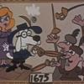
- Member

- 3,745 posts
- Gender:Male
- Location:Columbia, Md
- Interests:Stuff... and junk.
Posted July 30, 2007 · Report post
I think this is the quickest web page I ever slapped together...
Our Chyrgeon working under fire.
He's got a great impression. In fact, it's just the one you are talking about doing, the pressed doctor.
Feh. Lunchtime is over. Back to work!

Calico Jack
- Ship's Master
- Member

- 126 posts
- Location:Port o' Halifax, New Scotland...
Posted July 31, 2007 · Report post
Misson said:
Surely in the hundreds of ship's surgeons some of them may have used something to create a portable kit. (Or maybe not - perhaps all surgery was confined to the location on the ship where they were performed. It's hard to re-focus your perspective when we've had portable medical units for so long.)
Army surgeons would likely have had want of something somewhat portable, but I don't see that maritime surgeons would much have felt need. A surgery is not particularly portable, but men are. Rather than take the surgery up on deck, bring the wounded down to the cockpit... And how often would you be wandering off ship so far that you would need a "portable surgery" instead of that on ship? [Only, alas, when re-enacting]. For re-enactments, I usually stretch history so far as to allow for a quarantine/surgery tent ashore [cinematic equivilant being the self-surgery displayed in the film "Master and Commander: Far Side of the World], which gives an excuse to have a medical chest and surgery set up off-ship, even if admittedly not the best excuse. That seems to work, and gives an opportunity to explain how it would rarely have been used [the temporary surgery ashore would rarely have been used, not the quarantine tent, which would have].
Bleeding bowl and lancet appropriate to your period would be quite portable, 'though, I suppose.

capnwilliam
- Lost at Sea
- Member

- 1,287 posts
- Gender:Male
Posted July 31, 2007 · Report post
Wow! Glad to see that this old thread was resurrected!
Glad also to be able to recount that our cannon crew is doing a lot better than I was forced to indicate back in my November 2004 message.
Capt. William

BriarRose Kildare
- Scourge o' the 7 Seas
- 
- Member

- 2,004 posts
- Location:Pittsbugh Pennsylvania
- Interests:I love History. I have a deep thirst for knowledge and I am rarely with out a book under my nose. Some of my historical interests include: Greco-Roman times, Middle ages, Tudor-Elizabethan, the Golden Age of Pyracy, Napoleonic, French and Indian War, American Revolution, American Civil War, and the Victorian era.<br />Some of my many other interests include: Fencing, belly and romney gypsy dancing, apothecary and herbal healing, disease through out history and how it has effected societies. I also enjoy a good ghost story and I am always ready for ghost hunting. The paranormal absolutely fascinates me. <br />One of my life long dreams is to travel and to sail upon the ocean on a glorious period ship.<br />I also enjoy spending time with friends and family. And above all, I love having fun. And a good drink of Drambuie is always a warm touch to my heart.
Posted August 19, 2007 · Report post
I am so glad that this thread has been resurrected. I am very much interested in the medical aspects of the time period and the use of Surgeons upon ships. I am starting to put together and apothocary's kit in the hopes of using it for re-enactments. I do have experience in the medical field and I am hoping to expand upon it.
I recently just started a thread on Plagues, Viruses and Diseases. I am hoping that there are some out there that are as interested in this as I am. I may seem moribid, but I enjoy learning the about the different epidemics as well as the medica treatments that were given for wounds and such.
Are there any books that can be suggested that I study for this topic on surgeons? It would be greatly appreciated if some one could tell me.
what books are the best to get since at the moment my funds are limited. I am hoping to put several books on me Christmas/Yule wish list.

Calico Jack
- Ship's Master
- Member

- 126 posts
- Location:Port o' Halifax, New Scotland...
Posted August 19, 2007 · Report post
WOODALL, JOHN. The surgeon's mate, or military & domestique surgery... London: Printed by Rob. Young, for Nicholas Bourne, 1639
This book is your first and foremost, I think, and is so whether doing GAoP, Rev War, or even 1805 [it is a classic!].
Trouble is, a cheap repro is a hard thing to find [if you find one, do let me know!]. Even other forums bemoan that the Surgeon's Mate has yet to make it into Project Gutenberg.
http://www.piratebrethren.com/forum/viewto...topic.php?t=434
Reconstructing History have suggested that they're hoping to produce an affordable, if not actually cheap, edition in repro, but no sign yet. [alas]
[EDIT: a more comprehensive bibliography on the subject has already been made by someone else, and can be found here:
http://www.cindyvallar.com/surgeonresources.html
- You'll note there are a few issues of No Quarter Given that are of interest, and they include bibliographies themselves. Most books and articles will be looking either early or late for this period, but you should be able to cobble some good research together. I do recommend Brown, Stephen R. Scurvy: How a Surgeon, a Mariner, and a Gentleman Solved the Greatest Medical Mystery of the Age of Sail. New York: St. Martin’s Press, 2003; although Lind does not perform his experiment for a couple of decades past the GAoP, it is a good overview book of Scurvy, what it is, the many treatment theories, and such. Plus it is quite readable. Little, Benerson. The Sea Rover’s Practice. Washington, DC: Potomac Books, 2005, is an ex-navy seal and reenactor; text must be taken with a grain of salt as "experimental recreation," but it is also a good read. The medical information is a small fragment however. The Mary Rose museum's "Barber Surgeon" pages are of interest, 'though Tudor in focus.

Rats
- Dread Pyrate
- Member

- 1,095 posts
- Gender:Male
- Location:Whitewater WI.
- Interests:Theft, brigandry, pilfering and bad grammar
Posted August 21, 2007 · Report post
Having originally looked into a medical impression, when 1st becoming involved in GAoP, I will also have to attest, the Brethern's surgeon and also Doc Miller from Lock house, offer two of the most impressive surgical impressions I have ever seen.
Their knowledge and their impressive collection of equipment, as well as their general disposition and character make perfect the impression of the common practissioner of medicine.
Very impressive and congradulations on the good work!!
With Black John's approval I also have some pictures from last years November Lockhouse, featuring said surgical display and gentlemen?

Misson
- Dread Pyrate
- Member

- 1,001 posts
- Gender:Male
- Interests:Who me?
Posted July 17, 2008 · Report post
Bloody Jack Madd said:
The Sutler of Mount Misery, G. Gedney Godwin, offers 18th century medical instruments.
http://www.gggodwin.com/
One thing I'll say about Godwin...they're like elephants. I ordered some lancets from them several months ago and they all of a sudden arrived today. At least they didn't bill them until this month. It makes me wonder about that fleem I ordered right after PiP...

Matusalem
- Notorious Pyrate
- 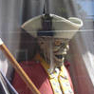
- Member

- 877 posts
- Location:Eastern Seaboard of North America
Posted July 17, 2008 · Report post
"chirugion"

Misson
- Dread Pyrate
- Member

- 1,001 posts
- Gender:Male
- Interests:Who me?
Posted July 17, 2008 · Report post
Calico Jack said:
WOODALL, JOHN. The surgeon's mate, or military & domestique surgery... London: Printed by Rob. Young, for Nicholas Bourne, 1639
This book is your first and foremost, I think, and is so whether doing GAoP, Rev War, or even 1805 [it is a classic!].
Trouble is, a cheap repro is a hard thing to find [if you find one, do let me know!]. Even other forums bemoan that the Surgeon's Mate has yet to make it into Project Gutenberg.
How about a free repro? The best way I've found to get a copy of the Surgeon's Mate is through the on-line database Early English Books Online. Most larger universities have access to it. Bring a memory stick and you can download your own .pdf copy. Many universities have free guest researcher computers available, although you should probably call ahead to make sure. (I suggest you say you're a researcher, otherwise you might wind up at a time-limited, grubby public terminal with limited access rights.)
However, I have my doubts that the Surgeon's Mate is the end-all be-all period sea surgical reference. it was just the first sea medicine reference in print - even then it was only given to East India Merchantmen surgeons; it wasn't for sale from what I've read. Woodall's book came out in 1617, was reprinted in 1639 or so with the third and last re-printing in 1655. The fact that it wasn't reprinted after that suggests to me it would have been more difficult to get after the 1680s or so.
Certainly it would have been on some ships and would have been traded back and forth, but it's by the frequency of reprints that the more scholarly articles seem to judge the time period a surgical book is used. (Joan Druett makes much of Woodall in her book. I wonder what resources she has that suggest that it would have been used as late as the 19th century as she hints.)
Another sea medical reference to consider that is closer to period which is available through the same database:
John Moyle's Chirurgus marinus, 1693
While it's not as comprehensive as Woodall, it was available closer to period and has much plainer language for sea surgeons, who were often newly minted and may have appreciated the simpler language. It went through several reprints as well.
In addition, there are many other period surgical books that could very easily have been used that were printed closer to the GAoP. Some other good period surgical references not specifically for the sea, yet still interesting and likely to have been brought on ship are available through the same database:
James Cooke (former sea surgeon), Mellificium chirurgiæ Or, The marrow of chirurgery, 1648 - note - this was reprinted at least six times I've found (and probably more) all the way through 1760, thus must have been very popular.
James Cooke, Supplementum chirurgiæ or The supplement to the marrow of chyrurgerie, 1655
John Shirley, A short compendium of chirurgery, 1673
Thomas Willis, Five treatises: 1. Of urines, 2. Of the accension of the blood, 3. Of musculary motion, 4. The anatomy of the brain, 5. The description and use of the nerves, 1681
Thomas Willis, Dr. Willis's practice of physick: being all the medical works of that renowned and famous physician, 1681
Richard Wiseman (former sea surgeon), A treatise of wounds, 1676 (I believe much of this is contained in his following work)
Richard Wiseman, Eight chirurgical treatises, 1696
James Yonge (former sea surgeon), Currus triumphalis, è terebinthô, 1679
James Yonge, Wounds of the brain proved curable, 1686
Here are some other good references if you want to learn about the surgeon and his tools that are also available on that database. Some of them are from well before period like Woodall:
Thomas Bonham, The chyrugians closet: or, an antidotarie chyrurgicall, 1630
Stephen Bradwell, Helps for suddain accidents endangering life, 1639
William Clowes (former sea surgeon), A profitable and necessarie booke of obseruations, for all those that are burned with the flame of gun powder, &c., 1588 - this is considered a classic because of the description of the flap method of amputation, but it wasn't reprinted after 1596, so buyer beware
Nicholas Culpeper, Two treatises, the first of blood-letting and the diseases to be cured thereby, the second of cupping and scarifying, and the diseases to be cured thereby, 1683
Randle Holme, The academy of armory, 1688 (This book was reprinted in 1972 as well and your library can probably get it for you.)
Ambroise Pare, Mikrokosmographia: A description of the body of man. Together vvith the controuersies thereto belonging, 1545, translated to English in 1615
Jacques Guillemeau, The Frenche chirurgerye, or all the manualle operations of chirurgerye, 1597 (Based on Pare's work)
Johannes Scultetus, The Chyrurgeons store-house, 1655
And that's about half of the surgical books I've found so far! In addition to general surgical books from period, there are a great many more on specific topics like VD, eye surgery and so forth.
Churgeon, chyrugon, chirurgeon, chirirgon, surgeon, sturgeon...it'll give you a headache after awhile. Two words for period spelling: phonetic and random.

Misson
- Dread Pyrate
- Member

- 1,001 posts
- Gender:Male
- Interests:Who me?
Posted July 17, 2008 · Report post
Misson said:
Yeah, but that's just one example. Surely in the hundreds of ship's surgeons some of them may have used something to create a portable kit. (Or maybe not - perhaps all surgery was confined to the location on the ship where they were performed. It's hard to re-focus your perspective when we've had portable medical units for so long.)
From another site I found much smaller vials that are quite different than those pictured on that link. I'm sure the approaches to equipment were as varied as were the people and countries involved in sailing the Caribbean islands.
Heh. I've sure learned a lot since then! Frequently, ship's surgeons set up tents at landfall to treat the wounded when no other buildings were available. They did indeed have portable kits, particularly for bleeding, which was carried out whereever they could. There are several examples of pocket kits from period. (If the me now could only have been around for the me then.)

Calico Jack
- Ship's Master
- Member

- 126 posts
- Location:Port o' Halifax, New Scotland...
Posted July 19, 2008 · Report post
Quote
How about a free repro?
That, Misson, is the very best kind [grins], and the find of the variety of texts the same, is even more welcome. In your debt, with thanks.
As a note, Geoffrey Keynes [in the Journal of the Royal College of Physicians] also thought Woodall's text was influential beyond the confines of the EIC, and also that it influenced similar texts later [as have others]. That said, things in popular print during your chosen period are the best sources, and thank you again Misson for finding sources equally accessible.

Mission
- Goat Specialist
- 
- 
- Admin

- 5,081 posts
- Gender:Male
- Location:Monroe, MI
- Interests:Scholarly piracy, designing and creating haunted house rooms and props, movies, abstract thinking, abstruse thinking, obstructive thinking, ideating, random thinking, movies, cartoons, movies, movies scores, cycling, world peace and small furry dogs, movies, writing, drawing, personal skills training, gremlins and, of course, lest I forget, movies.
Posted October 17, 2009 · Report post
Oh, I do like this.
“For one must aim at attaining a certain measure, and yet this measure admits neither weight nor calculation of any kind, by which it may be accurately determined, unless it be the sensation of the body; wherefore it is a task to learn this accurately, so as not to commit small blunders either on the one side or the other, and in fact I would give great praise to the physician whose mistakes are small, for perfect accuracy is seldom to be seen, since many physicians seem to me to be in the same plight as bad pilots, who, if they commit mistakes while conducting the ship in a calm do not expose themselves, but when a storm and violent hurricane overtake them, they then, from their ignorance and mistakes, are discovered to be what they are, by all men, namely in losing their ship.” (Hippocrates, On Ancient Medicine, Hippocratic Writings, translated by Francis Adams, 1952, p. 3)

Handcannon Chris
- Deck Swabber
- 
- 
- Member

- 24 posts
- Location:Bakersfield, Ca
- Interests:Guns, books, movies, mental health, Vietnam War, computers, food, water, shelter.
Posted October 19, 2009 · Report post
Does anybody know of other merchants to buy medical equipment from besides G. Gedney Godwin? Their capital saw, metacarpal saw, and scarificator have been on backorder forever. They say that metacarpal saw should be in this week but have no date for the others. I did notice that they have a wooden case for their medical instruments now. It's $350 price tag is a little steep for my 1 and a half shares though.

Mission
- Goat Specialist
- Admin

- 5,081 posts
- Gender:Male
- Location:Monroe, MI
- Interests:Scholarly piracy, designing and creating haunted house rooms and props, movies, abstract thinking, abstruse thinking, obstructive thinking, ideating, random thinking, movies, cartoons, movies, movies scores, cycling, world peace and small furry dogs, movies, writing, drawing, personal skills training, gremlins and, of course, lest I forget, movies.
Posted October 19, 2009 · Report post
GGG is about as close as you get to period repro that I've found. Their stuff seems to be dated around the time of Rev War as near as I can place it (maybe F&I war). There are some Civil War repro companies I've come across that make repro surgical stuff but since GGG compares pretty favorably to them in price, I don't see the point of purchasing stuff that far from period. I actually think GGGs prices are pretty decent, all things considered. My primary complaint about GGG is that they don't have all the stuff you need to make a full out surgeon's kit (Although they just added sort of crane's bill forceps, which makes me really happy. I've not seen any on eBay in the past two years and I've been actively looking. In fact, I was considering buying their regular forceps and bending them myself.) There's also the wait time...I waited over a year for one piece from them. I guess it's because their stuff is hand-made.
The other option I've found is eBay. But they are extremely hit & miss, you've got to know what will at least pass for period (because the true period stuff is really expensive), and even the pass-for-period stuff makes GGG look cheap by comparison. I bought an 1750-1800 bone saw off eBay, spending several times what they charge, making theirs look like a steal. The fact it, outfitting to be a surgeon is sort of expensive. If you want a decent medical kit, I'd be prepared to spend at least a thousand on your stuff. (This is why it's best to acquire stuff over time and build your collection gradually.)
Now as to their new box...it doesn't quite look correct to me. Since we don't have extant examples, it's hard to say if velvet-lining for medical tool chests was appropriate or not to period. Even if it is, that seems like a luxury. Most sea-surgeons were newly trained and couldn't find land-based positions. So they would go to sea instead to get experience. They would typically be financially strapped and probably would not have spent the extra money required for such luxurious accommodations for their tools. (This is admittedly guesswork on my part based on what I have read about sea surgeons.) I think you'd be better to make your own...which I plan to do some day. Some day... See the thread On Making a Medical Chest for my research progress (if not my actual construction progress).

Handcannon Chris
- Deck Swabber
- Member

- 24 posts
- Location:Bakersfield, Ca
- Interests:Guns, books, movies, mental health, Vietnam War, computers, food, water, shelter.
Posted October 21, 2009 · Report post
Well hopefully we wont be bidding on the same things.

Mission
- Goat Specialist
- Admin

- 5,081 posts
- Gender:Male
- Location:Monroe, MI
- Interests:Scholarly piracy, designing and creating haunted house rooms and props, movies, abstract thinking, abstruse thinking, obstructive thinking, ideating, random thinking, movies, cartoons, movies, movies scores, cycling, world peace and small furry dogs, movies, writing, drawing, personal skills training, gremlins and, of course, lest I forget, movies.
Posted October 22, 2009 · Report post
Fair winds to you if we are. (But not too fair. )
I am only looking for a few things at this point (or really interesting things that I didn't know I wanted) and I have definite price points in mind for them, so I doubt we will cross paths too many times.
What I really want to get my grubby paws on is a dental pelican. I wish someone would make a repro pelican because the cheapest I've found a real one for is $400+.

Mission
- Goat Specialist
- Admin

- 5,081 posts
- Gender:Male
- Location:Monroe, MI
- Interests:Scholarly piracy, designing and creating haunted house rooms and props, movies, abstract thinking, abstruse thinking, obstructive thinking, ideating, random thinking, movies, cartoons, movies, movies scores, cycling, world peace and small furry dogs, movies, writing, drawing, personal skills training, gremlins and, of course, lest I forget, movies.
Posted February 24, 2011 · Report post
I thought this was pretty funny. It's from T. Aubrey's book The sea-surgeon, or the Guinea man's vade mecum [handbook]. Based on his comments, I suspect Mr. Aubrey is a physician or an apothecary writing this manual focusing on fevers and medicines for the (in his opinion, hapless) sea surgeons.
"They had a kind of Barber-Surgeon on Board, which they might have as well been without, only that he served well enough to shave and bleed. I demanded of him, how he treated the Mate [the patient - Thomas Wright, "on Board a West-India Shallop" who had "Relicks of a Diarrhœtic Fever"], he said he had blooded him three times, and purged him as often, but with what he could scarcely tell me, or else was ashamed to let me know, altho' he had a Chest very handsomly furnished with Medicines for such a Vessel, had he had but Judgment to make use of them. Thus many pour Souls are cast away by the Ignorance of such Vermin, who without Consideration, or Conscious, undertake the charge of a Vessel." (Aubrey, p. 80)

Daniel
- Pyrate Captain
- 
- Member

- 652 posts
- Gender:Male
- Location:McLean, VA
- Interests:History, pirates, fiction, writing, writing historical fiction about pirates, jokes, games, law.
Posted August 4, 2011 · Report post
Mission, here's another paragraph from Rodger's Command of the Ocean that I thought might be particularly interesting to you, dealing as it does with Navy surgeons and medical care.
Quote
In the long term one of the most significant developments concerned the Navy's relations with the rival medical corporations: the College of Physicians of London, the Barber-Surgeons' Company and the Society of Apothecaries. By demanding practical remedies for mass outbreaks of disease (something impossible and disreputable according to orthodox Galenic medicine), by distributing its official favours between the medical bodies, and by requiring (in 1709) that naval surgeons undergo a qualifying course in medicine (the physician's preserve), the Admiralty and Navy Board began to undermine the official divisions of the medical world. This effect was reinforced by an act of 1698 permitting 'discharged soldiers' to practice outwith [sic - probably should say "without"] guild regulations, which led to a growing number of ex-naval and military surgeons, trained to some extent as 'general practitioners', taking up practice ashore.⁶⁵
Rodger, p. 196.
⁶⁵ Cook, 'Practical Medicine'. Rodger, 'Medicine and Science'. KMN II, 202, 265-76. Holmes, Augustan England, pp. 193, 197 and 203.

Mission
- Goat Specialist
- Admin

- 5,081 posts
- Gender:Male
- Location:Monroe, MI
- Interests:Scholarly piracy, designing and creating haunted house rooms and props, movies, abstract thinking, abstruse thinking, obstructive thinking, ideating, random thinking, movies, cartoons, movies, movies scores, cycling, world peace and small furry dogs, movies, writing, drawing, personal skills training, gremlins and, of course, lest I forget, movies.
Posted August 4, 2011 · Report post
Interesting that the qualifying course requirement occurred during our period. It definitely goes along with the concept of standardizing medicine. Most surgeons during period were apprenticed for 7 years and then had to take an oral test with surgeons of the Barber-Surgeon's Company to become practicing surgeons. (There were other levels of competence in the organization as well.) The Navy wanted fast results, for obvious reasons. They were also involved in searching for medicines that would be quick-fixes. I remember reading this long article on how they put their money behind some such medicine to cure Scurvy despite the fact that (based on the ingredients) it wouldn't do much good.

Mission
- Goat Specialist
- Admin

- 5,081 posts
- Gender:Male
- Location:Monroe, MI
- Interests:Scholarly piracy, designing and creating haunted house rooms and props, movies, abstract thinking, abstruse thinking, obstructive thinking, ideating, random thinking, movies, cartoons, movies, movies scores, cycling, world peace and small furry dogs, movies, writing, drawing, personal skills training, gremlins and, of course, lest I forget, movies.
Posted July 22, 2013 · Report post
Captain Sterling asked me "have ye ever come across 18th c. surgeons wearing blue linen aprons?"
Now, I had not looked into the question of the surgeon's apron in any depth before and the answer surprised even me, so I thought I would share it as others might be interested in knowing the answer.
The ONLY near-period reference I found to a surgeon having an apron is from John Woodall's book the surgions mate, 1639 edition:
"If the Surgeons Mate cannot trimme men, then by due consequence there is to be a Barber of the ships Company, and he ought not to be wanting of these following necessaries.
One Barbours case, containing,
Rasours foure. |Aprons three.
Scissers two paire. |Shaving towels twelve.
Combes three. |Water-pot one.
Combes-brush one. |Sweet water one.
Bare-picker one. |Washing-bols lesse or more.
Curling Instruments. |Hoane one.
Turning Instruments and Spunges. |Whet-stone one.
Mallet one. |Basons two.
Gravers two. | And what else is necessary to
Flegme one. | the Barbers profession, as the
Paring knives two. | expert Barber better knoweth."
(Woodall, Contents of the surgeon's chest, 6th page)
Woodall does not indicate what these three aprons would be made from, however. From this, it also sounds as if an apron was something used more by barbers than surgeons. (Note that barbers would also do bloodletting, which may lead to further need for an apron.) This sort of apron reminded me of a sketch made in 1669 by Maurice Sands for the comedic play Monsieur de Pourceaugnac:

This is a drawing of an apothecary (druggist in our terms) and since it is for a comedy, it may well be exaggerated. However, it is probably also reminiscent of what such people would wear, even if it may be overstated, because otherwise the image would not be recognized to contemporary audiences.
The only other account I have of a change of clothes for the operating theater is from a modern book, albeit a very well and fully researched one by Guy Williams called The Age of Agony:
"Near this, there is a row of pegs on which the surgeons would hang their ‘operating coats’ –discarded frock coats, usually, which, after they had been used in the theatre for any length of time, would be stiff with dried pus and blood. On entereing the theatre to operate, an eighteenth-century surgeon would take off his street coat and then would put on his ‘operating coat’, rolling up his sleeves and turning up the collar over his white linen to save it from becoming unnecessarily stained." (Williams, p. 117)
However, this is also not an apron, it is a coat and it is also for a land-based operating theater. This actually agrees with period and near period images of surgeons operating (on land.)
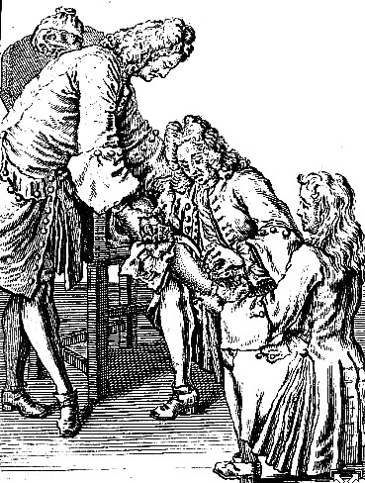
From Traite des Operations de Chirurgie, by Rene Garengeot, p. 365 (1723)
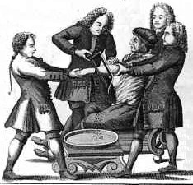
From A General System of Surgery, by Lorenz Heister (1743)
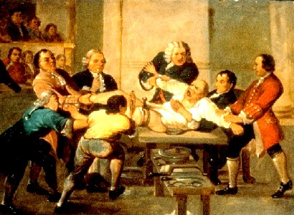
Leg Amputation, from an 18th c. Painting in the Royal College of Surgeons
I do have one image that may be of a surgeon wearing an apron, but it's not very good and I collected it before I started keeping track of sources and dates:
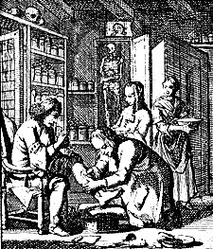
You may argue that these are not of ship's or even military surgeons, and I would agree that's a fair point. Such men would be going from patient to patient, encountering all manner of bodily fluids and may need better protection. The only sketch I have found of a ship's surgery is from the early 19th c., but it again fails to show anyone wearing an apron. Rather, they seem to be wearing regular clothes for that period:
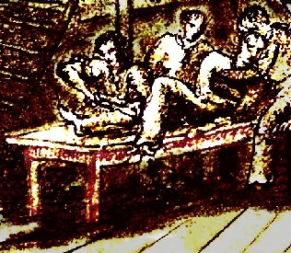
Ship's Surgery, unknown artist (1820)
So, taken all together, it is probably more appropriate not to wear an apron in the role of a ship's surgeon than it is to wear one. Which, as i mentioned, shocks even me, especially since I shelled out $60 for one several years ago.

Swashbuckler 1700
- Dread Pyrate
- 
- Member

- 1,115 posts
- Gender:Male
- Location:Europe
- Interests:pyrates, pryvateers, naval military and other history, different books, good movies, music (a little bit), drawing, games,...
Posted July 23, 2013 (edited) · Report post
Sorry if I somehow misunderstood the matter
What is interesting that there so few pictures of 18th century doctors with aprons
This one has some kind of cloth to cover his pants -much like the thing that apothecary had in that earlier picture....
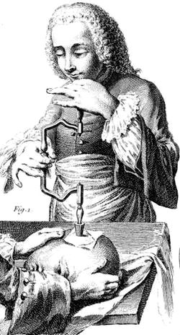
These are doctors studying death bodies by Hogarth (the two people with aprons with one button thingy) (similar than this You are wearing http://www.piratesurgeon.com/pages/pip07/images/Mission_Posed_Gear_Main_Page.jpg )
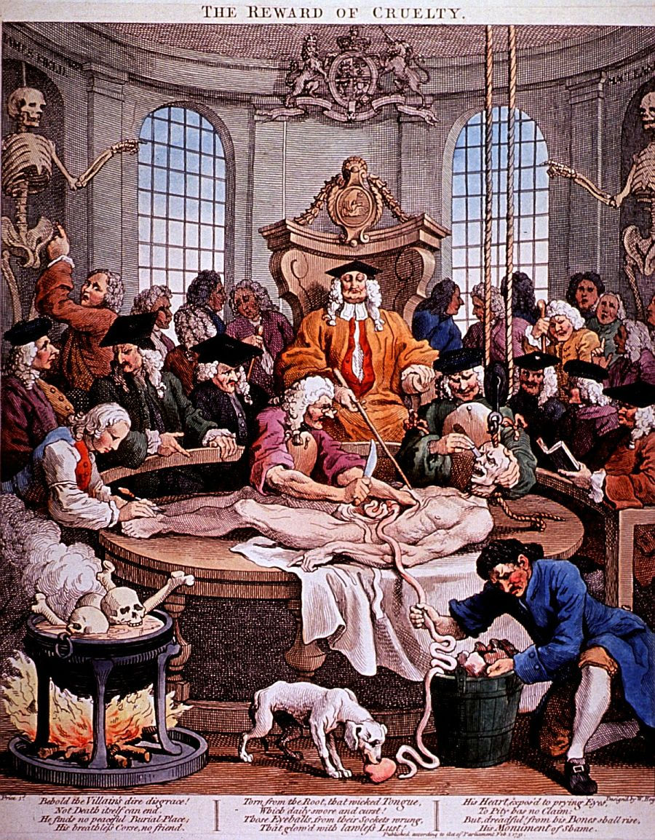
and this is a bit unclear but it seems that he has something like the brain surgeon was wearing earlier.
Country surgeon circa 1747

(http://www.chemheritage.org/discover/collections/collection-items/fine-art/le-chirurgien-de-campagne-fa-2000-001-140.aspx)
Also note this earlier Teniers school Foot operation 1663
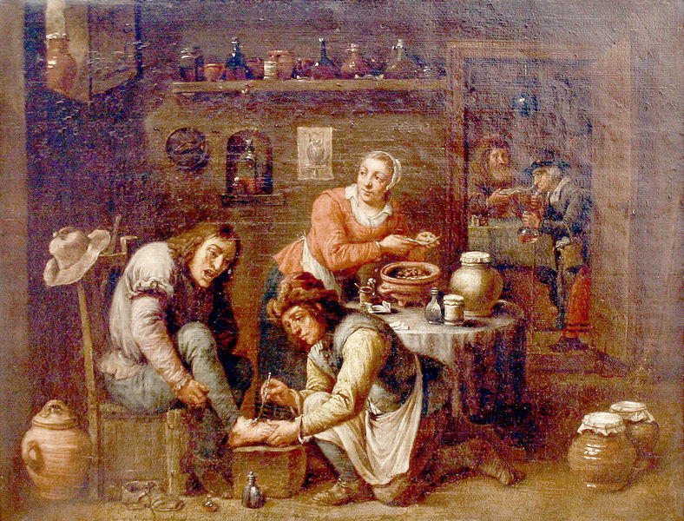
Edited July 23, 2013 by Swashbuckler 1700

Mission
- Goat Specialist
- Admin

- 5,081 posts
- Gender:Male
- Location:Monroe, MI
- Interests:Scholarly piracy, designing and creating haunted house rooms and props, movies, abstract thinking, abstruse thinking, obstructive thinking, ideating, random thinking, movies, cartoons, movies, movies scores, cycling, world peace and small furry dogs, movies, writing, drawing, personal skills training, gremlins and, of course, lest I forget, movies.
Posted July 23, 2013 · Report post
Excellent finds! Thank you for posting them here. (This is turning out to be more interesting than I thought.)
Most of them appear to be cloth, although the apron on the dissectionist is pretty clearly leather. It is also the sort I purchased - with the button. It's not very far from that to the grisly scene a ship's surgeon would face during battle, so an argument could be made. (Although someone of my SJ Facebook fan page pointed out the dissectionists did wear them.)

Swashbuckler 1700
- Dread Pyrate
- Member

- 1,115 posts
- Gender:Male
- Location:Europe
- Interests:pyrates, pryvateers, naval military and other history, different books, good movies, music (a little bit), drawing, games,...
Posted July 23, 2013 (edited) · Report post
You welcome
Further to this.... Well not Gaop but 18th century
The Persevering Surgeon by Thomas Rowlandson, c. 1775
(that looks like an apron of some sort at least in my opinion)
http://willigula.tumblr.com/post/35078968646/the-persevering-surgeon-by-thomas-rowlandson-c
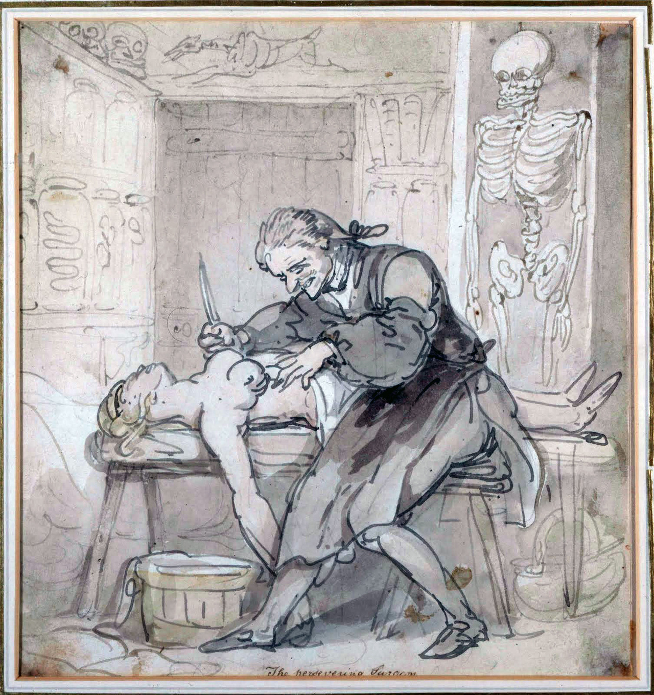
Edited July 23, 2013 by Swashbuckler 1700

Mission
- Goat Specialist
- Admin

- 5,081 posts
- Gender:Male
- Location:Monroe, MI
- Interests:Scholarly piracy, designing and creating haunted house rooms and props, movies, abstract thinking, abstruse thinking, obstructive thinking, ideating, random thinking, movies, cartoons, movies, movies scores, cycling, world peace and small furry dogs, movies, writing, drawing, personal skills training, gremlins and, of course, lest I forget, movies.
Posted July 23, 2013 · Report post
Here are some other images of surgeons at work...the majority of what I've seen to not wear aprons.
Adriaen Rombouts, mid-17th century
Surgeon attending to a wound in a man's side, by Johan Joseph Horemans (Antwerp), early 18th c.
(Say, I like that red, sleeved coat...)
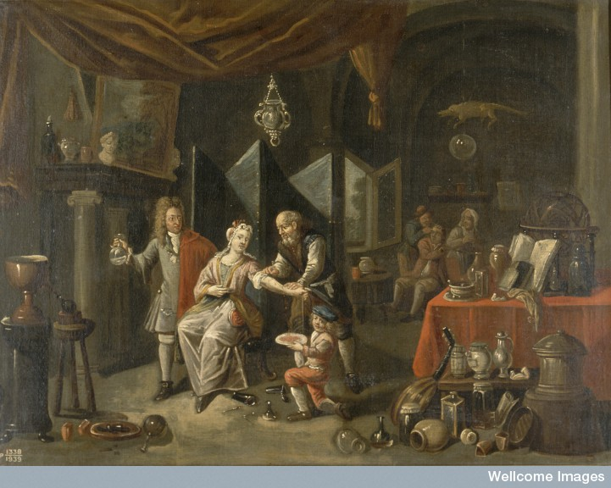
Surgeon letting blood (to the right of the patient), unknown Flemish painter, 18th c. He may be wearing an apron or that may be his belt and breeches. It's hard to tell.
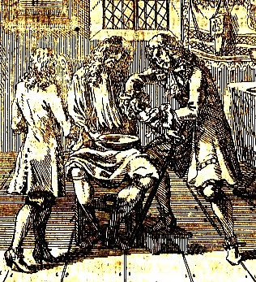
Bleeding a patient, Wolf Helmhardt von Hohberg, 1695
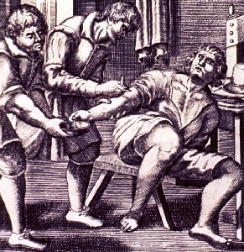
Bleeding, by Cintio Damato, 1671 from the book Nuova et utlilssima prattica di tutto quello ch'al diligente barbiero s'appartiene

By Garret Lundens (1649)
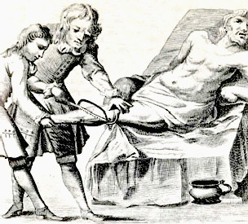
Leg Amputation from the book Chiurgia Curiosa (1716)
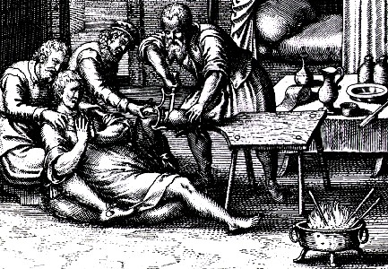
Amputation, From the book De Gangrena et Sphacelo by Hildanus (1617)

Swashbuckler 1700
- Dread Pyrate
- Member

- 1,115 posts
- Gender:Male
- Location:Europe
- Interests:pyrates, pryvateers, naval military and other history, different books, good movies, music (a little bit), drawing, games,...
Posted July 23, 2013 (edited) · Report post
Certainly most surgeons had normal clothes on during operations.
But if we generally look into use of aprons we can see at least that innkeepers alike had those
Hogarth again (right side)
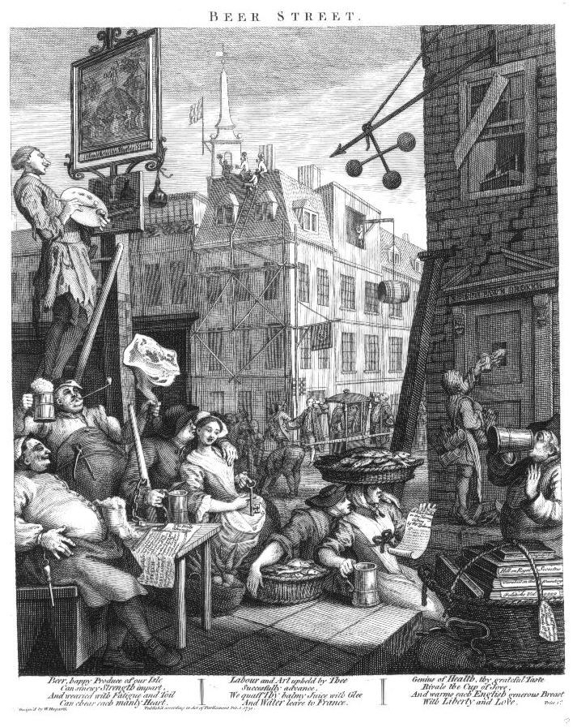
And well I am going a bit off-topic but this is only tells that doctors could cover themselves with special equipment.... but well it is not a surgeon but a plaque doctor and the suit is to prevent infection ...
http://en.wikipedia.org/wiki/File:Johann_Melchior_F%C3%BCssli_(1677%E2%80%931736),_Sketch_of_a_Cordovan-leather-clad_doctor_of_Marseilles.png
anyway
Edited July 23, 2013 by Swashbuckler 1700

Mission
- Goat Specialist
- Admin

- 5,081 posts
- Gender:Male
- Location:Monroe, MI
- Interests:Scholarly piracy, designing and creating haunted house rooms and props, movies, abstract thinking, abstruse thinking, obstructive thinking, ideating, random thinking, movies, cartoons, movies, movies scores, cycling, world peace and small furry dogs, movies, writing, drawing, personal skills training, gremlins and, of course, lest I forget, movies.
Posted July 23, 2013 · Report post
Plague Doctor costumes are wonderful. I thought about making one up, but they would not really apply to a ship.) There's actually a thread about it that was split off from another topic.

Mission
- Goat Specialist
- Admin

- 5,081 posts
- Gender:Male
- Location:Monroe, MI
- Interests:Scholarly piracy, designing and creating haunted house rooms and props, movies, abstract thinking, abstruse thinking, obstructive thinking, ideating, random thinking, movies, cartoons, movies, movies scores, cycling, world peace and small furry dogs, movies, writing, drawing, personal skills training, gremlins and, of course, lest I forget, movies.
Posted April 23, 2015 · Report post
Hey, John Moyle's book for sea-surgeons "Chirurgus Marinus" is now available on line! I just stumbled across it.
Most people who want to do pirate surgeon impressions look for John Woodall's book (which is also available on-line), which had been out of print for almost 50 years by the time the Golden Age of Pyracy began in the 1690s. Moyle's book is ten times easier to read than Woodall's, is much shorter and far more direct and to the point. I highly recommend to those interested in reading about period sea surgery.
John Moyle's is the only sea surgeon's book published during period. It was (apparently) first published in 1686 as Abstractum Chirurgiae Marinae, then greatly revised and published as Chirurgus Marinus in 1693 and slightly revised and republished in 1702. (For some reason, the 1702 version is listed as the 4th edition. I have only found two other editions, so someone either made a mistake or one of the versions has not been found and digitized.)

