Mission
- Goat Specialist
- 
- 
- Admin

- 5,082 posts
- Gender:Male
- Location:Monroe, MI
- Interests:Scholarly piracy, designing and creating haunted house rooms and props, movies, abstract thinking, abstruse thinking, obstructive thinking, ideating, random thinking, movies, cartoons, movies, movies scores, cycling, world peace and small furry dogs, movies, writing, drawing, personal skills training, gremlins and, of course, lest I forget, movies.
(IP: 24.247.94.112) ·
Posted April 25, 2012 (edited) · Report post
The heroic surgeon and his sword!
This is from "The History of the pirates" (or Volume II of the General History) in the chapter on Captain Halsey:
"The Dutchman (a Dutch ship of 60 guns) stayed, and fired a shot, which taking a swivel gun, carried it aft, narrowly missed the man at helm, and shattered the taffarel. The men perceiving they had caught a Tartar ['A person regarded as ferocious or violent' (thefreedictionary)], made the best of their way to shake her off, and some were running down between decks, whom the surgeon pricked up again with his sword, though he was no way consenting to their designed piracy." (p. 97)
Edited April 25, 2012 by Mission

- Quote
- Edit

Jib
- Dread Pyrate
- 
- 
- Member

- 1,078 posts
- Gender:Male
- Location:Minneapolis, MN
- Interests:Piracy, stage combat, martial arts, reading, film, travel
(IP: 198.12.16.4) · ·
Posted April 25, 2012 · Report post
Does this mean you plan to take up the sword Mission?

- Quote
- Edit
- Options

Mission
- Goat Specialist
- Admin

- 5,082 posts
- Gender:Male
- Location:Monroe, MI
- Interests:Scholarly piracy, designing and creating haunted house rooms and props, movies, abstract thinking, abstruse thinking, obstructive thinking, ideating, random thinking, movies, cartoons, movies, movies scores, cycling, world peace and small furry dogs, movies, writing, drawing, personal skills training, gremlins and, of course, lest I forget, movies.
(IP: 24.247.94.112) · ·
Posted April 25, 2012 · Report post
No, but I thought it was interesting that a surgeon would own one.
Although the author (whose details sometimes seem iffy to me) may not have been referring to a sword at all, but possibly to a capital knife which would be quite large - say about 12" long or so. Since the General History author appears to be relying mostly on other accounts, the person relating the information may not have known what to call the knife and referred to it as a sword. (I don't really know, I'm just positing a theory here. )

- Quote
- Edit
- Options

Fox
- Old Twillian
- 
- 
- Moderator

- 2,564 posts
- Gender:Male
- Location:Beautiful lush Devon, England
- Interests:Nautical history of the 16-18th centuries and living history based thereon.
Shooting pirates.
(IP: 86.168.44.52) · ·
Posted April 25, 2012 · Report post
Sword ownership was fairly widespread amongst anyone who could afford one, so it's quite possible that the surgeon in question owned a sword. Or, of course, he might have just picked one up...
(Bear in mind that Johnson's chapter on Halsey was written 25 years after the event).

- Quote
- Edit
- Options

Mission
- Goat Specialist
- Admin

- 5,082 posts
- Gender:Male
- Location:Monroe, MI
- Interests:Scholarly piracy, designing and creating haunted house rooms and props, movies, abstract thinking, abstruse thinking, obstructive thinking, ideating, random thinking, movies, cartoons, movies, movies scores, cycling, world peace and small furry dogs, movies, writing, drawing, personal skills training, gremlins and, of course, lest I forget, movies.
(IP: 24.247.94.112) · ·
Posted April 26, 2012 (edited) · Report post
He might have a sword, but probably not for use in battle. The surgeon would usually be below decks dressing the wounded during a battle, so he would have little use for a sword in that situation.
Edited April 26, 2012 by Mission

- Quote
- Edit
- Options

Swashbuckler 1700
- Dread Pyrate
- 
- Member

- 1,115 posts
- Gender:Male
- Location:Europe
- Interests:pyrates, pryvateers, naval military and other history, different books, good movies, music (a little bit), drawing, games,...
(IP: 80.223.160.249) · ·
Posted April 26, 2012 · Report post
Practically all 17th- 18th C genteleman had swords. It seems that it was status symbol.

- Quote
- Edit
- Options

Mission
- Goat Specialist
- Admin

- 5,082 posts
- Gender:Male
- Location:Monroe, MI
- Interests:Scholarly piracy, designing and creating haunted house rooms and props, movies, abstract thinking, abstruse thinking, obstructive thinking, ideating, random thinking, movies, cartoons, movies, movies scores, cycling, world peace and small furry dogs, movies, writing, drawing, personal skills training, gremlins and, of course, lest I forget, movies.
(IP: 24.247.94.112) · ·
Posted April 26, 2012 (edited) · Report post
On 4/26/2012 at 10:08 AM, Swashbuckler 1700 said:
Practically all 17th- 18th C genteleman had swords. It seems that it was status symbol.
What is your source for this?
(Keep in mind that portrait paintings were often romanticized - cleaned up and made to look better than the truth.)
Edited April 26, 2012 by Mission

- Quote
- Edit
- Options

Swashbuckler 1700
- Dread Pyrate
- Member

- 1,115 posts
- Gender:Male
- Location:Europe
- Interests:pyrates, pryvateers, naval military and other history, different books, good movies, music (a little bit), drawing, games,...
(IP: 80.223.160.249) · ·
Posted April 26, 2012 (edited) · Report post
On 4/26/2012 at 10:09 AM, Mission said:
On 4/26/2012 at 10:08 AM, Swashbuckler 1700 said:
Practically all 17th- 18th C genteleman had swords. It seems that it was status symbol.
What is your source for this?
(Keep in mind that portrait paintings were often romanticized - cleaned up and made to look better than the truth.)
You are irritating mood today aren't you?
I was reading Chuck Wills' " The Illustrated History of Weaponry"
And Well there were own sword type for gentlemen and it was "small sword".
Illegal duels were problem e.g. in court of France
On one meeting poster from 1740s says something like this:
”Dear gentlemen leave your swords at home that we would have more seats available.”
Walking sticks were also fashionable and so were walking sticks with sword in them ( but these walking stick swords are more later 18th C stuff)
men from 1690s

man from 1715

Hogarth's from 1735
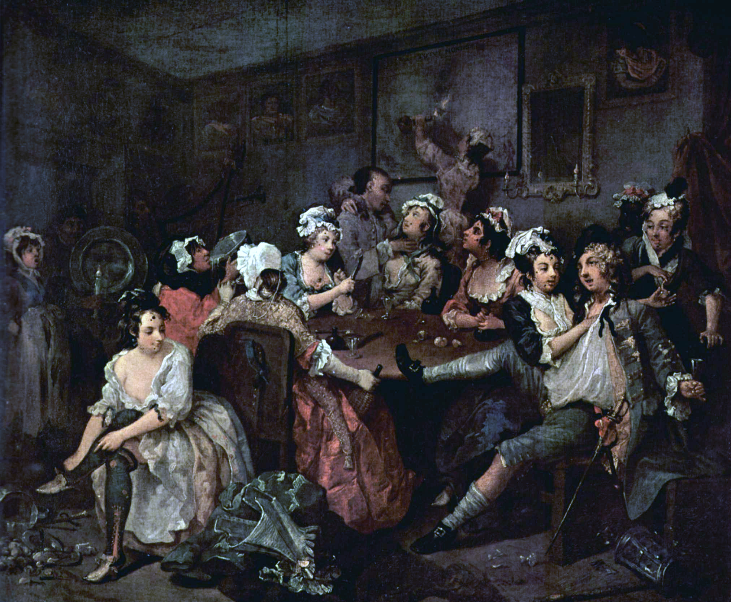
Edited April 26, 2012 by Swashbuckler 1700

- Quote
- Edit
- Options

Mission
- Goat Specialist
- Admin

- 5,082 posts
- Gender:Male
- Location:Monroe, MI
- Interests:Scholarly piracy, designing and creating haunted house rooms and props, movies, abstract thinking, abstruse thinking, obstructive thinking, ideating, random thinking, movies, cartoons, movies, movies scores, cycling, world peace and small furry dogs, movies, writing, drawing, personal skills training, gremlins and, of course, lest I forget, movies.
(IP: 24.247.94.112) · ·
Posted April 26, 2012 (edited) · Report post
Those are all portrait drawings - the kind I mentioned. Of all the artwork I have showing period and near-period surgeons, none of them have swords. There is a portrait of Pierre Dionis wearing armor, but this is not typical of the other drawings of him, suggesting it is highly stylized. (I like to use it on my web page for that reason - it looks very dramatic.)
Armored Dionis

Non-Armored Dionis

Edited April 26, 2012 by Mission

- Quote
- Edit
- Options

Swashbuckler 1700
- Dread Pyrate
- Member

- 1,115 posts
- Gender:Male
- Location:Europe
- Interests:pyrates, pryvateers, naval military and other history, different books, good movies, music (a little bit), drawing, games,...
(IP: 80.223.160.249) · ·
Posted April 26, 2012 · Report post
On 4/26/2012 at 11:58 AM, Mission said:
Those are all portrait drawings - the kind I mentioned. Of all the artwork I have showing period and near-period surgeons, none of them have swords. There is a portrait of Pierre Dionis wearing armor, but this is not typical of the other drawings of him, suggesting it is highly stylized. (I like to use it on my web page for that reason - it looks very dramatic.)
Armored Dionis
Non-Armored Dionis

What are you arguing against gentlemen’s sword?
Fencing was also mainly gentlemen’s hobby and e.g. sailors were not too good at it. Indeed surgeons were not so fine blessed than even average gentleman.
I think those are ”fashion plates" and not portraits.
Read wiki ( yes it is wiki but it seems to be quite rigth http://en.wikipedia....iki/Small_sword)
no bad feelings

- Quote
- Edit
- Options

Mission
- Goat Specialist
- Admin

- 5,082 posts
- Gender:Male
- Location:Monroe, MI
- Interests:Scholarly piracy, designing and creating haunted house rooms and props, movies, abstract thinking, abstruse thinking, obstructive thinking, ideating, random thinking, movies, cartoons, movies, movies scores, cycling, world peace and small furry dogs, movies, writing, drawing, personal skills training, gremlins and, of course, lest I forget, movies.
(IP: 24.247.94.112) · ·
Posted April 26, 2012 (edited) · Report post
On 4/26/2012 at 0:55 PM, Swashbuckler 1700 said:
Fencing was also mainly gentlemen’s hobby and e.g. sailors were not too good at it. Indeed surgeons were not so fine blessed than even average gentleman.
I think those are ”fashion plates" and not portraits.
Read wiki ( yes it is wiki but it seems to be quite rigth http://en.wikipedia....iki/Small_sword)
Surgeons, particularly those who worked on ships, were usually lower-class gentleman. I don't know how such people would regard swords or why they would have one shipboard. On the other hand, I don't know that they wouldn't. It just seems like an odd thing for a surgeon to have, given that he had to deal with the results. Land surgeons and surgeons to royalty would probably be of a different social standing, although there was a definite aspect of the workman about all surgeons from what I've read. (Physicians, OTOH, I would figure to be inveterate sword-carriers based on what I read on the wiki.)
I like wikipedia, I actually think it's far more correct than incorrect, but it gets a bad rap from individual instances of incorrectly-entered info.
I didn't know a fashion plate was a real thing. (I looked it up on wikipedia, though. ) Just goes to show you what I know about clothing styles. (I wondered why all the people in certain types of images looked so damned goofy and effeminate.)
Edited April 26, 2012 by Mission

- Quote
- Edit
- Options

Swashbuckler 1700
- Dread Pyrate
- Member

- 1,115 posts
- Gender:Male
- Location:Europe
- Interests:pyrates, pryvateers, naval military and other history, different books, good movies, music (a little bit), drawing, games,...
(IP: 80.223.160.249) · ·
Posted April 26, 2012 (edited) · Report post
On 4/26/2012 at 1:32 PM, Mission said:
On 4/26/2012 at 0:55 PM, Swashbuckler 1700 said:
Fencing was also mainly gentlemen’s hobby and e.g. sailors were not too good at it. Indeed surgeons were not so fine blessed than even average gentleman.
I think those are ”fashion plates" and not portraits.
Read wiki ( yes it is wiki but it seems to be quite rigth http://en.wikipedia....iki/Small_sword)
Surgeons, particularly those who worked on ships, were usually lower-class gentleman. I don't know how such people would regard swords or why they would have one shipboard. On the other hand, I don't know that they wouldn't. It just seems like an odd thing for a surgeon to have, given that he had to deal with the results. Land surgeons and surgeons to royalty would probably be of a different social standing, although there was a definite aspect of the workman about all surgeons from what I've read. (Physicians, OTOH, I would figure to be inveterate sword-carriers based on what I read on the wiki.)
I like wikipedia, I actually think it's far more correct than incorrect, but it gets a bad rap from individual instances of incorrectly-entered info.
I didn't know a fashion plate was a real thing. (I looked it up on wikipedia, though. ) Just goes to show you what I know about clothing styles. (I wondered why all the people in certain types of images looked so damned goofy and effeminate.)
okay
Surgeons in many pictures don't have hat or wig ( correct me if needed). I think when aboard or working they would not use swords but on shore maybe. I think guite similarly about wiki.
CORRECTION
picture 3 is not perhaps a fashion plate but swords are common in actually plates from 16th/17th C to 18th C here are some pics http://pyracy.com/in...es/page__st__80
Here is one plate from late 1690s ( he is also taking snuff what was fashionable from 1680s onward ( I read that in R. Plat's book " pirate") and I think that doctors recommended it but that is your strong skill to tell about medicine )
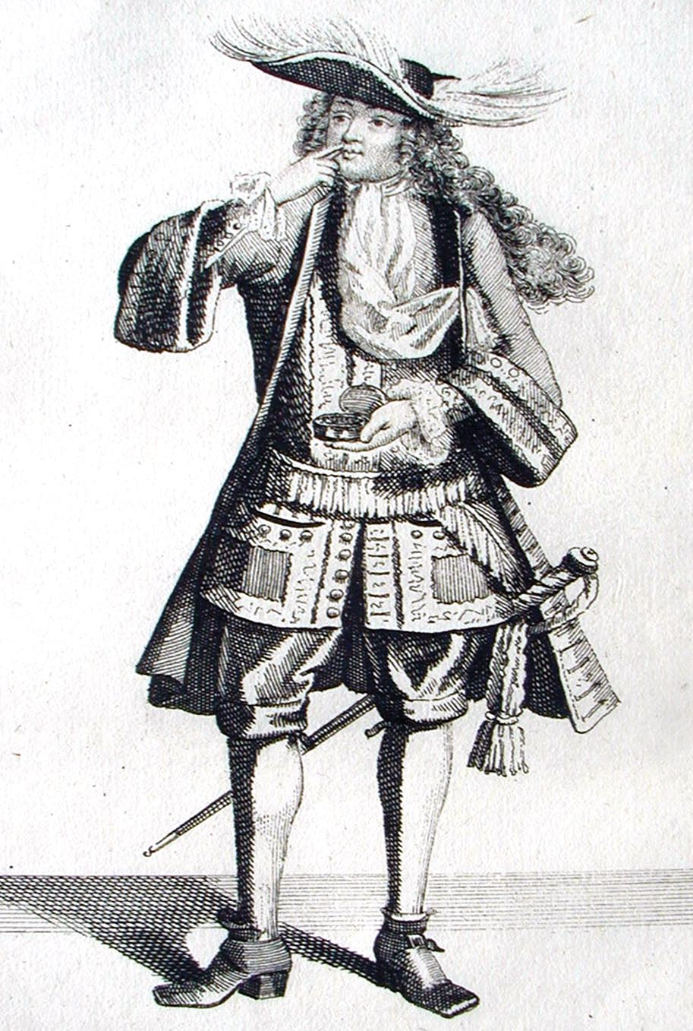
Edited April 26, 2012 by Swashbuckler 1700

- Quote
- Edit
- Options

Mission
- Goat Specialist
- Admin

- 5,082 posts
- Gender:Male
- Location:Monroe, MI
- Interests:Scholarly piracy, designing and creating haunted house rooms and props, movies, abstract thinking, abstruse thinking, obstructive thinking, ideating, random thinking, movies, cartoons, movies, movies scores, cycling, world peace and small furry dogs, movies, writing, drawing, personal skills training, gremlins and, of course, lest I forget, movies.
(IP: 24.247.94.112) · ·
Posted April 26, 2012 (edited) · Report post
I have found next to nothing about tobacco in any form in the surgical manuals. Thomas Sydenham - a Physician, mind you - introduced the tobacco smoke enema.
Thomas Sydenham, Physician:

Surgeons are often shown wearing wigs, although it would seem to me to be an obstacle when actually operating.
Amputations by Lorenz Heister (1743)
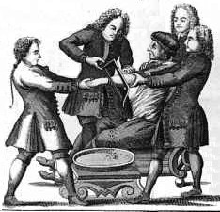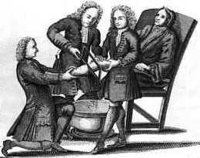
As for my English surgeons, I only have a few images:
Richard Wiseman:

John Moyle:

John Woodall:

All of these guys were surgeons to royalty at some time, yet to me they have a distinctly workman-like aura. (Woodall is from early in the 17th century, thus the ruff.) Of the three, only Moyle has that silly foppish look and I think it's due to the wig.
Edited April 26, 2012 by Mission

- Quote
- Edit
- Options

Swashbuckler 1700
- Dread Pyrate
- Member

- 1,115 posts
- Gender:Male
- Location:Europe
- Interests:pyrates, pryvateers, naval military and other history, different books, good movies, music (a little bit), drawing, games,...
(IP: 80.223.160.249) · ·
Posted April 26, 2012 · Report post
On 4/26/2012 at 2:20 PM, Mission said:
I have found next to nothing about tobacco in any form in the surgical manuals. Thomas Sydenham - a Physician, mind you - introduced the tobacco smoke enema.
Thomas Sydenham, Physician:

Surgeons are often shown wearing wigs, although it would seem to me to be an obstacle when actually operating.
Amputations by Lorenz Heister (1743)
As for my English surgeons, I only have a few images:
Richard Wiseman:
John Moyle:
John Woodall:
All of these guys were surgeons to royalty at some time, yet to me they have a distinctly workman-like aura. (Woodall is from early in the 17th century, thus the ruff.) Of the three, only Moyle has that silly foppish look and I think it's due to the wig.
Nice stuff.
If thinking swords
None of them are in their full dress or their waist cannot be seen. swords were certainly taken of as were hats when operating as were hat like in picture II.
Wigs were used it seems but not 24/7 so to speak....
So back to the tread I think that it is possible that some surgeons had even own swords.

- Quote
- Edit
- Options

Mission
- Goat Specialist
- Admin

- 5,082 posts
- Gender:Male
- Location:Monroe, MI
- Interests:Scholarly piracy, designing and creating haunted house rooms and props, movies, abstract thinking, abstruse thinking, obstructive thinking, ideating, random thinking, movies, cartoons, movies, movies scores, cycling, world peace and small furry dogs, movies, writing, drawing, personal skills training, gremlins and, of course, lest I forget, movies.
(IP: 24.247.94.112) · ·
Posted April 26, 2012 · Report post
These are the photos from their books. If not there, where would they be shown in their best dress?
See, that is my point. A surgeon, and particularly a sea-surgeon who was on the bottom run of the surgeon social scale ladder (unlike the ones I have shown in my post who were near the top of their professions), would probably not have fancy dress clothes. Some surgeons probably did have swords, although the first post I cited is the only place I've seen reference to such. I sincerely doubt it was a ceremonial sword (why have such on a ship?) nor am I totally convinced it was a sword at all. (Nor am I not, as I already said.)

- Quote
- Edit
- Options

Fox
- Old Twillian
- Moderator

- 2,564 posts
- Gender:Male
- Location:Beautiful lush Devon, England
- Interests:Nautical history of the 16-18th centuries and living history based thereon.
Shooting pirates.
(IP: 86.168.44.52) · ·
Posted April 26, 2012 · Report post
Quote
He might have a sword, but probably not for use in battle. The surgeon would usually be below decks dressing the wounded during a battle, so he would have little use for a sword in that situation.
Accepting that it's a generalising statement, I think SB1700 is more or less right ot say that swords were a status symbol and that gentlemen habitually carried them. The question is whether surgeons were gentlemanly enough to carry them.
But that's not what I've come here to post...
One of the joys of this forum, for me, is that I spend a great deal of time in my 'real life' reading period accounts of piracy and maritime stuff, and frequently come across odd snippets that add to current threads. The coincidences are often astonishing: one day I'll be reading an account that mentions, say, flogging, and the next day someone will ask about pirate punishments. I post the source I was just reading, and everyone remains convinced that I have all the answers at my fingertips.
Here, apropos of nothing, is today's coincidence, from the letter of William Reynolds to Sir John Gayer, giving an account of the battle between the EIC ship Dorrill and the pirate ship Mocha in 1697:
"When wee came to see what damage we had sustained wee found our chiefe mate Mr. Smith wounded in the leg close up to the knee with a piece of chaine, and the barber's mate two fingers shott off as he was sponging a gun."

- Quote
- Edit
- Options

Fox
- Old Twillian
- Moderator

- 2,564 posts
- Gender:Male
- Location:Beautiful lush Devon, England
- Interests:Nautical history of the 16-18th centuries and living history based thereon.
Shooting pirates.
(IP: 86.168.44.52) · ·
Posted April 26, 2012 · Report post
A quick search through various sources (newspapers, trial accounts etc) reveals sword owned by all sorts of tradesmen, and even servants, so even the lowest surgeon would have been in the 'sword-bracket' as it were. Didn't find any surgeons specifically mentioned with swords, but I did turn up this interesting snippet from Ned Ward's Wooden World DIssected. It's satire, but not worthless for that.
"His [the ship's surgeon's] tools are of various Sorts and Sizes: his best he always carried in his Breeches; and the most of these are of Silver, that's certains, for there's no probing a Man well, he thinks, with viler Metal. He's as proud of these, as a Highlander is of a Pair of Bagpipes, yet he's somewhat prouder of that long tool of his, that hangs without board, which tho' purposely forged for the Destruction of Flesh and Blood, it does the least Harm of any other"
So, Ward's sea-surgeon is carrying a sword, but fewer people have died from his sword than his scalpel...

- Quote
- Edit
- Options

Jib
- Dread Pyrate
- Member

- 1,078 posts
- Gender:Male
- Location:Minneapolis, MN
- Interests:Piracy, stage combat, martial arts, reading, film, travel
(IP: 198.12.16.4) · ·
Posted April 27, 2012 · Report post
Come on Mission! Get a sword! You'd totally badass with small sword hanging from your waist! You could proudly state that it is your "lance" for bursting boils.

- Quote
- Edit
- Options

Mission
- Goat Specialist
- Admin

- 5,082 posts
- Gender:Male
- Location:Monroe, MI
- Interests:Scholarly piracy, designing and creating haunted house rooms and props, movies, abstract thinking, abstruse thinking, obstructive thinking, ideating, random thinking, movies, cartoons, movies, movies scores, cycling, world peace and small furry dogs, movies, writing, drawing, personal skills training, gremlins and, of course, lest I forget, movies.
(IP: 24.247.94.112) · ·
Posted April 27, 2012 (edited) · Report post
On 4/26/2012 at 6:28 PM, Foxe said:
A quick search through various sources (newspapers, trial accounts etc) reveals sword owned by all sorts of tradesmen, and even servants, so even the lowest surgeon would have been in the 'sword-bracket' as it were. Didn't find any surgeons specifically mentioned with swords, but I did turn up this interesting snippet from Ned Ward's Wooden World DIssected. It's satire, but not worthless for that.
"His [the ship's surgeon's] tools are of various Sorts and Sizes: his best he always carried in his Breeches; and the most of these are of Silver, that's certains, for there's no probing a Man well, he thinks, with viler Metal. He's as proud of these, as a Highlander is of a Pair of Bagpipes, yet he's somewhat prouder of that long tool of his, that hangs without board, which tho' purposely forged for the Destruction of Flesh and Blood, it does the least Harm of any other"
So, Ward's sea-surgeon is carrying a sword, but fewer people have died from his sword than his scalpel...
In the beginning he's talking about the pocket instruments which were not always silver. I have extant examples I can point you to. So while some of them were silver, I take that as satire.
In the end, it sounds like he's talking about a sword, although he could have facilitated this argument discussion if he'd have just said so.
Either way, I am not getting a sword. It makes no sense to me for a surgeon to have a sword. It would make no sense to me in any age, but I don't tend to like to follow social conventions as a general rule, so I would be a poor example for historians I suppose. Although somewhere in the pirate accounts, I thought I saw another reference to a surgeon fighting (in a general way, not specifying weapons or such) during a battle. If I find it I will post it.
Thanks for the reference up there, Foxe. It revises my opinion, although based on other accounts where the surgeons complain of being too busy to service all their patients, I suggest the surgeon and his mates would fight 1) when there were no wounded to tend to or 2) when it looked so hopeless that it was more important to fight than do their jobs.
If you see any other interesting references to surgeons at sea, please post them or let me know of them.
Also, it occurred to me this morning that I am the fighting surgeon - fighting in this post, that is.
Edited April 27, 2012 by Mission

- Quote
- Edit
- Options

peglegstrick
- Dread Pyrate
- 
- Member

- 1,203 posts
- Gender:Male
- Location:Funston Ga
(IP: 71.31.122.148) · ·
Posted April 27, 2012 · Report post
Mission.....you don't need a sword to scare me....that bone saw gives me the hebie-jebies.....

- Quote
- Edit
- Options

Swashbuckler 1700
- Dread Pyrate
- Member

- 1,115 posts
- Gender:Male
- Location:Europe
- Interests:pyrates, pryvateers, naval military and other history, different books, good movies, music (a little bit), drawing, games,...
(IP: 80.223.160.249) · ·
Posted April 27, 2012 · Report post
On 4/26/2012 at 5:05 PM, Foxe said:
One of the joys of this forum, for me, is that I spend a great deal of time in my 'real life' reading period accounts of piracy and maritime stuff, and frequently come across odd snippets that add to current threads. The coincidences are often astonishing: one day I'll be reading an account that mentions, say, flogging, and the next day someone will ask about pirate punishments. I post the source I was just reading, and everyone remains convinced that I have all the answers at my fingertips.
Oh is that so . Aren't you supercomputer who has all the answers at your fingertips?
Searching old documents is the best life one can wish for...
and Mission if you have cash buy a sword it would be good....

- Quote
- Edit
- Options

Jib
- Dread Pyrate
- Member

- 1,078 posts
- Gender:Male
- Location:Minneapolis, MN
- Interests:Piracy, stage combat, martial arts, reading, film, travel
(IP: 198.12.16.4) · ·
Posted April 27, 2012 · Report post
On 4/27/2012 at 11:52 AM, peglegstrick said:
Mission.....you don't need a sword to scare me....that bone saw gives me the hebie-jebies.....
Last night I watched an episode of HBO's Game of Thrones season 2. They had a scene with a lad having his foot sawed off. Now I know it's a fantasy but the sound alone was horrible (also the way the woman 'rocked' the saw to have it bite into the limb).

- Quote
- Edit
- Options

Fox
- Old Twillian
- Moderator

- 2,564 posts
- Gender:Male
- Location:Beautiful lush Devon, England
- Interests:Nautical history of the 16-18th centuries and living history based thereon.
Shooting pirates.
(IP: 86.144.28.216) · ·
Posted April 27, 2012 (edited) · Report post
Mission old chum, it makes no difference to me whether or not you have a sword, I care not a jot. My contributions to this thread are therefore entirely academic.
FWIW, in the fight described above, the crew of the Dorrill suffered nine casualties in a 3 1/2 hour fight. You know more about procedures than me, but that seems like a fairly low number requiring patching up, I guess the sawbones could spare his assistant.
On 4/27/2012 at 0:01 PM, Swashbuckler 1700 said:
Searching old documents is the best life one can wish for...
Plus, it makes me irresistable to women.
Edited April 27, 2012 by Foxe

- Quote
- Edit
- Options

Mission
- Goat Specialist
- Admin

- 5,082 posts
- Gender:Male
- Location:Monroe, MI
- Interests:Scholarly piracy, designing and creating haunted house rooms and props, movies, abstract thinking, abstruse thinking, obstructive thinking, ideating, random thinking, movies, cartoons, movies, movies scores, cycling, world peace and small furry dogs, movies, writing, drawing, personal skills training, gremlins and, of course, lest I forget, movies.
(IP: 24.247.94.112) · ·
Posted April 27, 2012 (edited) · Report post
On 4/27/2012 at 1:12 PM, Foxe said:
Mission old chum, it makes no difference to me whether or not you have a sword, I care not a jot. My contributions to this thread are therefore entirely academic.
I probably should have quoted people in that response. I wasn't addressing you on that point, I was addressing Jib.
On 4/27/2012 at 0:01 PM, Swashbuckler 1700 said:
and Mission if you have cash buy a sword it would be good....
Sometimes I swear you don't read the entire post... I do not want a sword. To reiterate...
On 4/27/2012 at 11:07 AM, Mission said:
Either way, I am not getting a sword. It makes no sense to me for a surgeon to have a sword. It would make no sense to me in any age, but I don't tend to like to follow social conventions as a general rule, so I would be a poor example for historians I suppose.
This is my edged blade of choice:
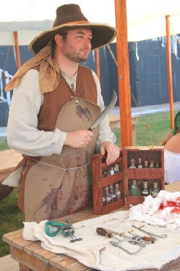
Edited April 27, 2012 by Mission

- Quote
- Edit
- Options

Fox
- Old Twillian
- Moderator

- 2,564 posts
- Gender:Male
- Location:Beautiful lush Devon, England
- Interests:Nautical history of the 16-18th centuries and living history based thereon.
Shooting pirates.
(IP: 86.144.28.216) · ·
Posted April 27, 2012 · Report post
Since I cut short the quotation earlier, and because I know you like medical things, the casualty list of the Dorrill was as follows:
"...our chiefe mate Mr Smith wounded in the leg close up to the knee with a piece of chaine, and the barber's mate two fingers shott off as hee was sponging a gun.
The Gunner's boy had his legg shot off when in the waist. Oure Quartermaster John Amos, had his leg shott off when at the helm, the Boatswaine's boy, a lad of thirteen,shott in the thigh going right through and splintering the bone, John Osbourne, in the Roundhouse, wounded in the temple, the Captain's boy on the Quarter deck, his skull raised by a shott. William Reynolds [the author of the letter] his boy, his hat shot off and his hand sore wounded, and John Blake, half his calf shott away."
Over a month later it was reported that "those who have since died of their wounds at sea are Chiefe Mate James Smith, Andrew Miller, George Mopp and Thomas Matthews.
Those who continue dangerously wounded are John Amos who hath lost one of his legs, and 'tis feared thatt one of John Blake's must also be cutt off."

Mission
- Goat Specialist
- Admin

- 5,082 posts
- Gender:Male
- Location:Monroe, MI
- Interests:Scholarly piracy, designing and creating haunted house rooms and props, movies, abstract thinking, abstruse thinking, obstructive thinking, ideating, random thinking, movies, cartoons, movies, movies scores, cycling, world peace and small furry dogs, movies, writing, drawing, personal skills training, gremlins and, of course, lest I forget, movies.
(IP: 12.232.174.154) · ·
Posted April 28, 2012 · Report post
Ah, thank you muchly! Interesting that most of the wounds appear to have been shot of some form or another. I wonder if they referred to splinters caused by cannon balls as being caused by gunshot?

- Quote
- Edit
- Options

Swashbuckler 1700
- Dread Pyrate
- Member

- 1,115 posts
- Gender:Male
- Location:Europe
- Interests:pyrates, pryvateers, naval military and other history, different books, good movies, music (a little bit), drawing, games,...
(IP: 80.223.160.249) · ·
Posted April 28, 2012 · Report post
On 4/28/2012 at 8:55 AM, Mission said:
Ah, thank you muchly! Interesting that most of the wounds appear to have been shot of some form or another. I wonder if they referred to splinters caused by cannon balls as being caused by gunshot?
I think both made enough splinters to cause damage. Even muskets were quite a guns.
One clear example that men prefered firearms.
I have heard from many (Yankee) documentaries that the musket could take your leg off but they are (too often) not be trusted( since the style is so often too scandal-seeking). This is not topic but is that a myth that the musket can took one's leg off?

