Mission
- Goat Specialist
- 
- 
- Admin

- 5,081 posts
- Gender:Male
- Location:Monroe, MI
- Interests:Scholarly piracy, designing and creating haunted house rooms and props, movies, abstract thinking, abstruse thinking, obstructive thinking, ideating, random thinking, movies, cartoons, movies, movies scores, cycling, world peace and small furry dogs, movies, writing, drawing, personal skills training, gremlins and, of course, lest I forget, movies.
Posted May 15, 2012 · Report post
Swashbuckler 1700 was sharing some images of Blas de Lezo with me. Señor de Lezo was a Spanish Commander active during the Golden Age of Piracy. (Wiki notes that he defended the city of Cartagena de Indias against the British Admiral Vernon (of grog invention fame) in a 1741 battle which was a turning point in the War of Jenkin's ear. I mention this only to bring up the War of Jenkin's Ear again, a war which continues to fascinate me. But I digress...)
Although he was not a pirate, Blas appears to have lost one of each of the standard pirate-associated missing body parts: an arm, a leg and an eye. This led me to wonder...
Where the heck did the eye patch-pirate association come from? Even Blas is never shown with one in the images Swashbuckler shared with me.
I can readily see how seamen and pirates lost eyes, what with all the splinters flying about during naval battles. Yet not one surgical author mentions this or the emblematic eye patch according to my notes. I can cite you all sorts of references to cataract-removal operations (done via a procedure then called 'couching'), but that procedure was designed to save vision, not cover it over with a black swatch.
So... pirate or even period sailor eye patches. Stories? References? Images? Anyone?

Swashbuckler 1700
- Dread Pyrate
- 
- 
- Member

- 1,115 posts
- Gender:Male
- Location:Europe
- Interests:pyrates, pryvateers, naval military and other history, different books, good movies, music (a little bit), drawing, games,...
Posted May 15, 2012 (edited) · Report post
Note that Lezo lost those in naval battles.
BTW in that the same Gartagena attack there was C. Ogle (who killed Black Bart) and the brother of G.Washington...
not sailor or even gaop but 16th C lady
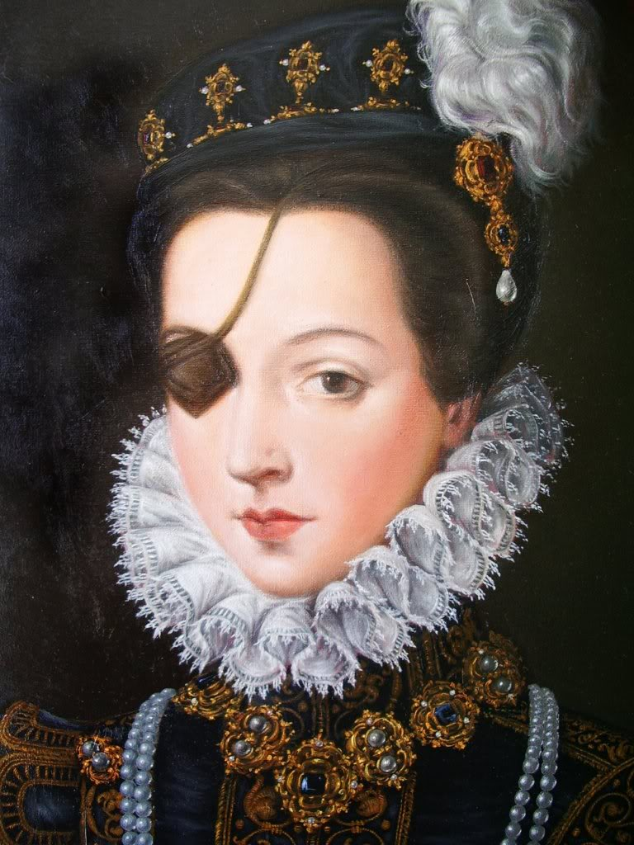
http://es.wikipedia....oza_de_la_Cerda
Edited May 15, 2012 by Swashbuckler 1700

Swashbuckler 1700
- Dread Pyrate
- Member

- 1,115 posts
- Gender:Male
- Location:Europe
- Interests:pyrates, pryvateers, naval military and other history, different books, good movies, music (a little bit), drawing, games,...
Posted May 16, 2012 (edited) · Report post
I think That the eye patches were used only for some time to keep the eye area free of dirt and bacteria.
This is from wiki but... I cannot say how accurate it is.
" (Captain) Levasseur proved himself a good leader and shipmate, although he already had a scar across one eye limiting his sight.
After a year of successful looting, the Hornigold party split, with Levasseur deciding to try his luck on the West African coast. In 1719 he operated together with Howell Davis and Thomas Cocklyn for a time. In 1720, they attacked the slaver port of Ouidah, on the coast of Benin, reducing the local fortress to ruins. Later that year, he was shipwrecked in theMozambique Channel and stranded on the island of Anjouan, one of the Comores. His bad eye had become completely blind by now so he started wearing an eyepatch."
Edited May 16, 2012 by Swashbuckler 1700

Mission
- Goat Specialist
- Admin

- 5,081 posts
- Gender:Male
- Location:Monroe, MI
- Interests:Scholarly piracy, designing and creating haunted house rooms and props, movies, abstract thinking, abstruse thinking, obstructive thinking, ideating, random thinking, movies, cartoons, movies, movies scores, cycling, world peace and small furry dogs, movies, writing, drawing, personal skills training, gremlins and, of course, lest I forget, movies.
Posted May 16, 2012 · Report post
Interesting that all the Wiki references are modern. Where is the period source of all information La Buse? It appears as if it may well be written in French...
[Edit]
Well, this page contains quite a bit of info as well as musings on why La Buse/La Bouche/Levasseur may not be as widely covered by the popular media as many of the other GAoP pirates. He also fails to mention his sources (bad form), but I suspect it's mostly culled from the General History.
Curious that this page, which appears to have done at least some actual period research, only describes him as "slight of build and as having had a limp." No eye patch or scar noted. I'm sure someone out there has better period info than that, though.
__
I did find a reference to a pirate captain without an eye, although an eye patch isn't mentioned. This is from the Captain Burgess account in The History of the Pirates (aka. Vol II of The General History):
"Burgess being of great use to them [an unnamed Dutch ship], they took him on board, and steered for a port, where some Dutch, taken in another ship, were marooned; but they were wrecked at Youngoul, where Burgess continued 18 months. After this time was expired, he was desirous of leaving the place, and addressed himself to the king.
__
who was uncle to the king of Methelage, he requested his black majesty to send him back to that port which he readily complied with, where Burgess continued almost five years, afflicted with sickness, in which he lost one eye." (Johnson, p. 183)
This was near the end of the chapter on Burgess and it is indicated that he committed no more pyracy during that time.

Mission
- Goat Specialist
- Admin

- 5,081 posts
- Gender:Male
- Location:Monroe, MI
- Interests:Scholarly piracy, designing and creating haunted house rooms and props, movies, abstract thinking, abstruse thinking, obstructive thinking, ideating, random thinking, movies, cartoons, movies, movies scores, cycling, world peace and small furry dogs, movies, writing, drawing, personal skills training, gremlins and, of course, lest I forget, movies.
Posted June 1, 2012 · Report post
Bumping this up to see if anyone has knowledge of any period references to La Buse/La Bouche/Levasseur outside of the General History...

Fox
- Old Twillian
- 
- 
- Moderator

- 2,564 posts
- Gender:Male
- Location:Beautiful lush Devon, England
- Interests:Nautical history of the 16-18th centuries and living history based thereon.
Shooting pirates.
Posted June 1, 2012 · Report post
Lots, but none that refer to him having only one eye.

Swashbuckler 1700
- Dread Pyrate
- Member

- 1,115 posts
- Gender:Male
- Location:Europe
- Interests:pyrates, pryvateers, naval military and other history, different books, good movies, music (a little bit), drawing, games,...
Posted June 1, 2012 · Report post
I think that the eye pach is no a thing that would need really much evidence...
De lezo apparently had no patch but he had eye that did not look so bad.... imagine ugglier looking eye wound that migth be thing covered by an eyepatch....


Swashbuckler 1700
- Dread Pyrate
- Member

- 1,115 posts
- Gender:Male
- Location:Europe
- Interests:pyrates, pryvateers, naval military and other history, different books, good movies, music (a little bit), drawing, games,...
Posted June 1, 2012 · Report post
Hey this 17th C beggar has charf around his (perhaps) wounded eye
Rembrandt Harmensz.(1606 Leiden - 1669 Amsterdam)
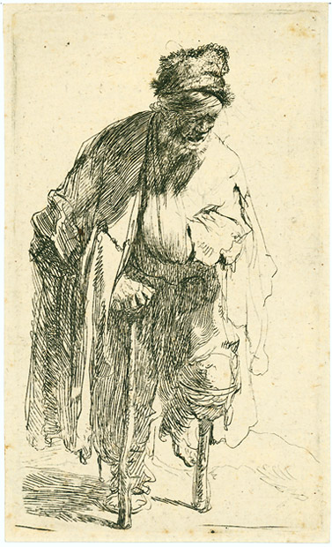

Mission
- Goat Specialist
- Admin

- 5,081 posts
- Gender:Male
- Location:Monroe, MI
- Interests:Scholarly piracy, designing and creating haunted house rooms and props, movies, abstract thinking, abstruse thinking, obstructive thinking, ideating, random thinking, movies, cartoons, movies, movies scores, cycling, world peace and small furry dogs, movies, writing, drawing, personal skills training, gremlins and, of course, lest I forget, movies.
Posted June 1, 2012 · Report post
Somehow eye patches got linked to the popular image of pirates and I'm trying to figure out how. Being a good researcher, I am trying to find some evidence...any evidence... of Golden Age of Piracy era eye patches on pirates. So far, nada. "Might be" and "no a thing that would need really much evidence" are a part of the reason crap like this is the modern conception of a pirate:

Say, where did the eye patch first enter the popular main stream?
[Edit]
This article by Johnathan Clayborn has some interesting features. He actually does find an historical pirate with an eye patch:
"The only pirate being recorded as having worn an eye patch is Rahmah ibn Jabir al-Jalahimah, an Arab pirate who sailed in the 1800's. He mostly sailed in the Persian Gulf and was described by an English author as "the most successful and the most generally tolerated pirate, perhaps, that ever infest any sea."
So, way past period. And, as he notes, not a popular mainstream persona, either. He makes a further interesting point.
"In examining the lives of over 400 notable naval officers of America, England, France & Spain I could not find any evidence that supports the notion that injuries to the eye were commonplace. And yes, there is a mountain of evidence to suggest that splinters were indeed very lethal aboard ships during combat, but usually the most common splinter injuries were to the torso, legs and arms. Most people use their hands and arms to shield their face in the case of flying debris, so injuries to the eye would have been somewhat mitigated by that action."

Silver
- Plunderer
- 
- 
- Member

- 347 posts
- Gender:Male
- Location:Virginia Beach, Virginia
- Interests:Maritime history
Posted June 1, 2012 · Report post
just a thought that came to mind, wearing an eye patch over a blind eye would be advertising your weak side to your enemies, i knew a girl with one good eye, it would annoy her if i stood to her blind side. no she didn't wear a patch.

Grymm
- First Mate
- 
- 
- Member

- 281 posts
- Gender:Male
- Location:Chilterns UK
- Interests:Stuff
Posted June 1, 2012 · Report post
Oooooh a project ... Interesting
Start now and work back,
TV and film, what's the earliest Pirate Movie are they
and all those naff Victorian prints of pirates
Popular or even crap novels, does treasure Island contain any descriptions of patched pirates or one eyed pirates
off to the bookshelf

Grymm
- First Mate
- Member

- 281 posts
- Gender:Male
- Location:Chilterns UK
- Interests:Stuff
Posted June 1, 2012 · Report post
Seems Ana de Mendoza y de la Cerda http://www.sightseeing-madrid.com/princess-of-eboli.php
'rocked' an eyepatch big time.

Mission
- Goat Specialist
- Admin

- 5,081 posts
- Gender:Male
- Location:Monroe, MI
- Interests:Scholarly piracy, designing and creating haunted house rooms and props, movies, abstract thinking, abstruse thinking, obstructive thinking, ideating, random thinking, movies, cartoons, movies, movies scores, cycling, world peace and small furry dogs, movies, writing, drawing, personal skills training, gremlins and, of course, lest I forget, movies.
Posted June 1, 2012 · Report post
Yeah, that's the portrait that Swashbuckler posted above. She's not a pirate, though.
Was there a pirate with an eye patch in the book Treasure Island? (Someone's gotta' help me here; I've never read it and Google isn't telling.)

Swashbuckler 1700
- Dread Pyrate
- Member

- 1,115 posts
- Gender:Male
- Location:Europe
- Interests:pyrates, pryvateers, naval military and other history, different books, good movies, music (a little bit), drawing, games,...
Posted June 2, 2012 · Report post
Lord Nelson was one eyed but he did not used an eye pacth http://www.forteantimes.com/strangedays/mythbusters/356/lord_nelsons_eyepatch.html

Swashbuckler 1700
- Dread Pyrate
- Member

- 1,115 posts
- Gender:Male
- Location:Europe
- Interests:pyrates, pryvateers, naval military and other history, different books, good movies, music (a little bit), drawing, games,...
Posted June 2, 2012 (edited) · Report post
From buccaneer artickles
"Thus they order for the loss of a right arm six hundred pieces of eight, or six slaves ; for the loss of a left arm five hundred pieces of eight, or five slaves ; for a right leg five hundred pieces of eight, or five slaves ; for the left leg four hundred pieces of eight, or four slaves ; for an eye one hundred pieces of eight, or one slave ; for a finger of the hand the same reward as for the eye."
So eyes were still in danger
Not only in battles but also in navigation as well:
When navigator was using a cross staff (used from 1400s till mid/ late 1700s) he needed always look directly to sun. Years of doing that would hurt your eyes quite a bit
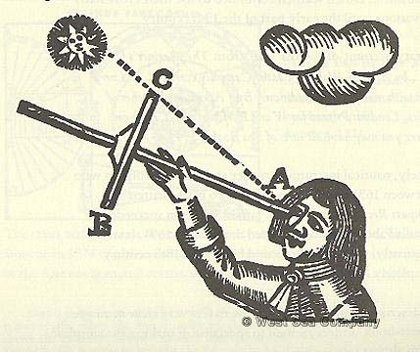
I think that there is no question were eyes losed or blinded but did those who lost or hurted them it use an pact? That is more hard question...
pictures of 1500s men
http://jcb.lunaimagi...2&mi=31&trs=112
http://jcb.lunaimagi...~2&mi=13&trs=20
Edited June 2, 2012 by Swashbuckler 1700

Swashbuckler 1700
- Dread Pyrate
- Member

- 1,115 posts
- Gender:Male
- Location:Europe
- Interests:pyrates, pryvateers, naval military and other history, different books, good movies, music (a little bit), drawing, games,...
Posted June 2, 2012 (edited) · Report post
Wiki says that this man was a eye patch user http://en.wikipedia....-Jacques_ContÃ© and him http://en.wikipedia....r_Francis_Bryan
they are in list of yey patch users
same with this man http://en.wikipedia....sco_de_Orellana look also this http://www.thepirate...rancisco_de.htm
It seems tha loosing limbs was more common than losing an eye
Robert's artickles
" X.
No Man to talk of breaking up their Way of Living, till each had shared a 1000 l. If in order to this, any Man should lose a Limb, or become a Cripple in their Service, he was to have 800 Dollars, out of the publick Stock, and for lesser Hurts, proportionably.
Edited June 2, 2012 by Swashbuckler 1700

Swashbuckler 1700
- Dread Pyrate
- Member

- 1,115 posts
- Gender:Male
- Location:Europe
- Interests:pyrates, pryvateers, naval military and other history, different books, good movies, music (a little bit), drawing, games,...
Posted June 2, 2012 (edited) · Report post
On 6/1/2012 at 7:19 PM, Mission said:
Yeah, that's the portrait that Swashbuckler posted above. She's not a pirate, though.
Was there a pirate with an eye patch in the book Treasure Island? (Someone's gotta' help me here; I've never read it and Google isn't telling.)
Pirate Pew is fully blind pirate
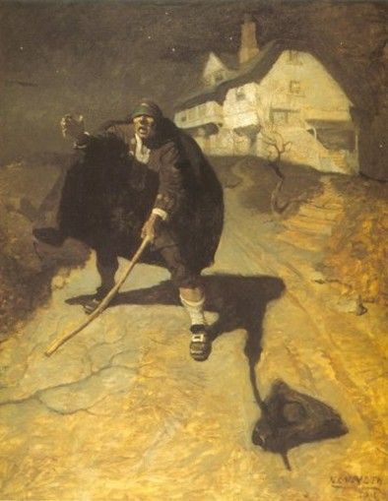
That was Treasure Island
now to history
I found this that seems to be an eye pacth
Greenwich hospital patients late 18th C

Edited June 2, 2012 by Swashbuckler 1700

Mission
- Goat Specialist
- Admin

- 5,081 posts
- Gender:Male
- Location:Monroe, MI
- Interests:Scholarly piracy, designing and creating haunted house rooms and props, movies, abstract thinking, abstruse thinking, obstructive thinking, ideating, random thinking, movies, cartoons, movies, movies scores, cycling, world peace and small furry dogs, movies, writing, drawing, personal skills training, gremlins and, of course, lest I forget, movies.
Posted June 2, 2012 · Report post
Wow, good stuff there! I particularly like the point about the articles. It doesn't really help with the eye patch point, but it does highlight the the idea that the danger of losing an eye was important enough to include in at least one set of articles. Thanks!

Swashbuckler 1700
- Dread Pyrate
- Member

- 1,115 posts
- Gender:Male
- Location:Europe
- Interests:pyrates, pryvateers, naval military and other history, different books, good movies, music (a little bit), drawing, games,...
Posted June 2, 2012 · Report post
BTW
those patients were in sailor hospital I forgot to told that but it is only one eye pacth and it is few decades later than gaop but they are sailors.....

Swashbuckler 1700
- Dread Pyrate
- Member

- 1,115 posts
- Gender:Male
- Location:Europe
- Interests:pyrates, pryvateers, naval military and other history, different books, good movies, music (a little bit), drawing, games,...
Posted June 2, 2012 (edited) · Report post
On 6/2/2012 at 5:05 AM, Swashbuckler 1700 said:
I think that there is no question were eyes losed or blinded but did those who lost or hurted them it use an pact? That is more hard question...
sorry for that
I mean that did those who lost an eye used eye patches or not? that is the more harder question not that were eyes lost or not since eyes were lost definately.
I also like to remind about hand grenades so often used. They could harm eyes quite a bit and you would not have much time to put your hands to cover your head or eyes before it explode.
Edited June 2, 2012 by Swashbuckler 1700

Swashbuckler 1700
- Dread Pyrate
- Member

- 1,115 posts
- Gender:Male
- Location:Europe
- Interests:pyrates, pryvateers, naval military and other history, different books, good movies, music (a little bit), drawing, games,...
Posted June 2, 2012 · Report post
one more way to lose an eye or eyes was pirate torture
this is quite good site . read the secion about "woolding” http://www.cindyvallar.com/torture.html

Mission
- Goat Specialist
- Admin

- 5,081 posts
- Gender:Male
- Location:Monroe, MI
- Interests:Scholarly piracy, designing and creating haunted house rooms and props, movies, abstract thinking, abstruse thinking, obstructive thinking, ideating, random thinking, movies, cartoons, movies, movies scores, cycling, world peace and small furry dogs, movies, writing, drawing, personal skills training, gremlins and, of course, lest I forget, movies.
Posted June 2, 2012 · Report post
On 6/2/2012 at 7:36 AM, Swashbuckler 1700 said:
I mean that did those who lost an eye used eye patches or not? that is the more harder question not that were eyes lost or not since eyes were lost definately.
Curiously, I have found very few accounts of this in the period medical literature. It was very common at this time for surgical writers to stuff case studies into the middle of their medical literature to illustrate the cures they had seen and performed. I now have six period or near-period books specific to sea surgery (two of which - Hugh Ryder's New practical observations in surgery containing divers remarkable cases and cures and John Moyle's Chyrurgic memoirs : being an account of many extraordinary cures which occurred in the series of the author's practice are devoted exclusively to case studies) and have not seen a complete account of a cure of someone having lost an eye. (So far. I haven't finished Ryder's book yet.) I have read LOTS of accounts of splinter-removals, amputations, open wounds, broken bones, abdominal damage and head wounds.

Swashbuckler 1700
- Dread Pyrate
- Member

- 1,115 posts
- Gender:Male
- Location:Europe
- Interests:pyrates, pryvateers, naval military and other history, different books, good movies, music (a little bit), drawing, games,...
Posted June 2, 2012 (edited) · Report post
But of course eyes were lost they are lost today as well ( I now it is not good looking history and compare it with modern people but...)... oh even now at least here people lost eyes in the new year when they were firing rockets think a world with real explosives, cannons, swords, bombs, and wood sticks.....
Here is pictures of old eye operation but most of them are cataract treatment
from 1500s of eye operation
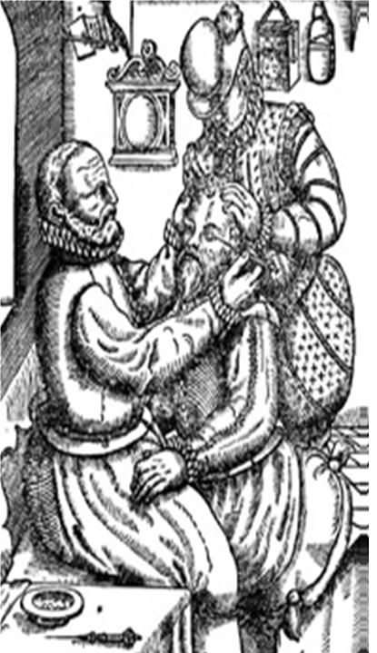
Here 18th C stuff
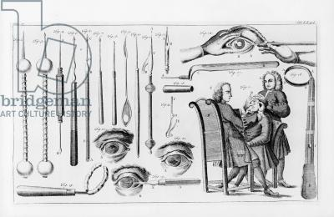
see here http://www.bridgeman...aving-b?lang=fr
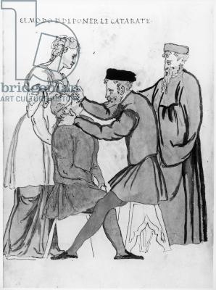
late medieval
http://www.bridgeman...tem_index":110}
Edited June 2, 2012 by Swashbuckler 1700

Swashbuckler 1700
- Dread Pyrate
- Member

- 1,115 posts
- Gender:Male
- Location:Europe
- Interests:pyrates, pryvateers, naval military and other history, different books, good movies, music (a little bit), drawing, games,...
Posted June 2, 2012 (edited) · Report post
On 6/2/2012 at 9:35 AM, Mission said:
On 6/2/2012 at 7:36 AM, Swashbuckler 1700 said:
I mean that did those who lost an eye used eye patches or not? that is the more harder question not that were eyes lost or not since eyes were lost definately.
Curiously, I have found very few accounts of this in the period medical literature. It was very common at this time for surgical writers to stuff case studies into the middle of their medical literature to illustrate the cures they had seen and performed. I now have six period or near-period books specific to sea surgery (two of which - Hugh Ryder's New practical observations in surgery containing divers remarkable cases and cures and John Moyle's Chyrurgic memoirs : being an account of many extraordinary cures which occurred in the series of the author's practice are devoted exclusively to case studies) and have not seen a complete account of a cure of someone having lost an eye. (So far. I haven't finished Ryder's book yet.) I have read LOTS of accounts of splinter-removals, amputations, open wounds, broken bones, abdominal damage and head wounds.
Interesting but eyes were lost still but it seems less constantly than many other things like legs. I trust your research since you have done lots of it and done it well and done it so long but perhaps you have missed some cases with eyes. It is also possible that eye wounds were so hard to deal with that some doctors not even dare to try.
But men like De Lezo or later Nelson are exsamples of one eyed naval persons.
OK from wiki but it seems to be accurate
" Nelson was struck by debris in his right eye and was forced to retire from the position, although his wound was soon bandaged and he returned to action"
Edited June 2, 2012 by Swashbuckler 1700

Swashbuckler 1700
- Dread Pyrate
- Member

- 1,115 posts
- Gender:Male
- Location:Europe
- Interests:pyrates, pryvateers, naval military and other history, different books, good movies, music (a little bit), drawing, games,...
Posted June 2, 2012 (edited) · Report post
The Nelson ideed lost his eye in battle but had no eye pacth http://www.telegraph...-historian.html
Eye patces are perhaps came from "Pirate's Own Book" which is not too good early 19th C book about pirates and especially the gaop ones
picture from there
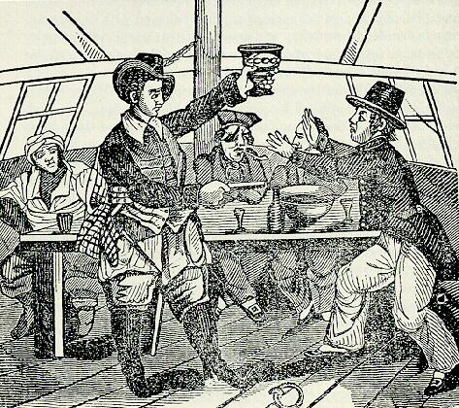
Edited June 2, 2012 by Swashbuckler 1700

Mission
- Goat Specialist
- Admin

- 5,081 posts
- Gender:Male
- Location:Monroe, MI
- Interests:Scholarly piracy, designing and creating haunted house rooms and props, movies, abstract thinking, abstruse thinking, obstructive thinking, ideating, random thinking, movies, cartoons, movies, movies scores, cycling, world peace and small furry dogs, movies, writing, drawing, personal skills training, gremlins and, of course, lest I forget, movies.
Posted June 2, 2012 · Report post
I'm not saying it didn't happen, that would be absurd. I'm saying it doesn't appear to have been very common at sea. If it were, at least one of the sea surgeon's guides would have devoted space on what to do in that case.
Sea surgeon manuals were targeted towards operations the surgeon might encounter. They were meant to be a sort of quick reference manual for newly minted surgeons or (in the worst case) laymen who were tasked with performing surgery at sea where no surgeon was present. This is why none of them discuss how to deliver infants, for example. So the lack of information on how to treat a damaged or missing eye is somewhat telling by its absence.
As for your images, those all appear to be examples of couching - pushing cataracts out of the way of vision in the eye. The middle drawing (from Lorenz Heister's 1742 book, I think) shows this pretty clearly. The surgeon actually inserts a small needle into the eye to try to move the cataract. That's why the surgeon is holding a small instrument each photo.
There are several examples of the couching procedure mentioned in period medicine books. (And why not? The operation has been around since before the birth of Christ.) But this procedure is not mentioned in any of the sea surgeon manuals, because, as an elective surgery, it would not be performed at sea where the ship moving might interfere with such a delicate operation.

Swashbuckler 1700
- Dread Pyrate
- Member

- 1,115 posts
- Gender:Male
- Location:Europe
- Interests:pyrates, pryvateers, naval military and other history, different books, good movies, music (a little bit), drawing, games,...
Posted June 2, 2012 (edited) · Report post
On 6/2/2012 at 1:42 PM, Mission said:
I'm not saying it didn't happen, that would be absurd. I'm saying it doesn't appear to have been very common at sea. If it were, at least one of the sea surgeon's guides would have devoted space on what to do in that case.
Sea surgeon manuals were targeted towards operations the surgeon might encounter. They were meant to be a sort of quick reference manual for newly minted surgeons or (in the worst case) laymen who were tasked with performing surgery at sea where no surgeon was present. This is why none of them discuss how to deliver infants, for example. So the lack of information on how to treat a damaged or missing eye is somewhat telling by its absence.
As for your images, those all appear to be examples of couching - pushing cataracts out of the way of vision in the eye. The middle drawing (from Lorenz Heister, I think) shows this pretty clearly. The surgeon actually inserts a small needle into the eye to try to move the cataract. That's why the surgeon is holding a small instrument each photo. There are several examples of the couching procedure mentioned in period medicine books. (And why not? The operation has been around since before the birth of Christ.) But this procedure is not mentioned in any of the sea surgeon manuals, because, as an elective surgery, it would not be an operation that would be performed at sea where the ship moving interfere with such a delicate operation.
Indeed I think that you are right.
I think you still need to mention (in your surgeon bage) that eyes were lost. But It was not as common than people migth think. so sailor with wooden leg was more common sight than one eyed or indeed eye pacthed...
What do you say about that sailor picture (pensioners) the man has quite clear eye pacth and I think that there are some few more pensioner pictures with eye patches than that. But sadly it is a bit later (from later 18th c) : /
Edited June 2, 2012 by Swashbuckler 1700

Mission
- Goat Specialist
- Admin

- 5,081 posts
- Gender:Male
- Location:Monroe, MI
- Interests:Scholarly piracy, designing and creating haunted house rooms and props, movies, abstract thinking, abstruse thinking, obstructive thinking, ideating, random thinking, movies, cartoons, movies, movies scores, cycling, world peace and small furry dogs, movies, writing, drawing, personal skills training, gremlins and, of course, lest I forget, movies.
Posted June 2, 2012 · Report post
I found this in Dionis's book (Dionis being a French land surgeon during period.) It doesn't say much about the likelihood of eye injuries, nor anything about their occurrence at sea, but it is still interesting in light of our discussion.
“We draw two Advantages from this Addition, the first is ornamental, as when we fix in an artificial Eye or Tooth; the second, is for Necessity, as when we add a wooden Arm or Leg; and ‘tis particularly this last Species of Prosthesis which is necessary, since without its help the Man can’t act." (Dionis, p. 416)
Oh, and here it is! I am wrong in what I said about there being no accounts of eyes being lost at sea!
Quote
“EXAMPLE III.
An Eye struck out by a Splinter making one Side of the Os Nasi and Spongiosi bare.
Alexander Henderson, in that grand Naval Fight of ours with the French off Malaga, 1703. had his left Eye struck out by a Splinter, making that Side of the Os Nasi and Spongiosi bare: and from which several little Splints of them were easily drawn away with the Forceps. I cut away the lacerated Teguments in the Wounds, as far as they appeared to be insensible; drest it and the Bone immediately with equal Parts of Tinct. Myrrh. a Fomentation and Decoction warm’d; over that again Pledgets of Digestive, a Compress, and a double Fold of Linnen pinned down to retain all. Where one Side of the Os Nasi was perceived loose, stricter
__
Bandage would have depressed and disfigur’d: Instead of which, I advised him to practice the Smoothing of it, with his Finger frequently, that it might fasten evenly.
In six Weeks the Wound was incarned [skin had regrown in it], and healed; but soon gave Notice by a pricking Pain, Tenderness, and Tumor about it, that some Ossicles [small pieces of bone] or Exfoliation was further to be expected. The Cicatrix [scar covering the wound] being thin, I broke through it with my Probe, and enlarged with the Scissars, discharging a fœtid Matter.
A small Scale or two soon came away by the Wound; as did also another thro’ his Nose, (on blowing of it;) after this it healed, and continued firm.” (John Atkins, The Navy Surgeon, p. 142-3)
No mention of an eye patch, but it is a splinter taking out an eye at sea. Unfortunately, it's the only one I found. (I don't know how I missed it before.)
Here's some grisly ones for you that have nothing to do with the sea. (Bradwell has some of the most bizarre cases and treatments in his book. That's why I read it.)
Quote
"I was in place about seaven yeares since, when some Gentlemen were taking Tobacco; and as one had knocked out the snuffe or coale of it on the Table; another in jest blew it toward him, he also blew it at him againe. This began to be pursued from one to the other, till a little Girle looking on (whose height was little above the Table) received the evill of their jesting; for some of the burning coale of Tobacco was blown into her eye. It tormented her extreamely (as nothing burneth more terribly) I ran into the garden, where I found some ground Ivie, whereof I gathered some,
__
which I stamped, and strayned, and putting a little fine powdred Sugar to the Juice, I dropped some of it into her eye; upon which she received sudden ease, and had it not applyed above twice more, before she was perfectly well: But in the meane time, her eye was muffled up from the outward ayre.
Here observe that the eye must never be dressed with any Oyle or Oyntment [the common treatment for burning was egg white with oil - I have often seen recipes call for "salatting [salad] oyle"]; because oyly and greasie things diminish the sight." (Stephen Bradwell, Helps for Suddain Accidents Endangering Life, p. 122-3)
___ ___ ___ ___ ___ ___ ___ ___ ___ ___ ___ ___ ___ ___ ___ ___
Not long agoe I saw a young man stung in the eye-ball with a Bee, while he was too closely looking into the doore of the hive: But the Bee left not her sting there. Upon the place, I tooke a handfull of Carduus benedictus [blessed thistle] newly gathered, pounded it into a morter very fine, and mixed it with the white of an egge, so spreading it upon a pledget of flaxe, I laid it to the eye, and as it waxed dry, renued it twice. This Playster of Carduus is excellent to recover the eye if any venomous juice be spurted into it, or if the eye be hurt by a corrupt ayre, which the common people call baslting: It easeth paines; taketh away bloudy spots in the eyes; and is good for all burnings in, or about the eyes." (Bradwell, p. 48-9)

Mission
- Goat Specialist
- Admin

- 5,081 posts
- Gender:Male
- Location:Monroe, MI
- Interests:Scholarly piracy, designing and creating haunted house rooms and props, movies, abstract thinking, abstruse thinking, obstructive thinking, ideating, random thinking, movies, cartoons, movies, movies scores, cycling, world peace and small furry dogs, movies, writing, drawing, personal skills training, gremlins and, of course, lest I forget, movies.
Posted June 2, 2012 · Report post
On 6/2/2012 at 1:46 PM, Swashbuckler 1700 said:
What do you say about that sailor picture (pensioners) the man has quite clear eye pacth and I think that there are some few more pensioner pictures with eye patches than that. But sadly it is a bit later (from later 18th c) : /
It's still a pretty good find IMO. It proves yet another sailor lost his eye somewhere along the way, although it doesn't necessarily mean this was at sea. But it is an 18th century eye patch on a sailor.

Swashbuckler 1700
- Dread Pyrate
- Member

- 1,115 posts
- Gender:Male
- Location:Europe
- Interests:pyrates, pryvateers, naval military and other history, different books, good movies, music (a little bit), drawing, games,...
Posted June 2, 2012 · Report post
At least there were one eyed men but how much did they have eye patches that is still a bit unsure....

Fox
- Old Twillian
- Moderator

- 2,564 posts
- Gender:Male
- Location:Beautiful lush Devon, England
- Interests:Nautical history of the 16-18th centuries and living history based thereon.
Shooting pirates.
Posted June 2, 2012 · Report post
Philip Lyne, a pirate, lost an eye. They didn't cure it though, they hanged him. Probably a bit extreme for most surgeons.

Swashbuckler 1700
- Dread Pyrate
- Member

- 1,115 posts
- Gender:Male
- Location:Europe
- Interests:pyrates, pryvateers, naval military and other history, different books, good movies, music (a little bit), drawing, games,...
Posted June 3, 2012 · Report post
On 6/2/2012 at 7:27 PM, Foxe said:
Philip Lyne, a pirate, lost an eye. They didn't cure it though, they hanged him. Probably a bit extreme for most surgeons.
Surgeon hangeg him?
I think since as far as I know eyes are hard to cure perhaps reason for that why there is little mentions about eye cases is due of that there were no real treantment....

Mission
- Goat Specialist
- Admin

- 5,081 posts
- Gender:Male
- Location:Monroe, MI
- Interests:Scholarly piracy, designing and creating haunted house rooms and props, movies, abstract thinking, abstruse thinking, obstructive thinking, ideating, random thinking, movies, cartoons, movies, movies scores, cycling, world peace and small furry dogs, movies, writing, drawing, personal skills training, gremlins and, of course, lest I forget, movies.
Posted June 3, 2012 · Report post
What's that from, Ed?

Fox
- Old Twillian
- Moderator

- 2,564 posts
- Gender:Male
- Location:Beautiful lush Devon, England
- Interests:Nautical history of the 16-18th centuries and living history based thereon.
Shooting pirates.
Posted June 3, 2012 · Report post
It was a bit tongue in cheek.
"as they were very much wounded, and no care taken in dressing, they were very offensive, and Stunk as they went along, particularly Lines, the Commander, who had one Eye shot out, which with part of his Nose hung down his Face..."
The Evening Post, 28 May 1726, describes Lyne and his crew on the way to their trial.

Mission
- Goat Specialist
- Admin

- 5,081 posts
- Gender:Male
- Location:Monroe, MI
- Interests:Scholarly piracy, designing and creating haunted house rooms and props, movies, abstract thinking, abstruse thinking, obstructive thinking, ideating, random thinking, movies, cartoons, movies, movies scores, cycling, world peace and small furry dogs, movies, writing, drawing, personal skills training, gremlins and, of course, lest I forget, movies.
Posted June 3, 2012 · Report post
Ah. Still it's another example of pirate with no eye.

Swashbuckler 1700
- Dread Pyrate
- Member

- 1,115 posts
- Gender:Male
- Location:Europe
- Interests:pyrates, pryvateers, naval military and other history, different books, good movies, music (a little bit), drawing, games,...
Posted June 3, 2012 (edited) · Report post
Hmm even greener ligth for one eyed pirates but for eyepatches evidence it is not too clear....
Edited June 3, 2012 by Swashbuckler 1700

Mission
- Goat Specialist
- Admin

- 5,081 posts
- Gender:Male
- Location:Monroe, MI
- Interests:Scholarly piracy, designing and creating haunted house rooms and props, movies, abstract thinking, abstruse thinking, obstructive thinking, ideating, random thinking, movies, cartoons, movies, movies scores, cycling, world peace and small furry dogs, movies, writing, drawing, personal skills training, gremlins and, of course, lest I forget, movies.
Posted June 3, 2012 · Report post
Yeah, I'd say we have to call pirate eyepatches an unknown at this time. They certainly existed and it seems logical that they might be used in the case of medical/cosmetic cases, but no evidence has been produced.

Swashbuckler 1700
- Dread Pyrate
- Member

- 1,115 posts
- Gender:Male
- Location:Europe
- Interests:pyrates, pryvateers, naval military and other history, different books, good movies, music (a little bit), drawing, games,...
Posted June 18, 2013 (edited) · Report post
Nothing groundbreaking but something more to this old thread
too late for gaop but it seems to me that scarfs were used to cover many wounds including eyes
No date but it is made by Thomas Rowlandson (13 July 1756 – 21 April 1827) likely not much after the battle (1798)
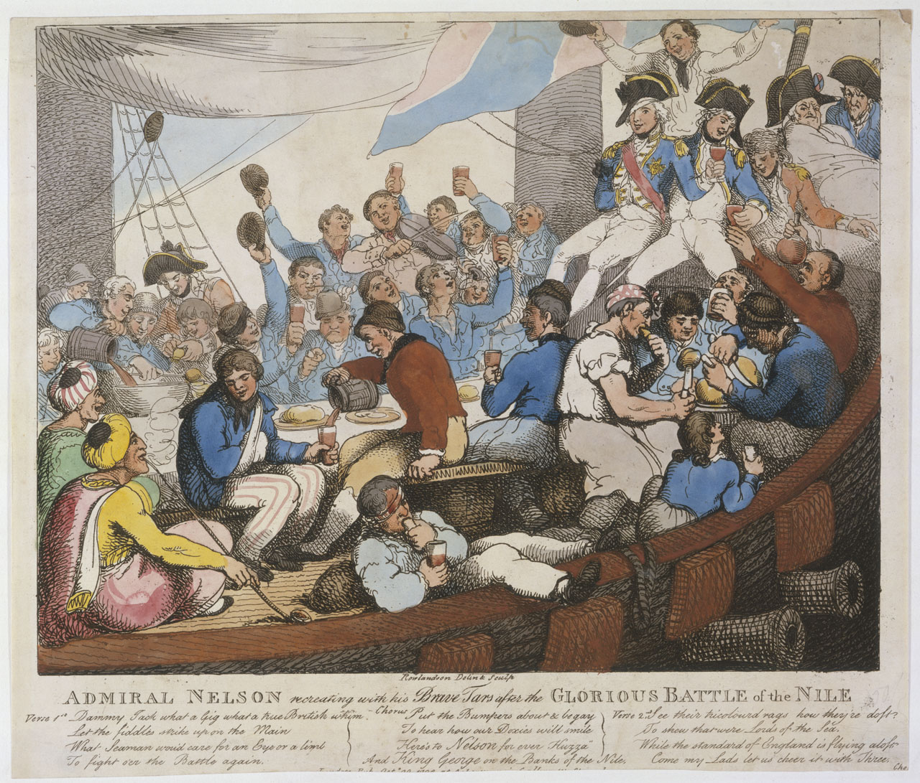
This is even later but a Trafalgar veteran circa 1844
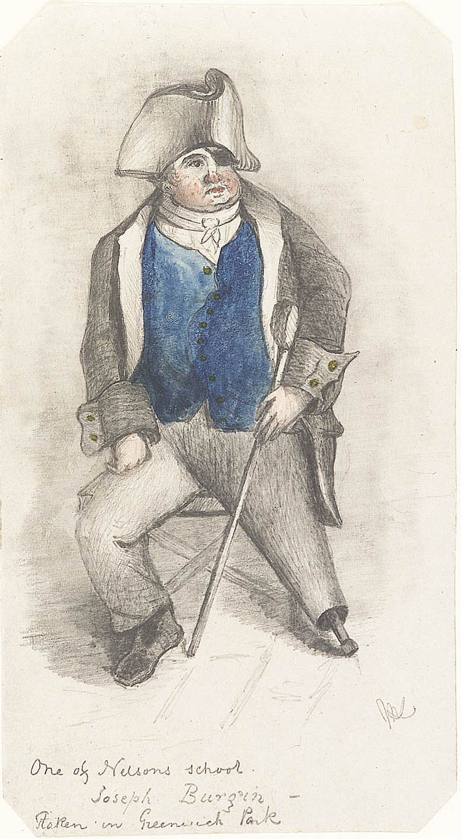
Edited June 18, 2013 by Swashbuckler 1700

Jib
- Dread Pyrate
- 
- Member

- 1,078 posts
- Gender:Male
- Location:Minneapolis, MN
- Interests:Piracy, stage combat, martial arts, reading, film, travel
Posted June 19, 2013 · Report post
When I was a kid and road the school bus to grade school, I had a friend who had what he called a "dead eye". His eye turned milky the older he got. Despite not being able to see out of the eye it was sensitive to light. By the time we were both in High School he had a permanent squint with one eye (think Popeye).
So let me suggest this. Perhaps a patch wasn't as often when a sailor lost an eye but instead had a damaged eye?

Mission
- Goat Specialist
- Admin

- 5,081 posts
- Gender:Male
- Location:Monroe, MI
- Interests:Scholarly piracy, designing and creating haunted house rooms and props, movies, abstract thinking, abstruse thinking, obstructive thinking, ideating, random thinking, movies, cartoons, movies, movies scores, cycling, world peace and small furry dogs, movies, writing, drawing, personal skills training, gremlins and, of course, lest I forget, movies.
Posted June 20, 2013 · Report post
It's quite possible. I vaguely recall having a discussion about using an an eye patch to cover damaged eyes, either here on on my Pirate Surgeon Facebook page.
The trope about peg-legged, hook-armed, patched-eye sailor probably originated with the Greenwich Pensioners, as pointed out by Foxe. Based on pm discussions I had with Brit.Privateer, I came to the conclusion that the pirate connection was just a refined Hollywood extension of those caricatured sailors. (Do an image search for Greenwich pensioner and you'll see all sorts of cartooned former sailors with battle damage.)
As I mentioned in the article I wrote after we had this discussion, damaged eyes were also common on land. I found several period references to this, although I didn't use all of them in my write-up because I was focusing on eye damage sustained at sea.

Swashbuckler 1700
- Dread Pyrate
- Member

- 1,115 posts
- Gender:Male
- Location:Europe
- Interests:pyrates, pryvateers, naval military and other history, different books, good movies, music (a little bit), drawing, games,...
Posted June 23, 2013 (edited) · Report post
Furthermore about Horatio Nelson. Yes not a pirate and later than Gaop but related enough I think.
​Firstly a picture of wounded Nelson wearing a scarf/bandage circa 1800
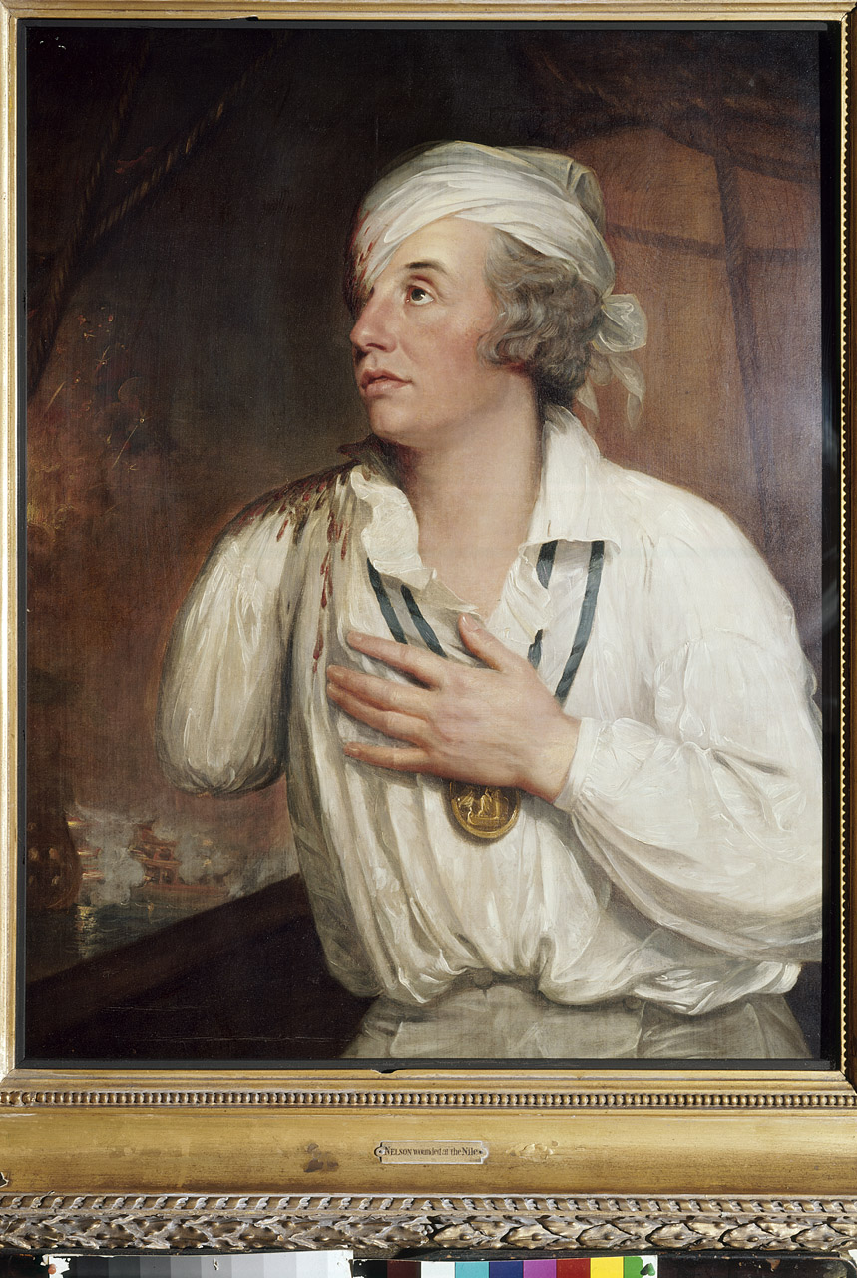
Here a part of the NMM's description "The portrait is believed to have been owned by Nelson. This significantly means that it is probably based on an accurate account of his battered appearance at this period. He had been severely injured above the eye, bandaged, racked with a headache and pain, and probably concussed."
Just to show that eyes could get hurt in battles during the age of sail. Not that anyone would have said anything else.
There has been a popular myth that Nelson wore an eye-patch
Hollywood seems to the one to blame but I don't know how old the myth is. Nelson in "That Hamilton Woman" in 1941

One of the countless places where the myth is busted Yes it is serious site while the picture there is humorous http://www.forteantimes.com/strangedays/mythbusters/356/lord_nelsons_eyepatch.html
The Stuff of the Nelson's navy and era has been mixed to pirates in great many fictional works and I believe the myth that nelson had an black eye-patch has something to do with the pirates' eye-patch too.
Edited June 23, 2013 by Swashbuckler 1700

Daniel
- Pyrate Captain
- 
- 
- Member

- 652 posts
- Gender:Male
- Location:McLean, VA
- Interests:History, pirates, fiction, writing, writing historical fiction about pirates, jokes, games, law.
Posted July 3, 2013 · Report post
Here's an article by Benerson Little on eyepatches http://undertheblackflag.com/?p=2904〈=en. He says Captain Colepepper wore an eyepatch in Walter Scott's The Fortunes of Nigel, which may have been the first appearance of a pirate eyepatch in fiction.
Oddly, I can't think of an eyepatch being shown by any of the famous old-time pirate illustrators: Pyle, Schoonover, or even Wyeth.

Swashbuckler 1700
- Dread Pyrate
- Member

- 1,115 posts
- Gender:Male
- Location:Europe
- Interests:pyrates, pryvateers, naval military and other history, different books, good movies, music (a little bit), drawing, games,...
Posted July 4, 2013 (edited) · Report post
Oh I knew that article. All in all I like all the stuff Beneson Little has in his sites and articles. Someday perhaps I need to read some of his books...
And well Pyle's paintings don't show much eye patches but he made also other illustrations. Like here
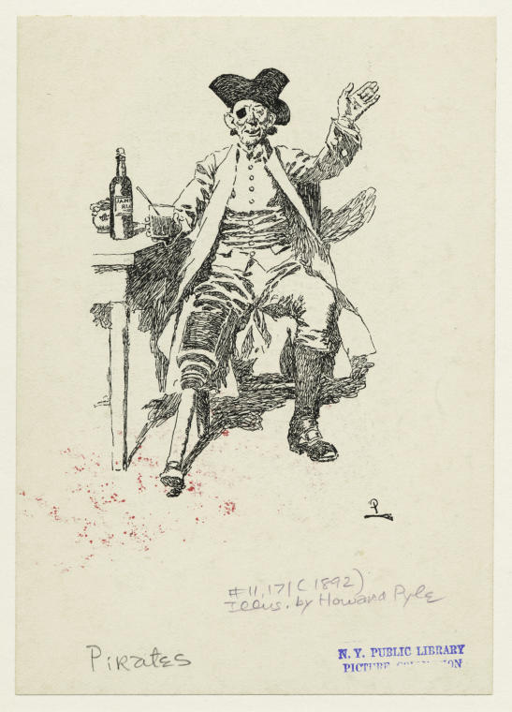
Still he generally showed pirates with both eyes and legs. I think the lack of those pirate cliches is one reason why at least sometimes, if not often, Pyle's works have been though to be more accurate than they are....
Edited July 4, 2013 by Swashbuckler 1700

Mission
- Goat Specialist
- Admin

- 5,081 posts
- Gender:Male
- Location:Monroe, MI
- Interests:Scholarly piracy, designing and creating haunted house rooms and props, movies, abstract thinking, abstruse thinking, obstructive thinking, ideating, random thinking, movies, cartoons, movies, movies scores, cycling, world peace and small furry dogs, movies, writing, drawing, personal skills training, gremlins and, of course, lest I forget, movies.
Posted July 4, 2013 · Report post
Some of Pyle's works are definitely more accurate than others. I have used them on my website on occasion. It is almost impossible to avoid putting modern touches in your work, though. We live in the now and can only view the past through a lens which includes our experiences. (I am always curious when people who say they should have been born in another time - past or future. They would be completely lost and anyone who believes otherwise is fooling themselves. You could adapt, of course, because humans are built to do that to a degree, but I doubt they'd be nearly as happy as they think.)

