Captain Jim
- Captain Jim for Captain!
- 
- 
- Member

- 2,254 posts
- Gender:Male
- Location:Off the coast of Tampa Bay (Unfortunately, inland from the coast)
- Interests:I'm 57, formerly a wildlife ecologist and biologist, now a stay-at-home dad. I grew up on the west coast of Florida, where Anna Maria Sound and Tampa Bay were my playground. My interests include, but are not limited to cannon, black powder arms, history, fishing the flats, sailing, fine wood working, flint gun building, hunting, good gun dogs. Above all, my wife and children.
(IP: 12.195.96.153) ·
Posted February 26, 2013 · Report post
For a long time now I have been looking for the earliest reference to a "tin kitchen", a kind of half-round reflector oven. To date I have only been able to find references to around the time of the Revolution. That is until tonight. On the 18th Century Material Culture's Facebook page I found two paintings dating to the late 1600's with clear depictions of the "tin kitchen." "The Cook, 1657-1667" and an untitled work dated sometime prior to 1678.

So now I will buy a tin kitchen and use it secure in the knowledge that it is at least period. Now, can anyone find a reference to one of these, or something similar, being aboard a ship?

- Quote
- Edit

William Brand
- Mercury Malefactor
- 
- 
- Admin

- 8,884 posts
- Gender:Male
- Location:Logan, Utah
- Interests:My name is William Pace and I live and work as a graphic designer, illustrator and photographer in Northern Utah. I'm married to the lovely Tracy Pace and we have three children. In addition to all things art, I enjoy traveling and meeting new people from every walk of life. I've always been a fan of history, theology, and of course, Pyracy.
http://www.youtube.com/watch?v=PSkt-q-HihQ
(IP: 166.70.59.121) · ·
Posted February 26, 2013 · Report post
I've seen them during Napoleonic times. In fact, I believe they show one in Master and Commander. It stands to reason that they'd use one if they could, but I'll start looking.

- Quote
- Edit
- Options

William Brand
- Mercury Malefactor
- Admin

- 8,884 posts
- Gender:Male
- Location:Logan, Utah
- Interests:My name is William Pace and I live and work as a graphic designer, illustrator and photographer in Northern Utah. I'm married to the lovely Tracy Pace and we have three children. In addition to all things art, I enjoy traveling and meeting new people from every walk of life. I've always been a fan of history, theology, and of course, Pyracy.
http://www.youtube.com/watch?v=PSkt-q-HihQ
(IP: 166.70.59.121) · ·
Posted February 26, 2013 · Report post
I haven't found it yet, but it's also called a vasculum and you can buy one here...
http://www.cg-tinsmith.com/catalog2.htm#vasculum

- Quote
- Edit
- Options

Captain Jim
- Captain Jim for Captain!
- Member

- 2,254 posts
- Gender:Male
- Location:Off the coast of Tampa Bay (Unfortunately, inland from the coast)
- Interests:I'm 57, formerly a wildlife ecologist and biologist, now a stay-at-home dad. I grew up on the west coast of Florida, where Anna Maria Sound and Tampa Bay were my playground. My interests include, but are not limited to cannon, black powder arms, history, fishing the flats, sailing, fine wood working, flint gun building, hunting, good gun dogs. Above all, my wife and children.
(IP: 12.195.96.153) · ·
Posted February 26, 2013 · Report post
Not the same thing, mate, although as a biologist I may have to get one of those now, too. Damn you.
This is what we're looking at:

- Quote
- Edit
- Options

Captain Jim
- Captain Jim for Captain!
- Member

- 2,254 posts
- Gender:Male
- Location:Off the coast of Tampa Bay (Unfortunately, inland from the coast)
- Interests:I'm 57, formerly a wildlife ecologist and biologist, now a stay-at-home dad. I grew up on the west coast of Florida, where Anna Maria Sound and Tampa Bay were my playground. My interests include, but are not limited to cannon, black powder arms, history, fishing the flats, sailing, fine wood working, flint gun building, hunting, good gun dogs. Above all, my wife and children.
(IP: 12.195.96.153) · ·
Posted February 26, 2013 (edited) · Report post
Oh, but on the same page as you posted, right below the vasculum, is a tin kitchen. But, like most, he wants $450 for it. Not going to happen. The one I posted is $130.
Edited February 26, 2013 by Captain Jim

- Quote
- Edit
- Options

William Brand
- Mercury Malefactor
- Admin

- 8,884 posts
- Gender:Male
- Location:Logan, Utah
- Interests:My name is William Pace and I live and work as a graphic designer, illustrator and photographer in Northern Utah. I'm married to the lovely Tracy Pace and we have three children. In addition to all things art, I enjoy traveling and meeting new people from every walk of life. I've always been a fan of history, theology, and of course, Pyracy.
http://www.youtube.com/watch?v=PSkt-q-HihQ
(IP: 166.70.59.121) · ·
Posted February 26, 2013 · Report post
Yeah, sorry. It was mislabled on a tin kitchen I found in an image search, but it led to the dealer, so it's sixes.

- Quote
- Edit
- Options

Captain Jim
- Captain Jim for Captain!
- Member

- 2,254 posts
- Gender:Male
- Location:Off the coast of Tampa Bay (Unfortunately, inland from the coast)
- Interests:I'm 57, formerly a wildlife ecologist and biologist, now a stay-at-home dad. I grew up on the west coast of Florida, where Anna Maria Sound and Tampa Bay were my playground. My interests include, but are not limited to cannon, black powder arms, history, fishing the flats, sailing, fine wood working, flint gun building, hunting, good gun dogs. Above all, my wife and children.
(IP: 12.195.96.153) · ·
Posted February 26, 2013 · Report post
Here is what I'm thinking, in terms of this tin kitchen. As far as I know, the iron oven/stove wasn't invented until 1735 or later (more likely after 1800.) Most cooking at this (1720) time was done on open hearths or brick and mortar bread-type ovens. So how did sailors cook before the advent of the iron stove? Would they have used what was common on shore and just moved it aboard ship? Were open hearth/oven combinations, like on shore, used on ship?

- Quote
- Edit
- Options

Captain Jim
- Captain Jim for Captain!
- Member

- 2,254 posts
- Gender:Male
- Location:Off the coast of Tampa Bay (Unfortunately, inland from the coast)
- Interests:I'm 57, formerly a wildlife ecologist and biologist, now a stay-at-home dad. I grew up on the west coast of Florida, where Anna Maria Sound and Tampa Bay were my playground. My interests include, but are not limited to cannon, black powder arms, history, fishing the flats, sailing, fine wood working, flint gun building, hunting, good gun dogs. Above all, my wife and children.
(IP: 12.195.96.153) · ·
Posted February 26, 2013 (edited) · Report post
Now here I have found this diagram of a warship that shows a brick-and-mortar open hearth fireplace and oven, #31 in the list, just abaft the foremast, second deck below weather.
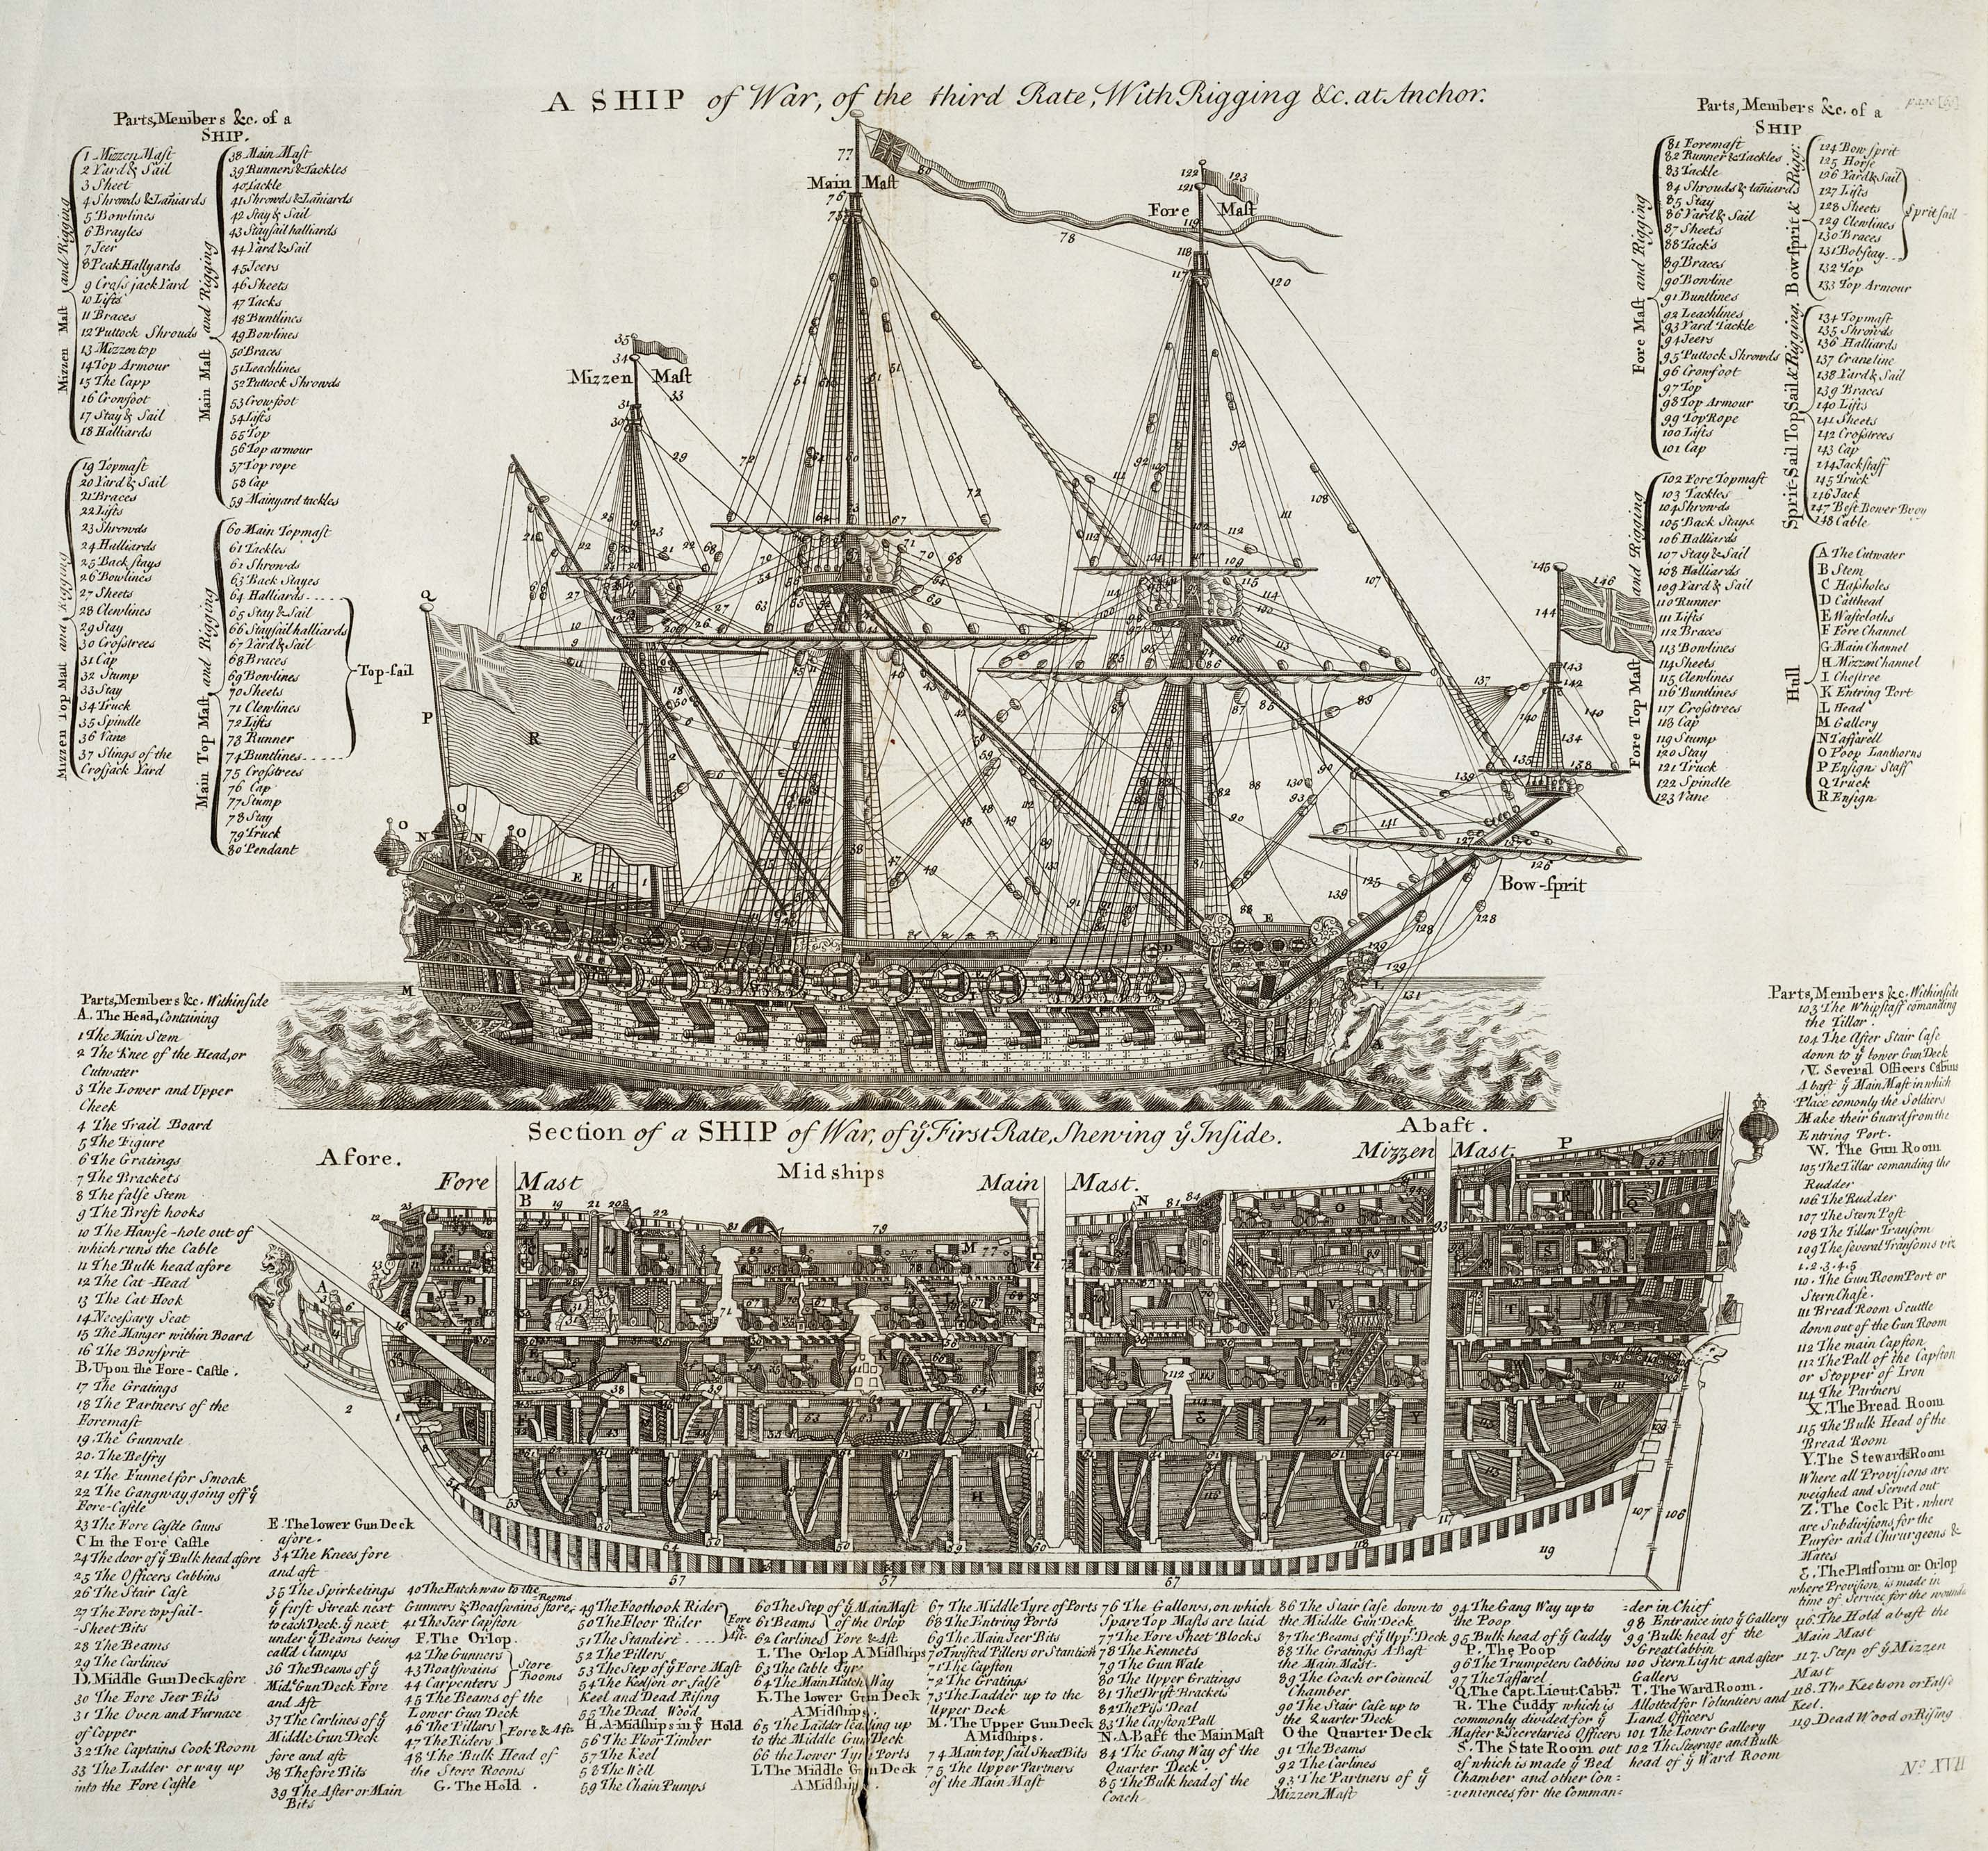
Edited February 26, 2013 by Captain Jim

- Quote
- Edit
- Options

Mission
- Goat Specialist
- 
- Admin

- 5,083 posts
- Gender:Male
- Location:Monroe, MI
- Interests:Scholarly piracy, designing and creating haunted house rooms and props, movies, abstract thinking, abstruse thinking, obstructive thinking, ideating, random thinking, movies, cartoons, movies, movies scores, cycling, world peace and small furry dogs, movies, writing, drawing, personal skills training, gremlins and, of course, lest I forget, movies.
(IP: 24.247.94.112) · ·
Posted February 26, 2013 · Report post
The 17th Century (built 1628) Swedish Warship Vasa has a brick galley as well. This is a photo of the model of the ship from the Vasa Museum in Stockholm.
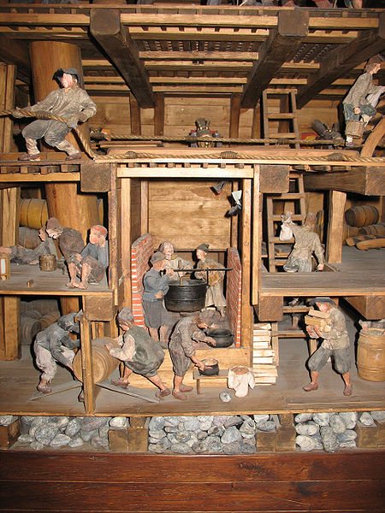
Photo from Wikimedia galley, taken by Peter Isotalo

- Quote
- Edit
- Options

William Brand
- Mercury Malefactor
- Admin

- 8,884 posts
- Gender:Male
- Location:Logan, Utah
- Interests:My name is William Pace and I live and work as a graphic designer, illustrator and photographer in Northern Utah. I'm married to the lovely Tracy Pace and we have three children. In addition to all things art, I enjoy traveling and meeting new people from every walk of life. I've always been a fan of history, theology, and of course, Pyracy.
http://www.youtube.com/watch?v=PSkt-q-HihQ
(IP: 166.70.59.121) · ·
Posted February 26, 2013 · Report post
The brick stoves, hearths, etc. were extensively talked about in another thread here on the Pub, but I can't find it. Almost every example of galley from the period includes a bricked structure and huge kettles and cooking ovens made of copper. Some examples...
The Susan Constant
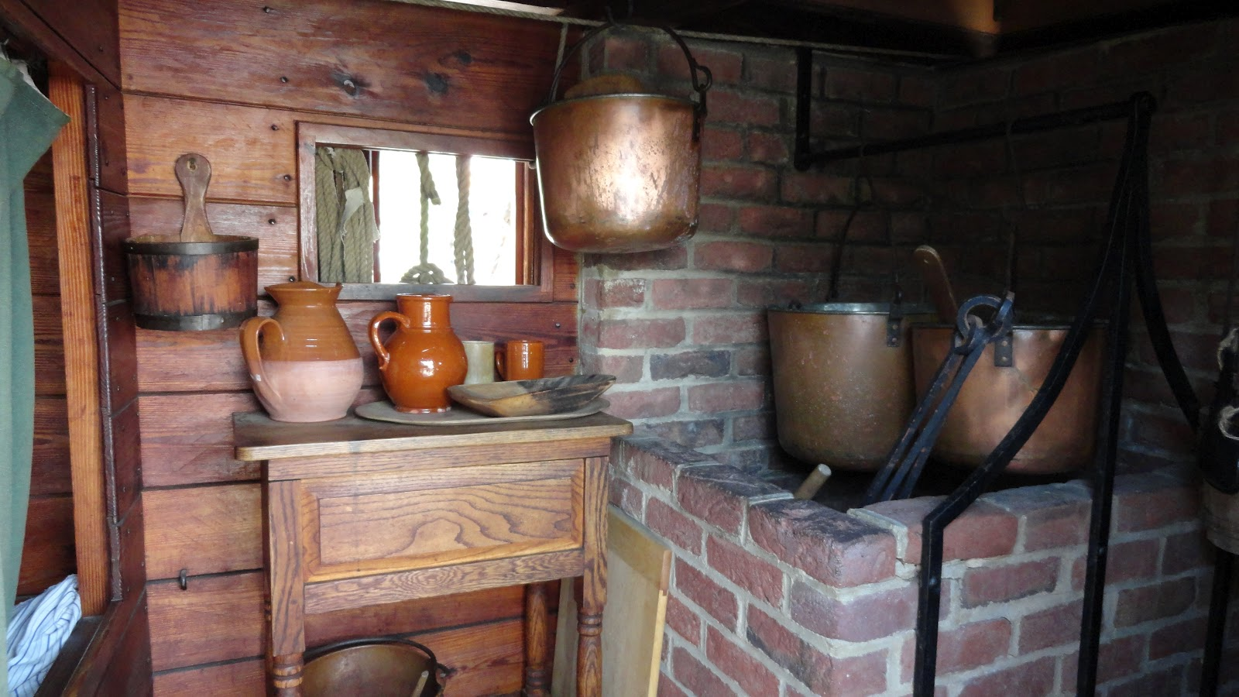
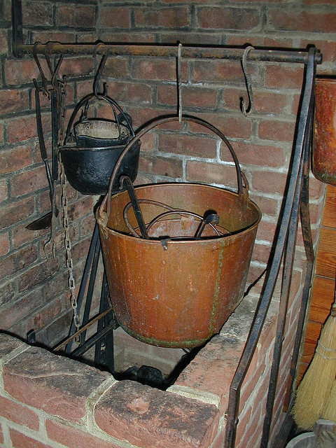
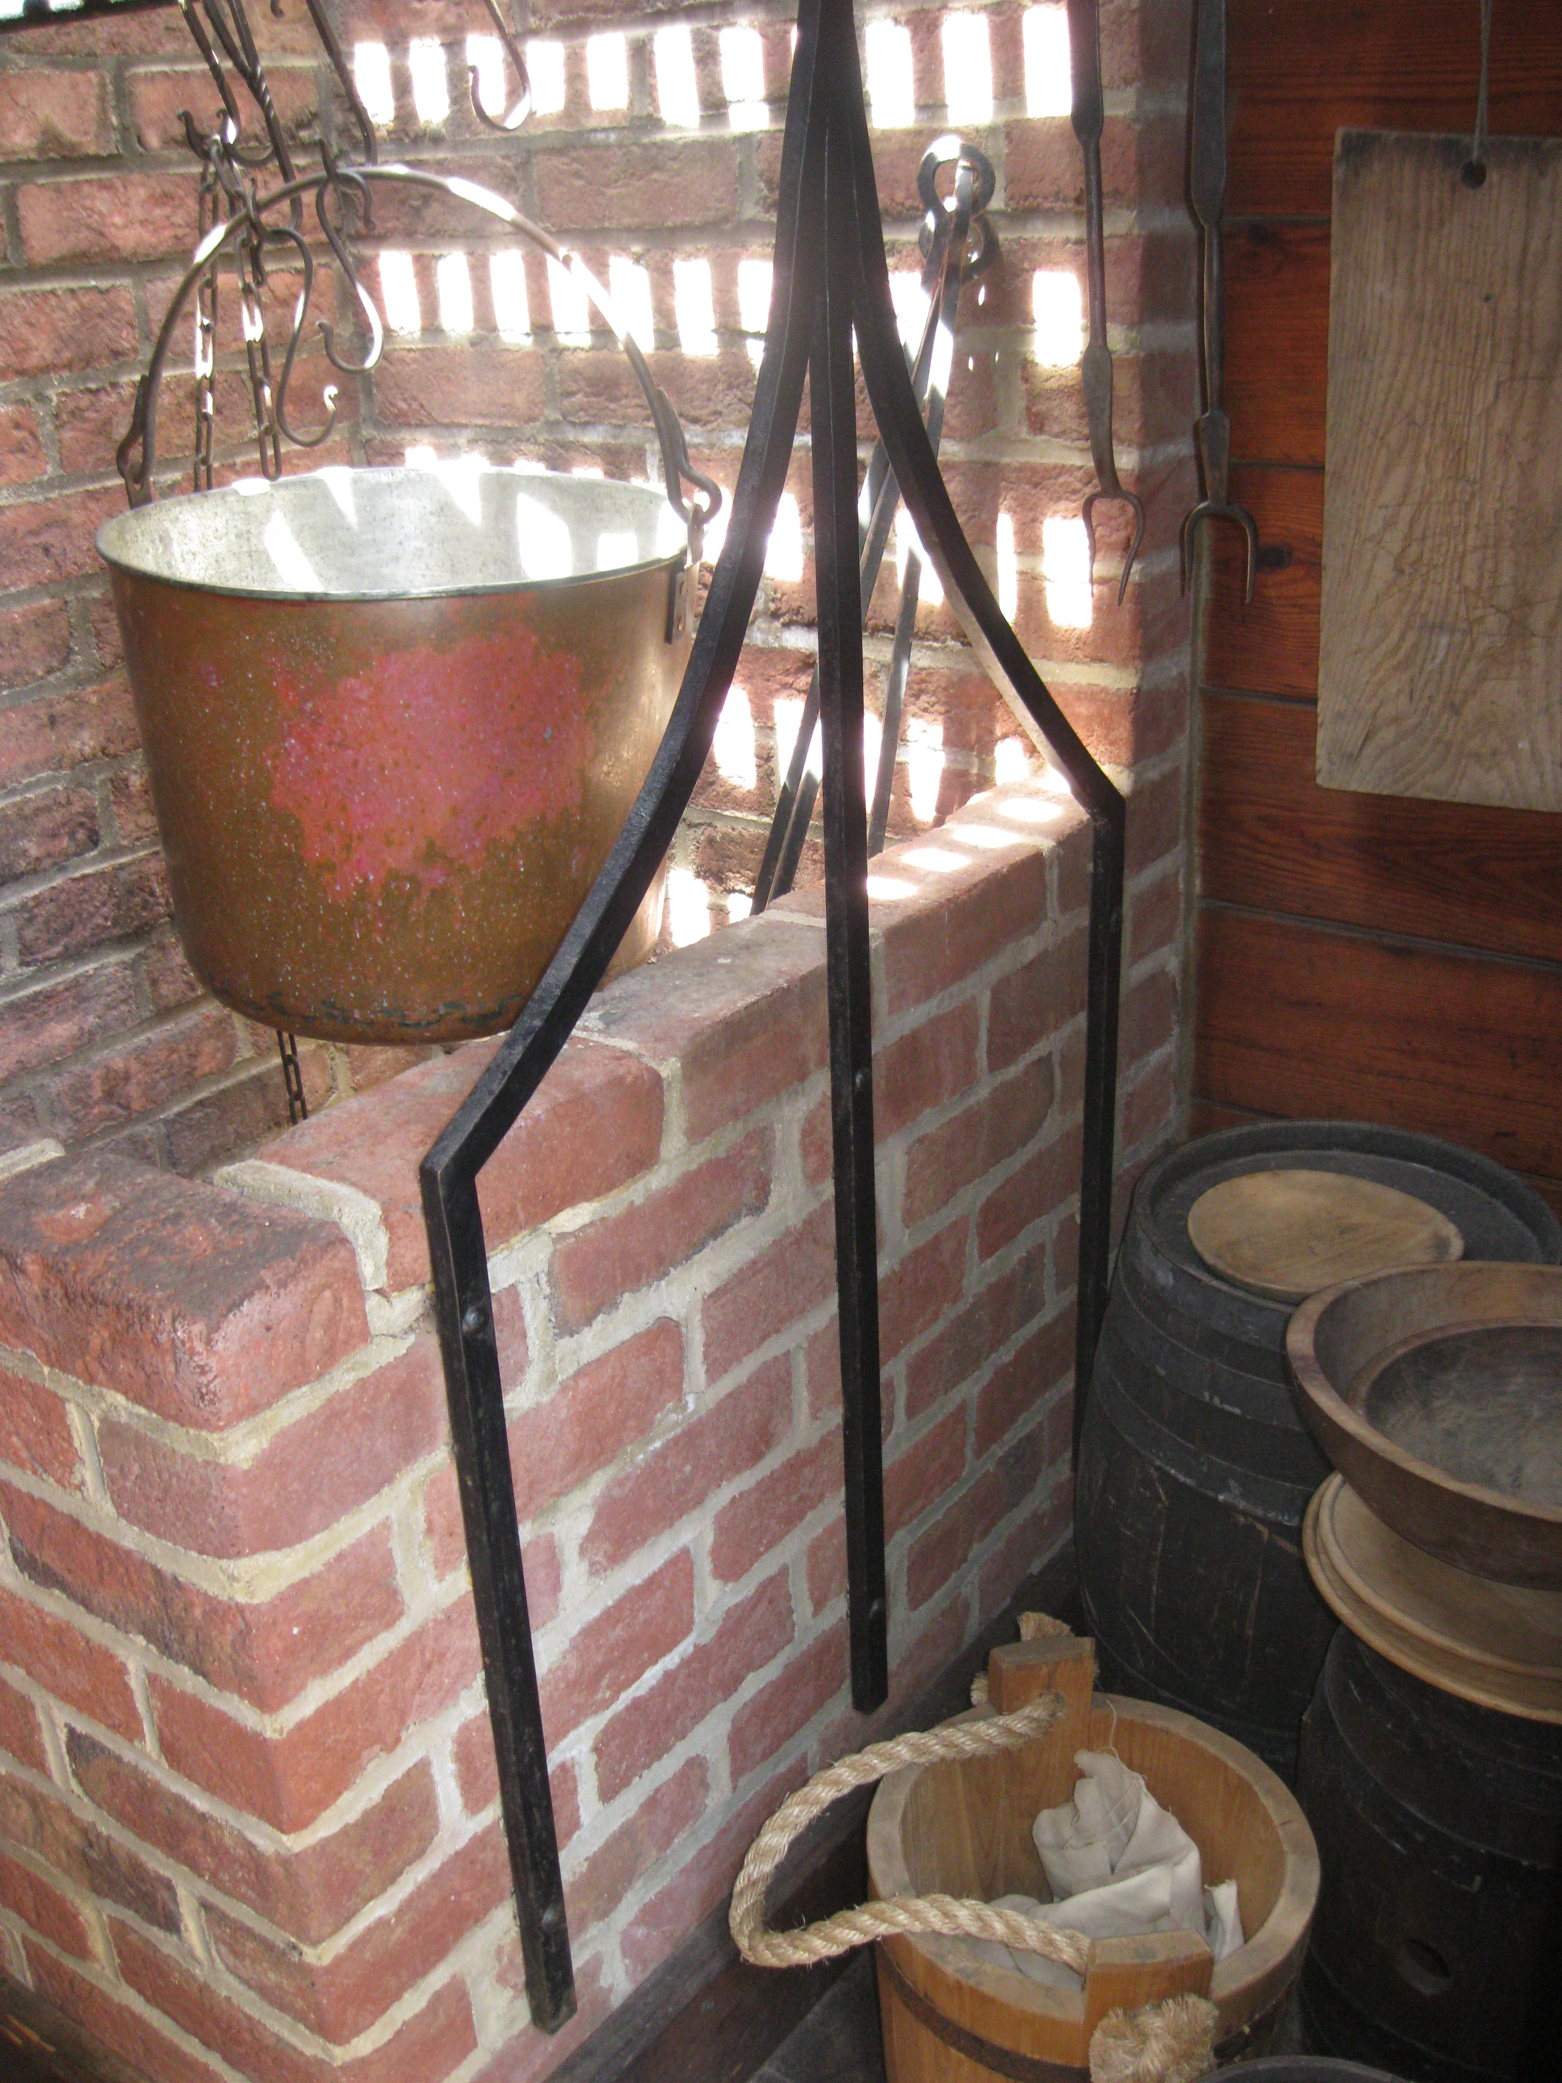
The Mayflower
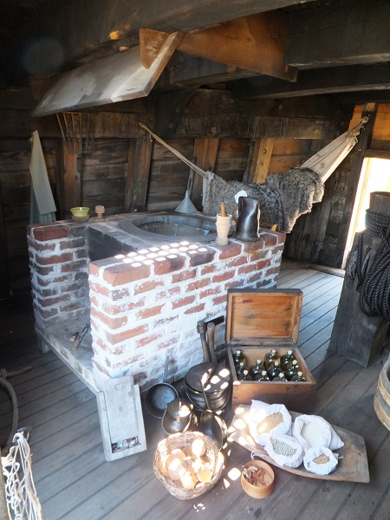

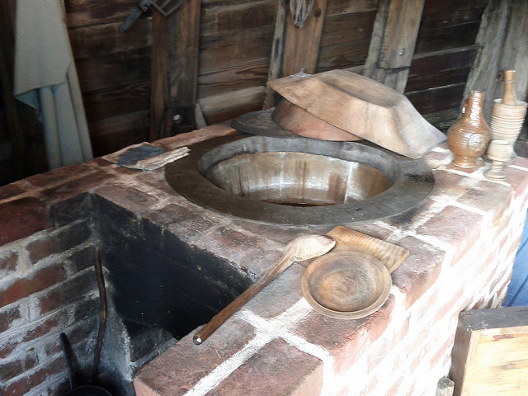
A copper oven inside a brick housing
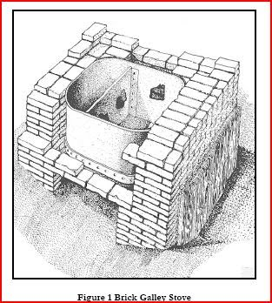

- Quote
- Edit
- Options

Mission
- Goat Specialist
- Admin

- 5,083 posts
- Gender:Male
- Location:Monroe, MI
- Interests:Scholarly piracy, designing and creating haunted house rooms and props, movies, abstract thinking, abstruse thinking, obstructive thinking, ideating, random thinking, movies, cartoons, movies, movies scores, cycling, world peace and small furry dogs, movies, writing, drawing, personal skills training, gremlins and, of course, lest I forget, movies.
(IP: 24.247.94.112) · ·
Posted February 26, 2013 (edited) · Report post
On 2/26/2013 at 0:53 PM, William Brand said:
The brick stoves, hearths, etc. were extensively talked about in another thread here on the Pub, but I can't find it.
Is this the other topic you were looking for? Galleys in the Golden Age
On 2/26/2013 at 0:53 PM, William Brand said:
Almost every example of galley from the period includes a bricked structure and huge kettles and cooking ovens made of copper. Some examples...
I would think that would be to protect the ship as much as possible. Once a flame jumps out of those little tin deals, you might quickly find yourself in serious trouble while sitting in the middle of the wooden world. This is why even the pirates had rules about lighted candles, pipes and so forth below decks.
As an OT aside, look at that nifty little box of bottles on the Mayflower.
The Mayflower
Edited February 26, 2013 by Mission

- Quote
- Edit
- Options

William Brand
- Mercury Malefactor
- Admin

- 8,884 posts
- Gender:Male
- Location:Logan, Utah
- Interests:My name is William Pace and I live and work as a graphic designer, illustrator and photographer in Northern Utah. I'm married to the lovely Tracy Pace and we have three children. In addition to all things art, I enjoy traveling and meeting new people from every walk of life. I've always been a fan of history, theology, and of course, Pyracy.
http://www.youtube.com/watch?v=PSkt-q-HihQ
(IP: 166.70.59.121) · ·
Posted February 26, 2013 (edited) · Report post
That's not the topic I was looking for, but thank you! It contains the galley of the Maryland Dove, which was one I was hunting for.
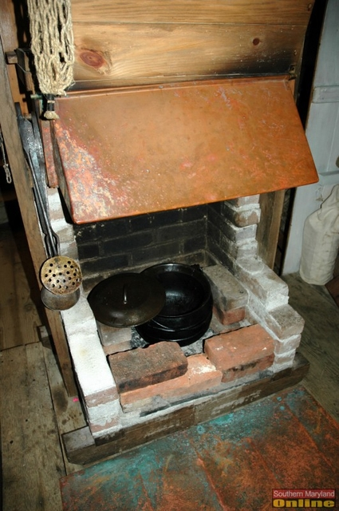
This is the one I'd like to build for events.
Edited February 26, 2013 by William Brand

- Quote
- Edit
- Options

Captain Jim
- Captain Jim for Captain!
- Member

- 2,254 posts
- Gender:Male
- Location:Off the coast of Tampa Bay (Unfortunately, inland from the coast)
- Interests:I'm 57, formerly a wildlife ecologist and biologist, now a stay-at-home dad. I grew up on the west coast of Florida, where Anna Maria Sound and Tampa Bay were my playground. My interests include, but are not limited to cannon, black powder arms, history, fishing the flats, sailing, fine wood working, flint gun building, hunting, good gun dogs. Above all, my wife and children.
(IP: 12.195.96.153) · ·
Posted February 26, 2013 · Report post
On 2/26/2013 at 4:06 PM, Mission said:
On 2/26/2013 at 0:53 PM, William Brand said:
The brick stoves, hearths, etc. were extensively talked about in another thread here on the Pub, but I can't find it.
Is this the other topic you were looking for? Galleys in the Golden Age
On 2/26/2013 at 0:53 PM, William Brand said:
Almost every example of galley from the period includes a bricked structure and huge kettles and cooking ovens made of copper. Some examples...
I would think that would be to protect the ship as much as possible. Once a flame jumps out of those little tin deals, you might quickly find yourself in serious trouble while sitting in the middle of the wooden world. This is why even the pirates had rules about lighted candles, pipes and so forth below decks.
As an OT aside, look at that nifty little box of bottles on the Mayflower.
The Mayflower
The Tin Kitchen was placed in front of a fire, not the fire placed in it. And, yes, one of the first things I saw in this picture was the case of case bottles. The hearth in William's post would be perfect for use with a tin kitchen. I also noticed that most of these galleys seem to be set up for stews and the like, which makes sense for a large crew.

- Quote
- Edit
- Options

Captain Jim
- Captain Jim for Captain!
- Member

- 2,254 posts
- Gender:Male
- Location:Off the coast of Tampa Bay (Unfortunately, inland from the coast)
- Interests:I'm 57, formerly a wildlife ecologist and biologist, now a stay-at-home dad. I grew up on the west coast of Florida, where Anna Maria Sound and Tampa Bay were my playground. My interests include, but are not limited to cannon, black powder arms, history, fishing the flats, sailing, fine wood working, flint gun building, hunting, good gun dogs. Above all, my wife and children.
(IP: 12.195.96.153) · ·
Posted February 26, 2013 · Report post
No brick bread ovens?

- Quote
- Edit
- Options

jendobyns
- Pyrate Captain
- 
- 
- Member

- 562 posts
- Gender:Female
- Location:Baltimore
- Interests:too numerous to mention, really. Period foodways, baroque dance, material culture, etc., etc.
(IP: 72.81.202.40) · ·
Posted February 26, 2013 · Report post
Bread for ship's use would have been baked before the voyage and shared. Those brick ovens take a huge amount of space and firewood, not practical at all.

- Quote
- Edit
- Options

landlubbersanonymous
- Plunderer
- 
- 
- Member

- 354 posts
- Gender:Not Telling
- Location:California, USA
- Interests:History, arts, collecting, reenacting
(IP: 173.58.218.109) · ·
Posted February 26, 2013 · Report post
On 2/26/2013 at 8:05 PM, jendobyns said:
....Those brick ovens take a huge amount of space and firewood, not practical at all.
Yeah, and on a Zodiac raft with little room for bottled water, a couple of extra RPG rockets and some snack bars ... forget about it.
Correct me if I'm wrong, but machine rolled tin is a post GAOP thing right????

- Quote
- Edit
- Options

jendobyns
- Pyrate Captain
- Member

- 562 posts
- Gender:Female
- Location:Baltimore
- Interests:too numerous to mention, really. Period foodways, baroque dance, material culture, etc., etc.
(IP: 72.81.202.40) · ·
Posted February 26, 2013 · Report post
file://localhost/Users/jenniferdobyns/Pictures/iPhoto%20Library/Originals/2013/Feb%2026,%202013_5/2013-02-26_14-35-01_158.jpg

OK, if this works, it's a pic of three different "ovens" in front of a fire. Two are tin, these are arranged so you can bake in them (they hold trays) and the bake kettle is self-explanatory. The tin ovens are a different shape, but they are here to show how the concept works for those who haven't seen it before. The ones pictured in the art at the beginning of this thread are for roasting meat.

file://localhost/Users/jenniferdobyns/Pictures/iPhoto%20Library/Originals/2013/Feb%2026,%202013_2/2013-02-26_15-33-50_15.jpg

Here are the results from today's efforts (we were baking at a workshop on Tea with Susan McLellan Plaisted). Yes, some of them are kind of dark on the bottom. 11 people juggling multiple tasks and one hearth. It gets kinda crazy. And I think maybe someone forgot to put the spacers between the pan and the bottom of the bake kettle. It wasn't my part of the project so I can't be sure, but that's the most likely cause. I was working on the knots.

- Quote
- Edit
- Options

jendobyns
- Pyrate Captain
- Member

- 562 posts
- Gender:Female
- Location:Baltimore
- Interests:too numerous to mention, really. Period foodways, baroque dance, material culture, etc., etc.
(IP: 72.81.202.40) · ·
Posted February 26, 2013 · Report post
Sigh, apparently not. I've posted pics here before, but heck if I can figure out how to do it now!

• • Quote
• Edit

• Op Mission
- Goat Specialist
- Admin

- 5,083 posts
- Gender:Male
- Location:Monroe, MI
- Interests:Scholarly piracy, designing and creating haunted house rooms and props, movies, abstract thinking, abstruse thinking, obstructive thinking, ideating, random thinking, movies, cartoons, movies, movies scores, cycling, world peace and small furry dogs, movies, writing, drawing, personal skills training, gremlins and, of course, lest I forget, movies.
(IP: 24.247.94.112) · ·
Posted February 27, 2013 (edited) · Report post
Jen, you appear to be trying to post an image that's located somewhere on your computer. Unfortunately you can't do that here.
If the images are on the web somewhere, call each up in a new tab or browser window and copy the URL (This URL will start with 'http://' not 'file://', The URL should appear near the top of the browser in a white box. If it does not, look up your browser type using google and 'display url' or something similar and you will find instructions for doing that.) Then post the copied URL string using the photo button above the editing space.
If your images are not on the web, load them into the gallery here at the Pub (or load them into a free image space if you have one set up) and then copy the URL as explained above.
Edited February 27, 2013 by Mission

- Quote
- Edit
- Options

jendobyns
- Pyrate Captain
- Member

- 562 posts
- Gender:Female
- Location:Baltimore
- Interests:too numerous to mention, really. Period foodways, baroque dance, material culture, etc., etc.
(IP: 72.81.202.40) · ·
Posted February 27, 2013 · Report post
Yep, that is exactly what was going on, no URL to use. Captain Jim is very generously going to post the pics for me. I tried going to the gallery and it wasn't cooperating either last night. If I have a chance to play with this when it isn't after a long day I'll give it another shot. Right now I'm juggling too many balls!

- Quote
- Edit
- Options

Captain Jim
- Captain Jim for Captain!
- Member

- 2,254 posts
- Gender:Male
- Location:Off the coast of Tampa Bay (Unfortunately, inland from the coast)
- Interests:I'm 57, formerly a wildlife ecologist and biologist, now a stay-at-home dad. I grew up on the west coast of Florida, where Anna Maria Sound and Tampa Bay were my playground. My interests include, but are not limited to cannon, black powder arms, history, fishing the flats, sailing, fine wood working, flint gun building, hunting, good gun dogs. Above all, my wife and children.
(IP: 12.195.96.153) · ·
Posted February 27, 2013 (edited) · Report post
Here are the pictures Jen was trying to post. The first two are of two reflectors (and a Dutch Oven) in use in front of a fireplace. Note the hearth being at floor level, which is quite common with cooking hearths. Since this kind of oven has to be used at the level of the fire, this is the usual setup. Some hearths, however, are built at waist or even chest level. So long as the hearth is wide enough, these can still be used. James Townsend & Sons has a purpose built demonstrations kitchen with just such a raised hearth. Eliminates all that bending over. The galley in the illustration I posted seems to have a raised hearth on one side and a large pot and open hearth on the other. Also note the small kettle in the second picture. Tea, anyone?
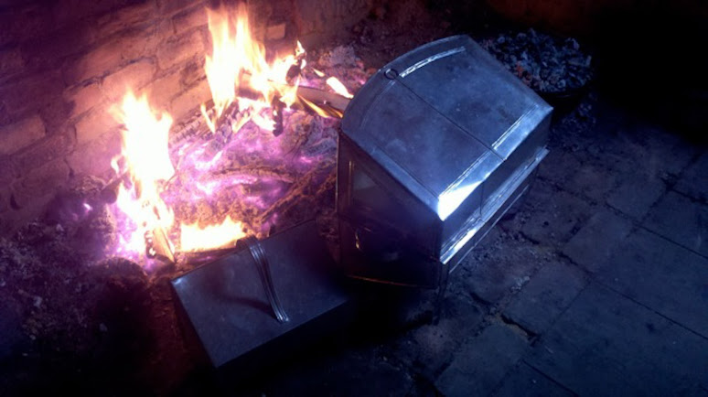
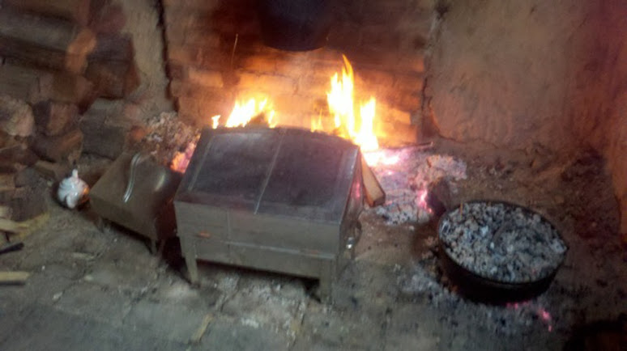
The third is of the results.
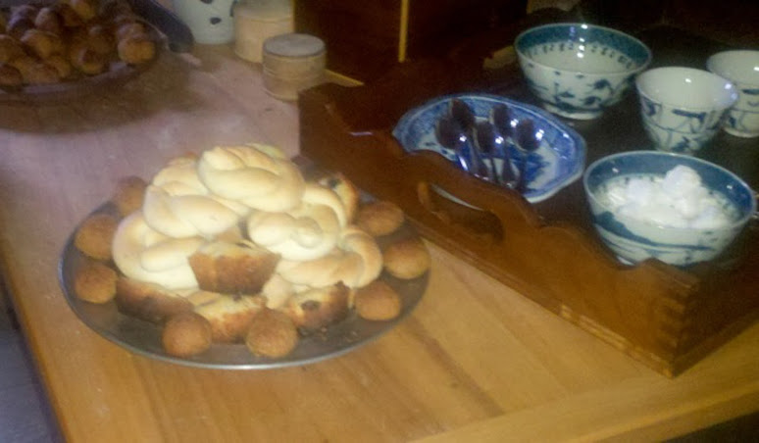
Edited February 27, 2013 by Captain Jim

- Quote
- Edit
- Options

Captain Jim
- Captain Jim for Captain!
- Member

- 2,254 posts
- Gender:Male
- Location:Off the coast of Tampa Bay (Unfortunately, inland from the coast)
- Interests:I'm 57, formerly a wildlife ecologist and biologist, now a stay-at-home dad. I grew up on the west coast of Florida, where Anna Maria Sound and Tampa Bay were my playground. My interests include, but are not limited to cannon, black powder arms, history, fishing the flats, sailing, fine wood working, flint gun building, hunting, good gun dogs. Above all, my wife and children.
(IP: 12.195.96.153) · ·
Posted February 27, 2013 · Report post
Thanks for the pictures, Jen.
So this kind of brings up bread again. Was bread never cooked on board? Or was it simply uncommon or not for the common sailor, just the Captain and officers? What I really need is someone with access to manifests and wills to do a search. If these, or similar ovens were recorded as having been aboard I would think that would definitively answer the question.

- Quote
- Edit
- Options

Mission
- Goat Specialist
- Admin

- 5,083 posts
- Gender:Male
- Location:Monroe, MI
- Interests:Scholarly piracy, designing and creating haunted house rooms and props, movies, abstract thinking, abstruse thinking, obstructive thinking, ideating, random thinking, movies, cartoons, movies, movies scores, cycling, world peace and small furry dogs, movies, writing, drawing, personal skills training, gremlins and, of course, lest I forget, movies.
(IP: 24.247.94.112) · ·
Posted February 27, 2013 (edited) · Report post
Ooooooooohhhh. >_< I could swear I saw something about a bread oven on a 1st rate navy ship either here or in one of the books I was reading. I may be wrong, but it sounds very familiar...
However, that would be a luxury not accorded a smaller vessel, so it would probably have nothing to do with the sort of vessels pirates had.
Edit: Here is the post I was thinking of - it's my comment that makes me think that may have made bread, actually - where the author refers to efforts at baking. But it's quoted from William Raines Thrower's book which I don't trust very much. (I know he has some facts wrong in his book on pirates, so I take everything he says with a grain of salt. Which you could use to make bread with, of course.)
Shipboard Cooking
Edited February 27, 2013 by Mission

- Quote
- Edit
- Options

Coastie04
- Dread Pyrate
- 
- 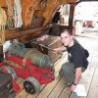
- Member

- 1,010 posts
- Gender:Male
- Location:Juneau, AK
- Interests:Nautical history, sailing (especially tall ships and my own 'Sanctioned Mistress'), shooting (of all eras and calibers), and homebrewing.
(IP: 69.178.67.219) · ·
Posted February 27, 2013 · Report post
Oh, for that 1st rate SoL, was the oven for general bread making, or did they just have a small one so that the officers could get fresh bread?

• Quote
• Edit

• Options tions Mission
- Goat Specialist
- Admin

- 5,083 posts
- Gender:Male
- Location:Monroe, MI
- Interests:Scholarly piracy, designing and creating haunted house rooms and props, movies, abstract thinking, abstruse thinking, obstructive thinking, ideating, random thinking, movies, cartoons, movies, movies scores, cycling, world peace and small furry dogs, movies, writing, drawing, personal skills training, gremlins and, of course, lest I forget, movies.
(IP: 24.247.94.112) · ·
Posted February 27, 2013 · Report post
Actually, I don't know where I got the first rate thing from. I referred back to the quote I was thinking about in the last post.
I do know there were things available to first rate ships that weren't available on other ships. (Physicians for example.)

- Quote
- Edit
- Options

jendobyns
- Pyrate Captain
- Member

- 562 posts
- Gender:Female
- Location:Baltimore
- Interests:too numerous to mention, really. Period foodways, baroque dance, material culture, etc., etc.
(IP: 72.81.202.40) · ·
Posted February 27, 2013 (edited) · Report post
On 2/27/2013 at 9:32 AM, Captain Jim said:
Thanks for the pictures, Jen.
So this kind of brings up bread again. Was bread never cooked on board? Or was it simply uncommon or not for the common sailor, just the Captain and officers? What I really need is someone with access to manifests and wills to do a search. If these, or similar ovens were recorded as having been aboard I would think that would definitively answer the question.
You're welcome.
As to baking bread on board, never say never. It might be done, but more likely in something like the bake kettle that is on the far right of the pic. It would require a good bed of coals above and below, which may work within a ship's galley--you can stack other pots on top of the bake kettle to double up on using the coals. But it would not be a lot of bread at a time. Then there is the whole issue of other equipment. Yeast could be stored, dry, in a dormant state inside dried bread dough brought along for the purpose and continued throughout the voyage. Then you would need some of the water supply to bring it back to life. Or use some of the ale/beer on board. A sponge would be made, allowed to work, then more flour added to make the dough. The galley would most likely be a good environment for allowing it to rise. Just depends on a whole lot of factors regarding distribution of the ship's supplies, wether the officers ate that much better than the men, etc. Not to mention the abilities of the ship's cook. I doubt the common sailor would reap the benefit, beyond the smell.
Even the larger galleys aren't all that big. You really have to be quite organized and spatially aware when working on a decent sized hearth, cooking for a lot of people. But a galley would even require more of it's cook.
And I suspect this is why the Navy had contracts to make ship's biscuit. Easier to make, package and store, distribute as needed. No additional risk of fire or use of extra resources once under way.
Good luck finding the documentation! Let us know what you find out.
Edited February 27, 2013 by Mission

- Quote
- Edit
- Options

Captain Jim
- Captain Jim for Captain!
- Member

- 2,254 posts
- Gender:Male
- Location:Off the coast of Tampa Bay (Unfortunately, inland from the coast)
- Interests:I'm 57, formerly a wildlife ecologist and biologist, now a stay-at-home dad. I grew up on the west coast of Florida, where Anna Maria Sound and Tampa Bay were my playground. My interests include, but are not limited to cannon, black powder arms, history, fishing the flats, sailing, fine wood working, flint gun building, hunting, good gun dogs. Above all, my wife and children.
(IP: 12.195.96.153) · ·
Posted February 27, 2013 · Report post
I really don't expect to discover that bread was a common item. From what I have read the general meal while underway was some kind of stew and ship's biscuit, over and over again. And again. Ad infinitum, ad nauseum.
As for the first raters and large 2nd raters, as Mission says, they had more comforts. In the plan I posted in post #8, the galley and the masonry for the fire has two distinct sides, one marked #32 "Captains Cook Room", just above the little guy cooking. It seems to have a separate firebox, a raised hearth, probably a brick floor. This is where I would expect to find the more normal "home style" cooking equipment, including reflector ovens, if they were ever aboard ship.
Just to make it perfectly clear what I am trying to accomplish, I am trying to add a tin kitchen/reflector oven to my careening camp. I need some documentation that one was aboard a ship, any ship, and in any capacity, including as cargo (That oven? I plundered that offen a whaler/merchantman. Never use it except ashore...) If we can establish bread baking aboard ships at that time, so much the better for our understanding of the times.
All that having been said, I can imagine the smell of baking bread, bread that you are not allowed to have, would be enough of an incentive to mutiny, all by itself. (Incidentally, I just pulled two loaves, one cinnamon, out of the oven not 20 minutes ago.)

- Quote
- Edit
- Options

William Brand
- Mercury Malefactor
- Admin

- 8,884 posts
- Gender:Male
- Location:Logan, Utah
- Interests:My name is William Pace and I live and work as a graphic designer, illustrator and photographer in Northern Utah. I'm married to the lovely Tracy Pace and we have three children. In addition to all things art, I enjoy traveling and meeting new people from every walk of life. I've always been a fan of history, theology, and of course, Pyracy.
http://www.youtube.com/watch?v=PSkt-q-HihQ
(IP: 166.70.59.121) · ·
Posted February 27, 2013 · Report post
The question of bread probably does come down to frequency. It also comes down to the cook, and with navies, quality gives way to quantity and convenience. Bread on the high seas probably did exist in a very limited way, so that's when it becomes hard to find historically. It's more likely to be something we trip over, than something that we purposely discover.
Jim's mutiny comment reminds me of a tactic my Grandfather used while living in a very poor, dangerous part of Southside Chicago years ago. He worked at a bakery all day and made certain that he baked 'extra bread' every night just before closing. Then he would carry generous portions of this fresh, delicious smelling bread on the cross town trains. He would share this bread with everyone on the train and it got to the point where if anyone bothered him at all, all the regular commuters would defend him, because he was the 'bread guy'.

- Quote
- Edit
- Options

Captain Jim
- Captain Jim for Captain!
- Member

- 2,254 posts
- Gender:Male
- Location:Off the coast of Tampa Bay (Unfortunately, inland from the coast)
- Interests:I'm 57, formerly a wildlife ecologist and biologist, now a stay-at-home dad. I grew up on the west coast of Florida, where Anna Maria Sound and Tampa Bay were my playground. My interests include, but are not limited to cannon, black powder arms, history, fishing the flats, sailing, fine wood working, flint gun building, hunting, good gun dogs. Above all, my wife and children.
(IP: 12.195.96.153) · ·
Posted February 27, 2013 · Report post
There is nothing in the world quite like the smell of freshly made bread.

- Quote
- Edit
- Options

Coastie04
- Dread Pyrate
- Member

- 1,010 posts
- Gender:Male
- Location:Juneau, AK
- Interests:Nautical history, sailing (especially tall ships and my own 'Sanctioned Mistress'), shooting (of all eras and calibers), and homebrewing.
(IP: 69.178.67.219) · ·
Posted February 28, 2013 · Report post
On 2/27/2013 at 11:16 PM, Captain Jim said:
There is nothing in the world quite like the smell of freshly made bread.
What about the liquid bretheren: freshly brewed beer? And even better, freshly poured beer!

- Quote
- Edit
- Options

Captain Jim
- Captain Jim for Captain!
- Member

- 2,254 posts
- Gender:Male
- Location:Off the coast of Tampa Bay (Unfortunately, inland from the coast)
- Interests:I'm 57, formerly a wildlife ecologist and biologist, now a stay-at-home dad. I grew up on the west coast of Florida, where Anna Maria Sound and Tampa Bay were my playground. My interests include, but are not limited to cannon, black powder arms, history, fishing the flats, sailing, fine wood working, flint gun building, hunting, good gun dogs. Above all, my wife and children.
(IP: 12.195.96.153) · ·
Posted February 28, 2013 · Report post
Well, one must have beer with one's bread now, mustn't one?

- Quote
- Edit
- Options

jendobyns
- Pyrate Captain
- Member

- 562 posts
- Gender:Female
- Location:Baltimore
- Interests:too numerous to mention, really. Period foodways, baroque dance, material culture, etc., etc.
(IP: 72.81.202.40) · ·
Posted March 3, 2013 · Report post
If you want to check out Heart to Hearth Cookery, choose the blog from her menu and you can see some of Susan's results from her baking in a tin reflector oven. It's under "uneven baking" in her post.

- Quote
- Edit
- Options

William Brand
- Mercury Malefactor
- Admin

- 8,884 posts
- Gender:Male
- Location:Logan, Utah
- Interests:My name is William Pace and I live and work as a graphic designer, illustrator and photographer in Northern Utah. I'm married to the lovely Tracy Pace and we have three children. In addition to all things art, I enjoy traveling and meeting new people from every walk of life. I've always been a fan of history, theology, and of course, Pyracy.
http://www.youtube.com/watch?v=PSkt-q-HihQ
(IP: 166.70.59.121) · ·
Posted March 4, 2013 · Report post
Here's another great galley image. While it does come from the Disney ship Columbia, it is fashioned beautifully after other ship galleys. The Columbia was vessel of the 1790s and when historian Ray Wallace built the replica at Disneyland he borrowed heavily from the 'Bounty'. Much of the layout in the interior was designed by chief art director Kuri.
You'll note that all of the cupboards have high lips at the base to prevent anything from falling from them. There are no cupboard doors or anything that can swing wide. The lowest cupboard space is a coal bin for the fire. The kitchen is fixed with a high cross rail so when the cook is moving about with heavy pots or trays there is a brace to lean upon or catch him if he sways. The tight quarters, which come naturally with ships and the conservation of space, actually work in the favor of a cook. The shorter the distance to travel with water, kettles, pots, etc., the less likely one will be overbalanced. One simply turns in place to work. Cookware is at a bare minimum. The problems of storing dishes are easily maintained, because each sailor keeps his own bowl, spoon, fork etc.
It looks like iron working tools and an anvil might be stationed on the opposite side of that cupboard larder. It's possible that there is a second bricked in space on the other side for limited metal working. I've never seen this setup before, but it shows pragmatism, if not accuracy.
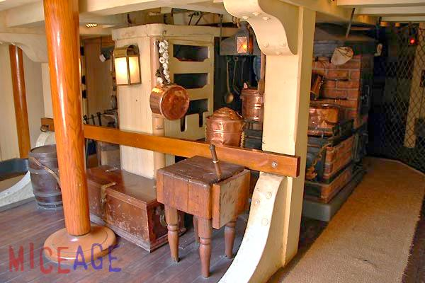
A detail of Columbia's stove. It's all brick with metal fittings and doors. The doors are not accurate for very early galleys, but the 'fish parts' stew is funny.
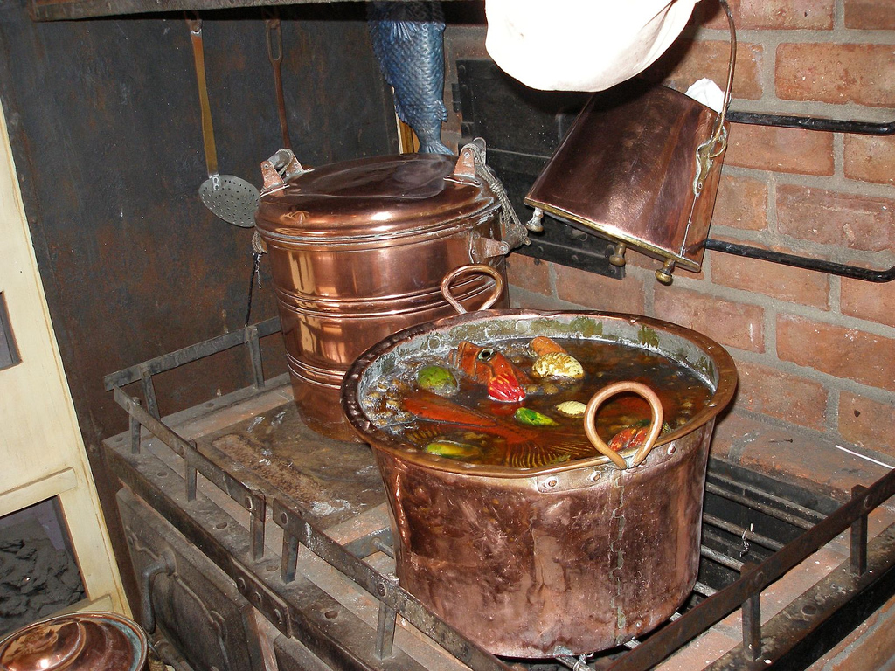
Another shot of the cozy space with Disney himself.
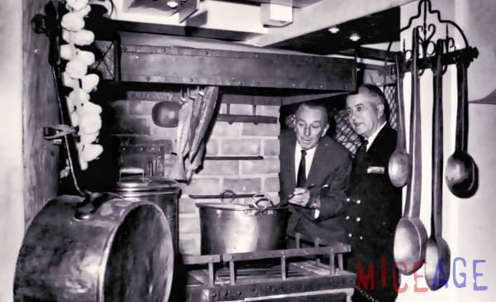

- Quote
- Edit
- Options

Jas. Hook
- Scourge o' the 7 Seas
- 
- Member

- 1,650 posts
- Gender:Male
- Location:Long Island NY
- Interests:Fishing & Piracy
(IP: 198.8.4.10) · ·
Posted March 4, 2013 · Report post
'fish parts' stew is funny.
Oh ya, that's why I won't eat fish chowda'... at least leave the squid head out.

- Quote
- Edit
- Options

Captain Jim
- Captain Jim for Captain!
- Member

- 2,254 posts
- Gender:Male
- Location:Off the coast of Tampa Bay (Unfortunately, inland from the coast)
- Interests:I'm 57, formerly a wildlife ecologist and biologist, now a stay-at-home dad. I grew up on the west coast of Florida, where Anna Maria Sound and Tampa Bay were my playground. My interests include, but are not limited to cannon, black powder arms, history, fishing the flats, sailing, fine wood working, flint gun building, hunting, good gun dogs. Above all, my wife and children.
(IP: 12.195.96.153) · ·
Posted March 4, 2013 (edited) · Report post
Is that the Kraken in that stew?
Great pictures, but a little late for our time. Now with the built-in oven there would have been no use for a reflector. Still, nice.
Edit: I believe the big doors you see on the front are for stoking the fire. The oven is the little iron door in the flue next to the blue fish in the second picture.
Edited March 4, 2013 by Captain Jim

- Quote
- Edit
- Options

Captain Jim
- Captain Jim for Captain!
- Member

- 2,254 posts
- Gender:Male
- Location:Off the coast of Tampa Bay (Unfortunately, inland from the coast)
- Interests:I'm 57, formerly a wildlife ecologist and biologist, now a stay-at-home dad. I grew up on the west coast of Florida, where Anna Maria Sound and Tampa Bay were my playground. My interests include, but are not limited to cannon, black powder arms, history, fishing the flats, sailing, fine wood working, flint gun building, hunting, good gun dogs. Above all, my wife and children.
(IP: 199.47.254.107) · ·
Posted January 22, 2014 · Report post
Having given this subject a bit more thought, I have come to the conclusion that tin ovens would not have been shipped completed but built locally by your neighborhood tinsmith. So there would not be any shipping manifests listing them. Sheet tin, maybe, but not completed items. Nor would they have been commonly used aboard, even on 1st raters, if at all. Now the point of this whole exercise was to qualify the use of a tin kitchen in a careening camp. Hence I have come to a further conclusion, that if the careening camp is in a remote area not associated with a friendly town then the tin kitchen would not have been available. However, since the Mercury careen is scripted to occur near a sympathetic town, a tin kitchen could easily be procured from said town or have been brought by someone seeking trade or offering services to the pyrates ashore.

- Quote
- Edit
- Options

silas thatcher
- Notorious Pyrate
- 
- 
- Member

- 774 posts
- Location:st. louis, mo.
- Interests:probably too many interests :) old vw's, sailing, photography, home improvements, and lots more ;)
(IP: 108.199.190.125) · ·
Posted January 26, 2014 · Report post
in order to bake fresh bread, an oven per say is not needed...an upside down copper pot or a cast pot is all that is needed... ( if you have a lid, skip the upside down part ) less clutter on board if you can use what you already have for other purposes... connie made bread in key west with a dutch oven

- Quote
- Edit
- Options

Captain Jim
- Captain Jim for Captain!
- Member

- 2,254 posts
- Gender:Male
- Location:Off the coast of Tampa Bay (Unfortunately, inland from the coast)
- Interests:I'm 57, formerly a wildlife ecologist and biologist, now a stay-at-home dad. I grew up on the west coast of Florida, where Anna Maria Sound and Tampa Bay were my playground. My interests include, but are not limited to cannon, black powder arms, history, fishing the flats, sailing, fine wood working, flint gun building, hunting, good gun dogs. Above all, my wife and children.
(IP: 199.47.254.107) · ·
Posted January 27, 2014 · Report post
Oh, I've made bread with a dutch oven. The tin kitchen was more for roasting. Although I guess it could be used for baking, if a shelf was installed.

• Quote
• Edit
• Options

Captain Jim
- Captain Jim for Captain!
- Member

- 2,254 posts
- Gender:Male
- Location:Off the coast of Tampa Bay (Unfortunately, inland from the coast)
- Interests:I'm 57, formerly a wildlife ecologist and biologist, now a stay-at-home dad. I grew up on the west coast of Florida, where Anna Maria Sound and Tampa Bay were my playground. My interests include, but are not limited to cannon, black powder arms, history, fishing the flats, sailing, fine wood working, flint gun building, hunting, good gun dogs. Above all, my wife and children.
(IP: 164.156.25.30) · ·
Posted February 2, 2014 · Report post
Very nice, and I do like the cut-out for the spit so one doesn't have to learn juggling to remove dinner. $395 though. (Pssst! Dixie Tinsmith, $130. No cut-out for spit. Slightly different dimensions. Shhhh...get yours before they find out and raise the price!)

- Quote
- Edit
- Options

Captain Jim
- Captain Jim for Captain!
- Member

- 2,254 posts
- Gender:Male
- Location:Off the coast of Tampa Bay (Unfortunately, inland from the coast)
- Interests:I'm 57, formerly a wildlife ecologist and biologist, now a stay-at-home dad. I grew up on the west coast of Florida, where Anna Maria Sound and Tampa Bay were my playground. My interests include, but are not limited to cannon, black powder arms, history, fishing the flats, sailing, fine wood working, flint gun building, hunting, good gun dogs. Above all, my wife and children.
(IP: 199.47.254.107) · ·
Posted February 2, 2014 · Report post
Sorry, that should be Dixie Tinworks http://www.dixietinworks.com/ .

- Quote
- Edit
- Options

jendobyns
- Pyrate Captain
- Member

- 562 posts
- Gender:Female
- Location:Baltimore
- Interests:too numerous to mention, really. Period foodways, baroque dance, material culture, etc., etc.
(IP: 72.81.193.185) · ·
Posted February 2, 2014 · Report post
Interesting. With tin ware, part of the cost is the quality of the tin, though. I would be curious to see a comparison between the two regarding that. Looks like a good entry price for a tin kitchen.
For a careening camp, there are other ways to roast meat, though. If you feel a need to have a surface reflecting heat back, or to create a wind break, strategically placed boards work. Could make some interesting use of weathered boards.

- Quote
- Edit
- Options

Captain Jim
- Captain Jim for Captain!
- Member

- 2,254 posts
- Gender:Male
- Location:Off the coast of Tampa Bay (Unfortunately, inland from the coast)
- Interests:I'm 57, formerly a wildlife ecologist and biologist, now a stay-at-home dad. I grew up on the west coast of Florida, where Anna Maria Sound and Tampa Bay were my playground. My interests include, but are not limited to cannon, black powder arms, history, fishing the flats, sailing, fine wood working, flint gun building, hunting, good gun dogs. Above all, my wife and children.
(IP: 199.47.254.107) · ·
Posted February 3, 2014 · Report post
I haven't yet pulled the trigger on a tin kitchen but am leaning toward the Dixie, simply on price point. I will post a review if I get one. As for camp, indeed board reflectors would be very accurate and I have used them in Scout camp situations. Aromatic wood (cedar or fruitwood) adds to the flavor of the dinner. They work, but not as well as a reflector. Decreases cooking time by a lot, or so I'm told and have read.

- Quote
- Edit
- Options

jendobyns
- Pyrate Captain
- Member

- 562 posts
- Gender:Female
- Location:Baltimore
- Interests:too numerous to mention, really. Period foodways, baroque dance, material culture, etc., etc.
(IP: 72.81.181.248) · ·
Posted February 6, 2014 · Report post
Oh yes, cedar and fruit wood are great for that. Have you tried planking fish on them? _That_ would be a great thing to be doing in camp!
Looking forward to hearing how you get on with the Dixie tin kitchen. If the tin isn't really great, just make sure you clean and dry it asap, and keep it really, really dry. Maybe even store it with the stuff that pulls moisture out of the air to prevent rusting.
Funny, I ran across tin kitchens in a period advertisement recently, somewhere between the 1730's and 1760's, in the Carolinas iirc, being imported aboard ships. Along with at least two types of bread _and_ ship's biscuit in barrels. I think I printed out that bit and put it in a binder to take with me to Florida. Will dig it out when I get down there to see. With any luck I can look it up again when I am there if I didn't print it.

- Quote
- Edit
- Options

Captain Jim
- Captain Jim for Captain!
- Member

- 2,254 posts
- Gender:Male
- Location:Off the coast of Tampa Bay (Unfortunately, inland from the coast)
- Interests:I'm 57, formerly a wildlife ecologist and biologist, now a stay-at-home dad. I grew up on the west coast of Florida, where Anna Maria Sound and Tampa Bay were my playground. My interests include, but are not limited to cannon, black powder arms, history, fishing the flats, sailing, fine wood working, flint gun building, hunting, good gun dogs. Above all, my wife and children.
(IP: 199.47.254.107) · ·
Posted February 7, 2014 · Report post
Very interesting. I would have thought shipping something with so much "empty space" would have been unprofitable. Sheet tin would be easier to ship to a local tinsmith to fashion an oven out of.

- Quote
- Edit
- Options

jendobyns
- Pyrate Captain
- Member

- 562 posts
- Gender:Female
- Location:Baltimore
- Interests:too numerous to mention, really. Period foodways, baroque dance, material culture, etc., etc.
(IP: 64.134.181.155) · ·
Posted February 7, 2014 · Report post
Ah well, there is a reason it's a good idea to find more than one reference for items. In this case it appears there was a typo or spelling mistake in the advertisement. Many of these ads run several weeks in a row. What was "tin kitchen" in one was "tea kitchen" in others by the same vendor. I wouldn't completely rule out their importation, but we would need to have a better handle on the trade of the tin smith (white smith?) in the colonies. When established, etc.
Checking out tradesman ads next.

- Quote
- Edit
- Options

William Brand
- Mercury Malefactor
- Admin

- 8,884 posts
- Gender:Male
- Location:Logan, Utah
- Interests:My name is William Pace and I live and work as a graphic designer, illustrator and photographer in Northern Utah. I'm married to the lovely Tracy Pace and we have three children. In addition to all things art, I enjoy traveling and meeting new people from every walk of life. I've always been a fan of history, theology, and of course, Pyracy.
http://www.youtube.com/watch?v=PSkt-q-HihQ
(IP: 174.52.248.73) · ·
Posted May 28, 2015 · Report post
Chris Bell pointed this one out on the Authentic Pirate Living Facebook page. Gabrieal Metsu painting. The earlier links in the thread didn't work, so I couldn't remember if it had been posted.


• Quote
• Edit
• Options

