Jib
- Dread Pyrate
- 
- 
- Member

- 1,078 posts
- Gender:Male
- Location:Minneapolis, MN
- Interests:Piracy, stage combat, martial arts, reading, film, travel
(IP: 69.81.103.112) ·
Posted June 14, 2006 · Report post
When was the Union Jack first used by Great Britian?

- Quote
- Edit

Sir Beachem Quick
- Ship's Master
- 
- 
- Member

- 123 posts
- Gender:Male
- Location:San Antonio, Texas
(IP: 24.110.17.218) · ·
Posted June 14, 2006 · Report post
Answer

- Quote
- Edit
- Options

Sir Beachem Quick
- Ship's Master
- Member

- 123 posts
- Gender:Male
- Location:San Antonio, Texas
(IP: 24.110.17.218) · ·
Posted June 14, 2006 · Report post
1801

- Quote
- Edit
- Options

Captain Jim
- Captain Jim for Captain!
- 
- 
- Member

- 2,254 posts
- Gender:Male
- Location:Off the coast of Tampa Bay (Unfortunately, inland from the coast)
- Interests:I'm 57, formerly a wildlife ecologist and biologist, now a stay-at-home dad. I grew up on the west coast of Florida, where Anna Maria Sound and Tampa Bay were my playground. My interests include, but are not limited to cannon, black powder arms, history, fishing the flats, sailing, fine wood working, flint gun building, hunting, good gun dogs. Above all, my wife and children.
(IP: 207.96.50.26) · ·
Posted June 20, 2006 (edited) · Report post
"The term 'Union Jack' possibly dates from Queen Anne's time (r. 1702-14), but its origin is uncertain.
"It may come from the 'jack-et' of the English or Scottish soldiers, or from the name of James I who originated the first union in 1603.
"Another alternative is that the name may be derived from a proclamation by Charles II that the Union Flag should be flown only by ships of the Royal Navy as a jack, a small flag at the bowsprit; the term 'jack' once meant small."
The preceeding is from the official web site of the British Monarchy and can found here.
1801 is when the flag in its present form was adopted.
Edited June 20, 2006 by Captain Jim

- Quote
- Edit
- Options

Capn_Enigma
- Plunderer
- 
- 
- Member

- 432 posts
(IP: 217.226.166.234) · ·
Posted June 20, 2006 · Report post
Captain Jim said:
1801 is when the flag in its present form was adopted.
... whilst the Union Flag was first used in 1606.

- Quote
- Edit
- Options

LadyBarbossa
- Wealth Redistributor & Mischief Making
- 
- 
- Moderator

- 4,641 posts
- Gender:Female
- Location:The Land Between Two Rivers, aka Iowa
- Interests:18th c Piracy to American Revolution, Victorian Thespians, Equitation, tigers, Friesians, cooking, playing my viola & music in general. Researcher of Major General Baron Johann de Kalb. LOVES the Phantom of the Opera (who's also Brethren)! Transformers, Stargate, Star Trek, Star Wars, NCIS, Bones, The X Files
(IP: 64.12.116.68) · ·
Posted June 21, 2006 · Report post
A tricky question... as pointed out already by these other Gents.
I don't know when it was first used, but the term Union Jack wasn't used during the American Rev War. Mostly to my knowledge was called the King's Colours. Or the British Colours. If I be mistaken, during that time I believe their were 3 types of King's Colours. And I am not talking about seperate Regimentals.
But it is possible that the term Union Jack was 1800+ after another British Isle conflict.
Again, pardon for my poor memory.
~Lady B

- Quote
- Edit
- Options

Jib
- Dread Pyrate
- Member

- 1,078 posts
- Gender:Male
- Location:Minneapolis, MN
- Interests:Piracy, stage combat, martial arts, reading, film, travel
(IP: 69.81.103.112) · ·
Posted June 26, 2006 · Report post
So during the Golden Age the British Army would have flown a different flag?

- Quote
- Edit
- Options

Fox
- Old Twillian
- 
- Moderator

- 2,564 posts
- Gender:Male
- Location:Beautiful lush Devon, England
- Interests:Nautical history of the 16-18th centuries and living history based thereon.
Shooting pirates.
(IP: 82.163.100.111) · ·
Posted July 8, 2006 · Report post
The first Union flag (if we're talking vexillology rather than etymology) was, as Enigma pointed out, adopted in the early 17thC when the Kingdoms of England and Scotland shared a monarch. The flag was specifically associated with the monarch, not the country, and so was only supposed to be used in a royal connection. Naval warships, for example, flew the Union flag, but privateers did not (or should not have...). This first flag was more or less the same as the modern version of the flag, but only bore the flags of England and Scotland (ie. the red saltire of Ireland was not included).
The current Union flag (including the Irish saltire) dates to the early 19thC, and belongs to the nation rather than the monarch, and can thus be used by anyone.
The use of the Union flag by non-official people was a bit of a headache for the authorities, and several acts and bills were passed during the 17thC to try to prevent it. By flying a Union flag a privateer gave the impression of being part of the Navy, which they were not. Woodes Rogers himself got into trouble for it when he arrived in Kinsale harbour flying a Union flag in about 1708.

- Quote
- Edit
- Options

Swashbuckler 1700
- Dread Pyrate
- 
- Member

- 1,115 posts
- Gender:Male
- Location:Europe
- Interests:pyrates, pryvateers, naval military and other history, different books, good movies, music (a little bit), drawing, games,...
(IP: 80.223.160.249) · ·
Posted May 26, 2012 (edited) · Report post
On 7/8/2006 at 7:22 AM, Foxe said:
The first Union flag (if we're talking vexillology rather than etymology) was, as Enigma pointed out, adopted in the early 17thC when the Kingdoms of England and Scotland shared a monarch. The flag was specifically associated with the monarch, not the country, and so was only supposed to be used in a royal connection. Naval warships, for example, flew the Union flag, but privateers did not (or should not have...). This first flag was more or less the same as the modern version of the flag, but only bore the flags of England and Scotland (ie. the red saltire of Ireland was not included).
The current Union flag (including the Irish saltire) dates to the early 19thC, and belongs to the nation rather than the monarch, and can thus be used by anyone.
The use of the Union flag by non-official people was a bit of a headache for the authorities, and several acts and bills were passed during the 17thC to try to prevent it. By flying a Union flag a privateer gave the impression of being part of the Navy, which they were not. Woodes Rogers himself got into trouble for it when he arrived in Kinsale harbour flying a Union flag in about 1708.
Interesting that union jack was not privateer flag (they had bloody flags but what other flags they used? personal?)
The fact that modern one is different than the 1700s one is forgotten in many movies e.g in Potc 4
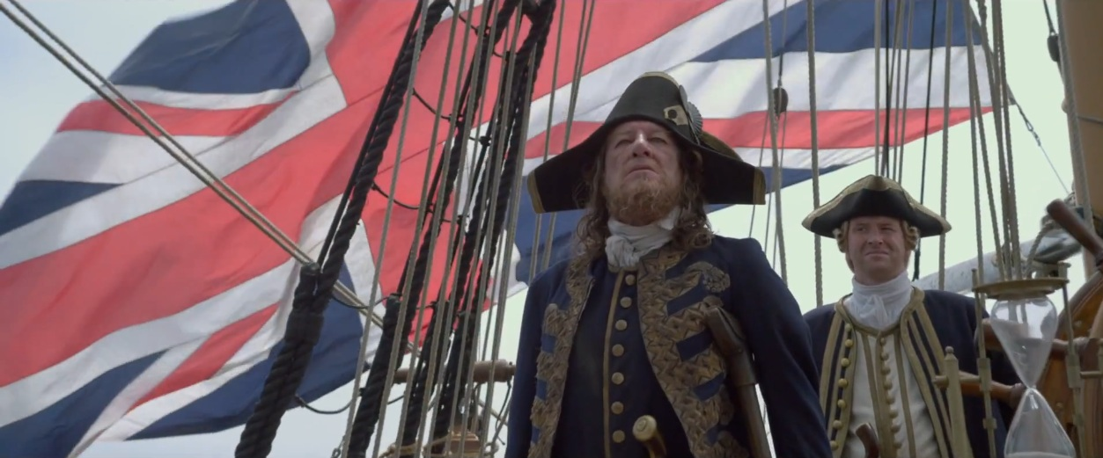
Edited May 26, 2012 by Swashbuckler 1700

- Quote
- Edit
- Options

Swashbuckler 1700
- Dread Pyrate
- Member

- 1,115 posts
- Gender:Male
- Location:Europe
- Interests:pyrates, pryvateers, naval military and other history, different books, good movies, music (a little bit), drawing, games,...
(IP: 80.223.160.249) · ·
Posted May 26, 2012 · Report post
On 5/26/2012 at 1:29 PM, Swashbuckler 1700 said:
On 7/8/2006 at 7:22 AM, Foxe said:
The first Union flag (if we're talking vexillology rather than etymology) was, as Enigma pointed out, adopted in the early 17thC when the Kingdoms of England and Scotland shared a monarch. The flag was specifically associated with the monarch, not the country, and so was only supposed to be used in a royal connection. Naval warships, for example, flew the Union flag, but privateers did not (or should not have...). This first flag was more or less the same as the modern version of the flag, but only bore the flags of England and Scotland (ie. the red saltire of Ireland was not included).
The current Union flag (including the Irish saltire) dates to the early 19thC, and belongs to the nation rather than the monarch, and can thus be used by anyone.
The use of the Union flag by non-official people was a bit of a headache for the authorities, and several acts and bills were passed during the 17thC to try to prevent it. By flying a Union flag a privateer gave the impression of being part of the Navy, which they were not. Woodes Rogers himself got into trouble for it when he arrived in Kinsale harbour flying a Union flag in about 1708.
Interesting that union jack was not privateer flag (they had bloody flags but what other flags they used? personal?)
The fact that modern one is different than the 1700s one is forgotten in many movies e.g in Potc 4
Here I am answering to myself
Foxe said this is one flag tread
" Many European privateers used their municipal or civic flags as identification."

- Quote
- Edit
- Options

Tartan Jack
- Notorious Pyrate
- 
- 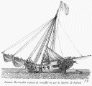
- Member

- 908 posts
- Location:South Carolina
- Interests:History, Scotland, Batman, Cars, and more<br />Married with 2 kids<br />
(IP: 74.181.91.31) · ·
Posted May 26, 2012 (edited) · Report post
It was OFFICIALLY adopted to replace the separate national flags completely in 1707 with the Act of Union. Previously, t had been used in connection to Royal stuff that was part of both nations. Up till 1707, English ships and Englishmen use the white flag with the red Latin cross, centered vertically and horizontally as the St George Flag, while the Scottish ships and Scots used the blue flag with a large white "X" which is a St Andrew's Cross (AKA St Andrews Flag). After 1707, All ships of England and Scotland would use the Union flag rather than their former national flags.
The Union Flag of 1707 looked like:
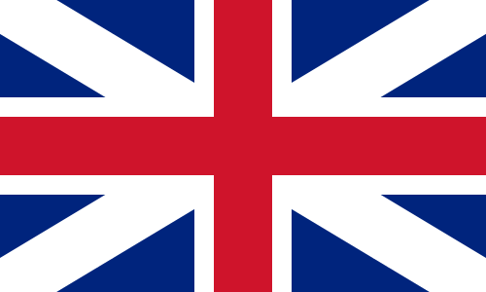
The modern variation added the "red cross of St Patrick" for Ireland, based on a white flag with a red "X" claimed to have been used by the Irish, The origin of the white/red "St Patrick Flag" is hotly debated. The Irish cross is offset to let Scotland's white cross have the "place of prominence" of being on the top of the canton corner. So, the top hoist-side corner should have the red on the bottom of the white.
Also, of interest, is that the original Union flag description was vague as to which cross was on top, so many Scots had the Scottish white cross over the English red cross . . .
It remains a point of contention to some Scots. The percentage is also a matter of debate.
On that matter, one is reminded that MUCH involving England, Scotland, Ireland, and Wales is hotly debated. Even simple stuff can be debated more than those outside it think makes any sense. History is revised and rewritten by all sides for each's own advantage. Unfortunately, such hides and make the truth (what really happened) harder and harder to decipher.
Edited May 26, 2012 by Tartan Jack

- Quote
- Edit
- Options

Swashbuckler 1700
- Dread Pyrate
- Member

- 1,115 posts
- Gender:Male
- Location:Europe
- Interests:pyrates, pryvateers, naval military and other history, different books, good movies, music (a little bit), drawing, games,...
(IP: 80.223.160.249) · ·
Posted May 27, 2012 · Report post
On 5/26/2012 at 4:26 PM, Tartan Jack said:
It was OFFICIALLY adopted to replace the separate national flags completely in 1707 with the Act of Union. Previously, t had been used in connection to Royal stuff that was part of both nations. Up till 1707, English ships and Englishmen use the white flag with the red Latin cross, centered vertically and horizontally as the St George Flag, while the Scottish ships and Scots used the blue flag with a large white "X" which is a St Andrew's Cross (AKA St Andrews Flag). After 1707, All ships of England and Scotland would use the Union flag rather than their former national flags.
The Union Flag of 1707 looked like:
The modern variation added the "red cross of St Patrick" for Ireland, based on a white flag with a red "X" claimed to have been used by the Irish, The origin of the white/red "St Patrick Flag" is hotly debated. The Irish cross is offset to let Scotland's white cross have the "place of prominence" of being on the top of the canton corner. So, the top hoist-side corner should have the red on the bottom of the white.
Also, of interest, is that the original Union flag description was vague as to which cross was on top, so many Scots had the Scottish white cross over the English red cross . . .
It remains a point of contention to some Scots. The percentage is also a matter of debate.
On that matter, one is reminded that MUCH involving England, Scotland, Ireland, and Wales is hotly debated. Even simple stuff can be debated more than those outside it think makes any sense. History is revised and rewritten by all sides for each's own advantage. Unfortunately, such hides and make the truth (what really happened) harder and harder to decipher.
Interesting
I have known for a long tine that 1707 flag was different than modern ones but I hate when in movies etc there is the wrong flag like in potc 4 ......

- Quote
- Edit
- Options

Tartan Jack
- Notorious Pyrate
- Member

- 908 posts
- Location:South Carolina
- Interests:History, Scotland, Batman, Cars, and more<br />Married with 2 kids<br />
(IP: 74.181.91.31) · ·
Posted May 27, 2012 · Report post
I figured you did. But, I posted in case some of the other folks didn't.
First, the English and Scottish flags separately:

And the combining:
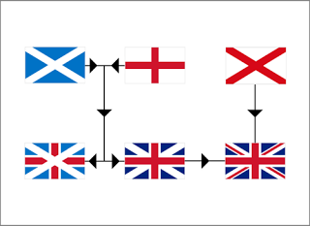
While watching the 2012 Monaco GP, I'm trying to find some on-line shots of the Scot version of the Union Flag:

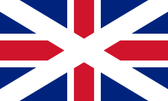
It is also discussed within the Wikipedia article on the Scottish flag: http://en.wikipedia.org/wiki/Flag_of_Scotland
In the present political situation in Scotland, regarding Scottish autonomy (whether semi-autonomous rule or independence), the "Scot on top" flag is making a reappearance.

- Quote
- Edit
- Options

Tartan Jack
- Notorious Pyrate
- Member

- 908 posts
- Location:South Carolina
- Interests:History, Scotland, Batman, Cars, and more<br />Married with 2 kids<br />
(IP: 74.181.91.31) · ·
Posted May 27, 2012 (edited) · Report post
Bigger image:

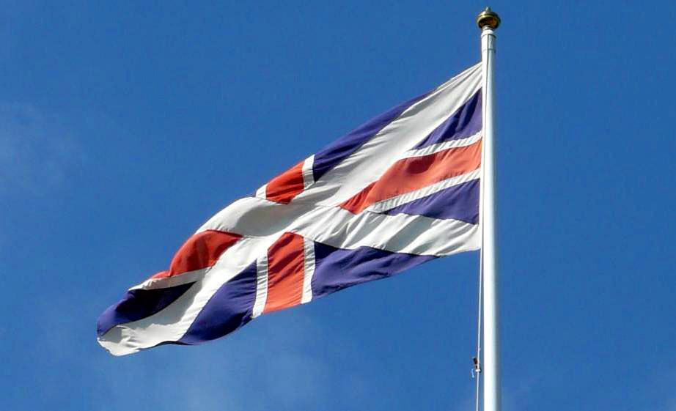
Edited May 27, 2012 by Tartan Jack

