Captain Pogue
- Ship's Master
- 
- 
- Member

- 190 posts
- Location:Portland, Or
- Interests:All things Piratical.<br>Escaping Texas and moving up to the Northwest.<br>Making things.
(IP: 66.68.185.229) ·
Posted December 30, 2007 · Report post
I've got a bit of a problem. Wy wife wants to dress more historically accurate but she doesn't care too much for the basic wench outfit; shift, stay, and skirt.
I had to mop up the drool after she saw Kass's pic/pattern for the Lady's Riding Habit. Not to mention the red velvet number Marianne wore in Brotherhood of the Wolf I know it's not exactly accurate, but she still liked it.
We've been discussing this today and she is getting a bit frustrated. She doesn't want to invest in a common woman's outfit if it isn't something that she even likes. We've discussed maybe dressing her as a sailor to provide an inexpensive way of being historically accurate. But, she'd rather dress like a woman, funny that.
What are the options for women to dress above being just a commoner or shopkeeper?
Quote
Patrick Hand - The well dressed Wench, Female clothing for 1680-1725
- May 28 2005
Off the top of my head, I can think of a few "respectable" ladys that would have had contact with pyrates......... but the majority of women that had anything to do with Pyrates were..... aaaaaah...... well..... wenches and harlots......
Any help or suggestions on this would be greatly appreciated.
Thanks,
Pogue

- Quote
- Edit

Patrick Hand
- The sailor's sailor
- 
- 
- Moderator

- 6,100 posts
- Gender:Male
- Location:TH' Mountains of Central California
- Interests:I like wierdness... Klingon, Pyrate..... and even..... gasp.... Renn Faires...... (Baseball and tractor pulls I'd have to think about.... could be wierd or Not,,,,)
(IP: 207.104.49.67) · ·
Posted December 30, 2007 · Report post
There were women durring the Golden Age of Pyrates.....
The quoted comment above, is in reference about what type of woman would associeate with Pyrates.....
Not all of them would have been lower class.... but it will take a bit of creative thinking to figure out what a "nice" lady was doing with a buncha Pyrates.....
But even someone who buys "loot/fences questionable goods", would have dressed nicer than the Renn Faire trollop look.....
There is a thread (I think in Plunder) about womans period garb,(I think it's female miminmu standards) with a lot of good pictures of woman's clothing/garb .....

- Quote
- Edit
- Options

Jack Roberts
- Dread Pyrate
- 
- 
- Member

- 1,063 posts
- Gender:Male
- Location:Orlando, FL
(IP: 97.101.55.161) · ·
Posted December 30, 2007 · Report post
A good start is;
Shift (Chimese)
Petticote (preferably 2 or more, one inner and one outer. The outer one can be a nice fabric, the inner can be just plain white)
Stays (the period version of a corset)
Mantua
To be a higher class just use nicer fabric, add trains to the petticotes and mantua. Add frilly trim to the shift. Things like that. Thats start. Have fun!

- Quote
- Edit
- Options

JoshuaRed
- Dread Pyrate
- 
- Member

- 1,342 posts
(IP: 72.224.164.87) · ·
Posted December 31, 2007 (edited) · Report post
There are plenty of "normal" gals who would have associated with pirates. Wives, girlfriends...innkeepers...shop keepers...right? Fine upstanding people who wouldn't be scantily dressed or pretending to be male sailors. There were plenty of widows who inherited their husband's businesses and made them their own rather than sell them off.
I recall reading about the families of a group of Rhode Island pirates, who I THINK may have been involved with Tew. Apparently they were fiercely protective of their husbands' occupations...to the point where they were known to lie to authorities to cover for their husbands while at sea. I'll see if I can find it.
Edited December 31, 2007 by JoshuaRed

- Quote
- Edit
- Options

Fox
- Old Twillian
- 
- 
- Moderator

- 2,569 posts
- Gender:Male
- Location:Beautiful lush Devon, England
- Interests:Nautical history of the 16-18th centuries and living history based thereon.
Shooting pirates.
(IP: 217.44.237.9) · ·
Posted December 31, 2007 · Report post
Genteel ladies slumming it with pirates... hmm... When some of Henry Every's men made their way to Philadelphia in the second half of the 1690s one of them married Governor Markham's daughter.

- Quote
- Edit
- Options

Captain Midnight
- Pyrate Captain
- 
- 
- Member

- 643 posts
- Gender:Male
- Location:Richland, GA USA
- Interests:I am the Captain of The Cursed Few, the deadliest pirate crew on the East Coast. I am a charter member of the Order of Leviathan, or "Devil's Dozen".
(IP: 74.244.192.183) · ·
Posted December 31, 2007 (edited) · Report post
Another gentle lady from history comes to my mind: the mother of the young Mr. King aboard the Whydah when it was captured by Samuel Bellamy. Of course we may never know if she was sympathetic towards the pirates, but it is believed that her young son was at any rate, as he joined them. It is also believed that the shoe, silk stocking, and small leg bone recovered from the wreck may have been his. If he was wearing silk stockings, it is probable that he was not the lowliest of commoners, so I would bet his mother was not dressed too shabbily herself. So there you have a possible historical incidence of a lady of higher social standing aboard a pirate ship...
Edited December 31, 2007 by Captain Midnight

- Quote
- Edit
- Options

Captain Pogue
- Ship's Master
- Member

- 190 posts
- Location:Portland, Or
- Interests:All things Piratical.<br>Escaping Texas and moving up to the Northwest.<br>Making things.
(IP: 66.68.185.229) · ·
Posted December 31, 2007 · Report post
Thanks all for the info! You've given me some good leads to look into and a glimmer of hope that my wife won't have to spend her hard-earned cash on an outfit that she doesn't really care for. When momma's not happy, nobody is...
Thanks mates,
Pogue

- Quote
- Edit
- Options

Patrick Hand
- The sailor's sailor
- Moderator

- 6,100 posts
- Gender:Male
- Location:TH' Mountains of Central California
- Interests:I like wierdness... Klingon, Pyrate..... and even..... gasp.... Renn Faires...... (Baseball and tractor pulls I'd have to think about.... could be wierd or Not,,,,)
(IP: 207.104.49.67) · ·
Posted January 1, 2008 · Report post
Quote
ome good leads to look into and a glimmer of hope that my wife won't have to spend her hard-earned cash on an outfit that she doesn't really care for
Like I kinda posted..... there were women durring the GAoP.....
So there is some "wiggle room"..... it just takes a little more "research" to figure why a "nice" (or well dressed ) lady would be around scummy Pyrates...
Now after saying that.... even the scummy ladys did dress kinda nice,.... not like the Renn Fair doxies (and that dress isn't really period anyway...)
Not to get into any trouble.... But I'm typing about the West Coast Renn faire doxies.... maybe back East they do it better..... but I don't know.......
Women did exist durring the Golden Age of Pyracy... and not all of them were whors or sluts...,or doxies... slanterns.... and .... hey you get the picture....
I'm kinda a poop about this... because I think there are too many woman playing Pyrates... and not enough playing what women realy did durring the Golden Age..... sorry if it never typed out that way.....
And the sillyist part of the whole thing.... as something like PiP... heck we don't kick out any O' th' women.....
Hey.. let her dress as fancy as she wants..... but also..... it's going to be hot.... (as in temputure.....).......
I'm kinda amazed that none of the ladys have posted some pictures of thier garb/clothing...... drat... maybe I shoud PM a few of them ..... just to show you and your lady what can be done......

- Quote
- Edit
- Options

Mary Diamond
- It's My Fault
- 
- Moderator

- 1,050 posts
- Gender:Female
- Location:Illinois
- Interests:Things I Love: Horticulture, Travel, Volleyball, Reading, Sewing, Costuming, Halloween, esp. props!, Halo, Halo2, Halo3, ODST, and, of course, Pyracy.
(IP: 67.167.49.211) · ·
Posted January 1, 2008 (edited) · Report post
Good Afternoon!
Patrick, was that a request?
Captain Pogue, attached is a photo of myself aboard the Liberty Clipper at PiP 2007, wearing my riding habit. I must advise ~ I flourish in 90 degree heat and high humidity. My hands are typically ice if the temperature is below 75.
The riding habit coat and petticoat is wool (with a linen lining for the coat) with a sleeveless dress waistcoat, stays, linen chemise, linen petticoat, linen pockets, stockings, cravat and sash. Yes, that is 10 items of clothing for a riding habit ~ not including shoes or hat, gloves, belt, etc.
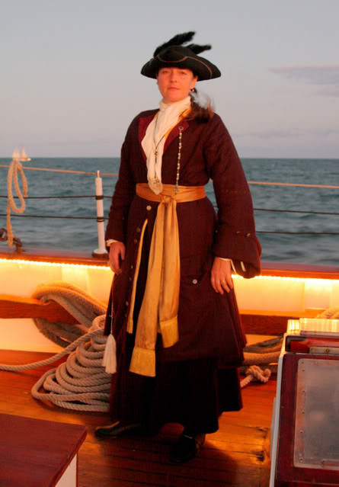
If your dearest wife has a normal or warm constitution, with intent to participate in summer weather events, I would advise her to consider a linen mantua instead, cutting her layers down to 7 (mantua, stays, pockets, 2 petticoats (outer petticoat and white), chemise, stockings).
I will see if Silkie can post her lovely green outfit ~ really a beautiful ensemble, and if Cheeky can post her common and dress mantuas.
Edited January 1, 2008 by Mary Diamond

- Quote
- Edit
- Options

callenish gunner
- Scourge o' the 7 Seas
- 
- 
- Member

- 2,138 posts
- Gender:Male
- Location:Pennsylvania mountains north of Clarion
- Interests:The Callenish gunner has just hoved into view looking for safe anchorage in these waters... purveyor of bladed and flintlock weaponry also leather accessories ..........painter of portraits and period scenes by avocation I'm getting my armoury business underway and will be doing as many festivals as I can ...right now along the east coast or great lakes
(IP: 75.117.131.26) · ·
Posted January 1, 2008 · Report post
don't know about Silkie posting it but I will!!!
She looked lovely and it was only about 75 degrees that day
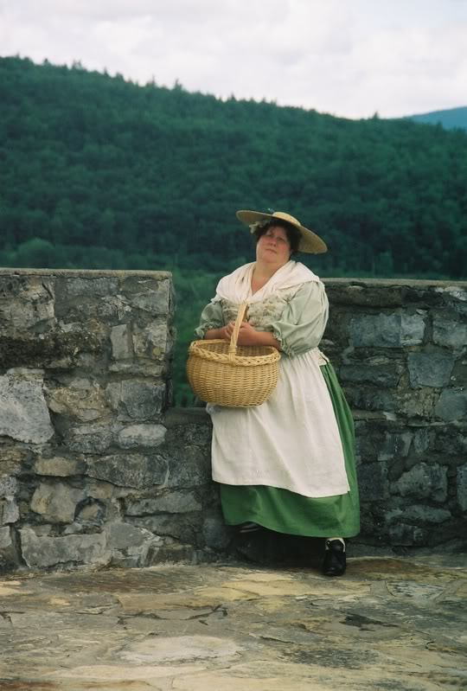

- Quote
- Edit
- Options

Captain Midnight
- Pyrate Captain
- Member

- 643 posts
- Gender:Male
- Location:Richland, GA USA
- Interests:I am the Captain of The Cursed Few, the deadliest pirate crew on the East Coast. I am a charter member of the Order of Leviathan, or "Devil's Dozen".
(IP: 74.244.192.183) · ·
Posted January 1, 2008 · Report post
Two lovely ensembles for period women, and two beautiful ladies wearing them...

- Quote
- Edit
- Options

Mary Diamond
- It's My Fault
- Moderator

- 1,050 posts
- Gender:Female
- Location:Illinois
- Interests:Things I Love: Horticulture, Travel, Volleyball, Reading, Sewing, Costuming, Halloween, esp. props!, Halo, Halo2, Halo3, ODST, and, of course, Pyracy.
(IP: 67.167.49.211) · ·
Posted January 1, 2008 · Report post
Thank you, Callenish! Precisely the image I was thinking of ~ Silkie is so beautiful in that outfit ~
And thank you for the compliments, Captain Midnight!

- Quote
- Edit
- Options

Capt. Sterling
- Sticky Fingers Sterling Needs a New Hat
- 
- Member

- 10,302 posts
- Gender:Pyrate Hunter
- Location:here
- Interests:Killing pirates, haven't met one yet worth keeping alive....
(IP: 76.1.134.141) · ·
Posted January 1, 2008 (edited) · Report post
Aye I have all the lovely women in my crewe...Silkie, Mad Mary, and...
not to mention... my indentured servant.... Bess

and the actress

Honestly what Bess has on serves well for a number of different female impressions, all depends on the choice of fabrics and length....
**Note don't tell the others, but Maddogge still looks the best in a dress...
Edited January 1, 2008 by Capt. Sterling

- Quote
- Edit
- Options

Cheeky Actress
- Contesse de Tosspot
- 
- Member

- 3,876 posts
- Gender:Female
- Location:Middlesort Port of the Midwest
- Interests:Seeking all who have been Forsaken in their quest.
(IP: 207.67.93.144) · ·
Posted January 1, 2008 · Report post
The look depends on the 'activity' really.
There is an assortment of attires that your lovely wife can wear just as Mary Diamond, Callenish, and Captain Sterling has stated.
Simple is best...especially if cost is one of the factors. What Bess Hagarty is wearing is 'standard' attire for middlesort.
But if you want flash, just like Mary has on...riding outfits are quite the proper thing to wear about town while doing business or traveling.
I, well...I like gowns...with lots of colour! You never know when you'll be ask to show up at the palace!

- Quote
- Edit
- Options

Silkie McDonough
- Proprietress of the Sealkies Hide
- 
- Moderator

- 5,695 posts
- Gender:Female
- Location:I have been a Virginian for 2 months now. LOVING it.
- Interests:Music, vocalizing, Irish balads. I love to draw, I do pencile portraits/detail drawings for barter and sale. The link in in my signature. Ireland, its history and culture. Sewing garb, mostly for myself. The arm of a strong gentleman round my waist.
Unfortunately, I don't do nearly enough of any of a these.
(IP: 68.45.193.195) · ·
Posted January 1, 2008 · Report post
Hugh and Mary, thank you both.

- Quote
- Edit
- Options

Captain Pogue
- Ship's Master
- Member

- 190 posts
- Location:Portland, Or
- Interests:All things Piratical.<br>Escaping Texas and moving up to the Northwest.<br>Making things.
(IP: 66.68.185.229) · ·
Posted January 1, 2008 · Report post
All of you ladies look wonderful!
My wife really wants to stay away from outfits like Silkie's and Bess's. Nothing against their outfits one bit, my wife just wants to look fancy and all. Cost isn't that much of a concern so much as making the right choice first off. We've bought several things at the beginning of this adventure that I wish I had just waited a bit longer or had found the pub...
All of your input and comments have helped us to feel better about going with a riding habit for her. My main concern was really having her look out of sort amongst a bunch of pirates. I think we can pull it off if we are careful about what I wear to accompany her.
Several of you mentioned temperature as a concern, I'd have to agree. Since living in Texas and attending some of the Ren Fests down here she'd be nuts to dress up in a full riding habit...
With that I have a question about the riding habits. Being male and living in the 21st century I can think of clothing in layers. Do the riding habits function like that? If it's too hot you can take the frock coat off, and not look too off? Might not look as fancied up, plus the whole stigma about appearing underdressed, but she'd still look decent. Would any of you ladys have any picture of the riding habit without a frock coat possibley?
I think the hard part is really not knowing a lot of the ettiquette for women's wear in the GAoP. I've looked over the Twill thread for women's wear and it's a bit thin when compared to the other Twill clothing threads. Any help pointing us in the right direction to do a bit more research would be great too.
Thank you all so much for contributing on this, it's important to for my wife to be able to share this with me. Even if she can't just look pretty and be my wench
Thanks,
Pogue

- Quote
- Edit
- Options

Mary Diamond
- It's My Fault
- Moderator

- 1,050 posts
- Gender:Female
- Location:Illinois
- Interests:Things I Love: Horticulture, Travel, Volleyball, Reading, Sewing, Costuming, Halloween, esp. props!, Halo, Halo2, Halo3, ODST, and, of course, Pyracy.
(IP: 67.167.49.211) · ·
Posted January 1, 2008 · Report post
Perhaps, if your wife likes the "fancy" look, a fancy mantua is perhaps more appropriate ~ please see the images below.
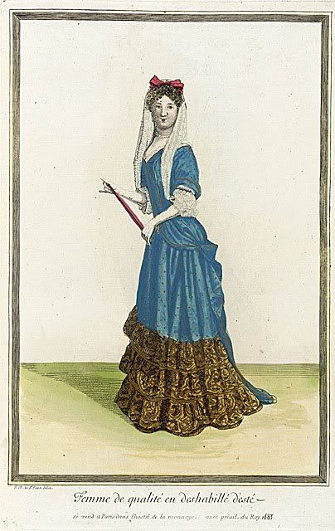dated 1683
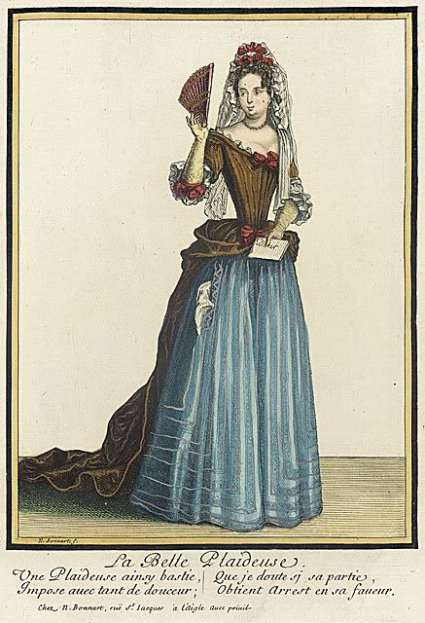dated 1686
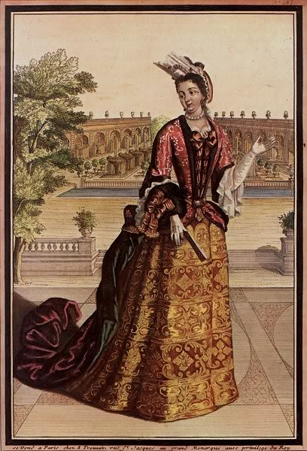dated 1698
dated 1718
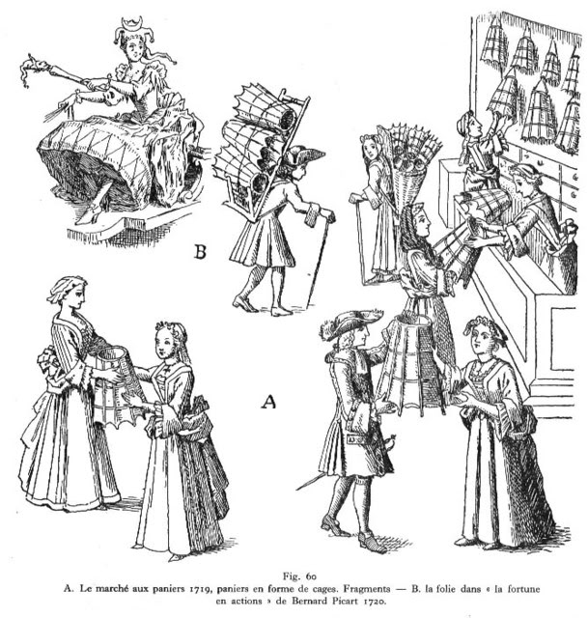dated 1719-20

- Quote
- Edit
- Options

Ransom
- It's Going on Your Permanent Record
- 
- Moderator

- 5,177 posts
- Gender:Female
- Location:The pirate wasteland of Southern OR.
- Interests:I belong to the Barn Owls Writers Group. My husband and I live on 20 acres with four cats, and a two horses, Delight and Apollo — used to have longhorn cattle, sheep, but no more. Our 28' Tollycraft is moored in Charleston harbor. She has no sails, but dreams of being a schooner.
I like to ride my horse doing Medieval gaming, and now mounted archery, and trail course challenges. I also garden, read, do artwork, write, make beaded jewelry for my Website "Found in the Ruins", and go on antique/junk crawls with my husband of 20+ years. I am somewhat of a costume making junkie. Now I make pyrate and steampunk costumes, as well as SCA costumes and horse bardings, and am having WAY too much fun....
(IP: 69.59.202.232) · ·
Posted January 2, 2008 · Report post
Oh, Mary, those are lovely. I think if I ever decided to go "girlie" I'd pick something like #2. (Okay, stop sniggering you lot, it could happen! )

- Quote
- Edit
- Options

Captain Midnight
- Pyrate Captain
- Member

- 643 posts
- Gender:Male
- Location:Richland, GA USA
- Interests:I am the Captain of The Cursed Few, the deadliest pirate crew on the East Coast. I am a charter member of the Order of Leviathan, or "Devil's Dozen".
(IP: 74.244.192.183) · ·
Posted January 2, 2008 · Report post
Aye, No.2 is a very lovely choice. Of course you can do it, Ransom! Let us see pics when you do. I rather like the historical, classy looking ladies' looks far more than those slutty modern "tavern wench" get-ups, anyway...

- Quote
- Edit
- Options

Ransom
- It's Going on Your Permanent Record
- Moderator

- 5,177 posts
- Gender:Female
- Location:The pirate wasteland of Southern OR.
- Interests:I belong to the Barn Owls Writers Group. My husband and I live on 20 acres with four cats, and a two horses, Delight and Apollo — used to have longhorn cattle, sheep, but no more. Our 28' Tollycraft is moored in Charleston harbor. She has no sails, but dreams of being a schooner.
I like to ride my horse doing Medieval gaming, and now mounted archery, and trail course challenges. I also garden, read, do artwork, write, make beaded jewelry for my Website "Found in the Ruins", and go on antique/junk crawls with my husband of 20+ years. I am somewhat of a costume making junkie. Now I make pyrate and steampunk costumes, as well as SCA costumes and horse bardings, and am having WAY too much fun....
(IP: 69.59.202.232) · ·
Posted January 2, 2008 · Report post
Thanks Captain Midnight. However, I don't dress like a tavern wench either. I dress like a guy — frock coat, shirt, breeches, boots and tricorn. No corsets, no petticotes, no stays.

- Quote
- Edit
- Options

Cheeky Actress
- Contesse de Tosspot
- Member

- 3,876 posts
- Gender:Female
- Location:Middlesort Port of the Midwest
- Interests:Seeking all who have been Forsaken in their quest.
(IP: 66.192.73.89) · ·
Posted January 3, 2008 · Report post
(Blink...Blink...Blink) - Then in a sing-songy voice...
Ransom....I've got a lovely green gown you could be fitted into...oh, and you get to wear the 'bunny ears' too!

- Quote
- Edit
- Options

Captain Pogue
- Ship's Master
- Member

- 190 posts
- Location:Portland, Or
- Interests:All things Piratical.<br>Escaping Texas and moving up to the Northwest.<br>Making things.
(IP: 66.68.185.229) · ·
Posted January 3, 2008 · Report post
Mary, thanks for the pics and the suggestion on Mantua. I've never really paid that much attention to Cheeky Actresses' outfit in the past, I figure one pirate in a dress is enough. At least according to the rumors from PiP
I guess I was lumping the fancy mantuas in with the riding outfits and assuming mantuas were for the common women. We all know what that means.
This opens up more possibilities.
The pic dated 1718 above almost looks like a mantua/shift combo. I read that the mantuas are pinned to the shift, but that doesn't look like the other pics. Any clarification on that one?
Thanks!
Pogue

- Quote
- Edit
- Options

Mary Diamond
- It's My Fault
- Moderator

- 1,050 posts
- Gender:Female
- Location:Illinois
- Interests:Things I Love: Horticulture, Travel, Volleyball, Reading, Sewing, Costuming, Halloween, esp. props!, Halo, Halo2, Halo3, ODST, and, of course, Pyracy.
(IP: 67.167.49.211) · ·
Posted January 3, 2008 · Report post
Sorry, what are the rumors from PiP? Or, perhaps you are referring to our enterprising Maddogge?
Perhaps look at it this way ~ the cut (fashion) of the clothes are fairly standardized, even today. It is the material that makes the clothing stand apart.
I am not sure I understand what you mean by a mantua/shift combo, and I must apologize for generically lumping all the dresses into a "fancy mantua" category (which they are not). I will do my best to answer your question, though I am still learning myself, and I am sure there are far more knowledgeable persons than myself. Please correct me if I am wrong!
I believe the 1718 dress is similar cut to one I am working on ~ what I have been told is called a "bodice gown". Essentially, it is a covered pair of back laced stays with fixed shoulders and/or sleeves and an attached petticoat (skirt)(all one piece, like a wedding dress with a split skirt), worn over a second, separate petticoat. So, the 4 layers are as follows: linen chemise (which I believe you are calling a shift?), linen petticoat, dress petticoat, bodice gown. Hoops optional.
This differs from the mantua, in that the mantua pulls on like a robe (pardon the comparison), and is pinned to the stays at the center waist. (For a more well-to-do, a stomacher (an embroidered piece of material) is pinned to the stays before the mantua is pulled on ~ see below image) A separate pair of petticoats are worn beneath. Bess's red wool mantua probably best illustrates the layering. The cream area under her mantua is her stomacher.
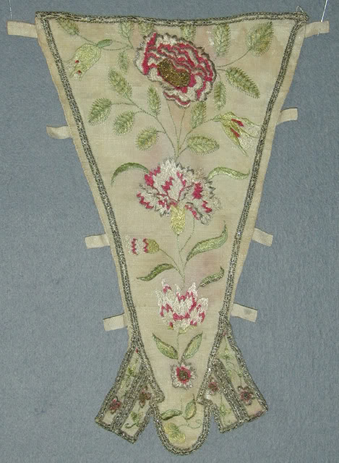
Oh, and Ransom ~ You would be stunning in a mantua. Your carriage, lovely peaches and cream skin... an absolute vision.

- Quote
- Edit
- Options

Captain Pogue
- Ship's Master
- Member

- 190 posts
- Location:Portland, Or
- Interests:All things Piratical.<br>Escaping Texas and moving up to the Northwest.<br>Making things.
(IP: 66.68.185.229) · ·
Posted January 3, 2008 · Report post
Yeah, I was talking about Maddogge... caught a picture of in the dress somewhere. He truly is a vision
That seems to make sense now. I had come across the term "bodice gown" just a little while ago on the net. I was wondering if that's what the image was of...
Yeah, I'm calling the chemise a shift, bad Pogue! I should know better when it comes to a lady's under garments
Thanks!
Pogue

- Quote
- Edit
- Options

Ransom
- It's Going on Your Permanent Record
- Moderator

- 5,177 posts
- Gender:Female
- Location:The pirate wasteland of Southern OR.
- Interests:I belong to the Barn Owls Writers Group. My husband and I live on 20 acres with four cats, and a two horses, Delight and Apollo — used to have longhorn cattle, sheep, but no more. Our 28' Tollycraft is moored in Charleston harbor. She has no sails, but dreams of being a schooner.
I like to ride my horse doing Medieval gaming, and now mounted archery, and trail course challenges. I also garden, read, do artwork, write, make beaded jewelry for my Website "Found in the Ruins", and go on antique/junk crawls with my husband of 20+ years. I am somewhat of a costume making junkie. Now I make pyrate and steampunk costumes, as well as SCA costumes and horse bardings, and am having WAY too much fun....
(IP: 69.59.202.54) · ·
Posted January 3, 2008 · Report post
Mary Diamond said:
Oh, and Ransom ~ You would be stunning in a mantua. Your carriage, lovely peaches and cream skin... an absolute vision.
Peaches and cream? A vision? Looks in mirror, then reads Mary's description again, looks in mirror...."Ummm, Mary, you are talking about the Ransom you met in Pt. Washington, right? I mean, okay, I can go with the carriage part, but...peaches and cream? Vision? At my age? Not hardly!
And Cheeky, I'll think about the dress, but pass on the bunny ears, thank-you ever so.

